NPFC-2025-TWG CMSA10-WP05

**Standardized Abundance Indices for Ages 0 and 1 Fish of Chub Mackerel from Northwest Pacific Autumn Surveys up to 2024**

Kazunari Higashiguchi, Shota Nishijima, Momoko Ichinokawa, and Ryuji Yukami

*Fisheries Resources Institute, Japan Fisheries Research and Education Agency*

**Summary**

We conducted CPUE standardization of surface trawl surveys in autumn for Pacific chub mackerel using the Vector Autoregressive Spatio-Temporal (VAST) model. We estimated local densities of 0-year-old fish and 1-year-old fish in the Northwest Pacific from 2005 to 2024 with consideration for environmental factors of sea surface temperature (SST) and 30m-depth temperature as well as spatial autocorrelation. The analysis showed high levels of abundances frequently occurred since 2013. However, the abundance had decreased in 2023 and 2024. Model diagnostics found no serious problems in residual patterns. We propose the standardized indices to be utilized as the abundance indices of age-0-fish and age-1-fish in the TWG CMSA.

# 1. BACKGROUND

Japan Fisheries Research and Education Agency (FRA) has conducted a sea surface trawl net survey in a broad range of Northwestern Pacific Ocean (141.5º–175º E and 37.0º–50.0º N, Fig. 1) from September to October annually to collect biological and abundance information on small pelagic fish including chub mackerel (here called *autumn survey*). The standardized CPUE of young-of-the-year (YOY) fish from this survey had long been used in the Japanese domestic stock assessment of chub mackerel and was submitted to TWG CMSA as working papers several times (e.g., Nishijima et al. 2022). In addition to age 0 fish, FRA has completed age identification for 1-year-old (YO) fish of chub mackerel in the autumn survey samples, and then newly used the standardized CPUE of age 1 fish in the latest Japanese domestic stock assessment (Yukami et al. 2024).

In this working paper, we updated CPUE standardization for both ages 0 and 1 fish of chub mackerel up to 2024 to propose the obtained standardized abundance indices be used for TWG CMSA. As in the previous working paper (Nishijima et al. 2024) we used the Vector Autoregressive Spatio-Temporal (VAST) model (Thorson 2019) in this paper, with minor modification on model settings.

# 2. METHOD

## 2.1 The data

The sea surface trawl net surveys have been conducted by FRA in a broad range of the Northwestern Pacific in autumn (September and October) annually. The autumn surveys were conducted from 2005 to 2024 in the area approximately of 141.5º–175º E and 37.0º–50.0º N (Table 1, Fig. 1A). The trawling times per towing, which were used as effort, were generally half to one hour (Fig. 1A). The CPUEs were calculated as the number of fish per hour of towing (Fig. 1B-E). The CPUE from the autumn survey has been historically aggregated for fish aged 1 year and older. However, with the implementation of age determination through otoliths, age disaggregation has been conducted for 1-year-old fish and those aged 2 years and older, allowing for the separate analysis of CPUE for 1-year-old fish. It is worth noting that the no survey were conducted near the Pacific coast of Japan in 2023 and 2024 (Fig. 1A) because a bad weather condition prevented us to conduct the survey there.

The proportions of positive catch were lower than 45% for age 0 and 15% for age 1 until 2012 but became higher than 45% for age 0 and 20% for age 1 from 2013 to 2022 (Table 1). However, the proportions of positive catch decreased to 30% for both ages 0 and 1 in 2023. In 2024, the proportions of positive catch was 53.6% and 42.9% for age 0 and age 1 fish, respectively. We used all samples (*N* = 765) because all the samples recorded necessary information for the analysis (catch, effort, location, and environmental variables).

## 2.2 Associations between independent variables and between dependent and independent variables

We used in situ SST and T30 as covariates in the previous document, but they were highly correlated with *r* = 0.67 of Pearson’s correlation coefficient (Fig. 2, left). Such collinearity in multiple regression models could destabilize parameter estimates and prediction to new data, suggesting that it might be problematic in the interpretation of results and model predictions in CPUE standardization. Therefore, we conducted the PCA and used PC1 and PC2 in the analysis, which became orthogonal covariates (Fig. 2, right). PC1 was negatively correlated with SST and T30, indicating a common component of SST and T30. By contrast, PC2 was positively correlated with SST but negatively with T30, reflecting a difference between SST and T30. The proportion of variance of PC1 and PC2 were 83.5% and 16.5%, respectively (Fig. 2).

We found that SST, PC1, and PC2 moderately varied over the years, while T30 seemed to be relatively stable (Fig. 3). SST and T30 tended to be higher in the northeast than in the southwest (Fig. 4A, B). PC1, which was negatively correlated with SST and T30, was thus higher in the northeast (Fig. 4C). PC2 tended to be higher off Hokkaido (Fig. 4D).

## 2.3 Full model description and model selection

We applied the VAST model (Thorson 2019) to age 0 fish and age 1 fish separately in the autumn survey. In simulations, VAST demonstrated superior overall performance in CPUE standardization compared to generalized linear models or generalized additive models (Grüss et al. 2019). In VAST, the survey CPUE is represented using two linear predictors for each sample *i*: the encounter probability (*p*1(*i*)) and the density (or CPUE) when encountered (*p*2(*i*)).

|  |  |
| --- | --- |
|  | (1) |
|  | (2) |

The first term on the right-hand side, $β\left(t_{i}\right)$, represents the coefficient indicating the effect of survey year *t*. The second term, $ω\left(s_{i}\right)$, signifies the spatial random effect for survey year *t*, while the third term, $ε\left(s_{i},t_{i}\right)$, denotes the spatiotemporal random effect for survey year *t* and location *s*. The fourth term represents the covariate *Q* influencing catchability, with its corresponding coefficient *λ*. In the VAST model, initially, spatial distribution is approximated by determining knots through a form of clustering called k-means from spatial information. The spatiotemporal variation in relative density at these knots is then modeled. A previous study recommended using 100 or more knots (Thorson 2019), and following this guidance, we selected 300 knots for this study (*nS* = 300). The probability density function for spatial effects is modeled using a multivariate normal distribution (MVN):

|  |  |
| --- | --- |
| $$ω_{1}\left(∙,f\right)\sim MVN\left(0,R_{1}\right), ω_{2}\left(∙,f\right)\sim MVN\left(0,R_{2}\right) ,$$ | (3) |

where ***R1*** and ***R2*** is the Matérn correlation function:

|  |  |
| --- | --- |
|  | (4) |
|  | (5) |

In VAST and in this analysis, the estimation of $φ$ is not conducted by assuming $φ=1$ fixed. Here, $Γ$ represents the gamma function, *Kν* is the modified Bessel function of the second kind, $κ_{1}$ and $κ_{2}$ are decorrelation rate to be estimated, $d\left(s_{n},s_{m}\right)$ is the distance between knots, and ***H*** is the matrix representing geographical anisotropy (variation in correlation depending on the direction). However, geographical anisotropy was not assumed ($H=I$) due to challenges in estimation. Similarly, the probability density function for spatiotemporal effects is given as follows:

|  |  |
| --- | --- |
| $$ε_{1}\left(∙,f,t\right)\sim \left\{\begin{matrix}MVN(0,R_{1}) & if t=1 \\ MVN(ρ_{ε1}ε_{1}\left(∙,f,t-1\right),R_{1}) & if t>1\end{matrix}\right. ,$$ | (6) |
| $$ε_{2}\left(∙,f,t\right)\sim \left\{\begin{matrix}MVN(0,R_{2}) & if t=1 \\ MVN(ρ_{ε2}ε_{2}\left(∙,f,t-1\right),R_{2}) & if t>1\end{matrix}\right. .$$ | (7) |

We used different model configurations between age-0-fish and age-1-fish considering the nature of data and estimated parameters (Table 2). In the age-0 analysis, the effects for each year (*β*) were estimated as fixed effects in both the first and second predictors. In the second predictor (positive CPUE when encountered), we turned-off the spatial effect ($ω_{2}$) for age 0 because in a model with no environmental covariates the variance explained by this spatial effect was almost zero and it was suggested to turn off the spatial effect by the *check_fit* function in VAST. We tuned-off the spatio-temporal effect in the first predictor ($ε_{1}$) for age 0 by the same reason, while we assumed independence of each year in the second predictor ($ε_{2}$).

Regarding age-1-fish, no fish were captured throughout the survey in 2006 and 2007 (Table 2). We therefore estimated the year effect as random effects under the IID process in the first and second predictors. We tuned off the spatial effect in the second predictor for age 1 because the variance explained by the year effect with the IID process was almost zero, revealed by the *check_fit* function in VAST as age 0. We assumed the spatio-temporal effects to be independent over years in the first and second predictors so that the abundance index obtained would be likely to be independent among years.

In the analysis, a delta-type model employing the binomial distribution and gamma distribution was utilized. The predicted encounter rate (*r*1(*i*)) and predicted CPUE when encountered (*r*2(*i*)) were expressed using the following equations (Thorson 2017):

|  |  |
| --- | --- |
| $$r_{1}\left(i\right)={logit}^{-1}p_{1}\left(i\right) ,$$ | (10) |
| $$r_{2}\left(i\right)=a_{i}×\log^{-1}p_{2}\left(i\right) .$$ | (11) |

Although the term *ai* represents the offset variable, it was set to 1 with CPUE as the dependent variable. The probability of observing CPUE is expressed as follows, and the parameters that maximize the marginal likelihood were estimated.

|  |  |  |
| --- | --- | --- |
|  |  | (12) |

The parameters of the aforementioned model are estimated using the maximum likelihood method. In this document, we used the ‘VAST’ package distributed by GitHub (<https://github.com/James-Thorson-NOAA/VAST>, Thorson 2019), where complex computations involving integrals due to the involvement of numerous random effects are efficiently analyzed using a software called Template Model Builder (Kristensen et al. 2016).

The covariate Q, influencing catchability, includes PC1, PC2, the square terms of PC1 and PC2, and interaction terms between PC1 and PC2 (Table 3). Model selection was conducted using exhaustive search based on Akaike Information Criterion with correction (AICc).

## 2.4 Yearly trend extraction

The abundance index was calculated by employing the model with minimum AICc. In VAST, densities for each year and location are computed as $d\left(s,t\right)=r_{1}^{*}(x,t)×r_{2}^{*}(x,t)$, where *r*\* is obtained using equations 10 and 11 from equations 1 and 2, excluding the fourth term regarding catchability. The abundance is then determined by summing the product of the area ($a\left(s\right)$) and density for each knot. Since the density is represented by CPUE (individuals/hour) in this analysis, the standardized CPUE (individuals/hour) was calculated by dividing the sum by the total area.

|  |  |
| --- | --- |
| $$I\left(t\right)=\frac{\sum_{s=1}^{n_{s}}{\left(a(s)×d\left(s,t\right)\right)}}{\sum_{s=1}^{n_{S}}{a(s)}}$$ | (13) |

The total sum of the areas for each knot from *S*=1 to 300 (=*nS*) remains constant across years; therefore, this procedure does not alter the relative trends of the standardized index values.

# 3. RESULT and DISCUSSION

The selected variables in the best model of age 0 fish were only PC1 and its squared term for both binomial and gamma distributions (Table 3).For the best model of age 1, PC1 and PC1 squared term were selected for binominal distribution, while all terms were selected for gamma distribution (Table 4). The maximum likelihood estimates and standard errors of fixed-effect parameters did not exhibit extreme values, and the gradients were all close to zero (Tables 5, 6).

We generated scaled residuals using the R package ‘DHARMa’ (Hartig 2022) for model diagnostics. This package enables to simulate the scaled residuals which should theoretically follow the uniform distribution from zero to one. As a result, the QQ plot and the Kolmogorov-Smirnov test showed that the scaled residuals were not significantly deviated from the theoretical prediction of the uniform distribution for both ages 0 and 1 (Fig. 5). Moreover, the scaled residuals were almost constant in response to varying predicted CPUE and dependent variables (PC1, PC2 and year) (Fig. 6). It also seemed that there were no systematic spatial patterns in the scaled residuals (Fig. 7).

Estimated densities of age 0 fish and age 1 fish were low until 2012, but increased thereafter (Fig. 8). The distribution centroid of age 0 fish had located at less than 160 °E and 45 °N since 2012, although it has shifted to offshore to more than 160 °E and 45 °N since 2013. The distribution of 1-year-old fish has more clearly shifted offshore, and over the 20-year period from 2005 to 2024, the centroid of the distribution has increased by approximately 15 degrees in longitude and about 5 degrees in latitude.

The partial dependence plot showed that the encounter probability and the positive CPUE when encountered for age 0 fish exhibited concave-down responses to PC1 (Fig. 9A). Assuming that the original variables SST and T30 change “independently,” the responses to changes in each variable were examined through partial dependence plots. As a result, it was indicated that the expected CPUE was the highest when SST was14.9°C and T30 was 12.5°C. The encounter probability of age 1 fish showed concave-down to PC1 and almost no response to PC2, while positive CPUE of age 1 fish showed concave-down responses to PC1 and PC2 (Fig. 9B). For age 1 fish, the expected CPUE was the highest when SST was 17.1°C and T30 was 9.4°C.

Standardized CPUE of age 0 remained low until 2012, but high values were frequently observed since 2013 (Fig. 10, upper). Especially in 2013, 2016, and 2018, the values were high, whereas the value of recent years (2023–2024) was on the lowest level since 2013. This yearly trend of the standardized CPUE was not greatly different from that of nominal CPUE The coefficients of variation (CV) of the standardized age-0 CPUE were in the range of 0.40−0.69 except for 2006 and 2023 (CV = 0.93 and 0.82, respectively).

Standardized CPUE of age 1 also remained low until 2012, and thereafter gradually increased with a fluctuation until 2019 (Fig. 10, lower). However, the standardized CPUE remained stable at moderate levels in latest four years (2020-2024). The standardized values were apparently lower in 2016 and 2019 than nominal values because extremely high CPUE values were observed and smoothed by the temporal and spatio-temporal effects in these years. The CV of the age-1 standardized CPUE were in the range of 0.40−0.92 except for 2006 and 2007, when no individuals of age 1 fish were captured in the survey (CV = 1.61 and 1.65 in 2006 and 2007, respectively) (Table 8).

In conclusion, the standardized indices obtained from this analysis cover a long time series from periods of poor chub mackerel recruitment in the Pacific to times of high recruitment. This provides highly valuable information for CMSA. In addition to covering a broad survey area, the use of the cutting-edge VAST model and favorable results from model diagnostics make these standardized indices useful. Therefore, we propose utilizing the two standardized indices from the autumn survey as abundance indices of the numbers of age-0 fish and age-1 fish t for the chub mackerel stock assessment in TWG CMSA.

# REFERENCES

Grüss, A., J. F. Walter III, E. A. Babcock, F. C. Forrestal, J. T. Thorson, M. V. Lauretta and M. J. Schirripac (2019) Evaluation of the impacts of different treatments of spatio-temporal variation in catch-per-unit-effort standardization models. Fish. Res., **213**, 75–93.

Hartig, F. (2022) DHARMa: Residual Diagnostics for Hierarchical (Multi-Level/Mixed) Regression Models. R package version 0.4.5. <https://CRAN>.R-project.org/package=DHARMa.

Kristensen, K., A. Nielsen, C. E. Berg, H. Skaug and B. M. Bell (2016) TMB: automatic differentiation and Laplace approximation. J. Stat. Softw., **70**, 1–21.

Nishijima, S., Ichinokawa M., Yukami R. (2024) Revised standardized abundance indices for ages 0 and 1 fish of chub mackerel from Northwest Pacific autumn surveys up to 2023. NPFC-2024-TWG CMSA09-WP06.

Thorson, J. T. (2017) Three problems with the conventional delta-model for biomass sampling data, and a computationally efficient alternative. Can. J. Fish. Aquat. Sci., **75**, 1369-1382.

Thorson, J. T. (2019) Guidance for decisions using the Vector Autoregressive Spatio-Temporal (VAST) package in stock, ecosystem, habitat and climate assessments. Fish. Res., **210**, 143-161.

Yukami R., Nishijima S., Kamimura Y., Isu S., Furuichi S., Watanabe R., Higashiguchi K., Saito R., Ishikawa K. (2024) Stock assessment and evaluation for the Pacific stock of chub mackerel (fiscal year 2023). Marine fisheries stock assessment and evaluation for Japanese waters. Japan Fisheries Agency and Japan Fisheries Research and Education Agency, Tokyo, 71pp, https://abchan.fra.go.jp/wpt/wp-content/uploads/2024/03/details_2023_05.pdf

# Table 1

Catch and effort information by SURVEY FLEET.

|  |  |  |  |  |  |  |  |  |
| --- | --- | --- | --- | --- | --- | --- | --- | --- |
| Year | Number of observations (stations) | Total trawling time (h) | Total Catch of age 0 fish (ind) | Number of positive catch (age 0) | % positive catch (age 0) | Total Catch of age 1 fish (ind) | Number of positive catch (age 1) | % positive catch (age 1) |
| 2005 | 54 | 30.6 | 640 | 14 | 25.9 | 50 | 5 | 9.3 |
| 2006 | 59 | 33.1 | 34 | 5 | 8.5 | 0 | 0 | 0 |
| 2007 | 46 | 28 | 233 | 13 | 28.3 | 0 | 0 | 0 |
| 2008 | 41 | 28 | 202 | 9 | 22 | 75 | 4 | 9.8 |
| 2009 | 49 | 34.5 | 1843.7 | 22 | 44.9 | 14.8 | 4 | 8.2 |
| 2010 | 50 | 39 | 647.3 | 19 | 38 | 27.7 | 5 | 10 |
| 2011 | 44 | 31.9 | 114 | 12 | 27.3 | 51 | 6 | 13.6 |
| 2012 | 37 | 33 | 607.9 | 16 | 43.2 | 6.1 | 4 | 10.8 |
| 2013 | 39 | 31 | 38953.4 | 26 | 66.7 | 1910.5 | 24 | 61.5 |
| 2014 | 32 | 23 | 3265.6 | 23 | 71.9 | 7918.6 | 24 | 75 |
| 2015 | 34 | 30 | 4970.4 | 18 | 52.9 | 116 | 17 | 50 |
| 2016 | 29 | 21.5 | 36196.8 | 15 | 51.7 | 1412.3 | 11 | 37.9 |
| 2017 | 29 | 17.5 | 14436.5 | 14 | 48.3 | 965.2 | 13 | 44.8 |
| 2018 | 28 | 18.5 | 99627.2 | 26 | 92.9 | 13808.4 | 26 | 92.9 |
| 2019 | 26 | 16.6 | 3801.4 | 20 | 76.9 | 7193.8 | 20 | 76.9 |
| 2020 | 35 | 23.6 | 21006.7 | 26 | 74.3 | 379.9 | 24 | 68.6 |
| 2021 | 43 | 31.5 | 24969.5 | 31 | 72.1 | 1029.1 | 21 | 48.8 |
| 2022 | 35 | 25.6 | 14713.4 | 26 | 74.3 | 1397.8 | 21 | 60 |
| 2023 | 27 | 27 | 1898.2 | 8 | 29.6 | 1218.3 | 8 | 29.6 |
| 2024 | 28 | 28 | 2225.8 | 15 | 53.6 | 557.9 | 12 | 42.9 |

# Table 2

Summary of explanatory variables used in VAST.

|  |  |  |  |  |  |
| --- | --- | --- | --- | --- | --- |
| Variable | Symbol1 | Number of categories | General configuration | Configuration of age-0-fish analysis | Configuration of age-1-fish analysis |
| Year | $$β\left(t\right)$$ | 19 | 2005-2024 | Categorical variable with fixed effects in both the first and second predictors | * Estimated as random effects * Assume to be independent identically distributed (IID) in both the first and second predictors |
| Spatial | $$ω\left(s\right)$$ | - | Estimated as random effects by SPDE approximation | Turn off in the second predictor | Turn off in the second predictor |
| Spatio-temporal | $$ε\left(s,t\right)$$ | 19  (the number of years) | Estimated as random effects by SPDE approximation | * Turn-off in the first predictor * Assume to be independent identically distributed (IID) in the second predictor | Assume IID for the first and second predictors |
| PC1 | $$λ(k)Q_{i}(i,k))$$ | - | * Negative correlation for SST and T30 * Continuous variable as a catchability covariate | No specific configurations for age 0 | No specific configurations for age 1 |
| PC1 squared | $$λ(k)Q_{i}(i,k))$$ | - | Continuous variable as a catchability covariate | No specific configurations for age 0 | No specific configurations for age 1 |
| PC2 | $$λ(k)Q_{i}(i,k))$$ | - | * Positive correlation for SST and negative correlation for T30 * Continuous variable as a catchability covariate | No specific configurations for age 0 | No specific configurations for age 1 |
| PC2 squared | $$λ(k)Q_{i}(i,k))$$ | - | Continuous variable as a catchability covariate | No specific configurations for age 0 | No specific configurations for age 1 |
| PC1 X PC2 | $$λ(k)Q_{i}(i,k))$$ | - | * Interaction between the two PC axes * Continuous variable as a catchability covariate | No specific configurations for age 0 | No specific configurations for age 1 |

1: See equations 1-2.

# Table 3

Top 20 models from the minimum AICc in the age-0 fish analysis. B: selected by the binomial-distribution model. G: selected by the Gamma-distribution model.

|  |  |  |  |  |  |  |  |  |  |
| --- | --- | --- | --- | --- | --- | --- | --- | --- | --- |
| Rank | PC1 | PC1 squared | PC2 | PC2 squared | PC1 x PC2 | Df | LogLik | AICc | ΔAICc |
| 1 | B,G | B,G |  |  |  | 31 | -2688.03 | 5439.39 | 0 |
| 2 | B,G | B,G | G |  | G | 33 | -2686.21 | 5439.92 | 0.53 |
| 3 | B,G | B,G | B |  |  | 32 | -2687.62 | 5440.64 | 1.25 |
| 4 | B,G | B,G | B,G |  | G | 34 | -2685.79 | 5441.18 | 1.78 |
| 5 | B,G | B,G | G |  |  | 32 | -2688.03 | 5441.47 | 2.08 |
| 6 | B,G | B,G | B |  | B | 33 | -2687.09 | 5441.68 | 2.28 |
| 7 | B,G | B,G | G | G | G | 34 | -2686.1 | 5441.79 | 2.4 |
| 8 | B,G | B,G | B,G |  | B,G | 35 | -2685.26 | 5442.21 | 2.82 |
| 9 | B,G | B,G | B | B |  | 33 | -2687.55 | 5442.6 | 3.21 |
| 10 | B,G | B,G | B,G |  |  | 33 | -2687.61 | 5442.73 | 3.33 |
| 11 | B,G | B,G | B,G | G | G | 35 | -2685.68 | 5443.05 | 3.65 |
| 12 | B,G | B,G | B,G | B | G | 35 | -2685.73 | 5443.14 | 3.74 |
| 13 | B,G | B,G | G | G |  | 33 | -2687.95 | 5443.41 | 4.02 |
| 14 | B,G | B,G | B | B | B | 34 | -2687.01 | 5443.61 | 4.21 |
| 15 | B,G | B,G | B,G |  | B | 34 | -2687.09 | 5443.76 | 4.37 |
| 16 | B,G | B,G | B,G | G | B,G | 36 | -2685.15 | 5444.09 | 4.69 |
| 17 | B,G | B,G | B,G | B | B,G | 36 | -2685.18 | 5444.15 | 4.76 |
| 18 | B,G | B,G | B,G | G |  | 34 | -2687.54 | 5444.66 | 5.27 |
| 19 | B,G | B,G | B,G | B |  | 34 | -2687.55 | 5444.69 | 5.29 |
| 20 | B,G | B,G | B,G | B,G | G | 36 | -2685.61 | 5445.01 | 5.62 |

# Table 4

Top 20 models from the minimum AICc in the age-1 fish analysis. B: selected by the binomial-distribution model. G: selected by the Gamma-distribution model.

|  |  |  |  |  |  |  |  |  |  |
| --- | --- | --- | --- | --- | --- | --- | --- | --- | --- |
| Rank | PC1 | PC1 squared | PC2 | PC2 squared | PC1 x PC2 | Df | LogLik | AICc | ΔAICc |
| 1 | B,G | B,G | G | G | G | 17 | -1538.35 | 3111.11 | 0 |
| 2 | B,G | B,G | B,G | G | B,G | 19 | -1536.60 | 3111.7 | 0.59 |
| 3 | B,G | B,G | G | G |  | 16 | -1540.27 | 3112.9 | 1.79 |
| 4 | B,G | B,G | B,G | G | G | 18 | -1538.33 | 3113.11 | 2 |
| 5 | B,G | B,G | B,G | B,G | B,G | 20 | -1536.36 | 3113.28 | 2.17 |
| 6 | B,G | B,G | B,G | G | B | 18 | -1538.51 | 3113.48 | 2.37 |
| 7 | B,G | B,G | G |  | G | 16 | -1540.68 | 3113.72 | 2.61 |
| 8 | B,G | B,G |  |  |  | 14 | -1542.82 | 3113.91 | 2.8 |
| 9 | B,G | B,G | B,G |  | B,G | 18 | -1538.93 | 3114.3 | 3.2 |
| 10 | B,G | B,G | B,G | B,G | G | 19 | -1537.97 | 3114.43 | 3.33 |
| 11 | B,G | B,G | B |  | B | 16 | -1541.06 | 3114.48 | 3.37 |
| 12 | B,G | B,G | G |  |  | 15 | -1542.21 | 3114.73 | 3.62 |
| 13 | B,G | B,G | B,G | G |  | 17 | -1540.24 | 3114.89 | 3.78 |
| 14 | B,G | B,G | B,G | B,G | B | 19 | -1538.28 | 3115.06 | 3.95 |
| 15 | B,G | B,G | B,G |  | B | 17 | -1540.45 | 3115.31 | 4.2 |
| 16 | B,G | B,G | B,G |  | G | 17 | -1540.65 | 3115.71 | 4.61 |
| 17 | B,G | G | B,G | G | B,G | 18 | -1539.67 | 3115.79 | 4.68 |
| 18 | B,G | B,G | B,G | B | B,G | 19 | -1538.69 | 3115.88 | 4.77 |
| 19 | B,G | B,G | B |  |  | 15 | -1542.79 | 3115.9 | 4.79 |
| 20 | B,G | B,G | B | B | B | 17 | -1540.82 | 3116.05 | 4.94 |

# Table 5

Maximum likelihood estimates (MLE), standard errors (SE), and final gradients of parameters in the age-0 fish analysis.

|  |  |  |  |
| --- | --- | --- | --- |
| Parameter | MLE | SE | Final gradient |
| beta1_ft | -1.7780 | 0.6631 | -2.77E-13 |
| beta1_ft | -3.4943 | 0.7540 | -1.97E-13 |
| beta1_ft | -1.8713 | 0.6771 | -2.43E-13 |
| beta1_ft | -2.3462 | 0.6969 | -2.84E-13 |
| beta1_ft | -1.4172 | 0.6669 | -3.58E-13 |
| beta1_ft | -1.3039 | 0.6607 | -3.58E-13 |
| beta1_ft | -1.3039 | 27.2835 | -3.58E-13 |
| beta1_ft | -2.0059 | 0.6925 | -3.35E-13 |
| beta1_ft | -0.3906 | 0.6654 | 8.95E-14 |
| beta1_ft | 0.8258 | 0.6926 | 2.28E-13 |
| beta1_ft | 0.3590 | 0.7220 | -6.83E-14 |
| beta1_ft | -0.4998 | 0.6837 | -1.01E-13 |
| beta1_ft | -0.4998 | 19.7206 | -1.01E-13 |
| beta1_ft | 0.2491 | 0.7286 | -5.94E-14 |
| beta1_ft | -0.7399 | 0.7288 | -6.05E-14 |
| beta1_ft | 2.0835 | 0.9760 | 3.00E-14 |
| beta1_ft | 0.9076 | 0.7681 | 5.51E-14 |
| beta1_ft | 1.0149 | 0.7103 | 6.55E-14 |
| beta1_ft | 1.3067 | 0.7004 | 3.48E-13 |
| beta1_ft | 1.4339 | 0.7376 | -5.82E-14 |
| beta1_ft | 1.4339 | 27.0786 | -5.82E-14 |
| beta1_ft | -1.1118 | 0.7304 | 1.21E-14 |
| beta1_ft | -0.0301 | 0.7339 | 1.69E-13 |
| beta1_ft | -0.0301 | 26.1086 | 1.69E-13 |
| lambda1_k | -0.2571 | 0.0695 | -4.01E-12 |
| lambda1_k | 0.6670 | 0.1603 | 1.86E-12 |
| L_omega1_z | 1.2304 | 0.2559 | -1.80E-11 |
| logkappa1 | -5.3806 | 0.3560 | 3.85E-12 |
| lambda2_k | -0.3119 | 0.0794 | 5.40E-13 |
| lambda2_k | 0.1451 | 0.1208 | -6.93E-13 |
| L_epsilon2_z | 1.3294 | 0.1601 | -1.13E-11 |
| L_beta2_z | 1.4933 | 0.2855 | -1.72E-13 |
| L_beta2_z | 1.4933 | 25.5363 | -1.72E-13 |
| logkappa2 | -4.5030 | 0.3349 | -2.81E-12 |
| Beta_mean2_c | 5.2026 | 0.3888 | -1.28E-13 |
| logSigmaM | 0.2487 | 0.0479 | 7.26E-12 |

# Table 6

Maximum likelihood estimates (MLE), standard errors (SE), and final gradients of parameters in the age-1 fish analysis.

|  |  |  |  |
| --- | --- | --- | --- |
| Parameter | MLE | SE | Final gradient |
| lambda1_k | -0.3641 | 0.1057 | -5.31E-10 |
| lambda1_k | 0.8319 | 0.2287 | 3.40E-10 |
| L_omega1_z | -1.4931 | 0.4091 | 4.86E-10 |
| L_epsilon1_z | 1.3537 | 0.2777 | -4.95E-09 |
| L_beta1_z | 2.9321 | 0.6535 | 1.81E-09 |
| logkappa1 | -5.8597 | 0.2741 | -3.41E-09 |
| Beta_mean1_c | -1.8684 | 1.2464 | -1.24E-11 |
| lambda2_k | -0.3890 | 0.1151 | -7.82E-14 |
| lambda2_k | 0.8708 | 0.4286 | -4.17E-14 |
| lambda2_k | -0.8474 | 0.3754 | -1.60E-13 |
| lambda2_k | 0.0097 | 0.1631 | -1.42E-13 |
| lambda2_k | 0.6327 | 0.3058 | 3.93E-14 |
| L_epsilon2_z | 1.7674 | 0.4072 | -2.37E-12 |
| L_beta2_z | 0.5381 | 0.3082 | -5.95E-13 |
| logkappa2 | -4.0458 | 0.7030 | -8.06E-12 |
| Beta_mean2_c | 4.3457 | 0.3303 | -1.85E-13 |
| logSigmaM | 0.3055 | 0.0670 | 8.39E-12 |

# Table 7

Nominal and standardized CPUE of age-0 fish with CV and 95% CI from 2005 to 2024.

|  |  |  |  |  |  |
| --- | --- | --- | --- | --- | --- |
| Year | Nominal (ind/h) | Standardized (ind/h) | CV | Lower 95%CI | Upper 95%CI |
| 2005 | 23.24 | 14.38 | 0.60 | 4.45 | 46.41 |
| 2006 | 0.78 | 1.05 | 0.93 | 0.17 | 6.47 |
| 2007 | 9.98 | 5.96 | 0.59 | 1.89 | 18.79 |
| 2008 | 9.54 | 5.44 | 0.69 | 1.39 | 21.23 |
| 2009 | 60.76 | 18.98 | 0.41 | 8.50 | 42.38 |
| 2010 | 16.62 | 12.38 | 0.47 | 4.97 | 30.82 |
| 2011 | 3.48 | 2.55 | 0.67 | 0.68 | 9.48 |
| 2012 | 18.24 | 18.39 | 0.53 | 6.46 | 52.36 |
| 2013 | 1287.61 | 733.51 | 0.42 | 321.64 | 1672.77 |
| 2014 | 117.37 | 73.51 | 0.46 | 29.81 | 181.27 |
| 2015 | 166.33 | 96.33 | 0.49 | 36.62 | 253.37 |
| 2016 | 1303.30 | 623.49 | 0.57 | 205.56 | 1891.11 |
| 2017 | 685.39 | 337.98 | 0.57 | 111.48 | 1024.67 |
| 2018 | 5765.05 | 2409.61 | 0.44 | 1024.89 | 5665.20 |
| 2019 | 165.91 | 106.51 | 0.54 | 37.08 | 305.94 |
| 2020 | 684.06 | 577.59 | 0.43 | 247.82 | 1346.22 |
| 2021 | 646.41 | 357.51 | 0.40 | 164.65 | 776.26 |
| 2022 | 471.63 | 466.89 | 0.45 | 193.96 | 1123.85 |
| 2023 | 70.30 | 14.94 | 0.82 | 2.99 | 74.54 |
| 2024 | 79.49 | 42.51 | 0.68 | 11.28 | 160.20 |

# Table 8

Nominal and standardized CPUE of age-1 fish with CV and 95% CI from 2005 to 2024.

|  |  |  |  |  |  |
| --- | --- | --- | --- | --- | --- |
| Year | Nominal (ind/h) | Standardized (ind/h) | CV | Lower 95%CI | Upper 95%CI |
| 2005 | 1.85 | 4.91 | 0.75 | 1.13 | 21.42 |
| 2006 | 0.00 | 0.46 | 1.61 | 0.02 | 10.95 |
| 2007 | 0.00 | 0.59 | 1.65 | 0.02 | 14.99 |
| 2008 | 3.66 | 3.57 | 0.76 | 0.81 | 15.78 |
| 2009 | 0.60 | 1.25 | 0.92 | 0.21 | 7.57 |
| 2010 | 1.07 | 2.74 | 0.81 | 0.56 | 13.32 |
| 2011 | 2.32 | 2.70 | 0.77 | 0.60 | 12.22 |
| 2012 | 0.27 | 5.02 | 0.87 | 0.91 | 27.61 |
| 2013 | 65.17 | 38.66 | 0.50 | 14.43 | 103.58 |
| 2014 | 341.64 | 71.26 | 0.48 | 28.06 | 180.99 |
| 2015 | 4.75 | 12.07 | 0.72 | 2.97 | 49.02 |
| 2016 | 90.05 | 40.33 | 0.59 | 12.59 | 129.16 |
| 2017 | 105.49 | 27.14 | 0.56 | 8.99 | 81.92 |
| 2018 | 1186.44 | 136.28 | 0.40 | 62.44 | 297.44 |
| 2019 | 436.80 | 134.02 | 0.66 | 36.42 | 493.16 |
| 2020 | 17.36 | 25.47 | 0.60 | 7.89 | 82.27 |
| 2021 | 30.17 | 34.70 | 0.51 | 12.67 | 95.06 |
| 2022 | 43.74 | 52.45 | 0.50 | 19.51 | 141.00 |
| 2023 | 45.12 | 25.90 | 0.65 | 7.30 | 91.83 |
| 2024 | 19.92 | 19.70 | 0.73 | 4.75 | 81.73 |

# Figure 1A

Map of autumn survey stations from 2005 to 2024. Colors indicate trawling time.

# Figure 1B

Map of catch amounts of age 0 from 2005 to 2024 in the autumn survey. The gray X indicates zero catch while the colors of circles indicate the amount of positive catch.

# Figure 1C

グラフ, カレンダー

Map of CPUE (ind/h) of age 0 from 2005 to 2024 in the autumn survey. The gray X indicates zero catch while the colors of circles indicate the amount of positive catch.

# Figure 1D

Map of catch amounts of age 0 from 2005 to 2024 in the autumn survey. The gray X indicates zero catch while the colors of circles indicate the amount of positive catch.

# Figure 1E

Map of CPUE (ind/h) of age 1 from 2005 to 2024 in the autumn survey. The gray X indicates zero catch while the colors of circles indicate the amount of positive catch.

# Figure 2

(left) Relationship between SST and T30 (30m-depth temperature). The Pearson’s correlation coefficient is shown at the upper-left corner. (right) Relationship between PC1 and PC2 along with the directions of SST and T30. The proportions of variance in each component are shown in the axis labels.

# Figure 3

Relationships between year and each of SST, T30, PC1, and PC2 (see Fig. 2).

# Figure 4A

Map of SST from 2005 to 2024.

# Figure 4B

Map of T30 (30m-depth temperature) from 2005 to 2024.

# Figure 4C

Map of PC1 (see Fig. 2) from 2005 to 2024.

# Figure 4D

Map of PC2 (see Fig. 2) from 2005 to 2024.

# Figure 5

QQ plot for ages 0 (left) and 1 (right) along with *p* value in the Kolmogorov-Smirnov test at the upper-left corner.

# Figure 6A

Relationships between scaled residuals and dependent variables or predicted CPUE in the age-0 analysis. Continuous variables are all rank transformed. Smooth curves in blue for the upper panels are described by LOESS.

# Figure 6B

Relationships between scaled residuals and dependent variables or predicted CPUE in the age-1 analysis. Continuous variables are all rank transformed. Smooth curves in blue for the upper panels are described by LOESS.

# Figure 7A

Maps of the scaled residuals from 2005 to 2024 in the age-0 analysis.

# Figure 7B

Maps of the scaled residuals from 2005 to 2024 in the age-1 analysis.

# Figure 8A

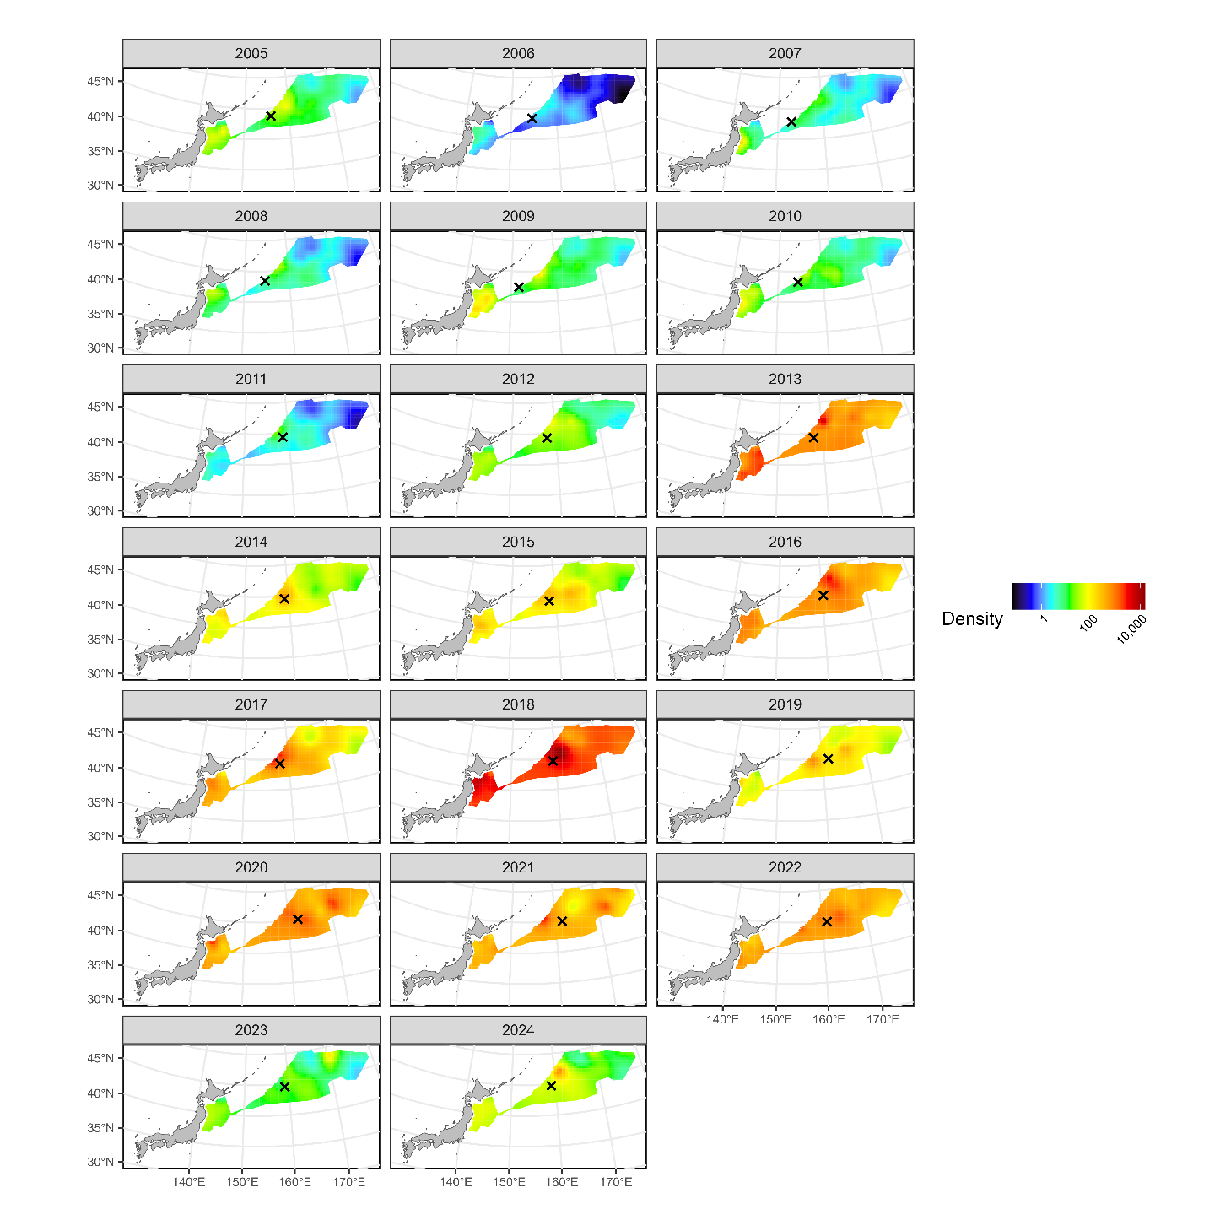

Estimated densities of age-0 fish from 2005 to 2024. The signs of X indicate the centroid of spatial distributions.

# Figure 8B

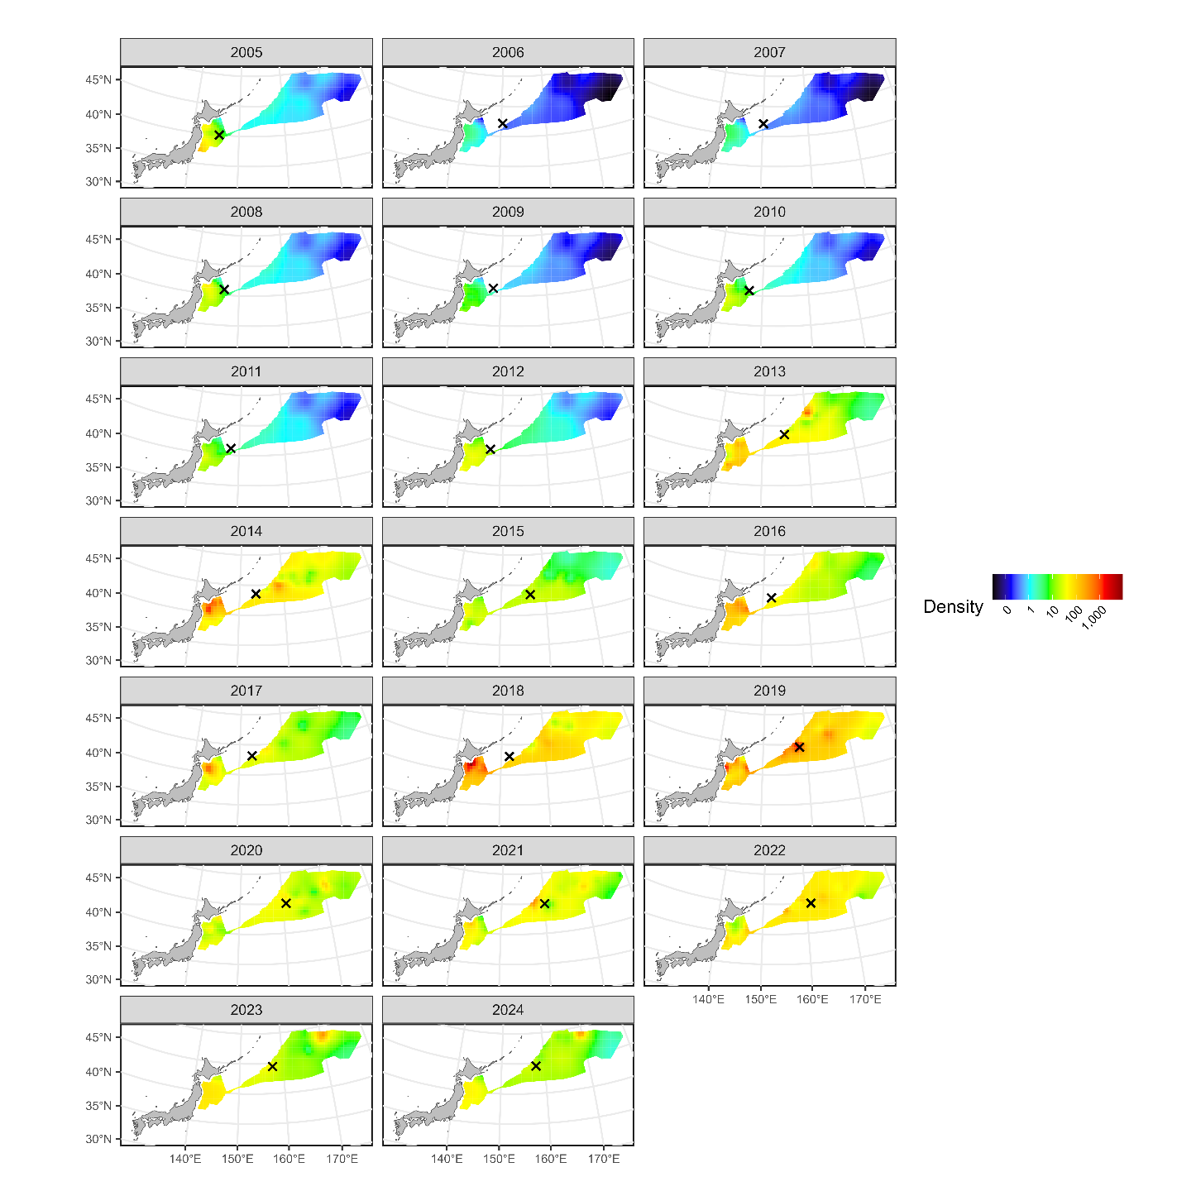

Estimated densities of age-1 fish from 2005 to 2024. The signs of X indicate the centroid of spatial distributions.

# Figure 9A

Estimated relationships between environmental variables (PC1, PC2, SST, and T30) and expected CPUE (upper: probability of positive catch, middle: positive catch rate, lower: catch rate) in the age-0 analysis. The expected CPUE versus SST and T30 was calculated with the assumption that the original variables SST and T30 change independently.

# Figure 9B

Estimated relationships between environmental variables (PC1, PC2, SST, and T30) and expected CPUE (upper: probability of positive catch, middle: positive catch rate, lower: catch rate) in the age-1 analysis. The expected CPUE versus SST and T30 was calculated with the assumption that the original variables SST and T30 change independently.

# Figure 10

Time series of nominal and standardized CPUE from 2005 to 2024 for age-0 (upper) and age 1 (lower) fish. The shadow area represents 95% confidence intervals of standardized CPUE.