NPFC-2025-TWG CMSA10-WP06

**Standardized CPUE of Japanese commercial dip-net fishery targeting spawners of chub mackerel in the Northwest Pacific up to 2024**

Shota Nishijima, Ryuji Yukami, and Momoko Ichinokawa

*Fisheries Resources Institute, Japan Fisheries Research and Education Agency*

**Summary**

We conducted CPUE standardization of Japanese commercial dip-net fishery for Pacific chub mackerel using a generalized linear mixed-effect model. The analysis showed that the dip-net fishery CPUE was affected by month, area, sea surface temperature, and ship as well as year. The abundance index standardizing these influential variables except for year showed a great decline in 2022-2024 after a high-level decade from 2011 to 2021. We propose this standardized index be used as an index of spawning stock biomass (SSB) in the Technical Working Group for the Chub Mackerel Stock Assessment (TWG CMSA) in NPFC.

# 1. BACKGROUND

The dip-net fishery operating around Izu islands is a small-scale artisanal fishery targeting spawning chub mackerel during the spawning season. While the total catch amount of chub mackerel in this fishery contributes less than 1% of the overall catch by Japan (Table 1), it is the only fishery that targets spawning chub mackerel and operates in the main spawning ground around the Izu Islands during the spawning season (Matsuda et al. 1994; Kanamori et al. 2019; Yamada et al. 1998). While chub mackerel are widely distributed along the Pacific coast of Japan and northwestern Pacific for foraging, most mature fish are known to migrate to this area for spawning (Watanabe and Yatsu 2006). Therefore, the catch per unit effort (CPUE) of the dip-net fishery is considered to represent the relative abundance of spawning stock biomass (SSB) for the Pacific chub mackerel. The CPUE has long been used as a reliable abundance index of SSB in the Japanese domestic stock assessment.

Following the previous document that reported the standardized CPUE values from 2003 to 2023 in the dip-net fishery (Nishijima et al. 2024), this document updated the results of CPUE standardization until 2024 by considering the effects of environmental and spatial variables. Since the dip-net CPUE of chub mackerel is known to be affected by water temperature (Nishijima et al. 2022), we used the sea surface temperature (SST) as an explanatory variable. The in-situ SST was recorded in each set. Furthermore, to account for the possible spatial and seasonal effects on the CPUE, we added explanatory variables of area and month.

# 2. METHOD

## 2.1 The data

The data of dip-net fishery from 2003 to 2024 was obtained from the logbooks from eight sampling ships in Kanagawa and Shizuoka Prefectures. The coverage of catch from the sampling ships against the total catch of the dip-net fishery is 10 to 56% (Table 1). The data was recorded by operation by ship, along with the information on locations (longitude/latitude or area name), sea surface temperatures (SST), the number of fishermen, and fishing time.

The number of samples in the original data was 2,630. We removed data with no spatial information, data with no effort information (fishing time and the number of fishermen), and no SST information from the analysis (Table 2). We exclusively focused on the data from January to June, the main spawning season of chub mackerel, and removed the data obtained during the other months. The sample size of the final dataset was 2,323 and that having positive catch was 1,880 (80.9%).

The dip-net fisheries are conducting in the area approximately from 138º–140.5º E and 32.5º–35º N (Fig. 1). There are many samples that had either longitude/latitude or area name. We therefore assigned the area whose center was closest, to each sample that had only longitude and latitude, and then used area as a categorical variable in CPUE standardization. The amounts of catch, effort, CPUE by area and month from 2003 to 2024 are shown in Fig. 2. We also plot maps for catch, effort, CPUE using samples having the information on longitude and latitude (Fig. 3).

## 2.2 Associations between independent variables and between dependent and independent variables

Independent variables available were year (categorical), month (categorical), area (categorical), SST (continuous), prefecture (categorical), and ship (categorical) (Table 3). Associations among the categorical variables are shown in Figs. 4A, B. The variables of ship and prefecture have a nested structure and year with operations strongly depended on prefectures (Fig. 4A). Thus, the correlations (Cramer’s V) between prefecture and ship and between year and prefecture were high (Fig. 4C). The associations between area and prefecture, between year and area, and between year and ship were moderately correlated.

SST was strongly correlated with month, but there was no apparent correlation of SST to the other categorical variable (Fig. 4D). The plots for the relationship between CPUE and each categorical variable showed that CPUE was seemingly correlated by all of these variables (Fig. 4E). The correlation between SST and CPUE was weak (Fig. 4F).

## 2.3 Full model description and model selection

The dependent variable CPUE (kg/net-hour) was a continuous value more than or equal to zero. We used a generalized linear mixed-effects model (GLMM) with a zero-inflated Tweedie distribution via the R package ‘glmmTMB’ (Brooks et al. 2017). The zero-inflated Tweedie distribution in this study is a mixture of binomial distribution (with logit link) and Tweedie distribution (with log link).

The full model involved all the five categorical variables (year, month, area, prefecture, and ship) (Table 3). We considered the squared term of SST in the full model because CPUE seemed to be the highest at an intermediate level of SST (Fig. 4F). We did not consider interactions between any combination of the independent variables because including interactions would cause many　missing categories (Fig. 4A, B). We estimated all parameters as fixed effect except for the year effect in the binomial model. We used random effects for the year effect in the binomial model, because all samples in several years were positive catch and using fixed effect for the year variable greatly increased estimation uncertainty (i.e., huge standard error and wide confidence interval).

We conducted the brute-force model selection approach except that the year effect was always selected and models with both prefecture and ship were not considered because of their nested structure and the strongest correlation (Fig. 4A, C), using the R package ‘MuMIn’ (Bartoń 2022). We determined the best model based on AICc.

## 2.4 Yearly trend extraction

To derive the standardized CPUE values, we calculated predicted CPUE values per each category (for the continuous variables, we divided their range at small regular intervals) of selected variables (e.g., Area = A, B, C…, Year = 2003, 2003, 2004…, SST = 10.0, 11.0, 12.0… ), and calculated the arithmetic mean. This averaging for extracting the year trend was necessary due to the nonlinearity of the logit link function in the zero-inflated Tweedie model. We did not implement an area-weighting approach because the size of each area was unknown. We computed confidence intervals of standardized CPUE by simulating new parameters from the multivariate normal distribution of the estimated parameters.

# 3. RESULT

The model selection showed that the effects of area, month, and SST had significant influences on CPUE and were always selected in both Tweedie and binomial parts in the top 10 models (Tables 4 and 5). Squared SST was also selected for both distributions in the top model with minimum AICc. Ship was selected only in binomial distribution in the top model. According to the result of the model selection, we select the model with minimum AICc in the Table 4 as the base model.

The percent deviance explained of the base model was 8.90% (Table 5). The coefficients and standard errors of estimated parameters in the base model were not extremely large (Table 6), indicating the successful convergence of parameter estimation.

We generated scaled residuals using the R package ‘DHARMa’ (Hartig 2022) for model diagnostics. This package enables to simulate the scaled residuals which should theoretically follow the uniform distribution from zero to one. As a result, the QQ plot and the Kolmogorov-Smirnov test indicate that the scaled residuals were significantly deviated from the theoretical prediction of the uniform distribution (Fig. 5A). Moreover, the scaled residuals had inconsistent pattens in response to predicted CPUE and year (Fig. 5B).

Partial dependence plots for estimated relationships between the selected dependent variables and predicted CPUE are shown in Figure 6. CPUE was expected be the highest at 19.4℃ and higher in February to April than in the other months.

Standardized CPUE has been relatively low until 2005, increased since then, and remained relatively stable at a high level from 2011 to 2021 (Fig. 7). However, it declined significantly thereafter and was at its lowest in 2023 since 2006. This yearly trend of the standardized CPUE was not largely different from that of nominal CPUE except that the scaled standardized CPUE was much lower in 2020 than the scaled nominal value (Fig. 7). The coefficients of variation (CV) of the estimates were 0.14−0.28 (Table 7).

# 4. DISCUSSION

Through this analysis, it became evident that the dip-net fishery CPUE is influenced by the factors of month, area, in-situ SST, and ship. These factors were considered to have an impact independent of the stock abundance in each year, and hence, standardized to eliminate sampling biases. The standardized indices obtained exhibited similar patterns to the nominal indices, but for the year 2020, the standardized values were lower than the nominal values. A reason for the difference between the nominal and standardized value in 2020 is because that the samples in 2020 had a large proportion of February to April and ship IDs of 3 and 4, when CPUE tends to be higher, while there were no operations in areas B and D, when CPUE tends to be lower, which elevated the nominal CPUE. The standardized indicator values showed a relatively stable trend at high levels from 2011 to 2021, followed by a sharp decline in 2022 through 2024.

In terms of model diagnostics, issues such as scaled residuals deviating from theoretical values were observed, and the % deviance explained was low. This might be attributed to the considerable variability in the original data and the possibility of overlooking other important variables. Despite not considering interactions among explanatory variables due to the presence of numerous missing categories, there might be room for model improvement in the future, along with the addition or modification of explanatory variables such as the examination of interaction terms in the future.

It is believed that the majority of spawning chub mackerel migrates around the Izu Islands and, therefore, the CPUE of the dip-net fishery targeting the spawners represents valuable information regarding the abundance of spawning fish of chub mackerel. Moreover, sampling bias would have been moderately mitigated by this CPUE standardization, as evident in 2020. Hence, we propose to use the standardized CPUE values calculated in this study as an abundance index of SSB in CMSA.

# 5. REFERENCES

Bartoń K (2022). MuMIn: Multi-Model Inference. R package version 1.47.1.

Brooks M., E., Kristensen K., van Benthem K. J., Magnusson A., Berg C. W., Nielsen A., Skaug H. J., Maechler, M., Bolker B. M. (2017). glmmTMB Balances Speed and Flexibility Among Packages for Zero-inflated Generalized Linear Mixed Modeling. The R Journal, 9(2), 378-400. doi: 10.32614/RJ-2017-066.

Hartig F (2022). DHARMa: Residual Diagnostics for Hierarchical (Multi-Level / Mixed) Regression Models. R package version 0.4.5.

Kanamori Y, Takasuka A, Nishijima S, Okamura H. (2019) Climate change shifts the spawning ground northward and extends the spawning period of chub mackerel in the western North Pacific. Marine Ecology Progress Series 624:155–166.

Matsuda, H., Mitani, I., Asano K. (1994) Impact factors of purse seine net and dip net fisheries on a chub mackerel population. Researches on Population Ecology. 36, 201–207.

Nishijima, S., Kisara Y., Ichinokawa M., Manabe A., and Yukami R. (2022) Standardizing CPUE of Japanese commercial dip-net fishery targeting spawners of chub mackerel in the Northwest Pacific. NPFC-2022-TWG CMSA06-WP09.

Nishijima, S., Ichinokawa M., and Yukami R. (2024) Standardized CPUE of Japanese commercial dip-net fishery targeting spawners of chub mackerel in the Northwest Pacific up to 2023. NPFC-2024-TWG CMSA08-WP03.

Yamada T, Aoki I, Mitani I (1998) Spawning time, spawning frequency and fecundity of Japanese chub mackerel, *Scomber japonicus* in the waters around the Izu Islands, Japan. Fisheries Research 38:83–89.

Watanabe C, Yatsu A (2006) Long-term changes in maturity at age of chub mackerel (*Scomber japonicus*) in relation to population declines in the waters off northeastern Japan. Fisheries Research 78:323–332

# Table 1

Catch and effort information by CPUE FLEET.

|  |  |  |  |  |  |  |
| --- | --- | --- | --- | --- | --- | --- |
| Year | Number of observations1 | % Coverage of CPUE FLEET (catch)2 | % Coverage of CPUE FLEET (effort)2 | Total Catch CPUE FLEET (mt) | Total Effort for CPUE FLEET (fishing days)3 | Percentage of overall catch by member (%)4 |
| 2003 | 132 | 21.56 | 20.99 | 60.81 | 132 | 0.13 |
| 2004 | 168 | 25.96 | 27.57 | 41.68 | 166 | 0.06 |
| 2005 | 117 | 26.64 | 25.16 | 34.97 | 117 | 0.02 |
| 2006 | 117 | 46.38 | 49.16 | 143.86 | 117 | 0.06 |
| 2007 | 198 | 14.91 | 43.14 | 350.95 | 198 | 0.14 |
| 2008 | 104 | 28.46 | 13.22 | 124.77 | 103 | 0.07 |
| 2009 | 112 | 31.22 | 31.73 | 137.79 | 112 | 0.08 |
| 2010 | 118 | 36.34 | 39.33 | 124.15 | 118 | 0.10 |
| 2011 | 105 | 22.57 | 43.15 | 177.01 | 104 | 0.14 |
| 2012 | 76 | 10.05 | 44.44 | 49.99 | 76 | 0.05 |
| 2013 | 98 | 21.01 | 26.98 | 495.18 | 58 | 0.39 |
| 2014 | 117 | 25.06 | 30.93 | 723.53 | 73 | 0.33 |
| 2015 | 84 | 36.59 | 32.70 | 851.09 | 52 | 0.30 |
| 2016 | 129 | 31.37 | 26.81 | 1492.43 | 85 | 0.45 |
| 2017 | 124 | 55.52 | 38.30 | 537.62 | 72 | 0.16 |
| 2018 | 113 | 33.38 | 26.84 | 1194.23 | 73 | 0.36 |
| 2019 | 120 | 45.37 | 32.43 | 1436.21 | 84 | 0.48 |
| 2020 | 178 | 47.64 | 37.06 | 1980.79 | 106 | 0.74 |
| 2021 | 179 | 44.69 | 33.44 | 1467.18 | 104 | 0.53 |
| 2022 | 72 | 36.31 | 22.61 | 549.65 | 52 | 0.29 |
| 2023 | 88 | 41.25 | 24.66 | 253.88 | 73 | 0.27 |
| 2024 | 81 | 49.04 | 26.86 | 145.66 | 65 | 0.20 |

1: The data was recorded by operation from each sampling ship in logbooks.

2: ‘% Coverage of CPUE FLEET’ indicates the proportion of catch or effort of sampling ships to overall catch or effort of the dip-net fishery.

3: The unit of effort in this table (fishing days) is different from the unit used for the analysis of CPUE standardization (net-hour).

4: This column indicates the proportion of overall dip-net fishery catch to the total catch by Japan.

# Table 2

Filtering “rules” used on data for CPUE standardization and the effect on the overall sample size.

|  |  |  |  |
| --- | --- | --- | --- |
| Filter Applied | Number of Records Remaining | Number Removed | Number of Records with Chub Mackerel Catch >0 |
| Initial Data set | 2,630 | - | 2,042 |
| Remove data with no spatial information (area or long/lat) | 2,620 | 10 | 2,038 |
| Remove data with no effort (time and person) | 2,515 | 105 | 1,960 |
| Remove data with SST = NA or 0 (not recorded) | 2,497 | 18 | 1,950 |
| Select data between January and June | 2,323 | 174 | 1,880 |

# Table 3

Summary of explanatory variables used in GLMM.

|  |  |  |  |  |
| --- | --- | --- | --- | --- |
| Variable | Abbreviation | Number of categories | Detail | Note |
| Year | year | 22 | 2003-2024 | Treated as fixed effect for Tweedie and as random effect for the binomial distribution |
| Month | month | 6 | January-June | Categorical variable with fixed effect |
| Area | area | 7 | A-G | Categorical variable with fixed effect |
| Sea surface temperature | SST | - | 13.2-28.2 | Continuous variable scaled by mean and SD |
| SST squared | I(SST^2) | - | Squared SST | Squared values of the scaled SST |
| Prefecture | pref | 2 | Belonging of ship (Kanagawa or Shizuoka) | Categorical variable with fixed effect |
| Ship | ship | 8 | Sampling ship | Categorical variable with fixed effect |

# Table 4

Selected variables in the top 20 models from the lowest AICc. (T) Tweedie distribution. (B) Binomial distribution.

|  |  |  |  |  |  |  |  |  |  |  |  |  |  |  |  |  |  |
| --- | --- | --- | --- | --- | --- | --- | --- | --- | --- | --- | --- | --- | --- | --- | --- | --- | --- |
| Rank | (T)area | (T)month | (T)pref | (T)ship | (T)SST | (T)I(SST^2) | (T)year | (B)area | (B)month | (B)pref | (B)ship | (B)SST | (B)I(SST^2) | df | logLik | AICc | ΔAICc |
| 1 | + | + |  | + | 0.116 | -0.117 | + | + | + |  |  | 0.7314 | 0.1914 | 59 | -10137.14 | 20395.53 | 0 |
| 2 | + | + |  | + | 0.115 | -0.117 | + | + | + | + |  | 0.7202 | 0.1900 | 60 | -10136.78 | 20396.91 | 1.38 |
| 3 | + | + |  | + | 0.116 | -0.122 | + | + | + |  |  | 0.7741 |  | 58 | -10140 | 20399.13 | 3.6 |
| 4 | + | + |  | + | 0.115 | -0.122 | + | + | + | + |  | 0.7557 |  | 59 | -10139.68 | 20400.6 | 5.07 |
| 5 | + | + |  | + | 0.115 | -0.117 | + | + | + |  | + | 0.6903 | 0.1898 | 66 | -10135.04 | 20406.15 | 10.62 |
| 6 | + | + |  | + | 0.115 | -0.121 | + | + | + |  | + | 0.7291 |  | 65 | -10137.98 | 20409.9 | 14.37 |
| 7 | + | + | + |  | 0.139 | -0.113 | + | + | + |  |  | 0.7415 | 0.1966 | 53 | -10152.3 | 20413.23 | 17.7 |
| 8 | + | + | + |  | 0.139 | -0.113 | + | + | + | + |  | 0.7277 | 0.1954 | 54 | -10151.98 | 20414.68 | 19.15 |
| 9 | + | + |  | + | 0.156 |  | + | + | + |  |  | 0.7269 | 0.2108 | 58 | -10148.18 | 20415.5 | 19.97 |
| 10 | + | + |  | + | 0.156 |  | + | + | + | + |  | 0.7185 | 0.2083 | 59 | -10147.78 | 20416.8 | 21.27 |
| 11 | + | + | + |  | 0.139 | -0.118 | + | + | + |  |  | 0.7754 |  | 52 | -10155.27 | 20417.07 | 21.54 |
| 12 | + | + | + |  | 0.139 | -0.118 | + | + | + | + |  | 0.7619 |  | 53 | -10154.99 | 20418.6 | 23.07 |
| 13 | + | + |  | + | 0.159 |  | + | + | + |  |  | 0.7700 |  | 57 | -10151.92 | 20420.87 | 25.34 |
| 14 | + | + |  | + | 0.158 |  | + | + | + | + |  | 0.7514 |  | 58 | -10151.51 | 20422.15 | 26.62 |
| 15 | + | + |  | + | 0.101 | -0.125 | + | + | + |  |  |  |  | 57 | -10153.36 | 20423.74 | 28.21 |
| 16 | + | + | + |  | 0.139 | -0.112 | + | + | + |  | + | 0.7026 | 0.1964 | 60 | -10150.3 | 20423.95 | 28.42 |
| 17 | + | + |  | + | 0.101 | -0.125 | + | + | + | + |  |  |  | 58 | -10152.82 | 20424.78 | 29.25 |
| 18 | + | + |  |  | 0.129 | -0.112 | + | + | + |  |  | 0.7575 | 0.1964 | 52 | -10159.57 | 20425.67 | 30.14 |
| 19 | + | + |  | + | 0.155 |  | + | + | + |  | + | 0.6884 | 0.2076 | 65 | -10146.05 | 20426.04 | 30.51 |
| 20 | + | + |  |  | 0.129 | -0.112 | + | + | + | + |  | 0.7439 | 0.1954 | 53 | -10159.36 | 20427.34 | 31.81 |

# Table 5

Analysis of deviance table for the best model.

|  |  |  |  |  |  |
| --- | --- | --- | --- | --- | --- |
| Variable | Chisq | Df | Pr(>Chisq) | signif.code | %deviance explained |
| Tweedie |  |  |  |  |  |
| area | 331.75 | 7 | 9.90E-68 | *** | 8.90% |
| month | 170.66 | 5 | 5.28E-35 | *** |  |
| ship | 45.91 | 7 | 9.11E-08 | *** |  |
| SST | 8.27 | 1 | 4.04E-03 | ** |  |
| I(SST^2) | 22.24 | 1 | 2.40E-06 | *** |  |
| year | 350.56 | 21 | 1.45E-61 | *** |  |
| Binomial |  |  |  |  |  |
| area | 84.45 | 6 | 4.28E-16 | *** |  |
| month | 47.51 | 5 | 4.46E-09 | *** |  |
| SST | 25.45 | 1 | 4.53E-07 | *** |  |
| I(SST^2) | 6.67 | 1 | 9.79E-03 | ** |  |

Significance codes: 0 ‘***’ 0.001 ‘**’ 0.01 ‘*’ 0.05 ‘.’ 0.1 ‘ ’ 1

# Table 6

Estimated coefficients and their standard errors in the best model. (T) Tweedie sisribution. (B) Binomial distribution.

|  |  |  |  |  |
| --- | --- | --- | --- | --- |
| **Variable** | **(T) Estimate** | **(T) Std. Error** | **(B) Estimate** | **(B) Std. Error** |
| (Intercept) | 2.976 | 0.275 | -0.694 | 0.727 |
| I(SST^2) | -0.119 | 0.025 | 0.202 | 0.078 |
| SST | 0.116 | 0.040 | 0.784 | 0.155 |
| areaB | -3.689 | 0.400 | -2.581 | 2.195 |
| areaC | -0.118 | 0.111 | 0.553 | 0.409 |
| areaD | 0.160 | 0.118 | -3.377 | 0.922 |
| areaE | -0.953 | 0.163 | -2.571 | 0.575 |
| areaF | 0.047 | 0.108 | -4.396 | 0.632 |
| areaG | -0.775 | 0.130 | -0.003 | 0.473 |
| month2 | 0.798 | 0.093 | -1.679 | 0.390 |
| month3 | 0.777 | 0.108 | -2.673 | 0.458 |
| month4 | 0.737 | 0.107 | -2.343 | 0.456 |
| month5 | 0.349 | 0.120 | -0.839 | 0.448 |
| month6 | -0.773 | 0.166 | 0.653 | 0.581 |
| ship4 | 0.060 | 0.064 |  |  |
| shipIK | -0.389 | 0.159 |  |  |
| shipIW | -1.645 | 0.279 |  |  |
| shipKG | -0.400 | 0.119 |  |  |
| shipKM | -0.273 | 0.177 |  |  |
| shipKW | -0.318 | 0.244 |  |  |
| shipSE | -1.141 | 0.317 |  |  |
| year2003 |  |  | 4.474 | 0.721 |
| year2004 | 0.015 | 0.263 | 2.464 | 0.648 |
| year2005 | -0.433 | 0.288 | 4.804 | 0.819 |
| year2006 | 0.968 | 0.281 | 3.082 | 0.708 |
| year2007 | 1.438 | 0.223 | -3.103 | 1.484 |
| year2008 | 0.568 | 0.241 | -2.117 | 1.504 |
| year2009 | 0.987 | 0.239 | -3.046 | 1.430 |
| year2010 | 0.953 | 0.236 | -1.709 | 1.022 |
| year2011 | 1.709 | 0.242 | 0.271 | 0.773 |
| year2012 | 1.700 | 0.242 | -0.837 | 0.868 |
| year2013 | 1.814 | 0.339 | -1.564 | 1.646 |
| year2014 | 1.534 | 0.271 | -2.090 | 0.992 |
| year2015 | 1.514 | 0.274 | -0.542 | 0.960 |
| year2016 | 2.008 | 0.260 | -1.194 | 0.738 |
| year2017 | 1.362 | 0.274 | -0.485 | 0.697 |
| year2018 | 1.840 | 0.262 | -1.504 | 0.839 |
| year2019 | 1.745 | 0.255 | -0.139 | 0.798 |
| year2020 | 1.738 | 0.255 | -0.191 | 0.702 |
| year2021 | 1.897 | 0.265 | 1.778 | 0.672 |
| year2022 | 1.118 | 0.287 | 1.752 | 0.707 |
| year2023 | 0.143 | 0.300 | 1.640 | 0.711 |
| year2024 | 0.045 | 0.315 | 2.595 | 0.770 |

* ‘year2003’ was set as the reference category in the Tweedie model, while in the binomial model, the effect of all years was estimated as random effects.

# Table 7

Nominal and standardized CPUE along with CV and 95% CI from 2003 to 2023.

|  |  |  |  |  |  |
| --- | --- | --- | --- | --- | --- |
| Year | Nominal (kg/man-hour) | Standardized (kg/man-hour) | CV | Lower 95% CI | Upper 95% CI |
| 2003 | 5.49 | 3.34 | 0.22 | 2.23 | 5.26 |
| 2004 | 4.46 | 5.53 | 0.2 | 3.88 | 8.34 |
| 2005 | 3.29 | 1.96 | 0.26 | 1.26 | 3.31 |
| 2006 | 25.46 | 12.6 | 0.22 | 8.4 | 19.77 |
| 2007 | 86.56 | 38.08 | 0.12 | 30.33 | 49.41 |
| 2008 | 45.53 | 15.47 | 0.14 | 12.17 | 21.15 |
| 2009 | 56.51 | 24.23 | 0.15 | 18.76 | 33.41 |
| 2010 | 54.51 | 22.33 | 0.15 | 17.11 | 30.13 |
| 2011 | 116.21 | 41.35 | 0.15 | 31.63 | 56.1 |
| 2012 | 120.54 | 44.87 | 0.16 | 33.22 | 61.84 |
| 2013 | 131.91 | 52.45 | 0.28 | 31.43 | 90.78 |
| 2014 | 110.94 | 40.61 | 0.16 | 30.54 | 56.03 |
| 2015 | 120.32 | 36.51 | 0.17 | 26.91 | 52.41 |
| 2016 | 172.48 | 62.46 | 0.15 | 48.05 | 84.6 |
| 2017 | 81.48 | 31.22 | 0.17 | 23.22 | 44.56 |
| 2018 | 142.86 | 53.66 | 0.16 | 40.93 | 75.33 |
| 2019 | 142.44 | 44.5 | 0.13 | 35.34 | 58.88 |
| 2020 | 167.34 | 44.43 | 0.14 | 34.64 | 60.14 |
| 2021 | 115.21 | 41.02 | 0.16 | 31.37 | 57.76 |
| 2022 | 63.17 | 18.9 | 0.18 | 13.76 | 26.67 |
| 2023 | 23.91 | 7.25 | 0.19 | 5.11 | 10.72 |
| 2024 | 16.15 | 5.55 | 0.21 | 3.74 | 8.48 |

# Figure 1

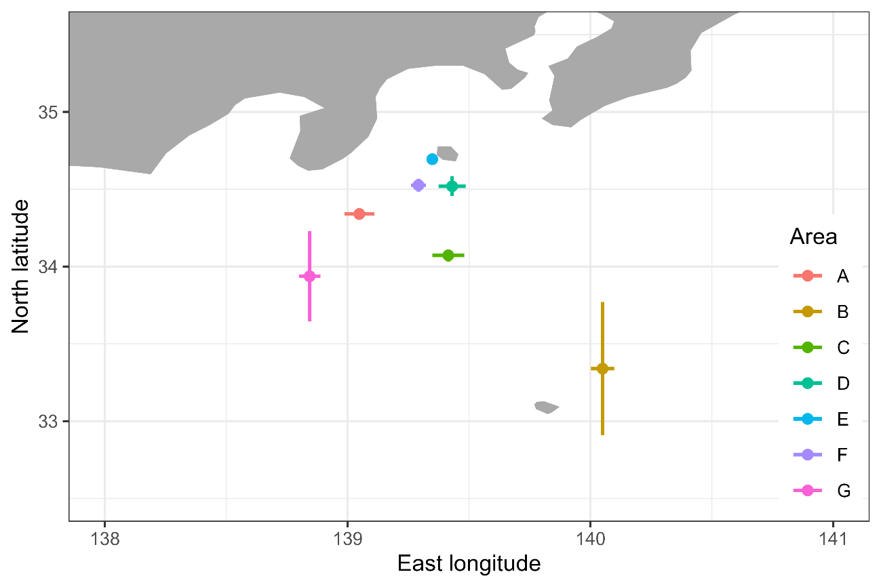Map of the area category (A to G). Each point represents the center of the fishing location of each category of the area, and error bars represent the dispersion (1 SD) of the fishing locations within the same category.

# Figure 2A

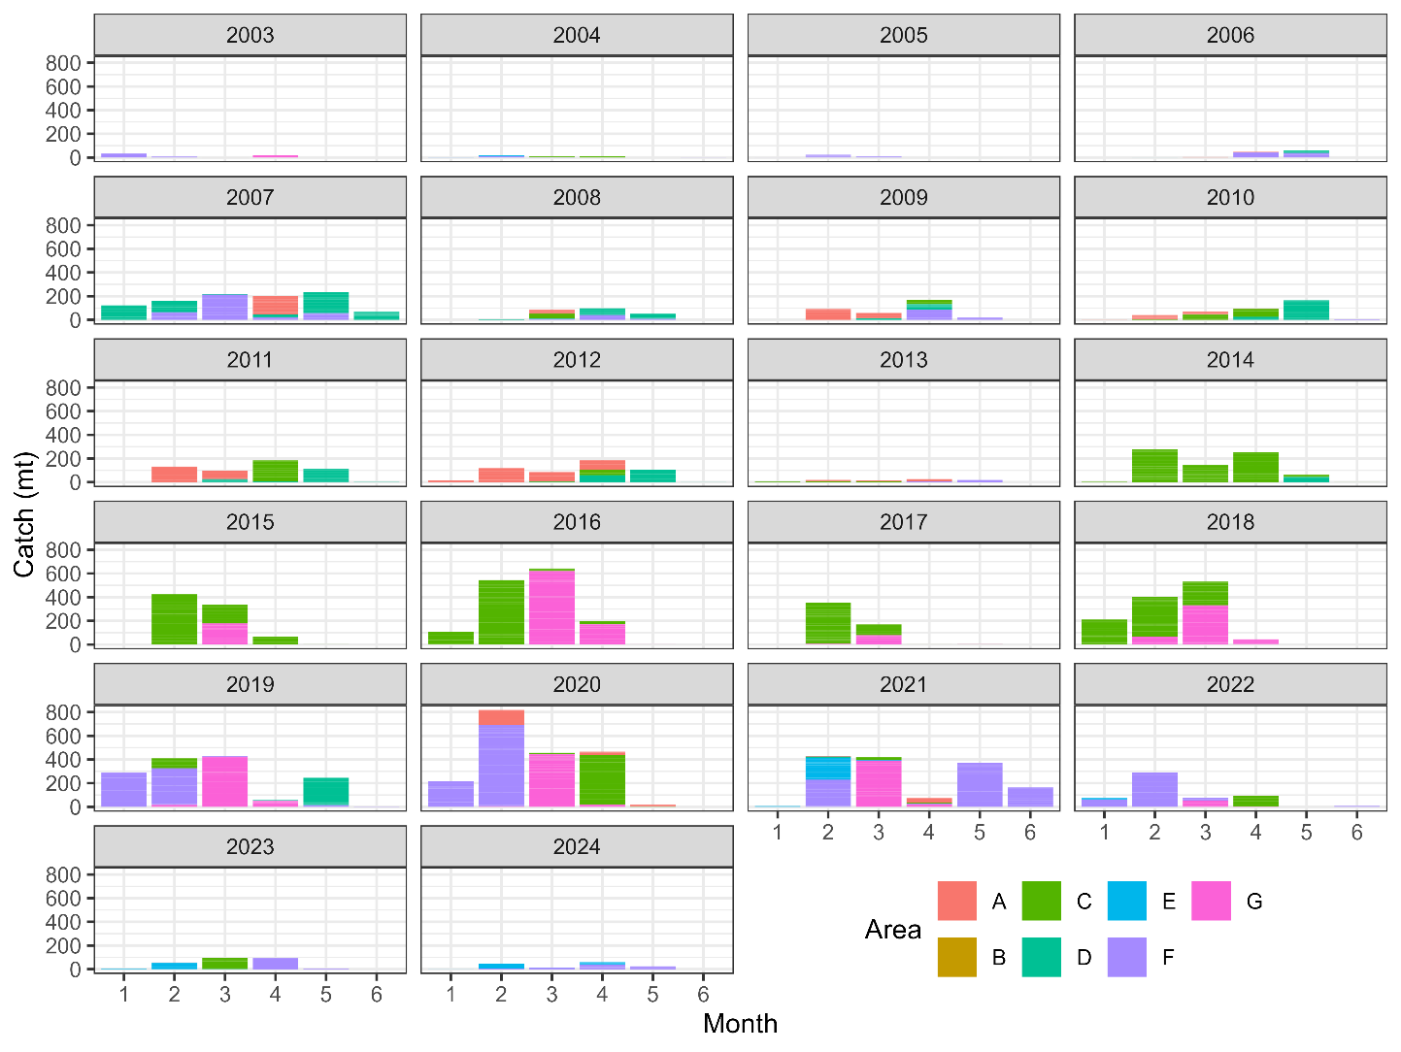  
Catch amounts (mt) by area (color, see Fig. 1) by month (*x*-axis) from 2003 to 2024.

# Figure 2B

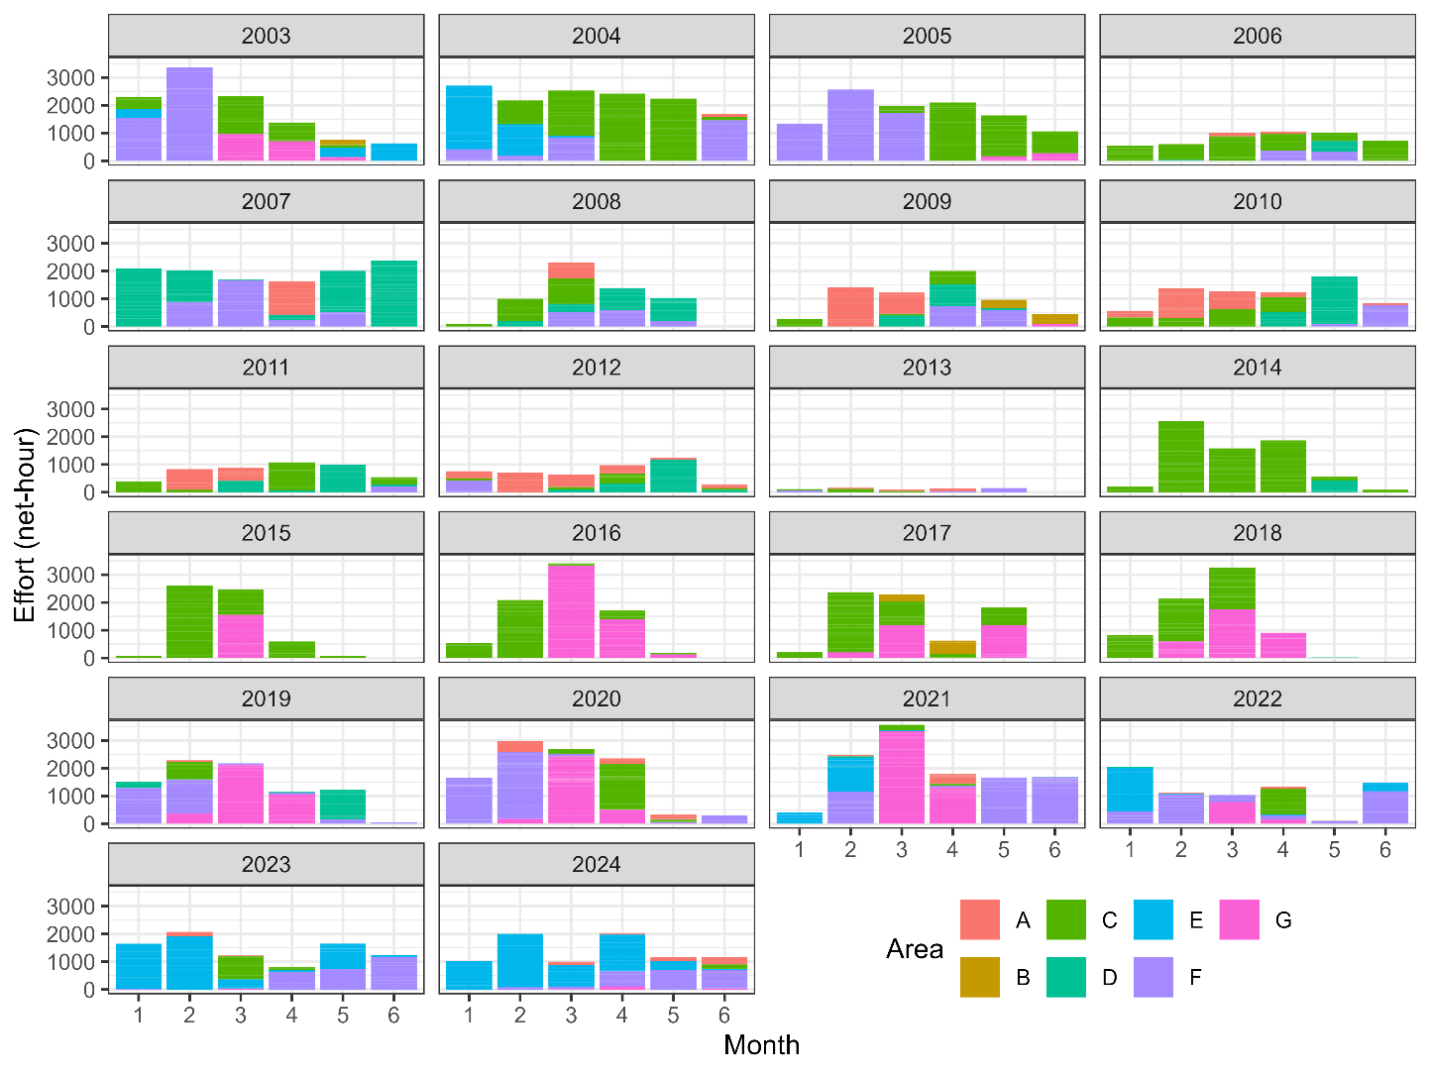  
Effort amounts (net-hour) by area (color, see Fig. 1) by month (*x*-axis) from 2003 to 2024.

# Figure 2C

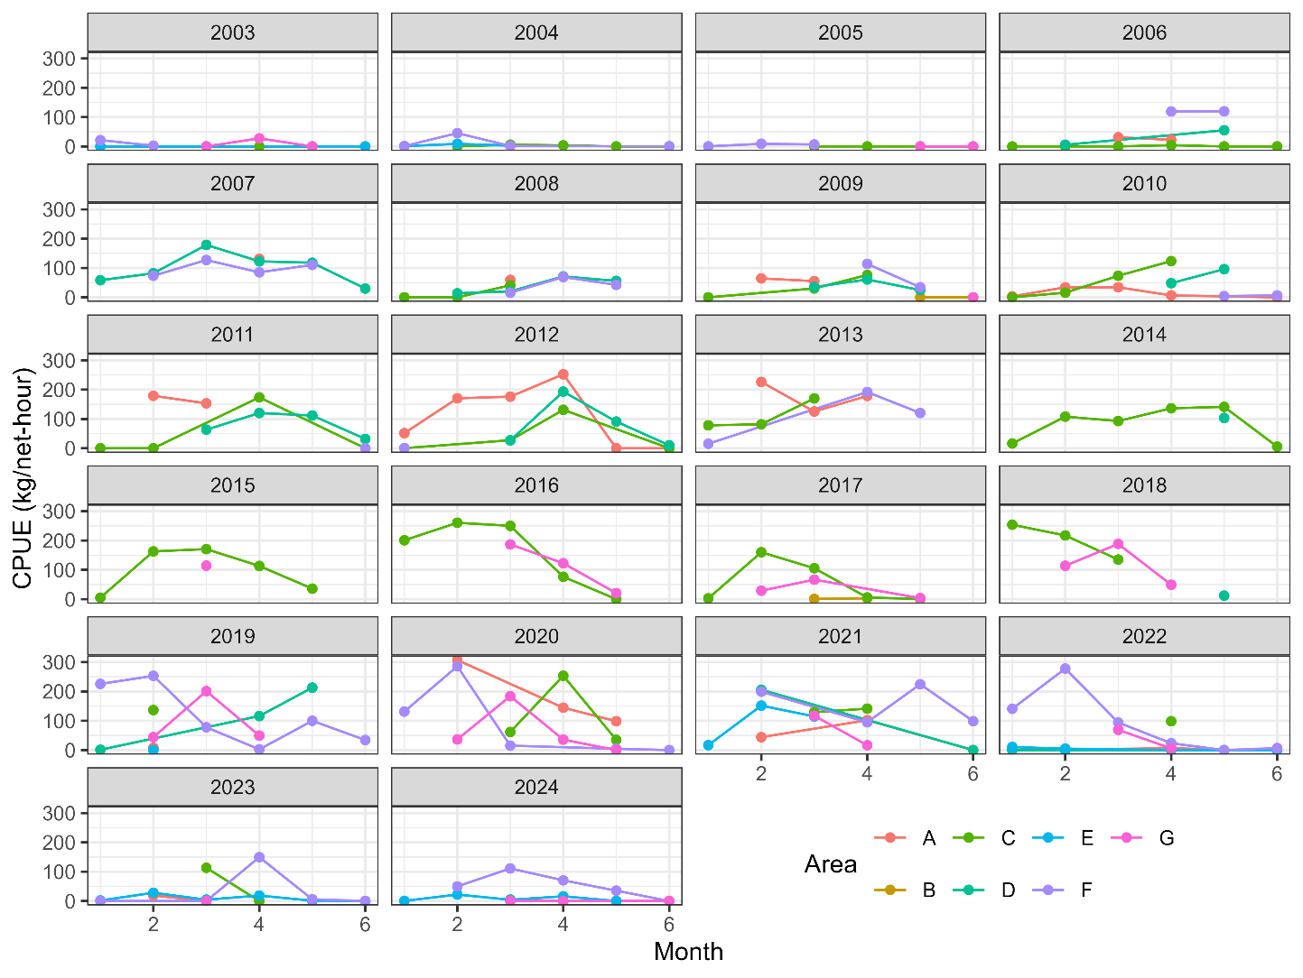  
CPUE (kg/net-hour) by area (color, see Fig. 1) by month (*x*-axis) from 2003 to 2024.

# Figure 3A

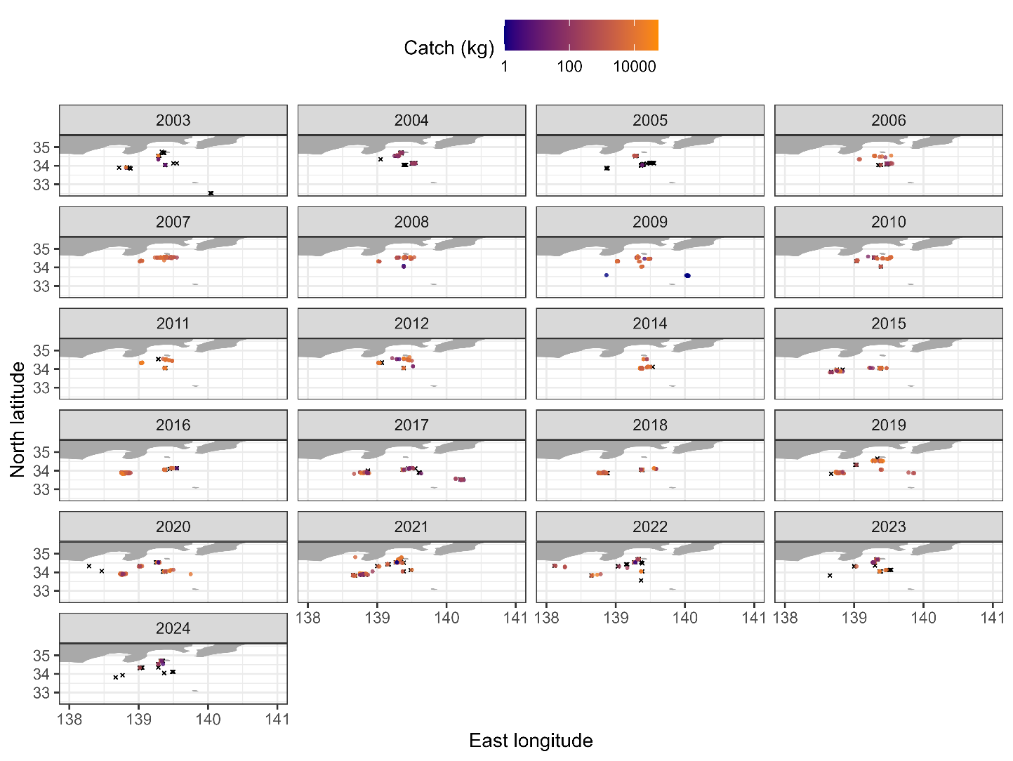  
Map of catch from 2003 to 2024 for samples having the information on longitude and latitude. Zero catch is shown as X in black and positive catch is shown as O with color scaling in log space. Note that the lack of 2013 is because no sample has the information on longitude and latitude in 2013.

# Figure 3B

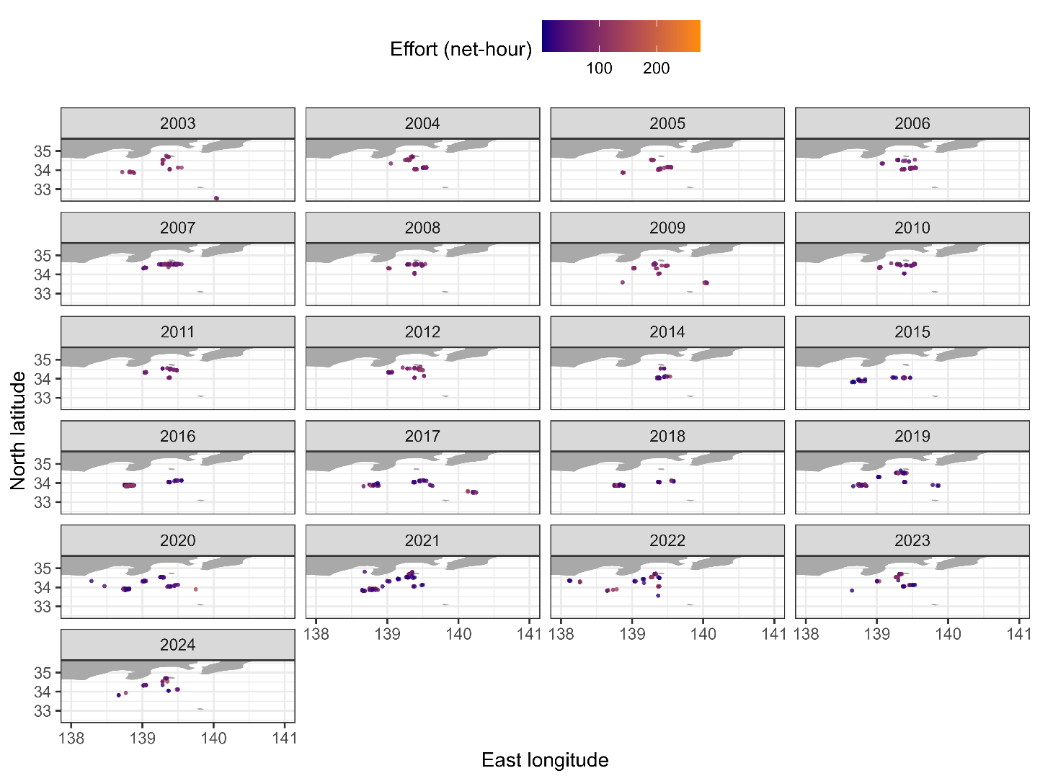  
Map of effort from 2003 to 2024 for samples having the information on longitude and latitude. The amount of effort is expressed by color scaling. Note that the lack of 2013 is because no sample has the information on longitude and latitude in 2013.

# Figure 3C

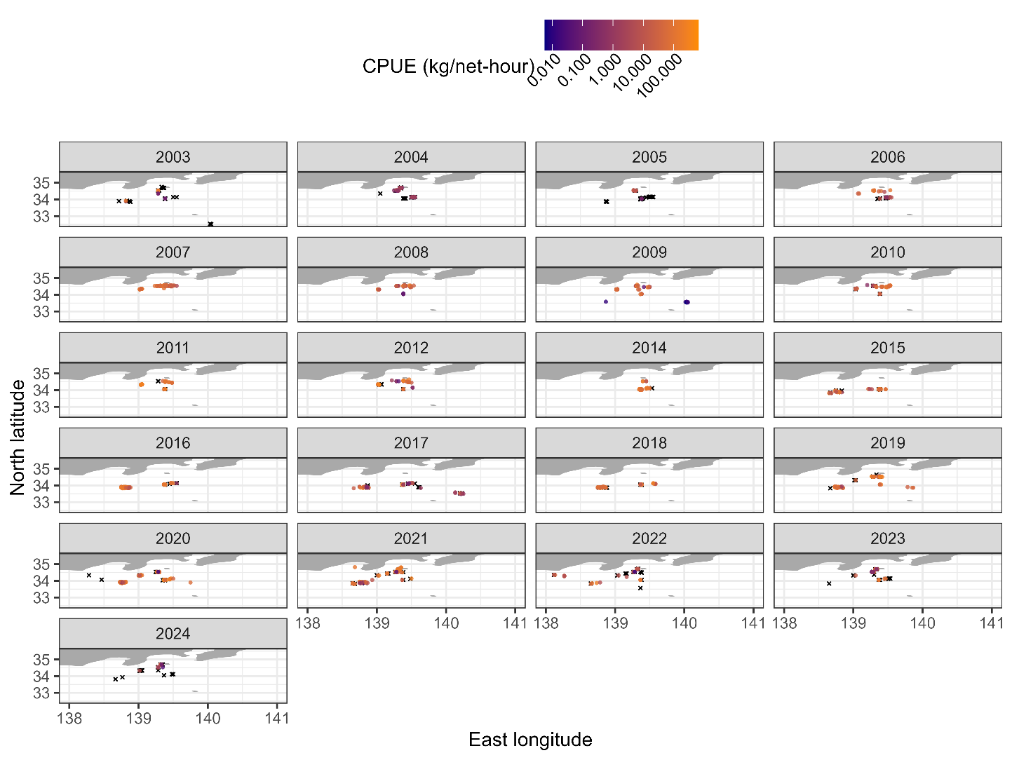  
Map of CPUE from 2003 to 2024 for samples having the information on longitude and latitude. Zero catch is shown as X in black and positive catch is shown as O with color scaling in log space. Note that the lack of 2013 is because no sample has the information on longitude and latitude in 2013.

# Figure 4A

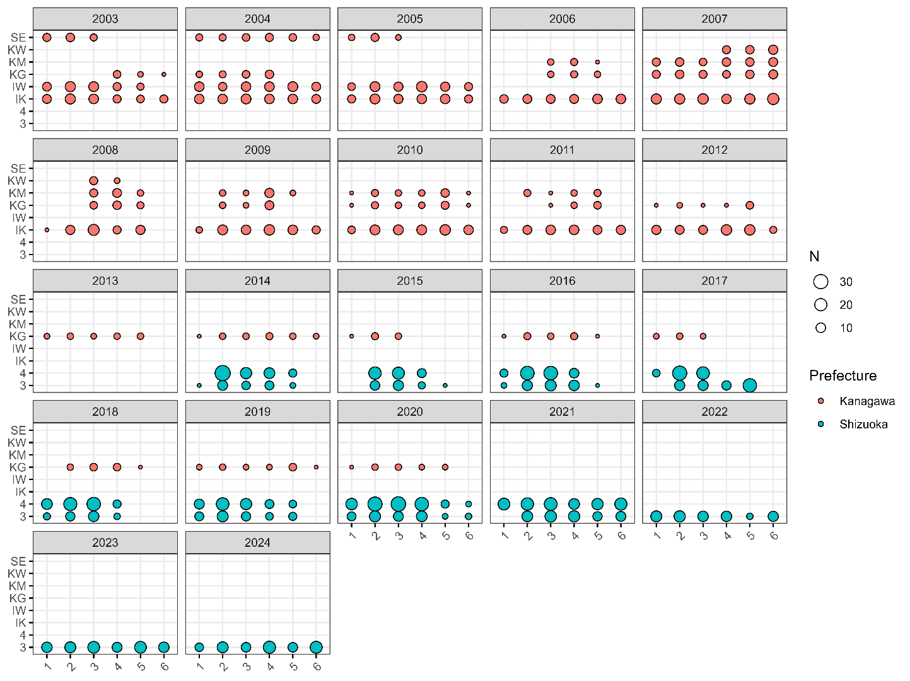  
Balloon plots showing sample sizes (represented by the magnitude of circles) in each category by month (*x*-axis) by ship (*y*-axis) from 2003 to 2024. The color represents the prefectures that ships belonged to.

# Figure 4B

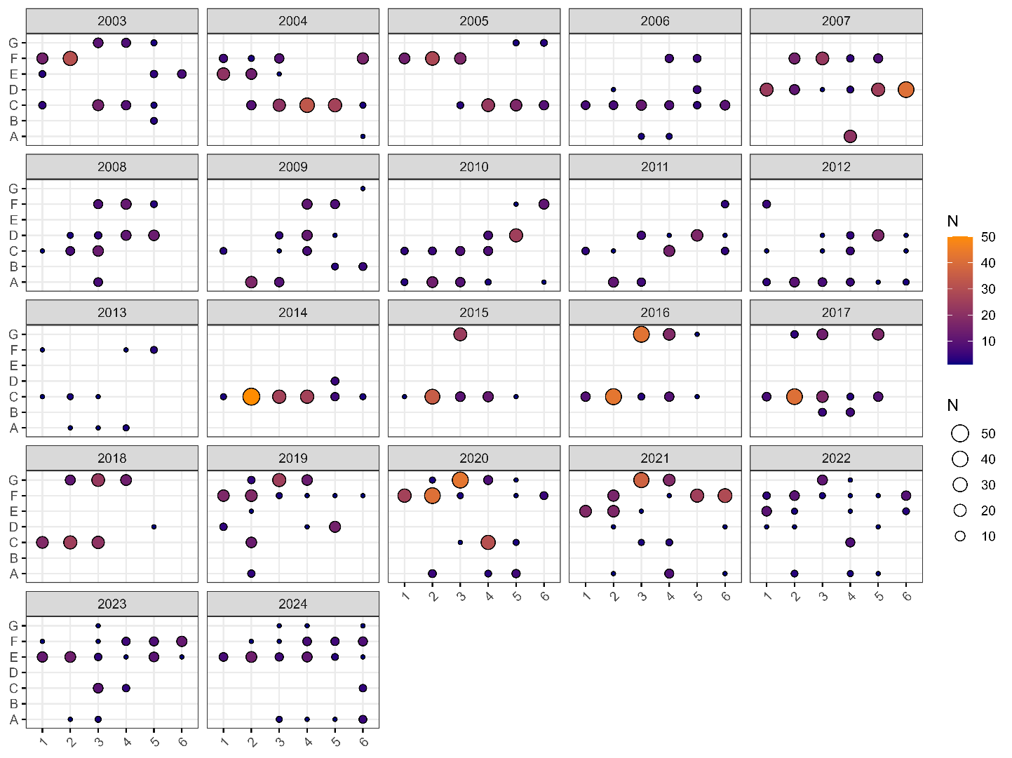  
Balloon plots showing sample sizes (represented by the magnitude of circles and color) in each category by month (*x*-axis) by area (*y*-axis) from 2003 to 2024.

# Figure 4C

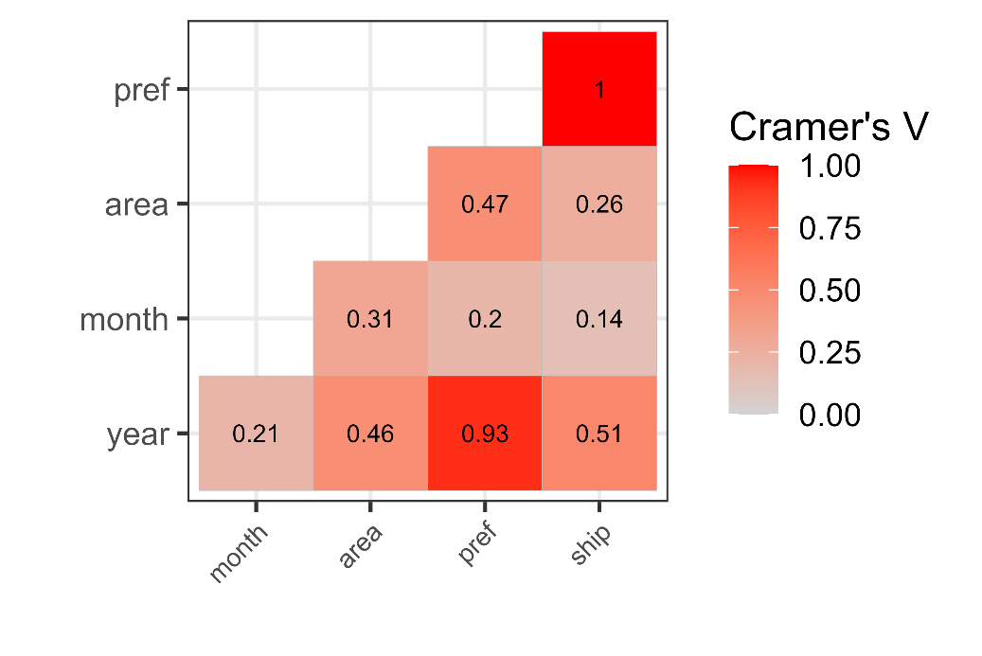  
Cramer’s V between two categorical variables.

# Figure 4D

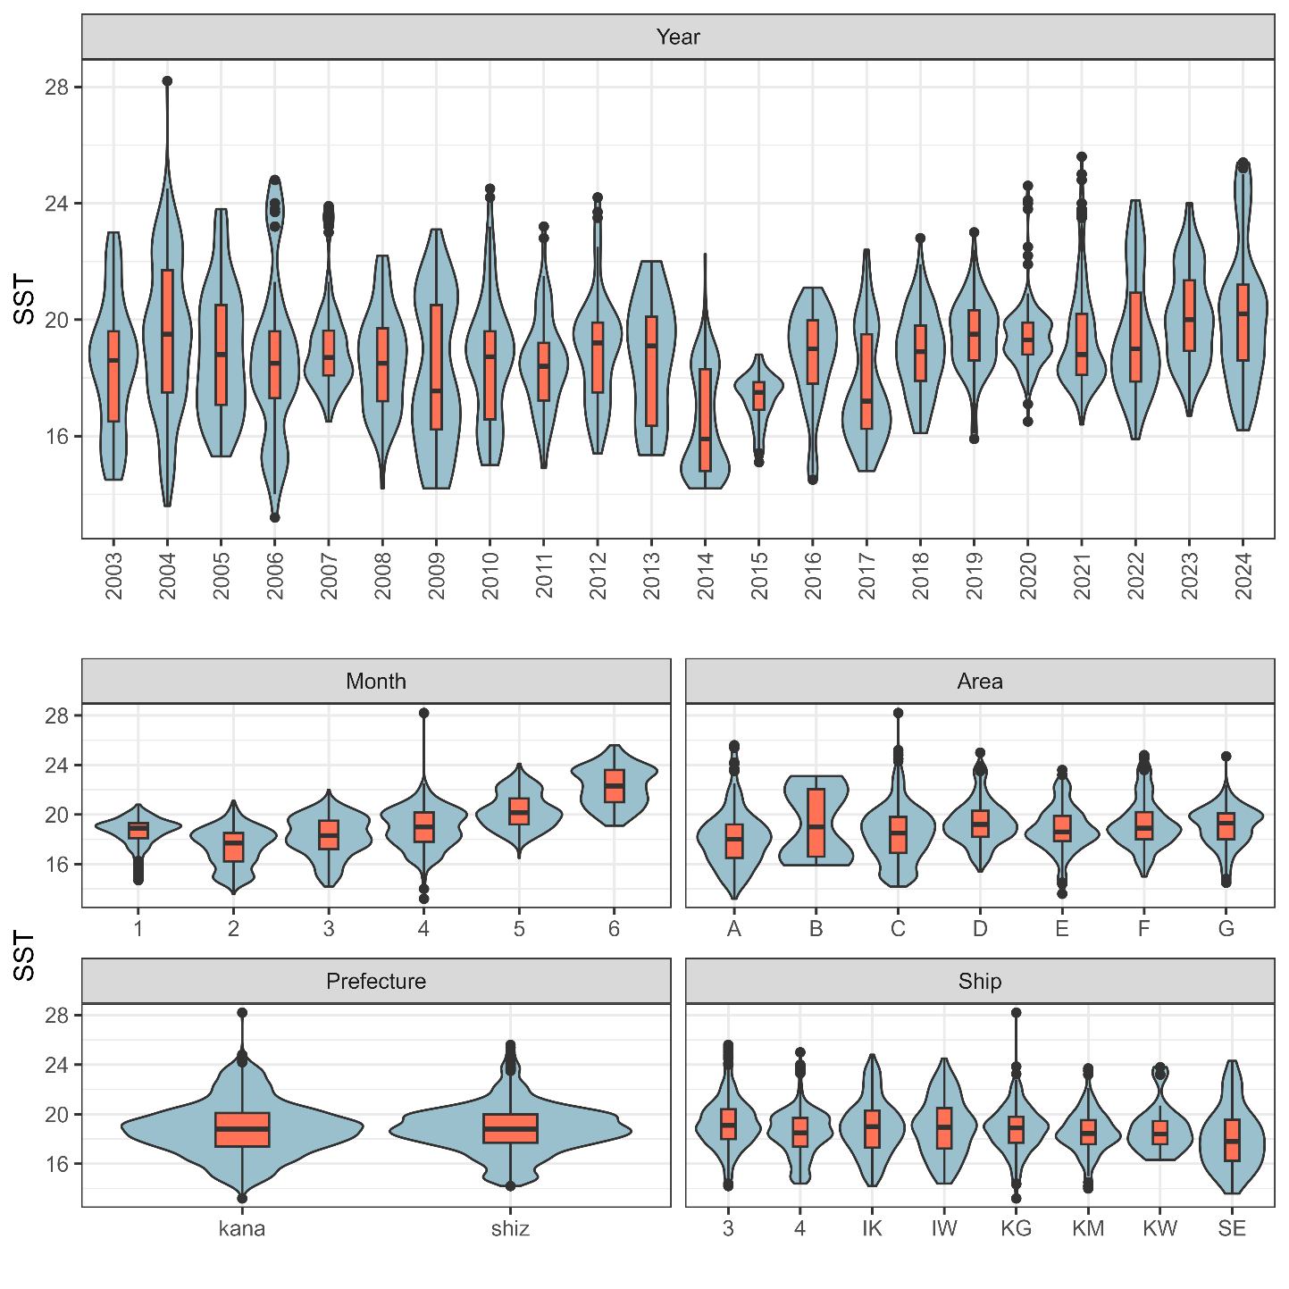  
Violin plots showing the relationship between SST and categorical variables (year, month, area prefecture, ship). Box plots are shown to indicate medians, quantiles, and outliers.

# Figure 4E

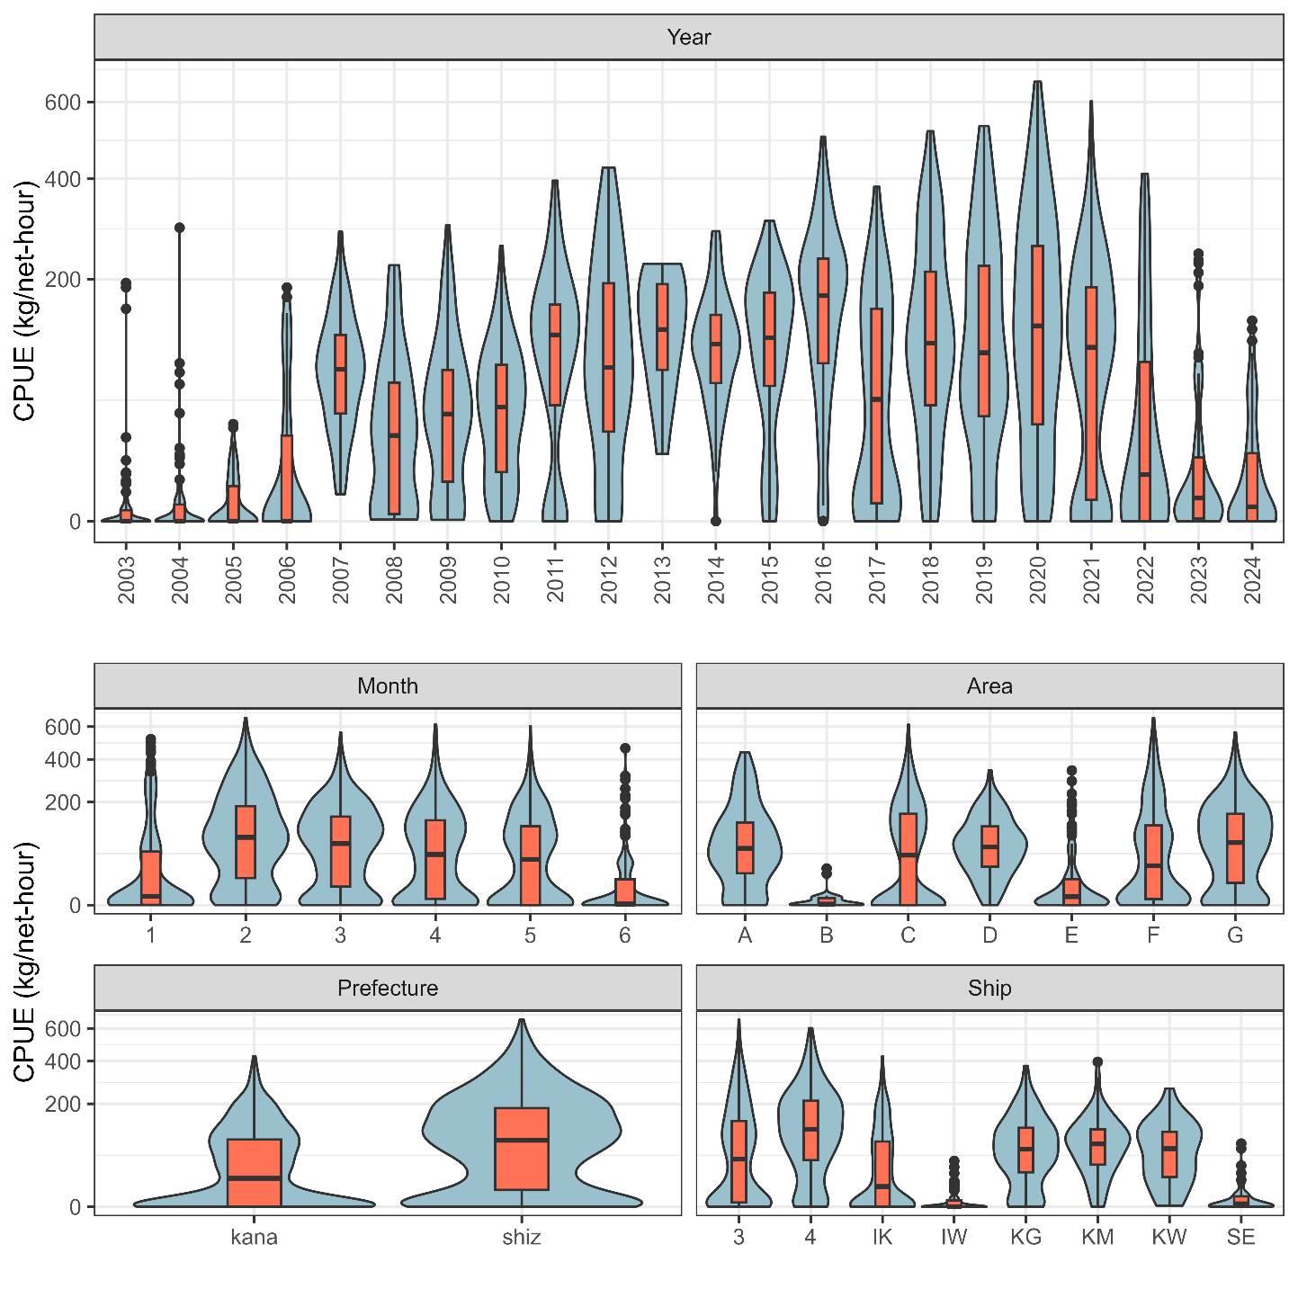  
Violin plots showing the relationship between CPUE (including zero-catches) and categorical variables (year, month, area prefecture, ship). Box plots are shown to indicate medians, quantiles, and outliers. Note that the *y*-axis is scaled by the square root for visualization.

# Figure 4F

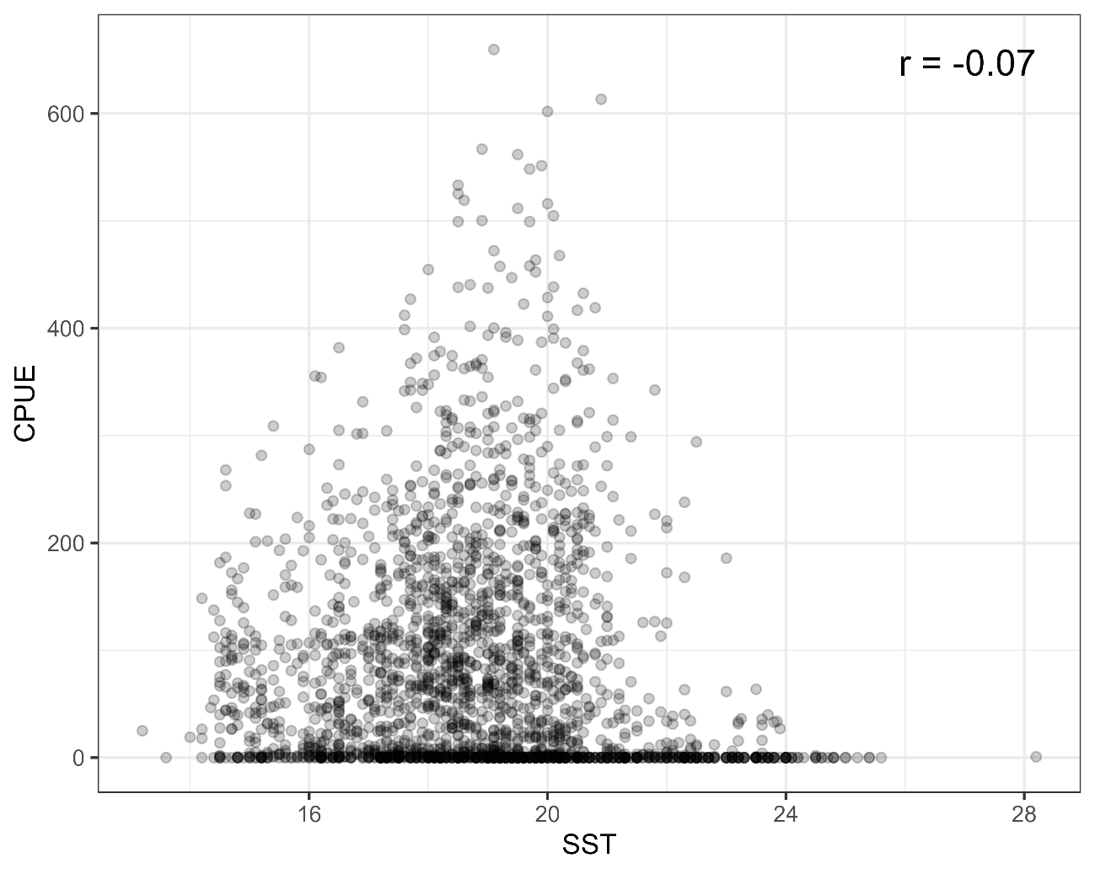  
Relationship between SST and CPUE. The Pearson’s correlation coefficient is shown at the upper right corner.

# Figure 5A

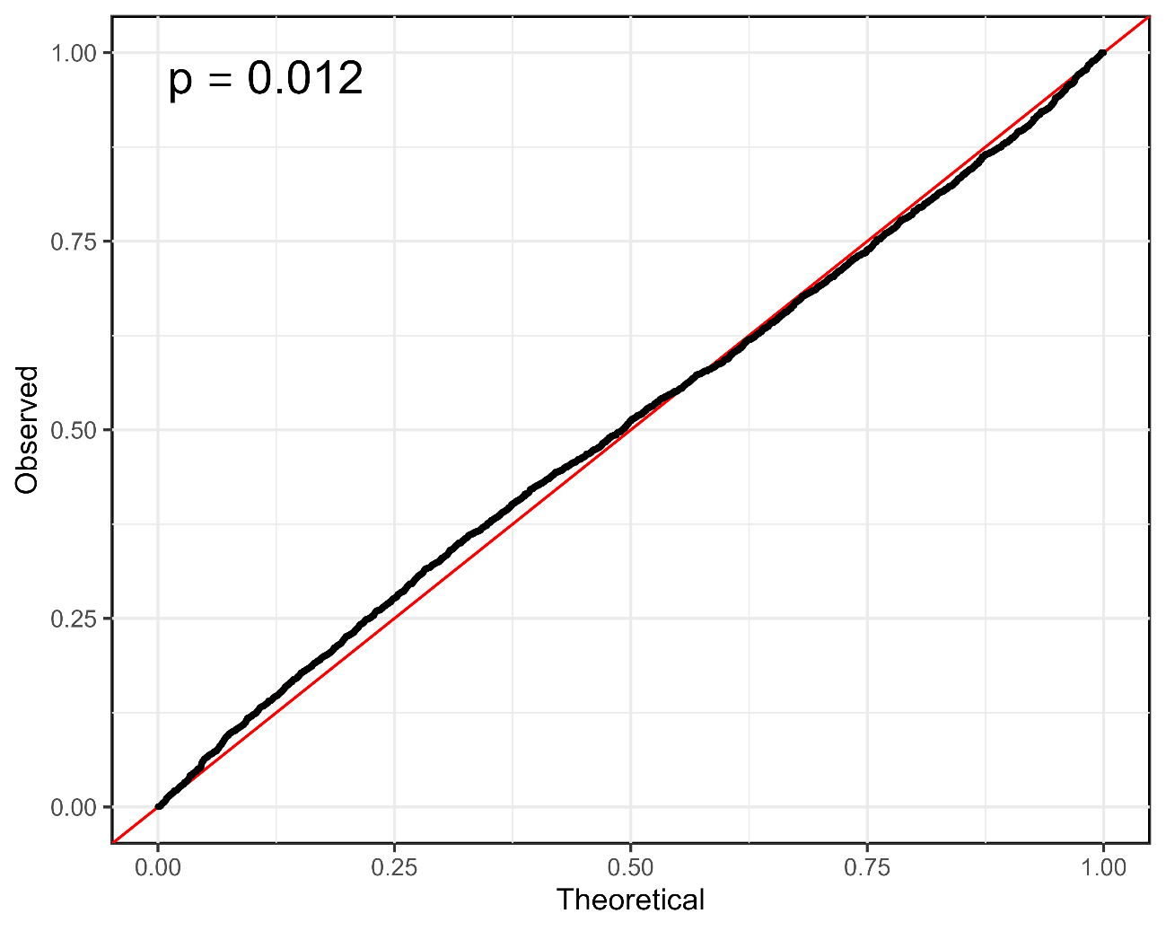  
QQ plot along with *p* value in the Kolmogorov-Smirnov test at the upper-left corner.

# Figure 5B

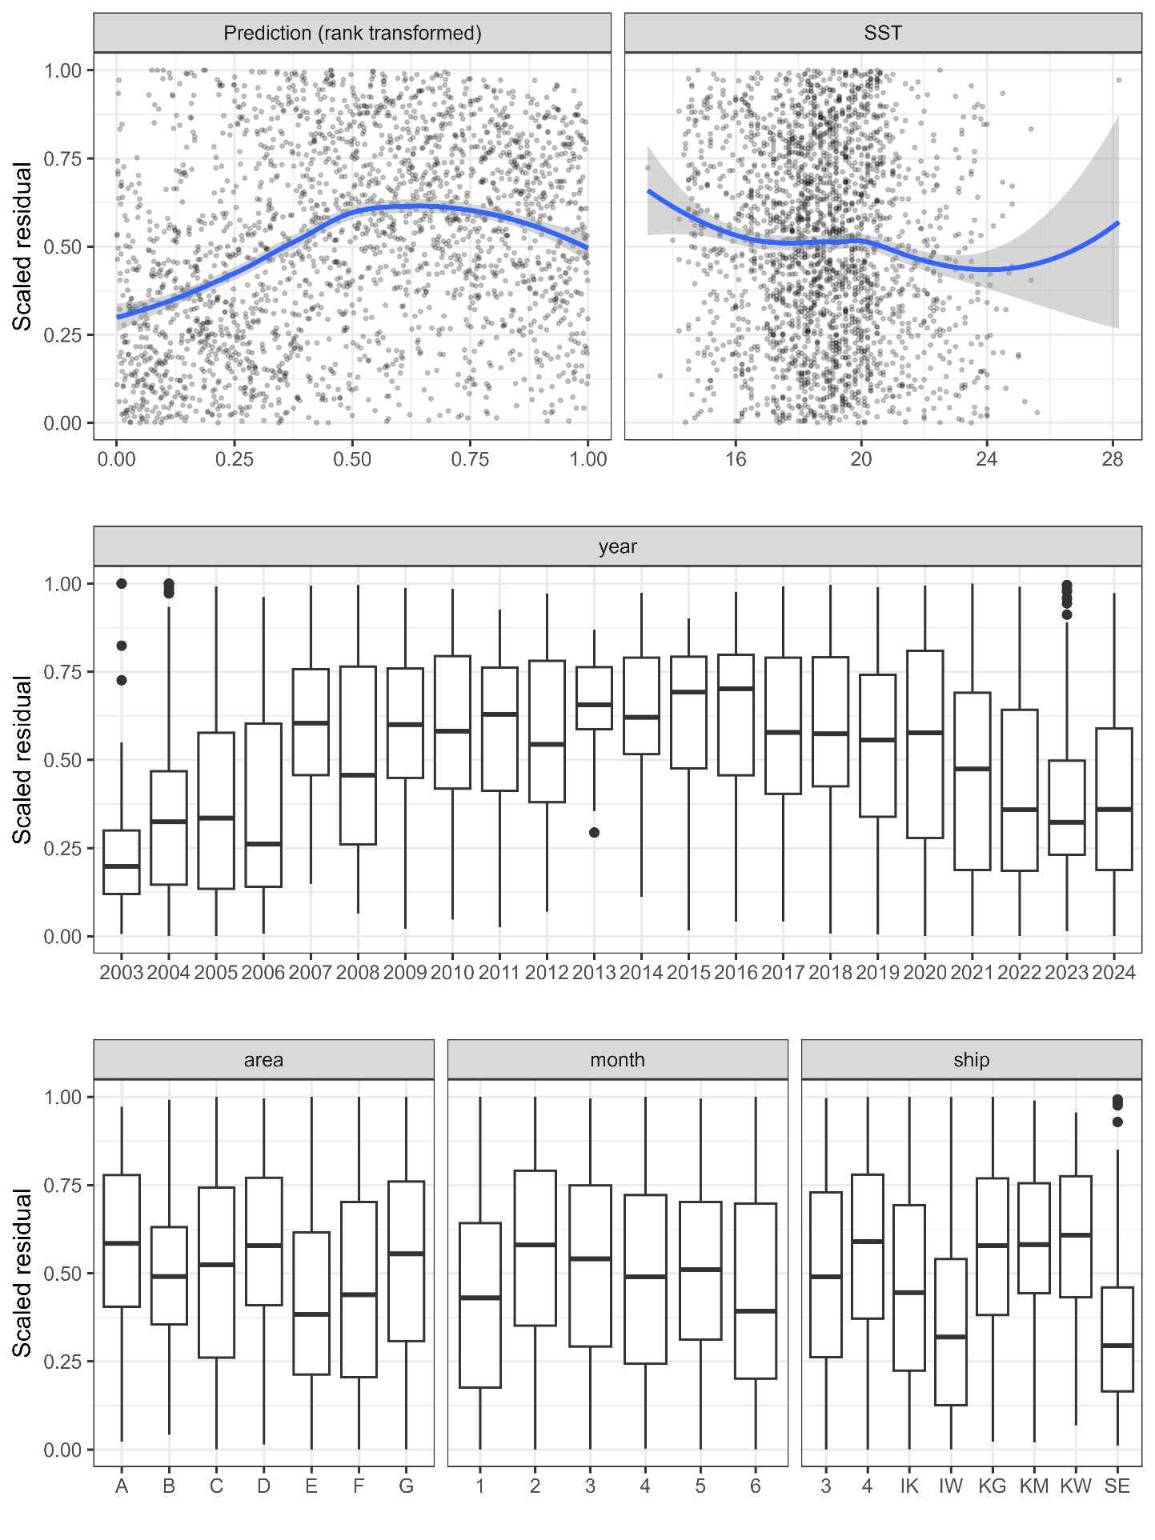  
Relationships between scaled residuals and the selected variables or predicted CPUE (rank-transformed, upper-left). Smooth curves in blue for the upper panels are described by LOESS.

# Figure 6

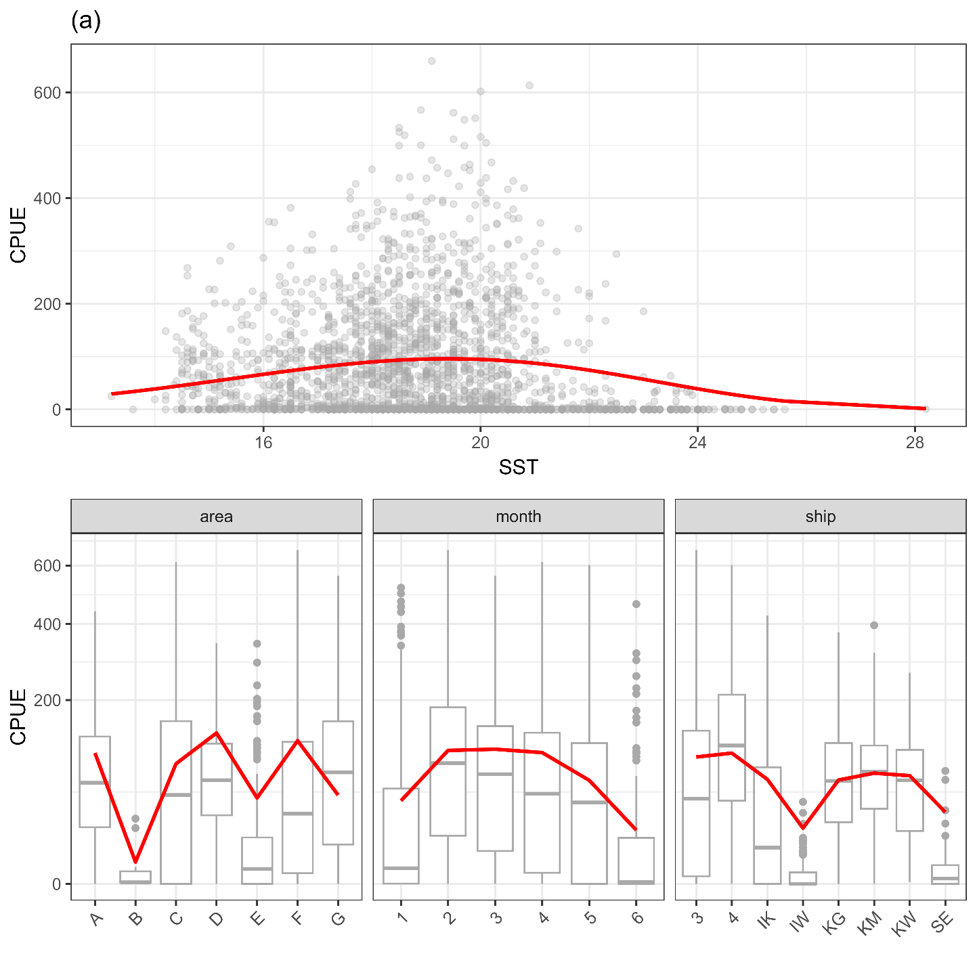  
Estimated relationships between independent variables and expected CPUE predicted by the best model. Note that the *y*-axis is scaled by the square root for visualization.

# Figure 7

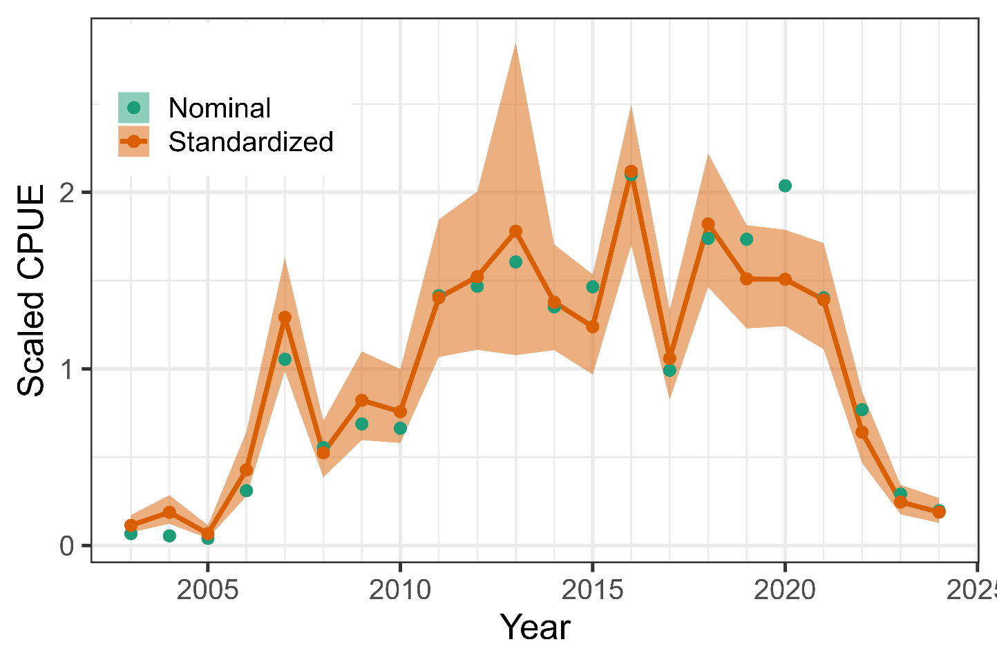  
Time series of scaled nominal and standardized CPUE from 2003 to 2024. The index values were scaled by mean and SD. The shadow area represents 95% confidence intervals of standardized CPUE.

# AppendIX

Checklist for the CPUE standardization protocol

|  |  |  |  |
| --- | --- | --- | --- |
| No. | Step-by-step protocols | yes/no | Note |
| 1 | Provide a description of the type of data (logbook, observer, survey, etc. ), and the “resolution” of the data (aggregated, set-by-set etc..). This description should also include the representativeness of the data in two tables: (1st table) Number of observations, % Coverage of CPUE fleet (catch), % Coverage of CPUE fleet (effort), Total Catch CPUE fleet (mt), Total Effort CPUE fleet, Percentage of overall catch by member (across all fleets/gears); and (2nd table) Number of records remaining, Number removed, Number of records with chub mackerel catch >0; | Yes | Section 2.1 (pages 1-2) and Tables 1 (page 6) and 2 (page 7) |
| 2 | Conduct a thorough literature review to identify key factors (i.e., spatial, temporal, environmental, and fisheries variables) that may influence CPUE values; | Yes | Section 1. Background (page 1) |
| 3 | Plot annual/monthly spatial distributions of fishing efforts, catch and nominal CPUE to determine temporal and spatial resolution for CPUE standardization | Yes | Figs. 2-3, (pages 13-18) |
| 4 | Make scatter plots (for continuous variables) and/or box plots (for categorical variables) and present correlation matrix if possible to evaluate correlations between each pair of those variables; | Yes | Fig 4 (pages 19-21] |
| 5 | Describe selected explanatory variables based on (2)-(4) to develop full model for the CPUE standardization; | Yes | Section 2.3*.* (pages 2-3) and Table 3 (page 7) |
| 6 | Specify model type and software (packages) and fit the data to the assumed statistical models (i.e., GLM, GAM, Delta-lognormal GLM, Neural Networks, Regression Trees, Habitat based models, and Statistical habitat based models); | Yes | Section 2.3. (pages 2-3) |
| 7 | Evaluate and select the best model(s) using methods such as likelihood ratio test, information criterions, cross validation etc.; | Yes | Tables 4 and 5 (pages 8-9) |
| 8 | Provide diagnostic plots to support the chosen model is appropriate and assumption are met (QQ plot and residual plots along with predicted values and important explanatory variables, etc.); | Yes | Fig. 5 (page 25-26) |
| 9 | Present estimated values of parameters and uncertainty in the parameters in table; | Yes | Table 6 (pages 9-10) |
| 10 | Present the relationship between the response variable and the explanatory variables. Check if it is interpretable. | Yes | Fig. 6 (page 27) |
| 11 | Extract yearly standardized CPUE and standard error by a method that is able to account for spatial heterogeneity of effort, such as least squares mean or expanded grid. If the model includes area and the size of spatial strata differs or the model includes interactions between time and area, then standardized CPUE should be calculated with area weighting for each time step. Model with interactions between area and season or month requires careful consideration on a case by case basis. Provide details on how the CPUE index was extracted. | Yes | Section 2.4. (page 3) |
| 12 | Calculate uncertainty (SD, CV, CI) for standardized CPUE for each year. Provide detailed explanation on how the uncertainty was calculated; | Yes | Table 7 (page 11) and Fig. 7 (page 28) |
| 13 | Provide a table and a plot of nominal and standardized CPUEs over time. When the trends between nominal and standardized CPUE are largely different, explain the reasons (e.g. spatial shift of fishing efforts), whenever possible. | Yes |