NPFC-2025-SSC NFS02-WP03

**Standardized CPUE for the autumn and winter-spring cohorts of neon flying squid based on Japanese driftnet surveys from 2001 to 2024**

Bungo Nishizawa*, Hajime Matsui, Suguru Okamoto, and Kazuhiro Oshima

*Fisheries Resources Institute,* *Japan Fisheries Research and Education Agency*

*Corresponding Author

Email: [nishizawa_bungo05@fra.go.jp](mailto:nishizawa_bungo05@fra.go.jp)

1. **Summary**

We updated the standardized catch per unit effort (CPUE) of the autumn and winter-spring cohorts of neon flying squid (*Ommastrephes bartramii*) based on Japanese driftnet surveys conducted in the western North Pacific from 2001 to 2024. The individuals caught by the driftnets were divided into cohorts based on their mantle length. We used generalized additive models to standardize the CPUE, incorporating temporal (year and ten-days), spatial (latitude and longitude), and environmental (SST and lunar illumination) variables. We found large interannual variation in the standardized CPUE for both cohorts, with no clear increasing or decreasing trends over the years for both cohorts. This standardized CPUE can serve as a fishery-independent abundance index for future stock assessments of this species.

# **Introduction**

The neon flying squid is an oceanic squid occurring in subtropical and temperate waters around the world (Roper et al. 1984), and the North Pacific population comprises an autumn cohort and a winter-spring cohort (Yatsu et al. 1997, 1998). To reveal interannual changes in abundance of these seasonal cohorts, Japan has conducted driftnet surveys annually in the western North Pacific since 2001. Here, we provide fishery-independent CPUE for both cohorts and CPUE standardized by a generalized additive model (GAM) incorporating temporal, spatial, and environmental variables.

# **Methods**

The research vessel *Kaiun-maru* (Aomori Prefecture, Japan) has been deployed to carry out driftnet surveys annually from June to August (mostly in July) in the western North Pacific. Driftnet surveys were made at 14–26 sites each year from 2001 to 2024 (Table 1). Each driftnet site was generally located on three longitudinal lines at 175.5oE, 155oE, and 144oE between 30oN and 50oN. At each driftnet station, 50 panels of net were deployed in the evening and retrieved the following morning at sunrise. The time duration from the net deployment to retrieval was 10-13 h. Each panel was 50 m long and 7 m deep. The survey driftnets comprised non-size-selective nets (14 mesh sizes ranging from 22 to 157 mm) to catch different sizes of squid. The dorsal mantle length (ML) of all squid caught was measured onboard to the nearest 1 cm.

From 2001 to 2024, a total of 28,187 neon flying squids were collected with the driftnet surveys. The size of squids exhibited a bimodal distribution with a boundary of 31 cm (Fig. 1). Individuals with a ML of 30 cm or smaller and lager than 31 cm were regarded as the winter-spring cohort and the autumn cohort, respectively (Ichii et al. 2004, Nishizawa et al. 2024). The winter-spring cohort was mainly caught by driftnets with a mesh size of 93 mm or less, while the autumn cohort was caught by driftnets with a mesh size of 106 mm or more. Therefore, the stock abundance indices of each squid cohort (survey CPUEs) were defined as the catch number per driftnet panel (50 m) of these mesh size classes.

To standardize the abundance index of neon flying squid, we developed generalized additive models (GAM) for each cohort, expressed in the following equation.

$$Squid abundance \sim Year+Tendays+s\left(Lat, Lon\right)+s\left(Lunar illumination\right)+s\left(SST\right)+offset(Effort)$$

The number of neon flying squids caught at each driftnet site (n = 451) was the response variable, assuming a negative binomial distribution. Year, ten-days (e.g., late-June, early-July, mid-July) and operational location (interaction between longitude and latitude) were included as explanatory variables. Environmental conditions, such as lunar cycle and sea surface temperature (SST), are known to influence catch rates and/or distribution of squid species (e.g., Chen 2010, Masuda et al. 2014). We therefore included lunar illumination near the sea surface at each driftnet site and date, calculated using the method described by Śmielak et al. (2023), and *in situ* SST as explanatory variables. In addition, due to an unequal total driftnet panel used at each driftnet site, survey effort (total driftnet panel at each driftnet site) was treated as an offset term. The functions such as s(Lat, Lon) were spline functions and thin plate regression splines were used in this model.

We considered 16 models for each cohort, always including at least Year and offset terms (Table 2) and assumed that the model with lowest Akaike Information Criterion (AIC) value is the best model (Burnham and Anderson 2010).

Time series of standardized CPUE were estimated using the best GAM. We used the expanded grid function in R software to generate a series of explanatory variables and then calculated predicted values of CPUE. Then, the annual standardized CPUE was calculated as the mean of the CPUE. The 95% confidential intervals for the standardized CPUE were calculated by bootstrap resampled residuals with 1000 replications.

# **Results and discussion**

The spatial distributions of CPUE for the autumn and winter-spring cohorts are shown in Figs 2 to 4. The autumn cohort of neon flying squid was distributed predominantly in the eastern part of the study area, and this distribution pattern seemed consistent across years (Figs 2 and 4). The cohort had a higher CPUE at the operational sites east of 170°E between 40 and 45°N (Figs 2 and 4). In contrast, the winter-spring cohort showed a wider distribution range (Figs 3 and 4). The CPUE of this cohort seemed to be higher at the operational sites along 144°E and 155°E than those east of 170°E (Figs 3 and 4). These results are generally consistent with findings from previous works (e.g., Yatsu et al. 1998, Chen and Chiu 2003, Ichii et al. 2009).

Based on AIC, the following models were selected as the best GAM for each cohort:

Autumn cohort: $Squid abundance \sim Year+s\left(Lat, Lon\right)+s\left(SST\right)+offset(Effort)$

$$Winter‐spring cohort: Squid abundance \sim Year+s\left(Lat, Lon\right)+s\left(Lunar illumination\right)+s\left(SST\right)+offset(Effort)$$

For both cohorts, the spatial variable (latitude and longitude) was the most important predictor, followed by SST (Fig. 5). These variables were included in the best model. Ten-days was a less important predictor and was eliminated from the best model for both cohorts (Fig. 5). Lunar illumination was included in the best model for the winter-spring cohort, but was a less important predictor among the variables (Fig. 5). Percentages of deviance explained for the Autumn and winter-spring models were 60.4% and 62.3%, respectively.

The diagnostics of the best model for each cohort are shown in Figs 6 and 7. They were considered satisfactory results with no evidence of non-normality and no significant bias in the residual plot for either cohort.

We found that the effect of the variable on CPUE differed between the two cohorts. CPUE was high for the autumn cohort in areas where SST was around 14°C, whereas CPUE was high for the winter-spring cohort in areas where SST was around 22°C (see Figures 8 and 9). This may reflect that the autumn cohort, particularly females, migrates farther north to feed than the winter-spring cohort (Ichii et al. 2009). Although the lunar illumination was a less important predictor, it was included in the best model for the winter-spring cohort and showed a negative relationship (Fig. 9), suggesting that squid aggregated more in the surface layer when moonlight intensity was low. This behavior may be partly explained by predator avoidance (Benoit-Bird et al. 2009).

The annual standardized CPUE derived from the best generalized additive model (GAM) in the autumn cohort exhibited a similar trend to the nominal CPUE (Fig. 10). In contrast, the winter-spring cohort showed large differences between the nominal and standardized CPUE prior to 2006. Since no surveys were conducted before 2006 in the western part of our study areas (Fig. 3), where CPUE is generally high, the nominal CPUE may have underestimated the stock level. Our standardized CPUE would more accurately reflect actual stock levels.

This paper provides not only information on the distribution of each cohort obtained from fishery-independent surveys, but also the cohort-specific abundance indices. These fishery-independent abundance indices can be useful for future stock assessments by SSC NFS.

This paper was written according to the CPUE standardization protocol for neon flying squid.

**References**

Benoit-Bird KJ, Au WWL, Wisdoma DW (2009) Nocturnal light and lunar cycle effects on diel migration of micronekton. Limnology and Oceanography 54: 1789–1800

Burnham KP, Anderson DR (2010) Model selection and multi-model inference: a practical information-theoretic approach, 2nd edn. Springer, New York

Chen C and Chiu T (2003) Variations of life history parameters in two geographical groups of the neon flying squid, *Ommastrephes bartramii*, from the North Pacific. Fisheries Research 63:349–366

Chen, CS (2010) Abundance trends of two neon flying squid (*Ommastrephes bartramii*) stocks in the North Pacific. ICES J. Mar. Sci. 67: 1336–1345

Ichii T, Mahapatra K, Sakai M, Inagake D, Okada Y (2004) Differing body size between the autumn and the winter−spring cohorts of neon flying squid (*Ommastrephes bartramii)* related to the oceanographic regime in the North Pacific: a hypothesis. Fisheries Oceanography 13: 295−309

Ichii T, Mahapatra K, Sakai M, Okada Y (2009) Life history of the neon flying squid: effect of the oceanographic regime in the North Pacific Ocean. Mar Ecol Prog Ser 378: 1−11

Masuda D, Kai S, Yamamoto N, Matsushita Y, Suuronen P (2014) The effect of lunar cycle, tidal condition and wind direction on the catches and proﬁtability of Japanese common squid *Todarodes paciﬁcus* jigging and trap-net ﬁshing. Fisheries Science 80: 1145–1157

Nishizawa B, Matsui H, Okamoto S, Oshima K (2024) Standardizing catch per unit effort for the autumn and winter-spring cohorts of neon flying squid based on Japanese driftnet surveys. NPFC-2024-SSC NFS01-WP09

Roper CFE, Sweeney MJ, Nauen CE (1984) FAO species catalogue. Vol 3: cephalopods of the world. An annotated and illustrated catalogue of species of interest to fisheries. FAO Fish Synop 125, Rome

Yatsu A, Midorikawa S, Shimada T, Uozumi Y (1997) Age and growth of the neon flying squid, *Ommastrephes bartramii*, in the North Pacific Ocean. Fisheries Research 29:257–270

Yatsu A, Tanaka H, Mori J (1998) Population structure of the neon flying squid, *Ommastrephes bartramii*, in the North Pacific Ocean. In: Okutani T (ed) International symposium on large pelagic squids. Japan Marine Fishery Resources Research Center, Tokyo, p 31–48

Śmielak, M.K. (2023) Biologically meaningful moonlight measures and their application in ecological research. Behav Ecol Sociobiol 77:21

**Table 1.** Summary of Japanese driftnet surveys and nominal CPUE (the number of individuals per driftnet panel) and standardized CPUE for the autumn cohort and winter-spring cohort of *Ommastrephes bartramii* between 2001 and 2024.



**Table 2.** Results of model selection based on AIC for the autumn and winter-spring cohorts of *Ommastrephes bartramii*. The best model with lowest AIC for each cohort is shown in bold.



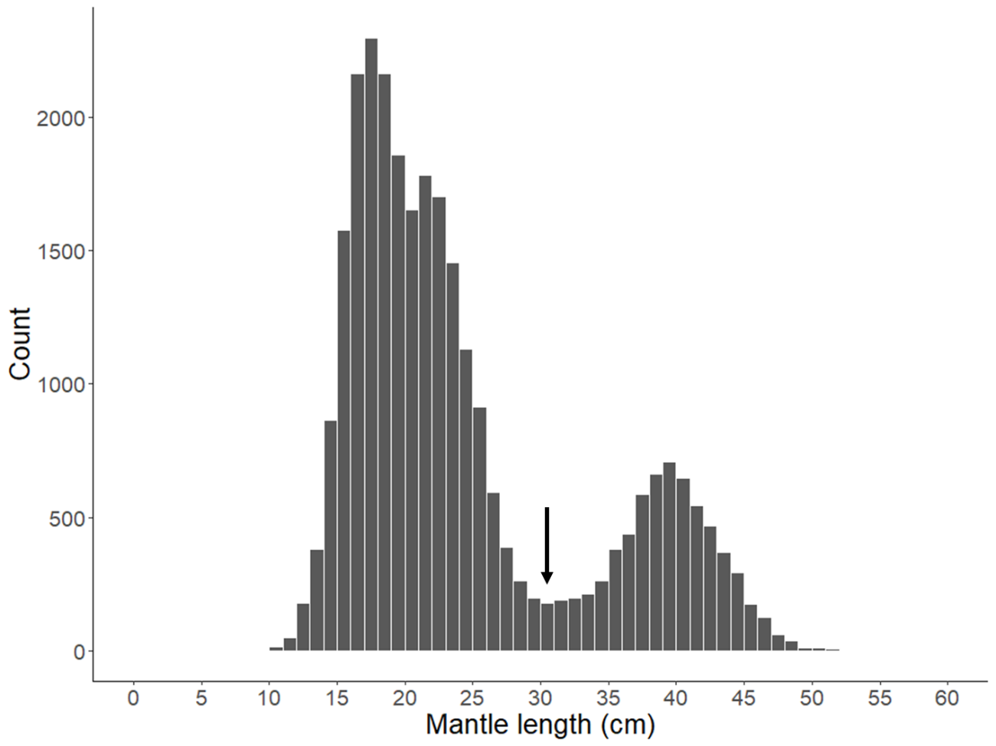

**Fig. 1.** Histogram for mantle length of *Ommastrephes bartramii* (n = 28,187 individuals) caught by survey driftnets. The black arrow indicates the 31 cm boundary, separating the two cohorts (autumn and winter-spring cohorts).

テーブル

AI によって生成されたコンテンツは間違っている可能性があります。

**Fig. 2.** Interannual changes in the spatial distribution of CPUE for the autumn cohort of *Ommastrephes bartramii* collected by survey driftnets.

テーブル

AI によって生成されたコンテンツは間違っている可能性があります。

**Fig. 3.** Interannual changes in the spatial distribution of CPUE for the winter-spring cohort of *Ommastrephes bartramii* collected by survey driftnets.

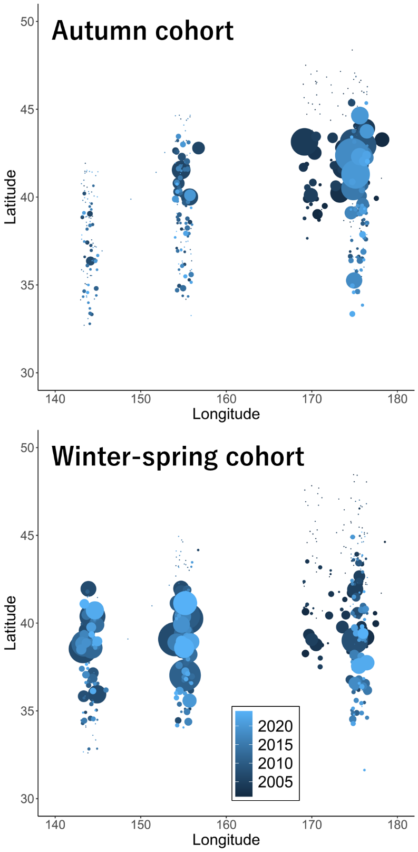

**Fig. 4.** Spatial distribution of CPUE for the autumn cohort and winter-spring cohort of *Ommastrephes bartramii* collected by survey driftnets from 2001 to 2024. Circle size indicates CPUE and colors distinguish survey years. For illustration purposes, each dot is a jitter point to avoid overplotting.

グラフ, 散布図

AI 生成コンテンツは誤りを含む可能性があります。

**Fig. 5.** Variable importance plot for the autumn cohort (a) and the winter-spring cohort (b). The relative importance of each variable in explaining squid abundance was ranked according to the increase in AIC on removal from the full model.

ダイアグラム

AI によって生成されたコンテンツは間違っている可能性があります。

**Fig. 6.** Diagnostics of the best model for the autumn cohort, including Q-Q plot, histogram of residuals, residual plots across years, and the relationship between observed and fitted values.

ダイアグラム

AI によって生成されたコンテンツは間違っている可能性があります。

**Fig. 7.** Diagnostics of the best model for the winter-spring cohort, including Q-Q plot, histogram of residuals, residual plots across years, and the relationship between observed and fitted values.

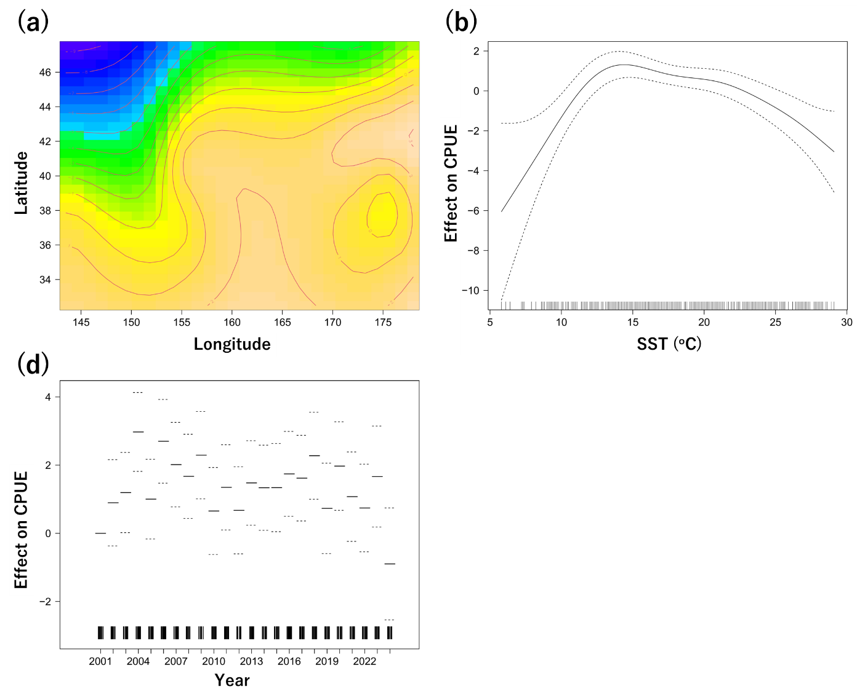

**Fig. 8.** GAM-derived effect of explanatory variables (a: Lat and Lon, b: SST, c: Year) on CPUE for the autumn cohort in the best model. The dotted lines indicate the 95% conﬁdence intervals, and the solid line shows the ﬁtted GAM function that describes the effect of a predictor variable on CPUE. The warmer color in (a) represents a higher CPUE estimated by the best GAM. The relative density of data points is shown by the rug plot on the x-axis.

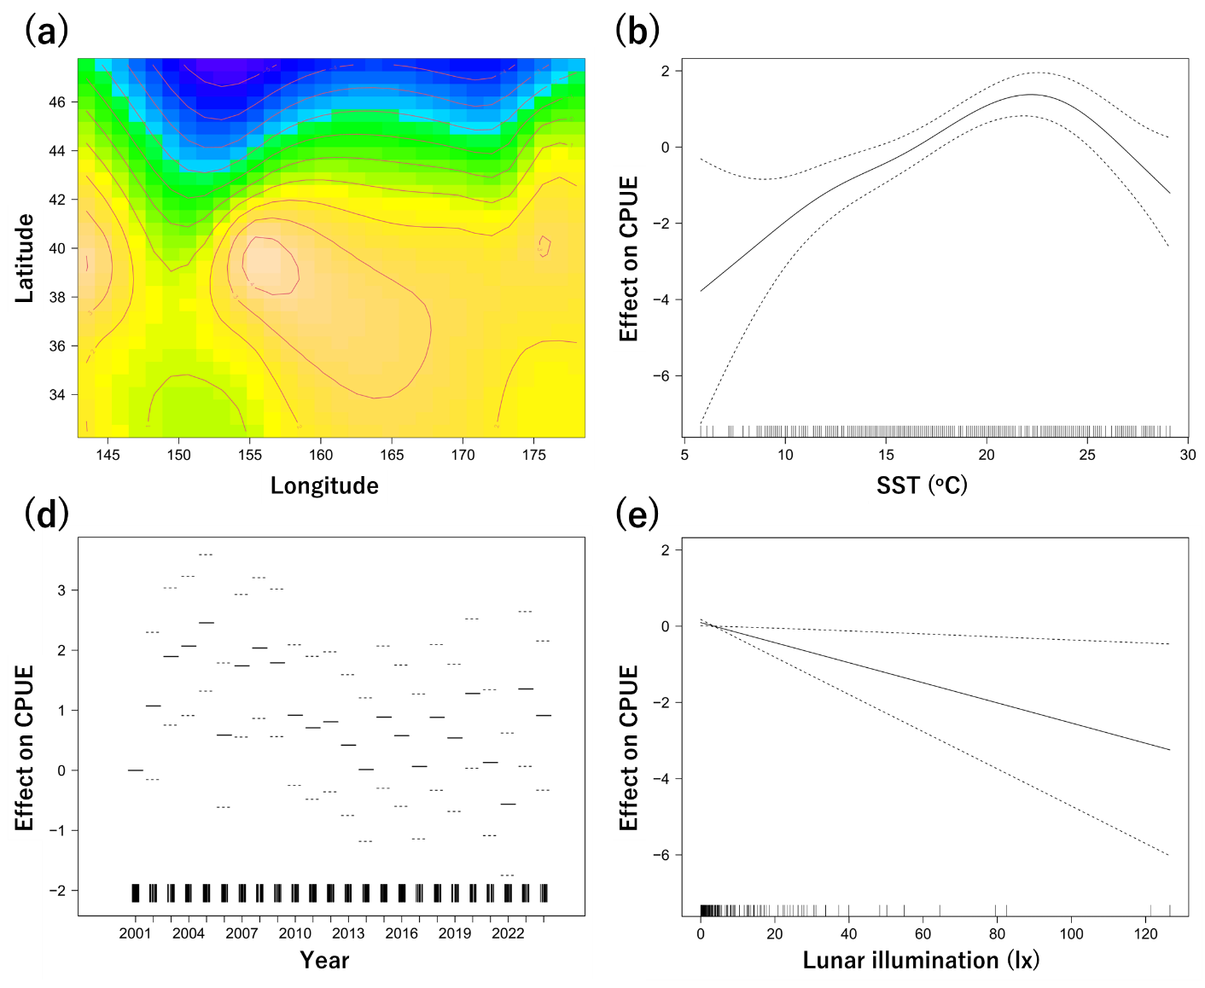

**Fig. 9.** GAM-derived effect of explanatory variables (a: Lat and Lon, b: SST, c: Year, d: Lunar illumination) on CPUE for the winter-spring cohort in the best model. The dotted lines indicate the 95% conﬁdence intervals, and the solid line shows the ﬁtted GAM function that describes the effect of a predictor variable on CPUE. The warmer color in (a) represents a higher CPUE estimated by the best GAM. The relative density of data points is shown by the rug plot on the x-axis.

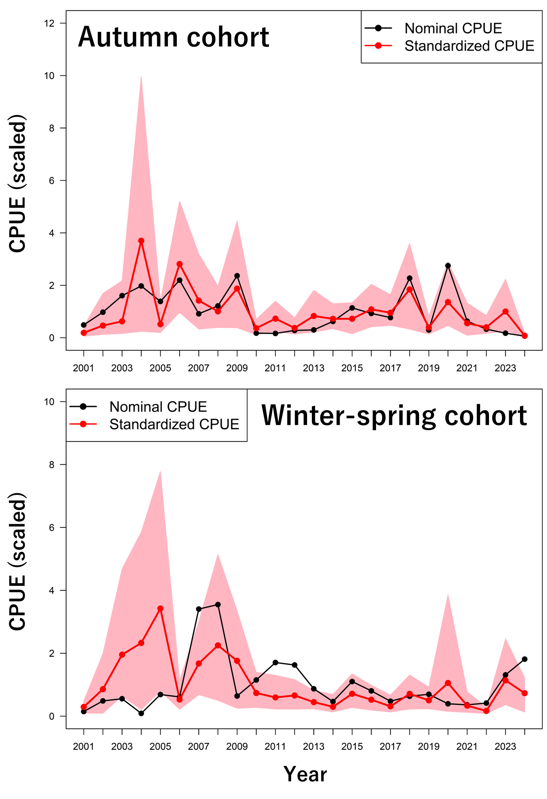

**Fig. 10.** Interannual changes in CPUE for the autumn cohort and winter-spring cohorts of *Ommastrephes bartramii*. The black and red lines indicate nominal and standardized CPUE, respectively. The shaded red areas indicate the 95% bootstrap confidence intervals, obtained by resampling the data 1,000 times.