NPFC-2025-SSC NFS02-WP04

**Estimation of the relationship between size box categories and the mantle length composition of neon flying squid caught by Japanese squid jigging vessels**

Hajime Matsui*, Bungo Nishizawa, Suguru Okamoto, and Kazuhiro Oshima

*Fisheries Resources Institute, Japan Fisheries Research and Education Agency*

*Corresponding Author

E-mail: matsui_hajime90@fra.go.jp

# **1. Summary**

This study investigates the relationship between size-box categories and mantle length of the neon flying squid (*Ommastrephes bartramii*, NFS) caught by Japanese squid jigging vessels in the North Pacific Ocean. On-board size measurements of mantle lengths of squid caught by commercial jigging were conducted from May to July in 2012 and 2013, covering eight size-box categories. In total, the mantle lengths of 3451 individuals were measured. Squid sorted into the 6-10, 11-15, and 16-20 size-box categories were mostly in the mantle length class of 35 cm or larger, whereas those in the 41-50 and 51-60 size box categories were in the mantle length class of 20 cm or smaller. These mantle length frequency distributions were fitted with a lognormal distribution. The mantle length compositions obtained in this paper could be used to estimate length distributions of NFS landings under condition of number of boxes by size-box category available.

# **2. Introduction**

NFS is an oceanic squid that occurs worldwide in subtropical and temperate waters (Roper et al. 1984). In the North Pacific, NFS population comprises an autumn cohort and a winter-spring cohort (Yatsu et al. 1997, 1998). Since the distribution ranges of each cohort overlap especially in the area east of 170˚E (Matsui et al. 2024a, b), it is important to collect size composition data for more accurately separating the two cohorts of NFS (Small Scientific Committee on Neon Flying Squid 2024). On Japanese squid jigging vessels, NFS are processed on board and frozen after being divided into four parts: fins, mantle without fins, arms and tentacles, and cartilage around mouth (Fig.1, Tone and Miki 2024). Therefore, it is difficult to measure the size of squid after they were unloaded at landing ports. Processed mantles without fins are sorted into market size categories (hereafter called size-box categories) according to body size. They are then packed into standard-size boxes under a rule of predetermined weight range per box (i.e. 12 to 13 kg/box). Given mantle length compositions by size-box category, we can estimate length composition of landings with number of landed boxes. The objective of this paper is to demonstrate mantle length distributions by size-box category using onboard length measurement data from squid jigging fishing vessels.

# **3. Methods**

The onboard size length measurements of squid were conducted in commercial squid jigging vessels from May to July in 2012 and 2013. Onboard mantle length measurements by fishermen were carried out on five squid jigging vessels in each year (Sakai et al. 2014). Although there are 12 size-box categories applied to NFS catch in Japan, the measurements in this study were covered following eight categories: 6-10, 11-15, 16-20, 21-25, 26-30, 31-40, 41-50, and 51-60 individuals per box. These categories accounted for over 99% of the size box categories recorded between July and October from 2010 to 2023 at Hachinohe Port, Japan (Fig.2), where most of NFS catch was landed. The mantle lengths of squid assigned to each size-box category were measured to the nearest 1 cm prior to processing. A total of 3451 individuals were measured for mantle length, comprising 2543 individuals in 2012 and 1008 individuals in 2013 (Table 1). Using the measurement data, the mantle length frequency distributions were calculated for each size-box category. Since squid are sorted into each size-box category according to body size, the size distribution of individuals within each size-box category is generally expected to follow a normal distribution. However, categories that include large individuals may also contain squid slightly beyond the typical size range, leading to a right-skewed distribution. Therefore, the size distributions of squid in each size-box category were fitted with a lognormal distribution using the R package ‘fitdistrplus’ (Delignette-Muller et al. 2025).

# **4. Results and Discussion**

Figure 3 show the mantle length frequency distributions in each size-box category with the fitted lognormal distribution curve. The mantle length ranged from 14 to 61 cm. The squid included in the 6-10, 11-15, and 16-20 size-box categories were mostly in the mantle length class of 35 cm or larger, whereas those in the 41-50 and 51-60 size box categories were in the mantle length class of 20 cm or smaller.

Tables 1 and 2 show the mean and median mantle length, standard deviation, skewness and kurtosis of squid included in each size-box category, based on the onboard measurements and estimates fitted with a lognormal distribution. The 6-10 size category showed the highest skewness and kurtosis values, and its mantle length frequency distribution showed a strongly right-skewed pattern (Fig.3). The mantle length frequency distributions of the 11-15, 26-30, and 31-40 size categories also showed right-skewed distribution patterns, whereas those of the 16-20, 21-25, 41-50, and 51-60 size categories showed weaker right-skewed tendencies (Fig. 3). In addition, the overlap in size ranges was greater among the 6-10 to 31-40 size categories than in the 41-50 and 51-60 categories. Since size-box categories that include larger individuals tend to be associated with higher market prices (Hachinohe Fish Market, unpublished data), fishermen may sometimes classify slightly larger individuals into the next larger size categories, which might have contributed to changes in the patterns of the mantle length frequency distributions.

Using the relationship between size-box categories and mantle length obtained in this study, along with the number of boxes by size-box categories, the size composition of the catch can be estimated. Furthermore, by combining the estimated size composition with the threshold size distinguishing the autumn and winter-spring cohort for each fishing month, it is possible to separate the NFS catch into each cohort. However, in fitting of lognormal distribution to observed distributions in this study, there were some differences between observed and predicted distributions especially in the size-box categories of 16-20 and 21-25. The observed distributions from those two categories seemed not to be distributed lognormally. As these categories account for a large proportion of the catch (Fig. 2), fitting an inappropriate distribution may lead to errors in estimating size composition and could affect the calculated catch amount for each cohort. Therefore, it may be necessary to further evaluate more appropriate distribution models that better fit the 16-20 and 21-25 size categories.

This paper provides information on the mantle length distributions by the size-box category based on the onboard measurement data. Consequently, the results could contribute to the estimation of the mantle length composition of NFS landings in Japan. However, this type of estimation depends on consistency of the predetermined weight range per box. In fact, the weight per box was changed to approximately 10 kg (Hachinohe Fish Market, unpublished data) in 2020. Accordingly, Japan is currently collecting size data to clarify the current relationship between size-box categories and mantle length composition for estimating the size composition of the catch since 2020.

# **References**

Delignette-Muller LM, Dutang C, Pouillot R, Denis JB, Siberchicot A (2025) Package ‘fitdistrplus’ R package version 1.2-2. https://cran.r-project.org/web/packages/fitdistrplus/fitdistrplus.pdf

Matsui H, Nishizawa B, Okamoto S, Oshima K (2024a) Differences in the distribution of the neon flying squid by spawning cohort in the North Pacific Ocean based on the results of age determination using statoliths. NPFC-2024-SSC NFS01-WP10

Matsui H, Nishizawa B, Okamoto S, Oshima K (2024b) Brief summary of the Japanese surveys for spawning grounds of the neon flying squid in the North Pacific Ocean. NPFC-2024-SSC NFS01-WP11

Roper CFE, Sweeney MJ, Nauen CE (1984) FAO species catalogue. Vol 3: cephalopods of the world. An annotated and illustrated catalogue of species of interest to fisheries. FAO Fish Synop 125, Rome

Sakai M, Kato Y, Seidou M (2014) Identification of seasonal cohorts of neon flying squid (*Ommastrephes bartramii*) based on brand-specific length composition analysis. FY2013 Report, Ministry of Education, Culture, Sports, Science and Technology Climate Change Adaptation Promotion Program, 'Innovation and Practical Application of Fishery Resource and Oceanographic Change Prediction Technologies under Climate Change. Japan Agency for Marine-Earth Science and Technology, Yokosuka, p 80–84 (in Japanese)

Small Scientific Committee on Neon Flying Squid (2024) 1st meeting report. NPFC-2024-SSC NFS01-Final Report. 30 pp.

Tone K, Miki N (2024) Current status of middle-sized squid jigging vessel fisheries and distribution of Japanese flying squid. Kaiyo System Engineering 174:83–97 (in Japanese)

Yatsu A, Midorikawa S, Shimada T, Uozumi Y (1997) Age and growth of the neon flying squid, *Ommastrephes bartramii*, in the North Pacific Ocean. Fish Res 29:257–270

Yatsu A, Tanaka H, Mori J (1998) Population structure of the neon flying squid, *Ommastrephes bartramii*, in the North Pacific Ocean. In: Okutani T (ed) International symposium on large pelagic squids. Japan Marine Fishery Resources Research Center, Tokyo, p 31–48

**Table 1.** Summary of onboard mantle length measurement. Number of squid (*n*) measured, observed mean mantle length (ML), observed median ML and observed standard deviation (SD) in each size box category.

|  |  |  |  |  |
| --- | --- | --- | --- | --- |
| Size box category (individuals / box) | *n* | Observed mean  ML (cm) | Observed median  ML (cm) | Observed SD  (cm) |
| 06-10 | 332 | 48.7 | 48.0 | 3.0 |
| 11-15 | 584 | 43.7 | 43.0 | 3.0 |
| 16-20 | 715 | 37.8 | 38.0 | 1.5 |
| 21-25 | 601 | 34.4 | 34.0 | 1.8 |
| 26-30 | 675 | 29.8 | 29.0 | 2.6 |
| 31-40 | 384 | 26.2 | 26.0 | 3.2 |
| 41-50 | 100 | 18.7 | 19.0 | 0.8 |
| 51-60 | 60 | 15.5 | 15.0 | 0.9 |

**Table 2.** Summary of lognormal distribution fitting to observed distribution. Number of squid (*n*) measured, estimated mean ML, median ML, SD, Skewness and Kurtosis in each size box category.

|  |  |  |  |  |  |
| --- | --- | --- | --- | --- | --- |
| **Size box category  (individuals / box)** | **Estimated mean ML (cm)** | **Estimated median ML (cm)** | **SD**  **(cm)** | **Skewness** | **Kurtosis** |
| **06-10** | 48.8 | 47.9 | 3.2 | 2.3 | 10.8 |
| **11-15** | 43.8 | 43.1 | 3.8 | 1.2 | 2.8 |
| **16-20** | 37.8 | 37.6 | 1.9 | 0.8 | 1.3 |
| **21-25** | 34.4 | 34.0 | 2.2 | 1.3 | 0.2 |
| **26-30** | 29.9 | 29.3 | 2.9 | 1.4 | 3.5 |
| **31-40** | 26.2 | 25.4 | 3.7 | 1.7 | 5.2 |
| **41-50** | 18.7 | 18.6 | 0.8 | 1.0 | 1.7 |
| **51-60** | 15.5 | 15.3 | 1.0 | 1.3 | 2.9 |

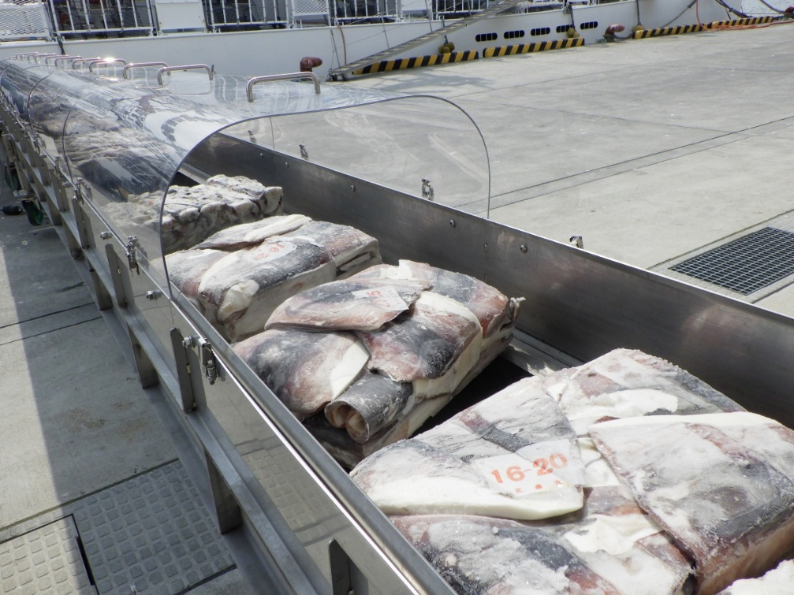

**Fig. 1.** Frozen neon flying squid divided by each part (fins, mantle without fins, arms and tentacles, and mouth cartilage), being unloaded from a commercial squid jigging vessel at Hachinohe Port, Japan, July 2019.

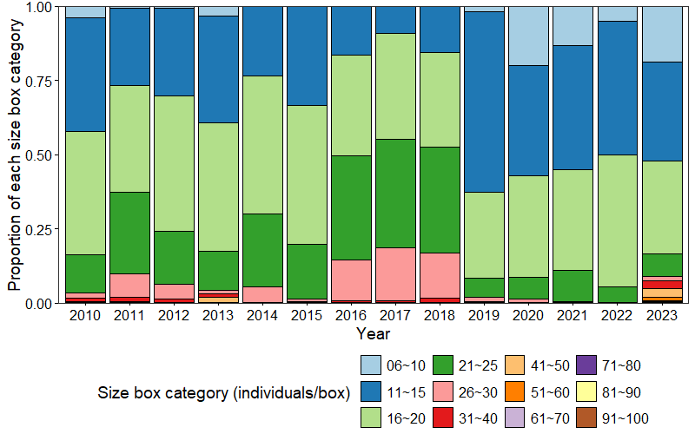

**Fig. 2.** Proportional distribution of size box categories landed from July to October between 2010 and 2023.

**グラフィカル ユーザー インターフェイス

AI 生成コンテンツは誤りを含む可能性があります。**

**Fig. 3.** Mantle length frequency distributions of neon flying squid in 6-10, 11-15, 16-20, 21-25, 26-30, 31-40, 41-50, and 51-60 size-box categories. Bars represent the observed measurement data, and solid lines indicate the lognormal distribution curves fitted for each size-box category.

グラフィカル ユーザー インターフェイス, アプリケーション

AI 生成コンテンツは誤りを含む可能性があります。

**Fig. 3.** *Continued*.