NPFC-2025-TWG CMSA11-WP03 Rev.1

**The data description for the base case stock assessment of chub mackerel *Scomber japonicus* in the northwestern Pacific Ocean for 2025 assessment**

Akihiro Manabe1, Karolina Molla Gazi2, and Kazuhiro OSHIMA1

*1. Fisheries Resources Institute, Japan Fisheries Research and Education Agency*

*2. European Union*

(corresponding author: Akihiro MANABE, manabe_akihiro97@fra.go.jp)

**Summary**

The details of input data used for the stock assessment of chub mackerel in the northwestern Pacific Ocean is described. The data consists of catch-at-age, weight-at-age, and maturity-at-age since 1970 fishing year (FY1970) with different length of temporal data from three members: China, Japan, and Russia. This working paper describes the details on each data and its derivation. A total of seven standardized abundance indices which are used for stock assessment are also presented. The present paper also provides information on the data used for sensitivity scenarios.

**Introduction**

The data used for the stock assessment is a fundamental component that affects the evaluation of the stock status. Since 2024, the TWG CMSA has been conducting stock assessment on chub mackerel (CM) using State-space Assessment Model (SAM). In TWG CMSA11, the TWG CMSA conducts the second stock assessment up to fishing year FY2023 (FY, i.e., the 3rd quarter (Q3) of the calendar year (CY) to the 2nd quarter). The input data were provided by each member: China, Japan, and Russia. The data preparation was conducted at the TWG CMSA10 meeting, which the preparatory method of catch-at-age, weight-at-age, maturity-at-age, and natural mortalities were discussed and finalized for the base case (NPFC 2025, Manabe et al., 2025a, b). In the present document, the finalized catch-at-age, weight-at-age, maturity-at-age, and natural mortality for the base-case stock assessment as well as additional data on maturity-at-age for sensitivity scenario are described.

**Catch-at-age**

Catch-at-age is one of fundamental data sets that characterizes the population dynamics and status. In the TWG CMSA, three members: China, Japan, and Russia harvest CM in both national waters and the Conventional Area. Quarterly catch-at-length, age-length-key (ALK), and catch-at-age data were submitted and the TWG CMSA had discussed the methodology to convert catch-at-length to catch-at-age using ALK on fishing-year-basis at its 10th meetings (Manabe et al., 2025a, NPFC 2025).

The data collection for catch-at-length and development of ALK are conducted by each member, however, considering the spatial difference, Japanese data are separated into the eastern and western Japan at Shizuoka-Mie prefectural border (Manabe et al., 2025a). For Chinese data collection and development of ALK and Russian method of data collection method, the details are described in Chernienko and Chernienko (2021), NPFC (2022), Antonenko (2025), and Zhang (2025).

Quarterly catch-at-length data from each member are converted into catch-at-age data by applying ALK of the equivalent region, quarter, and year. The details and preparation of ALKs are described in NPFC-2024-TWG CMSA08-WP15 (Manabe et al., 2024). Since the age incrementation of CM is defined differently across members which China and Russia set the date as January 1st (i.e., beginning of CY) and Japan as July 1st (i.e., beginning of FY), the Chinese age are converted to FY-based data by subtracting age by 1 year on the data between January 1st to July 30th (the 1st quarter to 2nd quarter). For the Russian aging on catch-at-age, the ALK from Eastern Japan is applied with the fishing-year based age incrementation. The catch of the YOY (young of year) fish during the 1st and 2nd quarter, the age is treated as 0 and included in the catch in the 3rd quarter. Additionally, the age conversion process creates the appearance of age-7 fish occurs only on the 3rd and 4th quarter; to avoid misinterpretation of the population dynamics, age-7 fish are aggregated with age-6 fish to create a plus group (i.e., age-6+). Quarterly catch-at-age data is aggregated from the 3rd quarter to the 2nd of the following year to calculate the fishing yearly catch-at-age.

The development of catch-at-age based on catch-at-length data and ALKs are conducted since FY2014 up to FY2022 fishing year. For the data since FY1970 to FY2013, the catch-at-age is sourced from the Japanese domestic stock assessment report of the Pacific stock of chub mackerel (Yukami et al., 2025). For FY1967 to FY1988, the catch-at-age contains catch conducted by Russia, however due to its difficulty to separate the catch-at-age into two members; Japan and Russia, the catch-at-age from FY1967 to FY1988 are considered as the catch obtained by Japan.

As referred in the 9th meeting of Scientific Committee, the sum of product of catch at age and weight at age provided by members exhibited discrepancies between the annual footprint of each member (NPFC 2024b). Therefore, the TWG CMSA investigated the causes and corrected the catch at age and weight at age (Manabe et al. 2025c). Therefore, the numbers prior to the most recent fishing year are also subjected to change.

Table 1 lists the quarter/year that contains unavailable data to develop catch-at-age. The solutions to supplement the unavailable data to develop catch-at-age for FY2014-2017 were discussed at the TWG CMSA10 meeting and following solutions listed in Table 1 were agreed and adopted as the base case (NPFC 2025).

For Chinese catch-at-age in CY2015 and Russian catch-at-age in CY2014-2016, the averaged of CY2016-2018 is assumed to be the age composition for CY2014-2015. The averaged catch-at-length is estimated as follows:

$$P_{m,t}=\frac{1}{2}\left(\frac{C_{m,2016}+C_{m,2017}+C_{m,2018}}{3}+C_{m,t}\right)$$

where $P_{m,t}$ is a proportion of catch *C* of member *m* at year *t*. The number of catch *N* at length bin *l* for member *m* at quarter *q* of year *t* is derived as follows:

$$N_{l, m, q,t}=P_{m,t}\left(\frac{N_{l,m,q,2016}+N_{l,m,q,2017}+N_{l,m,q,2018}}{3}\right)$$

The calculated quarterly catch-at-length is multiplied by the Eastern Japanese ALK of the equivalent year and quarter to develop the catch-at-age.

Figure 1 and Table 2 show the finalized quarterly catch-at-age of CM from each member from FY2014-2022 and Figure 3 shows the total quarterly catch-at-age from FY2014-2022. In combination with the historical data from the Japanese domestic stock assessment, Figure 3 and Table 3 show the finalized annual catch-at-age of CM in FY1970-2022 for each member and Figure 4 shows the total annual catch-at-age in FY1970-2022.

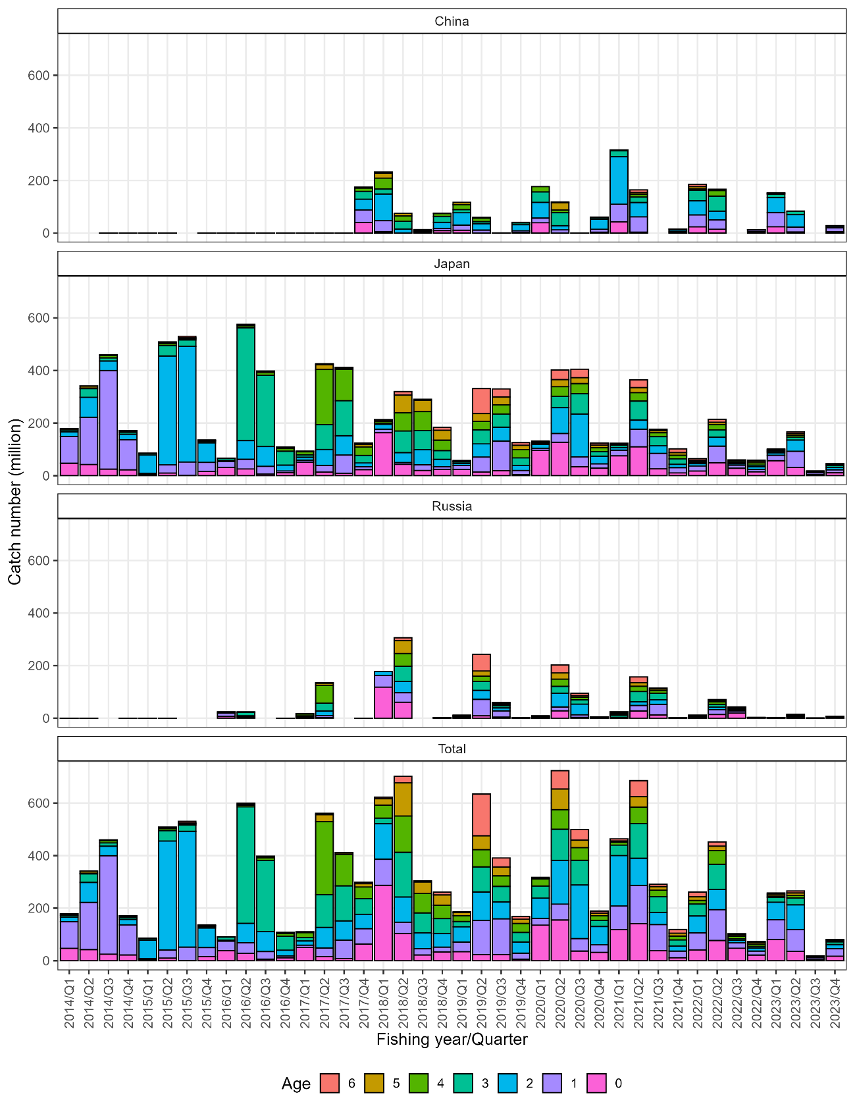

Figure 1. Quarterly catch-at-age from each member and total catch at age in FY2014-2023. Quarter is based on fishing year which Quarter 1, 2, 3, and 4 are April-June, July-September, October-December, and January-March, respectively.

グラフ, 棒グラフ

AI 生成コンテンツは誤りを含む可能性があります。

Figure 2. Annual catch-at-age from each member and total catch-at-age in FY1970-2023.

Table 1. List of year/quarter/member with unavailable data and solution.

|  |  |  |  |  |
| --- | --- | --- | --- | --- |
| Year (calendar) | Quarter | Member | Unavailable data | Solution |
| 2015 | Q2-Q4 | China | Catch-at-length  ALK | Use mean catch-at-length of China CY2016-2018  Use Eastern Japanese ALK of the equivalent quarter/year |
| 2016-2017 | Q2-Q4 | China | ALK | Use Eastern Japanese ALK of the equivalent quarter/year |
| 2014-2015 | Q2-Q4 | Russia | Catch-at-length  ALK | Use mean catch-at-length of Russia CY2016-2018  Use Eastern Japanese ALK of the equivalent quarter/year |
| 2022-2023 | Q1-Q4 | Russia | Catch-at-length  ALK | Use mean catch-at-length and ALK from Eastern Japan of the equivalent quarter/year |

Table 2. Quarterly catch-at-age of CM in the northwestern Pacific from each member in FY2014-2023. Quarter is based on fishing year which Quarter 1, 2, 3, and 4 are April-June, July-September, October-December, and January-March, respectively.

|  |  |  |  |  |  |  |  |  |  |
| --- | --- | --- | --- | --- | --- | --- | --- | --- | --- |
| Fishing year | Quarter (FY-based) | Member | Age_0 | Age_1 | Age_2 | Age_3 | Age_4 | Age_5 | Age_6+ |
| 2014 | 1 | China | 0 | 0 | 0 | 0 | 0 | 0 | 0 |
| 2014 | 1 | Japan | 47237077.4 | 101493371.2 | 17775820.17 | 6427994.194 | 685820.9648 | 5251715.71 | 20722.36623 |
| 2014 | 1 | Russia | 43.3043127 | 11.31252067 | 3.912611344 | 0.591286311 | 0.035357981 | 0.207640907 | 0.006093851 |
| 2014 | 2 | China | 0 | 0 | 0 | 0 | 0 | 0 | 0 |
| 2014 | 2 | Japan | 42347670.9 | 179706344.7 | 75918907.02 | 32709460.25 | 2270808.361 | 7906203.208 | 184.4855752 |
| 2014 | 2 | Russia | 12.1304811 | 12.95635789 | 31.12790023 | 5.446177616 | 0.379831784 | 1.038957934 | 0.029040168 |
| 2014 | 3 | China | 28.9758946 | 299.8559962 | 2.664106827 | 0 | 0 | 0 | 0 |
| 2014 | 3 | Japan | 24849503.9 | 374901015.6 | 36081139.33 | 12322603.77 | 8993750.885 | 2143575.989 | 666298.5825 |
| 2014 | 4 | China | 39184.8156 | 118202.8206 | 5579.991197 | 655.7940042 | 68.90362361 | 0 | 0 |
| 2014 | 4 | Japan | 22088939.9 | 114485701.9 | 20808283.44 | 7494880.908 | 4762635.574 | 1140659.518 | 68969.3842 |
| 2014 | 4 | Russia | 0.18380836 | 0.108094718 | 0.143243401 | 0.032712717 | 0.01222198 | 0.005182613 | 5.15E-04 |
| 2015 | 1 | China | 251664.85 | 59271.33234 | 78401.94977 | 15780.09 | 398.3236773 | 0 | 120.0860628 |
| 2015 | 1 | Japan | 4564178.5 | 4200513.089 | 69526241.33 | 6198456.945 | 360653.5297 | 31848.67648 | 405973.0396 |
| 2015 | 1 | Russia | 431.982688 | 115.3240699 | 69.32063008 | 12.3964065 | 0.467459819 | 0.049019058 | 0.695953256 |
| 2015 | 2 | China | 28544.5707 | 10515.26659 | 86769.46945 | 11915.92139 | 1709.286179 | 884.6298022 | 494.8025388 |
| 2015 | 2 | Japan | 9860198.61 | 30918344.54 | 414557710.8 | 39767239.5 | 7622601.87 | 4754074.927 | 1036650.589 |
| 2015 | 2 | Russia | 116.852588 | 29.72510064 | 337.6122299 | 160.459021 | 13.07449369 | 8.367039419 | 3.722739417 |
| 2015 | 3 | China | 0 | 0 | 0 | 0 | 0 | 0 | 0 |
| 2015 | 3 | Japan | 1122037.86 | 50786616.75 | 440511281.9 | 23768350.57 | 4759914.927 | 2922855.125 | 6561907.264 |
| 2015 | 4 | China | 868.436338 | 41949.50378 | 137799.3525 | 0 | 0 | 0 | 0 |
| 2015 | 4 | Japan | 15590075.1 | 34725749.8 | 74350663.19 | 5185340.982 | 3084384.54 | 1793391.717 | 1145102.639 |

Table 2. Continued.

|  |  |  |  |  |  |  |  |  |  |
| --- | --- | --- | --- | --- | --- | --- | --- | --- | --- |
| Fishing year | Quarter (FY-based) | Member | Age_0 | Age_1 | Age_2 | Age_3 | Age_4 | Age_5 | Age_6+ |
| 2016 | 1 | China | 228199.506 | 193748.2661 | 3973.300921 | 40794.98551 | 618.5333865 | 48.38312264 | 0 |
| 2016 | 1 | Japan | 31346763.1 | 22801023.57 | 3353126.081 | 7760657.426 | 498366.288 | 174562.0198 | 193372.9971 |
| 2016 | 1 | Russia | 6577864.83 | 13281423.33 | 296235.005 | 3807908.541 | 0 | 0 | 0 |
| 2016 | 2 | China | 8077.13841 | 24271.39773 | 34672.44312 | 60153.41691 | 1884.665629 | 2860.719857 | 5048.344847 |
| 2016 | 2 | Japan | 25176762.2 | 37141678.46 | 71023241.67 | 429130503.7 | 6414004.856 | 3507773.155 | 3365643.893 |
| 2016 | 2 | Russia | 3032179.23 | 3146992.219 | 2804077.423 | 13945999.12 | 183676.5709 | 123070.3467 | 169762.1182 |
| 2016 | 3 | China | 0 | 97.69669918 | 272.8122144 | 615.3024026 | 0 | 0 | 0 |
| 2016 | 3 | Japan | 5929279.24 | 29298962.77 | 75485367.7 | 271043631 | 9466497.326 | 5275137.395 | 1475767.263 |
| 2016 | 4 | China | 6781.28218 | 8291.954887 | 65147.29372 | 60843.13355 | 0 | 0 | 0 |
| 2016 | 4 | Japan | 11214378.9 | 6404007.452 | 22424940.64 | 52777617.82 | 10284985.26 | 3134032.719 | 2142262.21 |
| 2016 | 4 | Russia | 375.620613 | 197.445509 | 854.7608154 | 1932.460735 | 334.3461587 | 103.0924168 | 82.87659593 |
| 2017 | 1 | China | 123026.816 | 344227.8764 | 45833.88121 | 28600.36765 | 4808.651532 | 272.7796842 | 0 |
| 2017 | 1 | Japan | 51043384.6 | 7555217.385 | 11355460.5 | 9182874.663 | 11579713.12 | 1549971.816 | 665235.5098 |
| 2017 | 1 | Russia | 75.9663548 | 168115.5123 | 4598724.231 | 4087659.645 | 6850420.453 | 724592.6525 | 521950.9912 |
| 2017 | 2 | China | 41227.5867 | 66928.1473 | 21087.25496 | 30398.50696 | 58688.02551 | 295.9118674 | 0 |
| 2017 | 2 | Japan | 13205713.9 | 25702205.77 | 60735367.55 | 94821064.49 | 209604509.4 | 18279440.18 | 3511832.978 |
| 2017 | 2 | Russia | 2037561.95 | 7237650.573 | 18002490.49 | 29818485.77 | 68127672.96 | 8081123.339 | 1448877.987 |
| 2017 | 3 | China | 1851.835 | 9722.133 | 9259.174 | 7407.339 | 1388.876 | 0 | 0 |
| 2017 | 3 | Japan | 9066561.55 | 69175256.31 | 73578370.3 | 133217126.1 | 119457375.2 | 5381369.042 | 2000741.296 |
| 2017 | 4 | China | 40591262.2 | 47650612.13 | 40591262.19 | 30002237.27 | 12353862.4 | 3529674.973 | 0 |
| 2017 | 4 | Japan | 22702909.8 | 10949878.29 | 14443108.89 | 28828094.38 | 32228833.41 | 9141502.892 | 5121029.711 |
| 2017 | 4 | Russia | 30542.0336 | 11728.78206 | 9764.07808 | 11658.95196 | 19116.05421 | 9838.849074 | 5563.812084 |

Table 2. Continued.

|  |  |  |  |  |  |  |  |  |  |
| --- | --- | --- | --- | --- | --- | --- | --- | --- | --- |
| Fishing year | Quarter (FY-based) | Member | Age_0 | Age_1 | Age_2 | Age_3 | Age_4 | Age_5 | Age_6+ |
| 2018 | 1 | China | 5294512.46 | 41656792.62 | 101827715.3 | 18514130.05 | 41656792.62 | 18514130.05 | 4628532.513 |
| 2018 | 1 | Japan | 163305241 | 13199749.13 | 18677714.4 | 2890971.645 | 7687663.54 | 5686061.677 | 1539322.867 |
| 2018 | 1 | Russia | 118347280 | 44336959.25 | 14778986.42 | 0 | 0 | 0 | 0 |
| 2018 | 2 | China | 0 | 0 | 15439489.5 | 29163480.17 | 20585986 | 10292993 | 0 |
| 2018 | 2 | Japan | 42923585.5 | 6991766.311 | 37695246.57 | 82412225.01 | 69286078.62 | 66924478.58 | 13595377.93 |
| 2018 | 2 | Russia | 60810545 | 36012993.63 | 42656758.32 | 58481151.41 | 48216179 | 48882019.43 | 11054518.06 |
| 2018 | 3 | China | 2434842.37 | 2087007.748 | 3130511.623 | 3130511.623 | 2434842.373 | 0 | 0 |
| 2018 | 3 | Japan | 19662813.2 | 21445825.74 | 57685895.16 | 72591689.9 | 72393185.98 | 42589378.82 | 4184809.874 |
| 2018 | 4 | China | 9369473.37 | 8446610.92 | 23059598.71 | 22754435.33 | 10707969.57 | 1338496.196 | 0 |
| 2018 | 4 | Japan | 23911159.3 | 9746834.996 | 28406818.77 | 33176283.62 | 39771206.36 | 37584856.59 | 10861004.92 |
| 2018 | 4 | Russia | 136020.534 | 176492.8727 | 569387.6508 | 461689.2885 | 401783.5911 | 318121.4631 | 35683.59709 |
| 2019 | 1 | China | 10772228.2 | 19226714.98 | 46998636.62 | 12116280.62 | 19226714.98 | 8545206.658 | 0 |
| 2019 | 1 | Japan | 23620227.4 | 15105785.78 | 8033354.538 | 5540360.261 | 1410623.526 | 1980382.77 | 1883604.257 |
| 2019 | 1 | Russia | 6606.52498 | 2623281.71 | 2979308.499 | 2257178.022 | 1184870.172 | 1452845.354 | 1190813.306 |
| 2019 | 2 | China | 0 | 11310087.59 | 24235901.99 | 8078633.996 | 12925814.39 | 3231453.598 | 0 |
| 2019 | 2 | Japan | 13777801.1 | 56807014.58 | 49959014.62 | 53563013.21 | 32185356.19 | 29956714.9 | 94863536.47 |
| 2019 | 2 | Russia | 9101668.09 | 62446753.23 | 34406517.01 | 33579867.21 | 20393929.38 | 19481448.9 | 63697357.11 |
| 2019 | 3 | China | 152219.2 | 304438.4 | 426213.759 | 0 | 0 | 0 | 0 |
| 2019 | 3 | Japan | 19141117.8 | 111986510.9 | 53153380.69 | 50294500.53 | 34911410.16 | 29494398.07 | 31022591.23 |
| 2019 | 3 | Russia | 4096649.49 | 23961207.19 | 10889624.81 | 8470982.976 | 5214357.409 | 4280863.352 | 2978384.849 |
| 2019 | 4 | China | 2019586.14 | 6563654.943 | 23225240.57 | 7068551.477 | 2019586.136 | 0 | 0 |
| 2019 | 4 | Japan | 3761203.43 | 15828768.04 | 19023510.51 | 28876782.73 | 31993642.53 | 15858005.16 | 10281887.24 |
| 2019 | 4 | Russia | 68892.6627 | 664609.5526 | 357858.3075 | 301026.4304 | 190861.9913 | 74145.86339 | 65534.27528 |

Table 2. Continued.

|  |  |  |  |  |  |  |  |  |  |
| --- | --- | --- | --- | --- | --- | --- | --- | --- | --- |
| Fishing year | Quarter (FY-based) | Member | Age_0 | Age_1 | Age_2 | Age_3 | Age_4 | Age_5 | Age_6+ |
| 2020 | 1 | China | 39056745.5 | 17761234.9 | 59944167.8 | 39962778.54 | 19981389.27 | 0 | 0 |
| 2020 | 1 | Japan | 96249230.8 | 7769995.271 | 15258287.98 | 4168797.27 | 4136333.294 | 1608076.045 | 2206899.174 |
| 2020 | 1 | Russia | 6750.41458 | 338849.1298 | 1728235.856 | 2074446.655 | 2985513.119 | 1037387.46 | 1024987.013 |
| 2020 | 2 | China | 0 | 12064897.96 | 15990458.3 | 49303913.1 | 10660305.53 | 27983302.03 | 2748576.384 |
| 2020 | 2 | Japan | 126868195 | 33454452.82 | 98397715.49 | 43158647.22 | 36360840.11 | 27145856.94 | 36632522 |
| 2020 | 2 | Russia | 28210634.4 | 14684853.84 | 52114814.87 | 26144406.44 | 27511313.77 | 23404217.04 | 30339800.15 |
| 2020 | 3 | China | 55211.717 | 70986.494 | 106479.741 | 27605.859 | 3943.694 | 0 | 0 |
| 2020 | 3 | Japan | 33811638.6 | 37280458.44 | 163456002.8 | 77189997.42 | 38495465.28 | 22474105.63 | 32223642.24 |
| 2020 | 3 | Russia | 3058521.31 | 10047684.05 | 40346777.61 | 16684601.52 | 9776645.384 | 5900583.284 | 8524133.748 |
| 2020 | 4 | China | 3282285.56 | 10940951.86 | 38840379.09 | 5470475.928 | 2188190.371 | 0 | 0 |
| 2020 | 4 | Japan | 28251579.2 | 16537803.74 | 29384742.9 | 17004770.01 | 15020136.02 | 9621492.423 | 7976372.398 |
| 2020 | 4 | Russia | 474928.701 | 1013117.472 | 1711789.928 | 648973.5386 | 460579.0082 | 267641.2482 | 196740.8439 |
| 2021 | 1 | China | 42456772.1 | 67054248.11 | 180754929.7 | 23323216.73 | 2915402.092 | 0 | 0 |
| 2021 | 1 | Japan | 75317391.8 | 21772569.93 | 9683168.236 | 8631855.666 | 3036314.106 | 1593830.342 | 2989958.131 |
| 2021 | 1 | Russia | 244772.244 | 1210291.689 | 1715916.166 | 7972704.62 | 4977945.017 | 3054129.391 | 4778344.101 |
| 2021 | 2 | China | 3422479.7 | 58182154.91 | 54759675.21 | 20534878.2 | 10267439.1 | 6844959.401 | 10267439.1 |
| 2021 | 2 | Japan | 109610631 | 66865135.77 | 34773133.91 | 72193719.07 | 32142303.94 | 19497697.05 | 29177311.7 |
| 2021 | 2 | Russia | 27855520.1 | 20570526.78 | 14073273.05 | 38853358.32 | 20059562.36 | 13746767.19 | 21574229.89 |
| 2021 | 3 | China | 0 | 0 | 0 | 0 | 0 | 0 | 0 |
| 2021 | 3 | Japan | 25639403.4 | 59059351.35 | 28629392.96 | 35132973.86 | 14708660.12 | 7979163.456 | 5044338.25 |
| 2021 | 3 | Russia | 12326957 | 40429738.07 | 17712942.19 | 24466435.62 | 10313768.38 | 5693046.444 | 3543824.733 |
| 2021 | 4 | China | 1069533.04 | 4705945.387 | 5989385.038 | 2994692.519 | 641719.826 | 213906.609 | 0 |
| 2021 | 4 | Japan | 10135913.5 | 20182203.26 | 12609786.52 | 20644707.5 | 13872870.46 | 10293793.12 | 14202650.92 |
| 2021 | 4 | Russia | 203033.56 | 489799.0407 | 202452.9748 | 294949.1134 | 135339.6797 | 73028.53607 | 83598.49415 |

Table 2. Continued.

|  |  |  |  |  |  |  |  |  |  |
| --- | --- | --- | --- | --- | --- | --- | --- | --- | --- |
| Fishing year | Quarter (FY-based) | Member | Age_0 | Age_1 | Age_2 | Age_3 | Age_4 | Age_5 | Age_6+ |
| 2022 | 1 | China | 23725058 | 45311050 | 53806871.88 | 39647168.75 | 5663881.25 | 8495821.875 | 8495821.875 |
| 2022 | 1 | Japan | 17494414.1 | 19309515.43 | 8891791.588 | 3791974.247 | 5051779.242 | 3389646.338 | 6793492.238 |
| 2022 | 1 | Russia | 148471.981 | 421060.2505 | 1173048.994 | 1961767.633 | 3039126.226 | 1900377.35 | 3104890.908 |
| 2022 | 2 | China | 14295557.5 | 35738893.77 | 33356300.85 | 57182230.03 | 21443336.26 | 4765185.836 | 0 |
| 2022 | 2 | Japan | 48876286.2 | 63477644.63 | 33640880.52 | 27682185.69 | 21119980.84 | 8109570.819 | 11530886.25 |
| 2022 | 2 | Russia | 13989992.6 | 18057408.4 | 10024884.02 | 10812020.61 | 9680675.588 | 3721550.45 | 4651457.381 |
| 2022 | 3 | China | 0 | 0 | 0 | 0 | 0 | 0 | 0 |
| 2022 | 3 | Japan | 27979448.6 | 11975539.25 | 5554702.544 | 3139705.315 | 5772790.288 | 3180054.006 | 2326857.715 |
| 2022 | 3 | Russia | 19465084.9 | 8569385.425 | 4117457.359 | 2361752.872 | 4326383.463 | 2379274.633 | 1733297.331 |
| 2022 | 4 | China | 5797898.44 | 5932733.29 | 539339.39 | 269669.695 | 134834.848 | 0 | 0 |
| 2022 | 4 | Japan | 14793159 | 8649654.812 | 10895018.14 | 5675060.695 | 8353891.365 | 6254709.311 | 3586499.832 |
| 2022 | 4 | Russia | 1260118.69 | 404986.0296 | 423227.4781 | 172958.5243 | 259773.679 | 179771.9287 | 82313.24827 |
| 2023 | 1 | China | 23847185.4 | 54228286.16 | 56586037.73 | 12967633.65 | 2357751.572 | 2357751.572 | 1178875.786 |
| 2023 | 1 | Japan | 56944145.5 | 20452215.58 | 9698834.639 | 5065749.724 | 2747939.112 | 4004352.766 | 2708940.53 |
| 2023 | 1 | Russia | 42644.3858 | 448293.6477 | 446774.1765 | 396828.9738 | 354786.9476 | 576943.8907 | 275972.2146 |
| 2023 | 2 | China | 4056194.03 | 18720895.52 | 47738283.58 | 11856567.16 | 1248059.701 | 0 | 0 |
| 2023 | 2 | Japan | 31118658.3 | 61437047.65 | 42842723.03 | 11555300.66 | 6329623.167 | 6960119.876 | 6102112.471 |
| 2023 | 2 | Russia | 450764.512 | 2890406.013 | 3523095.771 | 2656850.82 | 2261840.617 | 2172645.714 | 1417060.068 |
| 2023 | 3 | China | 0 | 0 | 0 | 0 | 0 | 0 | 0 |
| 2023 | 3 | Japan | 3533723.49 | 7007999.93 | 3722307.187 | 1175042.647 | 1213098.935 | 645290.5483 | 502864.571 |
| 2023 | 3 | Russia | 41744.2437 | 174415.4028 | 95368.17228 | 25774.70715 | 30372.55635 | 14232.05424 | 11917.21868 |
| 2023 | 4 | China | 4895226.18 | 15438790.25 | 5271782.038 | 2071057.229 | 564833.79 | 0 | 0 |
| 2023 | 4 | Japan | 10756380.9 | 11467686.81 | 9259487.995 | 6955590.569 | 3355746.924 | 2297268.595 | 1478272.603 |
| 2023 | 4 | Russia | 1499590.73 | 1773167.625 | 1473536.508 | 1111169.483 | 534055.6546 | 366649.7944 | 235727.225 |

Table 3. Annual catch-at-age of CM in the northwestern Pacific in FY1970-2023.

|  |  |  |  |  |  |  |  |  |
| --- | --- | --- | --- | --- | --- | --- | --- | --- |
| Fishing year | Member | Age_0 | Age_1 | Age_2 | Age_3 | Age_4 | Age_5 | Age_6 |
| 1970 | Japan | 834153497 | 1201530100 | 1037301944 | 364874940.2 | 127479243 | 48870917.71 | 41361518.24 |
| 1971 | Japan | 334039692 | 814569531 | 888012239 | 288473458.4 | 103696881 | 56448914.05 | 18749683.38 |
| 1972 | Japan | 29022334.9 | 1846505570 | 680729021 | 241928130.2 | 73069935 | 35267621.02 | 17576606.85 |
| 1973 | Japan | 93175249.5 | 647123444 | 1210643871 | 547598229 | 183066073 | 46073495.15 | 12208770.22 |
| 1974 | Japan | 351124869 | 181956601 | 794061427 | 993752710.6 | 310059762 | 26350882.34 | 4372553.999 |
| 1975 | Japan | 1254231238 | 387855571 | 560121369 | 617525649 | 391233910 | 164578951.6 | 45867016.68 |
| 1976 | Japan | 631539246 | 923332728 | 547761974 | 445772190 | 251283050 | 41562414.46 | 3567383.274 |
| 1977 | Japan | 538985851 | 2083021197 | 726803278 | 471869021 | 236281244 | 81765283.23 | 15636377.15 |
| 1978 | Japan | 1039101579 | 1255785576 | 1468448951 | 640791035.4 | 338065987 | 172995580.5 | 16552963.17 |
| 1979 | Japan | 208231522 | 1918541758 | 1312222178 | 644674853.8 | 158389674 | 80206800.72 | 12837642.6 |
| 1980 | Japan | 198991657 | 472101029 | 286294538 | 419204041.7 | 309771087 | 126460996.9 | 11277505.13 |
| 1981 | Japan | 266173324 | 184459119 | 142036670 | 148722615.1 | 193911349 | 114759342.5 | 13402163.32 |
| 1982 | Japan | 123081551 | 323540250 | 301357211 | 159717361.8 | 80676187 | 70494102.86 | 12833282.92 |
| 1983 | Japan | 250359805 | 284122750 | 440153171 | 225430649.5 | 76212818 | 43563923.48 | 23247521.49 |
| 1984 | Japan | 548511345 | 544011504 | 358272090 | 208060588.5 | 89812338 | 45848979.69 | 17695953.92 |
| 1985 | Japan | 377730993 | 397592536 | 252510932 | 189871975.3 | 74546378 | 38311888.41 | 21369367.57 |
| 1986 | Japan | 182740814 | 1336026723 | 554794377 | 275872393.4 | 78946196 | 27700665.21 | 9116754.595 |
| 1987 | Japan | 72284437.2 | 315572656 | 351624753 | 170371515.3 | 41173087 | 19155761.28 | 6063893.97 |
| 1988 | Japan | 66882204.9 | 106468064 | 252813392 | 253117663.9 | 26354855 | 4128172.511 | 1728040.695 |
| 1989 | Japan | 33836048.7 | 23892453.2 | 52950482.1 | 70542150.47 | 77178781 | 3990339.668 | 630576.0173 |
| 1990 | Japan | 28736252.4 | 5964878.16 | 5997831.05 | 10645710.5 | 6324489.5 | 4230907 | 834779.9009 |
| 1991 | Japan | 52516265.8 | 8069326.6 | 10700439.4 | 8123560.597 | 4722320.7 | 2126594.594 | 303106.282 |

Table 3. Continued.

|  |  |  |  |  |  |  |  |  |
| --- | --- | --- | --- | --- | --- | --- | --- | --- |
| Fishing year | Member | Age_0 | Age_1 | Age_2 | Age_3 | Age_4 | Age_5 | Age_6 |
| 1992 | Japan | 296726170 | 10682932.9 | 13136721.9 | 11963048.53 | 6526453.3 | 10342490.03 | 7960334.707 |
| 1993 | Japan | 96467309.1 | 957212888 | 239669060 | 39138895.57 | 5191708.6 | 1706955.102 | 1594969.076 |
| 1994 | Japan | 127952732 | 98101182.6 | 97999618.7 | 28365431.08 | 4837596.8 | 1658262.716 | 1926381.229 |
| 1995 | Japan | 362077876 | 123330944 | 48660792.1 | 27646448.45 | 8871464.6 | 3450333.624 | 1651254.524 |
| 1996 | Japan | 1578156279 | 192976851 | 22748912.2 | 19666171.2 | 9740970.6 | 4475685.527 | 2708251.736 |
| 1997 | Japan | 147180180 | 884610285 | 60935921.8 | 13296018.24 | 6337105 | 3768655.103 | 2278785.438 |
| 1998 | Japan | 31587926.5 | 68642255.1 | 177414645 | 13184041.21 | 1067886.2 | 344767.1957 | 61264.11701 |
| 1999 | Japan | 144587018 | 17202574.5 | 24129316.6 | 40583177.32 | 10051030 | 1268127.412 | 449628.2174 |
| 2000 | Japan | 251842272 | 85522163.8 | 13314977.5 | 10764169.93 | 13602949 | 757053.1167 | 274595.9834 |
| 2001 | Japan | 7109794.97 | 68817151.3 | 40115946.1 | 5344320.652 | 3800043.2 | 2952296.589 | 2366378.966 |
| 2002 | Japan | 243788587 | 16557875.1 | 5877361.31 | 6481324.575 | 3614606.9 | 3240117.534 | 1912662.764 |
| 2003 | Japan | 65721525.6 | 205574627 | 32326746.3 | 6511313.102 | 2014698.8 | 1050708.578 | 955564.38 |
| 2004 | Japan | 767105074 | 86693621.9 | 71950921.8 | 11429534.8 | 4295027.2 | 1390499.578 | 1286317.12 |
| 2005 | Japan | 41515849.2 | 522895014 | 52726453 | 31965651.15 | 13154396 | 918572.8361 | 1059198.305 |
| 2006 | Japan | 6296243.25 | 61539292.7 | 376307035 | 24875600.37 | 7515206.4 | 1770320.442 | 481786.0045 |
| 2007 | Japan | 424936952 | 53165114.2 | 69503492.8 | 157128058.4 | 3684360.3 | 821495.1528 | 184879.4375 |
| 2008 | Japan | 59640311.6 | 274928168 | 46727735.2 | 44430957.8 | 51131380 | 3059030.233 | 1284798.498 |
| 2009 | Japan | 173813153 | 34660496.6 | 127110969 | 23502100.93 | 13098768 | 14953296.96 | 1308572.427 |
| 2010 | Japan | 79666431.8 | 162861244 | 53958139.6 | 37253510.04 | 9222520.6 | 5689821.038 | 553464.7642 |
| 2011 | Japan | 28037835.4 | 88153900.9 | 87304583.1 | 21348327.11 | 6648373 | 2106940.343 | 132091.2031 |
| 2012 | Japan | 62725113.7 | 51894046.2 | 90270961.4 | 66422761.64 | 20938460 | 4028704.029 | 589836.3061 |
| 2013 | Japan | 296564421 | 247763518 | 75483294.4 | 76526558.23 | 25140555 | 4972793.642 | 2338312.094 |

Table 3. Continued.

|  |  |  |  |  |  |  |  |  |
| --- | --- | --- | --- | --- | --- | --- | --- | --- |
| Fishing year | Member | Age_0 | Age_1 | Age_2 | Age_3 | Age_4 | Age_5 | Age_6 |
| 2014 | China | 39213.7915 | 118502.677 | 5582.6553 | 655.7940042 | 68.903624 | 0 | 0 |
| 2014 | Japan | 136523192 | 770586433 | 150584150 | 58954939.13 | 16713016 | 16442154.42 | 756174.8185 |
| 2014 | Russia | 55.6186021 | 24.3769733 | 35.183755 | 6.070176643 | 0.4274117 | 1.251781454 | 0.035649234 |
| 2015 | China | 281077.857 | 111736.103 | 302970.772 | 27696.01139 | 2107.6099 | 884.6298022 | 614.8886015 |
| 2015 | Japan | 31136490.1 | 120631224 | 998945897 | 74919388 | 15827555 | 9502170.445 | 9149633.533 |
| 2015 | Russia | 548.835276 | 145.049171 | 406.93286 | 172.8554275 | 13.541954 | 8.416058477 | 4.418692673 |
| 2016 | China | 243057.926 | 226409.315 | 104065.85 | 162406.8384 | 2503.199 | 2909.10298 | 5048.344847 |
| 2016 | Japan | 73667183.5 | 95645672.3 | 172286676 | 760712409.9 | 26663854 | 12091505.29 | 7177046.364 |
| 2016 | Russia | 9610419.68 | 16428613 | 3101167.19 | 17755840.12 | 184010.92 | 123173.4392 | 169844.9948 |
| 2017 | China | 40757368.4 | 48071490.3 | 40667442.5 | 30068643.48 | 12418748 | 3530243.665 | 0 |
| 2017 | Japan | 96018569.9 | 113382558 | 160112307 | 266049159.7 | 372870431 | 34352283.93 | 11298839.5 |
| 2017 | Russia | 2068179.95 | 7417494.87 | 22610978.8 | 33917804.36 | 74997209 | 8815554.84 | 1976392.791 |
| 2018 | China | 17098828.2 | 52190411.3 | 143457315 | 73562557.17 | 75385591 | 30145619.25 | 4628532.513 |
| 2018 | Japan | 249802799 | 51384176.2 | 142465675 | 191071170.2 | 189138135 | 152784775.7 | 30180515.59 |
| 2018 | Russia | 179293845 | 80526445.7 | 58005132.4 | 58942840.69 | 48617963 | 49200140.89 | 11090201.65 |
| 2019 | China | 12944033.5 | 37404895.9 | 94885992.9 | 27263466.09 | 34172116 | 11776660.26 | 0 |
| 2019 | Japan | 60300349.8 | 199728079 | 130169260 | 138274656.7 | 100501032 | 77289500.91 | 138051619.2 |
| 2019 | Russia | 13273816.8 | 89695851.7 | 48633308.6 | 44609054.64 | 26984019 | 25289303.47 | 67932089.54 |
| 2020 | China | 42394242.8 | 40838071.2 | 114881485 | 94764773.43 | 32833829 | 27983302.03 | 2748576.384 |
| 2020 | Japan | 285180643 | 95042710.3 | 306496749 | 141522211.9 | 94012775 | 60849531.04 | 79039435.81 |
| 2020 | Russia | 31750834.8 | 26084504.5 | 95901618.3 | 45552428.16 | 40734051 | 30609829.03 | 40085661.76 |
| 2021 | China | 46948784.8 | 129942348 | 241503990 | 46852787.45 | 13824561 | 7058866.01 | 10267439.1 |
| 2021 | Japan | 220703340 | 167879260 | 85695481.6 | 136603256.1 | 63760149 | 39364483.96 | 51414259 |
| 2021 | Russia | 40630282.9 | 62700355.6 | 33704584.4 | 71587447.67 | 35486615 | 22566971.56 | 29979997.22 |

Table 3. Continued.

|  |  |  |  |  |  |  |  |  |
| --- | --- | --- | --- | --- | --- | --- | --- | --- |
| Fishing year | Member | Age_0 | Age_1 | Age_2 | Age_3 | Age_4 | Age_5 | Age_6 |
| 2021 | China | 46948784.8 | 129942348 | 241503990 | 46852787.45 | 13824561 | 7058866.01 | 10267439.1 |
| 2021 | Japan | 220703340 | 167879260 | 85695481.6 | 136603256.1 | 63760149 | 39364483.96 | 51414259 |
| 2021 | Russia | 40630282.9 | 62700355.6 | 33704584.4 | 71587447.67 | 35486615 | 22566971.56 | 29979997.22 |
| 2022 | China | 43818514 | 86982677.1 | 87702512.1 | 97099068.48 | 27242052 | 13261007.71 | 8495821.875 |
| 2022 | Japan | 109143308 | 103412354 | 58982392.8 | 40288925.95 | 40298442 | 20933980.47 | 24237736.03 |
| 2022 | Russia | 34863668.2 | 27452840.1 | 15738617.8 | 15308499.64 | 17305959 | 8180974.362 | 9571958.868 |
| 2023 | China | 32798605.6 | 88387971.9 | 109596103 | 26895258.04 | 4170645.1 | 2357751.572 | 1178875.786 |
| 2023 | Japan | 102352908 | 100364950 | 65523352.9 | 24751683.6 | 13646408 | 13907031.79 | 10792190.18 |
| 2023 | Russia | 2034743.87 | 5286282.69 | 5538774.63 | 4190623.984 | 3181055.8 | 3130471.454 | 1940676.726 |

**Weight-at-age**

Weight-at-age plays an important role in calculating catch, biomass, and spawning stock biomass. Considering the frequent change in growth pattern (Kamimura et al. 2021), weight-at-age is calculated on the annual fishing-year basis to calculate the dynamics of the CM in the northwestern Pacific.

Quarterly weight-at-age data is collected from China, Eastern and Western Japan, and Russia since CY2018, CY2014, and CY2016, respectively. Since the quarterly weight-at-age from each member exhibited different patterns, the TWG CMSA has agreed in its 8th meeting to calculate a single weight value for each age to convert stock number into biomass (NPFC, 2024a). For the stock assessment in 2025, the TWG CMSA has agreed to apply the same methodology to calculate mean weight at age (NPFC 2025).

To properly aggregate the information collected by the three members with four regions, weighted-mean of body weight for each age using the catch number ratio from each region is calculated as follows.

The proportion of catch number by each region (China, Eastern Japan, Western Japan, and Russia) for each age (Figure 3). The ratio is used to weight the quarterly weight-at-age to calculate mean weight for each quarter. However, for quarter and year with missing weight-at-age data owing to lack of catch in certain age, the proportion is recalculated according to data availability (Figure 4).

Figure 5 shows the calculated weighted weight-at-age for each quarter in FY2014-2023. The weighted weight-at-age exhibits growing patterns within a fishing year and also detects the decrease in body weight at each age after the introduction of a strong 2013 year-class as such phenomena in growth rate was reported in Kamimura et al. (2021).

Since the weight-at-age prior to FY2014 was not reported by other members, the weight-at-age of CM in FY1970-2013 is sourced from the Japanese domestic stock assessment of the Pacific stock of chub mackerel. In combination with the Japanese data from FY1970-2013 and weighted weight-at-age from all members, the finalized weight-at-age is presented in Figure 6 and Table 4.

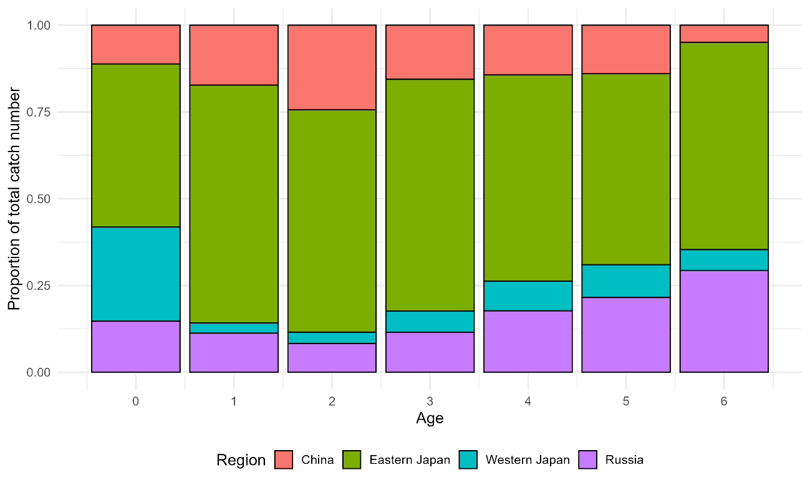

Figure 3. Proportion of catch number by each region for each age.

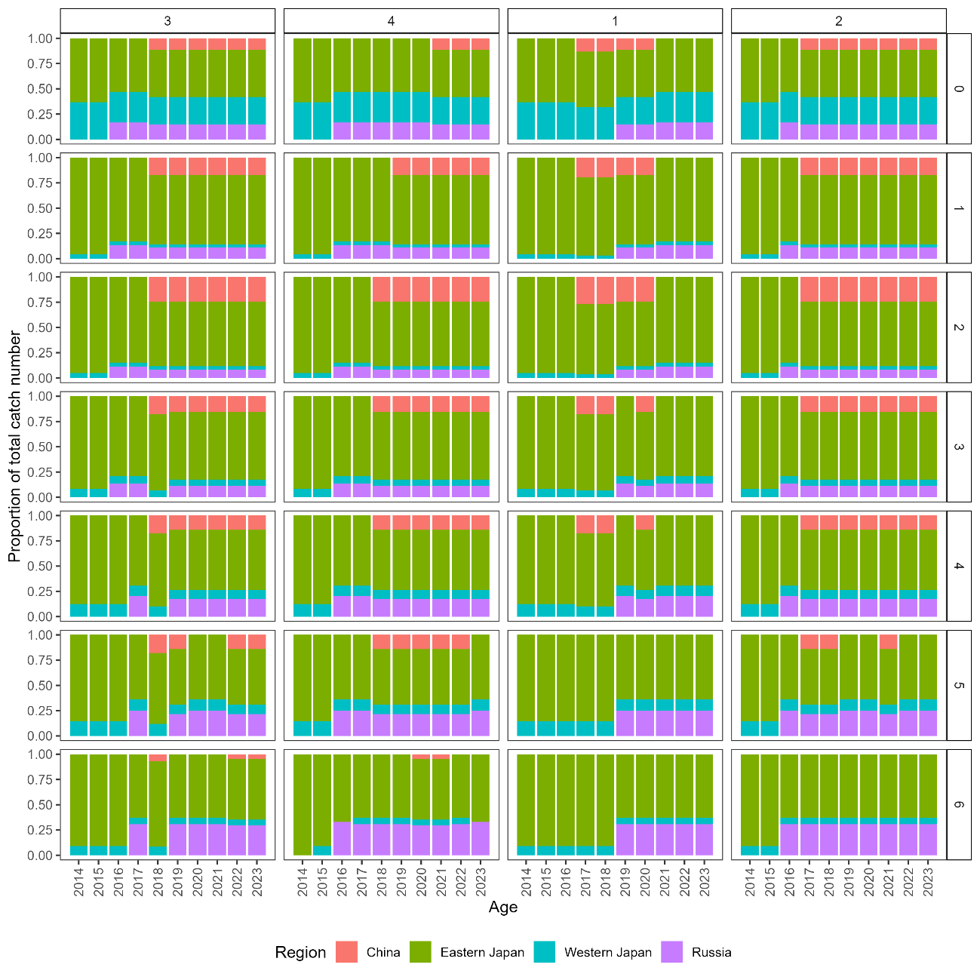

Figure 4. Recalculated proportion of catch at age.

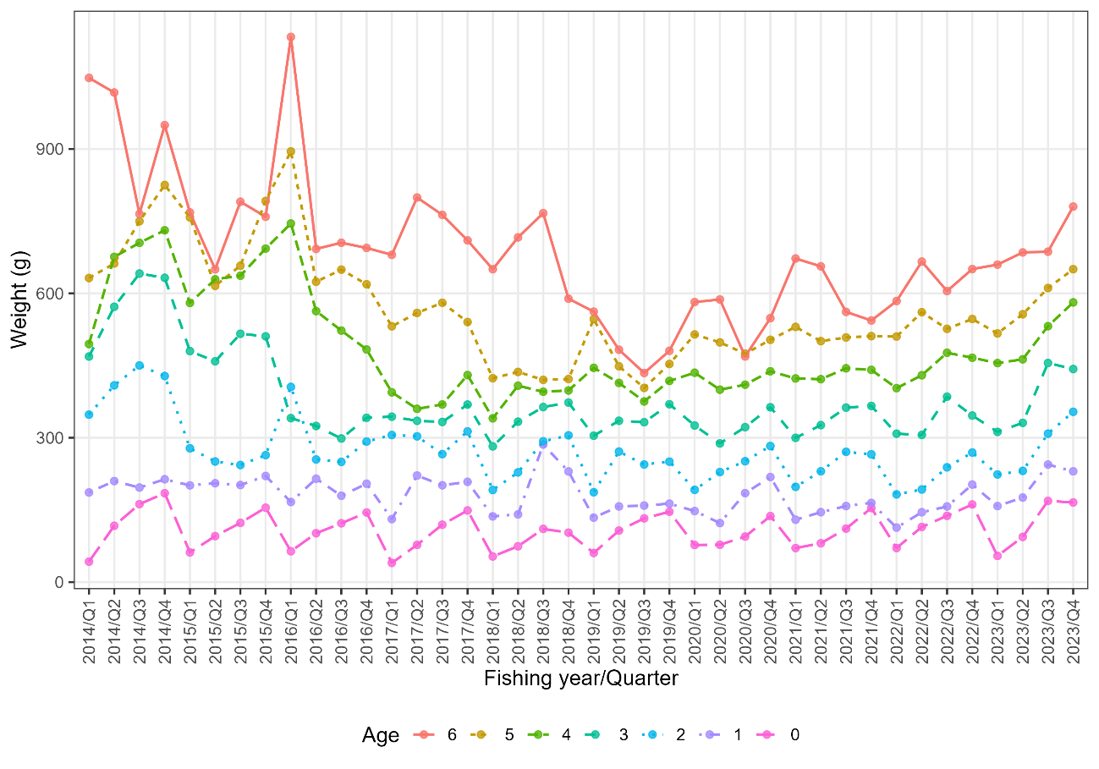

Figure 5. Quarterly weighted weight-at-age. Quarter is based on fishing year which Quarter 1, 2, 3, and 4 are April-June, July-September, October-December, and January-March, respectively.

グラフ, ヒストグラム

AI 生成コンテンツは誤りを含む可能性があります。

Figure 6. Weight-at-age of CM in the northwestern Pacific in FY1970-2023.

Table 4. Weight-at-age (g) of CM in the northwestern Pacific in FY1970 to FY2022.

|  |  |  |  |  |  |  |  |
| --- | --- | --- | --- | --- | --- | --- | --- |
| Fishing year | Age_0 | Age_1 | Age_2 | Age_3 | Age_4 | Age_5 | Age_6+ |
| 1970 | 75.6 | 188.3 | 288.2 | 403.7 | 531.6 | 654.7 | 731.0 |
| 1971 | 64.1 | 203.1 | 384.8 | 551.2 | 811.2 | 1065.8 | 1241.7 |
| 1972 | 77.8 | 225.9 | 338.7 | 459.4 | 591.8 | 736.9 | 843.2 |
| 1973 | 100.6 | 235.3 | 285.6 | 353.8 | 443.4 | 610.6 | 908.0 |
| 1974 | 70.7 | 236.0 | 330.0 | 389.5 | 483.7 | 698.5 | 946.5 |
| 1975 | 45.5 | 182.8 | 332.2 | 428.5 | 484.1 | 567.1 | 768.1 |
| 1976 | 75.9 | 153.6 | 289.7 | 452.7 | 529.7 | 682.5 | 917.4 |
| 1977 | 89.8 | 186.1 | 304.9 | 450.4 | 562.6 | 667.8 | 846.8 |
| 1978 | 96.8 | 260.9 | 307.9 | 397.5 | 514.9 | 600.5 | 893.4 |
| 1979 | 70.3 | 218.9 | 317.4 | 430.7 | 535.8 | 647.8 | 738.1 |
| 1980 | 61.8 | 163.6 | 332.0 | 447.8 | 544.3 | 674.8 | 953.9 |
| 1981 | 106.7 | 211.3 | 321.6 | 439.4 | 627.5 | 732.1 | 1067.3 |
| 1982 | 112.8 | 232.9 | 276.0 | 438.6 | 582.7 | 681.4 | 757.6 |
| 1983 | 77.2 | 199.9 | 307.0 | 401.7 | 475.1 | 576.4 | 645.5 |
| 1984 | 120.1 | 223.3 | 362.2 | 547.1 | 655.8 | 767.8 | 992.9 |
| 1985 | 81.5 | 241.1 | 375.9 | 488.5 | 740.8 | 854.7 | 942.9 |
| 1986 | 98.0 | 199.3 | 280.9 | 406.8 | 572.1 | 755.3 | 947.3 |
| 1987 | 85.8 | 243.7 | 335.8 | 446.4 | 643.7 | 837.5 | 1112.1 |
| 1988 | 168.4 | 254.6 | 341.2 | 439.6 | 653.7 | 885.6 | 1065.5 |
| 1989 | 207.3 | 325.2 | 425.5 | 536.9 | 598.6 | 813.8 | 1033.7 |
| 1990 | 169.6 | 365.2 | 581.6 | 660.9 | 827.6 | 954.4 | 1100.5 |
| 1991 | 169.3 | 305.2 | 488.1 | 584.6 | 654.1 | 789.9 | 956.9 |
| 1992 | 143.3 | 288.3 | 424.0 | 529.0 | 749.5 | 990.4 | 1114.4 |
| 1993 | 143.2 | 284.3 | 367.7 | 429.5 | 705.4 | 943.0 | 1115.2 |
| 1994 | 145.5 | 293.9 | 476.2 | 577.7 | 661.3 | 895.7 | 1116.0 |
| 1995 | 105.5 | 406.1 | 474.0 | 625.7 | 809.1 | 908.2 | 973.0 |
| 1996 | 118.0 | 260.3 | 450.9 | 544.9 | 632.9 | 742.8 | 818.5 |

Table 4. Continued.

|  |  |  |  |  |  |  |  |
| --- | --- | --- | --- | --- | --- | --- | --- |
| Fishing year | Age_0 | Age_1 | Age_2 | Age_3 | Age_4 | Age_5 | Age_6+ |
| 1997 | 152.0 | 287.4 | 428.3 | 535.2 | 642.0 | 699.2 | 840.2 |
| 1998 | 165.4 | 324.5 | 446.4 | 523.0 | 787.3 | 879.3 | 969.5 |
| 1999 | 168.9 | 307.9 | 514.9 | 606.2 | 802.7 | 949.6 | 1098.8 |
| 2000 | 157.8 | 365.6 | 420.9 | 517.1 | 592.8 | 894.6 | 1030.5 |
| 2001 | 136.9 | 350.1 | 440.4 | 599.1 | 625.5 | 688.5 | 1078.0 |
| 2002 | 112.7 | 354.0 | 454.6 | 576.3 | 643.3 | 779.7 | 1125.5 |
| 2003 | 123.9 | 235.9 | 374.2 | 529.7 | 755.9 | 787.6 | 1078.0 |
| 2004 | 131.8 | 280.2 | 568.6 | 742.1 | 835.4 | 1010.7 | 1086.7 |
| 2005 | 117.6 | 316.1 | 477.3 | 578.0 | 786.6 | 1002.2 | 1088.7 |
| 2006 | 135.9 | 361.5 | 527.5 | 630.7 | 726.2 | 1012.7 | 1121.8 |
| 2007 | 120.9 | 314.4 | 469.2 | 537.0 | 683.1 | 744.6 | 920.9 |
| 2008 | 138.5 | 312.2 | 384.9 | 589.4 | 671.8 | 805.8 | 995.2 |
| 2009 | 120.0 | 376.7 | 502.7 | 557.2 | 599.0 | 694.1 | 837.6 |
| 2010 | 125.6 | 350.6 | 490.1 | 605.8 | 728.7 | 795.6 | 939.8 |
| 2011 | 180.9 | 392.9 | 488.4 | 614.1 | 701.3 | 842.2 | 909.4 |
| 2012 | 155.6 | 373.2 | 479.6 | 550.3 | 627.5 | 750.9 | 868.4 |
| 2013 | 123.2 | 313.8 | 488.7 | 611.9 | 672.3 | 747.3 | 885.8 |
| 2014 | 126.6 | 201.6 | 408.8 | 578.6 | 651.6 | 717.2 | 944.9 |
| 2015 | 108.8 | 207.2 | 259.0 | 491.4 | 634.8 | 705.7 | 741.9 |
| 2016 | 108.2 | 191.3 | 300.6 | 326.3 | 578.6 | 696.8 | 806.2 |
| 2017 | 96.4 | 190.5 | 297.0 | 345.2 | 388.5 | 552.9 | 738.1 |
| 2018 | 85.3 | 198.3 | 254.2 | 338.1 | 385.6 | 425.7 | 680.5 |
| 2019 | 111.6 | 153.4 | 238.2 | 335.3 | 413.2 | 463.0 | 490.0 |
| 2020 | 96.7 | 168.4 | 238.6 | 324.8 | 420.8 | 497.7 | 546.6 |
| 2021 | 104.2 | 149.4 | 241.2 | 338.7 | 432.5 | 512.6 | 608.4 |
| 2022 | 121.2 | 154.6 | 220.7 | 336.5 | 443.9 | 536.0 | 626.3 |
| 2023 | 120.7 | 202.1 | 279.3 | 385.3 | 507.8 | 583.6 | 702.9 |

**Maturity-at-age**

Maturity-at-age is used to convert stock biomass into spawning stock biomass; hence it is an influential value that affects multiple outputs of stock assessment. The value represents the reproductive potential of each age. The TWG CMSA has agreed to use the annual maturity-at-age data from Japanese domestic stock assessment (NPFC, 2025), which FY1970-FY2022 are unchanged from the previous stock assessment conducted in TWG CMSA10 (Nishijima et al., 2024a). The maturity-at-age data is derived from the observation of catch from the spawning area, and based on previous studies (Watanabe and Yatsu, 2006; Watanabe, 2010). The recent maturity-at-age for age 2 and age 3 have declined since FY2015 and FY2016, respectively, possibly due to the impact of strong 2013-year-class. The newly introduced maturity-at-age for FY2023 remains the same value as FY2016-FY2022. The detailed maturity-at-age for FY1970-FY2023 are presented in Figure 7 and Table 5.

Chinese maturity-at-age data submitted on a calendar year basis were not included in the base-case maturity-at-age; however, the mean maturity-at-age between Chinese and Japanese data are agreed to use for the sensitivity scenarios. Due to lack of detailed data, calendar year is treated as similar as fishing year and mean maturity-at-age is calculated for FY2018-FY2023. The resulting figure and table are presented in Figure 8 and Table 6.

グラフ, 折れ線グラフ

AI 生成コンテンツは誤りを含む可能性があります。

Fig 7. Maturity-at-age of CM in the northwestern Pacific in FY1970-2023 (for the base case scenario).

グラフ, 折れ線グラフ

AI 生成コンテンツは誤りを含む可能性があります。

Fig 8. Comparison of maturity-at-age in FY2014-FY2023 for the base case and the sensitivity scenario.

Table 5. Maturity-at-age of CM in northwestern Pacific. The amount 1 represents 100% of the fish of the age is matured while 0 represents 0% of fish of the age is matured.

|  |  |  |  |  |  |  |  |
| --- | --- | --- | --- | --- | --- | --- | --- |
| Fishing year | Age_0 | Age_1 | Age_2 | Age_3 | Age_4 | Age_5 | Age_6+ |
| 1970 | 0 | 0 | 0.2 | 0.8 | 1 | 1 | 1 |
| 1971 | 0 | 0 | 0.2 | 0.8 | 1 | 1 | 1 |
| 1972 | 0 | 0 | 0.2 | 0.8 | 1 | 1 | 1 |
| 1973 | 0 | 0 | 0.2 | 0.8 | 1 | 1 | 1 |
| 1974 | 0 | 0 | 0.2 | 0.8 | 1 | 1 | 1 |
| 1975 | 0 | 0 | 0.2 | 0.8 | 1 | 1 | 1 |
| 1976 | 0 | 0 | 0.3 | 0.9 | 1 | 1 | 1 |
| 1977 | 0 | 0 | 0.3 | 0.9 | 1 | 1 | 1 |
| 1978 | 0 | 0 | 0.3 | 0.9 | 1 | 1 | 1 |
| 1979 | 0 | 0 | 0.3 | 0.9 | 1 | 1 | 1 |
| 1980 | 0 | 0 | 0.3 | 0.9 | 1 | 1 | 1 |
| 1981 | 0 | 0 | 0.3 | 0.9 | 1 | 1 | 1 |
| 1982 | 0 | 0 | 0.3 | 0.9 | 1 | 1 | 1 |
| 1983 | 0 | 0 | 0.3 | 0.9 | 1 | 1 | 1 |
| 1984 | 0 | 0 | 0.3 | 0.9 | 1 | 1 | 1 |
| 1985 | 0 | 0 | 0.3 | 0.9 | 1 | 1 | 1 |
| 1986 | 0 | 0 | 0.3 | 0.9 | 1 | 1 | 1 |
| 1987 | 0 | 0 | 0.4 | 1 | 1 | 1 | 1 |
| 1988 | 0 | 0 | 0.4 | 1 | 1 | 1 | 1 |
| 1989 | 0 | 0 | 0.4 | 1 | 1 | 1 | 1 |
| 1990 | 0 | 0 | 0.4 | 1 | 1 | 1 | 1 |
| 1991 | 0 | 0 | 0.4 | 1 | 1 | 1 | 1 |
| 1992 | 0 | 0 | 0.4 | 1 | 1 | 1 | 1 |
| 1993 | 0 | 0 | 0.4 | 1 | 1 | 1 | 1 |
| 1994 | 0 | 0 | 0.4 | 1 | 1 | 1 | 1 |
| 1995 | 0 | 0 | 0.4 | 1 | 1 | 1 | 1 |
| 1996 | 0 | 0 | 0.4 | 1 | 1 | 1 | 1 |
| 1997 | 0 | 0 | 0.4 | 1 | 1 | 1 | 1 |
| 1998 | 0 | 0 | 0.4 | 1 | 1 | 1 | 1 |
| 1999 | 0 | 0 | 0.4 | 1 | 1 | 1 | 1 |

Table 5. Continued.

|  |  |  |  |  |  |  |  |
| --- | --- | --- | --- | --- | --- | --- | --- |
| Fishing year | Age_0 | Age_1 | Age_2 | Age_3 | Age_4 | Age_5 | Age_6+ |
| 2000 | 0 | 0.05 | 0.8 | 1 | 1 | 1 | 1 |
| 2001 | 0 | 0.05 | 0.8 | 1 | 1 | 1 | 1 |
| 2002 | 0 | 0.05 | 0.8 | 1 | 1 | 1 | 1 |
| 2003 | 0 | 0.05 | 0.8 | 1 | 1 | 1 | 1 |
| 2004 | 0 | 0.05 | 0.8 | 1 | 1 | 1 | 1 |
| 2005 | 0 | 0 | 0.5 | 1 | 1 | 1 | 1 |
| 2006 | 0 | 0 | 0.5 | 1 | 1 | 1 | 1 |
| 2007 | 0 | 0 | 0.5 | 1 | 1 | 1 | 1 |
| 2008 | 0 | 0 | 0.5 | 1 | 1 | 1 | 1 |
| 2009 | 0 | 0 | 0.5 | 1 | 1 | 1 | 1 |
| 2010 | 0 | 0 | 0.5 | 1 | 1 | 1 | 1 |
| 2011 | 0 | 0 | 0.5 | 1 | 1 | 1 | 1 |
| 2012 | 0 | 0 | 0.5 | 1 | 1 | 1 | 1 |
| 2013 | 0 | 0 | 0.5 | 1 | 1 | 1 | 1 |
| 2014 | 0 | 0 | 0.5 | 1 | 1 | 1 | 1 |
| 2015 | 0 | 0 | 0 | 1 | 1 | 1 | 1 |
| 2016 | 0 | 0 | 0 | 0.3 | 1 | 1 | 1 |
| 2017 | 0 | 0 | 0 | 0.3 | 1 | 1 | 1 |
| 2018 | 0 | 0 | 0 | 0.3 | 1 | 1 | 1 |
| 2019 | 0 | 0 | 0 | 0.3 | 1 | 1 | 1 |
| 2020 | 0 | 0 | 0 | 0.3 | 1 | 1 | 1 |
| 2021 | 0 | 0 | 0 | 0.3 | 1 | 1 | 1 |
| 2022 | 0 | 0 | 0 | 0.3 | 1 | 1 | 1 |
| 2023 | 0 | 0 | 0 | 0.3 | 1 | 1 | 1 |

Table 6. Mean maturity at age for the sensitivity scenarios in which maturity-at-age is based on Chinese and Japanese maturity at age data.

|  |  |  |  |  |  |  |  |  |
| --- | --- | --- | --- | --- | --- | --- | --- | --- |
| Fishing year | Scenario | Age_0 | Age_1 | Age_2 | Age_3 | Age_4 | Age_5 | Age_6+ |
| 2018 | Sensitivity | 0 | 0 | 0 | 0.225 | 1 | 1 | 1 |
| 2019 | Sensitivity | 0 | 0 | 0 | 0.25 | 1 | 1 | 1 |
| 2020 | Sensitivity | 0 | 0 | 0 | 0.225 | 1 | 1 | 1 |
| 2021 | Sensitivity | 0 | 0 | 0 | 0.25 | 1 | 1 | 1 |
| 2022 | Sensitivity | 0 | 0 | 0.005 | 0.3 | 1 | 1 | 1 |
| 2023 | Sensitivity | 0 | 0 | 0 | 0.25 | 1 | 1 | 1 |

**Natural mortality**

In TWG CMSA10, the TWG CMSA has agreed to use the age-specific natural mortality at age calculated by natural mortality estimator using parameters from different areas (Convention area and Japanese EEZ; Ma et al. (2024), Nishijima et al (2024b). The estimated M at age is presented in Table 7. It is assumed that the natural M at age is time-invariant throughout all years.

Table 7. Natural mortality at age for base case.

|  |  |  |  |  |  |  |  |
| --- | --- | --- | --- | --- | --- | --- | --- |
| Age | Age_0 | Age_1 | Age_2 | Age_3 | Age_4 | Age-5 | Age_6+ |
| M | 0.80 | 0.60 | 0.51 | 0.46 | 0.43 | 0.41 | 0.40 |

**Abundance Indices**

In TWG CMSA10, a total of seven abundance indices were standardized and finalized (Chernienko and Chernienko, 2025; Higashiguchi et al., 2025; Nishijima et al., 2025a, b, c; Shi, et al., 2025). The indices are 1) CPUE of age-0 fish from Japanese summer survey for age-0 index, 2) CPUE of age-0 fish from Japanese autumn survey for age-0 index, 3) CPUE of age-1 fish from Japanese autumn survey for age-1 index, 4) Abundance of eggs from Japanese egg survey for SSB index, 5) CPUE of Japanese dip-net fishery for SSB index, 6) Chinese purse seine CPUE for abundance index for exploitable biomass of Chinese fleet, and 7) Russian trawl survey for index abundance index for exploitable biomass of Russian fleet (Fig 9, Table 8).

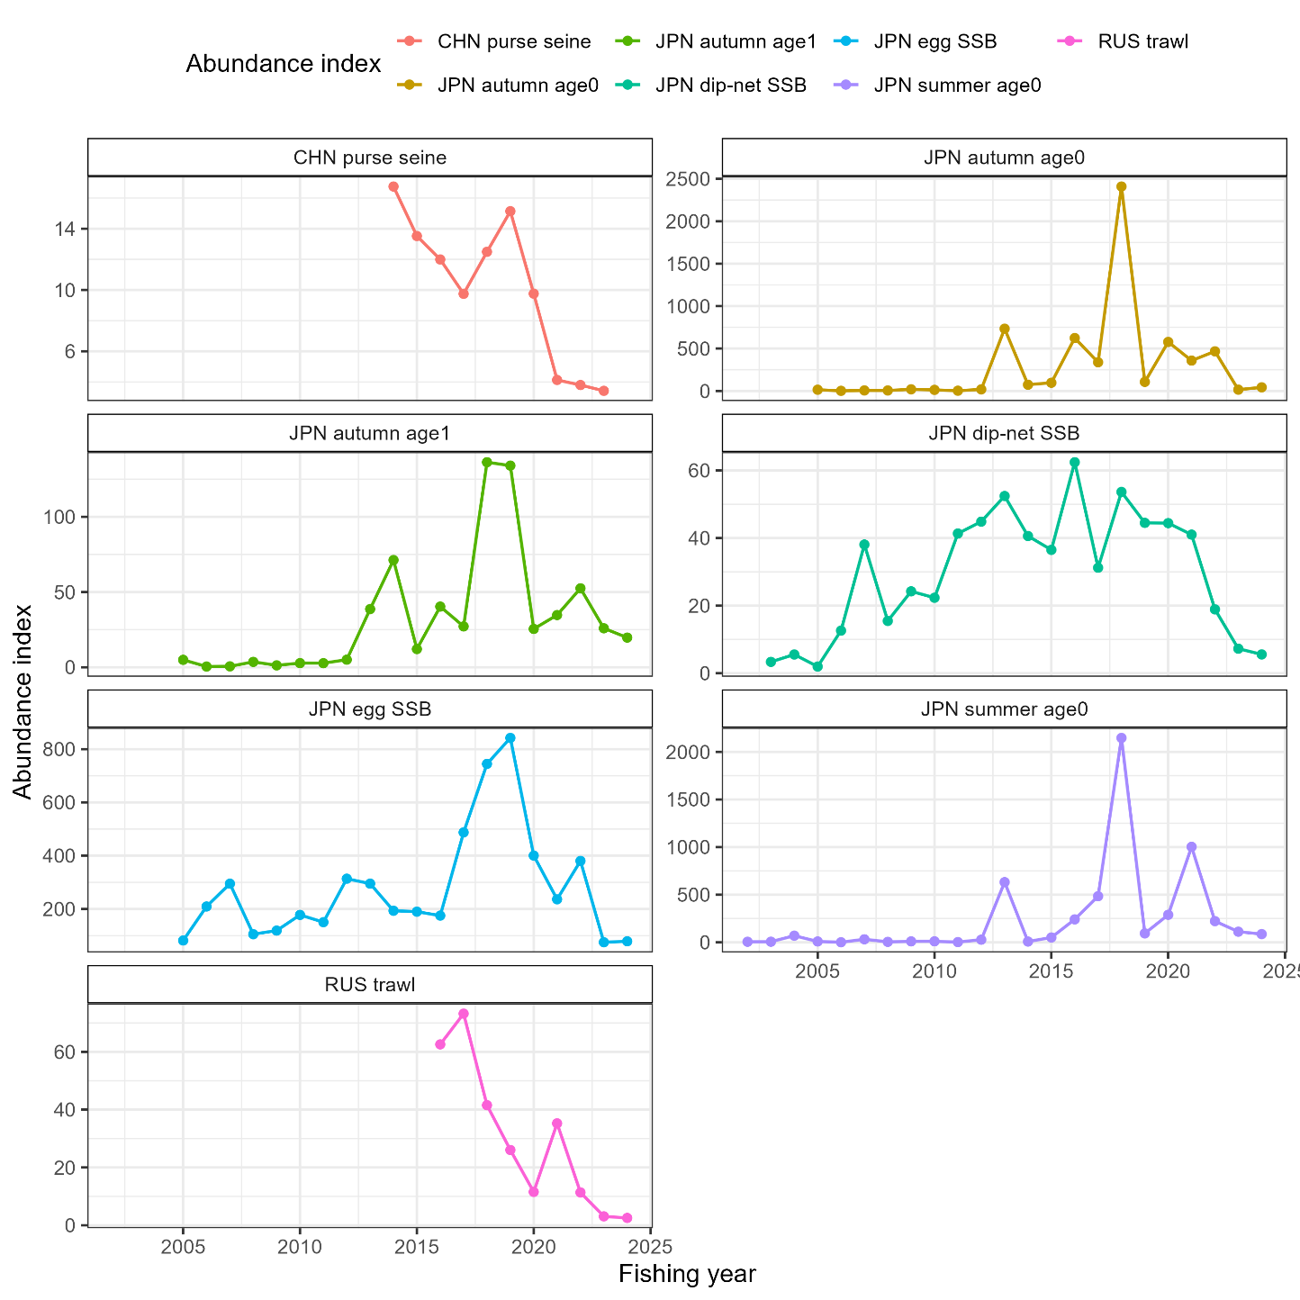

Figure 9. Standardized abundance indices of chub mackerel in the Northwest Pacific Ocean.

Table 8. Standardized abundance indices of chub mackerel in the Northwest Pacific Ocean

|  |  |  |  |  |  |  |  |  |  |  |
| --- | --- | --- | --- | --- | --- | --- | --- | --- | --- | --- |
| Index type | CHN Purse seine | |  | JPN Summer survey | |  | JPN Autumn survey | | | |
| Index target | CHN exploitable biomass | |  | Age 0 | |  | Age 0 | | Age 1 | |
| Fishing Year | Value | CV |  | Value | CV |  | Value | CV | Value | CV |
| 2002 |  |  |  | 5.49 | 0.27 |  |  |  |  |  |
| 2003 |  |  |  | 5.93 | 0.29 |  |  |  |  |  |
| 2004 |  |  |  | 69.13 | 0.39 |  |  |  |  |  |
| 2005 |  |  |  | 8.53 | 0.28 |  | 14.38 | 0.6 | 4.91 | 0.75 |
| 2006 |  |  |  | 0.19 | 0.5 |  | 1.05 | 0.93 | 0.46 | 1.61 |
| 2007 |  |  |  | 31.4 | 0.26 |  | 5.96 | 0.59 | 0.59 | 1.65 |
| 2008 |  |  |  | 4.48 | 0.32 |  | 5.44 | 0.69 | 3.57 | 0.76 |
| 2009 |  |  |  | 9.31 | 0.24 |  | 18.98 | 0.41 | 1.25 | 0.92 |
| 2010 |  |  |  | 9.92 | 0.25 |  | 12.38 | 0.47 | 2.74 | 0.81 |
| 2011 |  |  |  | 1.97 | 0.29 |  | 2.55 | 0.67 | 2.7 | 0.77 |
| 2012 |  |  |  | 26.78 | 0.24 |  | 18.39 | 0.53 | 5.02 | 0.87 |
| 2013 |  |  |  | 631.49 | 0.28 |  | 733.51 | 0.42 | 38.66 | 0.5 |
| 2014 | 16.75 | 3.57 |  | 7.5 | 0.4 |  | 73.51 | 0.46 | 71.26 | 0.48 |
| 2015 | 13.52 | 2.81 |  | 50.23 | 0.23 |  | 96.33 | 0.49 | 12.07 | 0.72 |
| 2016 | 11.99 | 4.35 |  | 240.65 | 0.25 |  | 623.49 | 0.57 | 40.33 | 0.59 |
| 2017 | 9.75 | 2.65 |  | 483.91 | 0.22 |  | 337.98 | 0.57 | 27.14 | 0.56 |
| 2018 | 12.49 | 1.61 |  | 2146.3 | 0.24 |  | 2409.61 | 0.44 | 136.28 | 0.4 |
| 2019 | 15.14 | 1.53 |  | 93.35 | 0.23 |  | 106.51 | 0.54 | 134.02 | 0.66 |
| 2020 | 9.76 | 2.06 |  | 288.37 | 0.26 |  | 577.59 | 0.43 | 25.47 | 0.6 |
| 2021 | 4.13 | 2.01 |  | 1002.57 | 0.17 |  | 357.51 | 0.4 | 34.7 | 0.51 |
| 2022 | 3.8 | 2.65 |  | 221.93 | 0.18 |  | 466.89 | 0.45 | 52.45 | 0.5 |
| 2023 | 3.42 | 2.31 |  | 111.15 | 0.26 |  | 14.94 | 0.82 | 25.9 | 0.65 |
| 2024 |  |  |  | 85.78 | 0.24 |  | 42.51 | 0.68 | 19.7 | 0.73 |

Table 8. Continued.

|  |  |  |  |  |  |  |  |  |
| --- | --- | --- | --- | --- | --- | --- | --- | --- |
| Index type | JPN Egg survey | |  | JPN Dip net survey | |  | RUS Trawl | |
| Index target | SSB | |  | SSB | |  | RUS exploitable biomass | |
| Fishing Year | Value | CV |  | Value | CV |  | Value | CV |
| 2003 |  |  |  | 3.34 | 0.22 |  |  |  |
| 2004 |  |  |  | 5.53 | 0.2 |  |  |  |
| 2005 | 81.76 | 0.27 |  | 1.96 | 0.26 |  |  |  |
| 2006 | 209.45 | 0.18 |  | 12.6 | 0.22 |  |  |  |
| 2007 | 295.04 | 0.2 |  | 38.08 | 0.12 |  |  |  |
| 2008 | 105.4 | 0.23 |  | 15.47 | 0.14 |  |  |  |
| 2009 | 119 | 0.2 |  | 24.23 | 0.15 |  |  |  |
| 2010 | 177.81 | 0.22 |  | 22.33 | 0.15 |  |  |  |
| 2011 | 150.51 | 0.18 |  | 41.35 | 0.15 |  |  |  |
| 2012 | 313.65 | 0.19 |  | 44.87 | 0.16 |  |  |  |
| 2013 | 295.22 | 0.18 |  | 52.45 | 0.28 |  |  |  |
| 2014 | 193.45 | 0.19 |  | 40.61 | 0.16 |  |  |  |
| 2015 | 189.98 | 0.2 |  | 36.51 | 0.17 |  |  |  |
| 2016 | 175.24 | 0.22 |  | 62.46 | 0.15 |  | 62.59 | 0.017 |
| 2017 | 487.47 | 0.18 |  | 31.22 | 0.17 |  | 73.23 | 0.014 |
| 2018 | 744.6 | 0.18 |  | 53.66 | 0.16 |  | 41.55 | 0.025 |
| 2019 | 842.02 | 0.15 |  | 44.5 | 0.13 |  | 26.05 | 0.04 |
| 2020 | 400.47 | 0.17 |  | 44.43 | 0.14 |  | 11.54 | 0.09 |
| 2021 | 236.47 | 0.21 |  | 41.02 | 0.16 |  | 35.26 | 0.03 |
| 2022 | 380.47 | 0.22 |  | 18.9 | 0.18 |  | 11.35 | 0.093 |
| 2023 | 75.23 | 0.22 |  | 7.25 | 0.19 |  | 3.08 | 0.342 |
| 2024 | 78.83 | 0.23 |  | 5.55 | 0.21 |  | 2.53 | 0.419 |

**Reference**

Antonenko, D. (2025) Chub mackerel Russian fishery in the northwest Pacific Ocean Pacific Ocean, research activities in 2024. NPFC-2025-TWG CMSA10-IP02.

Chernienko, E., Chernienko, I. (2021) Catch and weight at age of chub mackerel in Russia. NPFC-2021-TWG CMSA04-WP11. pp1-7.

Chernienko, I., and Chernienko, E. (2025) Standardized CPUE of Russian commercial trawl fishery of chub mackerel in the Northwest Pacific up to 2024. NPFC-2025-TWG CMSA11-WP05

Higashiguchi, K., Nishijima, S., Ichinokawa, M., Yukami, R. (2025) Standardized Abundance Indices for Ages 0 and 1 Fish of Chub Mackerel from Northwest Pacific Autumn Surveys up to 2024. NPFC-2025-TWG CMSA10-WP05

Kamimura, Y., Taga, M., Yukami, R., Watanabe, C., and Furuichi, S. (2021) Intra- and inter-specific density dependence of body condition, growth, and habitat temperature in chub mackerel (*Scomber japonicus*). ICES J. Mar. Sci. 78:9, pp3254-3264. https://doi.org/10.1093/icesjms/fsab191

Ma, Q., Liu, Z., Zhang, H., Tian, S. (2024) Growth and mortality estimation for chub mackerel based on Chinese data in the Convention Area of NPFC. NPFC-2024-TWG CMSA08-WP12.

Manabe, A., Yukami, R., Ichinokawa, M., Zheng, H., Chernienko, E., and Chernienko, I. (2024) Catch at length, age length key, and catch at age of chub mackerels *Scomber japonicus* caught in the northwestern Pacific Ocean by China, Japan, and Russia. NPFC-2024-TWG CMSA08-WP15.

Manabe, A., Higashiguchi, K., and Yukami, R. (2025) The estimation method and data on catch, weight, and maturity at age of the chub mackerel caught by Japan up to CY2024Q2. NPFC-2025-TWG CMSA10-WP03.

Manabe, A., Yukami, R., and Isu, S. (2025) Updated Maturity ag ate from Japan. NPFC-2025-TWG CMSA10-IP05.

Manabe, A., Yukami, R., Zhang, H., and Chernienko, I. (2025) Details and resolution on the discrepancy of annual footprint and sum of product of catch at age and weight at age from China, Japan, and Russia. NPFC-2025-TWG CMSA11 WP04.

Nishijima, S., Ichinokawa, M., Manabe, A., Oshima, K., and Rice, J. (2024) Base case stock assessment for chub mackerel in Northwest Pacific Ocean in 2024. NPFC-2024-TWG CMSA09-WP03 (Rev. 1).

Nishijima, S., Kamimura, Y., Yukami, R., Manabe, A., Oshima, K., and Ichinokawa, M. (2024) Update on natural mortality estimator for chub mackerel in the Northwest Pacific Ocean. NPFC-2024-TWG CMSA08-IP06.

Nishijima, S., Yukami, R., Ichinokawa, M. (2025) Standardized CPUE of Japanese commercial dip-net fishery targeting spawners of chub mackerel in the Northwest Pacific up to 2024. NPFC-2025-TWG CMSA10-WP06.

Nishijima, S., Ichinokawa, M., Yukami, R. (2025) Standardizing monthly egg survey data as an abundance index for spawning stock biomass of chub mackerel in the Northwest Pacific. NPFC-2025-TWG CMSA10-WP07 (Rev. 1).

Nishijima, S., Higashiguchi, K., Kamimura, Y., Ichinokawa, M., and Yukami, R. (2025) Standardized abundance index for recruitment of chub mackerel from Northwest Pacific summer survey up to 2024. NPFC-2025-TWG CMSA10-WP08.

NPFC (2022) Content of the document for data description in China. NPFC-2022-TWG CMSA 05-IP4. pp1-10.

NPFC (2024) North Pacific Fisheries Commission 8th Meeting of the Technical Working Group on Chub mackerel Stock Assessment. NPFC-2024-TWG CMSA08-Final Report. pp32. (Available at https://www.npfc.int/meetings/8th-scientific-committee-meeting, last accessed 2025-06-12)

NPFC (2024) North Pacific Fisheries Commission Science Committee 9th Meeting Report. NPFC-2024-SC09-Final Report. 405 pp. (Available at https://www.npfc.int/meetings/9th-scientific-committee-meeting, last accessed 2025-03-01)

NPFC (2025) North Pacific Fisheries Commission 10th Meeting of the Technical Working Group on Chub mackerel Stock Assessment. NPFC-2025-TWG CMSA10-Final Report. pp30. (Available at https://www.npfc.int/meetings/10th-twg-cmsa-meeting, last accessed 2025-06-12)

Shi, Y., Zhang, H., and Han, H. (2025) Standardized CPUE of Chub mackerel (Scomber japonicas) caught by the China’s lighting purse seine fishery up to 2023. NPFC-2025-TWG CMSA10-WP09.

Watanabe C. and Yatsu, A. (2006) Long-term changes in maturity at age of chub mackerel (*Scomber japonicus*) in relation to population declines in the waters off northeastern Japan. Fisheries Research, 78:2-3, pp323-332. https://doi.org/10.1016/j.fishres.2006.01.001

Watanabe C. (2010) Changes in the reproductive traits of the Pacific stock of chub mackerel *Scomber japonicus* and their effects on the population dynamics. Bulletin of the Japanese Society of Fisheries Oceanography, 74, pp46–50.

Yukami, R., Nishijima, S., Kamimura, Y., Isu, S., Furuichi, S., Watanabe, R. et al. (2025) Stock assessment and evaluation for　the Pacific stock of chub mackerel (Fiscal year 2024). Marine fisheries stock assessment and evaluation for Japanese waters. Japan Fisheries Agency and Japan Fisheries Research and Education Agency, Tokyo, pp96. FRA-SA2025-AC005. https://abchan.fra.go.jp/wpt/wp-content/uploads/2025/03/details_2024_05.pdf (last accessed 2025-06-12, in Japanese).

Zhang, H. (2025) Review of chub mackerel fishery in China and research activities. NPFC-2025-TWG CMSA10-IP03.