NPFC-2025-TWG CMSA11-WP05

**Standardized CPUE of Russian commercial trawl fishery of chub mackerel in the Northwest Pacific up to 2024**

*Igor CHERNIENKO, Emilia CHERNIENKO*

The Pacific Branch of Russian Research Institute of Fisheries and Oceanography (TINRO)

(corresponding author: Igor CHERNIENKO, igor_chernienko@tinro.vniro.ru)

**Summary**

We estimated index of abundance based on catches per vessel-day derived from commercial trawl catches, which can serve as an indicator of exploitable biomass (EB) for the Pacific mackerel population. Generalized additive models (GAMs) were applied to commercial trawl catch data for the period from 2016 to 2024 in the Russian EEZ covering the main mackerel feeding areas. This document contains key background material and diagnostic results of this standardization in accordance with the "CPUE Standardization Protocol for Mackerel".

The standardized catch per unit effort (CPUE) index reached its maximum value in 2017, but since then there has been a steady negative trend, with 2023 and 2024 recording the lowest values since 2016. As no significant weaknesses were identified during the GAM diagnostic, it is proposed that the calculated index be used as a exploitable biomass indicator for the upcoming stock status assessment of mackerel in the Working Group on Stock Assessment of this species.

This approach integrates the spatial and temporal characteristics of fisheries in the Russian EEZ, providing a sound basis for resource management in the face of changing fishing pressure and environmental factors.

**1. Background of the Chub mackerel fishery**

Russian fishermen discovered mackerel in the Far East in the early 1960s and harvested it until the late 1980s, when its stocks in the areas accessible to the domestic fleet were completely depleted (Baryshko, 2009). During 26 years of mackerel fishing, during 13 years it was harvested more than 50 thousand tons per year, including 9 years when the catch was more than 100 thousand tons. In fact, commercial fishing of mackerel in the North-West Pacific Ocean by Russian (Soviet) flagged vessels started in 1968. Since the second half of the 1980s, due to a sharp decline in mackerel abundance, its commercial aggregations in the Russian EEZ have not been formed. Until recently there was no targeted mackerel fishery by Russia in the north-west Pacific (NWP). Russian fisheries resumed fishing in 2015. In recent years there has been a consistent decline in Russian catches. While in 2018 the Russian catch was 98,812 tons, in 2024 was 7200 tons.

In all distribution areas, the chub mackerel is characterized by long migrations, allowing each population to develop a wide range in different seasons of the year, using favorable areas (primarily foraging areas) (Belyaev, 1979; Pozdnyakov, Vasilenko, 1994).

The annual biological cycle of NWP mackerel can be divided into the following main stages. Spawning begins after the end of the wintering period in areas where water surface temperature exceeds 15°C. Mackerel mature earlier and start spawning earlier in the southern part of their distribution area, which is due to higher temperatures during wintering and spawning in the south. The wintering period is longer in the north than in the south, and the spawning period, on the contrary, lasts longer in the south than in the north. The final maturation of spawners takes place directly in the wintering and spawning areas, but they arrive there at a certain stage of readiness for spawning, after they have finished feeding and reached a high degree of fatness. A significant proportion of immature juveniles winter in the open ocean (Vasilenko, 1990). Thus, temperature is the most important factor affecting CPUE. Specific catches are also dependent on production factors such as vessel type, period in the fishery, etc. (Chernienko, Chernienko, 2022).

**2. Method**

**2.1 The data**

This paper uses trawl catch data from Russian vessels for the period from 2016 to 2024, during the autumn period when mackerel feeding migrations take place in Russian national waters (Fig. 1-3).

Statistics of trawl fisheries for 2015-2024 within the Russian EEZ were used, based on vessel daily reports and vessel positions from the Russian Federal Agency for Fishery Industry Monitoring System (Pyrkov, 2015). Vessel characteristics were taken from the same source: vessel type, vessel length, engine power. CPUE was defined as catch per day per vessel; daily effort, which is defined as the number of fishing vessels, was also used. Only target fisheries (more than 50% of mackerel in the catch) and multi-depth trawls were selected as the most frequently used fisheries. The fishing period is September-December (see Figure 2). Depth data were obtained from the GEBCO Web Map Service (WMS) General Bathymetric Chart of the Oceans (Becker et al., 2009). SST data were obtained from the GHRSST multi-product SST ensemble (GMPE) (Chin et al., 2017). The spatial and temporal resolution of the SST data is daily 0.01°×0.01°.

The following variables were used: Year, Vessel type, Longitude, Latitude, Day of year, Daily fishing effort, Vessels length, Engine power, Sea surface temperature. We also performed cyclic transformation of dates. The designations and descriptions of the variables are given in Tab. 3. Fig. 4 shows the distribution of variables by year, Fig. 5 shows the correlation matrix.

**2.2 Full model description and model selection**

Generalized additive models (GAM) were used to standardize CPUE (Wood, 2003, 2011). Models with different numbers and combinations of factors were used.

| $$lnCPUE=β_{0}+β^{Y_{i}}$$ | (1) |
| --- | --- |
| $$lnCPUE=β_{0}+s\left(SST\right)+β^{Y_{i}}$$ | (2) |
| $$lnCPUE=β_{0}+te\left(x,y\right)+s\left(P_{V}\right)+s\left(SST\right)+β^{Y_{i}}$$ | (3) |
| $$lnCPUE=β_{0}+te\left(x,y\right)+s\left(L_{V}\right)+s\left(SST\right)+β^{Y_{i}}$$ | (4) |
| $$lnCPUE=β_{0}+te\left(x,y\right)+s_{4}\left(d_{Y}\right)+s\left(L_{V}\right)+s\left(SST\right)+β^{Y_{i}}$$ | (5) |
| $$lnCPUE=β_{0}+te\left(x,y\right)+s\left(d_{Y}\right)+s\left(P_{V}\right)+s\left(SST\right)+β^{Y_{i}}$$ | (6) |
| $$lnCPUE=β_{0}+te\left(x,y\right)+s\left(d_{sin}\right)+s\left(d_{cos}\right)+s\left(P_{V}\right)+s\left(SST\right)+β^{Y_{i}}$$ | (7) |
| $$lnCPUE=β_{0}+te\left(x,y\right)+s\left(d_{sin}\right)+s\left(d_{cos}\right)+s\left(L_{V}\right)+s\left(SST\right)+β^{Y_{i}}$$ | (8) |

where *β0* is the intercept, *te* is the tensor product of the coordinates, *s is* the thin plate regression spline spline functions (TPRS, Wood, 2003) estimated using generalized cross-validation (Wood, 2003, 2011), is the coefficient for the year factor.

The optimal model was selected using An Information Criterion (AIC), Schwarz's Bayesian criterion (BIC) and explained variance.

**2.3 Yearly trend extraction**

The time series of standardized CPUE was estimated using the best performing model. Median values of factors were substituted into the model. Standard deviations were derived from the model parameters.

**3 Result and Discussion**

In this study, we used several models to standardize CPUE. The results of selecting the best models are shown in Tab. 4. A summary of the GAM fit for the optimal model is shown in Tab 5-6. All explanatory variables are highly significant (p < 0.01). The residuals of the best GAM model are shown in Fig. 6. The estimated relationship between response and explanatory variables is shown in Fig 7. Table 7 and Fig. 8 show the annual changes in nominal CPUE and standardized CPUE under the best GAM model. There is a similar trend between nominal CPUE and standardized CPUE by GAM. The discrepancies on the left-hand side appear to be largely explained by the change in vessel characteristics. In conclusion, we prefer to choose the best GAM model to estimate the standardized CPUE of mackerel.

We standardized CPUE according to the standardization protocol. The checklist is shown in Appendix 1.

**References**

2009. Global Bathymetry and Elevation Data at 30 Arc Seconds Resolution: SRTM30_PLUS. Marine Geodesy 32:355-371. https://doi.org/10.1080/01490410903297766.

Baryshko M.E. 2009. Fisheries of mackerel and sardine-Ivasi in the Far East. Vladivostok DGTRU. 472 с.

Becker, J.J., Sandwell, D.T., Smith, W.H.F., Braud, J., Binder, B., Depner, J., Fabre, D., Factor, J., Ingalls, S., Kim, S.-H., Ladner, R., Marks, K., Nelson, S., Pharaoh, A., Trimmer, R., Von Rosenberg, J., Wallace, G., and Weatherall, P.

Belyaev V.A. 1979. On the population structure of Japanese mackerel in the North-West Pacific Ocean // Status of stocks and population dynamics of pelagic fishes of the World Ocean. Kaliningrad. AtlantNIRO. С. 13-14.

Burnham, K.P., and Anderson, D.R.. 2002. Model selection and multimodel inference: a practical information-theoretic approach. Springer, New York, NY., 2. ed., [4. printing}.

Chin, T.M., Vazquez-Cuervo, J., and Armstrong, E.M. 2017. A multi-scale high-resolution analysis of global sea surface temperature. Remote Sensing of Environment 200:154-169. https://doi.org/10.1016/j.rse.2017.07.029. <https://doi.org/10.1016/j.rse.2017.07.029>.

GEBCO Web Map Service (WMS) GEBCO. https://www.gebco.net/data_and_products/gebco_web_services/web_map_service/

Pozdnyakov S.E., Vasilenko A.V. 1994. Distribution, migration routes and helminth fauna of the Japorn mackerel Scomber japonicus in the north-western part of the Pacific Ocean // Vopr. ichthyol. Т. 34. №1, С. 22-34.

Pyrkov V.N., Solodilov A.V., Degaj A.Yu. Sozdanie i vnedrenie novyh sputnikovyh tekhnologij v sisteme monitoringa rybolovstva // Sovremennye problemy distancionnogo zondirovaniya Zemli iz kosmosa. - 2015. - T. 12, No 5. - S. 251-262.

R Core Team

2021. R: A Language and Environment for Statistical Computing. R Foundation for Statistical Computing, Vienna, Austria. URL https://www.R-project.org/.

Vasilenko A.V. Intraspecific structure and commercial value of Japanese mackerel populations. 1990. Avtoref. diss.... candidate of biological sciences. Vladivostok, 24 p.

Wickham, H. 2016. ggplot2: Elegant Graphics for Data Analysis. Springer International Publishing : Imprint: Springer, Cham., 2nd ed. 2016. https://doi.org/10.1007/978-3-319-24277-4.

Wood, S.N.. 2003. Thin plate regression splines. Journal of the Royal Statistical Society: Series B (Statistical Methodology) 65:95-114. https://doi.org/10.1111/1467-9868.00374. https://doi.org/10.1111/1467-9868.00374.

Wood, S.N.. 2011. Fast stable restricted maximum likelihood and marginal likelihood estimation of semiparametric generalised linear models: Estimation of Semiparametric Generalised Linear Models. Journal of the Royal Statistical Society: Series B (Statistical Methodology) 73:3-36.

Wood, S.N.. 2017. Generalised Additive Models: An Introduction with R. Chapman and Hall/CRC. 2nd ed. https://doi.org/10.1201/9781315370279.

Tables

Table 1. Catch and effort information by CPUE FLEET

|  |  |  |  |  |
| --- | --- | --- | --- | --- |
| Year | Number of observations | % Coverage of CPUE FLEET(catch ) | % Coverage of CPUE  FLEET(effort ) | Total Catch of CPUE FLEET |
| 2016 | 455 | 100 | 100 | 7804,334 |
| 2017 | 678 | 100 | 100 | 26543,517 |
| 2018 | 1440 | 100 | 100 | 65766,563 |
| 2019 | 1414 | 100 | 100 | 34962,2965 |
| 2020 | 2123 | 100 | 100 | 29831,8582 |
| 2021 | 1816 | 100 | 100 | 40140,31986 |
| 2022 | 1244 | 100 | 100 | 10132,354 |
| 2023 | 1314 | 100 | 100 | 8534,2138 |
| 2024 | 891 | 100 | 100 | 3921,73092 |

Table 2. Filter "Rules" used on data for CPUE standardization and the effect on the overall sample size.

|  |  |  |  |
| --- | --- | --- | --- |
| Filter Applied | Number of Records  Remaining | Number Removed | Number of Records with Chub  Mackerel Catch >0 |
| Initial Data set | 11375 |  | 11336 |
| sst between 5 and 20 | 11338 | 37 | 11329 |

Table 3. Summary of explanatory variables.

|  |  |  |  |
| --- | --- | --- | --- |
| Variable | Notation | Units | Details |
| Year | $$β_{i}^{Y}$$ | categorical | 9 years from 2016 to 2024 |
| Longitude | *x* | decimal degrees |  |
| Latitude | *y* | decimal degrees |  |
| Part of the year | *dY* | unitless | *d*/*NY*, Serial day of year (*d*), derived on 365 or 366 (*NY*), [0,1] |
| Cyclical component of the date | *dsin* | unitless | $sin\frac{2πd}{N_{y}}$, [-1,1] |
| *dcos* | unitless | $cos\frac{2πd}{N_{y}}$, [-1,1] |
| Vessels length | *LV* | meters | Vessel length |
| Engine power | *PV* | kWt | Vessel engine power |
| Sea surface temperature | *SST* | celsium degres | Sea surface temperature at vessel position |

Table 4. Result of model selection

|  |  |  |  |
| --- | --- | --- | --- |
| Model | AIC | BIC | Explaned variation |
| 1 | 80537,67 | 80618,36 | 15,8% |
| 2 | 80197,24 | 80299,61 | 17,7% |
| 3 | 75514,63 | 75761,23 | 41,2% |
| 4 | 76939,49 | 77184,46 | 34,8% |
| 5 | 75882,10 | 76139,85 | 39,6% |
| 6 | 74615,07 | 74890,68 | 45,1% |
| 7 | 74603,10 | 74879,21 | 45,2% |
| 8 | 75870,91 | 76136,24 | 39,7% |

Table 5. ANOVA test for best GAM model Parametric

|  |  |  |  |  |  |
| --- | --- | --- | --- | --- | --- |
| Explane | Df | Sum Sq | Mean Sq | F | p |
| $$β_{i}^{Y}$$ | 8 | 1906374 | 238297 | 182,879 | 0,0000 |
| *x* | 1 | 5688 | 5688 | 4,365 | 0,0367 |
| *y* | 1 | 669298 | 669298 | 513,646 | 0,0000 |
| *dsin* | 1 | 436510 | 436510 | 334,996 | 0,0000 |
| *dcos* | 1 | 367891 | 367891 | 282,335 | 0,0000 |
| *PV* | 1 | 1468910 | 1468910 | 1127,302 | 0,0000 |
| *SST* | 1 | 6086 | 6086 | 4,671 | 0,0307 |
| Residuals | 11323 | 14754226 | 1303 |  |  |

Approximate significance of smooth terms:

|  |  |  |  |  |
| --- | --- | --- | --- | --- |
|  | edf | Ref.df | *F* | *p* |
| *te(x,y)* | 17,36 | 18,67 | 53,05 | 0 |
| *s(dsin)* | 1,00 | 1,00 | 85,90 | 0 |
| *s(dcos)* | 1,99 | 2,00 | 281,22 | 0 |
| *s(PV)* | 2,00 | 2,00 | 1710,98 | 0 |
| *s(SST)* | 2,78 | 2,97 | 11,51 | 3,1*10-7 |

Table 6. The estimated coefficients in the best GAM models for CPUE standardization

|  |  |  |  |  |
| --- | --- | --- | --- | --- |
|  | Estimate | Std. Error | t value | Pr(>|t|) |
|  | 3,6208 | 0,0606 | 59,7043 | 0,0000 |
| $$β_{2017}^{Y}$$ | 0,1570 | 0,0731 | 2,1458 | 0,0319 |
| $$β_{2018}^{Y}$$ | -0,4098 | 0,0671 | -6,1078 | 0,0000 |
| $$β_{2019}^{Y}$$ | -0,8765 | 0,0684 | -12,8117 | 0,0000 |
| $$β_{2020}^{Y}$$ | -1,6912 | 0,0657 | -25,7491 | 0,0000 |
| $$β_{2021}^{Y}$$ | -0,5738 | 0,0693 | -8,2740 | 0,0000 |
| $$β_{2022}^{Y}$$ | -1,7077 | 0,0746 | -22,8790 | 0,0000 |
| $$β_{2023}^{Y}$$ | -3,0105 | 0,0758 | -39,7021 | 0,0000 |
| $$β_{2024}^{Y}$$ | -3,2103 | 0,0810 | -39,6085 | 0,0000 |

Table 7. Nominal and standardized CPUEs of CPUE FLEET from 2016 to 2024

|  |  |  |  |  |
| --- | --- | --- | --- | --- |
| Year | CPUE | Standardized CPUE | SE | 95% CI by GAM |
| 2016 | 16,03 | 62,59 | 1,0743 | [54,23 72,25] |
| 2017 | 39,15 | 73,23 | 1,0617 | [64,97 82,54] |
| 2018 | 44,56 | 41,55 | 1,0483 | [37,81 45,65] |
| 2019 | 24,08 | 26,05 | 1,0485 | [23,7 28,64] |
| 2020 | 13,99 | 11,54 | 1,0432 | [10,6 12,55] |
| 2021 | 21,66 | 35,26 | 1,0437 | [32,37 38,41] |
| 2022 | 8,06 | 11,35 | 1,0528 | [10,24 12,58] |
| 2023 | 5,16 | 3,08 | 1,0531 | [2,78 3,42] |
| 2024 | 4,29 | 2,53 | 1,0599 | [2,25 2,84] |

Figures:

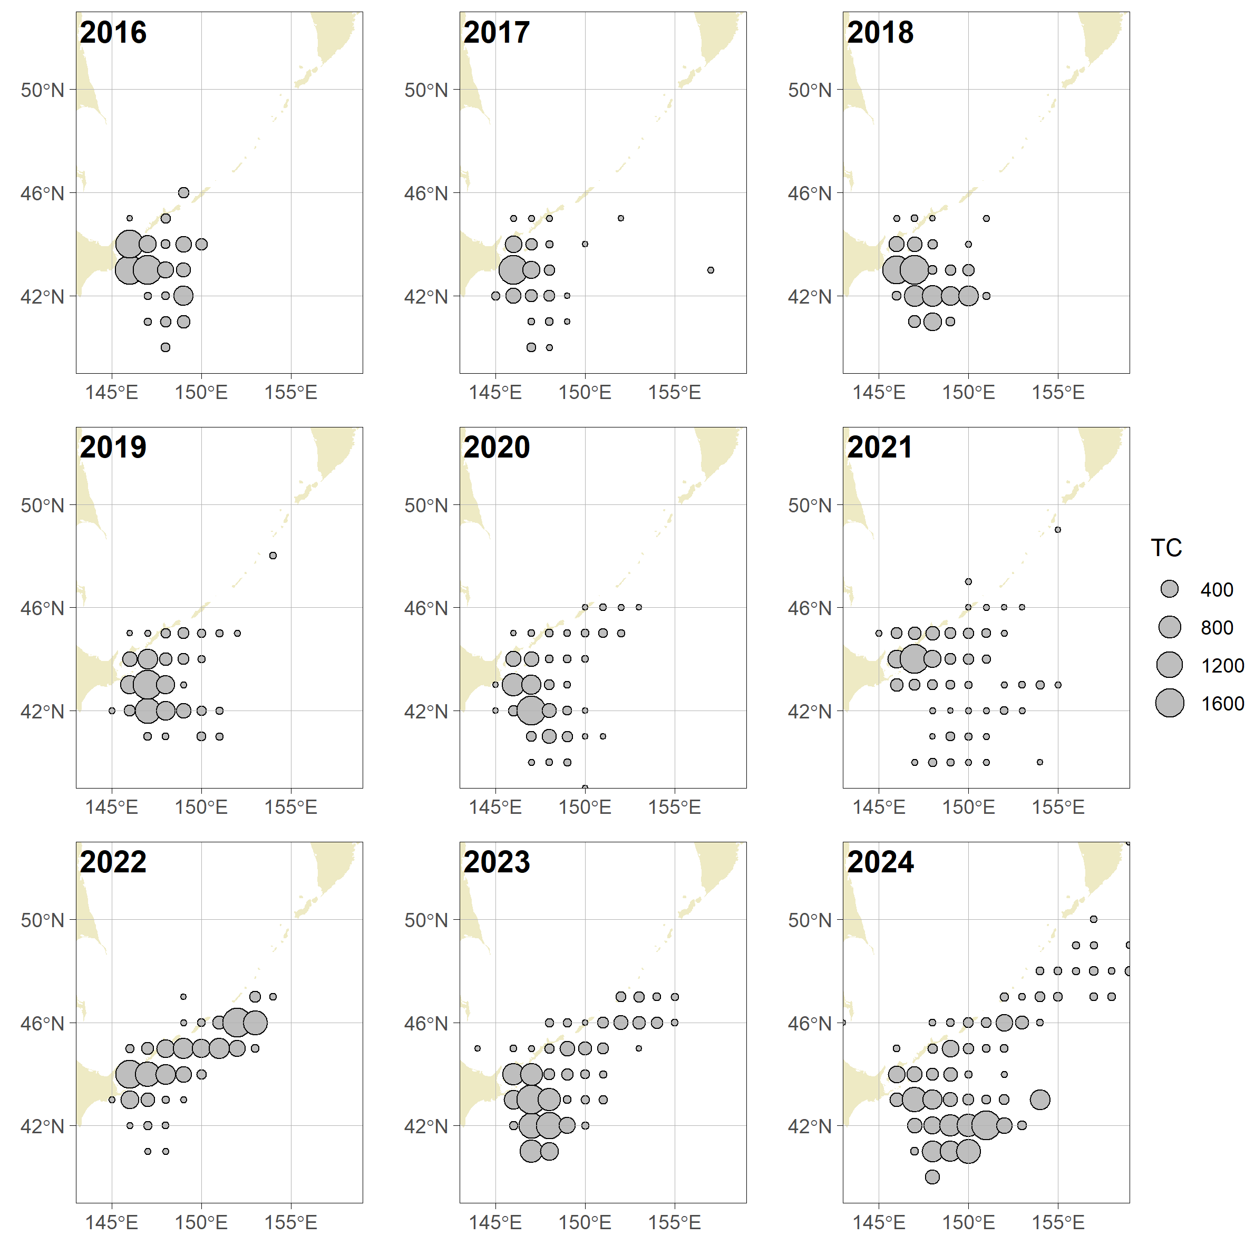

*Fig 1. Spatio-temporal distribution of the total catch of CPUE fleet (metric tons).*

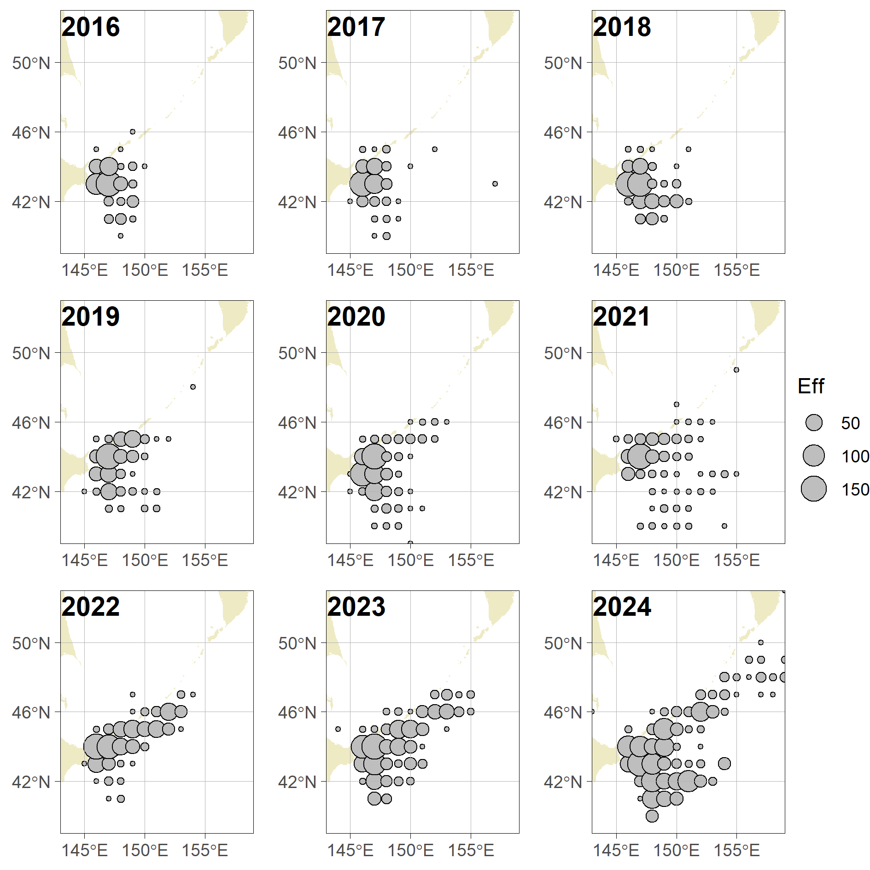

Fig 2. Spatio-temporal distribution of efforts by CPUE FLEET (vessel-day)

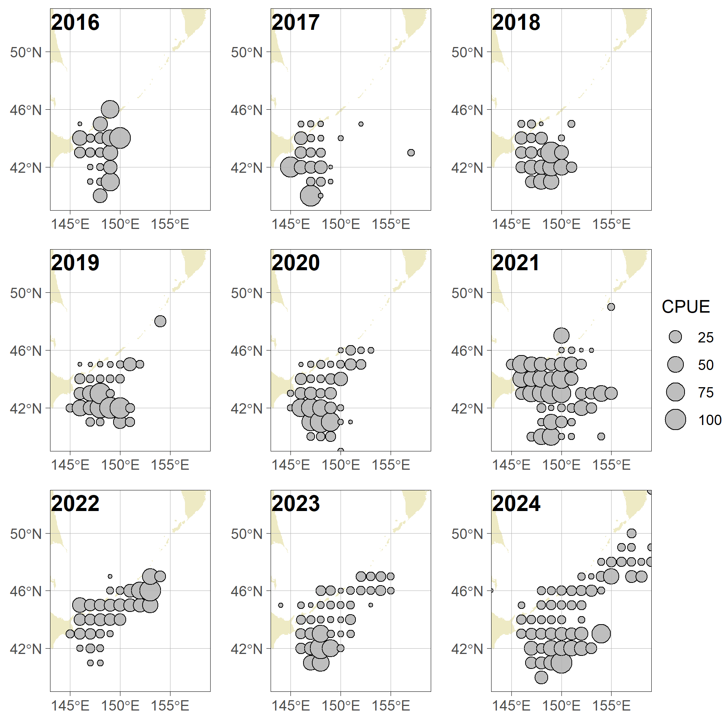

Fig 3. Spatio-temporal distribution of nominal CPUE of CPUE Fleet (t/v/d).

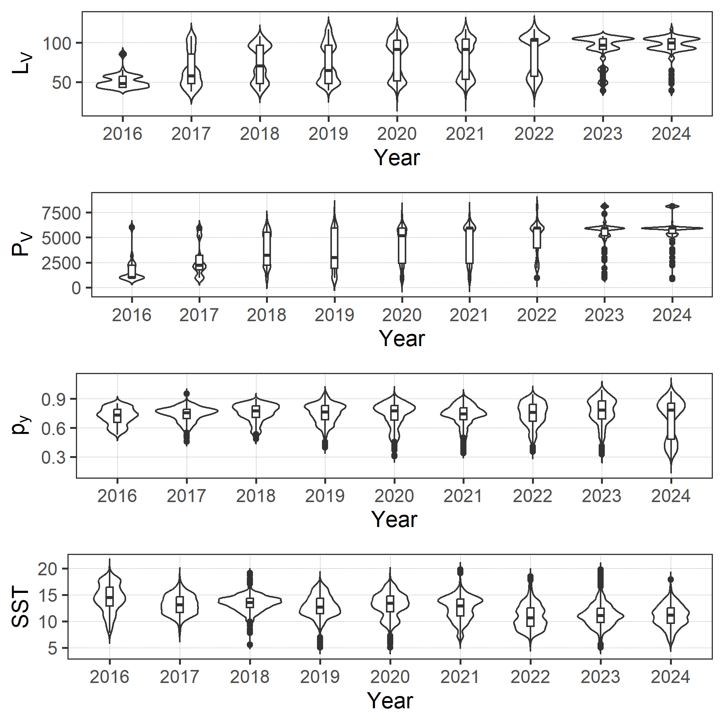

Fig 4. Violine plots of variables used in the analysis.

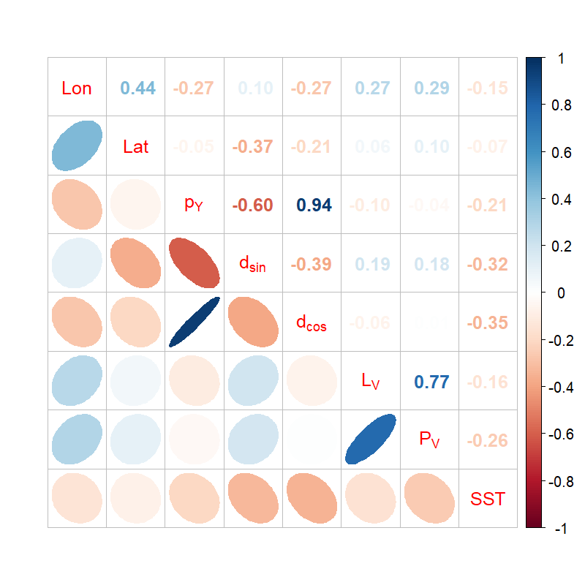

Fig 5. Correlation matrix of explanatory variables used in the analysis

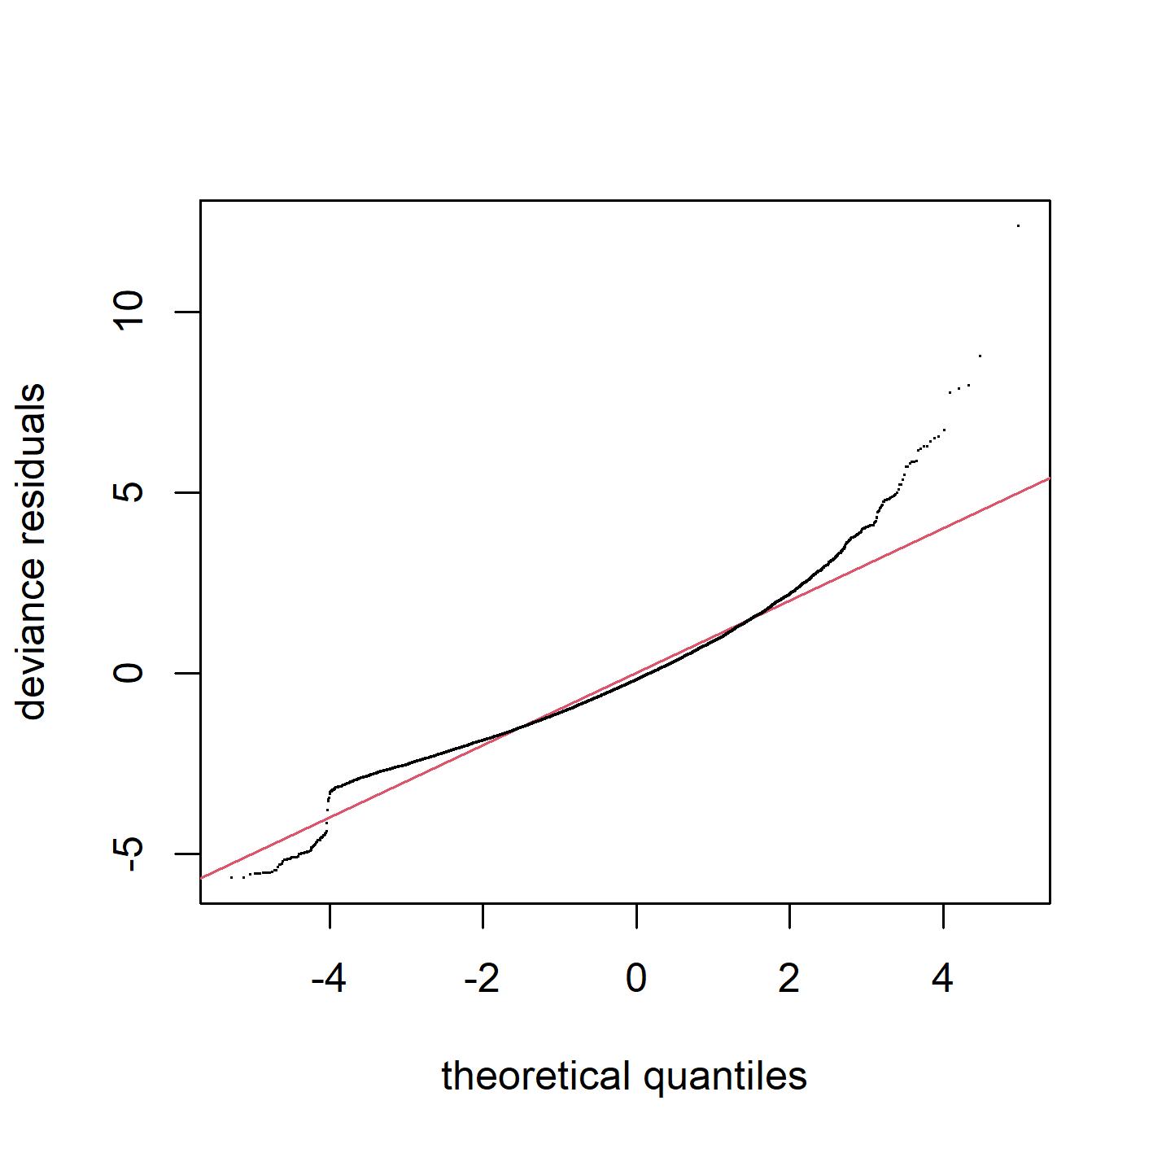

Fig 6. Q-Q plot, histogram of residuals and residual plots across years for the best GAM.

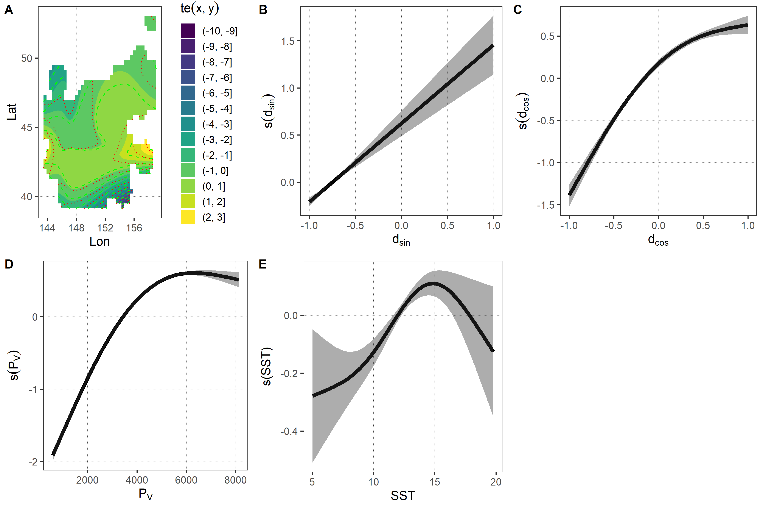

Fig 7. Estimated relationships between response and explanatory variables.

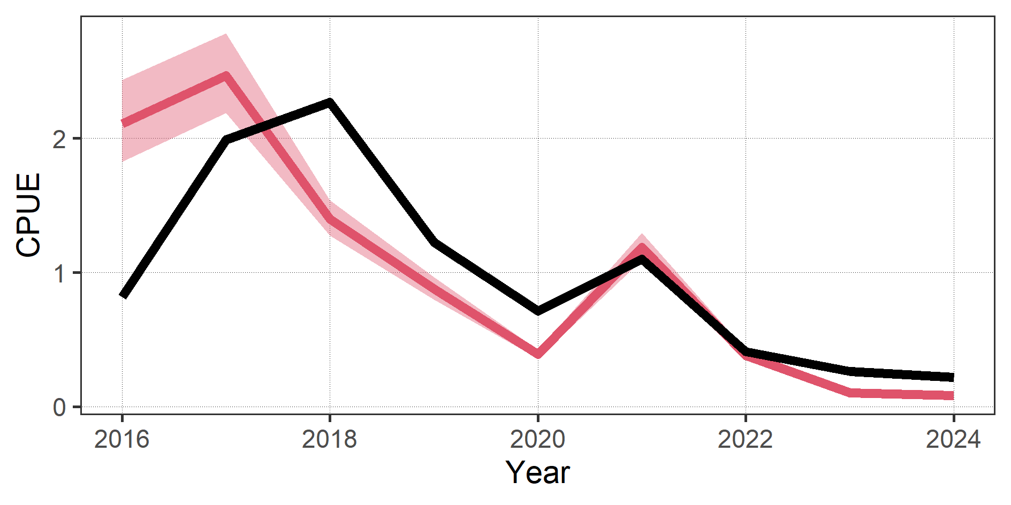

Fig 8. The scaled nominal CPUE and standardized CPUE of Chub mackerel by best GAM up to 2024.

APPENDICES

Appendix1. Checklist for the CPUE standardization protocol

|  |  |  |  |
| --- | --- | --- | --- |
| No. | Step-by-step protocols | yes/no | Note |
| 1 | Provide a description of the type of data (logbook, observer, survey, etc. ), and the "resolution" of the data (aggregated, set-by-set etc..). This description should also include the representativeness of the data in two tables: (1st table) Number of observations, % Coverage of CPUE fleet (catch), % Coverage of CPUE fleet (effort), Total Catch CPUE fleet (mt), Total Effort CPUE fleet, Percentage of overall catch by member (across all fleets/gears); and (2nd table) Number of records remaining, Number removed, Number of records with chub mackerel catch >0; | Yes | See section *2.1* ([page  2]) and Table 1,  [page 5] and 2, [page 5] |
| 2 | Conduct a thorough literature review to identify potential explanatory variables (i.e., spatial, temporal, environmental, and fisheries variables)  that may influence CPUE values; | Yes | See sections 1 ([page 2-3]) |
| 3 | Plot annual/monthly spatial catch, effort and nominal CPUE distributions and determine temporal and spatial resolution for CPUE standardization | Yes | See Fig. 1-3, [page8-10] |
| 4 | Make scatter plots (for continuous variables) and/or box plots (for categorical variables) and present correlation matrix if possible to evaluate correlations between each pair of those variables; | Yes | See Fig 5, [page 12] |
| 5 | Describe selected explanatory variables based on (2)-(4) to develop full model for the CPUE standardization; | Yes | See section *2.1.* ([page  2]) and Table 3, [page  5] |
| 6 | Specify model type and software (packages) and fit  the data to the assumed statistical models (i.e.,  GLM, GAM, Delta-lognormal GLM, Neural  Networks, Regression Trees, Habitat based models, and Statistical habitat based models); | Yes | See section *2.2.* ([page  2-3]) |
| 7 | Evaluate and select the best model(s) using methods such as likelihood ratio test, information criterions, cross validation etc.; | Yes | See Table 4, [page5] |
| 8 | Provide diagnostic plots to support the chosen model is appropriate and assumption are met (QQ plot and residual plots along with predicted values and important explanatory variables, etc.); | Yes | See Fig. 6, [page 13] |
| 9 | Present estimated values of parameters and | Yes | See Table 6, [page 6] |
|  | uncertainty in the parameters in table; |  |  |
| 10 | Present the relationship between dependent variable and independent variables. Check whether it is interpretable. | Yes | See Fig. 7, [page 14] |
| 11 | Extract yearly standardized CPUE and standard error by a method that is able to account for spatial heterogeneity of effort, such as least squares mean or expanded grid. If the model includes area and the size of spatial strata differs or the model includes interactions between time and area, then standardized CPUE should be calculated with area weighting for each time step. Model with interactions between area and season or month requires careful consideration on a case by case basis. Provide details on how the CPUE index was extracted. | Yes | See section 2.3. ([page 3-4]) |
| 12 | Calculate uncertainty (SD, CV, CI) for standardized CPUE for each year. Provide detailed explanation on how the uncertainty was calculated; | Yes | See section 2.3 (page 3), Table 7, [page 6] and Fig. 8, [page 14] |
| 13 | Provide a table and a plot of nominal and standardized CPUEs over time. When the trends between nominal and standardized CPUE are largely different, explain the reasons (e.g. spatial shift of fishing efforts), whenever possible. | Yes |