NPFC-2025-TWG CMSA11-WP06

Candidate Base Case Scenarios for the 2025 Chub Mackerel Stock Assessment in the Northwest Pacific Ocean

Shin-Ichiro Nakayama¹, Shota Nishijima¹, Momoko Ichinokawa¹, Akihiro Manabe¹, Kazuhiro Oshima¹, and Joel Rice²

1: Fisheries Resources Institute, Japan Fisheries Research and Education Agency (FRA)
2: NPFC consultant
(Corresponding author: Shin-Ichiro Nakayama, nakayama_shinichiro16@fra.go.jp)

SUMMARY
A state-space age-structured (assessment) model (SAM) was used to conduct a stock assessment of the chub mackerel stock in the Northwestern Pacific. This working paper proposes two candidate base case scenarios for the stock assessment this year. The difference between the two base case scenarios is exclusion or inclusion of the latest (2024) abundance indices. The two scenarios obtained almost identical population dynamics. Stock levels were historically high in the 1970s, but declined in the 1980s, were maintained at fairly low levels from the 1990s to the early 2000s; stock levels gradually recovered in the late 2000s and increased rapidly after the occurrence of the strong year class in 2013. However, after peaking in 2017 and 2018 in the scenarios without and with the latest abundance indices, respectively, the stock levels rapidly dropped again. In 2023, the spawning stock biomass was only 16% of the respective peak levels. Neither of the peaks in 2017 (without the latest indices) nor in 2018 (with the latest indices) reached the stock levels observed in the 1970s. We found no serious problems in the model diagnostics, except for the positive retrospective patterns in both scenarios. These patterns were smaller when the latest indices were included in the model. While the estimated population dynamics were generally consistent with the base case in the previous stock assessment, the total biomass, spawning stock biomass, and recruitment in the most recent years were revised downward considerably by the inclusion of 2023 indices, which were not included in the previous base case.

1. Introduction
Chub mackerel is a commercially important small pelagic fish in the Northwestern Pacific, and its stock assessment is important for providing scientific management advice. Through the simulation testing for stock assessment model selection, it has been agreed that the state-space stock assessment model (SAM) be used in the Technical Working Group for Chub Mackerel Stock Assessment (TWG CMSA) in NPFC (TWG CMSA 2023) and the first stock assessment was conducted in 2024 (TWG CMSA 2024a). In 2025, the TWG CMSA has agreed the data to be used for the assessment in the second stock assessment (TWG CMSA 2025).
In this working paper, we propose two candidate scenarios for the base case stock assessment in 2025. The difference in the two scenarios is exclusion/inclusion of the latest (2024) abundance indices. We show the detailed model configurations, estimated stock dynamics, and model diagnostics under these scenarios. Results of sensitivity cases are shown in another working paper (NPFC-2025-TWG CMSA11-WP07).

2. Method

2.1. Brief description of the data used
SAM uses age-specific data on catch numbers, individual weights, and maturity rates in each fishing year. We have prepared these data from the 1970 fishing year (FY1970) to FY2023 by aggregating data from Members (China, Japan and Russia) (Fig. 1a-c, Fig. 2). There are seven abundance indices from Japan and China (Fig. 1d). Details of the input data are shown in NPFC-2025-TWG CMSA11-WP03. Chinese light purse-seine fishery CPUE is up to 2023, whereas other six indices are up to 2024.

2.2. Model description
SAM is a statistical catch-at-age model that consists of two subparts: population dynamics model and observation model. The observation model accounts for errors in catch at age and abundance indices. The model was originally developed by Nielsen and Berg (2014), and modified version to consider the biological and data characteristics of chub mackerel were used for the previous stock assessment in 2024 (TWG CMSA 2024a). Details on the model development procedures are described in Nishijima and Ichinokawa (2023). We developed two candidate base case scenarios in this document according to the procedure described in the previous document.

2.2.1. Population dynamics model
The population dynamics of chub mackerel in SAM basically follows an age-structured model:
$$\log\left(N_{0,y}\right)=\log\left[f\left({SSB}_{y}\right)\right]+η_{0,y},$$ | a = 0 | (1)
$$\log\left(N_{a,y}\right)=\log\left(N_{a-1,y-1}\right)-F_{a-1,y-1}-M_{a-1,y-1}+η_{a,y},$$ | 1 ≤ a ≤ 5 | (2)
$$\log\left(N_{6+,y}\right)=\log\left(N_{5,y-1}e^{-F_{5,y-1}-M_{5,y-1}}+N_{6+,y-1}e^{-F_{6+,y-1}-M_{6+,y-1}}\right)+η_{6+,y} ,$$ | a = 6+ | (3)
where η_{a,y}$η_{a,y}$ is the process error at age a in year y following $η_{a,y}\sim N(0,ω_{a}^{2})$. The recruitment of chub mackerel occurs at age 0, described by a function of SSB and process errors (Eqn. 1). We use a Beverton-Holt stock-recruitment relationship (Beverton & Holt 1957):
$$f\left({SSB}_{y}\right)=\frac{α×{SSB}_{y}}{1+β×{SSB}_{y}} ,$$ | (4)
where $SSB_{y}$ is the sum-product of number (N), weight (w), and maturity (g) at age:
$${SSB}_{y}=\sum_{a=0}^{6+}{g_{a,y}w_{a,y}N_{a,y}} .$$ | (5)
For fish older than age 0, the number of each cohort decreases by fishing mortality coefficient (F_{a,y}) and natural mortality coefficient (M_{a,y}) from the previous year and also be affected by process errors $η_{a,y}$ (Eqn. 2). The natural mortality is assumed to be constant among year and specific for ages (M_{a,y} = 0.80, 0.60, 0.51, 0.46, 0.43, 0.41, and 0.40 for a = 0–6+, respectively, see Fig. 3), These values are derived from an existing natural mortality estimator that calculates natural mortality coefficient based on some biological traits (Nishijima et al., 2021). For the plus-age group (6+), the number is described as the sum of surviving numbers of age 5 and age 6+ from the previous year (Eqn. 3).
In SAM, fishing mortality coefficients are assumed to follow a multivariate random walk:
$$log⁡(F_{y})=log⁡{(F}_{y-1})+ξ_{y} ,$$ | (6)
where $F_{y}={(F_{1,y},…,F_{A+,y})}^{T}$, $ξ_{y}\sim MVN\left(0,Σ\right)$, and $Σ$ is the variance-covariance matrix of multivariate normal distribution (MVN). The diagonal elements of matrix $Σ$ were $σ_{a}^{2}$, while off-diagonal elements represent covariance of F process errors between age classes. This assumption of F random walk allows us to estimate time-varying selectivity (Nielsen and Berg 2014). For the covariance of MVN, we assume that the correlation coefficient of F between ages a and a’ decreases along with their age differences: $ρ^{|a-a^{'}|}σ_{a}σ_{a'}$ (a ≠ a’).

2.2.2. Observation model
SAM is fitted to the data of catch-at-age and abundance indices. SAM uses the Baranov catch equation for estimates in catch-at-age:
$${\hat{C}}_{a,y}=\frac{F_{a,y}}{F_{a,y}+M_{a,y}}\left(1-\exp\left(-F_{a,y}-M_{a,y}\right)\right)N_{a,y} .$$ | (7)
In this equation, F_{a,y} and N_{a,y} are estimated parameters as random effects. The predicted catch at age in number (${\hat{C}}_{a,y}$) is a derived parameter. SAM then fit to observed catch-at-age in a lognormal assumption:
$$\log\left(C_{a,y}\right)=log\left({\hat{C}}_{a,y}\right)+ε_{a,y} ,$$ | (8)
where $ε_{a,y}\sim N\left(0,τ_{a}^{2}\right)$.
We have agreed to use seven abundance indices (Fig. 1d) which represent, respectively,
- Relative number of age 0 fish from the summer survey by Japan,
- Relative number of age 0 fish from the autumn survey by Japan,
- Relative number of age 1 fish from the autumn survey by Japan,
- Relative spawning stock biomass (SSB) from the egg survey by Japan,
- Relative SSB from the dip-net fishery by Japan,
- Relative vulnerable stock biomass from the light purse-seine fishery by China, and
- Relative vulnerable stock biomass from the trawl fishery by Russia.
The seventh index is newly included to the candidate base case scenarios this year. The predicted values of these abundance indices can be expressed in the following general equation:
$${\hat{I}}_{k,y}=q_{k} {\left[\sum_{a=0}^{6+}{\left(χ_{a,y,k}N_{a,y}\right)}\right]}^{b_{k}}.$$ | (9)
The subscripts k, y, a represent index, year, and age, respectively. q_{k} and b_{k} are the proportionality constant and the nonlinear coefficient, respectively, for index k. Note that this equation does not mean that all the abundance indices are nonlinear against abundance but includes a linear case (b_{k} =1). The parameter $χ_{a,y,k}$ is a multiplier on the number of fish in age a and year y ${(N}_{a,y})$ for index k. For the abundance indices for age 0 fish number (k=1,2),
$$χ_{a,y,k}=\left\{\begin{aligned}1, &a=0 \\ 0, &otherwise\end{aligned} \right..$$ | (10)
For the abundance index for age 1 fish number (k=3),
$$χ_{a,y,k}=\left\{\begin{aligned}1, &a=1 \\ 0, &otherwise\end{aligned}\right. .$$ | (11)
For the abundance indices for SSB (k=4, 5),
$χ_{a,y,k}= g_{a,y}w_{a,y}$. | (12)
The abundance indices for vulnerable stock biomass for Chinese and Russian fleets (k=6, 7) would represent a part of the stock for each fleet or each member’s fishery. For the abundance indices for vulnerable stock biomass (k=6, 7), therefore,
$$χ_{a,y,k}= {\hat{s}}_{a,y,k}w_{a,y,k} ,$$ | (13)
where ${\hat{s}}_{a,y,k}$ is the estimated fishery selectivity in age a and year y for index (or fleet) k. Since we cannot estimate fleet-specific F in the current setting of SAM, we approximate it from the fleet-specific predicted catch at age (Fig. 2, Eqn. 14) as follows:
$$F_{a,y,k}≒ \frac{C_{a,y,k}}{\sum_{f}{C_{a,y,f}}}F_{a,y} ,$$ | (14)
where C_{a,y,k} are the observed catch number in age a and year y for fleet k. This approximation assumes that the fleet-specific F is proportional to fleet-specific “observed” catch at age in number. We then obtain the fleet-specific selectivity:
$${\hat{s}}_{a,y,k}= \frac{F_{a,y,k}}{E\left[F_{y,k}\right]} ,$$ | (15)
where $F_{y,k}={(F_{0,y,k},F_{1,y,k},…,F_{6+,y,k})}^{T}$. It is important to note that χ_{k,a,y} for k = 6 and 7 include the estimated parameters ($F_{a,y,k}$), whereas χ_{k,a,y} for k = 1–5 are provided from input data. We used the ratios of catch numbers of China and Russia to the total catch numbers as input data to fit the CPUE of Chinese and Russian fisheries, respectively. In calculating the vulnerable biomass, fleet- and age- specific weight (w_{a,y,k} in Eqn. 13) is needed. However, it is difficult to obtain accurate and precise data because there are no agreed data of fleet- and age- specific weights in fishing year by Chinese and Russian fisheries. We therefore took a simpler approach to using the stock weights for biomass calculation: w_{a,y,k} = w_{a,y} (Fig. 1b).
The list of fixed-effect and random-effect parameters is shown in Table 1. The parameters are estimated to maximize the marginal likelihood of summing process-error components and observation error components. The marginal likelihood is computed by the numerical integration using the Laplace approximation via Template Model Builder (TMB: Kristensen et al., 2016). We applied a generic bias-correction estimator for derived quantities calculated as a nonlinear function of random effects [ e.g., N_{a,y} is a derived quantity calculated from the random effect of log(N_{a,y}) ], which is implemented in TMB (Thorson and Kristensen, 2016). Estimation uncertainties including standard errors (SEs) and confidence intervals were computed from the delta method in TMB. In this stock of chub mackerel, the period from July to the following June is treated as a fishing year (NPFC-2024-TWG CMSA09-WP01), and the estimated abundance is that at the beginning of the fishing year (i.e., July 1st).

2.3. Candidate base case scenarios
In this working paper, we consider two scenarios as candidates for the base case analysis. The difference between these two base case scenarios is exclusion or inclusion of the latest abundance indices. The first scenario, namely S01-InitBase, excludes the six abundance indices in 2024 (Note that Chinese light purse-seine fishery CPUE has no 2024 data). The other scenario, S02-Index24_1, includes the 2024 indices. Because SAM requires biological parameters (weight at age and maturity at age) in 2024 and the proportion of Russian catch number in 2024 to estimate the 2024 population status, we assume they are the averages of themselves over 2016–2023 and 2021–2023, respectively. The sensitivity analysis for these settings was conducted, and the result is reported in another working paper (NPFC-2025-TWG CMSA11-WP07).

2.4. Model selection

SAM estimates age-specific process errors for F and N and age-specific observation error for C ($σ_{a}^{}$, $ω_{a}^{}$, and $τ_{a}^{}$, respectively: Table 1). Estimating these errors for all ages without any restriction may cause the failure to converge and/or over-parameterization. Estimating the nonlinearity parameters (b_{k}) for all of the abundance indices also may lead to the same problem. Because some abundance indices might respond linearly to the stock abundance, absence of the nonlinearity parameter of the abundance indices can lead to overestimation or underestimation of resources (Nishijima et al., 2019; Rose and Kulka, 1999). However, at the same time, estimation of nonlinear parameters for indices that actually react linearly to the abundance dynamics might cause overparameterization or even non-convergent estimation.

To address these problems, we conducted a series of model selections. We first focused on the optimization of the settings of the observation and process errors, fixing the relationship of the abundance dynamics and the abundance indices linear (b_{k} = 1). We introduced restrictions to these errors: For example, the process error for F can be restricted to be identical among ages 0–2 and among ages 3–6+. Because there are huge number of the restriction pattern, we applied a stepwise approach, rather than trying all the possible restriction patterns. We started from the simplest model in which $σ_{a}^{}$, $ω_{a}^{}$, and $τ_{a}^{}$ were common among all age classes. We assume that the seven abundance indices have different SDs of the measurement errors even in the simplest model because each abundance index is derived from different sources and/or age classes. Then we chose the best between-age breakpoints at which the values of $σ_{a}^{}$, $ω_{a}^{}$, and $τ_{a}^{}$ changed based on AIC. In this step, one breakpoint was set to each of $σ_{a}^{}$, $ω_{a}^{}$, and $τ_{a}^{}$. This process was iterated until no further reduction in AIC was observed. Exceptionally, the N process error ($ω_{a}^{}$) breakpoints were not placed between ages 2 and 3 in order to avoid setting independent process errors for each of them. This is because the maturities for ages 2 and 3 have declined to 0 and 0.3, respectively, after 2015 and we suspect that the SSB index does not have sufficient recent information corresponding to these ages.

In the second step, we consider which nonlinear coefficients of abundance indices should be estimated. We classified the seven abundance indices into five categories:
- Trawl surveys by Japan (summer for age 0 and autumn for ages 0 and 1)
- Egg survey for SSB by Japan
- Dipnet fishery CPUE for SSB by Japan
- Light purse-seine fishery CPUE by China
- Trawl fishery CPUE by Russia.
We analyzed 32 (= 2⁵) cases of all combinations in which the nonlinear coefficients of abundance indices in each category were either estimated or fixed at 1, with the selected restrictions of the errors above. We filtered out models without convergence, models that did not output SE due to non-positive definite of Hessian matrix, or models having very large SE of any of the fixed-effect parameters (>10). Among models meeting these criteria, the simplest model with ΔAIC < 2.0 was selected.

2.5. Model diagnostics
For the selected base case models, we applied several model diagnostics to check the reliability from a statistical view. Firstly, we performed a jitter analysis in which the initial values of the parameters were varied and re-estimated to confirm that the estimated parameters reach the global optimum. We checked whether the final gradients of the fixed effect parameters are close to zero, which is a necessary condition for model convergence.
We then plotted residuals in the catch number by age and in abundance indices to examine whether the residuals have temporal patterns. We also examined residuals in process errors for numbers by age ($η_{a,y}$ in Eqns. 1-3) and F by age (diagonal components of $ξ_{y}$ in Eqn. 6). to show the stock abundance historically changed by these process errors. To visualize the effect of the process errors for numbers by age on the biomass-at-age, we plotted the deviances between the biomass-at-age estimated with the process error and the biomass-at-age expected with no process error. The deviances were calculated by ${\hat{N}}_{a,y}×w_{a,y}×\left[\exp\left({\hat{η}}_{a,y}\right)-1\right]$. Furthermore, we performed one-step-ahead (OSA) projections using the parameters estimated with full data and visualized the residuals between observation and projection to check whether there are temporal patterns in the OSA residuals in catch-at-age and the abundance indices.
A five-year retrospective analysis was performed to examine if the estimates had systematic bias for the removal (updating) of data. Mohn’s rho was calculated for total biomass, SSB, recruitment, and mean F. We also performed a retrospective forecasting, which excludes the stock index values and catch number by age from the latest year and compares the results of a one-year-ahead forecasting from the terminal year of those data (in which age-specific weight and maturity rates were used) with estimates from the model using all data. We fixed the nonlinear coefficients (b_{k}) at the estimates with the full data in the retrospective analysis.
The leave-one-out (LOO) index analysis was next conducted by excluding the seven abundance indices one by one and comparing the estimates with the results obtained when all indices were used. This analysis allows us to examine the impact of each index on abundance estimates and check their robustness.
To evaluate whether the parameters converged to the maximum likelihood estimate (MLE) and the uncertainty of the estimate, we lastly examined the log-likelihood when the parameters were varied around the estimate. The parameters profiled are those related to the stock-recruitment relationship and proportionality constants for the abundance indices. For the indices for which nonlinear coefficients were estimated, the likelihood profile was obtained by fixing the nonlinear coefficients to the estimated values, because it was shown that the likelihood did not change much if the value of the proportionality constant was changed, and it was unclear whether the index had sufficient information on stock abundance. We also change the value of natural mortality coefficient (M), given as input data, and its effects on the likelihood and abundance estimates.

3. Results

3.1. Model selection
In the first step of the model selection, the selection of the restrictions of the process and observation errors, we finally identified the following most parsimonious setting (Table 2 and 3) for both of the scenarios:
- The SDs of measurement error in catch at age ($σ_{a}^{}$) had five groups: age 0, 1, 2–3, 4–5, and 6+.
- The SDs of F process error ($ω_{a}^{}$) had three groups: ages 0–1, 2, and above 3.
- The SDs of N process error ($τ_{a}^{}$) had two groups: age 0, and above 1.
Through the model selection for the nonlinear coefficient, the second step, we found that the most parsimonious setting for the both scenarios was estimating the nonlinear coefficients only for the three trawl surveys by Japan (Table 4). This setting obtained the lowest AIC in S01-InitBase. Although this setting obtained the second lowest AIC in S02-Index24_1, the difference of AIC under this setting and the lowest AIC was only 0.48 and this was the simplest setting among those with ΔAIC < 2.0.

3.2. Parameter estimates
The estimated fixed effects parameters are shown in Tables 5 (S01-InitBase) and 6 (S02-Index24_1). For all parameters, the final gradient values were very close to 0 and the SE values were less than 2.5. We found no problems in jitter analysis (results not shown). Correlation coefficients from the covariance matrices of the fixed effects parameters showed that q_{k} and b_{k} for age-0 and age-1 fish in the Japanese trawl surveys were highly negatively correlated (Fig .4). In addition, the parameters α and β of the Beverton-Holt stock-recruitment relationship were highly positively correlated. However, since β is a function of α, this is to be expected (Beverton & Holt 1957). These strong correlations between α and β are explained by the scales of abundance and SSB (for details, see Discussion in TWG CMSA 2024a), and there were no problems with model convergence, as indicated by the absolute values of the final gradients approaching zero and sufficiently small SEs for these parameters (Tables 5 and 6). The nonlinear coefficients in the Japanese trawl survey indices were estimated in the range of 1.7–2.4 (Tables 5 and 6), suggesting that they have a tendency of hyperdepletion (Figs 5 and 6).

3.3. Time-series estimates for abundances and fishing impacts
The two scenarios obtained almost identical population dynamics. Since 1970, total biomass, SSB, and recruitment of chub mackerel have drastically fluctuated (Tables 7 and 8, Fig. 7). Specifically, stock levels were historically high in the 1970s, but declined in the 1980s, were maintained at fairly low levels from the 1990s to the early 2000s; stock levels gradually recovered in the late 2000s and increased rapidly after the occurrence of the strong year class in 2013. However, after peaking in 2017 and 2018 in S01-InitBase and S02-Index24_1, respectively, the stock levels rapidly dropped again. In 2023, the spawning stock biomass was only 16% of the respective peak levels. Neither of the peaks in 2017 (S01-InitBase) nor in 2018 (S02-Index24_1) reached the stock levels observed in the 1970s. In addition, in S02-Index24_1, the spawning stock biomass in 2024 further declined from 2023, to 14% of the peak in 2018.

In SAM, the estimated catch (sum product of estimated age-specific catch and age-specific weight) and the observed catch (sum product of observed age-specific catch and age-specific weight) do not match because of the assumption of observation error in the age-specific catch numbers, but the difference between these values was small, except in some years (Fig. 7). Exploitation rate (estimated catch biomass / total biomass) and mean F remained constant, with some fluctuations, until the 2000s, but decreased thereafter (Fig. 8). F-at-age showed similar fluctuation patterns to total F, regardless of age (Fig. B1), while selectivity-at-age remained almost constant throughout the target period (Fig. B2).

3.4. Stock-recruitment relationship
The estimated Beverton-Holt stock-recruitment relationship is shown in Fig. 9. In both scenarios, the estimated stock-recruitment relationships were slightly convex, suggesting that the density-dependent effect in the stock-recruitment relationship is not strong in the chub mackerel population dynamics. SD of recruitment variability was 0.78 and 0.80 in S01-InitBase and S02-Index24_1, respectively (Tables 5 and 6).

3.5. Residual plots
Observation errors for catch-at-age were larger in the young and old age (ages 0, 1, and 6+) groups than those in the intermediate age (ages 2–5) groups (Figs 10-13, see also Tables 5-6). The time-series trend of the residuals was weak.
For abundance index values, observation error was notably high in the Russian trawl fishery CPUE (Figs 14-17). The summer and autumn age-0 indices tended to have positive residuals in recent years, except for the 2023 autumn (Fig. 15, 17).
The process errors in log(N) for age-0 fish fluctuated strongly, and those for age 1 and 2 fish fluctuated moderately, compared to those for older ages (Fig. 18, top). The recruitment residual has been positive after 2020. In addition, the first seven years from 1971 had positive recruitment residuals (except 1974), but for the next 13 years through 1990, the residuals were negative in all years except 1985. A large positive process error was observed in age 2 in 2015, resulting in a large positive deviance in the same year and age (Fig. 19).
Process errors for log(F) (deviation from random walk) were larger in ages 0 and 1 than in the other ages (Fig. 18, bottom). The pattern of random walks for each age was very similar, as evidenced by the very high correlation coefficient of 0.98 between the closely adjacent ages (Tables 5 and 6).
In the one-step-ahead projection, we observed no clear temporal tendencies in the residuals for catch-at-age and the indices except that the Japanese dipnet fishery’s standardized CPUE (ID = 5 in Figs. B3 and B4). The residuals almost followed a normal distribution (Fig. B5).

3.6. Retrospective analysis
In the retrospective analysis, the biomass and recruitment tended to be revised downward as the data were updated and as a result, F shows negative retrospective pattens in both scenarios (Figs. 20 and 21). SSB had much smaller retrospective pattern compared to biomass and recruitment. The observed Mohn’s rho values were smaller in S01-InitBase than those in S02-Index24_1.
Same tendencies, the positive retrospective patterns in the biomass, recruitment and SSB were obtained in the retrospective forecasting, but the Mohn’s rho values were expanded relative to those in the retrospective analyses. Again, S02-Index24_1 obtained smaller Mohn’s rho compared to S01-InitBase (Figs. 22 and 23).

3.7. Leave-one-out index analysis
In the LOO index analysis, although the abundance, SSB, recruitment, and exploitation rate somewhat varied in recent years depending on the index removed, the patterns observed were largely consistent, indicating that the stock estimates are robust (Figs 24 and 25). Among the abundance indices, the absence of summer Japanese trawl survey for age 0 had relatively large effect on the recruitment. This is natural because this index was slightly inconsistent with the autumn Japanese trawl survey index for age 0 (e.g., 2021 year class). The absence of Japanese trawl surveys for age 0 in summer and for age 1 in autumn also led to the increase of the recent exploitation rate, presumably because of the smaller number of recruitment estimated.

3.8. Likelihood profiling
To evaluate whether the recruitment parameters converged to the maximum likelihood estimate (MLE) and the uncertainty of the estimate, we examined the log-likelihood when the parameters were varied around the estimate. The negative log-likelihood had a convex shape against the parameters, with the MLE as the smallest, indicating convergence to the optimal value (Fig. 26). The dip of the negative log-likelihood of β was not as sharp as those of other parameters, suggesting a greater uncertainty in the density-dependent parameter. We also investigated likelihood profiles for proportionality constants for the seven abundance indices, indicating converged estimation of these parameters (Fig. 27).
Finally, the effect of the natural mortality coefficient (M), given as input data, was examined: the change in log likelihood was examined by adding values of -0.3 to 0.5 simultaneously from the values of M in the two scenarios. The results revealed that the negative log-likelihood monotonically decreases (i.e., the likelihood increases) as M is decreased (Fig. 28). This suggests that it is difficult to estimate M from these data inside SAM. Higher values of M resulted in higher values of total biomass, SSB, and recruitment and lower exploitation rates (Fig. 29). Although the relative trends did not change largely, higher values of total biomass, SSB, and recruitment in recent years relative to the 1970s were estimated higher as M increased; when 0.3 was added, the recent estimates were much higher than in the 1970s. In other words, the value of M affects recent estimates of stock abundances relative to the past.

4. Discussion
In this working paper, a stock assessment of Northwestern Pacific chub mackerel was conducted using SAM with existing agreed data. Two candidate base case scenarios (S01-InitBase and S02-Index24_1), in which the 2024 abundance indices were excluded/included, were considered. Since this is the second stock assessment, it is important to examine not only the differences between the two candidate base case scenarios but also the differences between the first and second assessments, in order to evaluate the robustness and plausibility of the results.
Only small differences were observed in the estimated population dynamics under the two scenarios, indicating that there are no large discrepancies between the 2024 indices and the input data before 2024. Looking over the results, the only major difference between the two candidate scenarios appeared in the retrospective analysis and forecasting (Figs. 20–23). Although both of the scenarios showed large positive retrospective patterns in the recruitment and total biomass, the strength of the patterns was relatively small in S02-Index24_1. This point can be a basis of discussion to select a single base case for this year’s stock assessment. The large positive retrospective patterns were obtained because recent high recruitment in 2018, elevated by high recruitment index values, has been revised downward by low catch numbers and low SSB index values (NPFC-2025-TWG CMSA11-WP08). This situation means that the high recruitment expected in the survey has disappeared, never showing up as catch or SSB. Unfortunately, the reason for this curious phenomenon is still unknown at this moment.
Comparing the current two scenarios with the previous base case (S28-ProcEst, TWG CMSA 2024a), the estimated historical population dynamics were also almost consistent (Fig. 31). However, focusing on the recent population dynamics, inclusion of 2023 indices revised the biomass, SSB, and recruitment downward considerably (Fig. 32). This is presumably because all abundance indices consistently decreased in 2023 and this information was not included in the previous base case. The unexpected decrease in the 2023 indices contributed to the increase in the retrospective patten this year from last year TWG CMSA 2024a). Some degree of revision to stock estimates due to data updates is an essential part of the annual assessment process. The sharp decline in the 2023 abundance index was difficult to predict based on prior data, and the resulting downward revision of stock estimates were therefore unavoidable. In fact, the 2023 Japanese indices were available in the last year’s assessment. However, it was not included in the base case due to the lack of biological parameters for 2023 and concerns over a large retrospective pattern. Nevertheless, the presence of retrospective pattern does not necessarily indicate model misspecification or bias in the estimates (Breivik et al., 2023; Cadrin, 2025; Hurtado-Ferro et al., 2015) and the extent of this year’s downward revision would have been smaller if the 2023 abundance indices had been incorporated in the stock assessment last year (Fig. 32). To improve the stability of stock assessments and fill the time lag between data collection and management implementation, we recommend adopting S02-Index24_1, which includes the 2024 abundance indices, as the final base case in the stock assessment this year.
The main modification of the model settings from the previous assessment is the inclusion of the Russian trawl fishery CPUE as an abundance index. In addition to the consistent population dynamics estimated last and this years, the robust result in the LOO index analysis (Figs 24 and 25) also suggested that the Russian fishery CPUE had no large discrepancy with other abundance indices, although the observation error for the Russian index was larger than those for others. Based on these results, we concluded that the inclusion of the Russian trawl fishery CPUE in SAM was beneficial from the viewpoint of data richness.
We selected the most parsimonious restriction patterns of the observation and process errors and whether we estimated or fixed the nonlinear coefficient for each abundance indices through the model selections. The completely same settings were selected in both of the current scenarios, which was different from the previous base case: The process error for N had groups of age 0 and above 1 in the current analysis (Table 3) while there were age 0, 1, 2–4, 5–6+ groups in the previous one (TWG CMSA 2024a). Nevertheless, the estimated process errors for the groups corresponding to age 1 and older in the previous base case (0.35, 0.27, and 0.28 for ages 1, 2–4, and 5–6+, respectively) were not substantially different from the process error estimated for the age 1–6+ group (0.31 and 0.32 for S01-InitBase and S02-Index24_1, respectively) in the current scenarios. Thus, the settings for the process error in N have not essentially changed.
All of the current candidate scenarios and the previous base case estimated the nonlinear coefficient for the three Japanese trawl survey indices (Table 4, TWG CMSA 2024a). The estimated nonlinear coefficients were larger than 1 for all the three abundance indices (Tables 5 and 6, Figs. 5 and 6), indicating a tendency toward hyperdepletion. The reason for this is not clear, but it may be because the survey was conducted at a particular time of year, and thus the variation in the index values is larger than the actual variation in recruitment.
One of the key characteristics of this model is the significant influence of process error for age-1 and older fish (SD = 0.31–0.32). This process error acted to increase total biomass from 2011 to 2018, but contributed to a decline in biomass from 2019 onward (see Fig. 19). This pattern of estimated process error reflects the need to reconcile discrepancies between recruitment indices and SSB index. For example, although both the 2013 and 2018 year-classes were strong cohorts, the recruitment index was higher for the 2018 year-class (Fig. 1d). However, a comparison of SSB indices during the periods when these cohorts were expected to be fully mature (2017–2018 for the 2013 year-class and 2022–2023 for the 2018 year-class) shows that the earlier period exhibited higher SSB levels. Moreover, catches have not increased markedly in recent years (Fig. 1a). It is therefore inferred that the initial abundance of the 2013 year-class as age-0 fish was lower than that of the 2018 year-class, but the 2013 year-class and surrounding cohorts were estimated to have been adjusted upward through process error, whereas cohorts from 2018 onward were adjusted downward. The particularly strong positive process error estimated for the 2013 year-class at age 2 in 2015 may be attributed to the lack of constraints from index data: this age group was not well covered by either Japanese trawl surveys targeting younger fish or SSB indices. These results imply that even if recruitment is estimated to be high, it may subsequently decline without leading to increases in catches or SSB. The process error for age 1 and older fish represents an important source of uncertainty that should be carefully considered in sustainable resource management.
In this stock, the choice of the stock-recruitment relationship is an important and difficult issue in the future assessment. We used the Beverton-Holt model, which is the simplest model and fits well with chub mackerel, but recruitment shows almost proportional relationship with SSB and the density-dependent effect is very small (Fig. 9). Therefore, the uncertainty of the parameters related to the density dependence was large. Such low density-dependent effects and large uncertainties greatly affect the calculation of biological reference points and future projections (NPFC-2024-TWG CMSA09-WP05). Estimating stock recruitment relationships in an assessment model is inherently challenging due to the complex interplay of biological and environmental factors that influence fish population dynamics. Variability in recruitment can result from factors such as fluctuating environmental conditions, changes in predator-prey interactions, and genetic diversity within the stock (Myers, 1998). Additionally, data limitations, such as insufficient time series data, measurement errors, and biases in sampling methods, further complicate the estimation process (Maunder & Deriso, 2013). These difficulties are exacerbated by the non-linear and often unpredictable nature of recruitment, making it hard to develop reliable models that accurately capture the true dynamics of fish populations (Hilborn & Walters, 1992). Another possible stock-recruitment relationship is the use of the hockey-stick model. While it cannot be applied directly to SAM using TMB, where optimization is performed by automatic differentiation, a continuous hockey-stick model (Mesnil & Rochet, 2010) may be a candidate to be applied. The results with the continuous hockey-stick are shown in a sensitivity scenarios (NPFC-2025-TWG CMSA11-WP07). From the viewpoint of stock assessment and management for chub mackerel, it is necessary to consider how the stock-recruitment relationship should be characterized as a upcoming task.

References
Beverton, R. J. H., & Holt, S. J. (1957). On the dynamics of exploited fish populations. Chapman and Hall, London, Fish and Fisheries Series No. 11, fascimile reprint 1993.
Breivik, O. N., Aldrin, M., Fuglebakk, E., & Nielsen, A. (2023). Detecting significant retrospective patterns in state space fish stock assessment. Canadian Journal of Fisheries and Aquatic Sciences, 80(9). https://doi.org/10.1139/cjfas-2022-0250
Cadrin, S. X. (2025). Misinterpreting retrospective patterns in fishery stock assessment. ICES Journal of Marine Science, 82(2). https://doi.org/10.1093/icesjms/fsaf014
Hashimoto, M., Okamura, H., Ichinokawa, M., Hiramatsu, K., and Yamakawa, T. (2018). Impacts of the nonlinear relationship between abundance and its index in a tuned virtual population analysis. Fisheries Science, 84(2), 335–347. https://doi.org/10.1007/s12562-017-1159-0
Hilborn, R., & Walters, C. J. (1992). Quantitative Fisheries Stock Assessment: Choice, Dynamics, and Uncertainty. Springer.
Hurtado-Ferro, F., Szuwalski, C. S., Valero, J. L., Anderson, S. C., Cunningham, C. J., Johnson, K. F., Licandeo, R., McGilliard, C. R., Monnahan, C. C., Muradian, M. L., Ono, K., Vert-Pre, K. A., Whitten, A. R., & Punt, A. E. (2015). Looking in the rear-view mirror: bias and retrospective patterns in integrated, age-structured stock assessment models. ICES Journal of Marine Science, 72(1), 99-110. https://doi.org/10.1093/icesjms/fsu198
Ichinokawa M., Nishijima S., Oshima K., and Rice J. (2024) Biological reference points and future projections with the results of stock assessment for the Pacific chub mackerel. NPFC-2024-TWG CMSA09-WP05.
Kristensen, K., Nielsen, A., Berg, C. W., Skaug, H., and Bell, B. M. (2016). TMB: Automatic differentiation and laplace approximation. Journal of Statistical Software, 70(5), 1–21. https://doi.org/10.18637/jss.v070.i05
Manabe, A., GAZI, M. K., Oshima K. (2025) The data description for the base case stock assessment of chub mackerel Scomber japonicus in the northwestern Pacific Ocean for 2025 assessment. NPFC-2025-TWG CMSA11-WP03. (Available at www.npfc.int)
Maunder, M. N., & Deriso, R. B. (2013). A stock–recruitment model for highly fecund species based on temporal and spatial extent of spawning. Fisheries Research, 146, 96-101.
Mesnil, B., & Rochet, M. J. (2010). A continuous hockey stick stock-recruit model for estimating MSY reference points. ICES Journal of Marine Science, 67, 1780-1784. https://doi.org/10.1093/icesjms/fsq055
Myers, R. A. (1998). When do environment-recruitment correlations work? *Reviews in Fish Biology and Fisheries*, 8(3), 285-305.
Nielsen, A., and Berg, C. W. (2014). Estimation of time-varying selectivity in stock assessments using state-space models. Fisheries Research, 158, 96–101. https://doi.org/10.1016/j.fishres.2014.01.014
Nishijima, S., and Ichinokawa, M. (2023). On the description and flexibility of state-space assessment model. NPFC-2023-TWG CMSA07-WP07.
Nishijima, S., Kamimura, Y., Yukami, R., Manabe, A., Oshima, K., and Ichinokawa, M. (2021). Update on natural mortality estimators for chub mackerel in the Northwest Pacific Ocean. NPFC-2021-TWG CMSA04-WP05.
Nishijima, S., Suzuki, S., Ichinokawa, M., and Okamura, H. (2019). Integrated multi-timescale modeling untangles anthropogenic, environmental, and biological effects on catchability. Canadian Journal of Fisheries and Aquatic Sciences, 76(11), 2045–2056. https://doi.org/https://doi.org/10.1139/cjfas-2018-0114
Rose, G., and Kulka, D. (1999). Hyperaggregation of fish and fisheries: how catch-per-unit-effort increased as the northern cod (Gadus morhua) declined. Canadian Journal of Fisheries and Aquatic Sciences, 56(S1), 118–127. https://doi.org/10.1139/cjfas-56-S1-118
Thorson, J. T., and Kristensen, K. (2016). Implementing a generic method for bias correction in statistical models using random effects, with spatial and population dynamics examples. Fisheries Research, 175, 66–74. https://doi.org/10.1016/j.fishres.2015.11.016
Technical Working Group on Chub Mackerel Stock Assessment (2023) 7th Meeting Report. NPFC-2023-TWG CMSA07-Final Report. 53 pp. (Available at www.npfc.int)
Technical Working Group on Chub Mackerel Stock Assessment. (2024a) Stock assessment report of chub mackerel in 9th Scientific committee. NPFC-2024-SC09-WP20 (Rev. 1). (Available at www.npfc.int)
Technical Working Group on Chub Mackerel Stock Assessment. (2024b) 8th Meeting Report. NPFC-2023-TWG CMSA08-Final Report. 32 pp. (Available at www.npfc.int)

Tables and Figures

Table 1
The list of mathematical notations for SAM, including the symbol used, its type (Index, Data, random effects: RE, fixed effects: FE, and derived quantities: DQ, and its description).
Symbol | Type | Description
a | Index | Age class (from 0 to 6+)
y | Index | Fishing year (from 1970 to 2022)
k | Index | Fleet ID for abundance index (from 1 to 6)
$$C_{a,y}$$ | Data | Observed catch number at age a in a year y
$$w_{a,y}$$ | Data | Stock weight at age a in a year y (also used as catch weight for simplicity)
$$g_{a,y}$$ | Data | Maturity at age a in a year y
$$M_{a,y}$$ | Data | Natural mortality coefficient at age a in a year y
$$N_{a,y}$$ | RE | Number at age a in a year y
$$F_{a,y}$$ | RE | Fishing mortality coefficient at age a in a year y
$$ω_{a}$$ | FE | SD for the process error in number at age a
$$σ_{a}$$ | FE | SD for the process error in F at age a
$$ρ$$ | FE | Correlation coefficient in MVN of F random walk between adjacent age classes
$$τ_{a}$$ | FE | SD for the measurement error in catch at age a
$$q_{k}$$ | FE | Catchability coefficient for abundance index k
$$ν_{k}$$ | FE | SD for the measurement error in abundance index k
$$b_{k}$$ | FE | Nonlinear coefficient for abundance index k
α | FE | Slope of stock-recruitment relationship at the origin
β | FE | Strength of density dependence in stock-recruitment relationship
$${\hat{C}}_{a,y}$$ | DQ | Predicted catch number at age a in a year y
$${\hat{s}}_{a,y}$$ | DQ | Selectivity at age a in a year y

Table 2
Model selection results for measurement errors of catch at age (Variable: C) and process errors of F (Variable: F). Boundary of 2 for Stage 1 means that the AIC minimum was to divide the error into different sizes for ages 1 and below and ages 2 and above. The bold rows indicate the AIC minimum.
Stage | AIC | Variable | Boundary
S01-InitBase
0 | 1245.35 | - | -
1 | 1234.05 | C | 6
2 | 1214.75 | C | 2
3 | 1211.54 | F | 2
4 | 1210.43 | C | 4
5 | 1210.22 | C | 1
6 | 1209.36 | F | 3
7 | 1210.68 | C | 5
S02-Index24_1
0 | 1259.85 | - | -
1 | 1248.47 | C | 6
2 | 1229.67 | C | 2
3 | 1226.24 | F | 2
4 | 1225.12 | C | 4
5 | 1225.04 | C | 1
6 | 1224.22 | F | 3
7 | 1225.55 | C | 5

Table 3
Patterns of measurement errors of catch-at-age (row C), process errors of F (row F), and process errors of N (row N) in the best model. Different numbers indicate different SDs. Both base case scenarios yielded the same pattern (see Table 2).
Age | 0 | 1 | 2 | 3 | 4 | 5 | 6+
C | 0 | 1 | 2 | 2 | 3 | 3 | 4
F | 0 | 0 | 1 | 2 | 2 | 2 | 2
N | 0 | 1 | 1 | 1 | 1 | 1 | 1

Table 4
Model selection results for nonlinear coefficients of five index categories (trawl survey by Japan: Trawl_jpn, spawning egg survey by Japan: EggSurv_jpn, Dipnet fishery by Japan: Dipnet_jpn, purse seine fishery by China: PS_chn, trawl fishery by Russia: TR_russ). ‘e’ and ‘f’ indicate ‘estimated’ and ‘fixed at 1’, respectively. Rank indicates the ranking within each scenario while ΔAIC was calculated across both scenarios. The bold rows indicate the selected base case models in each scenario. The column”pdHess” indicates whether the positive definite value of the Hesse matrix has been obtained or not, and ‘maxSE’ indicates the maximum value of SE for the parameters. Models for which the positive definite value of the Hesse matrix has not been obtained and the maximum value of SE exceeds 10 are considered to have estimation problems, and the Rank and AIC columns are marked "-". If the positive definite value of the Hesse matrix cannot be obtained, the SE of the parameter cannot be obtained, so it is set to NA.
Rank | Trawl_jpn | EggSurv_jpn | Dipnet_jpn | PS_chin | TR_russ | AIC | ΔAIC | pdHess | maxSE

S01-InitBase
1 | e | f | f | f | f | 1172.22 | 0 | ✓ | 2.34
2 | e | f | f | f | e | 1173.11 | 0.89 | ✓ | 2.39
3 | e | e | f | f | f | 1173.32 | 1.1 | ✓ | 2.33
4 | e | f | e | f | f | 1174.05 | 1.83 | ✓ | 2.36
5 | e | f | f | e | f | 1174.21 | 1.99 | ✓ | 2.35
6 | e | e | f | f | e | 1174.31 | 2.09 | ✓ | 2.37

S02-Index24_1
1 | e | f | f | f | e | 1187.47 | 0 | ✓ | 2.32
2 | e | f | f | f | f | 1188.16 | 0.69 | ✓ | 2.31
3 | e | e | f | f | e | 1188.91 | 1.44 | ✓ | 2.31
4 | e | f | e | f | e | 1189.04 | 1.57 | ✓ | 2.35
5 | e | e | f | f | f | 1189.39 | 1.92 | ✓ | 2.30
6 | e | f | f | e | e | 1189.46 | 1.99 | ✓ | 2.33
7 | e | f | e | f | f | 1189.79 | 2.32 | ✓ | 2.33

Table 5
Fixed-effect parameters (FE), their maximum likelihood estimates (MLE), their standard errors (SE), their final gradients, symbols including the information on age class and index fleet, and unlinked value (inverse link function of MLE) in the selected model (see Table 4) under Scenario S01-InitBase.
FE | MLE | SE | Gradient | Unlinked value
logQ (JPN summer survey) | -15.66019 | 2.3408706 | -8.65E-06 | 1.58E-07
logQ (JPN autumn survey age 0) | -14.744235 | 2.30258077 | 4.41E-07 | 3.95E-07
logQ (JPN autumn survey age 1) | -10.648674 | 1.60682097 | -2.57E-05 | 2.37E-05
logQ (JPN egg survey) | -0.2271382 | 0.12698076 | -6.61E-06 | 0.79681068
logQ (JPN dipnet) | -2.4437991 | 0.1570056 | 2.53E-05 | 0.08683035
logQ (CHN purse sein) | -5.4764757 | 0.14196201 | -7.95E-06 | 0.00418405
logQ (RUS trawl) | -4.0759971 | 0.24502031 | -3.99E-07 | 0.01697528
logB (JPN summer survey) | 0.86570013 | 0.12158874 | -0.0001603 | 2.37666948
logB (JPN autumn survey age 0) | 0.82683531 | 0.1235896 | -5.72E-06 | 2.28607257
logB (JPN autumn survey age 1) | 0.56916294 | 0.12307821 | -0.0001382 | 1.76678752
logσ (age 0–1) | -0.711492 | 0.18336391 | -1.94E-05 | 0.49091123
logσ (age 2) | -0.9952621 | 0.19313847 | 3.00E-05 | 0.36962655
logσ (age 3–) | -1.2750514 | 0.17011628 | -1.50E-05 | 0.27941662
logω (age 0) | -0.2612567 | 0.12744292 | 5.00E-07 | 0.77008321
logω (age 1–) | -1.1696498 | 0.13795139 | -2.19E-05 | 0.31047565
logτ (age 0) | -0.240506 | 0.13625482 | -3.34E-05 | 0.78622997
logτ (age 1) | -0.6449846 | 0.16902655 | 1.82E-06 | 0.52467061
logτ (age 2–3) | -1.5971847 | 0.32853356 | -1.52E-05 | 0.20246572
logτ (age 4–5) | -0.9197831 | 0.13817615 | 4.23E-06 | 0.39860547
logτ (age 6+) | -0.1209851 | 0.13153698 | 6.82E-06 | 0.88604714
logν (JPN summer survey) | -0.2678933 | 0.25517752 | 9.16E-07 | 0.76498942
logν (JPN autumn survey age 0) | -0.4479691 | 0.30906346 | -2.71E-05 | 0.63892443
logν (JPN autumn survey age 1) | -0.4688911 | 0.24698986 | 1.68E-05 | 0.62569573
logν (JPN egg survey) | -1.0239682 | 0.18603686 | -1.02E-05 | 0.35916687
logν (JPN dipnet) | -0.5300865 | 0.16761127 | 8.21E-06 | 0.58855408
logν (CHN purse sein) | -1.2363837 | 0.2621174 | -5.52E-06 | 0.29043261
logν (RUS trawl) | -0.5614886 | 0.26075444 | -2.03E-06 | 0.57035938
logα | -4.3455321 | 0.19242052 | -2.71E-05 | 0.01296461
logβ | -8.277446 | 1.58715382 | 2.64E-06 | 0.00025419
logitρ | 4.07762693 | 0.84481291 | -3.91E-06 | 0.9833348

Table 6
Same as Table 5 except that it is Scenario S02-Index24_1.
FE | MLE | SE | Gradient | Unlinked value
logQ (JPN summer survey) | -15.6792 | 2.30289004 | -7.62E-06 | 1.55E-07
logQ (JPN autumn survey age 0) | -14.504035 | 2.31148929 | 1.79E-05 | 5.02E-07
logQ (JPN autumn survey age 1) | -10.55497 | 1.60459597 | 1.43E-05 | 2.61E-05
logQ (JPN egg survey) | -0.2258006 | 0.12389846 | 8.10E-06 | 0.79787717
logQ (JPN dipnet) | -2.4622594 | 0.15433565 | -1.21E-05 | 0.08524213
logQ (CHN purse sein) | -5.4552764 | 0.13437866 | -3.17E-05 | 0.0042737
logQ (RUS trawl) | -4.1736122 | 0.24869381 | 1.02E-05 | 0.01539654
logB (JPN summer survey) | 0.86975 | 0.11907331 | -9.39E-05 | 2.3863142
logB (JPN autumn survey age 0) | 0.8151345 | 0.12543536 | 0.00033094 | 2.25947956
logB (JPN autumn survey age 1) | 0.5671192 | 0.12302012 | 0.00020807 | 1.76318035
logσ (age 0–1) | -0.7204778 | 0.18383944 | -9.29E-07 | 0.48651976
logσ (age 2) | -1.0075574 | 0.19443062 | -3.99E-05 | 0.36510972
logσ (age 3–) | -1.2833983 | 0.17074541 | 2.87E-05 | 0.27709406
logω (age 0) | -0.2462263 | 0.12565032 | 3.35E-05 | 0.78174529
logω (age 1–) | -1.1454601 | 0.13351863 | -3.37E-05 | 0.31807753
logτ (age 0) | -0.254829 | 0.13671048 | -1.85E-05 | 0.77504905
logτ (age 1) | -0.6482389 | 0.16962969 | -1.94E-05 | 0.52296595
logτ (age 2–3) | -1.6101614 | 0.33527145 | -2.33E-05 | 0.19985535
logτ (age 4–5) | -0.9270467 | 0.13953189 | 1.34E-05 | 0.39572066
logτ (age 6+) | -0.1216399 | 0.13187202 | 3.20E-05 | 0.88546719
logν (JPN summer survey) | -0.3178417 | 0.2609826 | -1.23E-05 | 0.72771799
logν (JPN autumn survey age 0) | -0.4051246 | 0.27451485 | -2.19E-05 | 0.66689369
logν (JPN autumn survey age 1) | -0.4699654 | 0.24942735 | 1.47E-06 | 0.6250239
logν (JPN egg survey) | -1.0565971 | 0.18352748 | 1.24E-05 | 0.34763676
logν (JPN dipnet) | -0.5338454 | 0.16441418 | -1.07E-05 | 0.58634587
logν (CHN purse sein) | -1.278561 | 0.25989131 | 1.77E-06 | 0.27843769
logν (RUS trawl) | -0.473255 | 0.24889304 | 5.76E-06 | 0.62297121
logα | -4.3024831 | 0.19719966 | -8.53E-06 | 0.01353491
logβ | -8.0077947 | 1.33589477 | 9.39E-08 | 0.00033286
logitρ | 4.06929803 | 0.83600232 | -8.99E-06 | 0.98319776

Table 7
Time series of estimates of total biomass, spawning stock biomass, recruitment, catch, and exploitation rate (catch/biomass) and their standard error (SE) under Scenario S01-InitBase. The SEs were derived using the delta method.
Fishing | Biomass (1000 MT) |  | SSB (1000 MT) |  | Recruitment (billion) |  | Catch (1000 MT) |  | Exploitation rate
year | MLE | SE | MLE | SE | MLE | SE | MLE | SE | MLE | SE
1970 | 4303.8 | 729.9 | 732.9 | 94.3 | 19.3 | 6.9 | 883.2 | 130.3 | 0.210 | 0.042
1971 | 4920.1 | 784.8 | 909.2 | 120.7 | 22.5 | 7.5 | 897.2 | 112.8 | 0.186 | 0.034
1972 | 5235.2 | 919.2 | 758.7 | 106.6 | 9.9 | 3.5 | 699.9 | 101.3 | 0.137 | 0.026
1973 | 4549.9 | 672.9 | 985.9 | 131.2 | 8.1 | 2.7 | 809.6 | 96.4 | 0.181 | 0.031
1974 | 4234.3 | 571.5 | 1394.3 | 197.4 | 12.6 | 4.2 | 880.9 | 103.1 | 0.211 | 0.033
1975 | 3701.2 | 508.6 | 1162.6 | 154.6 | 19.4 | 6.4 | 865.2 | 100.9 | 0.237 | 0.038
1976 | 4706.4 | 777.6 | 1126.3 | 149.5 | 23.8 | 7.8 | 734.8 | 87.7 | 0.160 | 0.030
1977 | 5777.4 | 889.2 | 1259.5 | 158.7 | 18.6 | 6.1 | 989.4 | 128.9 | 0.174 | 0.030
1978 | 5916.9 | 842.5 | 1379.9 | 163.3 | 13.1 | 4.3 | 1415.9 | 189.8 | 0.242 | 0.037
1979 | 3799.2 | 492.2 | 1350.1 | 169.1 | 6.5 | 2.2 | 1095.2 | 135.2 | 0.291 | 0.043
1980 | 2305.7 | 306.8 | 1076.5 | 153.1 | 7.2 | 2.4 | 596.0 | 72.0 | 0.261 | 0.039
1981 | 2534.8 | 418.4 | 756.8 | 114.2 | 8.8 | 2.9 | 395.7 | 52.5 | 0.160 | 0.031
1982 | 2391.9 | 373.1 | 582.4 | 79.1 | 5.9 | 1.9 | 380.6 | 47.7 | 0.162 | 0.028
1983 | 1926.2 | 266.8 | 548.3 | 68.8 | 6.3 | 2.0 | 394.4 | 46.4 | 0.208 | 0.032
1984 | 2435.8 | 367.4 | 620.5 | 76.1 | 7.5 | 2.4 | 517.3 | 62.8 | 0.216 | 0.035
1985 | 2095.0 | 297.5 | 498.9 | 59.5 | 7.6 | 2.4 | 463.5 | 62.5 | 0.224 | 0.035
1986 | 1622.3 | 218.7 | 378.5 | 44.5 | 3.5 | 1.1 | 569.9 | 88.5 | 0.353 | 0.045
1987 | 974.4 | 116.9 | 330.0 | 36.7 | 1.3 | 0.4 | 363.4 | 49.0 | 0.374 | 0.044
1988 | 602.2 | 71.3 | 280.9 | 38.1 | 0.6 | 0.2 | 252.5 | 33.2 | 0.421 | 0.045
1989 | 345.6 | 51.8 | 149.8 | 20.9 | 0.5 | 0.2 | 109.3 | 14.2 | 0.320 | 0.050
1990 | 257.1 | 48.6 | 78.8 | 13.1 | 0.6 | 0.2 | 30.6 | 4.1 | 0.122 | 0.028
1991 | 360.5 | 80.2 | 63.0 | 10.4 | 1.2 | 0.4 | 26.6 | 3.7 | 0.077 | 0.018
1992 | 656.9 | 149.3 | 70.3 | 10.4 | 2.9 | 1.0 | 56.6 | 11.5 | 0.089 | 0.024
1993 | 690.8 | 118.9 | 106.0 | 15.2 | 1.0 | 0.3 | 241.5 | 63.2 | 0.350 | 0.064
1994 | 419.5 | 58.1 | 109.7 | 14.0 | 0.9 | 0.3 | 118.8 | 17.1 | 0.286 | 0.042
1995 | 399.8 | 63.1 | 90.8 | 11.2 | 1.5 | 0.5 | 115.6 | 19.8 | 0.292 | 0.045
1996 | 701.8 | 173.2 | 52.2 | 6.1 | 4.2 | 1.4 | 163.1 | 42.8 | 0.236 | 0.046
1997 | 665.1 | 137.2 | 44.6 | 5.0 | 0.7 | 0.2 | 282.6 | 77.8 | 0.422 | 0.060
1998 | 335.5 | 45.8 | 94.1 | 14.6 | 0.4 | 0.1 | 104.1 | 17.1 | 0.312 | 0.046
1999 | 311.1 | 56.8 | 89.1 | 12.5 | 1.0 | 0.3 | 74.4 | 11.4 | 0.244 | 0.041
2000 | 259.7 | 46.4 | 54.7 | 6.9 | 0.6 | 0.2 | 60.5 | 12.5 | 0.235 | 0.045
2001 | 178.6 | 27.3 | 62.8 | 8.8 | 0.4 | 0.1 | 42.6 | 7.0 | 0.242 | 0.046
2002 | 275.1 | 47.1 | 40.7 | 5.9 | 1.5 | 0.4 | 31.3 | 6.1 | 0.116 | 0.025
2003 | 356.5 | 58.7 | 55.4 | 6.9 | 1.2 | 0.3 | 61.6 | 12.8 | 0.174 | 0.035
2004 | 853.6 | 147.4 | 138.3 | 18.9 | 4.4 | 1.1 | 131.8 | 23.3 | 0.156 | 0.029
2005 | 853.0 | 138.1 | 87.8 | 10.3 | 1.5 | 0.3 | 198.0 | 41.7 | 0.233 | 0.040
2006 | 755.2 | 99.9 | 281.0 | 43.2 | 0.6 | 0.2 | 224.3 | 36.6 | 0.298 | 0.042
2007 | 682.5 | 87.9 | 265.8 | 37.4 | 2.3 | 0.6 | 152.4 | 19.1 | 0.224 | 0.032
2008 | 662.3 | 85.6 | 156.9 | 21.2 | 1.3 | 0.3 | 153.2 | 23.9 | 0.232 | 0.035
2009 | 694.0 | 87.4 | 163.0 | 22.1 | 2.2 | 0.4 | 139.5 | 19.0 | 0.202 | 0.032
2010 | 777.7 | 107.2 | 144.7 | 21.2 | 2.0 | 0.4 | 123.0 | 18.5 | 0.159 | 0.028
2011 | 893.4 | 125.2 | 200.5 | 31.3 | 1.2 | 0.3 | 100.5 | 13.7 | 0.113 | 0.020
2012 | 1172.7 | 163.3 | 296.8 | 44.0 | 3.1 | 0.7 | 130.1 | 15.8 | 0.112 | 0.019
2013 | 2510.4 | 412.2 | 336.2 | 49.6 | 11.8 | 2.8 | 209.3 | 30.9 | 0.084 | 0.016
2014 | 2334.7 | 379.1 | 369.1 | 54.8 | 3.5 | 0.9 | 238.4 | 38.2 | 0.103 | 0.019
2015 | 2733.5 | 420.7 | 260.8 | 44.6 | 4.7 | 1.0 | 317.4 | 46.7 | 0.117 | 0.019
2016 | 3164.8 | 425.5 | 462.9 | 78.6 | 8.6 | 1.9 | 358.0 | 45.5 | 0.114 | 0.018
2017 | 3172.7 | 408.6 | 806.6 | 147.9 | 9.1 | 2.1 | 404.5 | 50.0 | 0.128 | 0.020
2018 | 3920.4 | 569.5 | 797.3 | 134.0 | 16.9 | 4.1 | 494.6 | 58.5 | 0.127 | 0.021
2019 | 2883.4 | 381.9 | 686.0 | 120.5 | 5.2 | 1.1 | 408.5 | 49.6 | 0.143 | 0.023
2020 | 2465.3 | 311.9 | 545.7 | 93.6 | 8.0 | 1.8 | 474.0 | 53.4 | 0.193 | 0.029
2021 | 2116.4 | 307.3 | 393.8 | 68.2 | 8.7 | 2.1 | 415.7 | 49.8 | 0.198 | 0.032
2022 | 1840.2 | 293.7 | 254.9 | 47.9 | 7.3 | 1.7 | 274.0 | 37.3 | 0.150 | 0.030
2023 | 1432.8 | 272.2 | 141.5 | 33.8 | 3.1 | 1.0 | 169.3 | 23.2 | 0.120 | 0.028

Table 8
Same as Table 7 except that it is ScenarioS02-Index24_1.
Fishing | Biomass (1000 MT) |  | SSB (1000 MT) |  | Recruitment (billion) |  | Catch (1000 MT) |  | Exploitation rate
year | MLE | SE | MLE | SE | MLE | SE | MLE | SE | MLE | SE
1970 | 4326.1 | 744.5 | 733.6 | 94.5 | 19.4 | 7.0 | 883.6 | 129.6 | 0.209 | 0.042
1971 | 4924.1 | 795.3 | 911.2 | 121.6 | 22.4 | 7.6 | 896.5 | 111.9 | 0.186 | 0.034
1972 | 5227.4 | 931.3 | 757.8 | 107.1 | 9.7 | 3.4 | 699.6 | 101.1 | 0.137 | 0.027
1973 | 4524.1 | 675.8 | 986.7 | 132.0 | 8.0 | 2.7 | 808.9 | 95.4 | 0.182 | 0.031
1974 | 4214.5 | 573.6 | 1398.7 | 198.4 | 12.5 | 4.2 | 882.7 | 102.4 | 0.212 | 0.033
1975 | 3685.5 | 512.2 | 1160.8 | 154.7 | 19.4 | 6.5 | 864.8 | 100.1 | 0.238 | 0.038
1976 | 4693.4 | 785.8 | 1122.3 | 149.4 | 23.7 | 7.9 | 735.3 | 87.2 | 0.160 | 0.030
1977 | 5768.0 | 899.8 | 1257.0 | 158.9 | 18.5 | 6.1 | 990.4 | 128.6 | 0.175 | 0.030
1978 | 5928.0 | 855.1 | 1382.0 | 164.1 | 13.2 | 4.4 | 1416.4 | 188.6 | 0.242 | 0.038
1979 | 3812.0 | 500.0 | 1352.3 | 170.0 | 6.5 | 2.2 | 1096.3 | 134.3 | 0.290 | 0.043
1980 | 2301.9 | 308.9 | 1079.1 | 154.0 | 7.2 | 2.4 | 596.8 | 71.6 | 0.262 | 0.039
1981 | 2531.6 | 423.6 | 756.8 | 114.8 | 8.8 | 2.9 | 396.6 | 52.3 | 0.160 | 0.031
1982 | 2389.7 | 377.8 | 581.2 | 79.2 | 5.9 | 1.9 | 380.8 | 47.5 | 0.162 | 0.029
1983 | 1928.2 | 270.6 | 548.1 | 69.1 | 6.3 | 2.1 | 394.4 | 46.0 | 0.208 | 0.033
1984 | 2443.7 | 373.9 | 619.7 | 76.2 | 7.6 | 2.4 | 517.4 | 62.4 | 0.215 | 0.035
1985 | 2098.1 | 301.7 | 498.3 | 59.5 | 7.7 | 2.5 | 463.6 | 62.2 | 0.224 | 0.035
1986 | 1626.0 | 221.0 | 379.9 | 44.7 | 3.5 | 1.1 | 569.5 | 87.9 | 0.352 | 0.045
1987 | 974.4 | 117.9 | 330.5 | 36.8 | 1.3 | 0.4 | 362.9 | 48.6 | 0.374 | 0.044
1988 | 604.2 | 71.8 | 282.7 | 38.2 | 0.6 | 0.2 | 253.0 | 33.0 | 0.420 | 0.046
1989 | 345.4 | 52.2 | 150.5 | 21.1 | 0.5 | 0.2 | 109.6 | 14.2 | 0.321 | 0.051
1990 | 255.7 | 49.1 | 78.0 | 13.1 | 0.6 | 0.2 | 30.6 | 4.0 | 0.123 | 0.028
1991 | 359.7 | 81.3 | 62.4 | 10.3 | 1.3 | 0.4 | 26.7 | 3.7 | 0.077 | 0.018
1992 | 665.3 | 153.7 | 69.9 | 10.4 | 3.0 | 1.0 | 57.2 | 11.7 | 0.089 | 0.024
1993 | 698.9 | 121.1 | 106.5 | 15.4 | 1.0 | 0.3 | 243.5 | 63.4 | 0.349 | 0.064
1994 | 421.6 | 59.2 | 109.6 | 14.0 | 0.9 | 0.3 | 119.1 | 17.1 | 0.285 | 0.043
1995 | 402.5 | 64.4 | 90.5 | 11.2 | 1.5 | 0.5 | 116.0 | 19.9 | 0.291 | 0.045
1996 | 712.8 | 177.5 | 52.0 | 6.1 | 4.3 | 1.5 | 165.2 | 43.4 | 0.235 | 0.046
1997 | 672.7 | 139.6 | 44.5 | 5.0 | 0.7 | 0.2 | 286.1 | 78.8 | 0.422 | 0.061
1998 | 337.3 | 46.4 | 94.6 | 14.7 | 0.4 | 0.1 | 104.7 | 17.0 | 0.312 | 0.046
1999 | 313.3 | 58.1 | 89.0 | 12.5 | 1.0 | 0.3 | 74.6 | 11.5 | 0.243 | 0.041
2000 | 263.3 | 47.8 | 54.5 | 6.9 | 0.6 | 0.2 | 61.1 | 12.6 | 0.234 | 0.045
2001 | 178.7 | 27.6 | 63.0 | 8.9 | 0.4 | 0.1 | 42.7 | 6.9 | 0.242 | 0.046
2002 | 273.4 | 46.3 | 40.4 | 5.9 | 1.5 | 0.4 | 31.3 | 6.0 | 0.116 | 0.025
2003 | 357.8 | 58.5 | 55.3 | 6.9 | 1.2 | 0.3 | 61.8 | 12.8 | 0.174 | 0.034
2004 | 845.3 | 142.9 | 138.0 | 18.8 | 4.3 | 1.0 | 131.4 | 22.9 | 0.157 | 0.029
2005 | 839.5 | 136.2 | 87.8 | 10.3 | 1.5 | 0.3 | 195.8 | 41.0 | 0.234 | 0.040
2006 | 747.4 | 99.2 | 281.1 | 43.1 | 0.5 | 0.1 | 223.9 | 36.4 | 0.301 | 0.043
2007 | 684.6 | 87.2 | 266.8 | 37.5 | 2.3 | 0.5 | 153.1 | 19.0 | 0.225 | 0.032
2008 | 657.5 | 85.2 | 156.7 | 21.2 | 1.3 | 0.3 | 153.3 | 23.8 | 0.234 | 0.036
2009 | 683.9 | 86.0 | 162.9 | 22.0 | 2.2 | 0.4 | 138.7 | 18.6 | 0.204 | 0.032
2010 | 765.7 | 105.4 | 144.4 | 21.1 | 1.9 | 0.4 | 122.2 | 18.2 | 0.161 | 0.028
2011 | 879.3 | 123.0 | 199.1 | 30.9 | 1.2 | 0.3 | 100.2 | 13.5 | 0.115 | 0.020
2012 | 1160.7 | 159.1 | 295.7 | 43.7 | 3.0 | 0.6 | 130.1 | 15.6 | 0.113 | 0.019
2013 | 2474.5 | 398.9 | 334.3 | 49.1 | 11.6 | 2.7 | 209.1 | 30.6 | 0.085 | 0.016
2014 | 2267.4 | 362.7 | 364.6 | 53.6 | 3.3 | 0.8 | 237.5 | 37.6 | 0.106 | 0.020
2015 | 2684.6 | 409.2 | 257.4 | 43.5 | 4.6 | 0.9 | 318.5 | 46.4 | 0.120 | 0.020
2016 | 3107.9 | 411.8 | 457.9 | 77.3 | 8.3 | 1.9 | 358.1 | 45.1 | 0.116 | 0.018
2017 | 3127.7 | 394.5 | 799.2 | 145.6 | 9.1 | 2.0 | 403.3 | 49.5 | 0.130 | 0.020
2018 | 3900.7 | 558.9 | 800.8 | 133.6 | 16.8 | 4.1 | 495.1 | 58.1 | 0.128 | 0.021
2019 | 2869.2 | 374.0 | 694.7 | 121.5 | 5.1 | 1.0 | 410.8 | 49.7 | 0.144 | 0.023
2020 | 2439.2 | 300.7 | 549.8 | 93.5 | 7.9 | 1.7 | 476.4 | 53.2 | 0.196 | 0.029
2021 | 2087.1 | 293.9 | 391.1 | 66.7 | 8.7 | 2.0 | 415.9 | 49.6 | 0.201 | 0.032
2022 | 1772.1 | 265.2 | 250.9 | 45.5 | 7.0 | 1.6 | 278.3 | 37.6 | 0.159 | 0.029
2023 | 1375.3 | 231.3 | 131.6 | 28.0 | 3.4 | 0.9 | 172.9 | 23.4 | 0.127 | 0.026
2024 | 1220.9 | 233 | 111.5 | 27.2 | 3.6 | 0.9 | NA | NA | NA | NA

Figure 1

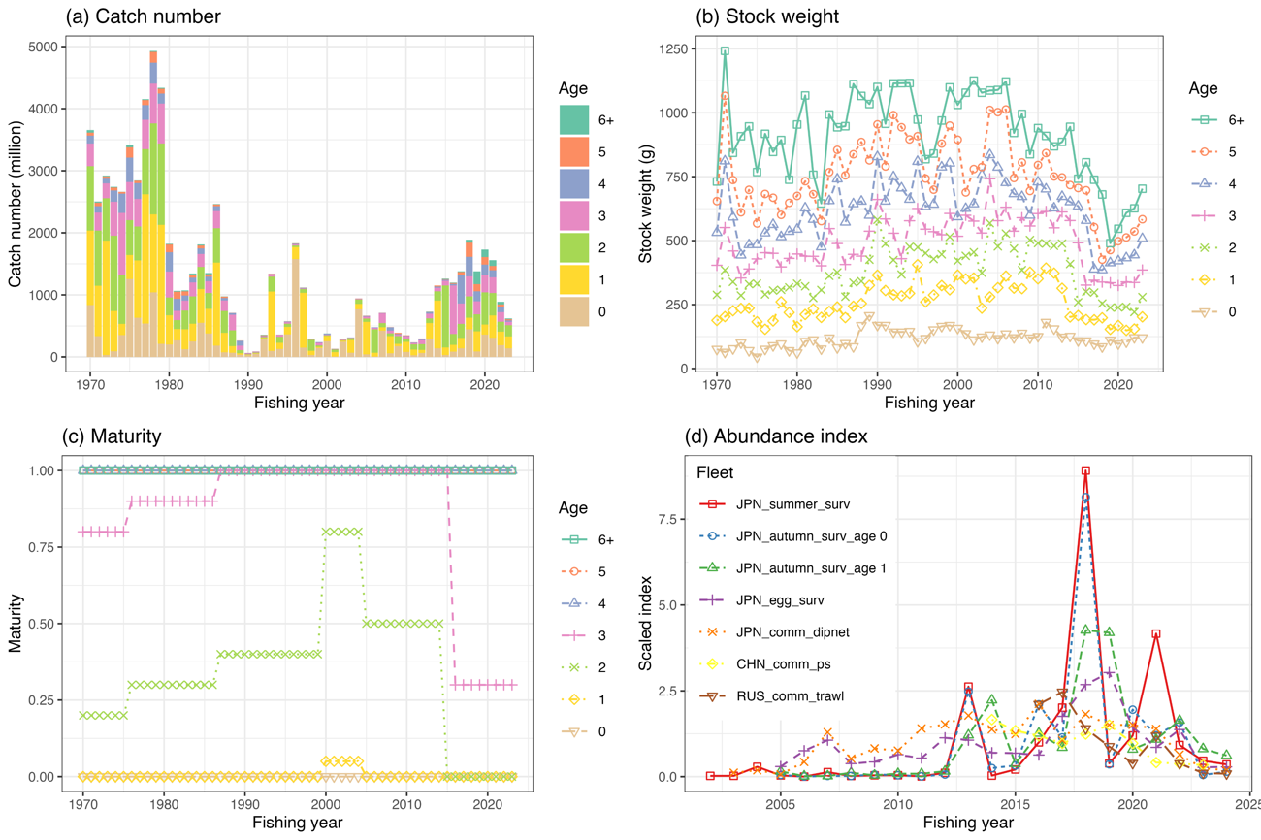
The time series data used for the base case scenario. (a) catch number by age, (b) weight by age, (c) maturity by age, (d) abundance index. Each abundance index is scaled by its mean value for visualization. Note that the five Japanese abundance indices and the Russian trawl CPUE are included through FY2024, but are not used in the S01-InitBase scenario.

Figure 2
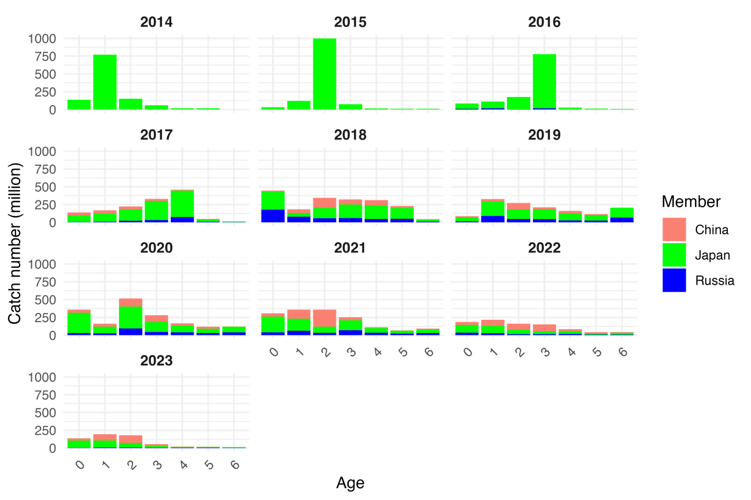
Catch number by member by age by year. Catch data from 1970 to 2013 are omitted here, but all time series data are shown NPFC-2025-TWG CMSA11-WP03.

Figure 3
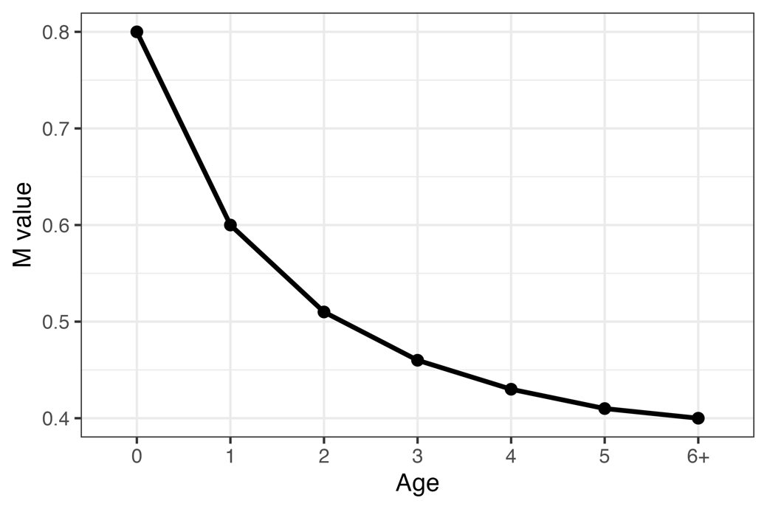

Natural mortality (M) values under the two candidate base case scenarios.

Figure 4
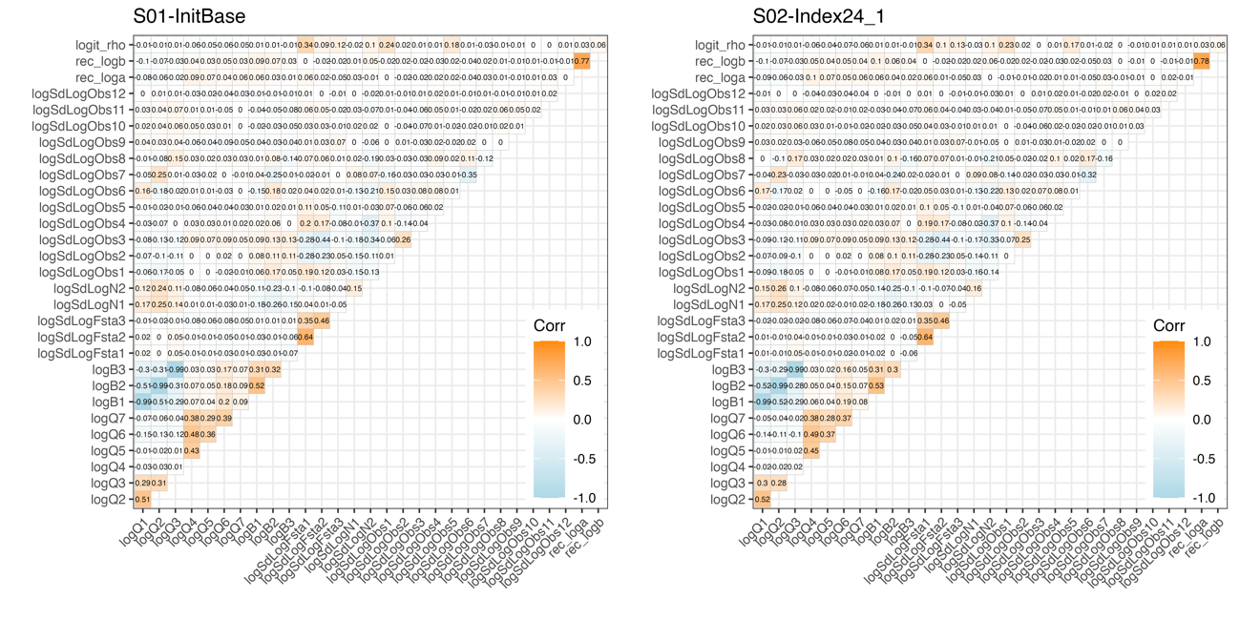
Plot of the correlation matrix obtained from the covariance matrix of the fixed effects parameter estimates. (left) Scenario S01-InitBase, and (right) Scenario S02-Index24_1. Orange colors indicate positive correlation, while light blue indicates negative correlation.

Figure 5
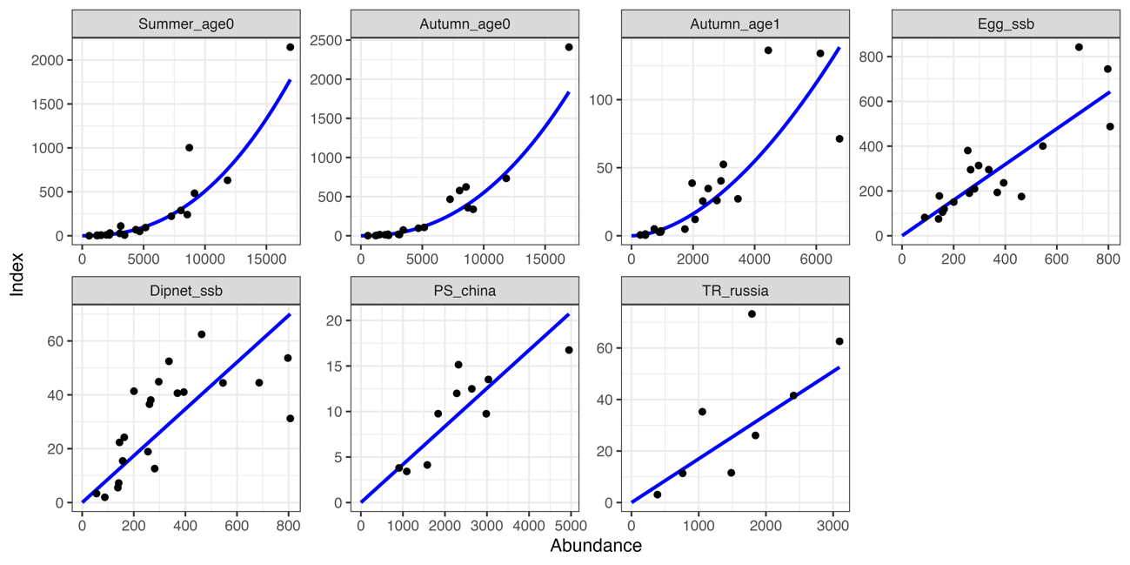
Relationship between the seven abundance indices and their corresponding abundance estimates under S01-InitBase. The blue lines indicate the precited relationships.

Figure 6

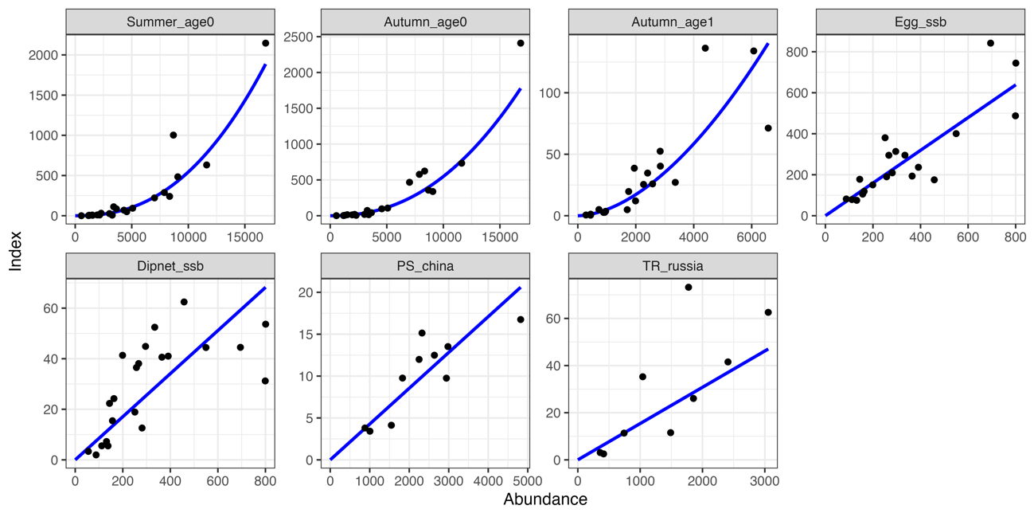
Same as Fig. 5 but for S02-Index24_1.

Figure 7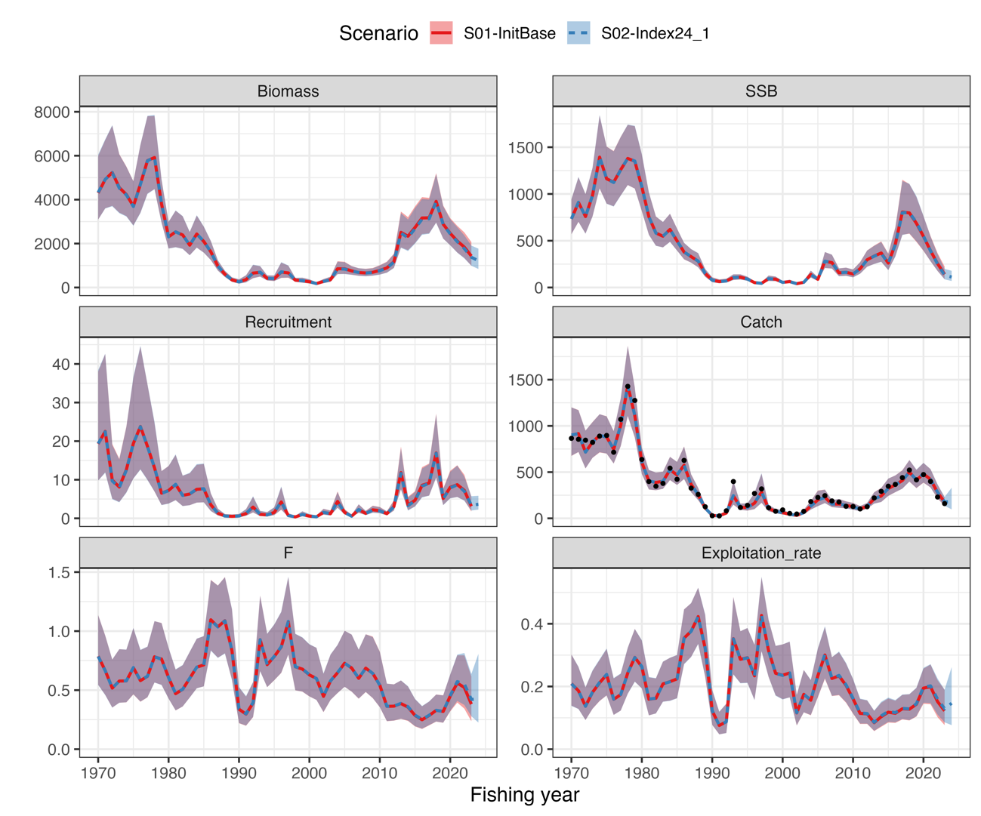
Time series of estimates of total biomass (1,000 MT), SSB (1,000 MT), recruitment (billion), catch (1,000 MT), mean F, and exploitation rate (catch divided by total biomass) under the two base case scenarios. Shaded areas indicate 95% confidence intervals. Black dots in catch indicate observed values which were calculated from the sum products of catch at age and stock weight at age.

Figure 8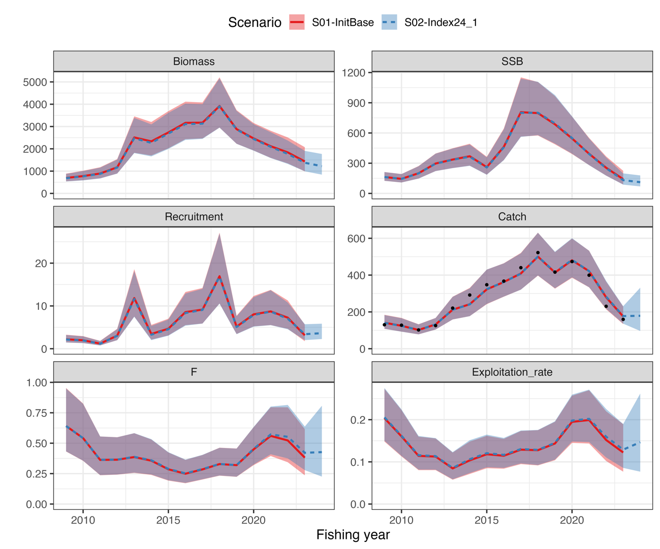
Time series of estimates of total biomass, SSB, recruitment, catch, mean F, and exploitation rate in recent years under the two scenarios. Shaded areas indicate 95% confidence intervals. Black dots in catch indicate observed values.

Figure 9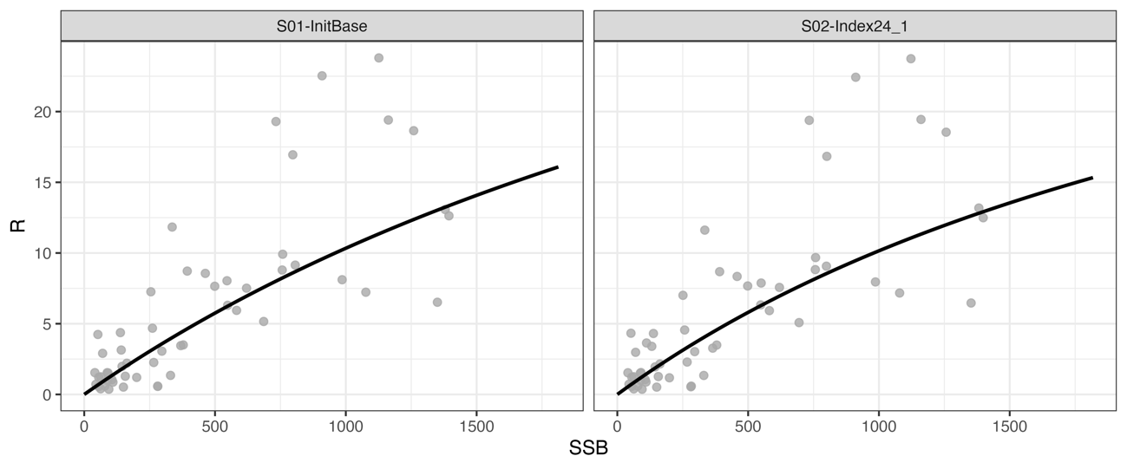
Beverton-Holt stock recruitment relationship under the two base case scenarios. The unit of SSB on the x-axis is 1000 MT and the unit of subscription on the y-axis is billions.

Figure 10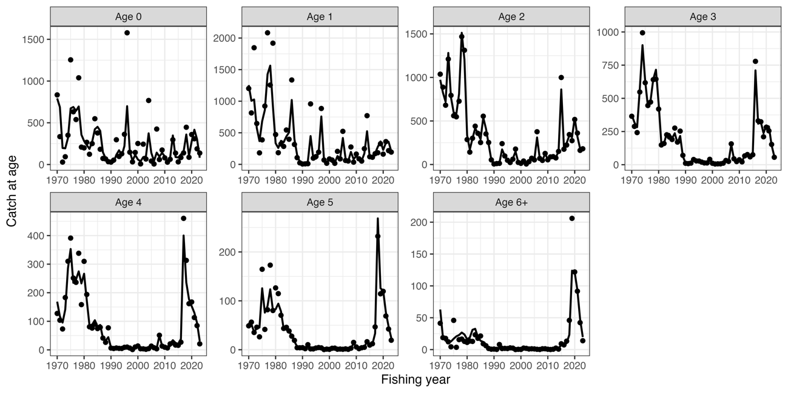
Observed catch numbers by age (dots) and their predicted values (lines) under S01-InitBase.

Figure 11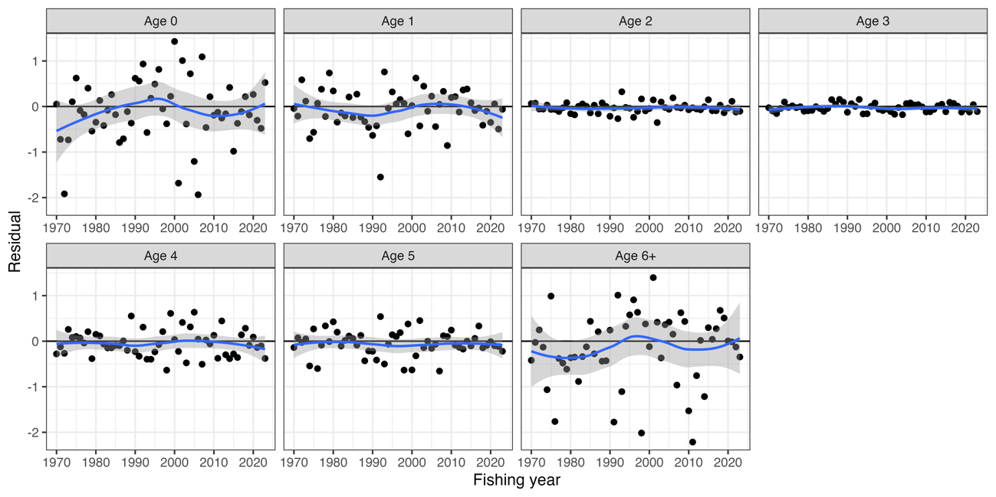
Residual plot for catch numbers by age under S01-InitBase . Blue curves and shaded areas indicate smoothed curves estimated by LOESS and their 95% confidence intervals.

Figure 12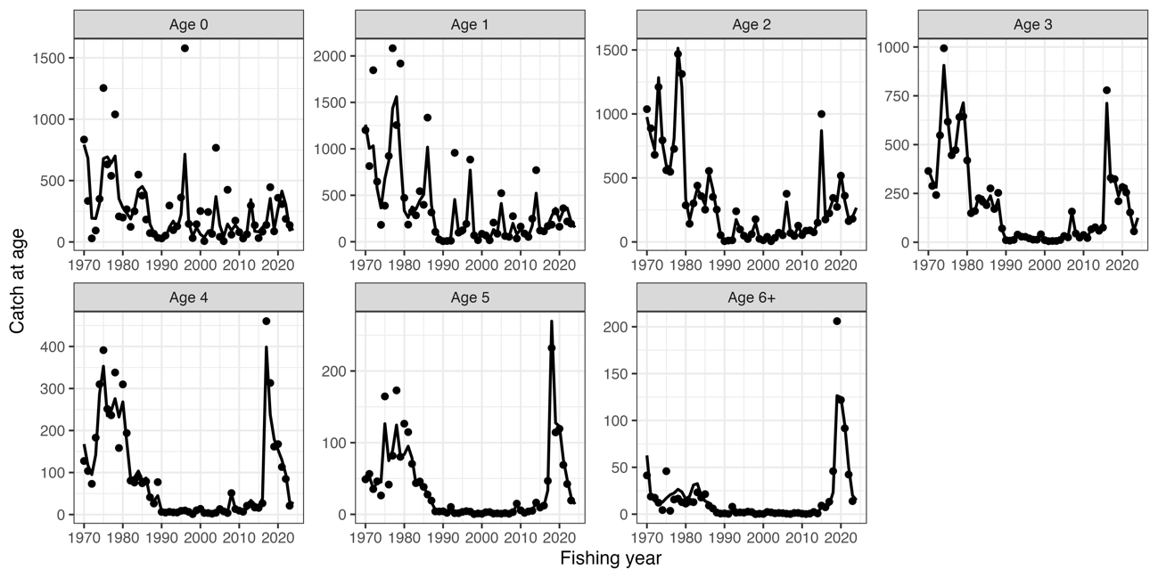
Same as Fig. 10 except that it is S02-Index24_1.

Figure 13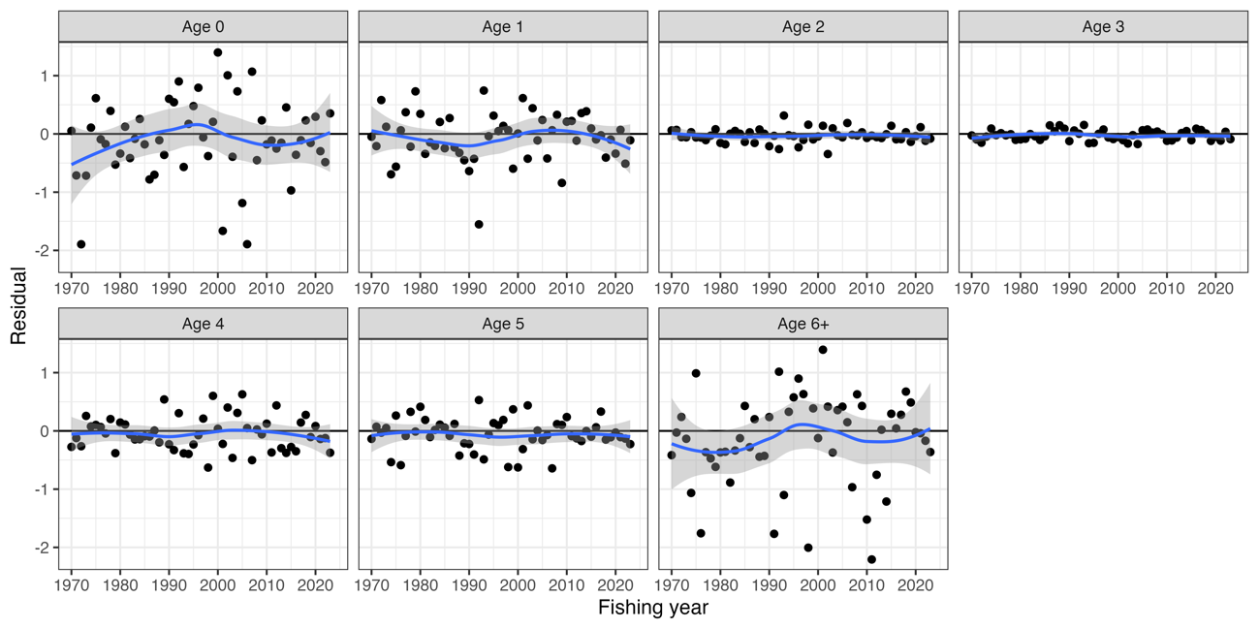
Same as Fig. 11 except that it is S02-Index24_1.

Figure 14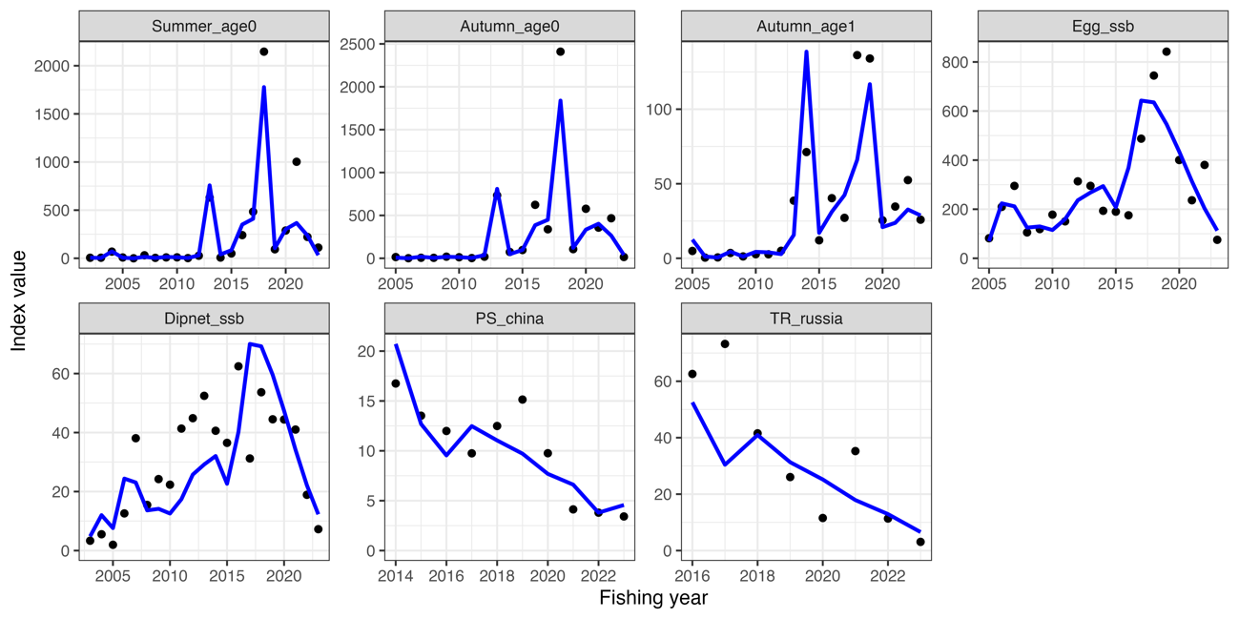
Trends of abundance indices used (dots) and their predicted values (lines) under S01-InitBase.

Figure 15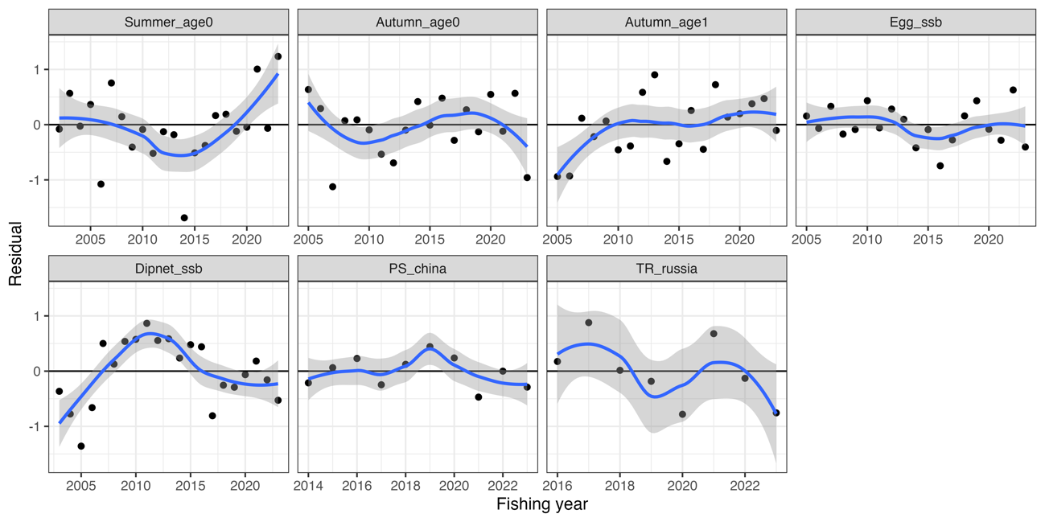
Residual plot for abundance indices under S01-InitBase. Blue curves and shaded areas indicate smoothed curves estimated by LOESS and their 95% confidence intervals.

Figure 16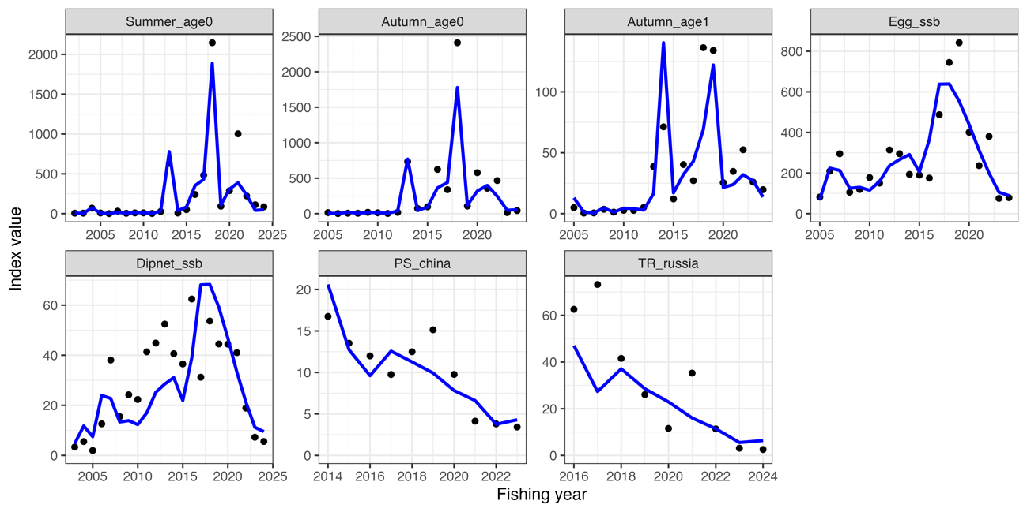
Same as Fig. 14 except that it is S02-Index24_1.

Figure 17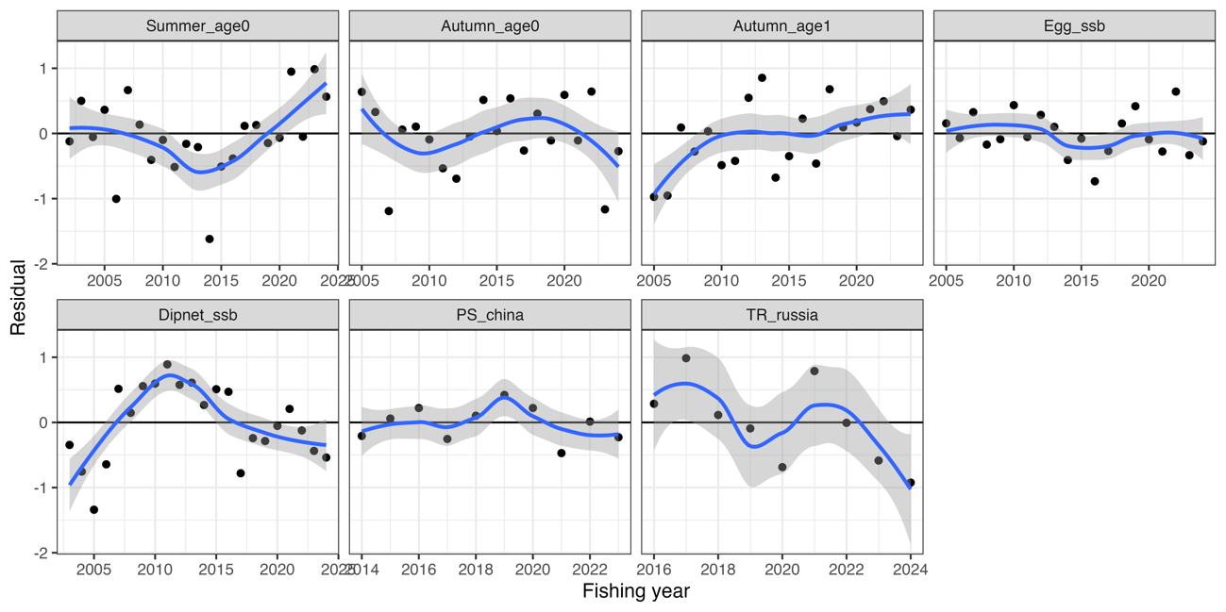
Same as Fig. 15 except that it is S02-Index24_1.

Figure 18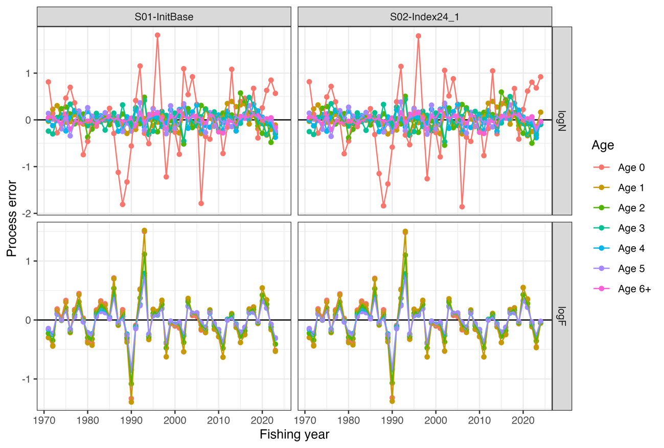
Process errors log(N) (top) and log(F) (bottom) under S01-InitBase (left) and S02-Index24_1 (right) scenarios.

Figure 19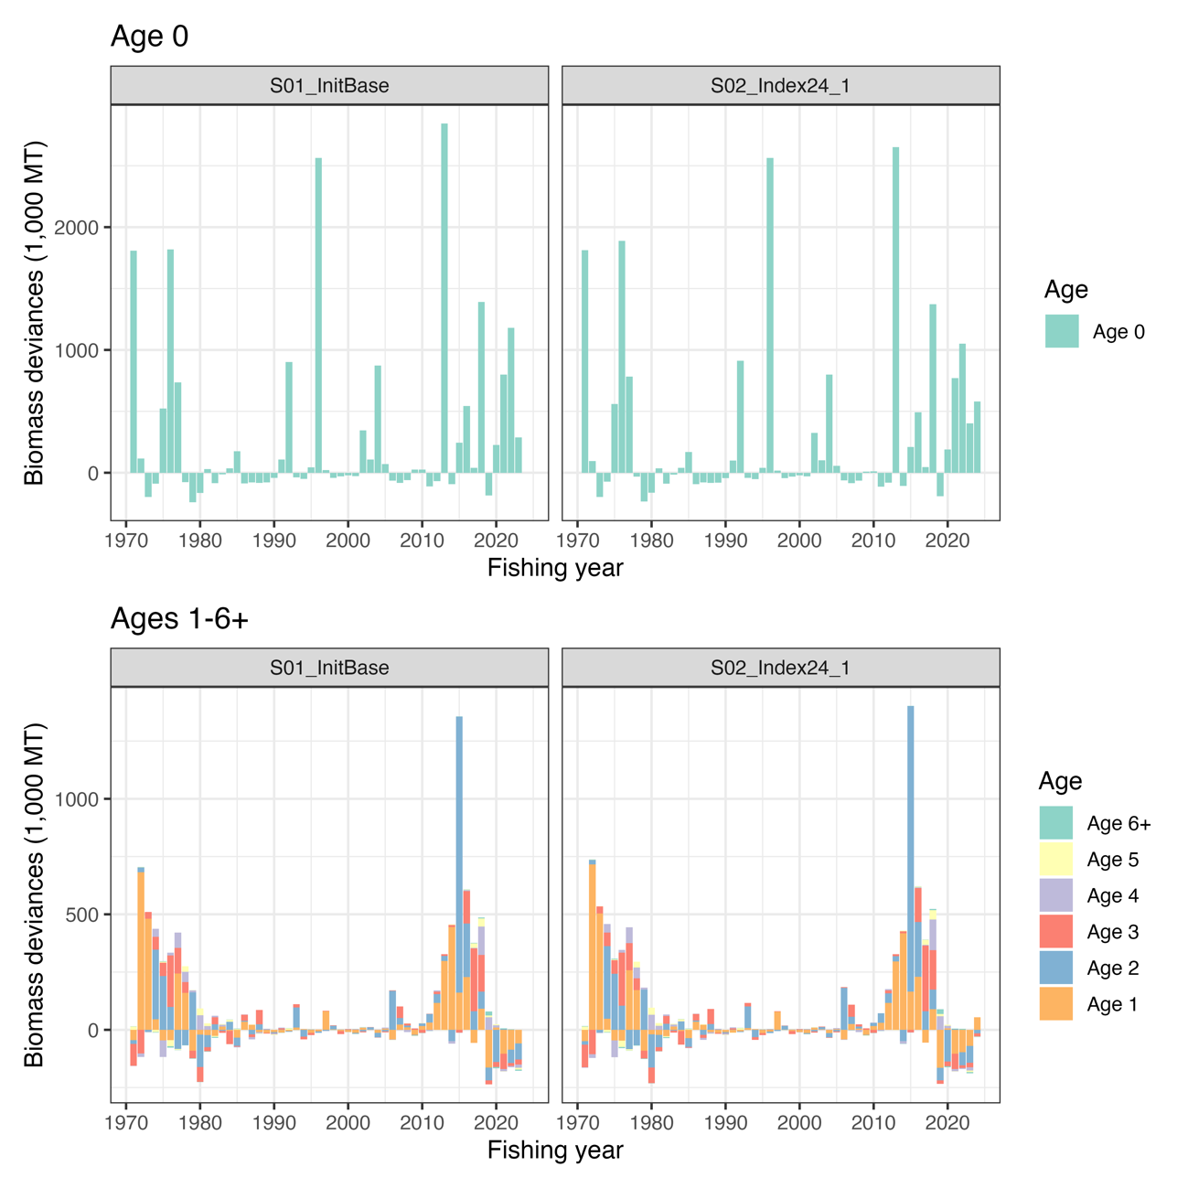
Deviances of abundances under S01-InitBase (left) and S02-Index24_1 (right) scenarios. Only Age 0 deviances are plotted separately (Top) because of the different scale of the observed deviances.

Figure 20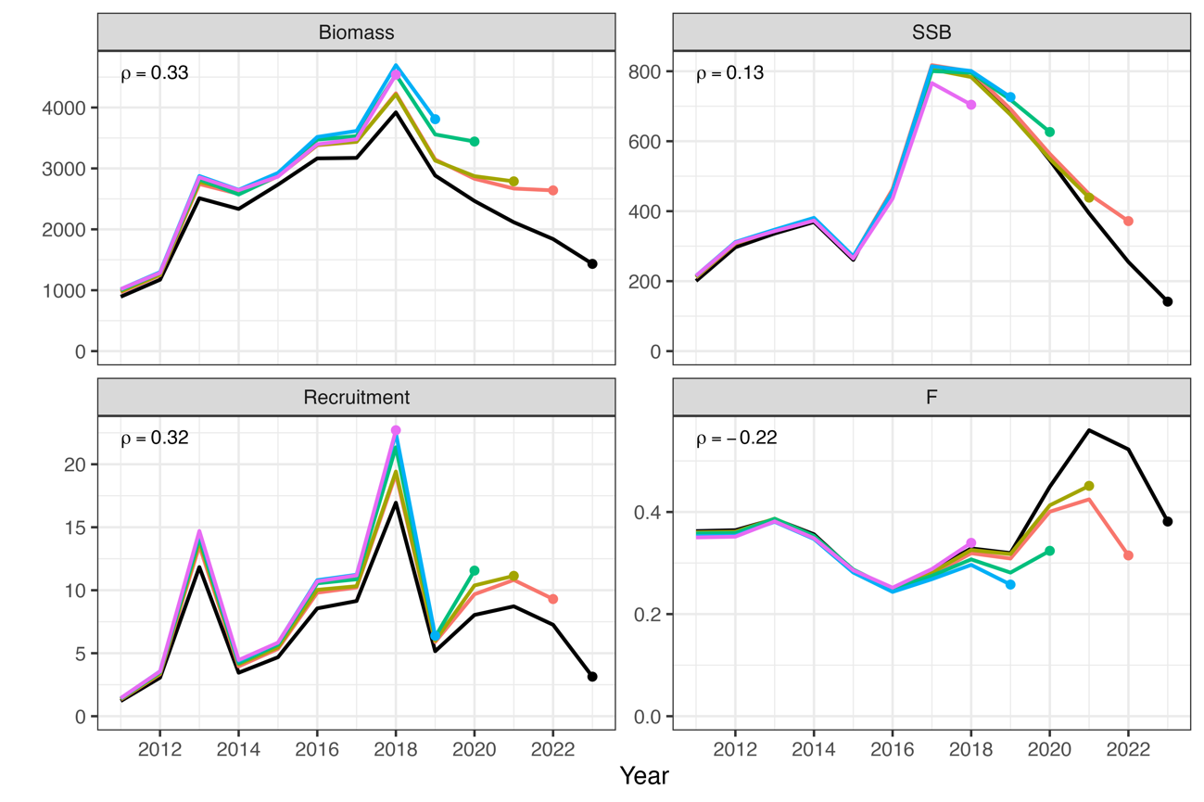
Retrospective patterns for total biomass (top left), SSB (top right), recruitment (bottom left), and mean F (bottom right) under S01-InitBase. Black Lines represent models with all data, and colored lines represent models with the most recent data trimmed. Mohn's rho is shown in the upper left corner. The dots indicate the terminal year for the calculation of Mohn’s rho.

Figure 21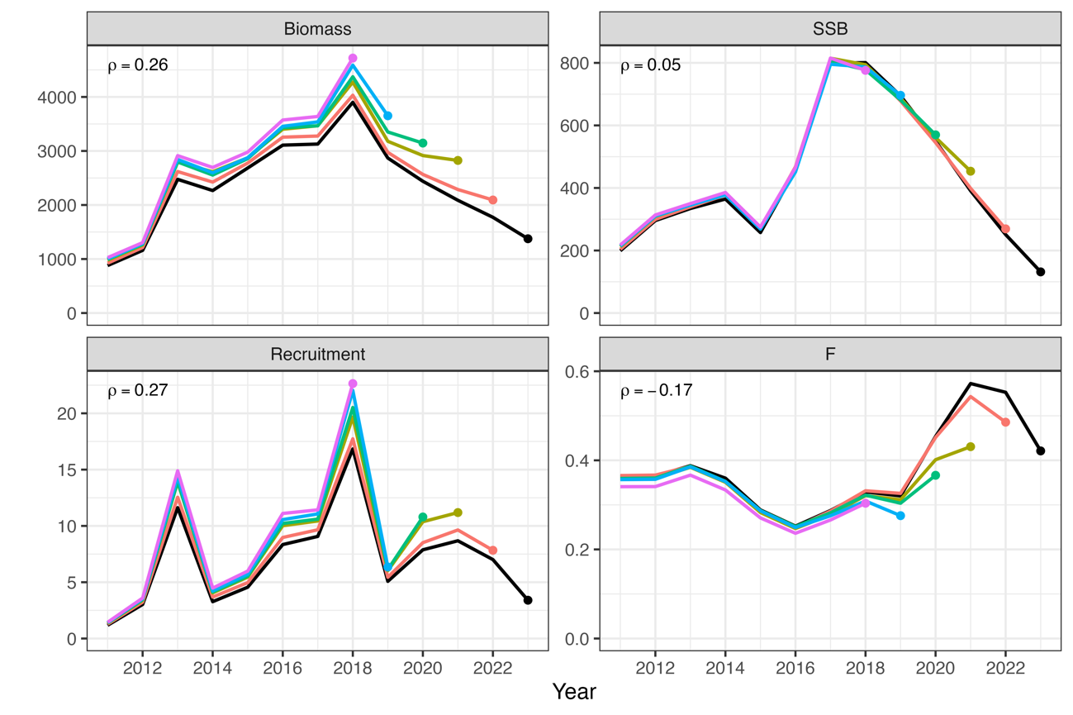
Same as Fig. 19 except that it is S02-Index24_1.

Figure 22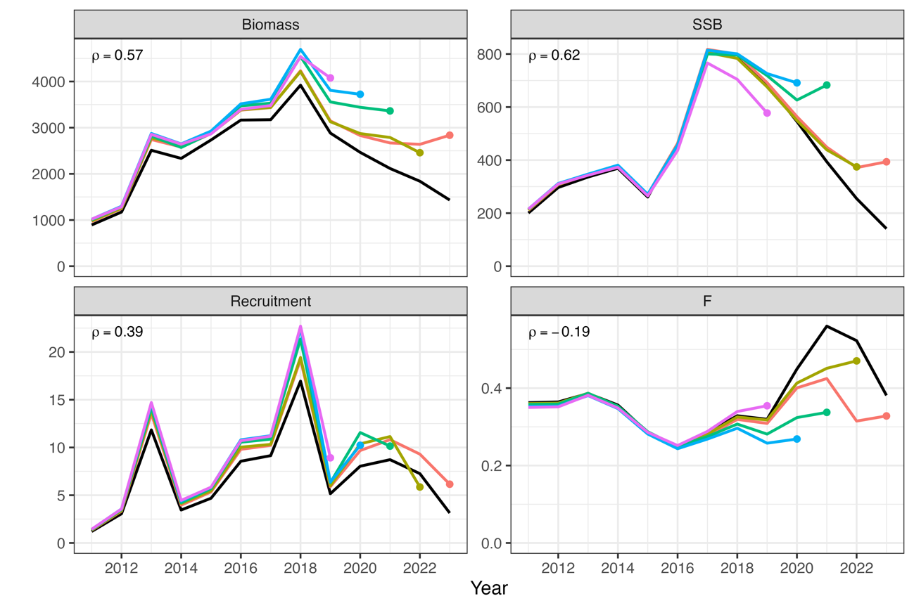
Patterns of retrospective forecasting for total biomass (top left), SSB (top right), recruitment (bottom left), and mean F (bottom right) for S01-InitBase. Black Lines represent models with all data, and colored lines represent models with the most recent data trimmed. Mohn's rho is shown in the upper left corner. The dots indicate the year of one-year-ahead forecasting, used for the calculation of Mohn’s rho.

Figure 23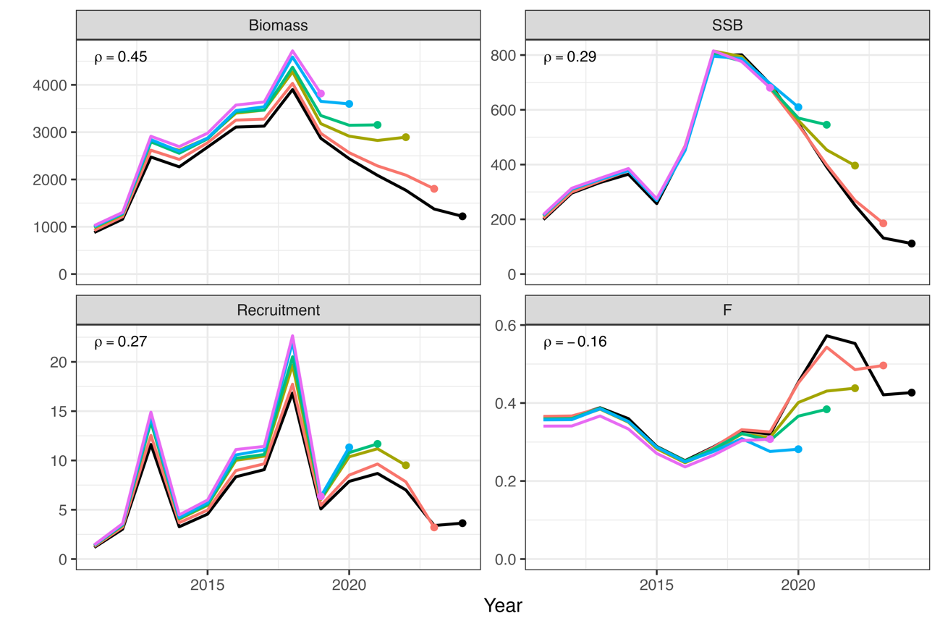
Same as Fig. 19 except that it is S02-Index24_1.

Figure 24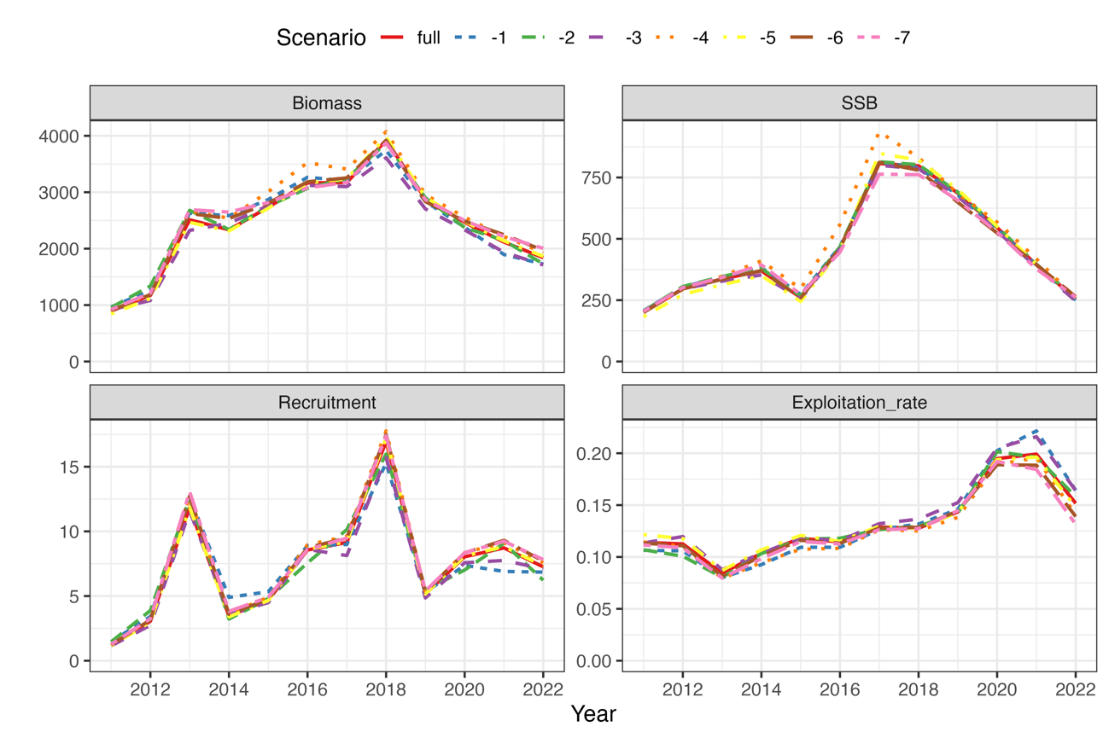
Comparison of the results of the estimates when all index values are used and when each indicator is excluded for S01-InitBase. The IDs of the index are as follows: (1) relative stock number of age 0 from the summer survey by Japan, (2) relative stock number of age 0 from the autumn survey by Japan, (3) relative stock number of age 1 from the autumn survey by Japan, (4) relative SSB from the egg survey by Japan, (5) relative SSB from the dip-net fishery by Japan, (6) relative vulnerable stock biomass from the light purse-seine fishery by China, and (7) relative vulnerable stock biomass from the trawl fishery by Russia.

Figure 25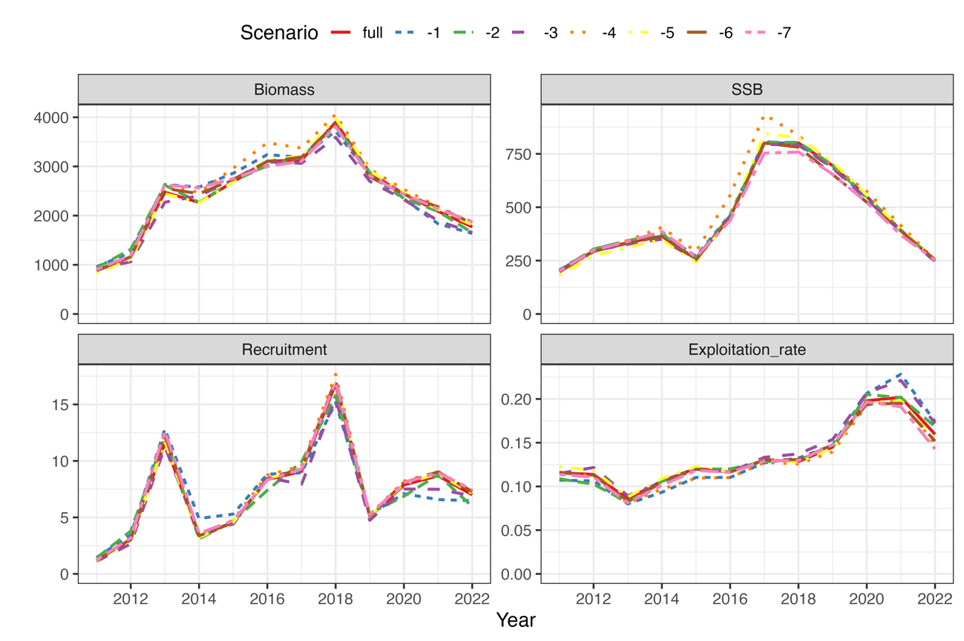
Same as Fig. 23 except that it is S02-Index24_1.

Figure 26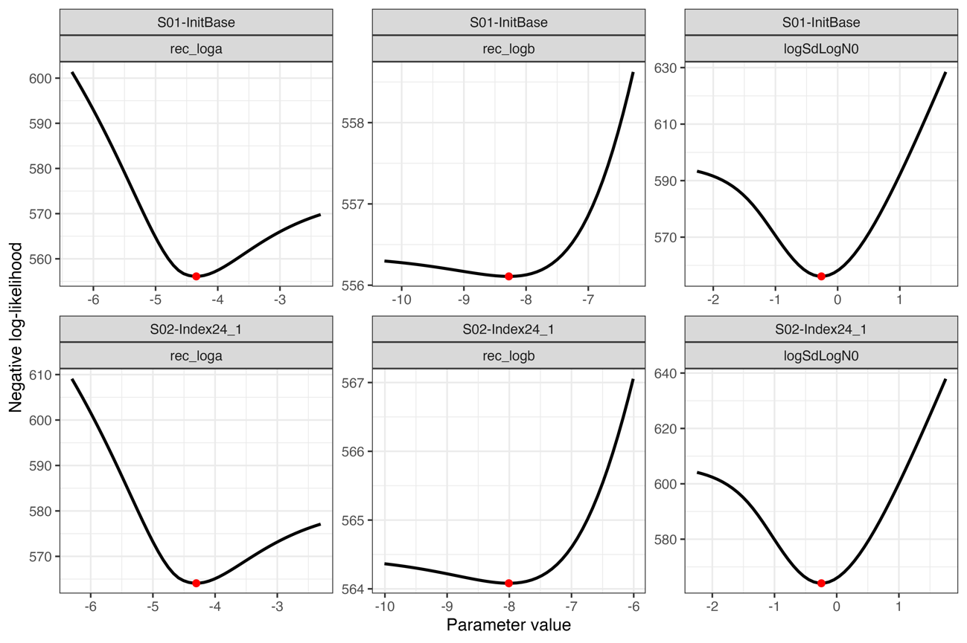
Changes in negative log-likelihoods by varying parameters related to the stock-recruitment relationship (α, β, ω₀ in log space).

Figure 27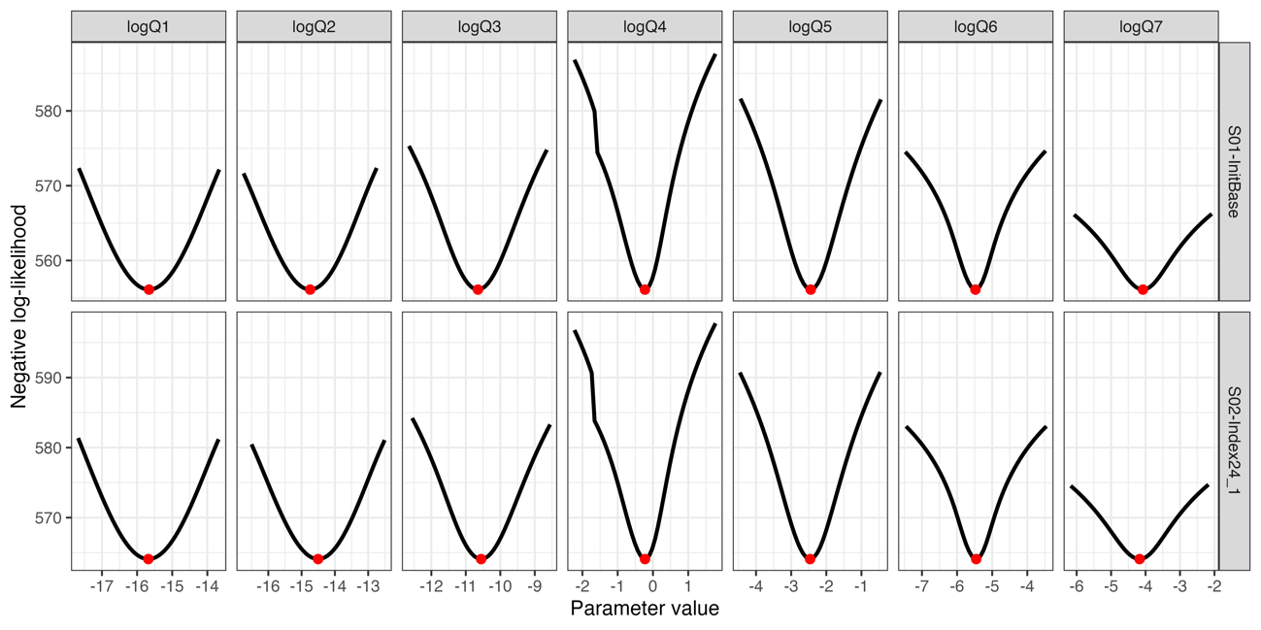
Changes in negative log-likelihoods by varying parameters of proportionality constants for abundance indices (q_{k} in log space). The red dotes indicate the input values for the base case scenarios.

Figure 28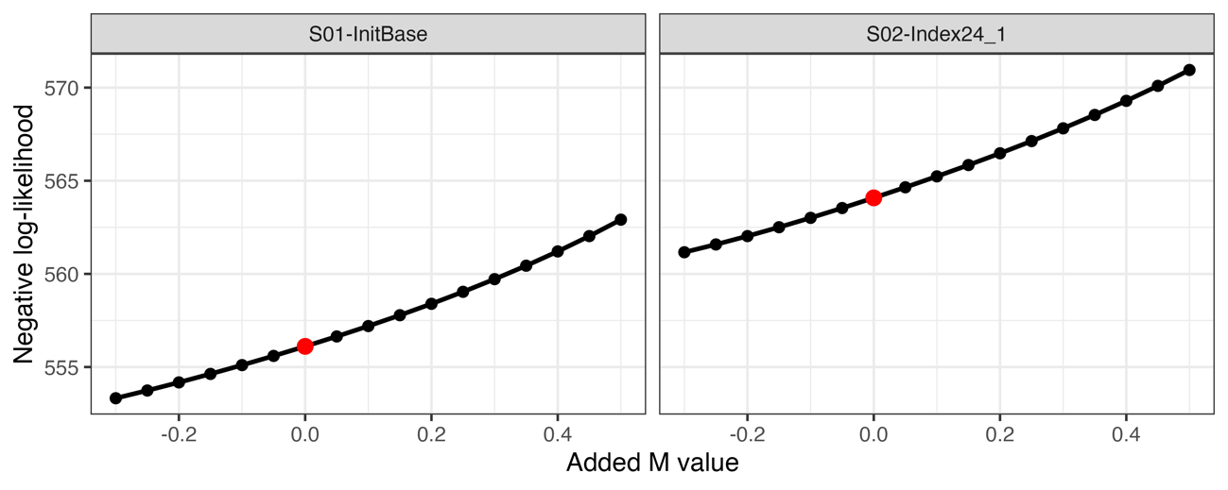
Changes in negative log-likelihood ay adding different M values. The red dotes indicate the input values for the base case scenarios.

Figure 29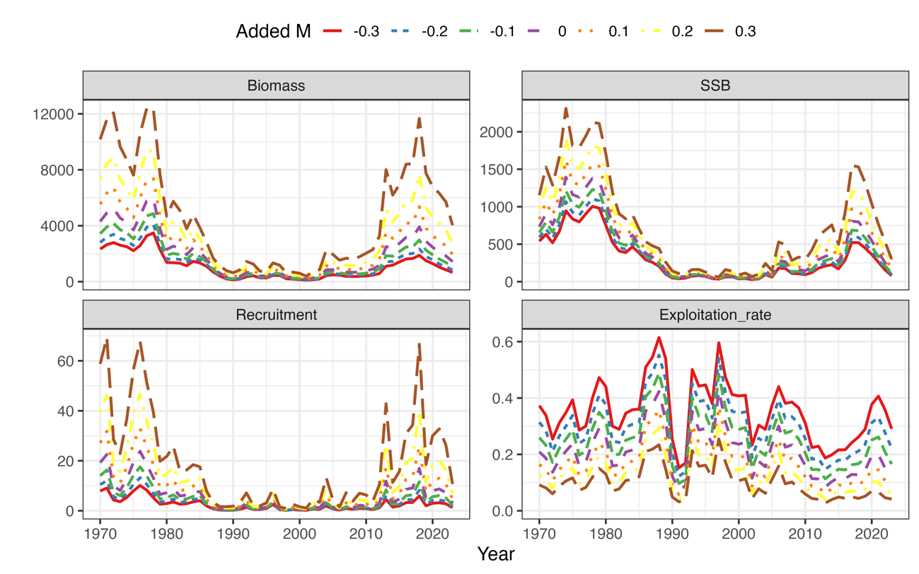

Effects of varying M values on the estimates total biomass, SSB, recruitment, and exploitation rate under S01-InitBase.

Figure 30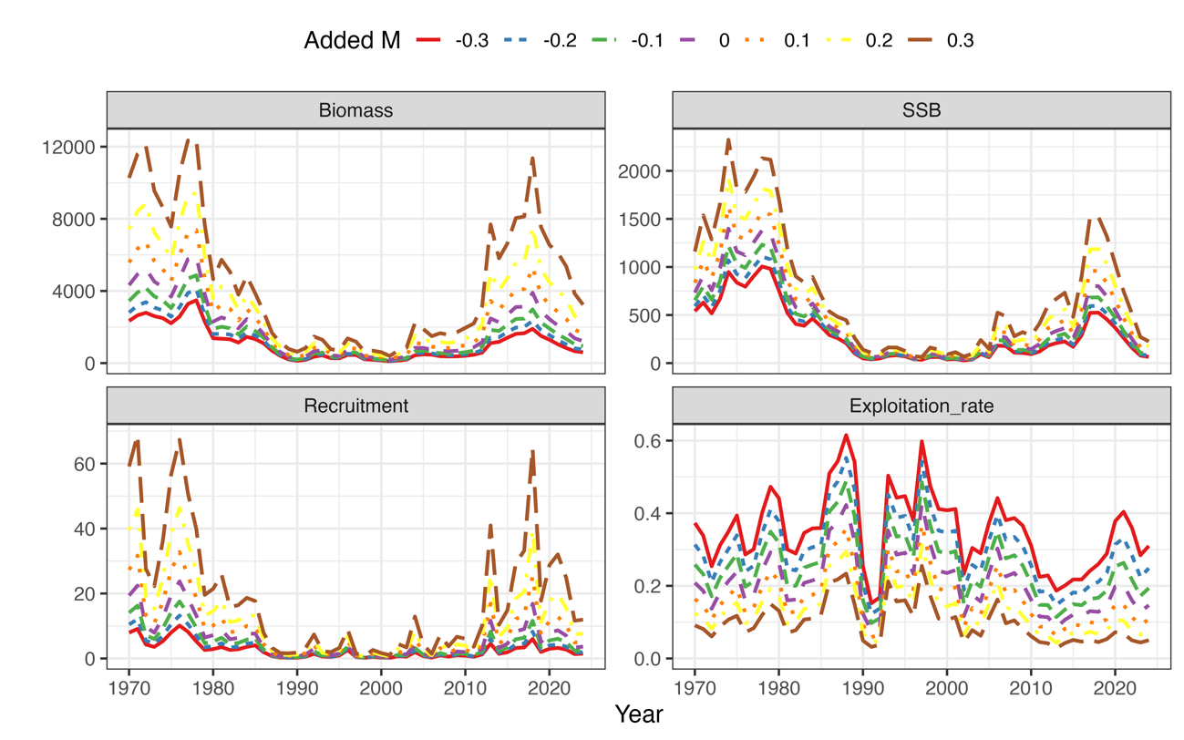
Same as Fig. 28 except that it is S02-Index24_1.

Figure 31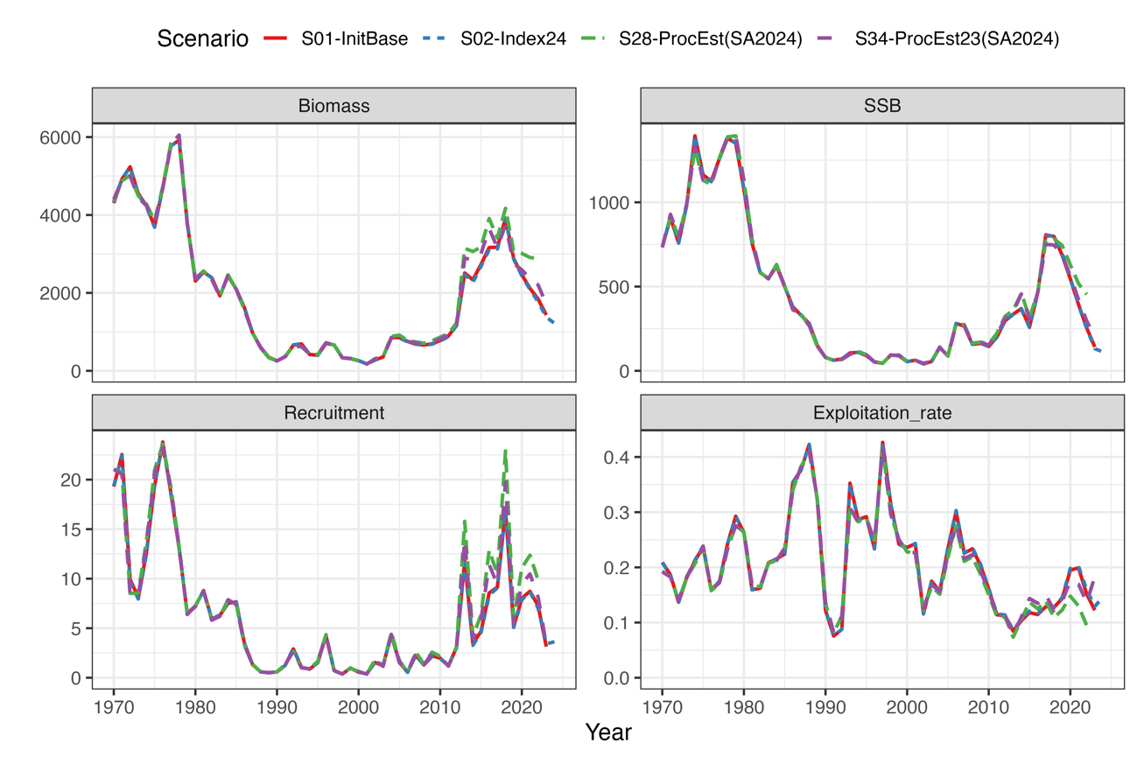
Comparison of the estimated population dynamics between current (red and blue for S01-InitBase and S02-Index24_1, respectively) and previous (S28ProcEst, denoted by green) stock assessments. Note that the purple line indicates S34-ProcEst23, a representative scenario in the previous stock assessment, in which the 2023 indices were used.

Figure 32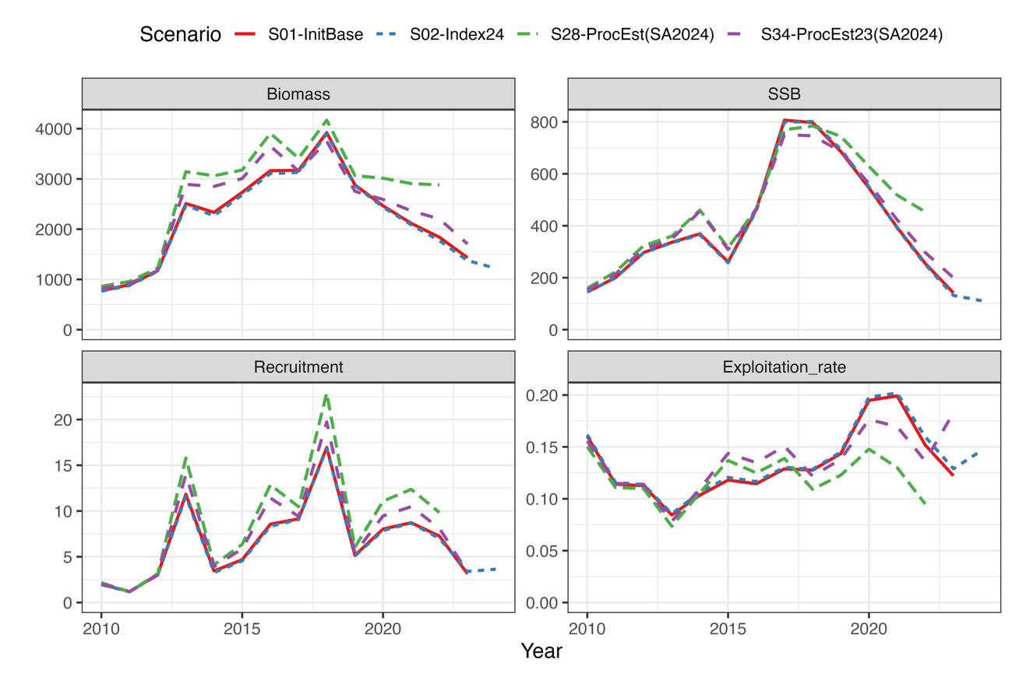
Same to Fig. 31, but focusing on the recent years.

Appendix A: Age-specific estimates of F, stock numbers and catch numbers

Table A1
Estimated F at age since FY1970 to2022 under S01-InitBase.
FY | Age 0 | Age 1 | Age 2 | Age 3 | Age 4 | Age 5 | Age 6+
1970 | 0.061 | 0.256 | 0.538 | 0.781 | 1.004 | 1.435 | 1.435
1971 | 0.045 | 0.189 | 0.428 | 0.664 | 0.862 | 1.236 | 1.236
1972 | 0.029 | 0.121 | 0.303 | 0.518 | 0.682 | 0.984 | 0.984
1973 | 0.035 | 0.142 | 0.338 | 0.573 | 0.761 | 1.096 | 1.096
1974 | 0.037 | 0.144 | 0.336 | 0.575 | 0.763 | 1.096 | 1.096
1975 | 0.051 | 0.194 | 0.412 | 0.674 | 0.900 | 1.297 | 1.297
1976 | 0.043 | 0.157 | 0.339 | 0.575 | 0.761 | 1.094 | 1.094
1977 | 0.051 | 0.184 | 0.371 | 0.611 | 0.800 | 1.151 | 1.151
1978 | 0.080 | 0.281 | 0.504 | 0.766 | 0.995 | 1.426 | 1.426
1979 | 0.083 | 0.284 | 0.498 | 0.753 | 0.966 | 1.380 | 1.380
1980 | 0.058 | 0.194 | 0.370 | 0.609 | 0.782 | 1.116 | 1.116
1981 | 0.039 | 0.126 | 0.269 | 0.483 | 0.618 | 0.877 | 0.877
1982 | 0.047 | 0.147 | 0.303 | 0.529 | 0.665 | 0.929 | 0.929
1983 | 0.064 | 0.198 | 0.381 | 0.631 | 0.781 | 1.073 | 1.073
1984 | 0.085 | 0.255 | 0.459 | 0.733 | 0.899 | 1.216 | 1.216
1985 | 0.089 | 0.262 | 0.471 | 0.762 | 0.929 | 1.242 | 1.242
1986 | 0.181 | 0.523 | 0.802 | 1.151 | 1.386 | 1.815 | 1.815
1987 | 0.170 | 0.476 | 0.747 | 1.101 | 1.327 | 1.718 | 1.718
1988 | 0.202 | 0.542 | 0.816 | 1.161 | 1.379 | 1.759 | 1.759
1989 | 0.145 | 0.374 | 0.606 | 0.914 | 1.076 | 1.360 | 1.360
1990 | 0.039 | 0.094 | 0.207 | 0.396 | 0.462 | 0.586 | 0.586
1991 | 0.036 | 0.084 | 0.186 | 0.355 | 0.405 | 0.508 | 0.508
1992 | 0.060 | 0.140 | 0.269 | 0.460 | 0.520 | 0.647 | 0.647
1993 | 0.266 | 0.632 | 0.816 | 1.009 | 1.100 | 1.336 | 1.336
1994 | 0.194 | 0.454 | 0.616 | 0.794 | 0.861 | 1.046 | 1.046
1995 | 0.233 | 0.543 | 0.689 | 0.853 | 0.926 | 1.122 | 1.122
1996 | 0.268 | 0.627 | 0.768 | 0.926 | 1.014 | 1.229 | 1.229
1997 | 0.368 | 0.871 | 0.994 | 1.118 | 1.233 | 1.488 | 1.488
1998 | 0.199 | 0.468 | 0.620 | 0.762 | 0.833 | 1.000 | 1.000
1999 | 0.187 | 0.443 | 0.598 | 0.740 | 0.818 | 0.981 | 0.981
2000 | 0.169 | 0.406 | 0.558 | 0.691 | 0.761 | 0.909 | 0.909
2001 | 0.149 | 0.368 | 0.528 | 0.661 | 0.730 | 0.877 | 0.877
2002 | 0.087 | 0.216 | 0.362 | 0.508 | 0.571 | 0.693 | 0.693
2003 | 0.122 | 0.312 | 0.494 | 0.646 | 0.724 | 0.875 | 0.875
2004 | 0.131 | 0.345 | 0.555 | 0.719 | 0.813 | 0.984 | 0.984
2005 | 0.139 | 0.377 | 0.623 | 0.809 | 0.919 | 1.115 | 1.115
2006 | 0.117 | 0.325 | 0.576 | 0.774 | 0.878 | 1.072 | 1.072
2007 | 0.096 | 0.263 | 0.493 | 0.687 | 0.772 | 0.945 | 0.945
2008 | 0.112 | 0.312 | 0.570 | 0.773 | 0.874 | 1.082 | 1.082
2009 | 0.096 | 0.270 | 0.520 | 0.725 | 0.822 | 1.030 | 1.030
2010 | 0.073 | 0.205 | 0.424 | 0.621 | 0.702 | 0.884 | 0.884
2011 | 0.039 | 0.109 | 0.263 | 0.431 | 0.482 | 0.607 | 0.607
2012 | 0.039 | 0.110 | 0.267 | 0.436 | 0.484 | 0.607 | 0.607
2013 | 0.044 | 0.123 | 0.292 | 0.465 | 0.508 | 0.636 | 0.636
2014 | 0.038 | 0.108 | 0.268 | 0.434 | 0.469 | 0.588 | 0.588
2015 | 0.026 | 0.074 | 0.203 | 0.353 | 0.382 | 0.480 | 0.480
2016 | 0.021 | 0.058 | 0.169 | 0.311 | 0.337 | 0.425 | 0.425
2017 | 0.025 | 0.069 | 0.197 | 0.351 | 0.383 | 0.484 | 0.484
2018 | 0.031 | 0.086 | 0.234 | 0.401 | 0.439 | 0.554 | 0.554
2019 | 0.030 | 0.082 | 0.225 | 0.389 | 0.427 | 0.542 | 0.542
2020 | 0.051 | 0.140 | 0.343 | 0.537 | 0.588 | 0.744 | 0.744
2021 | 0.072 | 0.198 | 0.448 | 0.659 | 0.721 | 0.912 | 0.912
2022 | 0.062 | 0.172 | 0.404 | 0.617 | 0.679 | 0.862 | 0.862
2023 | 0.038 | 0.104 | 0.273 | 0.459 | 0.506 | 0.645 | 0.645

Table A2
Same as Table A1 except it is S02-Index24_1.
FY | Age 0 | Age 1 | Age 2 | Age 3 | Age 4 | Age 5 | Age 6+
1970 | 0.061 | 0.256 | 0.538 | 0.781 | 1.004 | 1.435 | 1.435
1971 | 0.045 | 0.189 | 0.428 | 0.664 | 0.862 | 1.236 | 1.236
1972 | 0.029 | 0.121 | 0.303 | 0.518 | 0.682 | 0.984 | 0.984
1973 | 0.035 | 0.142 | 0.338 | 0.573 | 0.761 | 1.096 | 1.096
1974 | 0.037 | 0.144 | 0.336 | 0.575 | 0.763 | 1.096 | 1.096
1975 | 0.051 | 0.194 | 0.412 | 0.674 | 0.900 | 1.297 | 1.297
1976 | 0.043 | 0.157 | 0.339 | 0.575 | 0.761 | 1.094 | 1.094
1977 | 0.051 | 0.184 | 0.371 | 0.611 | 0.800 | 1.151 | 1.151
1978 | 0.080 | 0.281 | 0.504 | 0.766 | 0.995 | 1.426 | 1.426
1979 | 0.083 | 0.284 | 0.498 | 0.753 | 0.966 | 1.380 | 1.380
1980 | 0.058 | 0.194 | 0.370 | 0.609 | 0.782 | 1.116 | 1.116
1981 | 0.039 | 0.126 | 0.269 | 0.483 | 0.618 | 0.877 | 0.877
1982 | 0.047 | 0.147 | 0.303 | 0.529 | 0.665 | 0.929 | 0.929
1983 | 0.064 | 0.198 | 0.381 | 0.631 | 0.781 | 1.073 | 1.073
1984 | 0.085 | 0.255 | 0.459 | 0.733 | 0.899 | 1.216 | 1.216
1985 | 0.089 | 0.262 | 0.471 | 0.762 | 0.929 | 1.242 | 1.242
1986 | 0.181 | 0.523 | 0.802 | 1.151 | 1.386 | 1.815 | 1.815
1987 | 0.170 | 0.476 | 0.747 | 1.101 | 1.327 | 1.718 | 1.718
1988 | 0.202 | 0.542 | 0.816 | 1.161 | 1.379 | 1.759 | 1.759
1989 | 0.145 | 0.374 | 0.606 | 0.914 | 1.076 | 1.360 | 1.360
1990 | 0.039 | 0.094 | 0.207 | 0.396 | 0.462 | 0.586 | 0.586
1991 | 0.036 | 0.084 | 0.186 | 0.355 | 0.405 | 0.508 | 0.508
1992 | 0.060 | 0.140 | 0.269 | 0.460 | 0.520 | 0.647 | 0.647
1993 | 0.266 | 0.632 | 0.816 | 1.009 | 1.100 | 1.336 | 1.336
1994 | 0.194 | 0.454 | 0.616 | 0.794 | 0.861 | 1.046 | 1.046
1995 | 0.233 | 0.543 | 0.689 | 0.853 | 0.926 | 1.122 | 1.122
1996 | 0.268 | 0.627 | 0.768 | 0.926 | 1.014 | 1.229 | 1.229
1997 | 0.368 | 0.871 | 0.994 | 1.118 | 1.233 | 1.488 | 1.488
1998 | 0.199 | 0.468 | 0.620 | 0.762 | 0.833 | 1.000 | 1.000
1999 | 0.187 | 0.443 | 0.598 | 0.740 | 0.818 | 0.981 | 0.981
2000 | 0.169 | 0.406 | 0.558 | 0.691 | 0.761 | 0.909 | 0.909
2001 | 0.149 | 0.368 | 0.528 | 0.661 | 0.730 | 0.877 | 0.877
2002 | 0.087 | 0.216 | 0.362 | 0.508 | 0.571 | 0.693 | 0.693
2003 | 0.122 | 0.312 | 0.494 | 0.646 | 0.724 | 0.875 | 0.875
2004 | 0.131 | 0.345 | 0.555 | 0.719 | 0.813 | 0.984 | 0.984
2005 | 0.139 | 0.377 | 0.623 | 0.809 | 0.919 | 1.115 | 1.115
2006 | 0.117 | 0.325 | 0.576 | 0.774 | 0.878 | 1.072 | 1.072
2007 | 0.096 | 0.263 | 0.493 | 0.687 | 0.772 | 0.945 | 0.945
2008 | 0.112 | 0.312 | 0.570 | 0.773 | 0.874 | 1.082 | 1.082
2009 | 0.096 | 0.270 | 0.520 | 0.725 | 0.822 | 1.030 | 1.030
2010 | 0.073 | 0.205 | 0.424 | 0.621 | 0.702 | 0.884 | 0.884
2011 | 0.039 | 0.109 | 0.263 | 0.431 | 0.482 | 0.607 | 0.607
2012 | 0.039 | 0.110 | 0.267 | 0.436 | 0.484 | 0.607 | 0.607
2013 | 0.044 | 0.123 | 0.292 | 0.465 | 0.508 | 0.636 | 0.636
2014 | 0.038 | 0.108 | 0.268 | 0.434 | 0.469 | 0.588 | 0.588
2015 | 0.026 | 0.074 | 0.203 | 0.353 | 0.382 | 0.480 | 0.480
2016 | 0.021 | 0.058 | 0.169 | 0.311 | 0.337 | 0.425 | 0.425
2017 | 0.025 | 0.069 | 0.197 | 0.351 | 0.383 | 0.484 | 0.484
2018 | 0.031 | 0.086 | 0.234 | 0.401 | 0.439 | 0.554 | 0.554
2019 | 0.030 | 0.082 | 0.225 | 0.389 | 0.427 | 0.542 | 0.542
2020 | 0.051 | 0.140 | 0.343 | 0.537 | 0.588 | 0.744 | 0.744
2021 | 0.072 | 0.198 | 0.448 | 0.659 | 0.721 | 0.912 | 0.912
2022 | 0.062 | 0.172 | 0.404 | 0.617 | 0.679 | 0.862 | 0.862
2023 | 0.038 | 0.104 | 0.273 | 0.459 | 0.506 | 0.645 | 0.645

Table A3
Estimated stock number at age (million) since FY1970 to2022 under S01-InitBase.
FY | Age 0 | Age 1 | Age 2 | Age 3 | Age 4 | Age 5 | Age 6+
1970 | 19298.0 | 7290.3 | 2916.7 | 837.9 | 316.3 | 85.7 | 95.7
1971 | 22532.2 | 7693.4 | 2974.2 | 798.3 | 242.6 | 86.5 | 31.7
1972 | 9913.6 | 11887.4 | 3473.5 | 854.7 | 231.7 | 68.4 | 25.8
1973 | 8111.1 | 5740.3 | 5617.4 | 1605.7 | 318.1 | 77.4 | 24.5
1974 | 12630.4 | 3629.9 | 3389.9 | 2514.2 | 640.8 | 80.2 | 22.3
1975 | 19403.6 | 5099.2 | 2219.1 | 1564.1 | 709.2 | 202.1 | 27.3
1976 | 23796.2 | 7810.8 | 2555.4 | 1226.1 | 527.6 | 134.1 | 36.6
1977 | 18649.1 | 11199.3 | 3283.8 | 1289.8 | 534.5 | 153.4 | 39.1
1978 | 13075.1 | 8369.4 | 4775.6 | 1458.6 | 518.1 | 189.4 | 40.9
1979 | 6518.4 | 4867.6 | 3846.8 | 1640.1 | 446.7 | 125.9 | 36.8
1980 | 7228.7 | 2510.2 | 1361.3 | 1231.6 | 588.2 | 144.4 | 28.3
1981 | 8797.4 | 2893.0 | 912.8 | 517.5 | 451.6 | 191.0 | 38.3
1982 | 5944.0 | 3600.1 | 1447.6 | 477.1 | 212.8 | 153.2 | 60.5
1983 | 6303.7 | 2559.8 | 1653.1 | 613.2 | 195.1 | 76.6 | 58.1
1984 | 7513.1 | 2578.6 | 1213.5 | 541.1 | 208.6 | 68.2 | 33.2
1985 | 7649.6 | 2887.4 | 966.7 | 450.9 | 161.1 | 59.5 | 22.7
1986 | 3500.4 | 3244.2 | 1206.8 | 414.7 | 136.3 | 41.6 | 16.5
1987 | 1346.1 | 1368.4 | 969.4 | 291.3 | 65.4 | 23.8 | 6.9
1988 | 586.9 | 458.8 | 516.5 | 376.7 | 50.5 | 8.8 | 3.7
1989 | 518.4 | 158.2 | 144.8 | 129.3 | 79.9 | 7.8 | 1.5
1990 | 590.0 | 166.0 | 50.4 | 45.4 | 26.0 | 14.2 | 1.8
1991 | 1248.3 | 203.0 | 82.6 | 31.5 | 24.0 | 9.7 | 5.4
1992 | 2906.1 | 509.4 | 91.8 | 39.7 | 14.3 | 15.1 | 7.2
1993 | 1044.6 | 1232.9 | 383.6 | 63.3 | 13.7 | 4.5 | 7.6
1994 | 865.7 | 362.6 | 270.5 | 73.8 | 14.9 | 3.2 | 2.5
1995 | 1524.5 | 276.6 | 126.0 | 68.2 | 22.2 | 5.2 | 1.6
1996 | 4239.7 | 504.7 | 66.6 | 39.1 | 19.6 | 6.7 | 1.8
1997 | 714.4 | 1663.5 | 131.8 | 21.9 | 8.5 | 4.7 | 1.8
1998 | 367.3 | 223.0 | 404.2 | 31.9 | 4.3 | 1.2 | 0.9
1999 | 972.4 | 113.8 | 73.4 | 103.0 | 11.7 | 1.6 | 0.6
2000 | 556.9 | 327.6 | 40.6 | 27.7 | 29.5 | 2.8 | 0.6
2001 | 398.2 | 156.3 | 105.7 | 15.0 | 11.0 | 8.3 | 1.2
2002 | 1539.9 | 171.5 | 34.6 | 23.6 | 6.6 | 4.9 | 3.0
2003 | 1211.6 | 642.2 | 94.0 | 17.1 | 7.6 | 2.5 | 2.8
2004 | 4371.7 | 431.0 | 215.8 | 32.4 | 6.7 | 2.6 | 1.7
2005 | 1537.1 | 1735.4 | 150.2 | 65.4 | 13.8 | 1.9 | 1.2
2006 | 568.8 | 452.0 | 885.0 | 51.8 | 14.7 | 3.4 | 0.7
2007 | 2257.7 | 287.9 | 227.3 | 372.4 | 13.6 | 3.1 | 0.9
2008 | 1285.9 | 963.2 | 138.5 | 96.0 | 102.1 | 4.8 | 1.2
2009 | 2206.2 | 453.2 | 380.4 | 55.8 | 29.7 | 24.8 | 1.5
2010 | 1980.9 | 949.3 | 210.4 | 110.7 | 19.3 | 9.0 | 5.1
2011 | 1203.5 | 905.2 | 489.4 | 84.0 | 30.6 | 6.0 | 3.2
2012 | 3059.6 | 741.7 | 513.3 | 245.7 | 42.4 | 12.1 | 3.3
2013 | 11836.0 | 1968.6 | 404.2 | 248.4 | 102.8 | 15.0 | 5.8
2014 | 3451.7 | 6757.8 | 812.8 | 195.5 | 79.3 | 44.2 | 6.8
2015 | 4682.9 | 2065.1 | 5928.5 | 347.4 | 80.1 | 33.2 | 21.3
2016 | 8559.6 | 2906.3 | 1567.1 | 3278.0 | 163.4 | 39.9 | 24.4
2017 | 9144.6 | 3457.0 | 1737.9 | 1282.3 | 1526.3 | 104.5 | 31.4
2018 | 16945.9 | 4443.3 | 2020.7 | 1193.8 | 804.4 | 755.4 | 65.4
2019 | 5157.6 | 6133.9 | 1967.4 | 904.8 | 618.6 | 359.5 | 353.0
2020 | 8038.1 | 2316.6 | 2322.3 | 872.6 | 415.4 | 273.9 | 273.6
2021 | 8721.6 | 2490.8 | 1118.4 | 726.1 | 303.3 | 150.8 | 183.3
2022 | 7258.8 | 2985.3 | 692.9 | 388.0 | 229.4 | 97.7 | 98.2
2023 | 3139.0 | 2774.3 | 1058.7 | 208.0 | 93.4 | 60.7 | 49.2

Table A4
Same as Table A3 except that it is S02-Index24_1.
FY | Age 0 | Age 1 | Age 2 | Age 3 | Age 4 | Age 5 | Age 6+
1970 | 19380.9 | 7343.4 | 2939.5 | 838.9 | 315.0 | 85.6 | 95.5
1971 | 22429.1 | 7702.8 | 2996.1 | 797.9 | 242.7 | 86.8 | 31.7
1972 | 9678.2 | 11938.9 | 3473.4 | 852.5 | 231.1 | 68.5 | 26.0
1973 | 7954.7 | 5688.8 | 5622.7 | 1606.7 | 318.4 | 77.4 | 24.6
1974 | 12494.2 | 3568.8 | 3386.0 | 2526.1 | 643.8 | 79.5 | 22.3
1975 | 19444.0 | 5037.4 | 2202.7 | 1562.3 | 708.0 | 203.1 | 27.3
1976 | 23739.6 | 7805.7 | 2536.8 | 1224.6 | 527.4 | 132.0 | 36.4
1977 | 18543.2 | 11232.6 | 3267.4 | 1287.6 | 535.8 | 152.8 | 38.5
1978 | 13181.3 | 8360.5 | 4780.6 | 1458.0 | 520.4 | 191.0 | 40.5
1979 | 6465.1 | 4910.3 | 3869.3 | 1639.8 | 446.3 | 126.4 | 37.0
1980 | 7172.4 | 2500.6 | 1355.7 | 1231.2 | 592.1 | 146.0 | 28.4
1981 | 8826.1 | 2873.8 | 903.6 | 514.9 | 452.5 | 192.4 | 38.6
1982 | 5925.8 | 3607.2 | 1444.7 | 475.9 | 212.3 | 152.9 | 60.5
1983 | 6331.8 | 2554.9 | 1657.7 | 612.0 | 194.9 | 76.5 | 58.0
1984 | 7567.4 | 2587.5 | 1214.4 | 539.2 | 208.3 | 68.5 | 33.3
1985 | 7670.1 | 2898.8 | 964.3 | 450.5 | 160.7 | 59.6 | 22.8
1986 | 3492.1 | 3253.6 | 1212.7 | 417.4 | 136.2 | 41.5 | 16.5
1987 | 1341.8 | 1369.4 | 967.8 | 292.5 | 65.5 | 23.9 | 7.0
1988 | 587.3 | 456.8 | 519.5 | 380.1 | 50.4 | 8.8 | 3.7
1989 | 516.7 | 156.7 | 144.4 | 129.8 | 80.8 | 7.7 | 1.5
1990 | 592.3 | 164.0 | 49.5 | 44.9 | 25.8 | 14.2 | 1.8
1991 | 1252.4 | 201.1 | 81.7 | 31.4 | 23.8 | 9.5 | 5.3
1992 | 2977.9 | 505.8 | 90.4 | 39.5 | 14.3 | 15.2 | 7.1
1993 | 1047.5 | 1254.9 | 387.9 | 63.5 | 13.6 | 4.4 | 7.6
1994 | 877.0 | 363.4 | 271.3 | 73.5 | 14.9 | 3.2 | 2.5
1995 | 1546.5 | 278.3 | 126.0 | 67.8 | 22.1 | 5.2 | 1.6
1996 | 4328.1 | 507.9 | 66.1 | 39.1 | 19.5 | 6.7 | 1.8
1997 | 719.6 | 1687.9 | 131.4 | 21.9 | 8.5 | 4.7 | 1.8
1998 | 368.2 | 223.6 | 407.5 | 31.8 | 4.2 | 1.2 | 0.8
1999 | 988.1 | 113.3 | 73.2 | 102.7 | 11.8 | 1.6 | 0.6
2000 | 573.3 | 331.0 | 40.5 | 27.6 | 29.4 | 2.8 | 0.6
2001 | 392.7 | 158.1 | 106.3 | 15.0 | 11.0 | 8.2 | 1.2
2002 | 1532.9 | 170.0 | 34.1 | 23.4 | 6.7 | 5.0 | 3.0
2003 | 1220.5 | 643.4 | 94.0 | 17.0 | 7.5 | 2.5 | 2.8
2004 | 4309.6 | 432.0 | 215.2 | 32.2 | 6.8 | 2.6 | 1.7
2005 | 1505.3 | 1704.6 | 149.9 | 65.5 | 13.9 | 1.9 | 1.2
2006 | 542.0 | 439.8 | 885.6 | 51.8 | 14.6 | 3.4 | 0.7
2007 | 2289.9 | 280.2 | 225.7 | 375.2 | 13.5 | 3.0 | 0.9
2008 | 1264.3 | 958.7 | 137.2 | 95.9 | 102.1 | 4.8 | 1.2
2009 | 2155.1 | 443.3 | 380.0 | 55.7 | 29.7 | 24.7 | 1.6
2010 | 1946.5 | 929.0 | 209.0 | 110.6 | 19.4 | 9.1 | 5.1
2011 | 1176.5 | 887.8 | 485.2 | 83.6 | 30.4 | 6.0 | 3.1
2012 | 3026.4 | 728.5 | 509.7 | 245.2 | 42.6 | 12.0 | 3.3
2013 | 11618.7 | 1948.8 | 399.6 | 247.7 | 102.4 | 15.0 | 5.8
2014 | 3273.0 | 6571.3 | 799.7 | 193.9 | 78.3 | 44.0 | 6.8
2015 | 4556.7 | 1991.2 | 5864.9 | 342.3 | 79.2 | 32.8 | 21.2
2016 | 8343.5 | 2848.3 | 1532.7 | 3247.4 | 160.6 | 39.6 | 24.2
2017 | 9068.4 | 3363.3 | 1703.9 | 1272.7 | 1510.7 | 104.2 | 31.1
2018 | 16835.2 | 4398.4 | 2002.9 | 1192.1 | 811.2 | 757.9 | 65.4
2019 | 5079.3 | 6070.7 | 1952.3 | 901.2 | 626.0 | 364.9 | 360.2
2020 | 7877.4 | 2268.5 | 2300.5 | 866.6 | 415.4 | 276.8 | 279.6
2021 | 8680.4 | 2407.9 | 1091.5 | 711.6 | 298.8 | 149.8 | 185.3
2022 | 7008.4 | 2841.6 | 654.3 | 375.2 | 225.0 | 95.7 | 98.7
2023 | 3400.1 | 2579.3 | 934.3 | 189.4 | 86.3 | 56.9 | 46.5
2024 | 3638.7 | 1754.7 | 1253.7 | 386.1 | 71.8 | 32.8 | 34.6

Table A5
Predicted catch number at age (million) since FY1970 to2022 under S01-InitBase.
FY | Age 0 | Age 1 | Age 2 | Age 3 | Age 4 | Age 5 | Age 6+
1970 | 792.2 | 1255.3 | 972.7 | 375.0 | 168.7 | 56.1 | 62.9
1971 | 687.1 | 1006.4 | 826.0 | 318.2 | 117.4 | 52.4 | 19.3
1972 | 197.7 | 1027.5 | 719.8 | 282.5 | 95.4 | 36.3 | 13.7
1973 | 194.0 | 575.8 | 1281.4 | 573.3 | 141.5 | 43.8 | 13.9
1974 | 316.7 | 367.9 | 769.3 | 900.6 | 285.7 | 45.4 | 12.7
1975 | 672.4 | 683.1 | 597.0 | 630.3 | 353.1 | 125.7 | 17.1
1976 | 689.4 | 861.2 | 583.9 | 439.5 | 234.7 | 75.9 | 20.8
1977 | 643.3 | 1425.6 | 810.2 | 483.8 | 246.1 | 89.3 | 22.9
1978 | 695.3 | 1563.2 | 1512.6 | 644.1 | 274.7 | 123.6 | 26.8
1979 | 357.3 | 919.1 | 1207.0 | 715.4 | 232.5 | 80.9 | 23.8
1980 | 281.2 | 335.6 | 335.1 | 460.6 | 266.5 | 82.6 | 16.2
1981 | 233.4 | 260.1 | 170.6 | 161.9 | 172.9 | 94.2 | 19.0
1982 | 186.8 | 372.7 | 300.0 | 160.3 | 86.0 | 78.4 | 31.1
1983 | 271.8 | 349.8 | 416.6 | 235.5 | 88.3 | 42.8 | 32.6
1984 | 422.7 | 441.7 | 356.6 | 231.7 | 103.7 | 41.0 | 20.0
1985 | 451.7 | 506.5 | 290.2 | 198.3 | 81.8 | 36.2 | 13.8
1986 | 403.0 | 1019.5 | 539.1 | 237.1 | 87.1 | 30.2 | 12.0
1987 | 146.8 | 398.7 | 412.1 | 162.3 | 40.9 | 16.9 | 4.9
1988 | 74.9 | 148.3 | 233.5 | 216.5 | 32.2 | 6.4 | 2.7
1989 | 48.7 | 37.8 | 52.8 | 64.2 | 44.4 | 4.9 | 1.0
1990 | 15.5 | 11.2 | 7.4 | 12.1 | 8.0 | 5.3 | 0.7
1991 | 30.1 | 12.3 | 11.0 | 7.6 | 6.6 | 3.2 | 1.8
1992 | 116.7 | 50.3 | 17.2 | 11.9 | 4.8 | 6.0 | 2.9
1993 | 170.8 | 448.1 | 173.4 | 33.5 | 7.7 | 2.8 | 4.8
1994 | 106.6 | 101.8 | 100.0 | 33.4 | 7.2 | 1.8 | 1.4
1995 | 221.5 | 89.5 | 50.6 | 32.4 | 11.2 | 3.0 | 0.9
1996 | 699.0 | 182.3 | 28.9 | 19.6 | 10.5 | 4.1 | 1.1
1997 | 155.1 | 758.5 | 67.8 | 12.3 | 5.1 | 3.1 | 1.2
1998 | 46.2 | 64.2 | 150.2 | 14.0 | 2.0 | 0.7 | 0.5
1999 | 115.6 | 31.3 | 26.6 | 44.4 | 5.5 | 0.9 | 0.3
2000 | 60.4 | 83.8 | 13.9 | 11.4 | 13.1 | 1.4 | 0.3
2001 | 38.3 | 36.8 | 34.7 | 6.0 | 4.8 | 4.1 | 0.6
2002 | 89.0 | 25.3 | 8.4 | 7.7 | 2.4 | 2.1 | 1.3
2003 | 96.5 | 131.6 | 29.3 | 6.7 | 3.2 | 1.2 | 1.4
2004 | 373.9 | 96.2 | 73.6 | 13.7 | 3.1 | 1.4 | 0.9
2005 | 138.7 | 417.8 | 56.0 | 30.0 | 7.0 | 1.1 | 0.7
2006 | 43.7 | 95.7 | 311.0 | 23.0 | 7.2 | 1.9 | 0.4
2007 | 142.7 | 50.7 | 70.7 | 152.2 | 6.1 | 1.6 | 0.5
2008 | 94.6 | 197.2 | 48.3 | 42.7 | 49.8 | 2.7 | 0.7
2009 | 140.4 | 81.6 | 123.5 | 23.7 | 13.9 | 13.5 | 0.8
2010 | 96.4 | 133.8 | 57.9 | 42.0 | 8.1 | 4.5 | 2.6
2011 | 31.8 | 70.9 | 89.7 | 23.9 | 9.7 | 2.3 | 1.2
2012 | 81.0 | 58.5 | 95.3 | 70.7 | 13.4 | 4.6 | 1.3
2013 | 348.2 | 172.6 | 81.1 | 75.3 | 33.9 | 5.9 | 2.3
2014 | 89.9 | 524.9 | 151.2 | 56.1 | 24.5 | 16.4 | 2.6
2015 | 83.9 | 111.3 | 862.2 | 84.0 | 20.9 | 10.6 | 6.8
2016 | 120.9 | 122.8 | 192.6 | 710.7 | 38.4 | 11.5 | 7.1
2017 | 155.3 | 174.5 | 245.0 | 308.5 | 400.3 | 33.5 | 10.1
2018 | 359.8 | 277.6 | 333.9 | 321.0 | 235.8 | 268.7 | 23.3
2019 | 104.1 | 362.8 | 313.5 | 237.4 | 177.5 | 125.7 | 123.9
2020 | 275.9 | 229.8 | 535.5 | 296.4 | 153.2 | 120.9 | 121.2
2021 | 416.9 | 340.5 | 322.1 | 287.9 | 129.9 | 76.3 | 93.1
2022 | 303.1 | 357.6 | 183.5 | 146.6 | 94.1 | 47.7 | 48.1
2023 | 81.1 | 206.4 | 200.8 | 62.4 | 30.7 | 24.2 | 19.7

Table A6
Same as Table A5 except that it is S02-Index24_1.
FY | Age 0 | Age 1 | Age 2 | Age 3 | Age 4 | Age 5 | Age 6+
1970 | 792.7 | 1260.5 | 976.1 | 374.6 | 167.7 | 56.0 | 62.7
1971 | 681.5 | 1004.5 | 828.8 | 317.3 | 117.2 | 52.5 | 19.3
1972 | 193.1 | 1032.6 | 719.5 | 281.5 | 95.1 | 36.4 | 13.8
1973 | 190.8 | 572.3 | 1283.6 | 573.5 | 141.5 | 43.8 | 14.0
1974 | 315.3 | 364.1 | 771.1 | 906.0 | 287.2 | 45.1 | 12.7
1975 | 679.3 | 680.4 | 595.2 | 631.0 | 353.0 | 126.5 | 17.1
1976 | 693.3 | 867.8 | 583.0 | 440.2 | 235.1 | 74.8 | 20.7
1977 | 642.2 | 1436.3 | 808.7 | 483.8 | 247.0 | 89.1 | 22.5
1978 | 700.2 | 1561.5 | 1513.4 | 643.8 | 275.9 | 124.7 | 26.5
1979 | 352.8 | 924.3 | 1211.2 | 714.4 | 232.1 | 81.1 | 23.8
1980 | 279.0 | 334.5 | 334.2 | 460.6 | 268.3 | 83.5 | 16.3
1981 | 235.3 | 259.9 | 169.9 | 161.5 | 173.7 | 95.1 | 19.2
1982 | 186.4 | 374.5 | 300.4 | 160.1 | 85.9 | 78.4 | 31.1
1983 | 272.5 | 349.2 | 418.1 | 235.1 | 88.3 | 42.8 | 32.6
1984 | 425.0 | 443.3 | 357.0 | 230.9 | 103.6 | 41.2 | 20.1
1985 | 452.2 | 508.7 | 289.6 | 198.1 | 81.6 | 36.2 | 13.9
1986 | 399.2 | 1018.2 | 539.6 | 238.2 | 86.9 | 30.2 | 12.0
1987 | 145.8 | 398.5 | 410.7 | 162.8 | 40.9 | 17.0 | 5.0
1988 | 74.6 | 147.3 | 234.3 | 218.2 | 32.1 | 6.3 | 2.7
1989 | 48.5 | 37.5 | 52.8 | 64.5 | 44.9 | 4.9 | 1.0
1990 | 15.7 | 11.3 | 7.4 | 12.0 | 8.0 | 5.3 | 0.7
1991 | 30.5 | 12.4 | 11.1 | 7.7 | 6.6 | 3.2 | 1.8
1992 | 120.6 | 50.5 | 17.1 | 11.9 | 4.8 | 6.1 | 2.9
1993 | 170.2 | 454.7 | 174.9 | 33.6 | 7.6 | 2.8 | 4.8
1994 | 107.8 | 102.0 | 100.3 | 33.3 | 7.2 | 1.8 | 1.4
1995 | 224.6 | 90.1 | 50.6 | 32.2 | 11.2 | 3.0 | 0.9
1996 | 714.4 | 183.9 | 28.7 | 19.6 | 10.5 | 4.1 | 1.1
1997 | 156.3 | 770.8 | 67.6 | 12.3 | 5.1 | 3.1 | 1.2
1998 | 46.2 | 64.4 | 151.5 | 14.0 | 2.0 | 0.6 | 0.5
1999 | 117.5 | 31.3 | 26.5 | 44.3 | 5.5 | 0.9 | 0.3
2000 | 62.2 | 84.9 | 13.9 | 11.4 | 13.1 | 1.4 | 0.3
2001 | 37.6 | 37.2 | 34.9 | 6.0 | 4.8 | 4.0 | 0.6
2002 | 89.2 | 25.3 | 8.3 | 7.6 | 2.4 | 2.1 | 1.3
2003 | 97.3 | 132.2 | 29.4 | 6.7 | 3.2 | 1.2 | 1.4
2004 | 369.7 | 96.9 | 73.6 | 13.6 | 3.2 | 1.4 | 0.9
2005 | 136.1 | 412.0 | 55.9 | 30.0 | 7.0 | 1.1 | 0.7
2006 | 41.8 | 93.8 | 312.1 | 23.1 | 7.2 | 1.9 | 0.4
2007 | 145.9 | 49.9 | 70.6 | 153.6 | 6.1 | 1.6 | 0.5
2008 | 93.6 | 198.1 | 48.0 | 42.7 | 49.8 | 2.7 | 0.7
2009 | 137.8 | 80.4 | 123.6 | 23.7 | 13.9 | 13.5 | 0.9
2010 | 95.3 | 132.1 | 57.8 | 42.0 | 8.1 | 4.5 | 2.5
2011 | 31.4 | 70.6 | 89.8 | 23.9 | 9.6 | 2.3 | 1.2
2012 | 80.7 | 58.2 | 95.4 | 70.7 | 13.5 | 4.6 | 1.3
2013 | 345.0 | 173.4 | 81.0 | 75.4 | 33.8 | 5.9 | 2.3
2014 | 86.7 | 522.5 | 151.4 | 56.1 | 24.4 | 16.5 | 2.5
2015 | 82.8 | 109.9 | 869.5 | 83.6 | 20.9 | 10.5 | 6.8
2016 | 119.6 | 123.5 | 192.5 | 711.8 | 38.1 | 11.5 | 7.0
2017 | 154.8 | 172.8 | 244.3 | 308.6 | 398.6 | 33.5 | 10.1
2018 | 354.2 | 276.4 | 333.9 | 321.3 | 238.0 | 269.6 | 23.4
2019 | 101.1 | 360.2 | 313.8 | 237.0 | 179.8 | 127.6 | 126.5
2020 | 267.7 | 227.1 | 537.6 | 296.5 | 154.2 | 122.8 | 124.6
2021 | 414.6 | 336.1 | 321.5 | 286.4 | 129.9 | 76.8 | 95.4
2022 | 305.0 | 363.0 | 183.0 | 147.2 | 96.0 | 48.4 | 50.1
2023 | 96.5 | 216.4 | 195.9 | 61.1 | 30.5 | 24.3 | 20.0

Appendix B: Additional model diagnostics
Figure B1
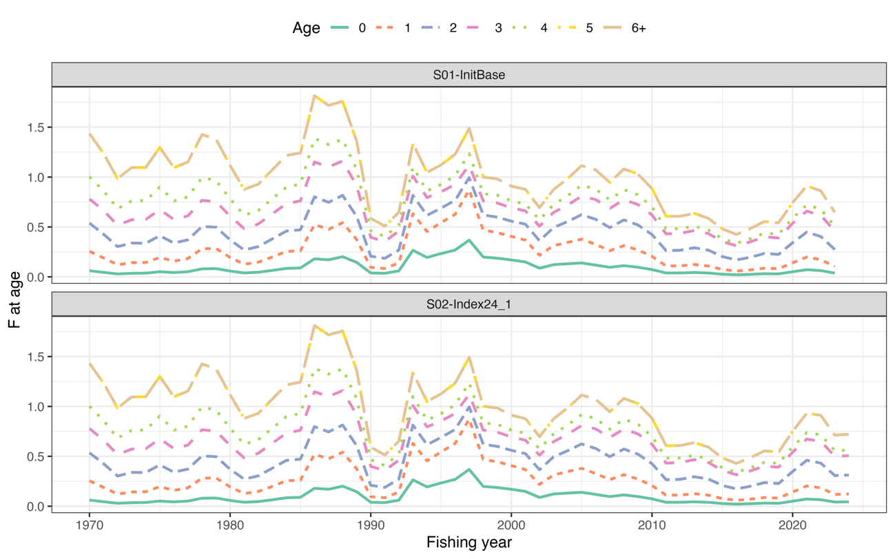
Estimated dynamics of F-at-age for the two candidate base case scenarios.

Figure B2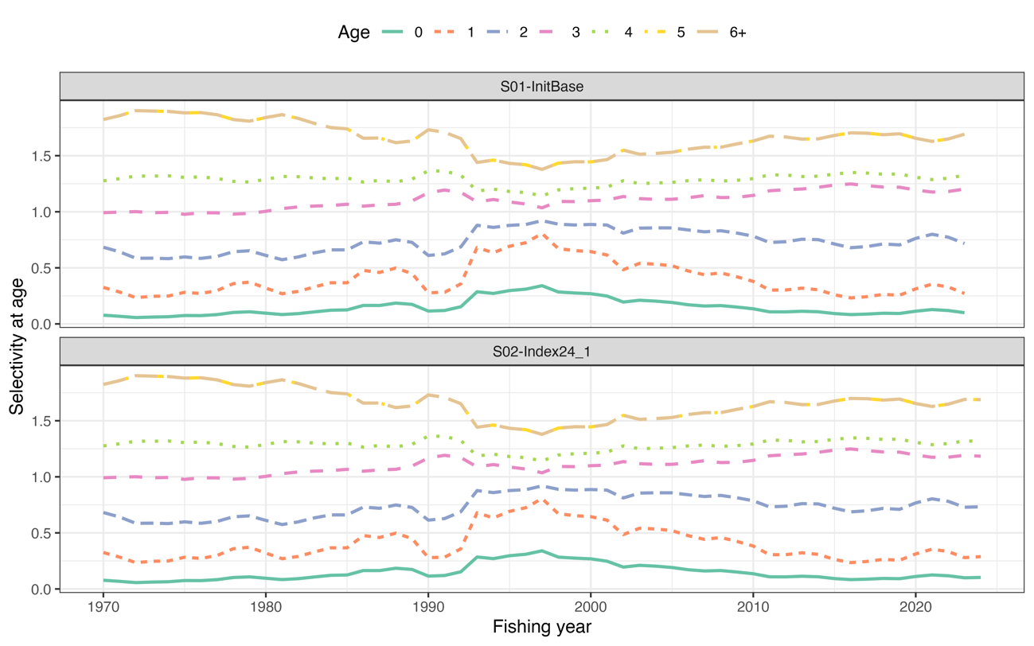
Estimated dynamics of selectivity-at-age for the two candidate base case scenarios.

Figure B3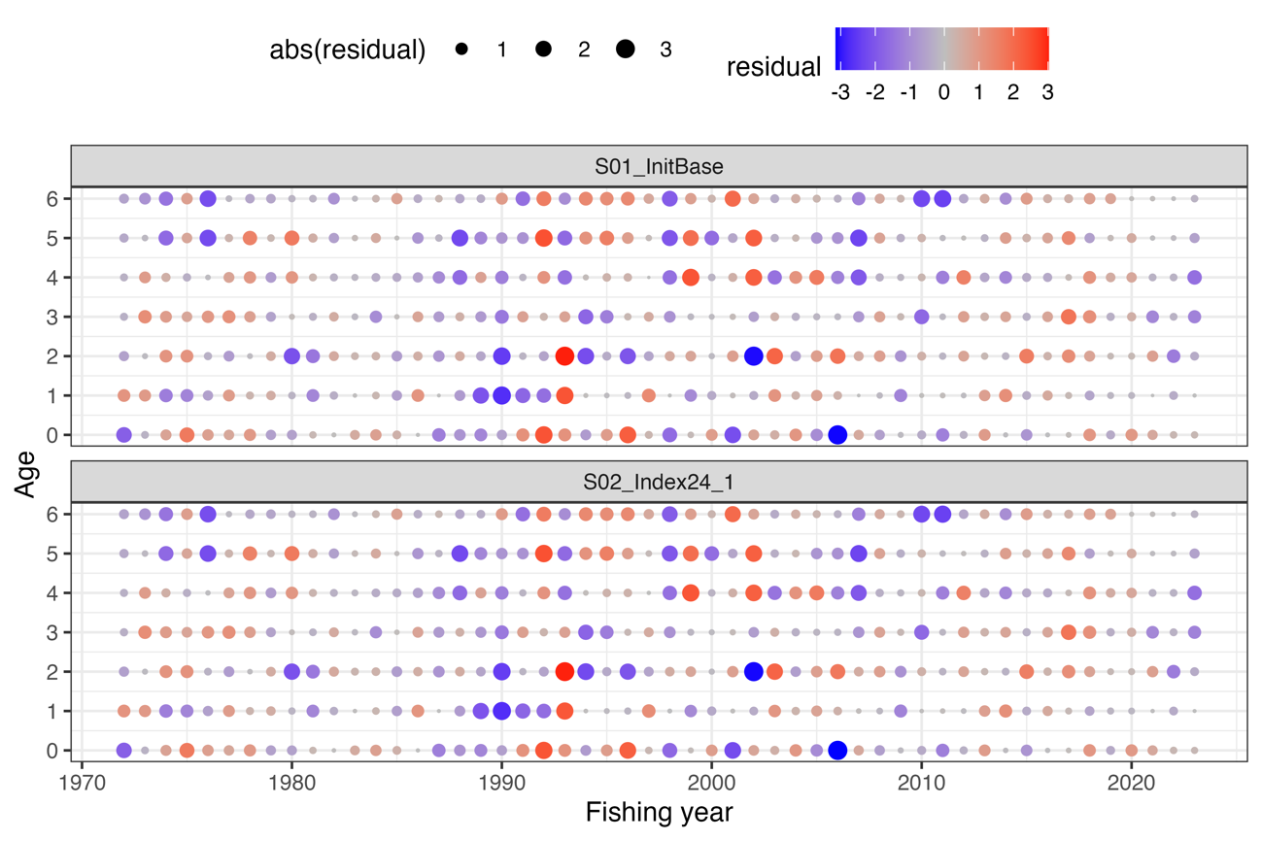
One-step-ahead residuals in catch-at-age for the two candidate base case scenarios.

Figure B4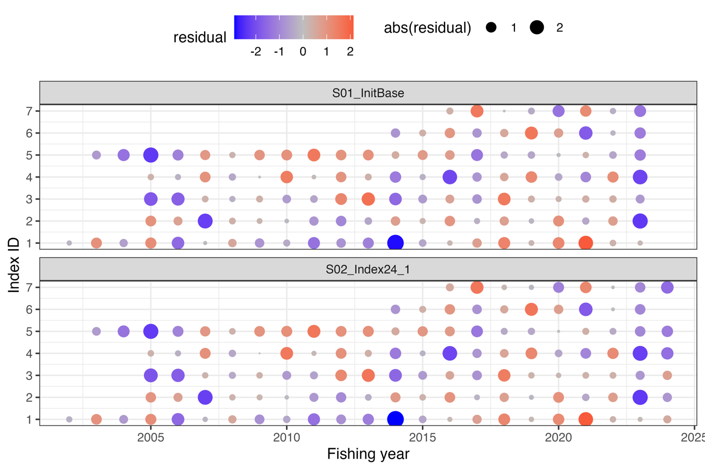
One-step-ahead residuals in the abundance indices for the two candidate base case scenarios.

Figure B5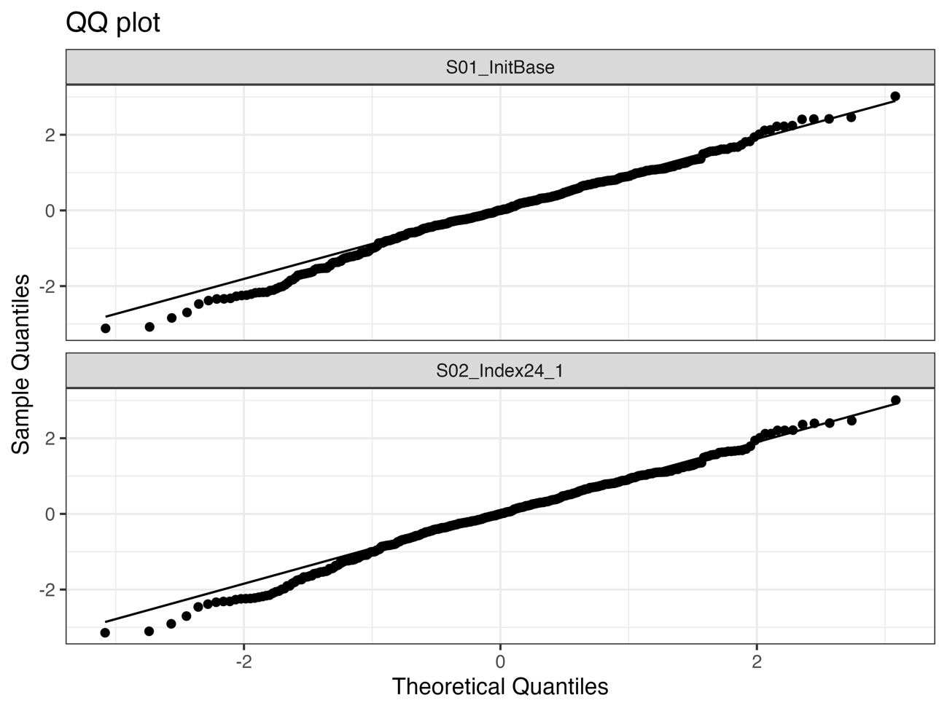
Normal Q-Q plot for the one-step-ahead residuals in catch-at-age for the two candidate base case scenarios.

