NPFC-2025-TWG CMSA11-WP04

**Details and resolution on the discrepancy of annual footprint and sum of product of catch at age and weight at age from China, Japan, and Russia**

Akihiro MANABE1, Ryuji YUKAMI1, Heng ZHANG2, Yongchuang SHI2, Igor CHERNIENKO3, and Emilia CHERNIENKO3, and Kazuhiro OSHIMA1

1 Fisheries Resources Institute, Japan Fisheries Research and Education Agency (FRA)

2 East China Sea Fisheries Research Institute, Chinese Academy of Fishery Science, China

3 The Pacific Branch of Russian Research Institute of Fisheries and Oceanography (TINRO)

(corresponding author: Akihiro MANABE, manabe_akihiro97@fra.go.jp)

**Summary**

Catch number at age (CAA), Weight at age (WAA), Catch Weight at Age (WCAA) and catch from footprint are important biological data sources for the Chub mackerel stock assessment. It is necessary to clarify their calculation methods and how to solve the problem of catch discrepancy of annual footprint. The causes of discrepancy from China, Japan, and Russia are clarified and resolved to develop catch at age that has minimal discrepancies to the annual footprint from each member.

**Introduction**

In the 9th meeting report of the Scientific Committee of NPFC, discrepancies of calculated catch and annual footprint are discovered. The Scientific Committee therefore tasked the TWG CMSA to investigate the source of the discrepancies (NPFC 2024). In the present paper, the discrepancies of catches by China, Japan, and Russia are explained and their solutions to fix the catch at age are introduced.

**Catch of chub mackerel (SOP: sum of product)**

In the present paper, SOP (sum of product) is defined as catch at age multiplied by weight at age. The SOP is derived as:

$${SOP}_{cy,q}=\sum_{0≤t≤7}{n_{t,cy,q}w_{t,cy,q}}$$

$${SOP}_{cy}=\sum_{1≤q≤4}{c_{cy,q}}$$

where *n* is catch in number (catch at age), *w* is weight of individual fish (weight at age), *SOP* is sum of product (~catch yield), *t* is age, c*y* is calendar year, and *q* is quarter.

**Footprint**

Since the annual footprint of NPFC presents the catch yield of two mackerel species (Chub: *Scomber japonicus* and Blue: *S. australasicus*) for China and Japan, annual footprint of chub mackerel data is calculated using chub-blue mackerel ratio shared among the Members of TWG CMSA. The catch of chub mackerel according to the annual footprint is expressed as:

$$C_{chub, cy}=C_{cy}*P_{chub}$$

where C is the catch according to footprint and P is the proportion of chub mackerel within the annual footprint of mackerels. Since the proportion of blue mackerel in Russian catches is negligible, the Russian footprint is assumed to be identical to the catch of chub mackerel.

**Comparison of SOP and Footprint**

The comparison of SOP based on the catch at age and weight at age data submitted for the TWG CMSA09 meeting is compared to the annual footprint data from each member (Tables 1, 2, and 3). The difference between two catches is calculated by $Footprint-SOP$ and difference in percentage is calculated by $\frac{Footprint-SOP}{Footprint} *100$. For Chinese catches, a significant difference was observed in the catch from 2018 and 2019 in which the footprint was 1065 and 1888 tons lower than SOP, which accounted for 0.9% and 3.3% of the footprint (Figure 1, Table 1). For Japanese catches, a significant difference was observed in the catch from CY2015 in which the footprint was 35,680 tons more than SOP, which accounted for 11.5% of the footprint (Figure 2, Table 2). For the Russian catch, the difference between SOP and footprint were consistently present from CY2016 to CY2022 with SOP being significantly lower than footprint (Figure 3, Table 3). For other years, the difference was found to be minimal in China and Japan.

**Cause of the discrepancy**

**China**

*Methodology to develop catch at age*

The calculation process of CAA involves several steps:

1. Annual Total Catch in Weight (tons): This is specific to chub mackerel, with blue mackerel removed from the footprint data. Quarterly catch data is calculated using fishing logbooks.
2. Biological Sampling on the vessels or ports:
   1. Original measurements for samplings include weight, length, age, and maturity.
   2. Weight at Age (WAA) is calculated as the mean weight of all individuals at specific age group, assuming it accurately represents the weight per age for each quarter. Additionally, weight at size is determined.
   3. Maturity at Age (MAA) is assessed.
   4. Length Frequency: The total number and total catch weight for each length group (1 cm intervals) are recorded for each quarter.
   5. An Age-Length Key is established to link age and length data.
3. Catch Weight at Size: The percentage of catch weight in each length group is multiplied by the total catch weight to determine the catch weight at size.
4. Catch Number at Size: The catch weight at size is divided by the weight at size to calculate the catch number at size.
5. Catch Number at Age (CAA): The Age-Length Key is combined with the catch number at size to derive the catch number at age.

In China, the sample sizes vary across quarters during the aggregation and estimation process. Additionally, onboard sampling is influenced by specific vessel operations, leading to misrepresentation of the length frequency of the total catch across all vessels. Also, the Age-Length Key is significantly impacted by the small sample size of large individuals.

**Japan**

*Difference in calculation procedures*

In Japan chub mackerel catch is reported from each prefectural institution. The catch of chub mackerel is reported by month, prefecture, and gear. The total catch in fishing year is a sum of the reported catches.

The catch at age is developed according to Manabe et al. (2025a). The catch at length is estimated using length frequency sampling from each prefecture and length-weight relationship which is estimated every year at each prefecture basis (with few exceptions if sufficient data to construct the relationship is unavailable). The detailed method to calculate calculated catch at age is presented in Figure 4.

The minor discrepancy between two numbers: annual footprint and calculated catch is expected to be caused by two different origins of the data, which annual footprint is raw summarization of catch yield data whereas calculated catch is represented by length frequency data, length-weight relationship, and age-length key.

*Errors in calculation process*

In addition to the different nature of numbers, there were few minor errors within the calculation process. In CY2015, the preliminary catch yield value was used to multiply length frequency to calculate catch number at length while annual footprint was updated, hence creating a large discrepancy in CY2015 (Table1).

Additionally, in few prefectures, the calculation process conducted on MS Excel did not pass the result of length-weight relationships in some fork length bins, specifically in small fish < 15cmFL and large fish > 45cmFL. The lack of weighted catch at length and existing catch at length data resulted in incorrect values for weight at age in some quarter, year, and age (Figure 4). Since weight at age is one of two components that calculate SOP, the discrepancy was developed.

**Russia**

The source of the discrepancies was that the calculations were made only for Russian waters. However, catch is also obtained in Japanese EEZ (Antonenko 2025), therefore the catch-at-age is updated to cover the remaining catches.

**Result and discussion**

**China**

The revised catch at exhibited equal amounts for CY2018, 2021, and 2022, with small discrepancy on other years with maximum difference of 3% (Figure 1, Table 1). Considering the difference being less than 5% and cause of discrepancy is explicit as described above, the remaining discrepancies between SOP and footprint is acceptable.

**Japan**

The calculation process was checked, and errors were resolved to obtain revised values. Figure 5 shows the comparison of catch at age from TWG CMSA9 and resolved catch at age obtained in the present paper. The catch at age in CY2015 is fixed as the updated catch yield is used for calculation. The weight at age is also recalculated (Figure 6 and 7). The weight at age is significantly increased in 2014 for age-7 and slightly increased in CY2015 and CY2023. Figure 1 and Table 1 show the SOP and annual footprint up to CY2023. The substantial discrepancy in CY2015 was resolved and slight improvement in CY2019 and CY2022.

In the present document, the cause of discrepancy was examined, and solutions were applied to resolve the large discrepancy. With improvement and update of the calculation process, the large discrepancy is resolved, and other discrepancies are less than 1.5% with 0% difference in many years. Considering the difference in calculation process of annual footprint and SOP, the present difference in percentage is considered as acceptable level, hence the discrepancy between SOP and annual footprint is considered to be resolved.

**Russia**

Once catches in Japanese waters were taken into account, the discrepancies were removed (Figure 3, Table 3).

**Conclusion**

This document ensures consistency between the calculated catch by age and the catches reported in the Annual Summary Footprint. Although some discrepancies are still present between SOP and the footprint, the percentage is considered at an acceptable level, smaller than 5%. The data has been uploaded to the data/information sharing site of the TWG CMSA (NPFC Collaboration site) and developed into the finalized catch-at-age and weight-at-age (Manabe et al., 2025b).

**References**

Antonenko, D. (2025) Chub mackerel Russian fishery in the northwest Pacific Ocean research activities in 2024. NPFC-2025-TWG CMSA10-IP02.

Manabe, A., Higashiguchi, K., and Yukami, R. (2025) The estimation method and data on catch, weight, and maturity at age of the chub mackerel caught by Japan up to CY2024 Q2. NPFC-2025-TWG CMSA10-WP03.

Manabe, A., Gazi, K. M. (2025) The data description for the base case stock assessment of chub mackerel Scomber japonicus in the northwestern Pacific Ocean for 2025 assessment. NPFC-2025-TWG CMSA11-WP03.

NPFC (2024) North Pacific Fisheries Commission Science Committee 9th Meeting Report. NPFC-2024-SC09-Final Report. 405 pp.   
(Available at https://www.npfc.int/meetings/9th-scientific-committee-meeting, last accessed 2025-03-01).

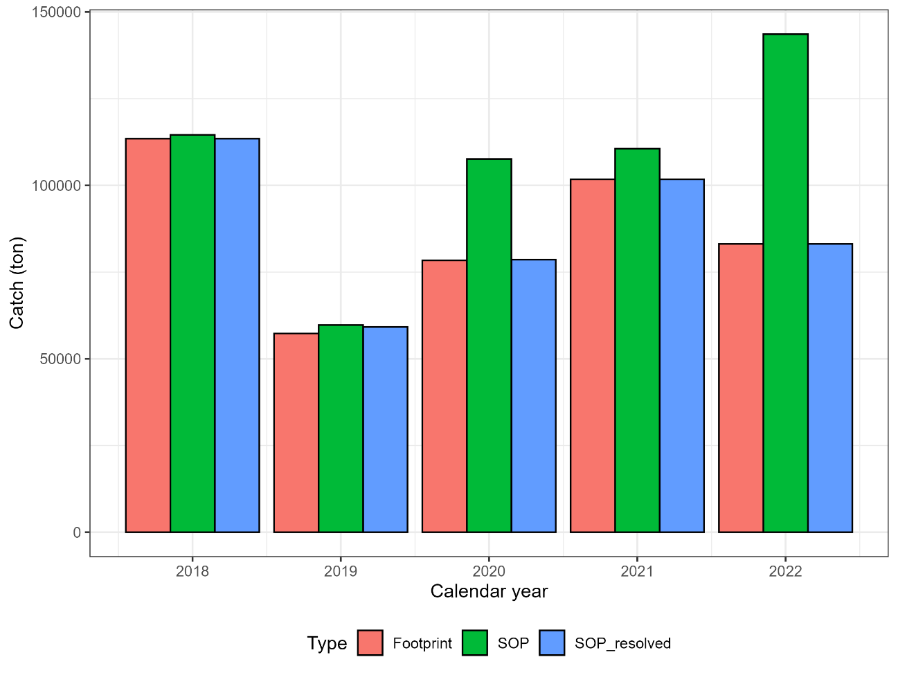

Figure 1. Comparison between annual footprint, SOP for TWG CMSA9 data, and resolved SOP in China.

グラフ, 棒グラフ

AI 生成コンテンツは誤りを含む可能性があります。

Figure 2. Comparison between resolved SOP and annual footprint up to CY2023 in Japan. SOP represents SOP for TWG CMSA9, which is only available up to CY2022.

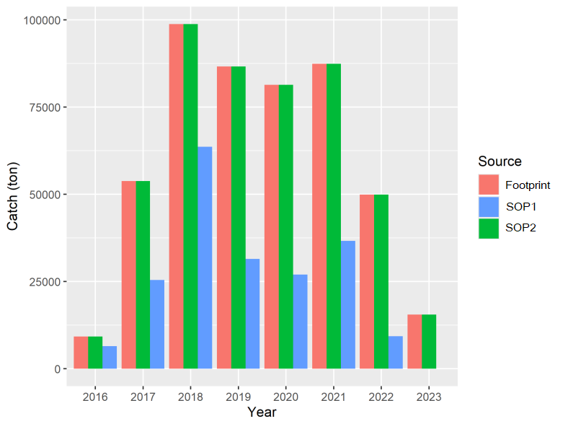

Figure 3 Comparison between SOP in TWG CMSA9 (SOP1), resolved SOP (SOP2) and annual footprint in Russia.

タイムライン

AI によって生成されたコンテンツは間違っている可能性があります。

Figure 4. Flow chart to develop weight at age in Japan. The calculated catch is also expressed as the fishing year-based summarization of catch weight at age (quarterly-regionally), which is one step before the final product.

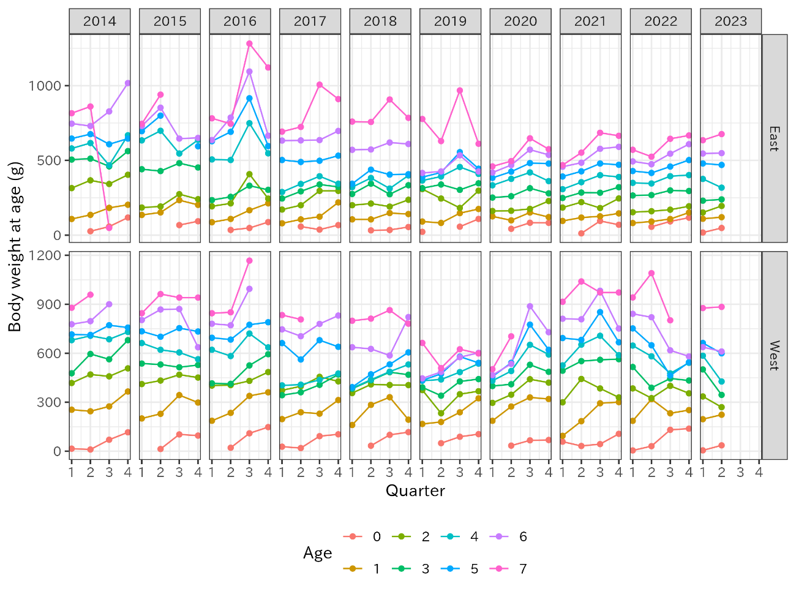

Figure 4. Weight at age from Eastern and Western Japan. Year represents the calendar year. Note that age-7 in Eastern Japan CY2014 exhibits an incorrect value in the 3rd quarter.

グラフィカル ユーザー インターフェイス が含まれている画像

AI によって生成されたコンテンツは間違っている可能性があります。

Figure 5. Comparison of catch at age in TWG CMSA9 and resolved catch at age. The solid line represents that the catch at age in TWG CMSA9 equals to the resolved catch at age.

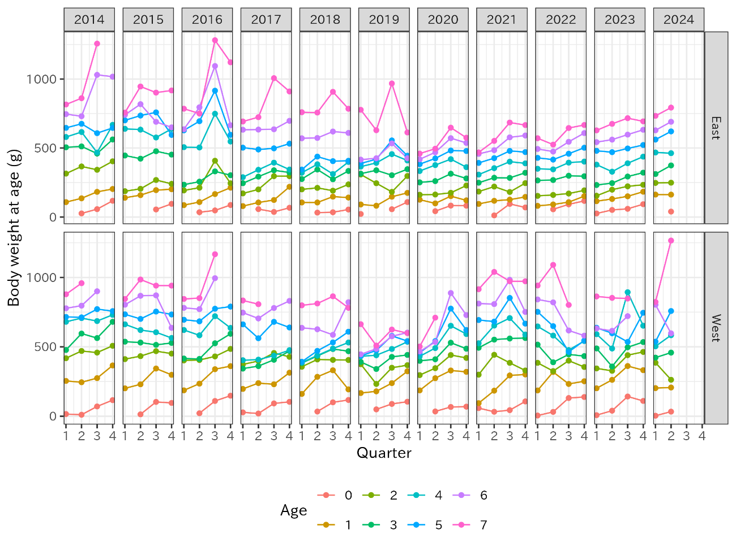

Figure 6. Resolved weight at age.

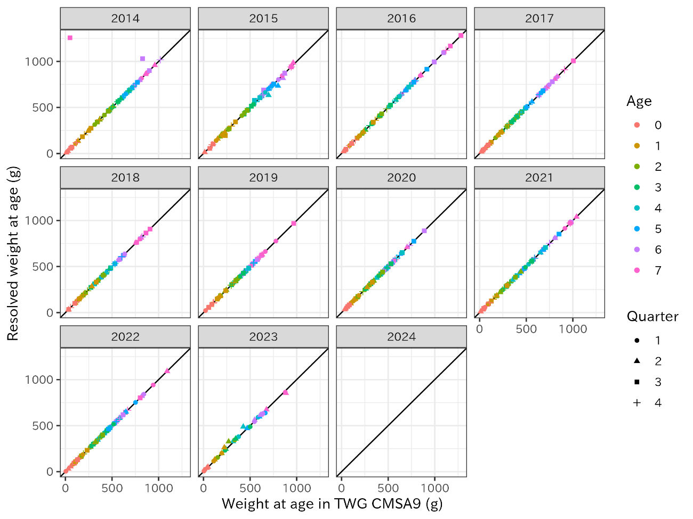

Figure 7. Comparison of weight at age in TWG CMSA9 and resolved weight at age. The solid line represents that the weight at age in TWG CMSA9 equals to the resolved weight at age.

Table 1. Comparison between SOP of TWG CMSA9 dataset, resolved SOP, and annual footprint in China.

|  |  |  |  |  |  |  |  |  |
| --- | --- | --- | --- | --- | --- | --- | --- | --- |
| Calendar year | Footprint (ton) | SOP (TWG CMSA9) | | | SOP (resolved) | | | SOP-SOP(resolved) |
| SOP | Difference  (ton) | Difference  (%) | Resoled SOP (ton) | Difference  (ton) | Difference  (%) |
| 2018 | 113,489 | 114,554.7 | 1,065.8 | 0.9% | 113,489.0 | 0.1 | 0.0% | 1,066 |
| 2019 | 57,284 | 59,766.1 | 2,482.1 | 4.3% | 59,172.3 | 1,888.4 | 3.3% | 594 |
| 2020 | 78,403 | 107,638.5 | 29,235.8 | 37.3% | 78,610.4 | 207.7 | 0.3% | 29,028 |
| 2021 | 101,770 | 110,570.5 | 8,800.4 | 8.6% | 101,769.7 | -0.3 | 0.0% | 8,801 |
| 2022 | 83,142 | 143,587.5 | 60,445.5 | 72.7% | 83,142.0 | 0.0 | 0.0% | 60,445 |
| 2023 | 42,011 | 42,011.1 | -0.1 | 0.0% | 42,011.1 | -0.1 | 0.0% | 0 |

Table 2. Comparison between SOP of TWG CMSA9 dataset, resolved SOP, and annual footprint in Japan.

|  |  |  |  |  |  |  |  |  |
| --- | --- | --- | --- | --- | --- | --- | --- | --- |
| Calendar year | Footprint (ton) | SOP (TWG CMSA9) | | | SOP (resolved) | | | SOP-SOP(resolved) |
| SOP (ton) | Difference (ton) | Difference (%) | Resolved SOP (ton) | Difference (ton) | Difference (%) |
| 2014 | 260,057 | 260,067 | -10 | 0.0% | 260,067 | -10 | 0.0% | 0 |
| 2015 | 308,996 | 273,316 | 35,680 | 11.5% | 308,996 | 0 | 0.0% | -35,680 |
| 2016 | 348,523 | 348,527 | -4 | 0.0% | 348,531 | -8 | 0.0% | -3 |
| 2017 | 309,879 | 309,607 | 272 | 0.1% | 309,607 | 272 | 0.1% | 0 |
| 2018 | 303,473 | 301,630 | 1,843 | 0.6% | 301,630 | 1,843 | 0.6% | 0 |
| 2019 | 306,528 | 301,968 | 4,560 | 1.5% | 301,981 | 4,547 | 1.5% | -13 |
| 2020 | 256,427 | 255,530 | 897 | 0.3% | 255,530 | 897 | 0.3% | 0 |
| 2021 | 272,958 | 272,254 | 703 | 0.3% | 272,254 | 703 | 0.3% | 0 |
| 2022 | 147,237 | 147,232 | 5 | 0.0% | 147,237 | 0 | 0.0% | -5 |
| 2023 | 86,943 |  |  |  | 86,943 | 0 | 0.0% |  |

Table 3. Comparison between SOP of TWG CMSA9 dataset, resolved SOP, and annual footprint in Russia.

|  |  |  |  |  |  |  |  |  |
| --- | --- | --- | --- | --- | --- | --- | --- | --- |
| Calendar year | Footprint (ton) | SOP (TWG CMSA9) | | | SOP (resolved) | | |  |
| SOP (ton) | Difference (ton) | Difference % | SOP (ton) | Difference (ton) | Difference % | SOP-SOP(resolved) |
| 2016 | 9242.462 | 6517.731 | 2724.731 | 29.48 | 9242.462 | 0 | 0 | -2724.731 |
| 2017 | 53791.729 | 25427.01 | 28364.719 | 52.73 | 53791.729 | 0 | 0 | -28364.719 |
| 2018 | 98812 | 63651.994 | 35160.006 | 35.58 | 98812 | 0 | 0 | -35160.006 |
| 2019 | 86592.378 | 31479.908 | 55112.47 | 63.65 | 86592.378 | 0 | 0 | -55112.47 |
| 2020 | 81384 | 26992.559 | 54391.441 | 66.83 | 81384 | 0 | 0 | -54391.441 |
| 2021 | 87388 | 36687.443 | 50700.557 | 58.02 | 87388 | 0 | 0 | -50700.557 |
| 2022 | 49894 | 9377.612 | 40516.388 | 81.20 | 49894 | 0 | 0 | -40516.388 |
| 2023 | 15540.028 |  |  |  | 15540.028 |  |  |  |