NPFC-2025-SSC NFS02-WP07 (Rev. 1)

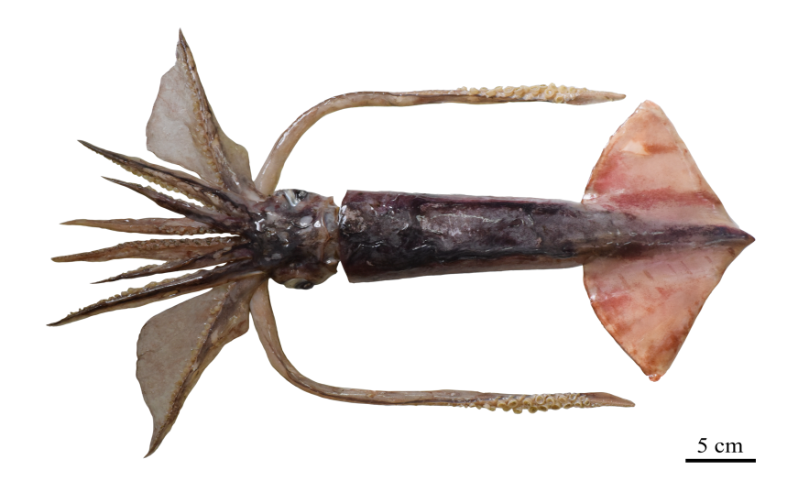

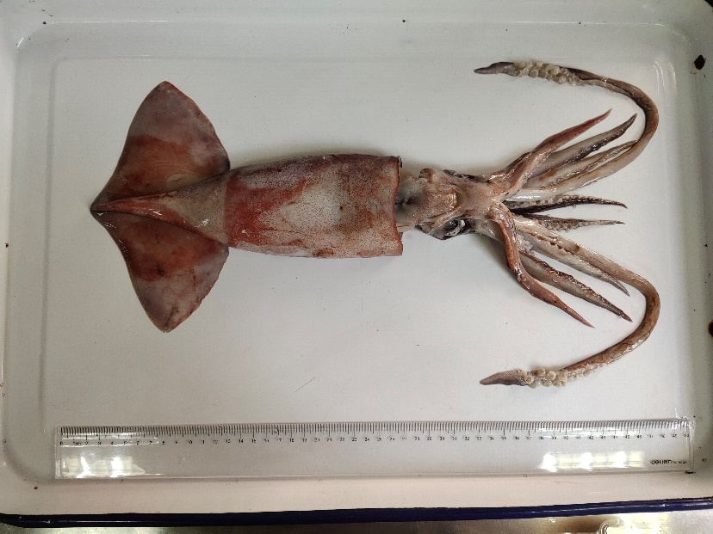

*Figure 1. The pictures of neon flying squid*

**Neon Flying Squid (*****Ommastrephes bartramii*)**

**Common names:**

柔鱼 [rou yu] (Chinese); neon flying squid (English); アカイカ [akaika] (Japanese); 빨강오징어 [ppalgangojingeo] (Korean); Кальмар Бартрама [kalmar bartrama] (Russian); 赤魷 [chi-you] (Chinese Taipei).

Other common names: Red flying squid; Webbed flying squid; Red ocean squid

(<https://www.sealifebase.ca/comnames/CommonNamesList.php?ID=58132&GenusName=Ommastrephes&SpeciesName=bartramii&StockCode=3971>)

**Management**

**Active management measures**

The following NPFC conservation and management measure (CMM) pertains to this species:

CMM 2025-11 For Japanese Sardine, Neon Flying Squid and Japanese Flying Squid

Available from <https://www.npfc.int/active-conservation-and-management-measures>.

**Management summary**

Does not specify catch limits.

Members of the Commission and CNCPs with substantial harvest of neon flying squid in the Convention Area shall refrain from expansion, in the Convention Area, of the number of fishing vessels authorized to fish such species from the historical existing level.

Members of the Commission and CNCPs without substantial harvest of the neon flying squid in the Convention Area are encouraged to refrain from expansion, in the Convention Area, of the number of fishing vessels entitled to fly their flags and authorized to fish for such species from the historical existing level.

Members of the Commission participating in fishing for the neon flying squid in areas under their jurisdiction adjacent to the Convention Area are requested to take compatible measures.

*Table1. Management Summary*

|  |  |  |
| --- | --- | --- |
| Convention/Management Principle | Status | Comment/Consideration |
| Biological reference point(s) |  | Not established. |
| Stock status |  | Status determination criteria not established. |
| Catch or effort limits |  | Recommended effort limits. |
| Harvest control rule |  | Not established. |
| Other |  |  |

C:\Users\user\AppData\Local\Temp\1639292761(1).png

**Stock assessment**

No unified stock assessment has been conducted by NPFC for the species.

Some members have conducted stock assessment or related studies for neon flying squid based on the information only from their own fisheries or surveys (Ichii et al. 2006; Chen, 2010; Cao et al. 2014).

**Data**

**Survey**

Japan conducted drift net survey in summer from 1999-2024 and jigging survey in winter from 2018-2024. Russia conducted upper epipelagic surveys from 1984-1992 and from 1999-2019 (see details in Table 2). China conducted squid jigging survey in summer from 2021-2024.

**Fishery**

Neon flying squid was harvested by China, Japan, Korea, Russia, Chinese Taipei and Vanuatu. Fishing methods included jigging, drift net, dip net and set net.

*Figure 2. The historical catch of neon flying squid reported by members.*

**Data availability**

*Table 2. Data availability from Members regarding neon flying squid*

|  |  |  |  |  |
| --- | --- | --- | --- | --- |
| **Category and data sources** | **Description** | **Years with available data** | **Average sample size/ year or data coverage** | **Potential issues to be reviewed** |
| **CHINA** | | | | |
| **Catch statistics** | | | | |
| Squid-jigging fisheries | Official statistics, reports from annual report | Official statistics:  2005-2024  Fishery data before 2005 (need to be confirmed) | Coverage  = 100% | The neon flying squid catches are obtained from the fisheries logbook data provided by the fisheries company |
| **Size composition data** | | | | |
| Length measurements | Sampling from commercial squid-jigging fishing vessels | 2010-2018  Data before 2005 (need to be confirmed) | 800-1000 fish/year | May lack representativeness |
| Aging | Sampling from commercial squid-jigging fishing vessels | 2010-2016  Data before 2005 (need to be confirmed) | 80-200 fish /year | May lack representativeness |
| **Abundance indices (commercial)** | | | | |
| Squid-jigging fisheries | Squid-jigging logbook | 1995-2022  Fishery data before 2005 (need to be confirmed) | Coverage= 100% |  |

|  |  |  |  |  |
| --- | --- | --- | --- | --- |
| **Category and data sources** | **Description** | **Years with available data** | **Average sample size/ year or data coverage** | **Potential issues to be reviewed** |
| **JAPAN** | | | | |
| **Catch statistics** | | | | |
| Jigging fishery | Logbook | 1995-2024 | Coverage=100% |  |
| **Size composition data** | | | | |
| Length and weight measurements | Drift net survey (Summer) | 1999-2024 | 500-600 squid/year |  |
| Jigging survey (Winter) | 2018-2024 | 300-400 squid/year |  |
| **Abundance indices (survey)** | | | | |
| Summer survey on abundance of the autumn and winter-spring cohorts | Drift net survey CPUE for each cohort (individuals/panel) | 1999-2024 | 20-30 stations/year | Small samples of male and matured female for the autumn cohort |
| Winter survey on abundance of the winter-spring cohort | Jigging survey CPUE (individuals/line) | 2018-2024 | 12-16 stations/year |  |
| **Abundance indices (commercial)** | | | | |
| Jigging fishery | Logbook  Standardized CPUE of the winter-spring cohort | 1995-2023 | Coverage=100% | Standardize CPUE for the autumn cohort |

|  |  |  |  |  |
| --- | --- | --- | --- | --- |
| **Category and data sources** | **Description** | **Years with available data** | **Average sample size/ year or data coverage** | **Potential issues to be reviewed** |
| **KOREA** | | | | |
| **Catch statistics** | | | | |
| Jigging | Official statistics, reports from fisheries | 2017, 2019 and 2021-2024 | Coverage =100% |  |
| **Size composition data** | | | | |
| Length measurements | Measured by observers while onboard | 2017, 2021, 2022 | 1000 squid/year | Measurement details to be reviewed |
| **Abundance indices (commercial)** | | | | |
| Jigging | Logbook data available | 2017, 2021, 2022 | 30-40 stations/year | Data coverage details to be reviewed |

|  |  |  |  |  |
| --- | --- | --- | --- | --- |
| **Category and data sources** | **Description** | **Years with available data** | **Average sample size/year or data coverage** | **Potential issues to be reviewed** |
| **RUSSIA** | | | | |
| **Catch statistics** | | | | |
| Drift net fishery | Official statistics, reports from fisheries associations | Official statistics:  1982-1990, 1999-2007, 2011  1985-1998, 2008-2010 and 2012-2020 (no data available); publications: 1972-2012 | Coverage  1982-1984 ?%,  1999-2007, 2011 =100% | Data coverage details to be reviewed |
| **Size composition data** | | | | |
| Length measurements | Sampling from commercial fishing vessels.  Sampling during research surveys. | 1999-2007, 2011  2012-2019 | 100-4,000 squids /year (ca. 50 measurements per sampling) | Data coverage details to be reviewed |
| **Abundance indices (survey)** | | | | |
| Summer-autumn surveys to assess pelagic squid abundance | Upper epipelagic surveys | 1984-1992, 1999-2019  (August-  November) | 60-80 stations/year  60-80 stations/year | Changes in abundance and migration patterns; development survey protocol and conduct standardization |

|  |  |  |  |  |
| --- | --- | --- | --- | --- |
| **Category and data sources** | **Description** | **Years with available data** | **Average sample size/ year or data coverage** | **Potential issues to be reviewed** |
| **CHINESE TAIPEI** | | | | |
| **Catch statistics** | | | | |
| Dip net fishery | Fishing gear used in different periods:  1977-1979: jigging  1980-1983: jigging and gillnet  1984-1992: gillnet  1993 till now: jigging | Data from 1977-1996 was provided by Taiwan Squid Fishery Association, data from 1997-2017 was based on logbook, and data from 2018-2024 was the statistics on landings.  (No fishery: 2010, 2012-2015) | Coverage  =100% |  |
| Set net |
| **Size composition data** | | | | |
| Length measurements | Sampling from a research survey (1997).  Sampling from commercial fishing vessels. | 1997; 1998-2003 | 200-300 squids /year | Data coverage details to be reviewed |
| **Abundance indices (commercial)** | | | | |
| Squid-jigging fisheries | Squid-jigging logbook | 2001-2023  (No fishery: 2010, 2012-2015) | Data Coverage  2001-2016  = 87.3%  Data Coverage  2017-2023  =100% | Will conduct standardization |

|  |  |  |  |  |
| --- | --- | --- | --- | --- |
| **Category and data sources** | **Description** | **Years with available data** | **Average sample size/ year or data coverage** | **Potential issues to be reviewed** |
| **VANUATU** | | | | |
| **Catch statistics** | | | | |
| Squid jigging fishery | from logbook | 2019, 2021-2023 | logbook from 2013 to now, coverage 100% | Vanuatu has authorized 4 vessels to conduct Pacific saury and squid jigging fishery in NPFC Convention Area. These vessels can target both neon flying squid and Pacific saury, and mainly target Pacific saury. |

**Biological Information**

**Distribution and migration**

Neon flying squid is an oceanic squid distributed in temperate and subtropical waters of the Pacific, Indian and Atlantic Oceans. The North Pacific population occurs mainly between 20◦ and 50◦N, and comprises two cohorts: a fall cohort with a hatching period from September to February and a winter–spring cohort with a hatching period mainly from January to May, but extending to August. Neon flying squid makes an annual round-trip migration between its subtropical spawning grounds and its northern feeding grounds near the Subarctic Boundary.

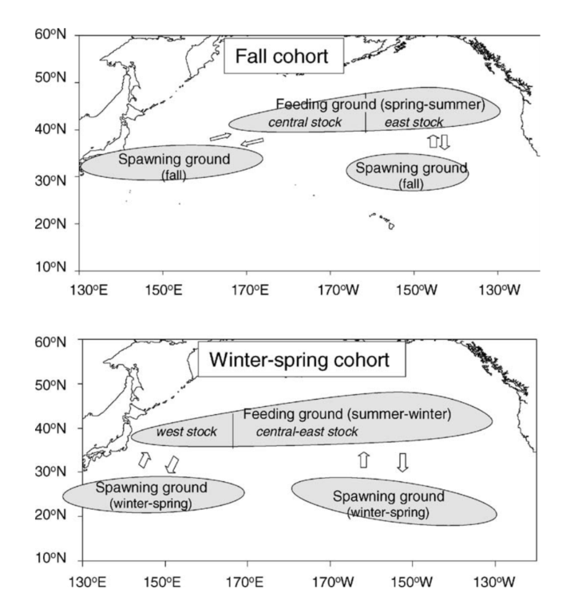

*Figure 3. Migration patterns of the fall and winter–spring cohorts of neon flying squid in the North Pacific.*

**Life history**

Growth is exponential during the first 30 days after hatching and then becomes more or less linear. It is suggested that this shift in growth accompanies a change in the feeding behavior that is thought to occur once the fused tentacles, which form a proboscis in the hatchlings, separate and become functional.

Neon flying squid at 7-10 months of age and has an estimated 1-year life span. Size at maturity is about 30–33 cm ML in males and 40–55 cm ML in females. The maximum ML is around 45 cm in males and 60 cm in females.

During its northward migration and at the feeding grounds in the central North Pacific, neon flying squid feeds mainly on fishes, squids and crustaceans. Many marine mammals feed on neon flying squid. It is an important prey of northern fur seals in the central North Pacific, and a minor prey of short-beaked common dolphins (Bower and Ichii 2005).

**Literature cited**

John R. Bower; Taro Ichii. The red flying squid (*Ommastrephes bartramii*): A review of recent research and the fishery in Japan. 2005. Fisheries Research.

Chih-Shin Chen. Abundance trends of two neon flying squid (*Ommastrephes bartramii*) stocks in the North Pacific. 2010. ICES Journal of Marine Science.

Cao, Jie; Chen, Xinjun; Tian, Siquan. A Bayesian hierarchical DeLury model for stock assessment of the west winter-spring cohort of neon flying squid (*Ommastrephes bartramii*) in the northwest Pacific Ocean. 2015. Bulletin of Marine Science.

Taro, Ichii; Kedarnath, Mahapatra; Hiroshi, Okamura; Yoshihiro, Okada. Stock assessment of the autumn cohort of neon flying squid (*Ommastrephes bartramii*) in the North Pacific based on past large-scale high seas driftnet fishery data. 2006. Fisheries Research.