NPFC-2025-SSC PS15-IP01

**Length composition data from the Japanese survey**

Miyako Naya, Shin-Ichiro Nakayama, Taiki Fuji, Hiroomi, Miyamoto Midori Hashimoto, Shingo Minamikawa, and Satoshi Suyama

*Fisheries Resources Institute, Japan Fisheries Research and Education Agency*

**Introduction**

Small Scientific Committee on Pacific saury (SSC PS) and its subsidiary group (Working Groupe on New Stock Assessment Models, WG NSAM) is developing a new age-structured stock assessment model for Pacific saury (PS) stock assessment using Stock Synthesis 3 (SS3). In the WG NSAM meeting held in May 2025 (WG NSAMint 2025-01), the group requested Japan to provide the length composition of PS caught in the Japanese fishery independent survey as follows:

“The WG NSAM **requested** Japan to provide length composition data from Japanese surveys as follows: total number of catch individuals in each 1 cm size class by three areas, west of 165°E, 165°E – 180° and 180° - 165°W, from 2003 to the most recent year.” (meeting summary of 2nd intersessional meeting of WG NSAM)

As a response, Japan will provide the corresponding data (length_composition_survey.xlsx) to WG NSAM on the collaboration site (https://collaboration.npfc.int/node/157). This data is provided only for use in the PS stock assessment in SSC PS. This document provides information on how the raw data was collected and processed to generate the length composition data to facilitate further understanding of WG NSAM on this data.

**About the survey**

The Japanese fishery independent survey has been conducted since 2003, from June to July, using a surface trawl net [NST-99 Nichimo Co., Ltd. (Tokyo, Japan)]. The target of this trawl net is PS larger than15cm in knob length, although smaller fish can occasionally be caught. The survey covers the area between 143°E and 165°W and sea surface temperatures of approximately 8°C to 18°C (Fig. 1). The survey lines are set along the meridian, generally spaced at 4° intervals of longitude. Typically 5 to 16 sampling stations are on each survey line. At each sampling station, one-hour trawl is conducted during daytime. For detailed information on the survey methods, see Hashimoto et al. (2020).

テキスト

**Data collection and processing**

At each sampling station that had more than 100 PS catch, approximately 100 fish were randomly sampled. At the sampling stations with less than 100 PS catch, basically all undamaged fish were sampled. The fish were immediately frozen on the board and transported to the laboratory. In the laboratory, knob lengths of the fish were measured after thawing. The knob lengths were binned into 1 cm size classes.

The obtained length composition for each sampling station was then expanded to the total number of fish caught at the corresponding station. The raised length composition for each sampling station was summed within area 1 (west of 165°E), area 2 (165°E–180°), and area 3 (180°–165°W).

The final length composition data (“CAS_by_Area” sheet) consists of 34 columns. The first two columns indicate year (2003–2024) and area (1–3). The third to 33rd columns, whose column names are 5, 6, …, 35, indicates the size bins. The column name of 29 corresponds to knob lengths equal or larger than 29 cm and smaller than 30 cm. The final (34th) column indicates the total number of PS caught in the corresponding year and area. Note that the frequencies inside this table are not integers because these numbers are after being expanded. Additionally, the age-length key for each year, each area is attached on another sheet (“Age_length_key” sheet).

**Reference**

Hashimoto M, Kidokoro H, Suyama S, Fuji T, Miyamoto H, Naya M, Vijai D, Ueno Y and Kitakado T (2020) Comparison of biomass estimates from multiple stratification approaches in a swept area method for Pacific saury *Cololabis saira* in the Northwestern Pacific Ocean, Fish. Sci 86, 445–456.

WG NSAM (2025) Summary of 2nd intersessional meeting of the Working Group on New Stock Assessment Models.

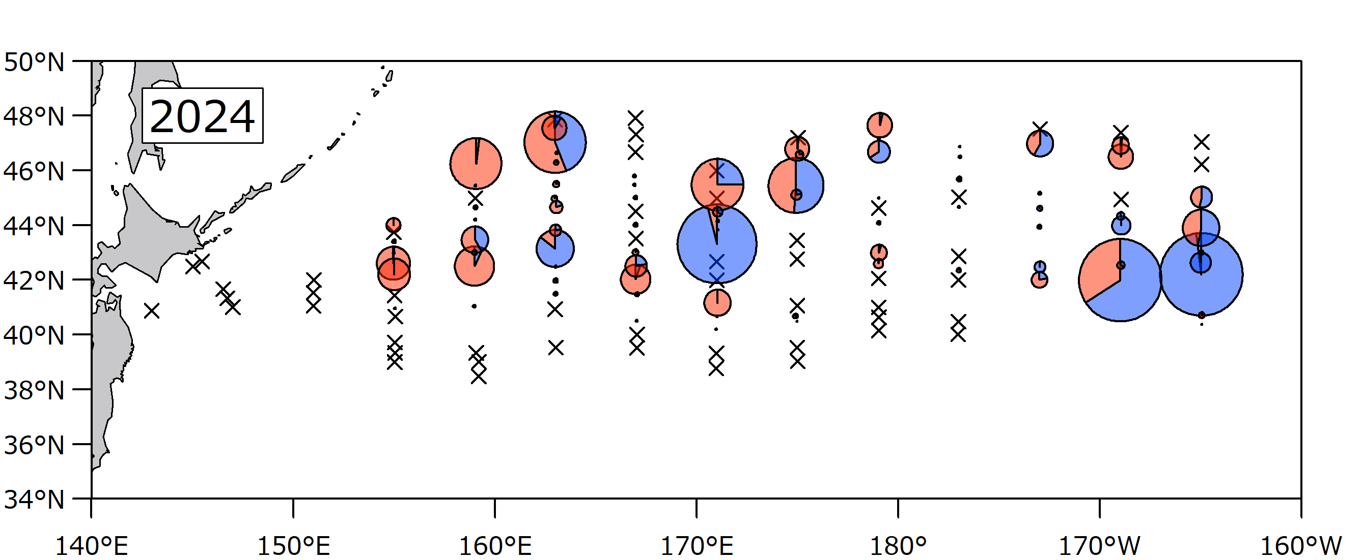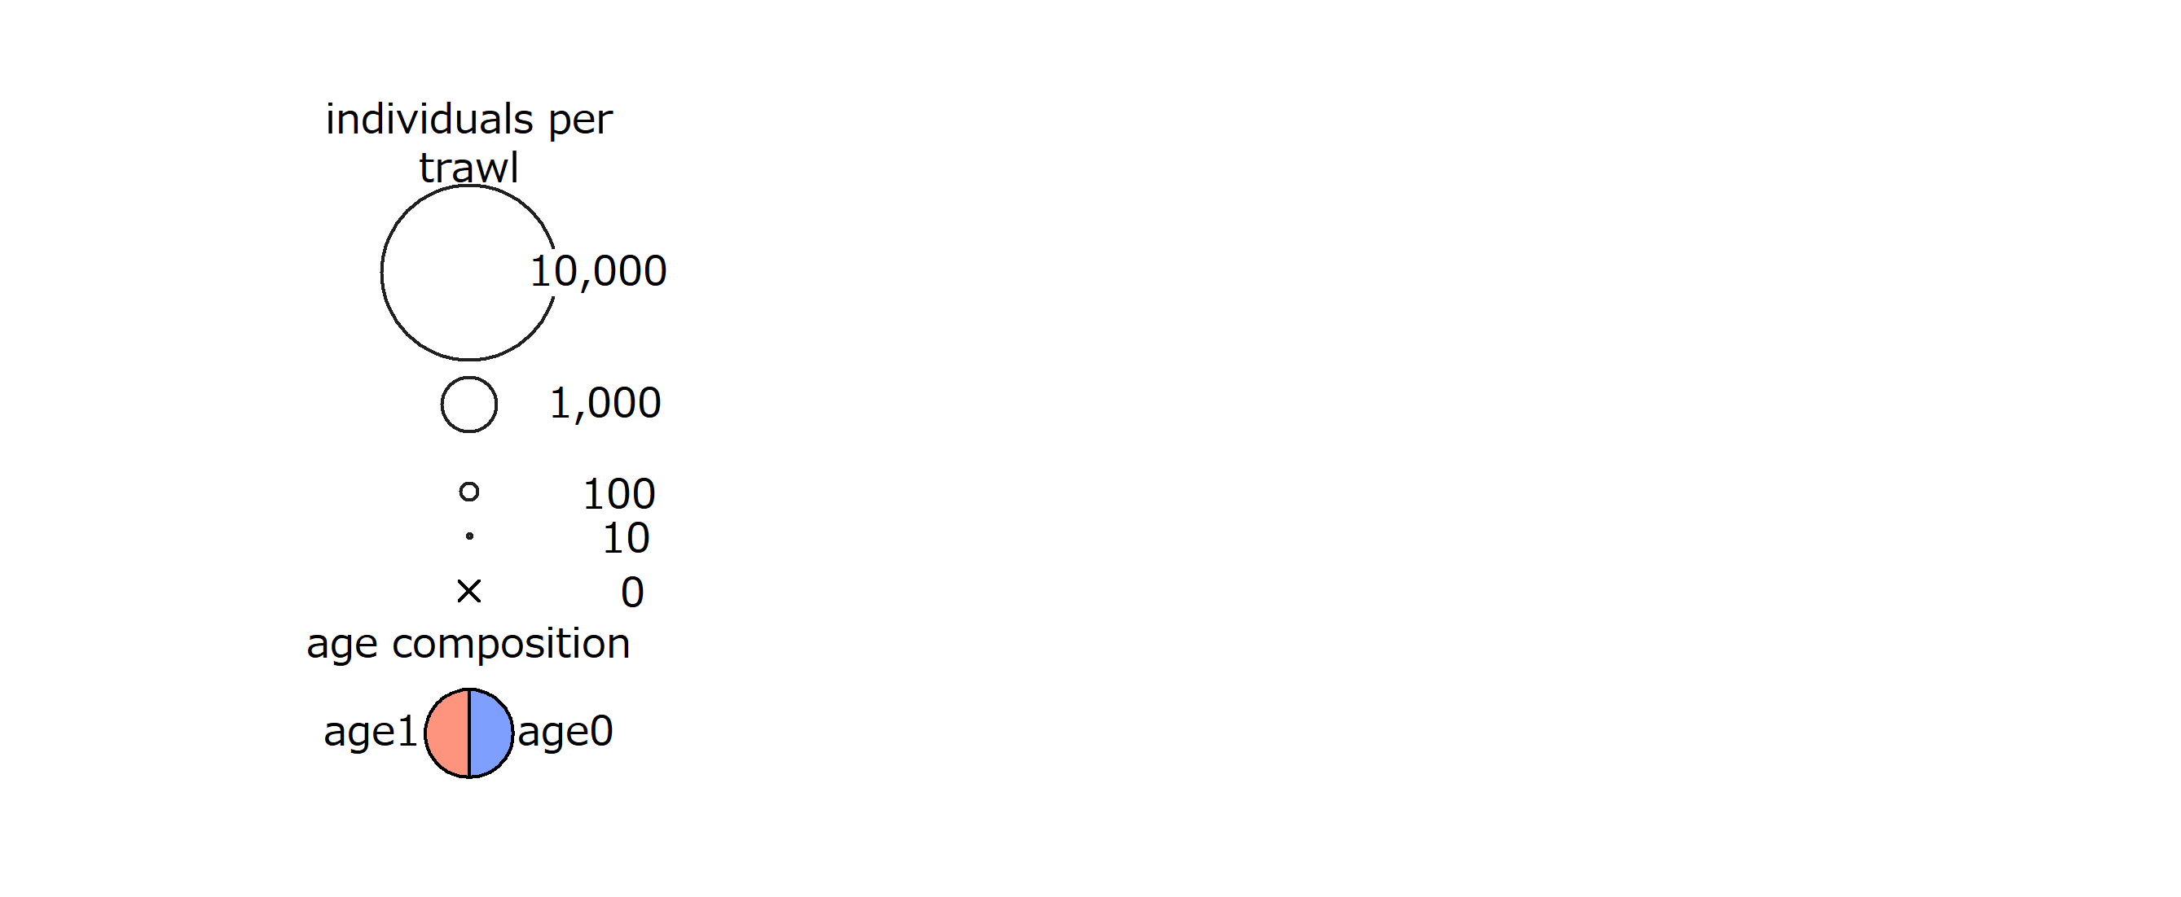

Figure 1. Survey design in 2024. The circles and crosses indicate the sample stations. Sizes of the circles are the number of fish caught at the corresponding stations. Crosses indicate that no fish were caught. Red and blue colors in the circles indicate the proportions of age 1 and age 0 fish, respectively.