NPFC-2025-SSC PS15-WP03

**Progress report on application of the VAST model**

**in CPUE standardization for the Japanese fishery of Pacific saury**

Midori Hashimoto, Satoshi Suyama, Shin-Ichiro Nakayama, Taiki Fuji,

Hiroomi Miyamoto, Miyako Naya and Shingo Minamikawa

*Fisheries Resources Institute, Japan Fisheries Research and Education Agency*

# **Summary**

Vector Autoregressive Spatio-temporal (VAST) model was applied to the catch-per-unit-effort (CPUE) data of Pacific saury caught by the Japanese stick-held dip net fishery. Here, models with seasonal effects instead of monthly effects were also considered in model selection. The standardized CPUE derived from the selected VAST model with minimum AIC indicated similar year trends with that derived from the conventional method with the generalized linear model. Evaluations of the impacts of the shortened fishing season revealed that the year trends of standardized CPUE from the VAST model were at least robust to missing data at the late stage of the Japanese fishing season.

# **1. Introduction**

Pacific saury (*Cololabis saira,* PS) is widely distributed in the North Pacific, around the subarctic and transitional waters. PS migrates northward in the western and central North Pacific during the early summer to forage and moves south-westward during autumn and winter to spawn (Fukushima, 1979). It is commercially exploited by several members of the North Pacific Fisheries Commission (NPFC) in its primary fishing season from August to November. The fishing grounds have been shifting eastward in the Japanese PS fishery (Figure 2 in Hashimoto et al. 2025), similar to the eastward shift of PS distribution since 2010 clarified using the NPFC members’ fishery data (joint CPUE) (Hsu et al. 2020). In 2023, a large fishing area was formed in the Sea of Okhotsk, where little fishing had taken place in the Japanese PS fishery from 1994 to 2022 (Hashimoto et al. 2024).

The standardized CPUEs of PS caught in the stick-held dip net fishery was used as an essential input to the latest PS stock assessment by the NPFC (NPFC-2024-SSC PS14-Final Report). We have updated the standardized CPUE of PS caught by the Japanese fishery using the generalized linear model (GLM) (Hashimoto et al. 2025). The annual shift of fishing grounds causes missing data in specific months and sea areas in some years. This makes it difficult to maintain a consistent definition of sea areas in GLM analyses.

Current PS stock management is conducted by the NPFC according to the catch limits calculated based on the interim harvest control rule adopted at the 7th Commission meeting in 2024 (NPFC Commission, 2024). Because the catch limits are likely to shorten the length of fishing season (regularly from August to December for the Japanese stick-held dip net fishery for PS), the CPUE standardization methodology may need to be modified in the future. To treat this issue, the Small Scientific Committee on PS agreed to investigate the sensitivity and robustness to changes in the duration of member’s fishing season (paragraph 48 in NPFC-2024-SSC PS13-Final Report).

A Vector Autoregressive Spatio-Temporal (VAST) model allows to predict variation in density across multiple locations and time intervals at a fine scale (Thorson and Barnett, 2017; Thorson, 2019). This model has been applied in the standardization of the PS joint CPUE and was suggested to be considered as a standard tool in the CPUE standardization (Hsu et al. 2022). The Small Scientific Committee on PS encouraged Japan to compare the results of CPUE standardizations between the existing method and one applying VAST model (paragraph 46 in NPFC-2022-SSC PS09-Final Report) and we have reported the progress on model improvement (Hashimoto et al. 2023; Hashimoto et al. 2024). The objective of this working paper is to show the progress on the CPUE standardization by applying the VAST model to the Japanese fishery data up to 2024 and to compare the standardized CPUE using the VAST model with that using the GLM. Next, we evaluate the impacts of the Japanese PS fisheries data limitation on the time series of standardized CPUE by applying the selected VAST model to the data up to the middle of the fishing season. Finally, we discuss the usefulness of the VAST model in the CPUE standardization.

# **2. Methods**

**2.1 Data**

We used data of the Japanese stick-held dip net fishery for PS from August to December was obtained from two sources: the landing surveys at six major landing ports during 1994 to 1999 and the logbook during 2000 to 2024. The fishery record for each fishing vessel in one night includes information on vessel size, date, fishing position (longitude and latitude), catch in weight (metric ton, mt), number of hauls, *in situ* sea surface temperature (SST) measured using an on-board thermometer. Records with zero catch were very few (no records in 2024) and were eliminated from data.

**2.2 Model structure**

The VAST model was employed to estimate the PS spatial distribution and the year trend of its abundance index. The VAST model can predict variation in density across multiple locations and time intervals, and is therefore expected to predict a plausible distribution, even if there is no fishing in a part of the fishing ground in some years. Analysis using the GLM reveals that interaction terms between year and area, between year and month, and between year and vessel size contribute to standardize the CPUE of the Japanese PS fishery (see **Appendix II** in Hashimoto et al., 2025). Since the spatio-temporal effect in VAST model can play a role of interaction between year and area, interactions between year and month (or season) and between year and vessel size were incorporated into the candidate models.

The CPUE, which is defined as catch in weight per number of hauls (tons/hauls) in a fishing operation conducted by one vessel in one night, for year *y* and location *s* [CPUE(*s,y*)] was approximated using a linear predictor with a log-link function:

$$\log\left[CPUE\left(s,y\right)\right]=β\left(y\right)+β\left(m\right)+ω\left(s\right)+ε\left(s,y\right)+\sum_{p=1}^{n_{p}}{γ(y,p)X(s,y,p)}+ η\left(v\right)+\sum_{k=1}^{n_{k}}{λ(k)Q(k)},$$

where $β\left(y\right)$ is an intercept and represents the temporal variation in year *y* (30 years), $β\left(m\right)$ is the monthly fixed effects (August to December) or three seasonal fixed effects (defined as early stage, Aug.-Sep.; middle stage, Oct.; and late stage, Nov.-Dec.) corresponding to the beginning, main and end of fishing seasons. $ω\left(s\right)$ is the spatial variation at location *s* (100 spatial knots), $ε\left(s,t\right)$ is the spatio-temporal variation at location *s* in year *y*. $γ(y,p)$ is the estimated impact of the *p*th habitat covariate (SST in this analysis) in year *y* and $X(s,y,p)$ is *np* measured habitat covariates that explain variation in CPUE at location *s* in year *y*. Month/Season and SST effects were used as a density covariate. $η\left(v\right)$ represents the random variation in catchability. Interaction between year and month/season, or interaction between year and vessel size was incorporated into $η\left(v\right)$. $λ(k)$ is the estimated impact of *k*th catchability covariate (vessel size effect in this analysis) and $Q(k)$ is *nk* measured catchability covariates that explain variation in catchability. Details of explanatory variables used in this analysis are summarized in **Table 1**.

All the parameters were estimated via the R package ‘VAST’ (Thorson 2019) which is freely available from the website (https://github.com/James-Thorson-NOAA/VAST). Model convergence was evaluated by confirming whether the absolute value of the final gradient of the likelihood function was sufficiently small (<1.0 × 10−4) for all parameters, and whether the Hessian of the likelihood function was positive definite.

**2.3 Model selection**

Akaike Information Criterions (AIC; Akaike 1974) was used to select the most parsimonious model from multiple combinations of explanatory variables (**Table 2**). The monthly relationships between CPUE and the observed SST are shown in **Figure 1**, respectively. Optimum SST values appear in August and September (upper panels of **Fig. 1**), while the CPUE increased at both edges of SST ranges in October (lower than 9 oC and higher than 20 oC) and December (lower than 12 oC and higher than 22 oC) (middle left and bottom panels in **Fig. 1**) and the CPUE decreased for the higher SST in November (middle right panel in **Fig. 1**). Reflecting these relationships with SST, we employed monthly linear SST effect or monthly quadratic functions of SST as candidates (Models 11 and 12 in **Table 2**). Seasonal relationships with SST were also considered into the model candidate (Models 13 and 14 in **Table 2**).

**2.4 Standardization of abundance index**

Year trend of the standardized abundance index of PS was then calculated using the VAST model with the minimum AIC and was compared with that from the analysis using the GLM (Hashimoto et al. 2025). The relative density was predicted by excluding the terms corresponding to the catchability (i.e., $η\left(v\right)$ and $Q\left(k\right)$ in this analysis). Annual abundance index was estimated as the area weighted density:

$I(y)=\sum_{g=1}^{n_{g}}{A\left(g\right)}×exp⁡[β\left(y\right)+β\left(m\right)+ω\left(s\right)+ε\left(s,y\right)+\sum_{p=1}^{n_{p}}{γ(y,p)X(s,y,p)}]$,

where *ng* is the total number of knots and *A*(*g*) represents the areaassociated with grid *g*. Standard error estimates of the abundance indices were computed via the generalized delta-method based on a first-order Taylor series expansion.

To examine the trait of changes in spatial distribution over time according to Thorson et al. (2016), center of distribution was calculated as:

$Z\left(y\right)=\sum_{g=1}^{n_{g}}{\{Z\left(g\right)×A(g)×exp⁡[β\left(y\right)+β\left(m\right)+ω\left(s\right)+ε\left(s,y\right)+\sum_{p=1}^{n_{p}}{γ(y,p)X(s,y,p)}]\}}/I(y)$,

where $Z\left(g\right)$ represents the location of grid g.

**2.5 Robustness of standardized CPUE to data limitations**

The Japanese stick-held dipnet fishery of PS is conducted generally from August to December, with a peak in October. In some years, the fishery closed by November and there were no records in December. To evaluate the robustness of the estimated abundance indices to the shortened fishing season, we applied the selected VAST model to the data with shortened fishing seasons and then compare the estimated abundance indices to those estimated using complete data up to 2024. Three scenarios with limited data through the middle of fishing season (Scenario 1: data through the end of November, Scenario 2: data through mid-November, and Scenario 3: data through the end of October) during the recent maximum five years (i.e., every year since 2020, 2021, 2022, 2023 and 2024) were considered in this analysis.

# **3. Results**

**3.1 Model selection and diagnostics**

Since model with 10 categories of vessel size (Model 4) indicates lower AIC than model with 5 categories of vessel size (Model 5), other variables were incorporated into Model 4 (**Table 2**). Incorporating monthly fixed effects did not obtain model convergence (Model 6) and seasonal fixed effects did not decrease AIC (Model 7). The interaction between year and month (Model 8), the interaction between year and season (Model 9) and the interaction between year and vessel size (Model 10) decreased AIC. Because Model 8 decreased AIC more than Models 9 and 10, SST effect was incorporated into Model 8. Model with monthly quadratic functions of SST (Model 12) was finally selected. According to Q-Q plot of residuals for CPUE in the selected model, the assumption of normality was satisfied (**Fig. 2**).

**3.2 Effects of SST**

SST functions in the selected model reflected the observed relationships between CPUE and SST (**Fig. 3**). SST of 15°C and 11°C were optimum on CPUE in August and September, respectively.

**3.3 Distribution patterns**

The predicted spatial distribution (averaged from August to December) indicated that PS was distributed in the coastal areas of Japan throughout 31 years (**Fig. 4**). Fish densities were relatively high from 2005 to 2009 and then showed a decreasing trend until 2024. The center of spatial distribution located approximately between 151°E and 152°E in longitude from 2003 to 2016, whereas it has shifted westward since 2017 (upper in **Fig. 5**). For the north-south direction, little shift was observed compared with the east-west direction (lower in **Fig. 5**).

**3.4 Annual abundance index**

Annal trend of abundance index derived from the selected VAST model was similar to that from the GLM (**Fig. 6**). The abundance index dropped to the historical lowest and the third lowest since 1994 in 2022 and 2023, respectively. The CV of the abundance index estimate did not largely change before and after 2010, when the fishing grounds have shifted eastward (**Table 3**).

**3.5 Robustness of standardized CPUE to data limitations**

Even when data at the late stage of the fishing season was omitted for the maximum 5 years, annual trends of abundance index were similar to those estimated using the complete data (Fig. 7). Only the estimates in 2024 exceeded the upper bound of 95% confidence intervals of the estimates using complete data, in the five cases of limited data (through the end of November since 2020, through the mid-November since 2020, 2021, 2024, and through the end of October in 2024).

# **4. Discussion**

In this working paper, new models with seasonal effects (five months of the fishing season were divided into three stages) instead of monthly effects were considered as candidates for model selection, compared with our preliminary application of VAST model (Hashimoto et al., 2024). As a result, incorporating seasonal fixed effects, interaction between year and season, or seasonal relationships with SST could not improve the VAST model (decrease AIC). Explanatory variable explaining monthly changes in CPUE seems to be particularly important for species like PS that migrate over large sea area within a year.

We confirmed that the estimated monthly SST effects generally reflected the characteristics of the collected fishery data, and the VAST model can estimate similar year trends of standardized abundance index as the GLM. In the future, if the fishing season closes earlier than usual, the currently employed GLM structure will need to be modified to avoid missing data in the year-month interaction term, whereas the current VAST model can be used without any modifications. Therefore, the selected VAST model was applied to a variety of scenarios with limited data through the middle of fishing season. Evaluations with the shortened fishing season revealed that the year trends of standardized CPUE from the VAST model were at least robust to missing data at the late stage of the Japanese fishing season.

# **References**

Akaike H (1974) A new look at statistical-model identification. IEEE Transactions on Automatic Control. 19, 716–723.

Fukushima S (1979) Synoptic analysis of migration and fishing conditions of saury in the northwest Pacific Ocean. Bulletin of Tohoku Regional Fisheries Research Laboratory. 41, 1–70 (in Japanese with English abstract).

Hashimoto M, Suyama S, Nakayama S, Fuji T, Miyamoto H, Naya M, and Kubota H (2023) Preliminary application of the VAST model in CPUE standardization for the Japanese fishery of Pacific saury. NPFC-2023-SSC PS11-WP07.

Hashimoto M, Suyama S, Nakayama S, Fuji T, Miyamoto H, Naya M, and Minamikawa S (2024) Progress report on application of the VAST model in CPUE standardization for the Japanese fishery of Pacific saury. NPFC-2024-SSC PS13-WP04.

Hashimoto M, Naya M, Suyama S, Nakayama S, Fuji T, Miyamoto H, and Minamikawa S (2025) Standardized CPUE of Pacific saury (*Cololabis saira*) caught by the Japanese stick-held dip net fishery up to 2024. NPFC-2025-SSC PS15-WP02.

Hsu J, Chang YJ, Kitakado T, Kai M, Li B, Hashimoto M, Hsieh C, Kulik V, and Park KJ (2021) Evaluating the spatiotemporal dynamics of Pacific saury in the Northwestern Pacific Ocean by using a geostatistical modeling approach. Fisheries Research. 235, 105821.

NPFC Commission (2024) Meeting Report. NPFC-2024-COM08-Final Report. 734 pp. (Available at www.npfc.int)

Small Scientific Committee on Pacific Saury (2022) 9th Meeting Report. NPFC-2022-SSC PS09-Final Report. 23 pp. (Available at www.npfc.int)

Small Scientific Committee on Pacific Saury (2024a) 13th Meeting Report. NPFC-2024-SSC PS13-Final Report. 35 pp. (Available at www.npfc.int)

Small Scientific Committee on Pacific Saury (2024b) 14th Meeting Report. NPFC-2024-SSC PS14-Final Report. 60 pp. (Available at www.npfc.int)

Thorson JT (2019) Guidance for decisions using the Vector Autoregressive Spatio-Temporal (VAST) package in stock, ecosystem, habitat and climate assessments. Fisheries Research. 210, 143–161.

Thorson JT and Barnett LAK (2017) Comparing estimates of abundance trends and distribution shifts using single- and multispecies models of fishes and biogenic habitat. ICES Journal of Marine Science. 74, 1311–1321.

Thorson JT, Pinskey ML, Ward EJ (2016) Model-based inference for estimating shift in species distribution, area occupied and centre of gravity. Methods in Ecology and Evolution. 7, 990–1002.

**Table 1** Summary of explanatory variables used in VAST model.

|  |  |  |  |
| --- | --- | --- | --- |
| **Variables** | | **Number of categories** | **Detail** |
| Year | *y* | 30 | 1994 – 2023 |
| Month (or season) | *m* | 5 (3) | August – December  (Aug.-Sep., Oct., Nov.-Dec.) |
| Spatial knot | *s* | 100 | 35 – 48 °N and 140 – 166 °E |
| Monthly (or seasonal) SST effect | *p* | 5 (3) | Continuous variable (5 – 23 °C) |
| Random variation in catchability | *v* | - | Interaction between year and month/season/vessel size |
| Fishing vessel size | *k* | 10 or 5 | Categorical variable at intervals of 20 or 40 mt, respectively |

**Table 2** Model selection based on the values of AIC with the fishery data up to 2024. The selected model is Model 12.

|  |  |  |  |  |
| --- | --- | --- | --- | --- |
| Model No. | Model structures | Number of parameters  (Fixed effect) | AIC | *Δ*AIC |
| 1 | Year | 32 | 1152184 | 49337 |
| 2 | Year + Site | 36 | 1137153 | 34306 |
| 3 | Year + Site+ Year:Site | 38 | 1117166 | 14319 |
| 4 | Year + Site+ Year:Site  + Vessel (10 categories) | 47 | 1112228 | 9381 |
| 5 | Year + Site+ Year:Site  + Vessel (5 categories) | 42 | 1113082 | 10235 |
| 6 | Model 4 + Month * | - | - | - |
| 7 | Model 4 + Season | 49 | 1112231 | 9384 |
| 8 | Model 4 + Year:Month | 48 | 1103207 | 360 |
| 9 | Model 4 + Year:Season | 48 | 1109198 | 6351 |
| 10 | Model 4 + Year:Vessel | 48 | 1109078 | 6231 |
| 11 | Model 4 + Year:Month + Month:SST | 53 | 1102958 | 111 |
| 12 | **Model 4 + Year:Month**  **+ Month:(SST + SST^2)** | **58** | **1102847** | **0** |
| 13 | Model 4 + Year:Month + Season:SST | 51 | 1103011 | 164 |
| 14 | Model 4 + Year:Month  + Season:(SST + SST^2) | 54 | 1102915 | 68 |

*Hessian was not positive definite.

**Table 3** Nominal CPUE and standardized abundance index derived from the selected VAST model for Japanese stick-held dip net fishery of Pacific saury from 1994 to 2024.

| Year | Nominal CPUE (metric ton/haul) | Standardized CPUE by VAST model | CV (%) | Lower limit of 95% CI | Upper limit of 95% CI |
| --- | --- | --- | --- | --- | --- |
| 1994 | 5.38 | 1.54 | 0.92 | 2.26 | 21.40 |
| 1995 | 4.41 | 1.21 | 0.72 | 1.78 | 21.49 |
| 1996 | 2.45 | 0.60 | 0.39 | 0.84 | 18.78 |
| 1997 | 4.76 | 1.86 | 1.08 | 2.80 | 22.77 |
| 1998 | 1.49 | 0.42 | 0.26 | 0.60 | 19.79 |
| 1999 | 1.50 | 0.44 | 0.26 | 0.64 | 21.23 |
| 2000 | 1.77 | 0.60 | 0.38 | 0.85 | 19.52 |
| 2001 | 2.46 | 1.14 | 0.69 | 1.66 | 20.95 |
| 2002 | 1.83 | 0.50 | 0.31 | 0.70 | 19.68 |
| 2003 | 2.79 | 1.05 | 0.66 | 1.46 | 19.06 |
| 2004 | 2.98 | 1.12 | 0.69 | 1.59 | 20.04 |
| 2005 | 4.75 | 2.09 | 1.26 | 3.06 | 21.19 |
| 2006 | 4.49 | 2.15 | 1.30 | 3.13 | 21.02 |
| 2007 | 5.33 | 1.72 | 1.06 | 2.47 | 20.26 |
| 2008 | 5.61 | 2.77 | 1.71 | 3.96 | 20.07 |
| 2009 | 4.01 | 1.75 | 1.08 | 2.50 | 20.05 |
| 2010 | 2.58 | 0.94 | 0.62 | 1.28 | 17.68 |
| 2011 | 3.14 | 1.18 | 0.74 | 1.65 | 19.05 |
| 2012 | 3.29 | 1.05 | 0.70 | 1.42 | 17.18 |
| 2013 | 3.02 | 0.93 | 0.63 | 1.26 | 17.04 |
| 2014 | 4.42 | 1.35 | 0.90 | 1.83 | 17.28 |
| 2015 | 2.70 | 0.90 | 0.60 | 1.24 | 17.82 |
| 2016 | 2.94 | 1.03 | 0.69 | 1.40 | 17.14 |
| 2017 | 1.62 | 0.65 | 0.44 | 0.88 | 16.86 |
| 2018 | 3.17 | 0.80 | 0.54 | 1.06 | 16.33 |
| 2019 | 1.58 | 0.41 | 0.28 | 0.55 | 16.41 |
| 2020 | 0.88 | 0.18 | 0.13 | 0.24 | 16.03 |
| 2021 | 0.58 | 0.14 | 0.09 | 0.19 | 18.64 |
| 2022 | 0.43 | 0.11 | 0.07 | 0.14 | 16.93 |
| 2023 | 0.54 | 0.15 | 0.11 | 0.21 | 16.54 |
| 2024 | 1.02 | 0.22 | 0.15 | 0.31 | 17.44 |

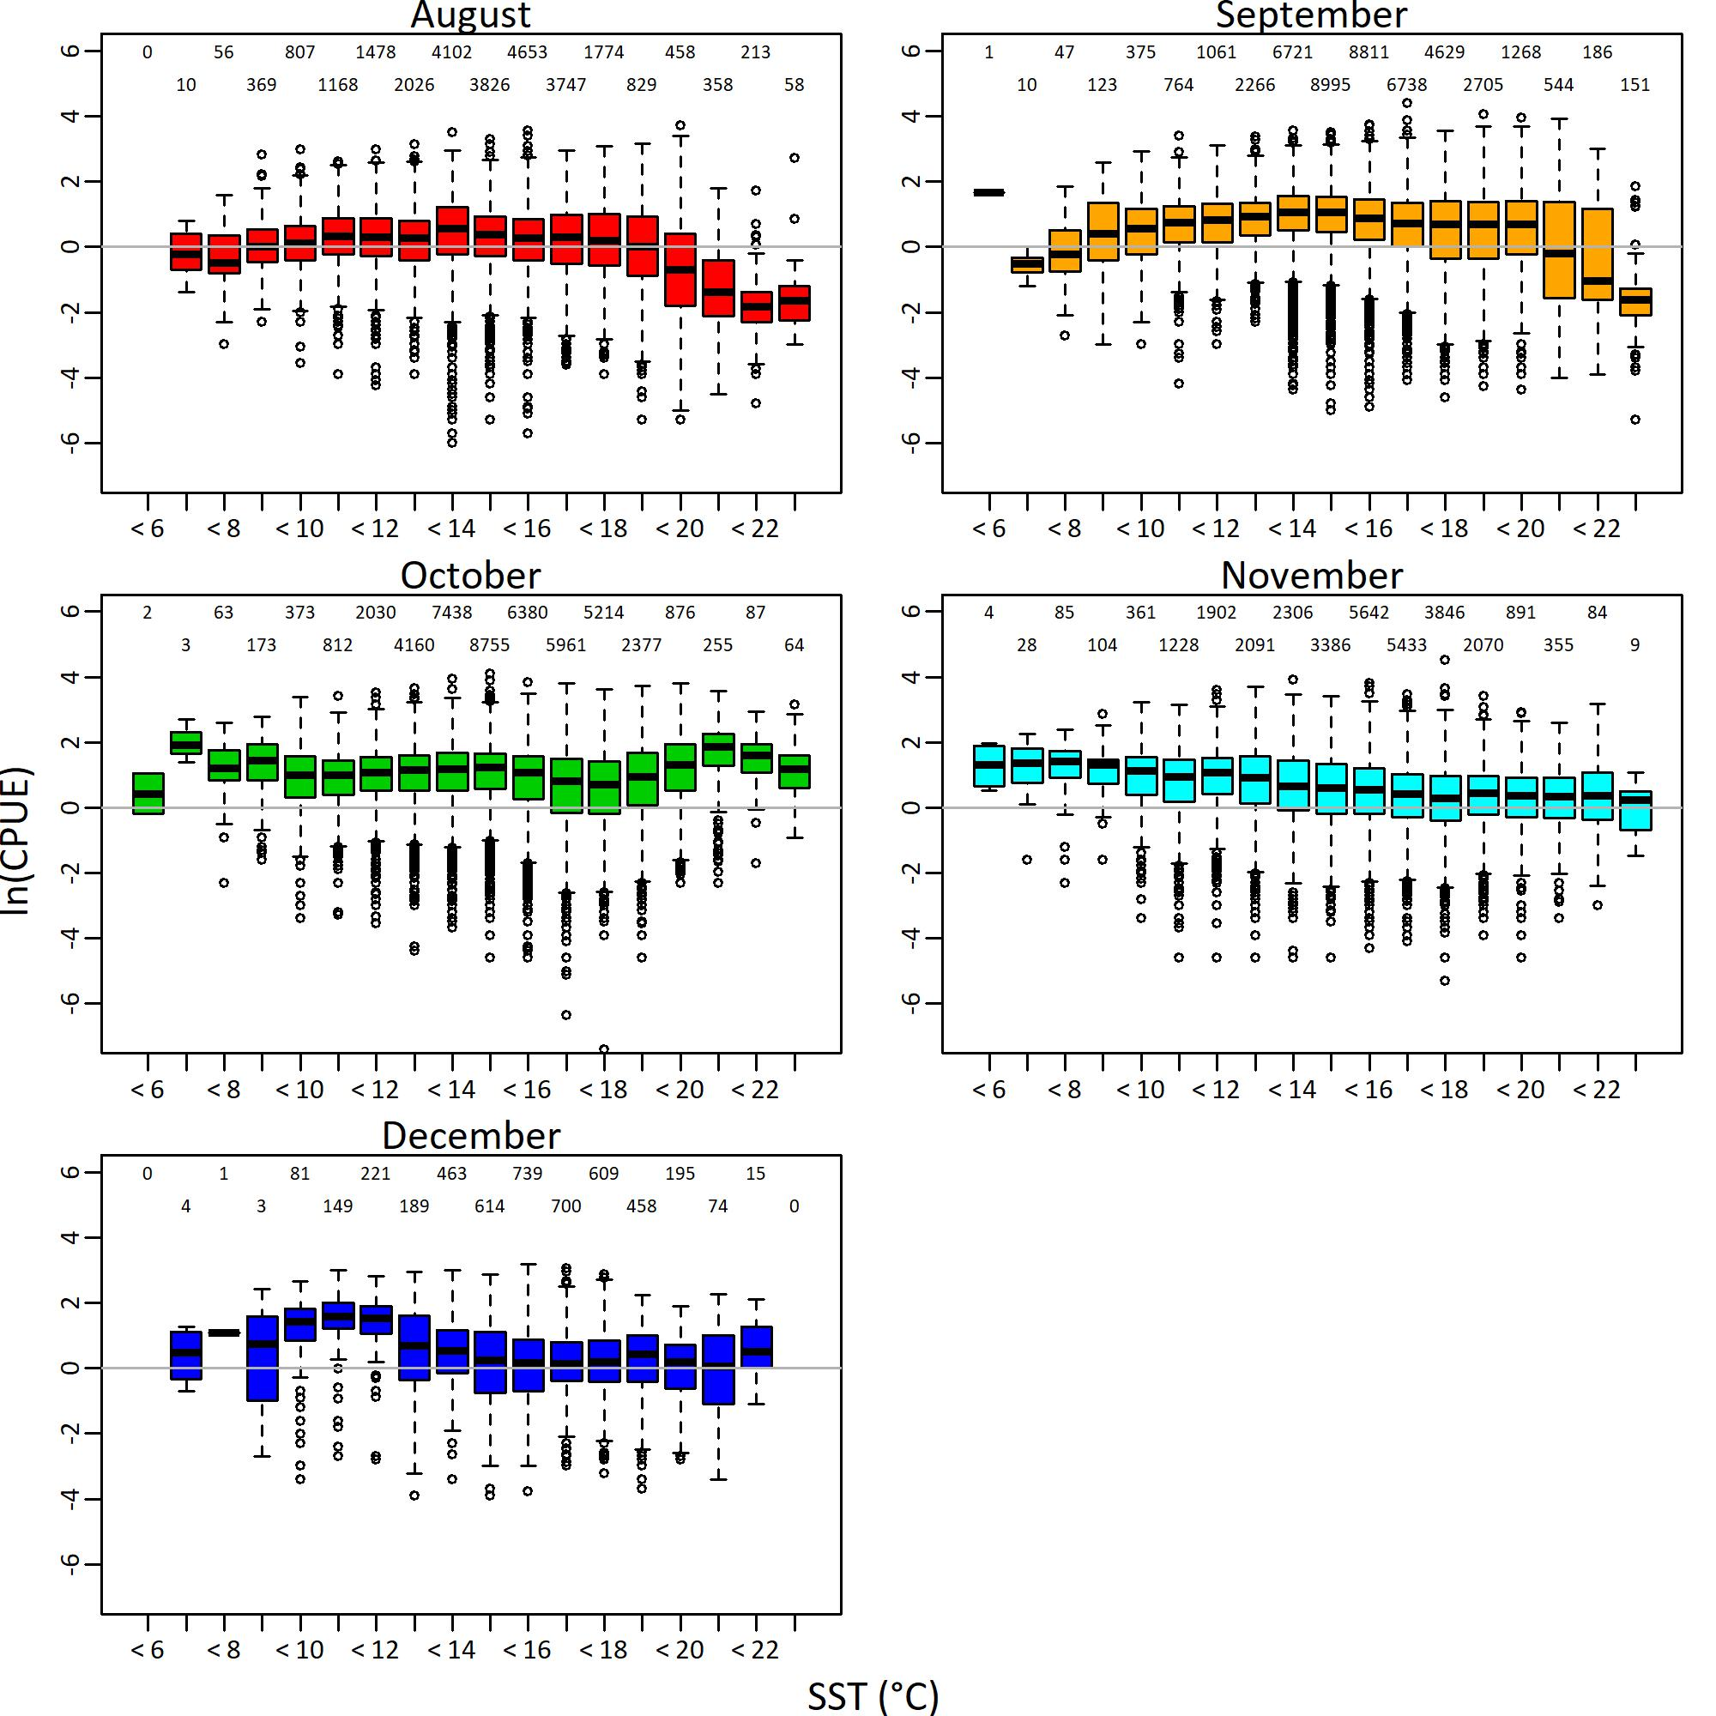

**Fig. 1** Monthly relationships between the observed SST and the logarithm of CPUE in the Japanese fishery of Pacific saury during August to December from 1994 to 2024. Numbers at the top part of each panel are sample size for each category.

**Fig. 2** Q-Q plot of residuals for CPUE in the selected VAST model.

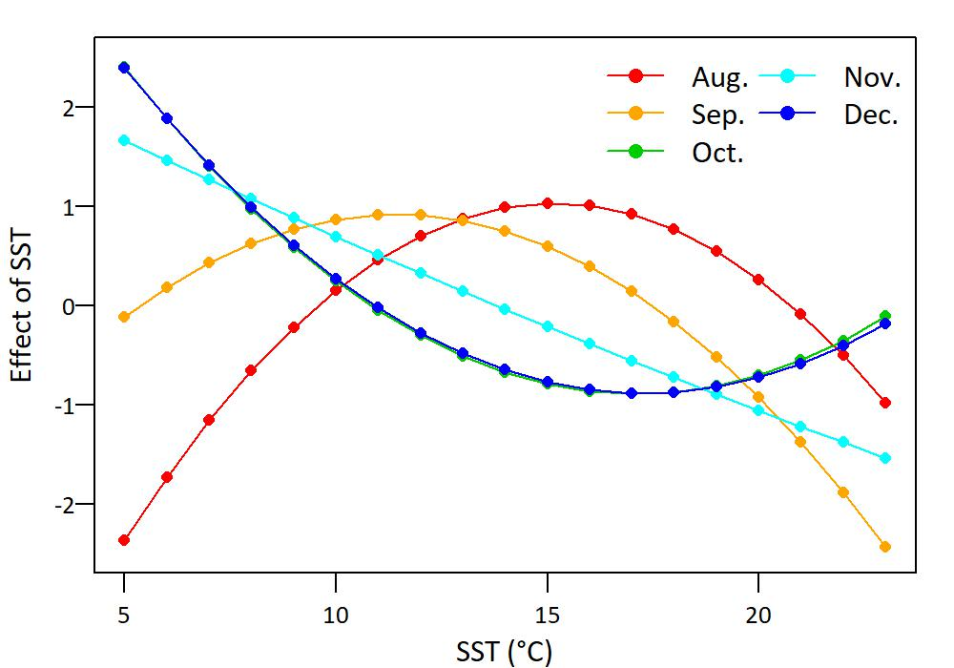

**Fig. 3** Relative effect of SST when using monthly quadratic functions of SST in the selected VAST model.

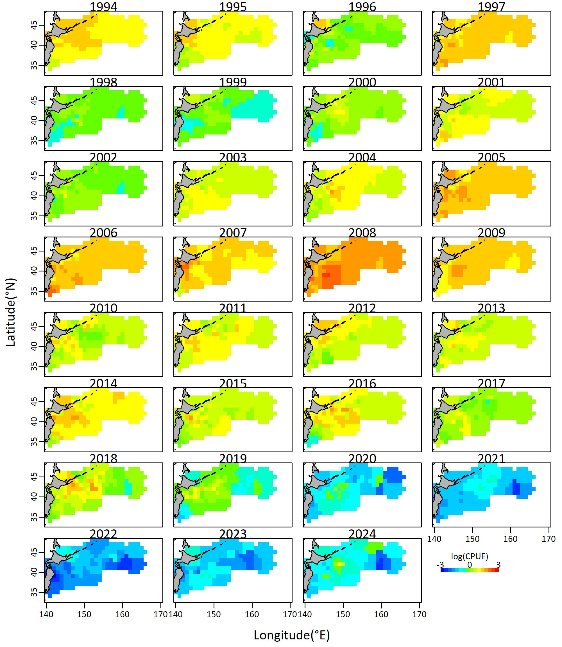

**Fig. 4** Spatial distribution of predicted log scaled CPUE (tons/hauls) for Pacific saury from 1994 to 2024, derived from the selected VAST model.

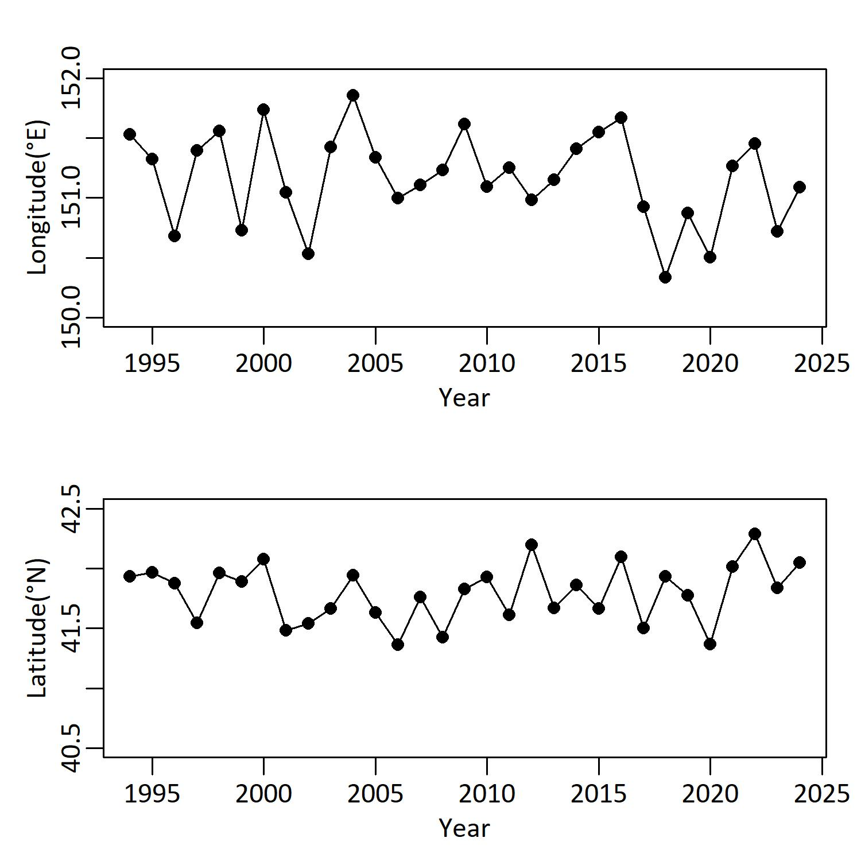

**Fig. 5** Annual shift of the estimated center of distribution of Pacific saury in the east-west direction (upper) and in the north-south direction (lower).

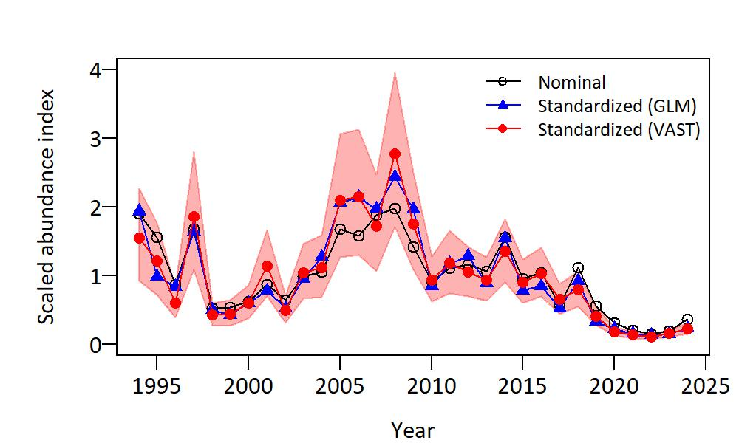

**Fig. 6** Annual trends in the standardized abundance index and the 95% confidence intervals (red zone) for Pacific saury derived from the selected VAST model, compared with nominal CPUE and standardized abundance index derived from the GLM (see Hashimoto et al. 2025 for details).

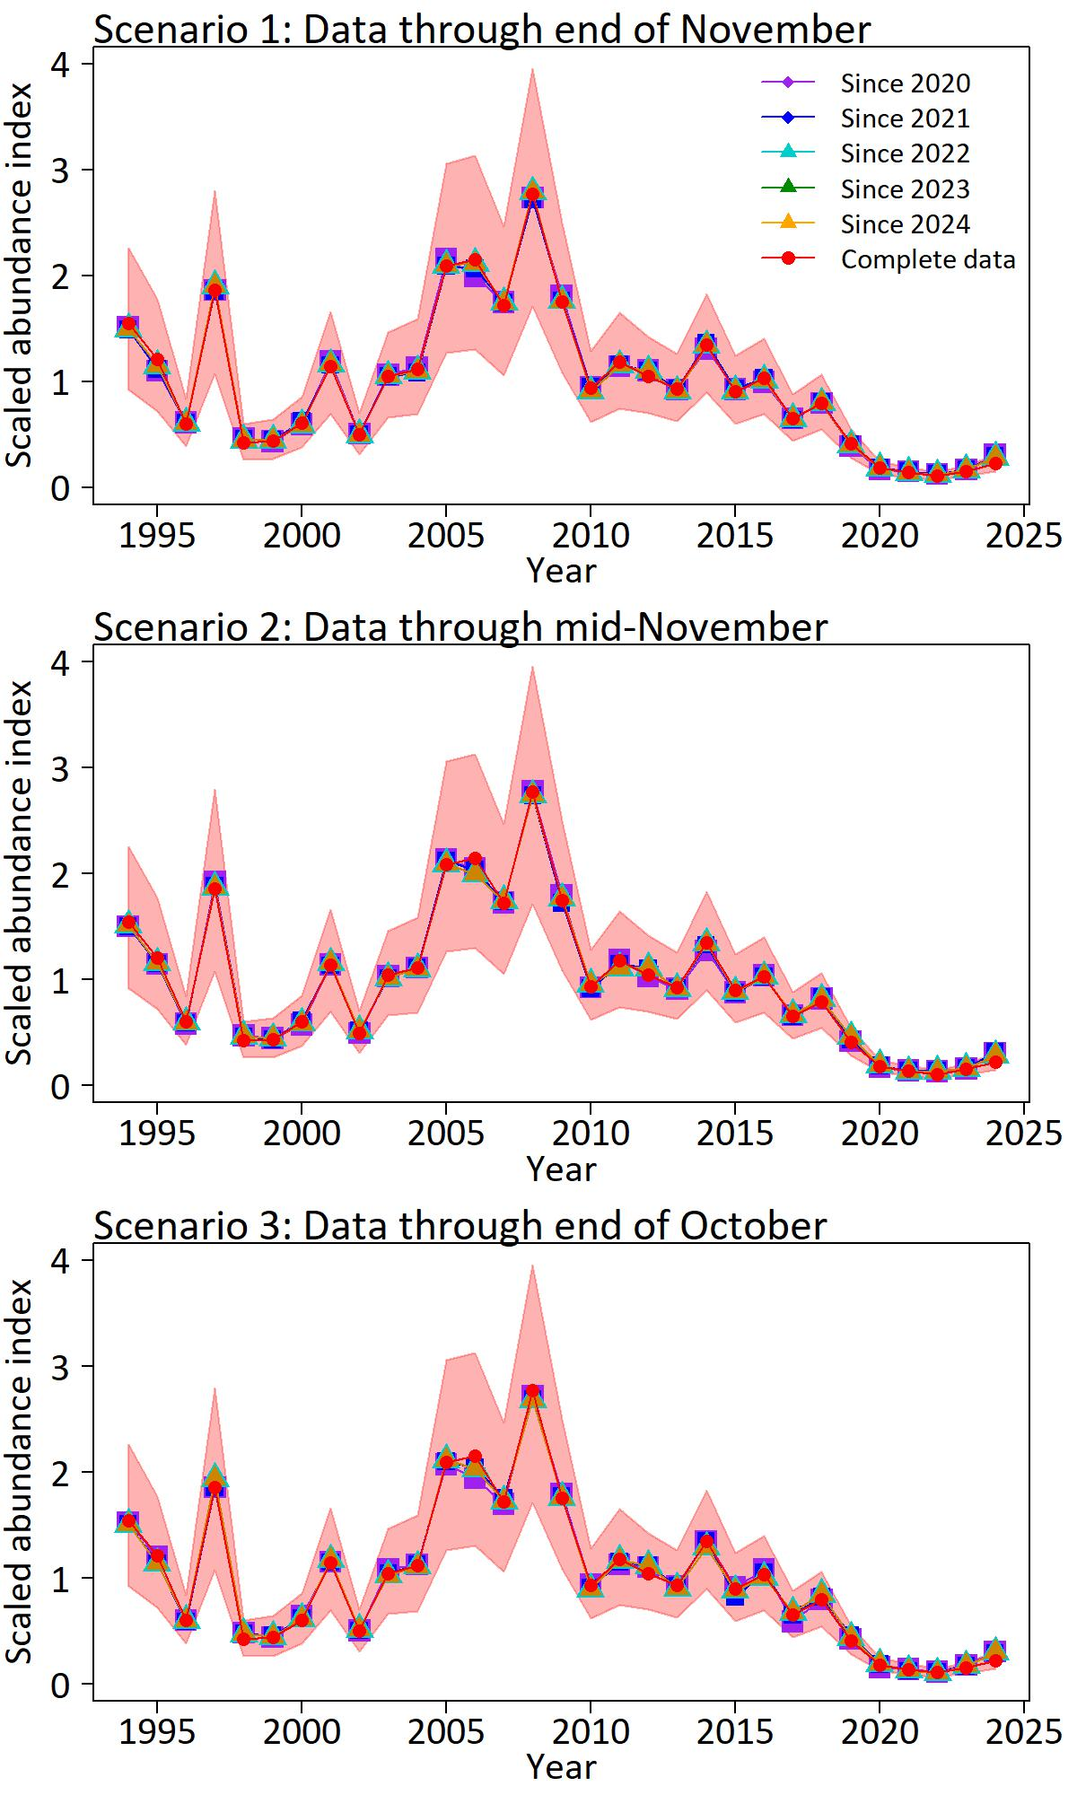

**Fig. 7** Annual trends in the standardized abundance indices using the Japanese PS fishery data through the end of November, mid-November, or the end of October every year since 2020, 2021, 2022, 2023 and 2024, compared with those using complete data up to 2024. Red zones indicate the 95% confidence intervals of abundance indices estimated using complete data.