NPFC-2025-TWG CMSA011-WP02 (Rev. 1)

**Species summary for chub mackerel**

**Chub mackerel (*Scomber japonicus*)**

**Common names:**

鲐鱼, Taiyu (China)

マサバ, Masaba (Japan)

고등어, Godeungeo (Korea)

Японская скумбрия, Yaponskaya skumbriya (Russia)

白腹鯖, Bai-Fu-Qing (Chinese Taipei)

**Management**

**Active NPFC Management Measures**

The following NPFC conservation and management measure (CMM) pertains to this species:

* CMM 2025-07 For Chub Mackerel

Available from https://www.npfc.int/cmm-2025-07-chub-mackerel

**Management Summary**

The current conservation and management measure (CMM) for Chub mackerel specifies catch limits. The CMM states that Members and Cooperating non-Contracting Parties currently harvesting Chub mackerel should refrain from expansion of the number of fishing vessels authorized to fish Chub mackerel in the Convention Area.

Additionally, the Commission established the annual total allowable catch of chub mackerel in the Convention Area as a provisional measure until the Scientific Committee adopts NPFC stock assessment of chub mackerel and the Commission accordingly revises this CMM. The annual total allowable catch of chub mackerel in the Convention Area, excluding the amount in paragraph 11, shall be set at 66,740 tons for each of the 2024 fishing seasons. Of this annual total allowable catch, the catch for trawlers shall not exceed 7,940 tons and the catch for purse seiners shall not exceed 58,800 tons for each of the 2025 fishing seasons. China shall not authorize more than 3 trawlers and the EU shall not authorize more than 1 trawler to conduct fishing operations at the same time. In addition to the above fishing opportunities, the EU shall be entitled to fish an additional 4,260 tons of chub mackerel for each of the 2025 fishing seasons.

To comply with this provisional measure, Members of the Commission shall report to the Executive Secretary, in electronic format, their monthly catches of chub mackerel in the Convention Area.

|  |  |  |
| --- | --- | --- |
| Convention/Management Principle | Status | Comment/Consideration |
| Biological reference point(s) |  | The TWG CMSA agreed to base its future discussions on the following candidate biological reference points:  (a) F-based reference points  i. FMSY  ii. F%SPR  iii. F0.1, Fmax  (b) Biomass-based reference points (including SSB, summary biomass, etc.)  i. BMSY  ii. %B0  iii. Certain historical level of B |
| Stock status |  | Status determination criteria not established. |
| Catch limit |  | 66,740 mt for CA |
| Harvest control rule |  | Not established. |
| Other |  | Encouragement to refrain from expansion, in the Convention Area, of the number of fishing vessels. |

|  |  |  |  |  |  |  |  |
| --- | --- | --- | --- | --- | --- | --- | --- |
|  | OK |  | Intermediate |  | Not accomplished |  | Unknown |

**Assessment**

The Technical Working Group on Chub Mackerel Stock Assessment (TWG CMSA) completed the stock assessment at its 11th meeting in July 2025. A State-space Stock Assessment Model (SAM) was used for the stock assessment. China, Japan and Russia submitted catch-at-age data up to the 2023 fishing year (June 2024) for the base case scenario. The TWG agreed on the stock assessment results (see TWG CMSA11 report for details).

**Data**

**Surveys**

China has been conducting a scientific survey program using its fishery research vessel "Song Hang" with mid-trawl as the main survey gear in the NPFC convention area since 2021 (Ma et al. 2023).

Japan annually conducts two mid-water trawls surveys in summer (2001–2024) and autumn (1995–2024) that serve information on recruitment abundance indices of age-0 fish to the Japanese domestic stock assessment of the Pacific stock of Chub mackerel (Table 1) (Nishijima et al. 2025a, Higashiguchi et al. 2025). The autumn mid-water trawl survey also provides age-1 fish abundance indices for the stock assessment. Japan also conducts a year-round egg survey (2005–2024) providing egg density as index of spawning stock biomass for the stock assessment (Nishijima et al. 2025b). The survey protocol can be found at Oozeki et al. (2007).

Russia has conducted a summertime acoustic-trawl survey since 2010 that examines mid-water and upper epipelagic species including Chub mackerel.

**Fishery**

China, Japan and Russia catch Chub mackerel (Figure 1). China harvests this species dominantly by light purse seine fishery in the NPFC Convention Area. A smaller component of the catch is taken by pelagic trawl. Chinese catch statistics on mackerels in the NPFC Convention Area are available from 2015. The Chinese mackerel fisheries in the NPFC Convention Area initiated in 2014 mainly caught the three fish species such as Chub mackerel, blue mackerel, and Japanese sardine (Zhang et al. 2023). Chub mackerel catch accounts for 75% to 94%, 88% on average, in the mackerels catch up to 2023.

Japan’s fishery for Chub mackerel occurs inside their Exclusive Economic Zone (EEZ) and is mostly conducted by large purse seine vessels (≥50% of the catch). Additional components of the fishery include set nets, dip nets and other gears. Proportion of Chub mackerel catch in mackerels catch is obtained through extensive port sampling. The Chub mackerel catch accounts for 69% to 92%, 86% on average, of the mackerels catch in 2014-2023.

The Russian fisheries catching mackerels are operated in their EEZ and is prosecuted primarily by mid-water trawling (>90% of the catch), with a smaller component of the catch coming from purse seiners and bottom trawlers. The Russian mackerels catch, comprising approximately 100% of Chub mackerel, are available in the NPFC Annual Summary Footprint since 2014.

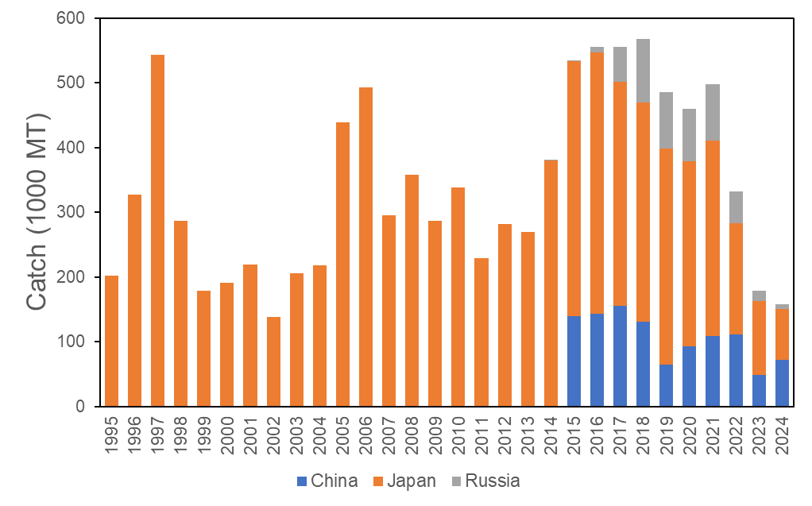

*Figure 1. Historical catch of mackerels obtained from the annual summery footprint of Chub and Blue mackerels.*

Other NPFC Members (Canada, EU, Korea, Chinese Taipei, USA and Vanuatu) do not have Chub mackerel catch records in the NPFC Convention Area.

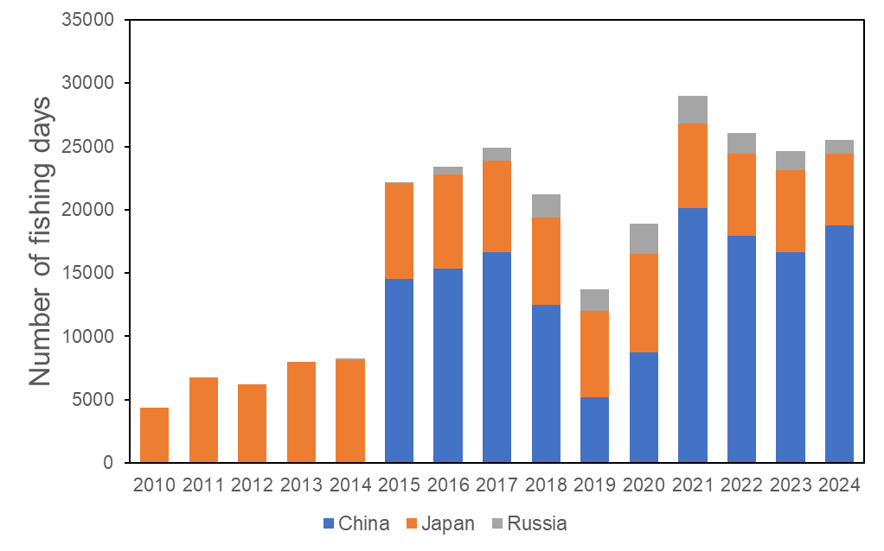

*Figure 2. Historical fishing effort for mackerels obtained from the annual summary footprint of Chub and Blue mackerels. Fishing efforts of Japan were derived from purse seine and bottom trawl.*

**Biological collections**

China has collected length frequency data of commercial catch through onboard and port samplings since 2016. Aging of the samples has been started since 2017.

Japan also collects length, weight, maturity and age data from the survey and fishery to support their stock assessment.

Russian length frequency and aging data of commercial catch are available since 2016. The length frequency data obtained through research surveys are available since 2010.

*Table 1: Data availability from Members regarding Chub mackerel.*

|  |  |  |  |  |
| --- | --- | --- | --- | --- |
| **Category and data sources** | **Description** | **Years with available data** | **Average sample size/year or data coverage** | **Potential issues to be reviewed** |
| **JAPAN** | | | | |
| **Catch statistics** | | | | |
| Purse seine fishery | Official statistics, reports from fisheries associations and markets | Official statistics: 1950-2024, other reports: 1970-2024 | Coverage=100% | The Chub mackerel catches are estimated from Chub and blue mackerel catches based on port sampling data for purse seine and set net fisheries. No detailed information of the ratio is presented. |
| Dip net fishery |
| Set net |
| **Size composition data** | | | | |
| Length measurements | Port sampling by 17 local fishery institutes in 17 prefectures | 1970-2024 | 20,000-120,000 (average 40,000) fish/year (ca. 100 measurements per sampling) | Detailed information in NPFC-2020-TWG CMSA03-WP02. |
| Aging | Port sampling by 17 local fishery institutes in 17 prefectures | 1970-2024 | 500-1000 fish/year | Detailed information in NPFC-2020-TWG CMSA03-WP02. |
| Catch at age  (CAA) | Estimate CAA from the above data | 1970-2024 | Age-length keys are created approximately by quarter and local regions | Evaluate uncertainty of catch at age; Changes of growth depending on recruitment abundance is reviewed in NPFC-2022-TWG CMSA05-IP06 and published as Kamimura et al (2022, https://doi.org/10.1093/icesjms/fsab191) |
| **Abundance indices (survey)** | | | | |
| Spring survey for recruitment | Mainly for sardine and Chub mackerel of pre-recruits. This research is conducted for biological research of early life history. Mid-water trawl | 1995-2024 | 30-60 stations/year | Too early for the use of abundance index |
| Summer survey for recruitment | Mainly for saury, mid-water trawl | 2001-2024 | 60-80 stations/year | Detailed information on data and standardization is in NPFC-2022-TWG CMSA06-WP11 (Rev.1). Detailed sampling design and method are shown in [Hashimoto et al. (2020, https://doi.org/10.1007/s12562-020-01407-3).](https://d.docs.live.net/97fbd8355b740407/バヌアツ/Hashimoto%20et%20al.%20(2020,%20https:/doi.org/10.1007/s12562-020-01407-3).) |
| Autumn survey for recruitment and age 1 fish | Mainly for sardine and Chub mackerel, mid-water trawl | 1995-2024 | 30-60 stations/year | Detailed information on data and standardization for recruitment is in NPFC-2022-TWG CMSA06-WP11 (Rev.1). That for age 1 has not been presented. |
| Year-round for egg density | Almost all local fishery institutes join this survey program. NORPAC net. Not only for Chub mackerel. | 1978-2024  (2005-, species identification between Chub and blue mackerel) | ca. 6000 stations in total, 1000-4000 stations with Chub mackerel eggs/year | Detailed information on data and standardization is in NPFC-2022-TWG CMSA06-WP10 |
| **Abundance indices (commercial)** | | | | |
| Dip net fishery | Log book data are collected from fishermen in Kanagawa prefecture since 2003 and Shizuoka prefecture since 2013 (ca. 10 and 90% of total dip net catch in 2017, respectively) | 2003-2024 | 10-100/year | Detailed information on its data and standardization is in NPFC-2022-TWG CMSA06-WP09 |
| **RUSSIA** | | | | |
| **Catch statistics** | | | | |
| Purse seine fishery | Official statistics, reports from fisheries associations | Official statistics:  1980-1993, 2015-2024,  1994-2014 (no data available); publications: 1970-2024 | Coverage  1980-1993 = ?%;  Coverage  2015-2023 =100% | Data coverage details to be reviewed |
| Pelagic trawl fishery |
| **Size composition data** | | | | |
| Length measurements | Sampling from commercial fishing vessels.  Sampling during research surveys. | 2016-2024  2010-2024 | 1,000-10,000 fish/year (ca. 100 measurements per sampling) | Data coverage details to be reviewed |
| Aging | Sampling during research surveys and from commercial fishing vessels | 2016-2024 | 300-500 fish/year | Details to be reviewed |
| Catch at age  (CAA) | Estimate CAA from the above data | 2016-2024 | Age-length keys are to be developed | Evaluate uncertainty of catch at age, especially on changes of growth depending on recruitment abundance |
| **Abundance indices (survey)** | | | | |
| Summer trawl and acoustic (echointegration) surveys to assess pelagic fish abundance and recruitment | Mid-water upper epipelagic surveys | 2010-2024  (June-July)  2015-2024 (July-September) | 60-80 stations/year  60-80 stations/year | Changes in abundance and migration patterns; development survey protocol and conduct standardization |
| **Abundance indices (fishery)** | | | | |
| Daily reports of catch by each vessel | Target (>50%) Mid-water trawls | 2015-2024  May-  December |  | Test the effect of targeting |
| **CHINA** | | | | |
| **Catch statistics** | | | | |
| Purse seine fishery | Official statistics, reports from annual report | Official statistics：2014-2024 | Coverage=100% | The Chub mackerel catches are from the fishing catch provided by the fishery company |
| Trawl fishery | Official statistics, reports from annual report | Official statistics:  2014-2024 | Coverage=100% | Catches are from the fishing catch provided by the fishery company |
| **Size composition data** | | | | |
| Length measurements | Port sampling by Institute and technology group. | 2016-2024 | 550-800 fish/year | Details to be reviewed |
| Length measurements | Purse seine vessel sampling from commercial vessel | 2016-2024 | 530-1050 fish/year | Details to be reviewed |
| Aging | Sampling during research surveys and from commercial fishing vessels | 2017-2024 | 30-180 fish/year | Details to be reviewed |
| **Abundance indices (commercial)** | | | | |
| Purse seine fishery | Purse seine logbook (Technical group for Chub mackerel Fishery, Distant-water Fishery Society of China) | 2014-2024  April-December | 10-105/year | Review survey protocol and conduct standardization |

**Special Comments**

None

**Biological Information**

**Distribution**

The Pacific stock of Chub mackerel is distributed from the southern coastal waters on the Pacific side of Japan to offshore area off the Kuril Islands (Figure 3). This stock corresponding to straddling one is harvested in both national waters of Japan and Russia and the NPFC Convention Area. Adult fish spawn in Izu Islands waters in spring and then engage northward feeding migration to waters of Sanriku to east Hokkaido from summer to autumn.

**Life history**

Longevity of Chub mackerel is estimated to be 7 or 8 years old. There was the oldest record of 11 years old. It is known that growth of this stock could be changed according to recruitment abundance and oceanic environment (Watanabe and Yatsu 2004). Recent decrease in mean weight by age was highly likely induced by feeding competition in conjunction with intra-/inter-specific increase of density resulted from biomass increases of Chub mackerel and Japanese sardine (Kamimura et al. 2021). Adult female spawns more than once during a spawning season. Maturity at age was changed depending on changes in growth (Watanabe and Yatsu 2006).

*Figure 3. Map of distribution of Chub mackerel in the North Pacific (Yukami et al. 2025).*

**Literature cited**

Higashiguchi, K., Nishijima, S., Ichinokawa, M. and Yukami, R. (2025) Standardized Abundance Indices for Ages 0 and 1 Fish of Chub Mackerel from Northwest Pacific Autumn Surveys up to 2024 NPFC-2025-TWG CMSA10-WP05.

Kamimura, Y., M. Taga, R. Yukami, C. Watanabe and S. Furuichi (2021) Intra- and inter specific density dependence of body condition, growth, and habitat temperature in chub mackerel (*Scomber japonicus*). ICES J. Mar. Sci., 78, 3254-3264.

Ma, Q., Liu, B. and Dai, L. (2023) Overview surveys from 2021 to 2023 by Chinese research vessel "Song Hang" in the NPFC convention area. NPFC-2023-SC08-WP12. 10pp. https://www.npfc.int/system/files/2023-12/NPFC-2023-SC08-WP12%20Chinese%20surveys%202021-2023%20by%20Song%20Hang%20in%20NWP.pdf

Nishijima, S., Higashiguchi, K., Kamimura, Y., Ichinokawa, M. and Yukami, R. (2025a) Standardized abundance index for recruitment of chub mackerel from Northwest Pacific summer surveys up to 2024. NPFC-2025-TWG CMSA10-WP08.

Nishijima, S., Ichinokawa, M. and Yukami R. (2025b) Standardizing monthly egg survey data as an abundance index for spawning stock biomass of chub mackerel in the Northwest Pacific NPFC-2024-TWG CMSA10-WP07 (Rev.1).

Oozeki, Y., A. Takasuka, H. Kubota and M. Barange (2007) Characterizing spawning habitats of Japanese sardine (*Sardinops melanostictus*), Japanese anchovy (*Engraulis japonicus*), and Pacific round herring (*Etrumeus teres*) in the northwestern Pacific. CalCOFI Reports, 48, 191-203.

Technical Working Group on Chub Mackerel Stock Assessment (TWG CMSA) (2023) Report of 7th Meeting of the Technical Working Group on Chub Mackerel Stock Assessment, NPFC-2023-TWG CMSA07-Final Report, 53pp. https://www.npfc.int/system/files/2023-10/TWG%20CMSA07%20Report.pdf

Watanabe, C. and A. Yatsu (2004) Effects of density-dependence and sea surface temperature on inter-annual variation in length-at-age of chub mackerel (*Scomber japonicus*) in the Kuroshio-Oyashio area during 1970–1997. Fish. Bull., 102, 196-206.

Watanabe, C. and A. Yatsu (2006) Long-term changes in maturity at age of chub mackerel (*Scomber japonicus*) in relation to population declines in the waters off northeastern Japan. Fish. Res., 78, 323-332.

Yukami, R., Nishijima, S., Kamimura, Y., Isu, S., Furuichi, S., Watanabe, R., Higashiguchi, K., Saito, R. and Ishikawa, K. (2025). Stock assessment and evaluation for Chub Mackerel Pacific Stock (fiscal year 2024). Marine fisheries stock assessment and evaluation for Japanese waters. Japan Fisheries Agency and Japan Fisheries Research and Education Agency, Tokyo, 96pp, https://abchan.fra.go.jp/wpt/wp-content/uploads/2025/03/details_2024_05.pdf

Zhang, H., Han, H., Sun, Y., Xiang, X., Li, Y. and Shi, Y. (2023) Data description on fisheries bycatch in the chub mackerel fisheries in China. NPFC-2023-TWG CMSA07-WP12 (Rev. 1). 3pp. https://www.npfc.int/system/files/2023-09/NPFC-2023-TWG%20CMSA07-WP12%28Rev%201%29%20Data%20description%20on%20fisheries%20bycatch%20in%20CM%20fisheries%20in%20China.pdf