NPFC-2025-TWG CMSA11-WP09
Biological reference points and future projections in the 2025 stock assessment for the Northwestern Pacific chub mackerel

Shota Nishijima^{*,1}, Momoko Ichinokawa¹, Kazuhiro Oshima¹, and Joel Rice²
1. Fisheries Resources Institute,
Japan Fisheries Research and Education Agency (FRA)
2. NPFC consultant
(*Corresponding author: Shota Nishijima, nishijima_shota02@fra.go.jp)

Summary
We conducted stochastic future projections with candidate base-case stock assessment results to provide scientific information that could be used to draft management advice on the Northwestern Pacific stock of chub mackerel (including the NPFC convention area). The estimated spawning stock biomass at maximum sustainable yield (SSB_{MSY}) was highly sensitive to input data and model configurations, estimated values were consistently higher than the current stock abundance. We propose using the first to third quartiles of historical SSB as interim reference points which might be used for short- or long-term target and limit, and with future probabilities calculated over these empirical reference points as well as the MSY-based ones. Stochastic future projections showed that, under constant-catch scenarios, unless the annual total catch is kept below 60,000–70,000 tons, there is less than a 90% probability of maintaining SSB above the first quartile, and less than 60% probability of reaching the median five years later (in the 2031 fishing year). Under constant-F scenarios, fishing pressure must be F50%SPR (correspond to about 70,000 tons catch in the 2026 fishing year) or lower to achieve the median SSB with a probability exceeding 50% after five years. Considering the projection results that the stock continues to decline under the current fishing pressure (16-17% SPR) as long as the body weight and maturity rate are kept at a current low level, it is necessary to substantially reduce fishing pressure in order to avoid further decline and facilitate stock recovery. We also argue that development of harvest control rule and target and limit reference points are urgently needed for the long-term sustainable management of this stock.

Introduction
Chub mackerel in the Northwestern Pacific Ocean has historically been fished by China, Japan, and Russia, and is an important fishery resource for these Members. Before 2010, this species was mainly caught within Japan's EEZ, but since the early 2010s, catches within the NPFC Convention Area have increased. The priority for stock assessment and management in the NPFC places it as the second most important fish species after Pacific saury. The TWG CMSA has carried out the task of assessing this stock. The first stock assessment was carried out in the TWG CMSA09 meeting last year using an age-structured state-space stock assessment model called State-space Assessment Model (SAM, Nielsen and Berg 2014).
This document provides useful information for future management of this stock by presenting the methods and results of biological reference points and future projections using the estimated population dynamics of this stock under candidate base case scenarios of SAM (NPFC-2025-TWG CMSA11-WP06). The management reference points of F%SPR, F0.1, F_{MSY}, and SSB_{MSY} were calculated. However, the estimated SSB_{MSY} was highly sensitive to a variety of assumptions including input data, biological parameters, and stock-recruitment relationships and was unrealistically higher than the observed ranges of historical SSB (NPFC-2025-TWG CMSA11-WP07). We therefore calculated percentiles of historical SSB (e.g. 1st, 2nd, 3rd quartiles) between FY1970-2023, which were robust to the variety of assumptions and input data. We propose using these quartiles as interim and empirical reference points for short- and long-term management objectives. In the future projections, simulations based on forward calculations of population dynamics with stochastic uncertainty in process errors were conducted under the assumption of constant catches or constant F. Constant-F scenarios were newly analyzed this year following a request from NPFC Commission (NPFC-2025-COM09-WP14). We computed the statistics of catch and SSB and probabilities that the stock exceeds the empirical and MSY-based reference points in any year until FY2036 (ten years after management implementation in FY2026) under constant-catch and constant-F scenarios. Output values from this analysis will be useful to make scientific advice for the international management of this stock.

Methods

Stock assessment scenarios and biological reference points
This document used parameter estimates of candidate base case scenarios of SAM: S01-InitBase and S02-Index24_1 (NPFC-2025-TWG CMSA11-WP06). The only difference between these two scenarios is exclusion or inclusion of FY2024 abundance indices (Table 1) and the abundance estimates were fairly similar between the scenarios (Fig. 1).
We calculated commonly used biological reference points such as F%SPR (30%, 40%, 50%, 60%, and 70%), F0.1, F_{MSY}, and SSB_{MSY}. The most recent three-year average of F at age (F2021-2023), estimated by the two candidate base cases, was defined as current F (F_{CUR}) and its selectivity at age was used to calculate the biological reference points (Fig. 2).
The chub mackerel stock is characterized by large annual fluctuations in weight-at-age and maturity-at-age. Spawners per recruit (SPR), expressed by the formula below, is an index that measures how much spawning biomass a single recruit produces:
$$\text{SPR(}\text{F}\text{)}=\sum_{a=0}^{∞}{\exp\left(-M_{a}-F_{a}\right)g_{a}w_{a}} ,$$where $F_{a}$, $M_{a}$, $g_{a}$ and $w_{a}$ are fishing mortality coefficient, natural mortality coefficient, maturity rate, and weight at age $a$. SPR at F=0 (SPR0) represents the reproductive potential in the absence of fishing, but it has shown substantial interannual variability, and has declined to unprecedented levels since the strong 2013 year class (Fig. 3). For the calculation of biological reference points and future projections, the average weight-at-age and maturity-at-age for the recent eight years (FY2016–2023) was used (Fig. 4) because a change point analysis identified the ‘regime’ of spawners per recruit without fishing (SPR0) was separated before FY2016 and onward and the last year stock assessment used the averages since FY2016 (NPFC-2024-SC09-WP20 (Rev. 1)). Furthermore, as in last year’s stock assessment, biological reference points were also calculated using biological parameters averaged over all years (Fig. 4). These two assumptions—the recent eight-year average (Recent8YRave) and the all-year average (AllYRave)—were also used in future projections (Table 1). We also calculated MSY reference points under the selectivity of F_{CUR} with biological parameters averaged during each decade (y=1970-1979, 1980-1989, etc.…) to evaluate the effect of the changes in biological parameters on MSY reference points.
According to last year’s and this year’s stock assessments, MSY-based reference points are highly sensitive to various assumptions (NPFC-2024-TWG CMSA09-WP05, NPFC-2024-TWG CMSA11-WP07). When using the Beverton-Holt stock-recruitment relationship, they are estimated at levels exceeding historical maxima, which makes them rather distant targets given the current declining and low state of the stock. In addition to MSY-based reference points, we therefore calculated some percentiles (e.g. median and first and third quartiles) of historical SSB. These historical quantiles are proposed as robust, interim reference points in CMSA.

Population dynamics in future projection
The population dynamics model for future projections is the same as that used in SAM. The calculation was conducted by the R package ‘frasyr’ (https://github.com/ichimomo/frasyr), which has been developed for the stock assessment of Japanese domestic fisheries resources. In particular, we used the functions for future projection and the calculation of biological reference points in frasyr. The general equations of the forward calculation of the population dynamics are
$$N_{y,a}^{i}=\left\{\begin{aligned}\frac{\hat{α}S_{y}^{i}}{1+\hat{β}S_{y}^{i}}\exp\left(ε_{y,a}^{i}\right) (a=0) \\ N_{y-1, a-1}^{i}\exp\left(-M_{a-1}-F_{y-1, a-1}^{i}\right)\exp\left(ε_{y,a}^{i}\right) (0<a<6) \\ \left[N_{y-1, a-1}^{i}\exp\left(-M_{a-1}-F_{y-1, a-1}^{i}\right)+N_{y, a}^{i}\exp\left(-M_{a}-F_{y, a}^{i}\right)\right]\exp\left(ε_{y,a}^{i}\right) (a=6+)\end{aligned}\right.$$
where $\hat{α}$ and $\hat{β}$ are stock recruitment parameters estimated by SAM, $N_{y,a}^{i}$ is the number of fish in year $y$ and age $a$ at $i$th iteration, $F_{y,a}^{i}$ is fishing mortality coefficient in year $y$ and age $a$ at $i$th iteration, $ε_{y}^{i}\sim \text{N}\left(0,{\hat{σ}}_{a}^{2}\right)$ where ${\hat{σ}}_{a}^{2}$ is the variance of process error for age a estimated by SAM, and $S_{y}^{i}$ is SSB defined as $\sum_{a=0}^{6}{N_{y,a}^{i}w_{a}g_{a}}$. The equations are generally applied from the end year of the stock assessment period with the initial conditions of $N_{2023,a}^{i}={\hat{N}}_{2023,a}^{}$ in Scenario S01-InitBase and $N_{2024,a}^{i}={\hat{N}}_{2024,a}^{}$ in S02-Index24_base, where ${\hat{N}}_{y,a}^{}$ is the point estimates by SAM. Before management measures are implemented in 2026, we assumed that the fishing mortality in FY2024 and FY2025 would be the same as the 2023 fishing mortality estimated by SAM. If we were to assume the average fishing mortality for FY2021–2023 (F_{CUR}) during this period, the projected catch in the FY2024 would exceed 200,000 tons, which is unrealistically high considering current fishing situation. The fishing mortality in FY2023 was lower than in FY2021–2022, and using F2023 results in projected catches for FY2024–2025 that are similar to FY2023 (170,000 –180,000 tons), so we adopted this assumption. The future biological parameters of $w_{a}$ and $m_{a}$ are given according to future-projection scenarios for $y≥2024$ (Fig. 4).
Two types of future harvesting methods were considered: constant-catch scenarios and constant-F scenarios. In the constant-catch scenarios, a total catch (CC) was predetermined ranging from 0 to 200,000 tons (Table 1). Catch number at age $C_{y,a}^{i}$ in year y and age a is calculated with the Baranov catch equation
$$C_{y, a}^{i}=\frac{F_{y, a}^{i}}{F_{y, a}^{i}+M_{a}}\left(1-\exp\left(-F_{y,a}^{i}-M_{a}\right)\right)N_{y,a}^{i} ,$$
where $F_{y,a}^{i}$ is equal to $x_{y}^{i}Fcur$ with the same selectivity as Fcur and adjustment factor of $x_{y}^{i}$ that is determined to satisfy the equation of $\sum_{a=0}^{6+}{w_{a}C_{y,a}^{i}}=CC$. If we cannot find $x_{y}^{i}$ to satisfy the equation because of too small number of fishes, we took the smaller of the two numbers, $x_{i}=exp⁡(10)$ or fishing mortality corresponding to 99% of total catches when $x_{i}=exp⁡(100)$.
In the constant-F scenarios, we examined F ranging from F30%SPR to F70%SPR in 5% increments. In the Baranov equation above, $F_{y,a}^{i}$ was set as $xF_{CUR}$, where x used the values obtained when calculating the biological reference points. The constant-catch and constant-F scenarios were initiated in FY2026, and population dynamics were projected through to 2036, ten years later. We also conducted a future scenario in which the stock is exploited with current F since FY2026 to inform the current fishing impact on the stock in the future. The stochastic simulations were conducted 3,000 times for each model and scenario.

Results

Stock recruitment relationship and biological reference points
In the stock-recruitment relationship estimated by the two models, there was weak density dependence effect within the range of spawning stock biomass (SSB) and recruitment numbers observed in past, so the SSB0 and SSB_{MSY} calculated based on this stock-recruitment relationship are extrapolated values that exceed the past recruitment and spawning stock biomass (Fig. 5). Furthermore, since the productivity of this stock, represented by SPR0_{y}, has changed significantly over the years as seen in Fig. 3, the estimated values of SSB0 and SSB_{MSY} (even under the single stock-recruitment relationship) varied greatly depending on which year's biological parameters were used. In particular, SSB0 using the biological parameters of the 2020s, when growth and maturation were heavily delayed, was equivalent to SSB_{MSY} in other decades. Moreover, even between the two models, the MSY reference points differed greatly probably because the influence of a slight difference of estimated stock-recruitment relationships became larger by the extrapolation of estimating MSY (Fig. 5). Steepness (h) was higher for S02 scenario than for S01 scenario, suggesting a higher recruitment productivity for S02 (Table 2).
The current fishing mortality (F_{CUR} = F2021-2023) was equivalent to 16-17%SPR and much higher than commonly used F reference points including F_{MSY} = F67-68%SPR (Table 2). However, if using the all-year average of biological parameters, the ratios of F reference points to F_{CUR} became lower, although F_{CUR} still exceeded them but F_{MED}.
The first, second (median), and third quartiles of SSB during FY1970-2023 were robust between the two scenarios, and 110,000 tons, 290,000 tons, and 720,000 tons, respectively (Table 2). The current status of SSB (130-140 thousand tons in FY2023) was lower than a half of the median SSB and slightly higher than the first quartile, while the third quartile of SSB is a level which SSB in FY2017-2018 exceeded (Fig. 6).

Future projections
Since the use of biological parameters for the last eight years (Recent8YRave) is more realistic for the near future setting than the use of all-year averages (AllYRave), the results for the future scenario Recent8YRave are presented in the main text. The results of the future scenarios AllYRave are shown in the Appendix.
If current fishing pressure continues, the exploitation rate (catch/stock biomass) will remain around 20%, and spawning biomass will continue to decline (Fig. 7). Under constant-catch scenario of 100,000 tons, the exploitation rate becomes higher when stock biomass is low and lower when stock biomass is high, resulting in wider prediction intervals for SSB then those under the current-F scenario. For example, maintaining catches at 100,000 tons would lead to a gradual increase in the median SSB, but there is also a possibility that the stock could collapse, and catches become unsustainable within ten years. This result is worse than last year’s base-case assessment (NPFC-2024-SC09-WP20 (Rev. 1)), likely reflecting a decrease in estimated stock biomass in this year’s update. When using S01-InitBase, even a catch of 60,000 tons results in a decrease in the 5th percentile of SSB (Fig. 8). Under S02-Index24_1, catches below 60,000 tons maintain the 5th percentile of SSB at about the current level, likely because steepness of the stock-recruitment relationship was estimated slightly higher in this scenario (Table 2).
We output the predicted median catch and SSB in each year, along with the probabilities of exceeding SSB_{MSY} and the three quartiles, under varying levels of constant catch (Tables 3-6). For example, the catch amount needs to be lower than 80 to 90 thousand tons (depending on the base-case scenario) to achieve a probability higher than 50% that SSB will exceed historical median in FY2031 (five years after management implementation in FY2026). Furthermore, the catch amount needs to be lower than 60 to 70 thousand tons to achieve a probability higher than 50% that SSB will exceed its third quartile in FY2036 (ten years after management implementation) and to achieve a probability higher than 90% that SSB will exceed its first quartile thorough FY2036. On the other hand, even with no fishing, the probability of reaching SSB_{MSY} by 2036 was 37% in S01-InitBase and 52% in S02-Index24_1.
Examining the relationship between the FY2026 catch and the realized F (median), catches below 50,000 tons corresponded to F < F_{MSY}, and catches below 100,000 tons corresponded to F < F50%SPR (Fig. 9). Compared to S01-InitBase, the uncertainty in the projected F in S02-Index24_1 was smaller. This is because stock biomass up to FY2024 was estimated in S02, reducing the influence of process error.
Under constant-F scenarios, the prediction intervals for SSB are narrower compared to constant-catch scenarios, because the exploitation rate remains roughly constant. Under F40%SPR, for example, the exploitation rate is around 10%, and the median projected SSB and catch gradually increase, while the 5th percentile remains at about the current level (Fig. 10). If fishing mortality is set lower than F35%, the median SSB is projected to increase; however, under F30%, it is projected to be maintained only slightly above the current level (Table 7, Fig. 11).
Looking at probabilities with SSB over the historical quartiles, F50%SPR (corresponding to a catch of 69–71 thousand tons in FY2026) represent the upper fishing mortality levels needed to achieve a probability higher than 50% that SSB will exceed its median in FY2031 (Tables 7-10). F65%SPR (corresponding to a catch of 41–42 thousand tons in FY2026) or lower F is needed to achieve a probability higher than 50% that SSB will exceed its third quartile in FY2036. Even with F70%SPR, the probability of reaching SSB_{MSY} by 2036 was 14% in S01-InitBase and 23% in S02-Index24_1.
Assuming that weight-at-age and maturity-at-age are at their all-year averages, the future projection patterns differ greatly from those based on the recent eight-year averages (Appendix). Even under F_{CUR}, the stock recovers, and in all fishing scenarios examined, SSB recovers at a rapid pace (Tables A1-2 and A5-6, Figs. A1-2). Under the constant catch scenario of 100,000 tons, the probability of exceeding SSB_{MSY} by FY2032 exceeds 50% (Tables A3-4). Under F55%SPR in S01 and F50%SPR in S02, the probability of exceeding SSB_{MSY} by FY2036 also exceeds 50% (Tables A7-8). These results suggest that achieving MSY-based reference points would be a realistic goal if growth and maturity rates recover, while also indicating that the current slow growth and delayed maturity are hindering stock recovery.

Discussion

Importance of the assumption of biological parameters
The historical changes of SPR0_{y} (Fig. 3) revealed that the recent slowing growth caused a serious depletion of spawning potential and a decrease of SSB_{MSY} and SSB0 (Fig. 4) in this stock. The observed historical changes of biological parameters such as weight and maturity have been considered as the response to the changes of stock abundance (i.e. density-dependent changes) (Watanabe and Yatsu (2006) for maturity, Watanabe and Yatsu, (2004) and Kamimura et al (2021) for growth parameters). However, the recent decline in SPR0 cannot be explained only by the density-dependent effect because it has been kept at low levels despite the recent decline of the stock. It is therefore difficult to predict the future based on the relationships observed in the past. This indicates that there is great uncertainty about future biological parameters, and by extension, about reference points and future predictions in this stock. Further research on the biological parameters especially for maturity at age, real-time monitoring of biological parameters, and precautionary management advice robust to such uncertainty are needed.
Biological parameters are usually assumed to be constant over time in most stock assessments, but there are a few cases of such drastic changes in biological parameters as observed in this stock assessment. As far as is currently known, Brooks (2014) and Miller and Brooks (2020) demonstrate how time-varying biological parameters result in the changes of steepness parameters and management reference point and recommend retaining the traditional parameterization of the stock recruit functions in terms of $α$ and $β$ to avoid model misspecification that can result from the steepness parameterization. Our stock assessment model of SAM uses the appropriate parameterization, but caution should be need when applying models that uses the steepness parameter to this stock. Regarding the issue of management reference points, the typical approach for calculating SPR reference points is to use a recent 3–5 year average of the biological parameters (thought to characterize “prevailing environmental conditions”) and fishery selectivity (Miller and Brooks, 2020). Otherwise, there are some studies modeling density-dependent effects on growth and maturity for Atlantic cod (Miller et al 2019, ICES 2016).

Uncertainty of MSY-based reference points
SSB_{MSY} and SSB0 are still estimated beyond the ranges of historically observed SSB and recruitment, highly sensitive to input data and model settings, and time-varying depending on fluctuating biological parameters. Due to such difficulties, we do not recommend explicitly using SSB_{MSY}, SSB0, and related reference points as target biomass-based reference points at this moment.
In this document, we suggest using the first quartile, median, and third quartile of SSB as empirical and provisional reference points, because these reference points are found to be robust to the model settings and input data (NPFC-2025-TWG CMSA11-WP07). In addition, in order to present uncertainties of MSY reference points to the empirical reference points, we can show potential ranges of these empirical reference points relative to SSB_{MSY}: the first, second (median), and third quartiles of SSB correspond to 3-7%, 7-19% and 16-46% of SSB_{MSY} according to Table 2. The ranges could be expanded when considering the scenario with alternative stock-recruitment relationship of SHS (Table 4, 5 in NPFC-2025-TWG CMSA11-WP07) to 3-11%, 7-31% and 16-77%. Although the exact value of SSB_{MSY} is highly uncertain, it could be possible to provide guidance on how these empirical management reference points could be used (i.e., as target or limit reference points) by presenting such plausible range derived from currently available estimation results.

Importance of development of harvest control rule
Unpredictability in the chub mackerel stock is substantial. In addition to the uncertainties in the biological parameters mentioned above, process errors estimated by SAM indicate a tendency for age-1 and older fish to decline after recruitment. This suggests that fish are being lost between recruitment and becoming spawners due to unknown factors. In the current projections, we assumed that process errors would vary symmetrically around zero, both positive and negative. However, recent negative process errors estimated in SAM could continue, making these projections in the near future potentially optimistic. It will be important to adopt a robust and precautionary approach that takes such uncertainties into account.
The development and introduction of harvest control rules (HCRs) that can respond quickly to rapidly changing stock status is needed. The important uncertainties to be considered in developing HCRs are listed as 1) temporal variability in biological parameters as discussed above, 2) uncertainties and biases in parameter estimates by SAM although they are not considered in this document, 3) uncertainties in stock-recruitment relationship, and 4) uncertainties in process errors for not only recruitment but also for age-1 and older fish.
Because development of HCR by management strategy evaluation (MSE) with considering such important uncertainties takes a long time, we can only evaluate provisional management measures based on the results of short- or mid-term future predictions under simple harvesting scenarios such as constant catch and F. While the stock is currently declining, in order to avoid further decline and promote recovery, it is necessary to agree, even on a provisional basis, on target and/or limit reference points such as the historical SSB quartiles presented here, and on management objectives based on those references as soon as possible.

Summary of status

Trends of stock abundance and fishing mortality
Compared to last year’s stock assessment results, recent estimates of SSB were revised downward, highlighting a more pronounced declining trend since FY2019. This downward revision was caused by consistently low stock abundance indices in FY2023. Since the stock abundance indices in FY2024 are also consistently to be similar or slightly lower to the values of FY2023, further decline of SSB in FY2024 are estimated by the scenario including 2024 indices. Current fishing pressure (F2021-2023) corresponds to 15–16% of SPR.

Stock abundance level relative to biomass-based reference point
SSB_{MSY} and SSB0 are found to be still unrealistic beyond the ranges of historically observed SSB and recruitment, highly sensitive to input data and model settings, and time-varying depending on fluctuating biological parameters. Due to such difficulties, we do not recommend explicitly using SSB_{MSY}, SSB0, and related reference points as target biomass-based reference points at this moment. On the other hand, we propose using empirical reference points such as percentiles of historical SSB as interim management target. The first quartile (3–11% of potential SB_{MSY}) can be used as a limit reference point below which the future SSB fall, the median (7–31%) as a provisional short-term target (~5 years), and the third quartile (16–77%) as a possible medium-term target (~10 years).

Current fishing mortality relative to F-based reference points
The current fishing mortality (FY2021-2023 = F15-16%SPR) is 6 times higher than F_{MSY} (corresponding to F67-68%SPR). Although the estimate of F_{MSY} remains uncertain due to the difficulties described above, it would be certain that the current fishing mortality substantially exceeds the level of F_{MSY}.

Future projection
Future SSB is highly dependent on the assumption of future biological parameters. If weight-at-age and maturity-at-age were to recover to their historical average levels, the stock would be expected to recover even under the current fishing mortality. However, such a scenario is considered unrealistic at this point, and it is more plausible to assume that the current low levels of weight and maturity will persist.
Under the constant-catch scenarios, the median SSB gradually increases if the annual catch is kept below 110,000 tons, but to ensure an increase in SSB with more than 95% probability, the catch must be limited to below 40,000 tons.
Under the constant-F scenarios, the median SSB gradually increases if fishing mortality is kept at or below F35%SPR, but to ensure an increase in SSB with more than 95% probability, fishing pressure must be kept at or below F50%SPR.

Recommendation
As for the short-term recommendation (1-2 years), considering the fact that SSB is far lower than potential SSB_{MSY}, fishing mortality is far higher than potential F_{MSY}, and recent spawning potential is the historically lowest, it is required to reduce current fishing mortality at a certain level to avoid further decrease and facilitate stock recovery in SSB even under such the lowest spawning potential. The first quartile of historical SSB (3–11% of potential ranges of SSB_{MSY}) may be used as an empirical-based limit reference point. Under constant-catch scenarios, unless the total catch in each year is kept below 60,000 or 70,000 tons, there is less than a 90% probability of maintaining SSB above the first quartile.
On the other hand, the median and third quartile of SSB may be used as mid- and long-term empirical-based target reference points, which corresponds to 7–31% and 16–77% of potential SSB_{MSY,} respectively. For example, to achieve over 50% probability of exceeding the median SSB in five years, 90,000 tons or lower must be chosen under a constant-catch scenario, while F50% or lower (corresponding to about 69–71 thousand tons of catch in FY2026) must be satisfied under a constant-F scenario. Furthermore, to achieve over 50% probability of exceeding the third quartile in ten years, the total catch should be lower than 60,000 or 70,000 tons under a constant-catch scenario and F should be lower than F65%SPR under a constant-F scenario (corresponding to a catch of 41–42 thousand tons in FY2026). We recommend using this kind of historical SSB quantiles as interim and empirical biological reference points for this stock.
A critically important recommendation that should be carried out in 2-3 years is to develop a harvest control rule specific to this stock via an MSE process. This HCR should be dynamic and able to adjust annual total catches depending on the stock abundance as well as the target and limit reference points. During the process of the development of MSE, uncertainties in parameter estimates, time-varying nature of biological parameters, stock-recruitment assumptions, and process errors should be considered.

References
Brooks, E. N. (2013). Effects of variable reproductive potential on reference points for fisheries management. Fisheries Research, 138, 152–158. https://doi.org/10.1016/J.FISHRES.2012.06.003
European Union. (2025). Additional considerations for the discussion on the revision of the chub mackerel CMM. NPFC-2025-COM09-WP14.
Kamimura Y, Taga M, Yukami R, Watanabe C, Furuichi S (2021) Intra- and inter-specific density dependence of body condition, growth, and habitat temperature in chub mackerel (Scomber japonicus). ICES Journal of Marine Science 78: 3254–3264, https://doi.org/10.1093/icesjms/fsab191
ICES (2016) Report of the second workshop on Management Plan Evaluation on Northeast Arctic cod and haddock and Barents Sea capelin (WKNEAMP-2), 25-28 January 2016. https://doi.org/10.17895/ICES.PUB.5296
Ichinokawa M, Okamura H, Kurota H, The status of Japanese fisheries relative to fisheries around the world (2017) ICES Journal of Marine Science, 74: 1277–1287, https://doi.org/10.1093/icesjms/fsx002
Miller TJ, Brooks EN (2021) Steepness is a slippery slope. Fish and Fisheries, 22(3), 634–645. https://doi.org/10.1111/FAF.12534
Miller TJ, O’Brien L, Fratantoni PS (2018) Temporal and environmental variation in growth and maturity and effects on management reference points of Georges Bank Atlantic cod. Canadian Journal of Fisheries and Aquatic Sciences, 75(12), 2159–2171. https://doi.org/10.1139/CJFAS-2017-0124/SUPPL_FILE/CJFAS-2017-0124SUPPLA.TEX
NPFC 9th Meeting of the Technical Working Group on Chub Mackerel Stock Assessment (2024) Stock Assessment of Chub Mackerel in the Northwest Pacific Ocean. NPFC-2024-SC09-WP20 (Rev. 1).

Nielsen A, Berg CW (2014) Estimation of time-varying selectivity in stock assessments using state-space models. Fisheries Research 158:96–101
Watanabe C, Yatsu A (2004) Effects of density-dependence and sea surface temperature on interannual variation in length-at-age of chub mackerel (Scomber japonicus) in the Kuroshio–Oyashio area during 1970–1997. Fisheries Bulletin, 102: 196–206.
Watanabe C, Yatsu A (2006) Long-term changes in maturity at age of chub mackerel (Scomber japonicus) in relation to population declines in the waters off northeastern Japan. Fisheries Research, 78: 323–332.

Table 1. Candidates of settings for future projection and reference points
Model settings | S01-InitBase (S01): Initial base case with no FY2024 abundance indices  S02-Index24_1: Another candidate base case with FY2024 abundance indices
Biological parameters (weight and maturity) | Recent8YRave: Average during FY2016-2023  AllYRave: rAverage during FY1970-2023
Constant-catch scenarios | Catch a fixed amount (ranging from 0 to 200,000 tons in increments of 10,000 tons) each year since FY2026.
Constant-F scenarios | Catch by fixed fishing pressure (ranging from F30%SPR to F70%SPR in increments of 5%SPR) each year since FY2026.

Table 2. All performance measure statistics calculated in the two candidates base-case scenarios with two different assumptions of biological parameters: average during FY2016-2023 and FY1970-2023 (same table as NPFC-2025-TWG CMSA11-WP07, but results of the 2 scenarios are picked up).
Scenario | S01-InitBase |  | S02-Index24_1
Biological parameter | Ave2016-2023 | Ave1970-2023 | Ave2016-2023 | Ave1970-2023
TBy2023 | 1,433 | 1,433 | 1,375 | 1,375
SBy2023 | 141 | 141 | 132 | 132
Ry2019 | 5,158 | 5,158 | 5,079 | 5,079
Ry2020 | 8,038 | 8,038 | 7,877 | 7,877
Ry2021 | 8,722 | 8,722 | 8,680 | 8,680
Ry2022 | 7,259 | 7,259 | 7,008 | 7,008
Ry2023 | 3,139 | 3,139 | 3,400 | 3,400
AFy2019 | 0.359 | 0.359 | 0.361 | 0.361
AFy2020 | 0.488 | 0.488 | 0.495 | 0.495
AFy2021 | 0.570 | 0.570 | 0.584 | 0.584
AFy2022 | 0.483 | 0.483 | 0.513 | 0.513
AFy2023 | 0.325 | 0.325 | 0.355 | 0.355
Ey2019 | 0.144 | 0.144 | 0.145 | 0.145
Ey2020 | 0.195 | 0.195 | 0.198 | 0.198
Ey2021 | 0.199 | 0.199 | 0.202 | 0.202
Ey2022 | 0.152 | 0.152 | 0.160 | 0.160
Ey2023 | 0.122 | 0.122 | 0.129 | 0.129
currentSPR/SPR0 | 0.174 | 0.291 | 0.162 | 0.278
SSBmedian | 289 | 289 | 289 | 289
deple_median_last3 | 0.912 | 0.912 | 0.892 | 0.892
SSB_Q1 | 107 | 107 | 107 | 107
deple_Q1_last3 | 2.463 | 2.463 | 2.404 | 2.404
SSB_Q3 | 721 | 721 | 724 | 724
deple_Q3_last3 | 0.365 | 0.365 | 0.356 | 0.356
Fmed/Fcur | 0.312 | 1.091 | 0.310 | 1.067
F0.1/Fcur | 0.902 | 0.902 | 0.838 | 0.838
FpSPR.30.SPR/Fcur | 0.613 | 0.964 | 0.580 | 0.911
FpSPR.40.SPR/Fcur | 0.435 | 0.644 | 0.412 | 0.609
FpSPR.50.SPR/Fcur | 0.311 | 0.440 | 0.295 | 0.416
FpSPR.60.SPR/Fcur | 0.219 | 0.299 | 0.207 | 0.282
FpSPR.70.SPR/Fcur | 0.147 | 0.194 | 0.139 | 0.184
Fmsy/Fcur | 0.160 | 0.422 | 0.161 | 0.415
Bmsy | 6,551 | 11,882 | 5,417 | 9,597
SBmsy | 1,915 | 4,158 | 1,561 | 3,317
h | 0.354 | 0.501 | 0.364 | 0.512
SB0 | 4,680 | 11,892 | 3,863 | 9,613
SBmsy/SB0 | 0.409 | 0.350 | 0.404 | 0.345
FmsySPR | 0.679 | 0.511 | 0.665 | 0.501
B/Bmsy | 0.219 | 0.121 | 0.254 | 0.143
SB/SBmsy | 0.074 | 0.034 | 0.084 | 0.040
SBmsy/SBmax | 1.373 | 2.982 | 1.116 | 2.371

Table 3. Medians of catch and SSB under different constant-catch levels in S01-InitBase.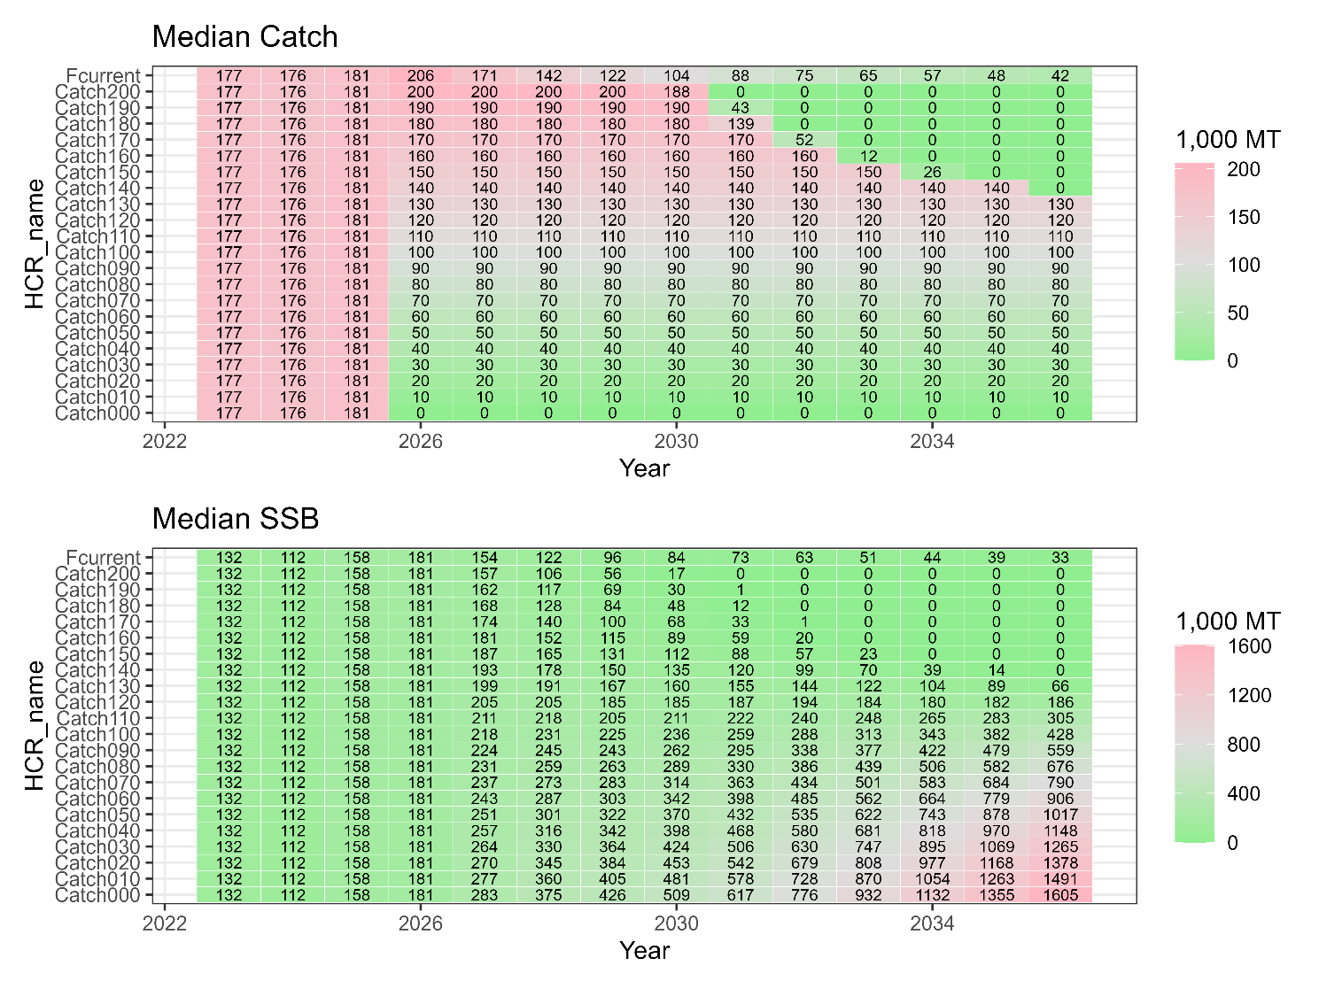

Table 4. Same as Table 3 except that the scenario is S02-Index24_1.
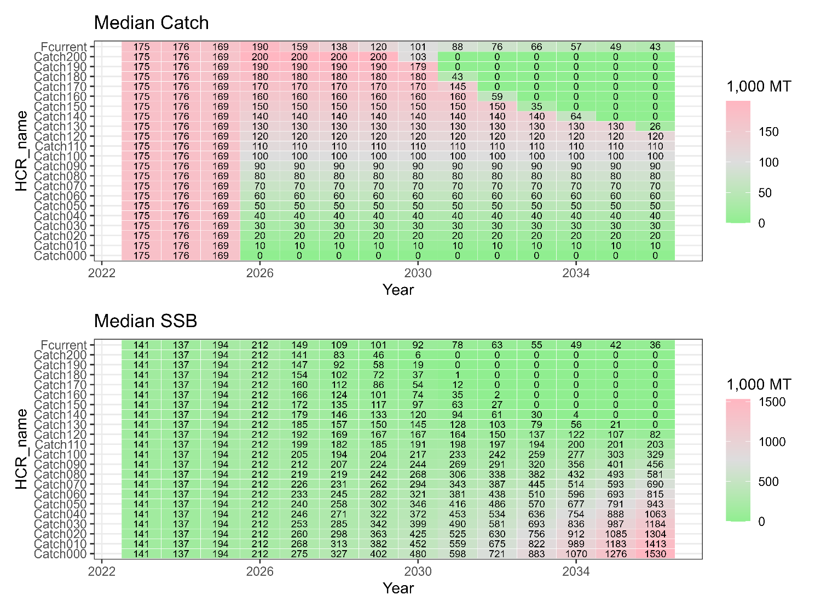

Table 5. Probabilities (%) that SSB is over SSB_{MSY}, the third quartile (Q3), the median, and the first quartile (Q1) under different levels of constant catch in S01-InitBase.
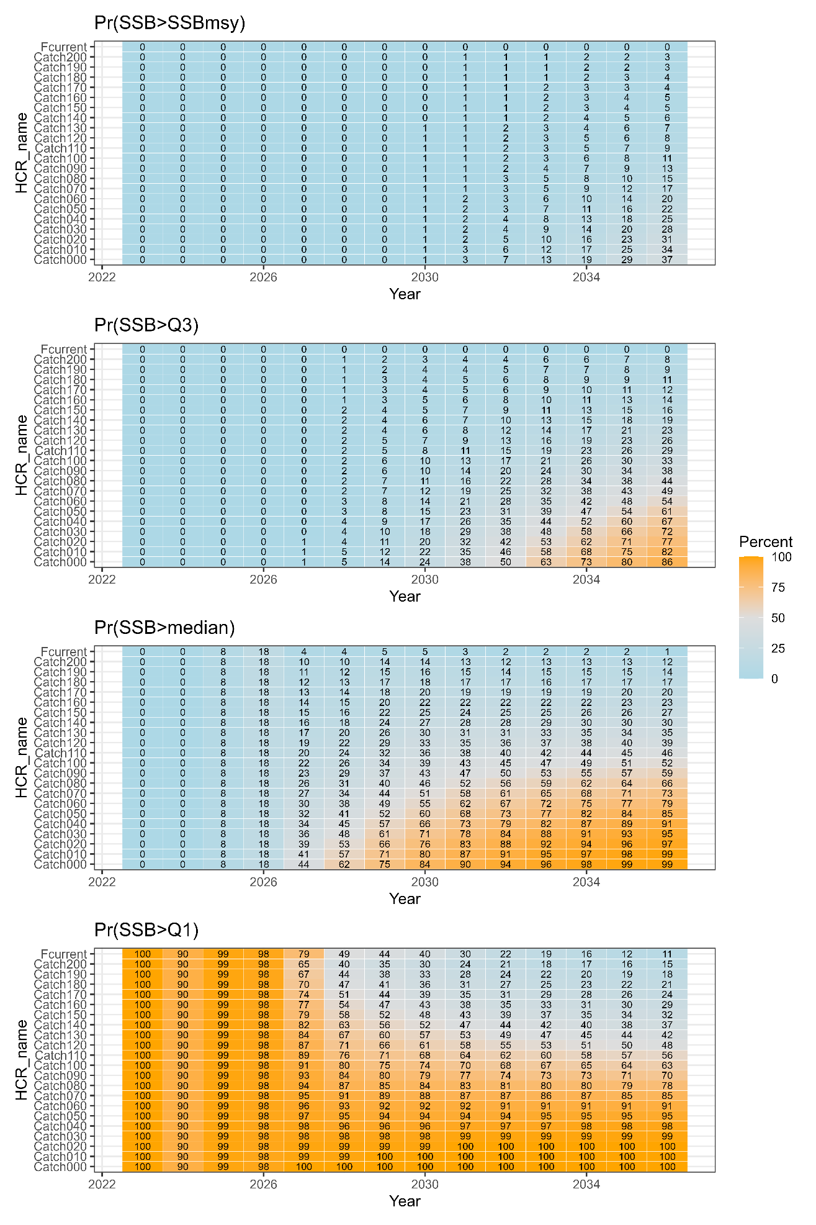

Table 6. Same as Table 5 except that the scenario is S02-Index24_1.
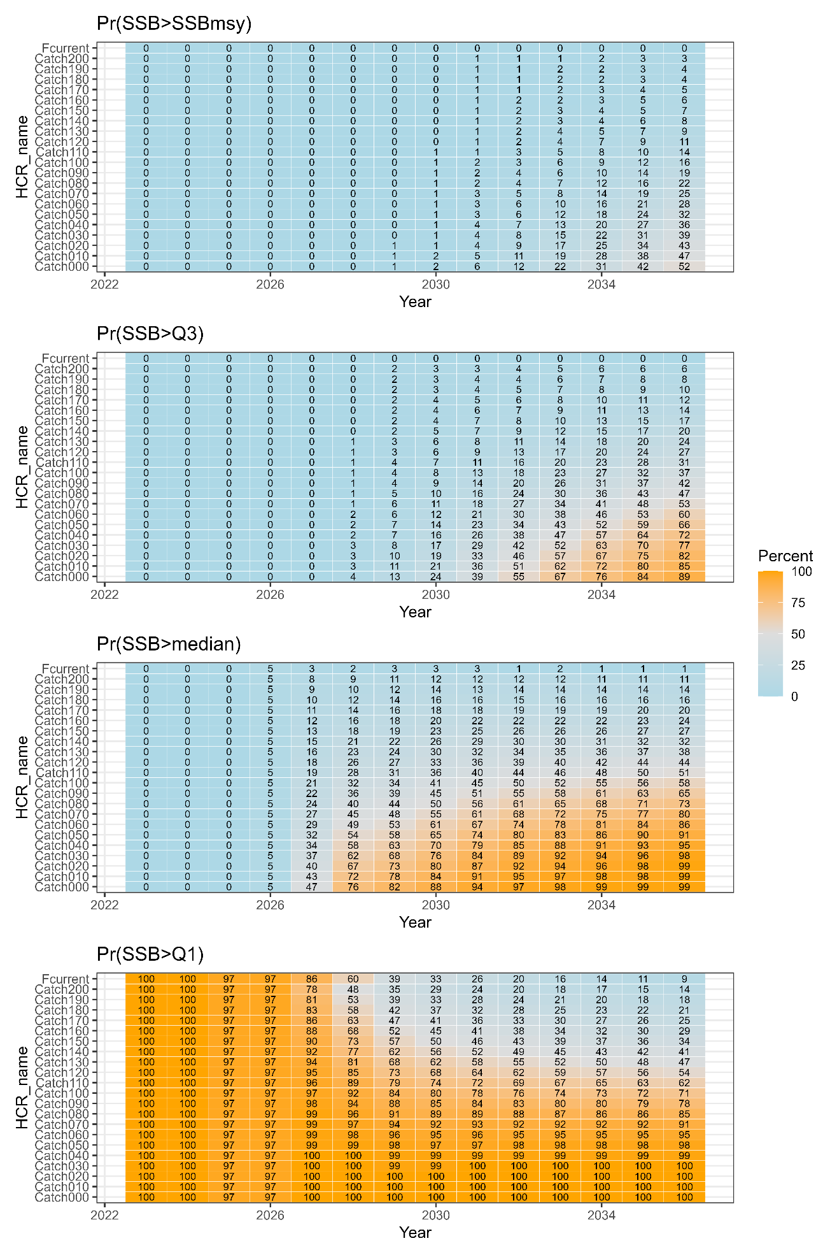

Table 7. Medians of catch and SSB under different constant-F levels in S01-InitBase.
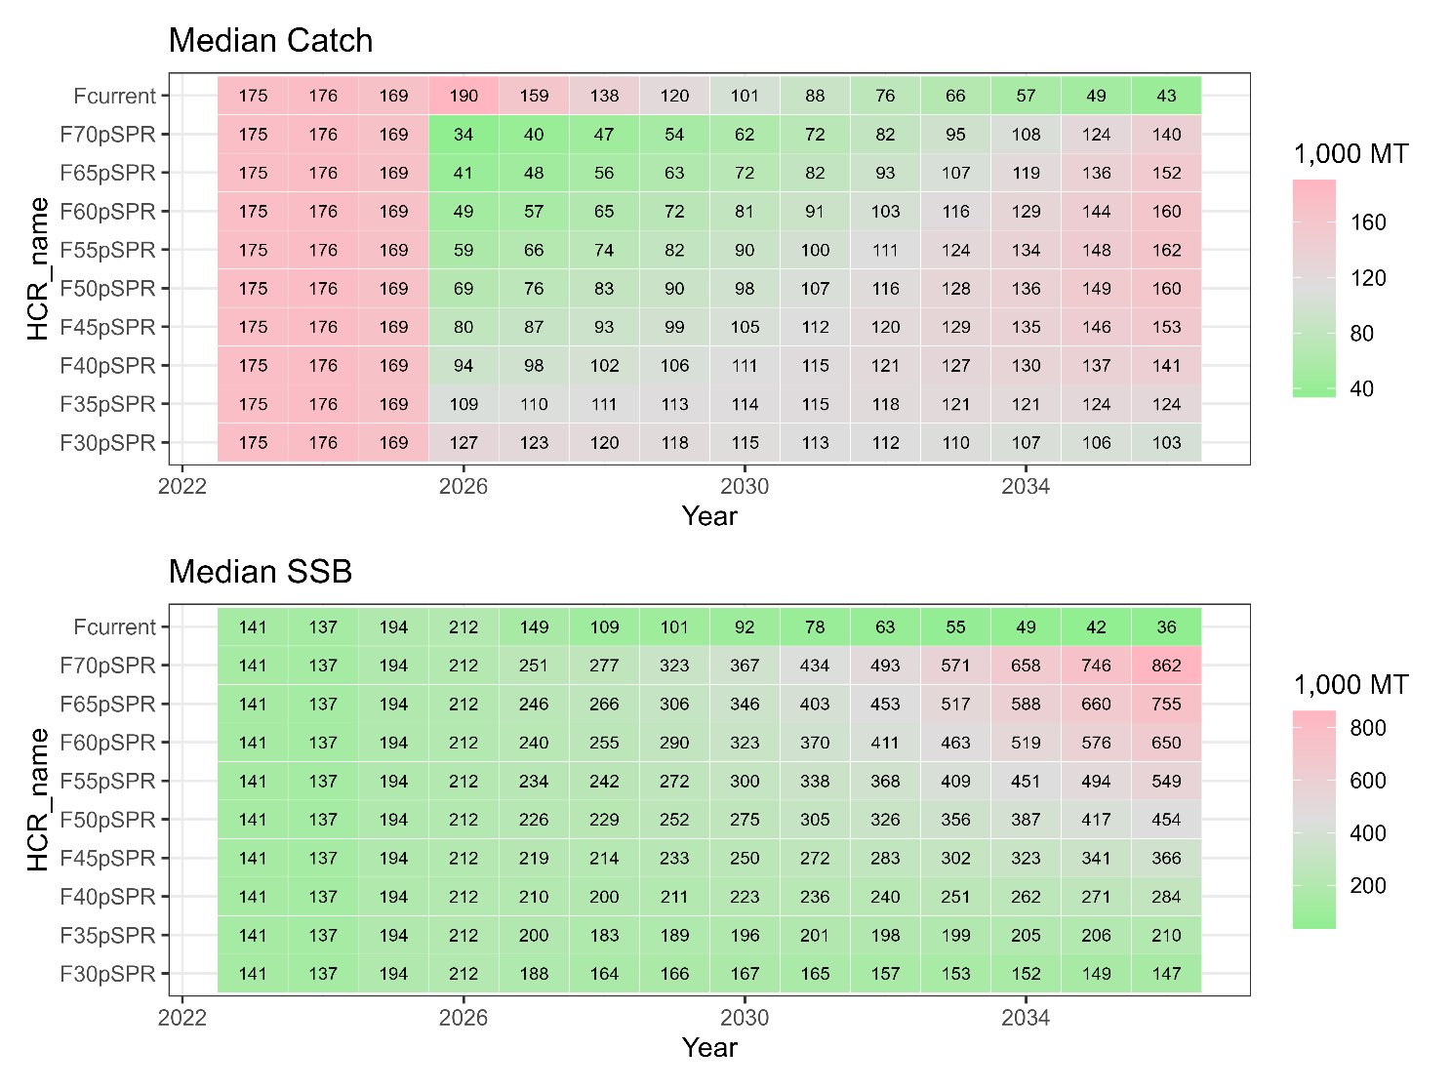

Table 8. Same as Table 7 except that the scenario is S02-Index24_1.
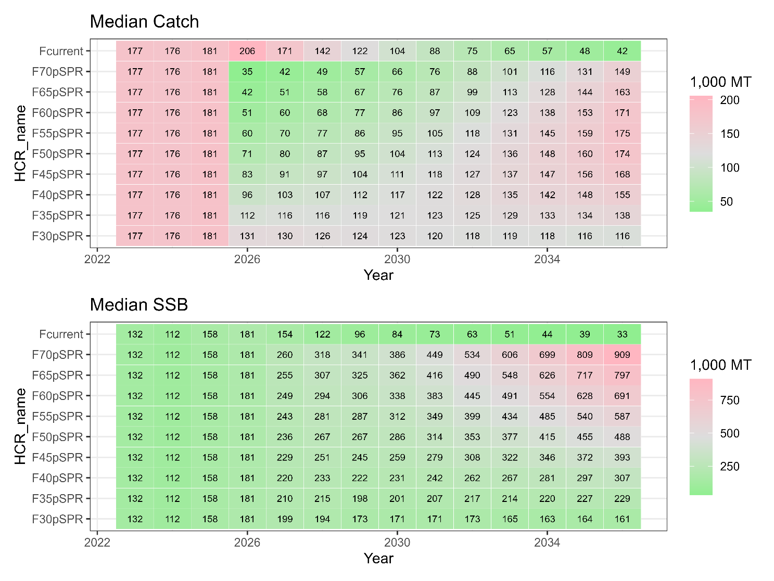

Table 9. Probabilities (%) that SSB is over SSB_{MSY}, the third quartile (Q3), the median, and the first quartile (Q1) under different levels of constant F in S01-InitBase.
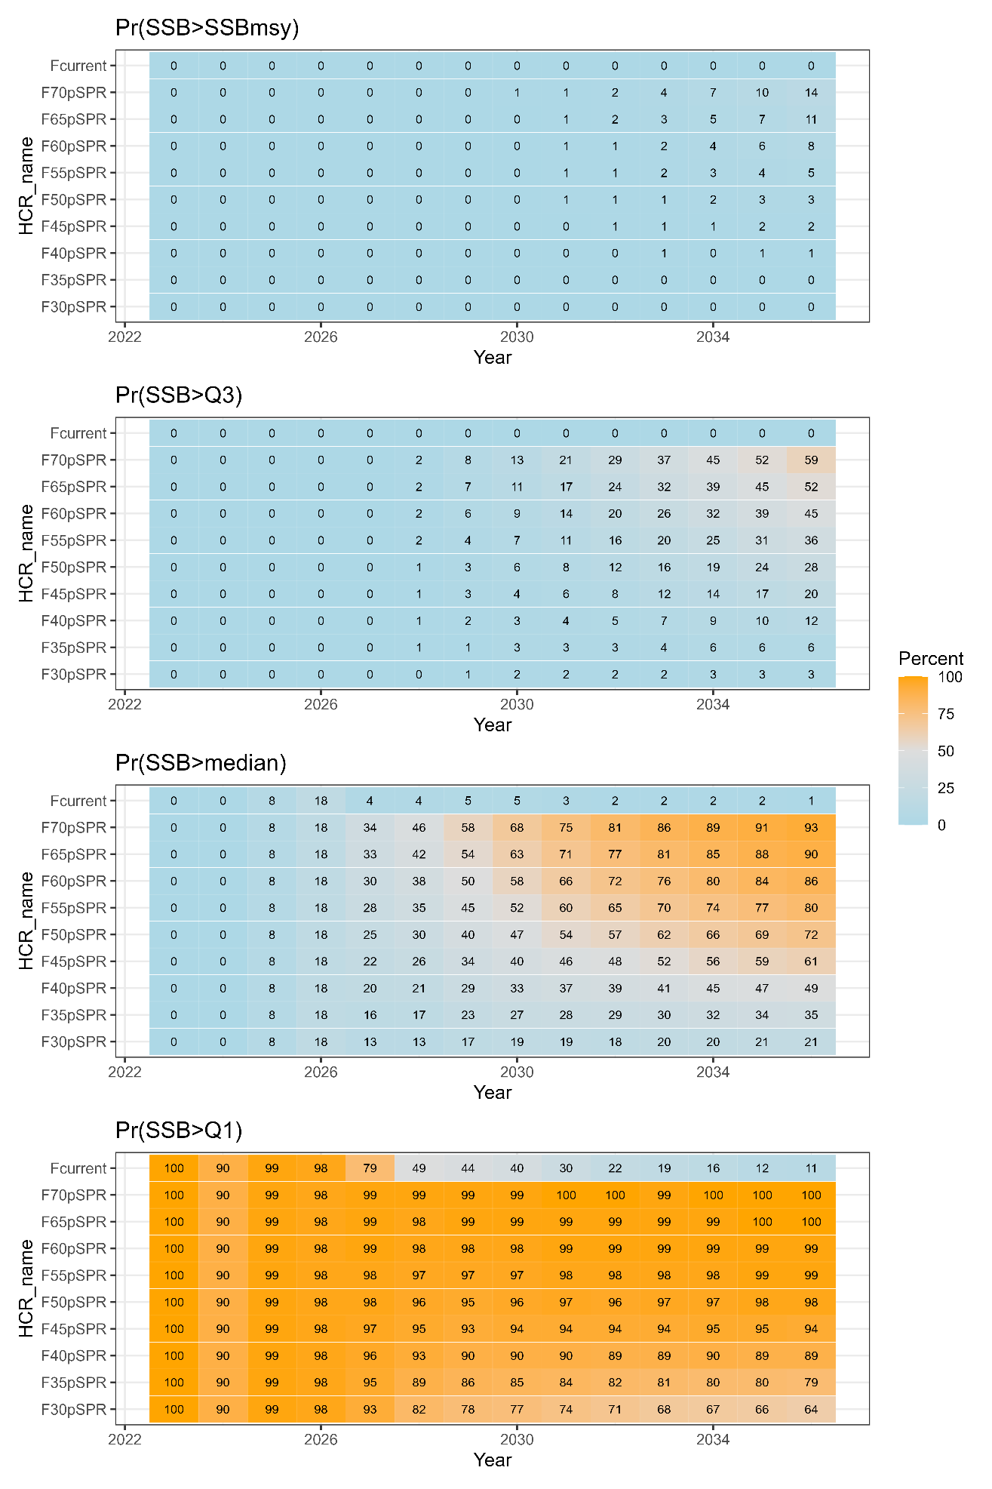

Table 10. Same as Table 9 except that the scenario is S02-Index24_1.
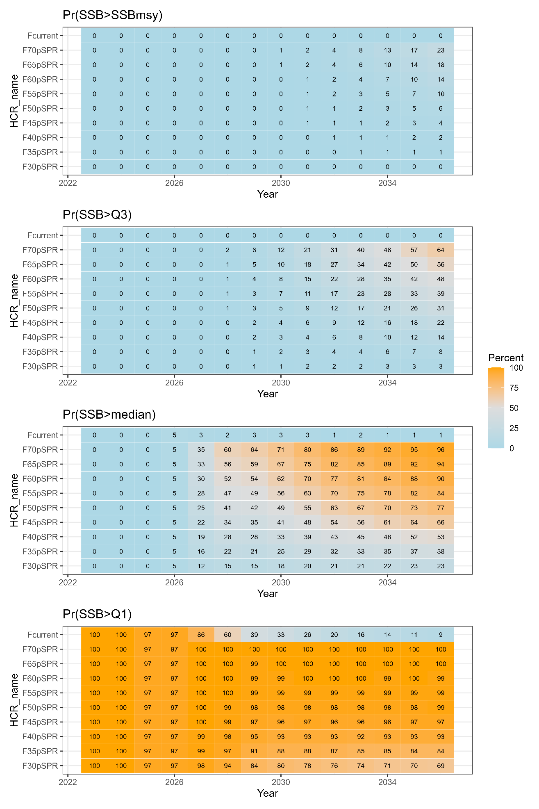

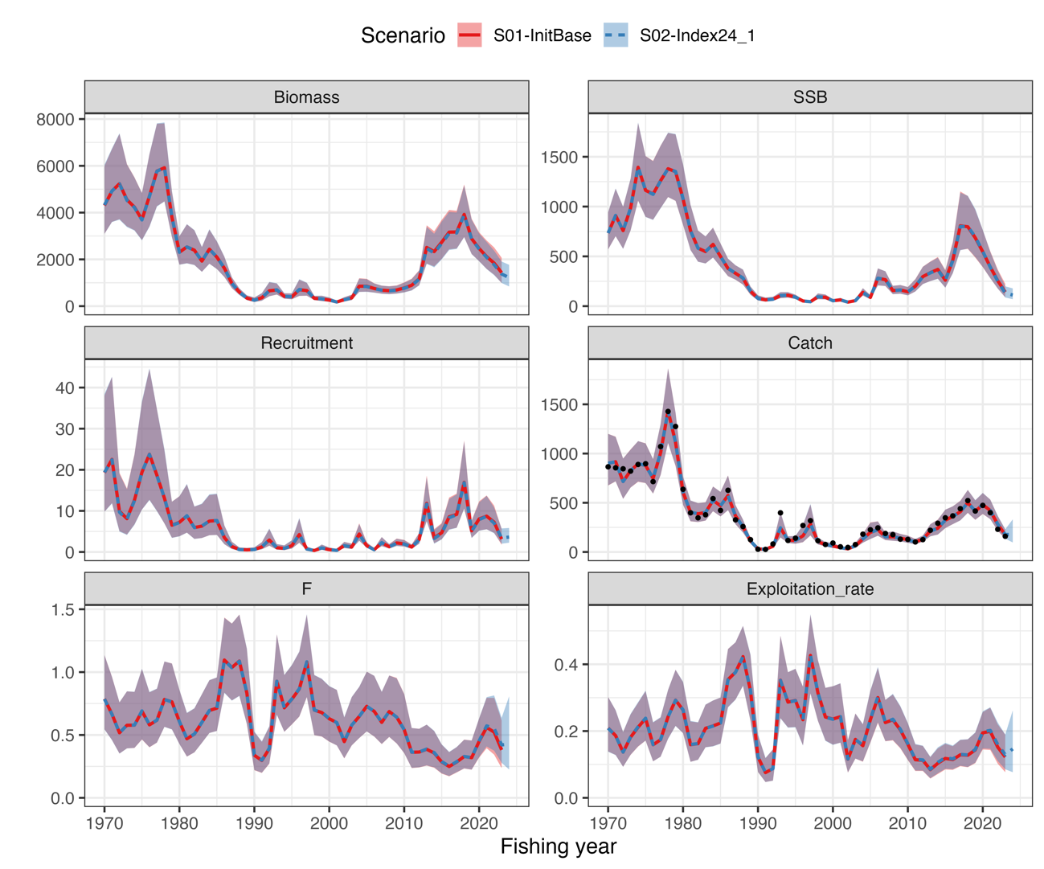
Fig. 1. Trajectories of stock biomass, spawning stock, catch, mean F, and exploitation rates (U, catch/biomass) between the candidate base case scenarios. This figure is extracted from NPFC-2025-TWG CMSA11-WP06.

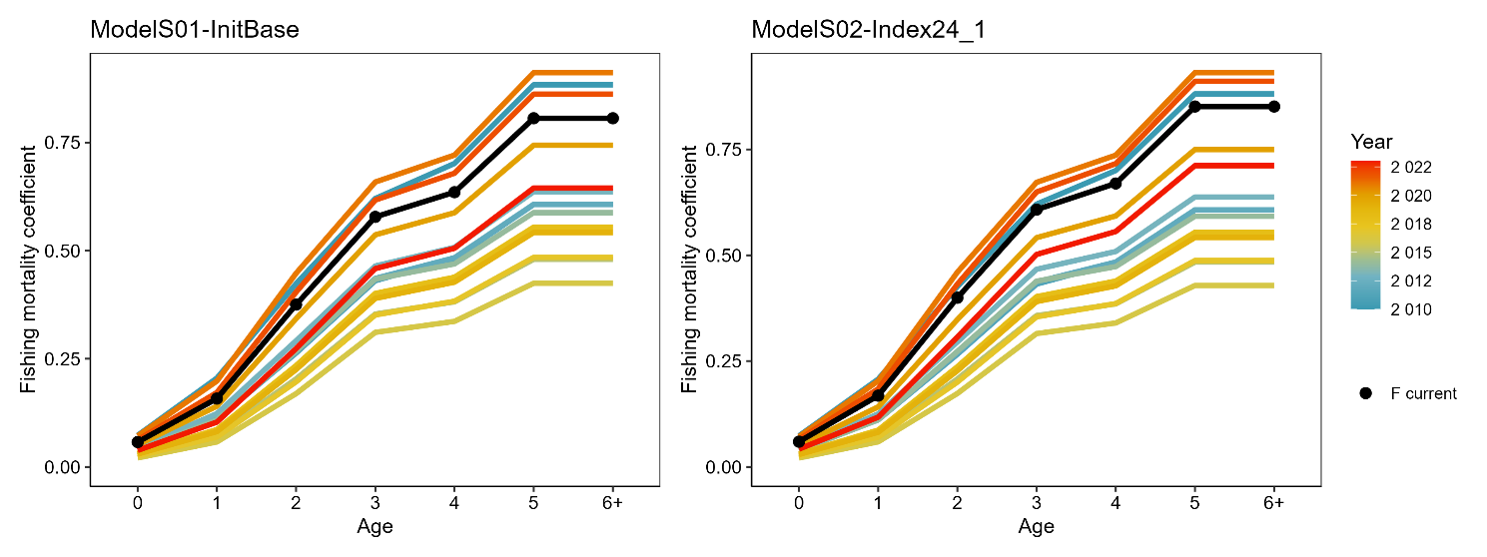
Fig. 2. Fishing mortality coefficient by age assumed as current fishing mortality (Fcur, black solid lines) in calculating reference points. Estimated fishing mortality coefficients by age and year since 2010 are concurrently shown to be compared.

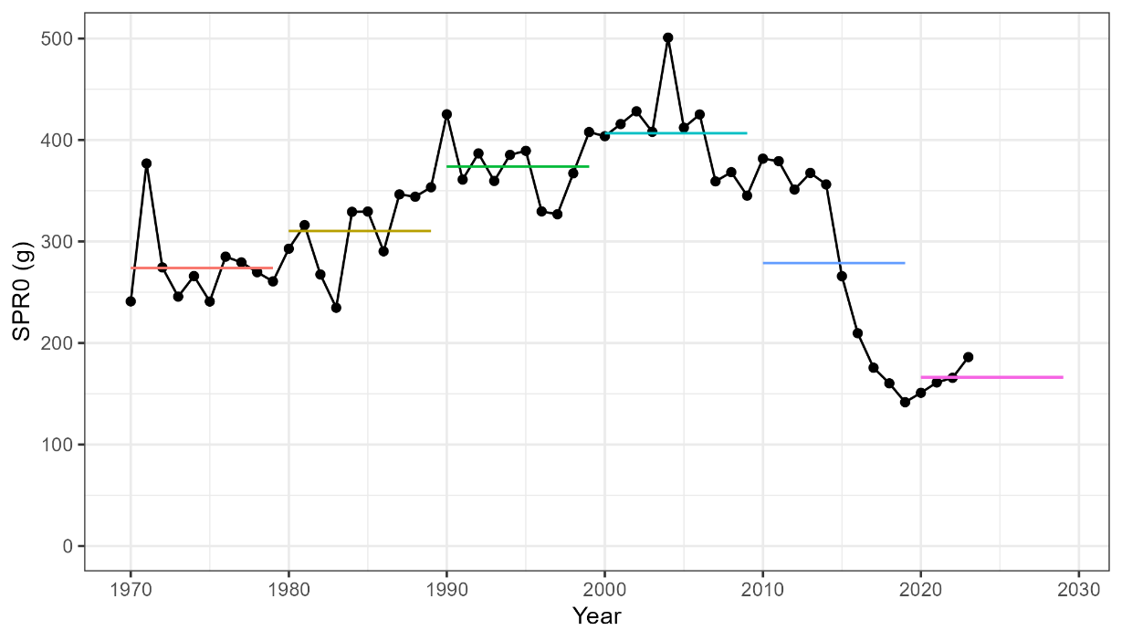
Fig. 3. Spawners per recruit without fishing (SPR0, g) varying with biological parameters of weight and maturity rate at age. SPR0 is annually calculated based on the biological parameters in each year. The horizontal line in each decade represents the average value during the decade.

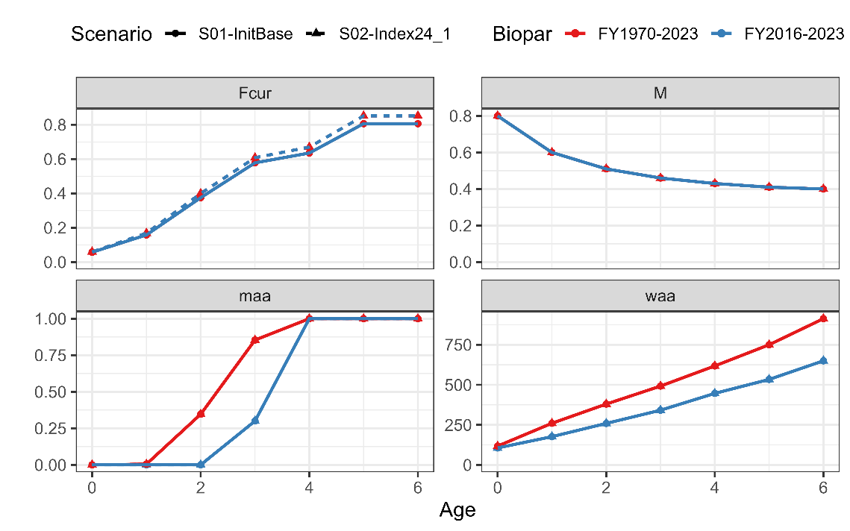
Fig. 4. Current fishing mortality (F_{CUR}), natural mortality (M), maturity (maa), weight (waa) at age used for future projections with different SAM scenarios (S01 and S02) and biological parameters (average during FY2016-2023 and during FY1970-2023).

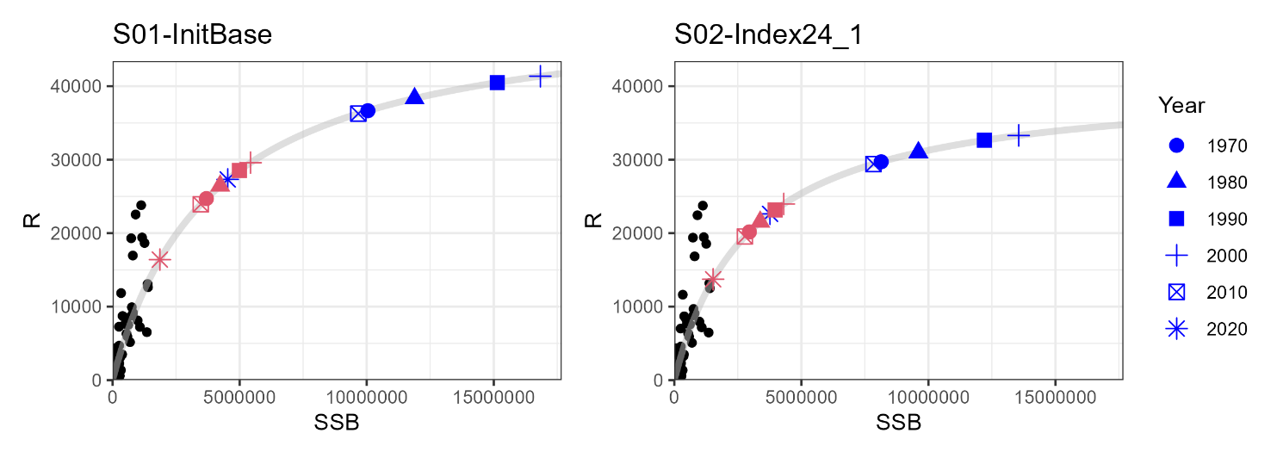
Fig. 5. Estimated stock-recruitment relationship (gray lines) and estimated past SSB and a number of recruits (black circles) overplotted with estimated SSB0 (equilibrium unexploited spawning biomass, blue symbols) and SSB_{MSY} (red symbols). The reference points are calculated using biological parameters averaged during the decades.

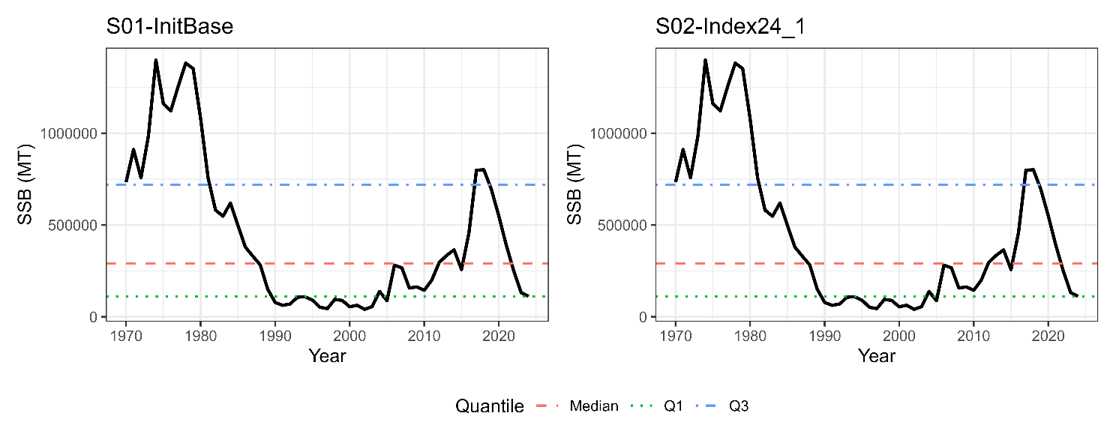
Fig. 6. Historical trajectories of SSB and its median and the first (Q1) and third (SSB) quartiles under the candidate base case scenarios.

(a) S01-InitBase under the constant catch of 100,000 tons
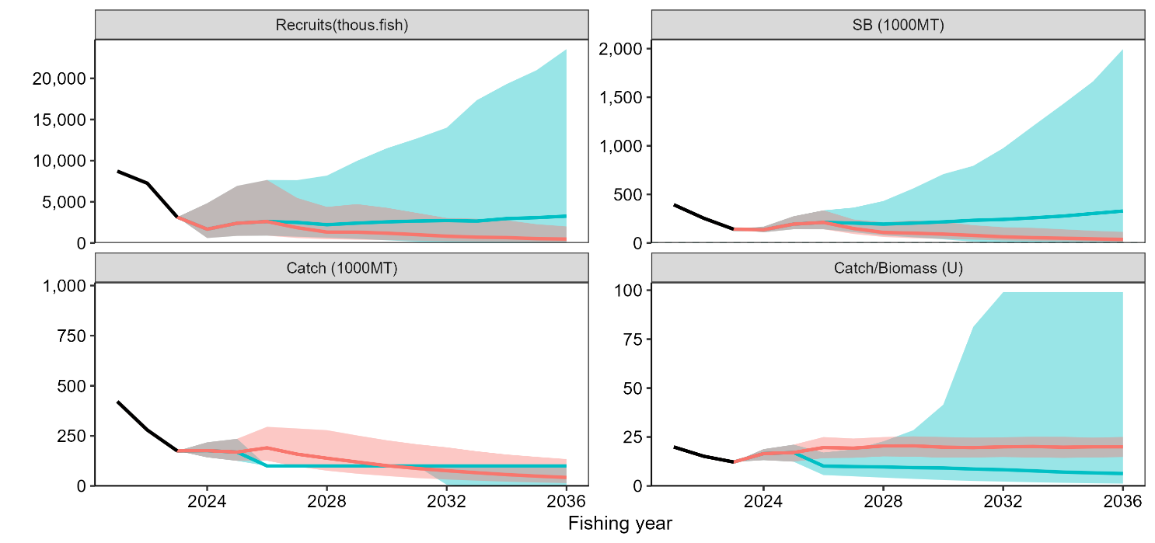

(b) S02-Index_1 under the constant catch of 100,000 tons
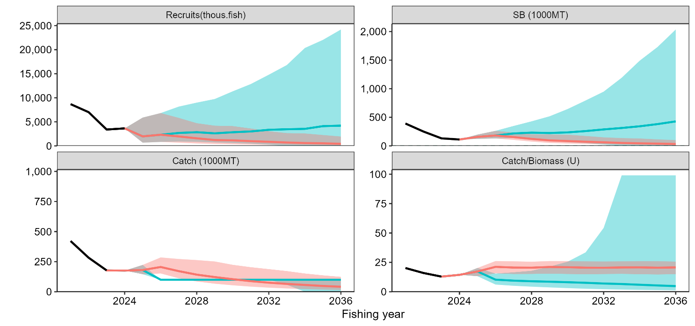
Fig. 7. Examples of stochastic future projection under the constant catch of 100,000 tons (blue) and current F (red) in S01-InitBase (a) and S02-Index24_1 (b). The shaded areas represent 90% prediction intervals, black solid lines are estimates by SAM, and colored solid lines are the median.

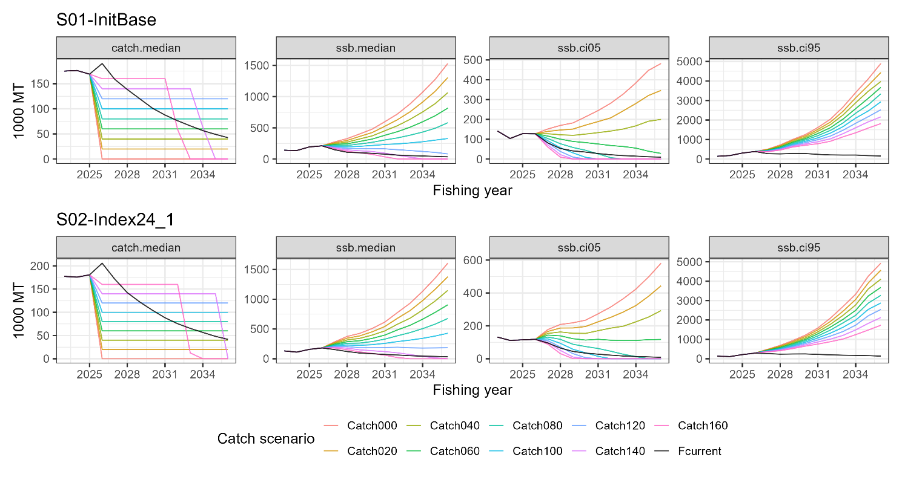
Fig. 8. Comparison of future trajectories in different levels of constant catch (“Catch100” means 100,000 tons of constant catch) for median catch (first column, catch.median), median SSB (second column, ssb.median), the 5th percentile of SSB (third column, ssb.ci05), and the 95th percentile of SSB (fourth column, ssb.ci95) under Scenarios S01-InitBase (top) and S02-Index24_1 (bottom).

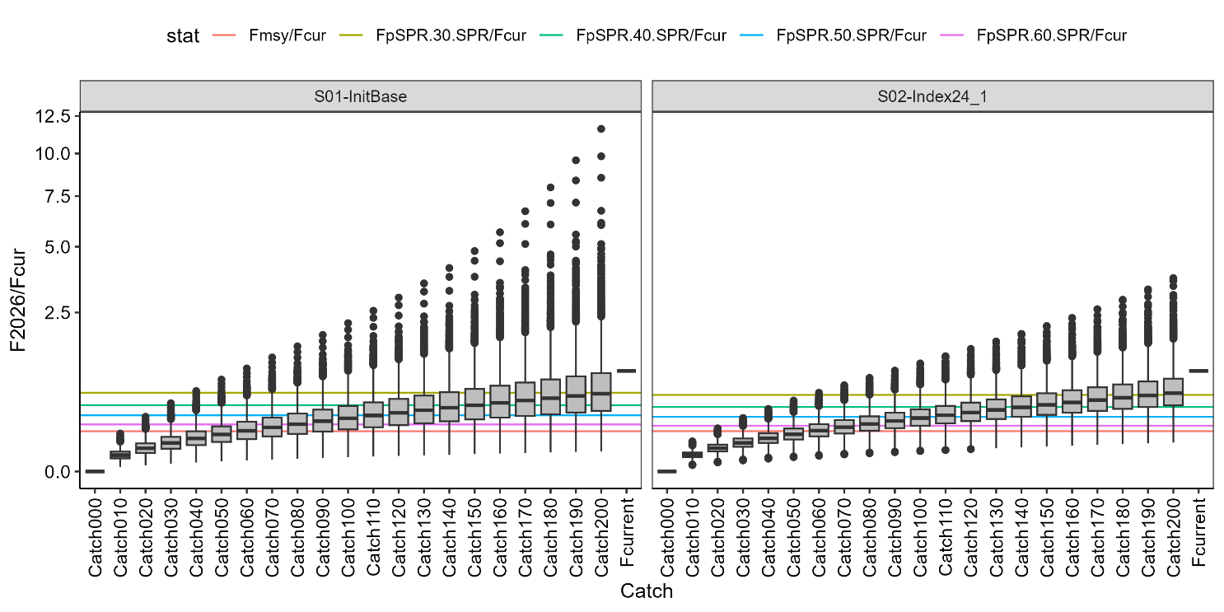
Fig. 9. Relative fishing mortality rates in 2026 to F_{CUR} under different constant-catch scenarios. The colored horizontal lines represent relative values of biological reference points to Fcur shown by Table 2.

(a) S01-InitBase under the constant F40%SPR
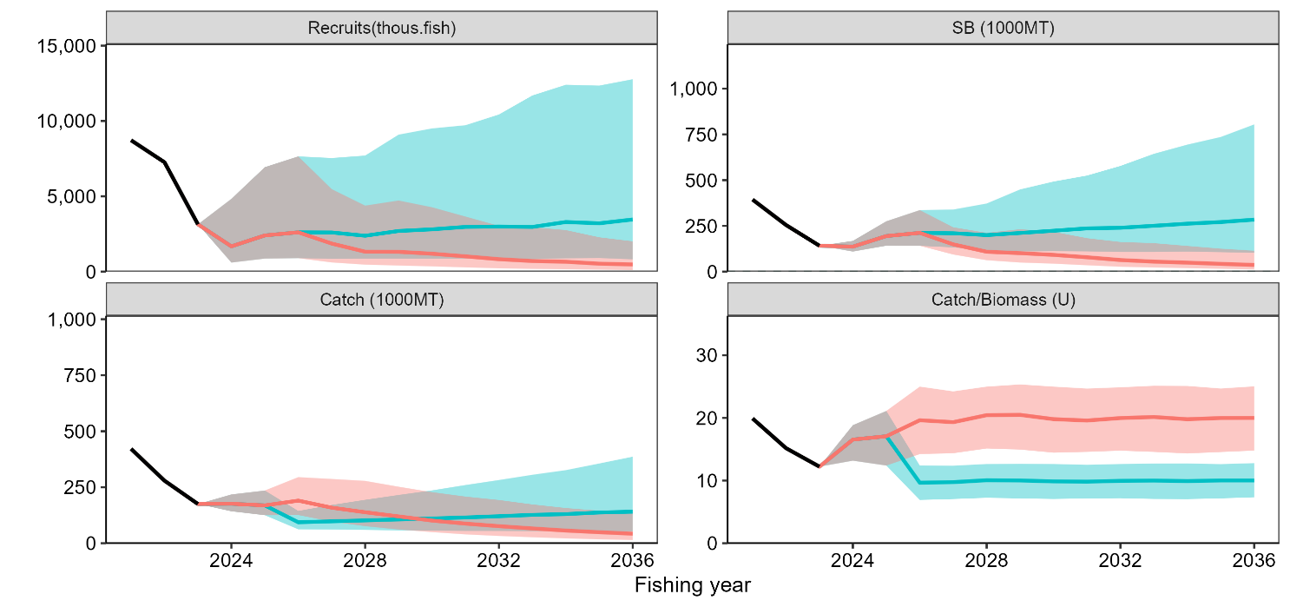

(b) S02-Index_1 under the constant F40%SPR
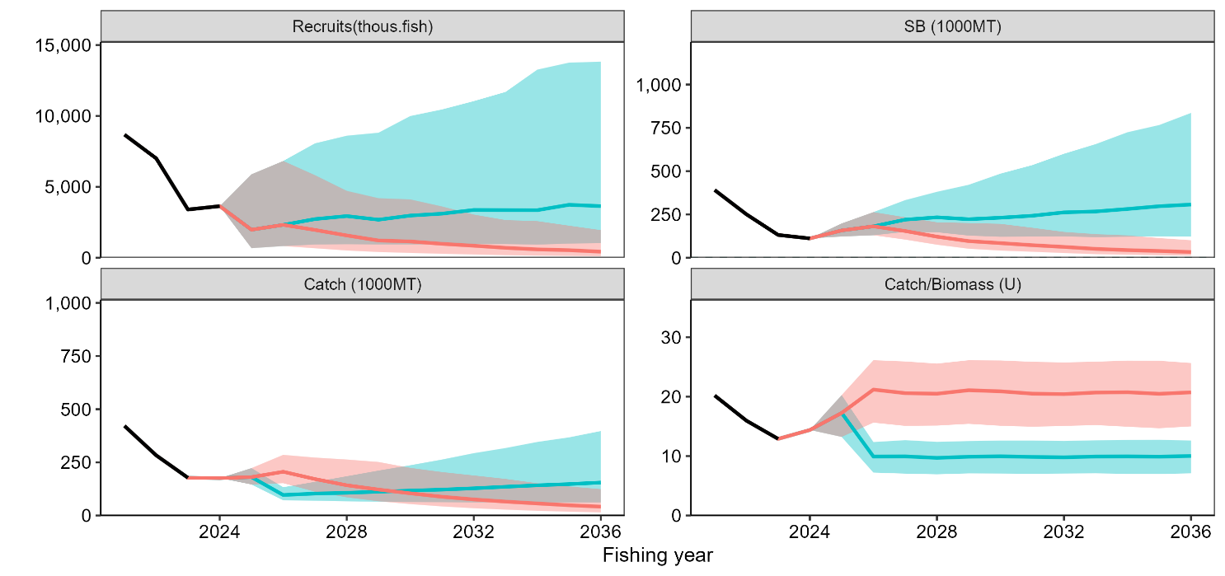
Fig. 10. Examples of stochastic future projection under the constant F40%SPR (blue) and current F (red) in S01-InitBase (a) and S02-Index24_1 (b). The shaded areas represent 90% prediction intervals, black solid lines are estimates by SAM, and colored solid lines are the median.

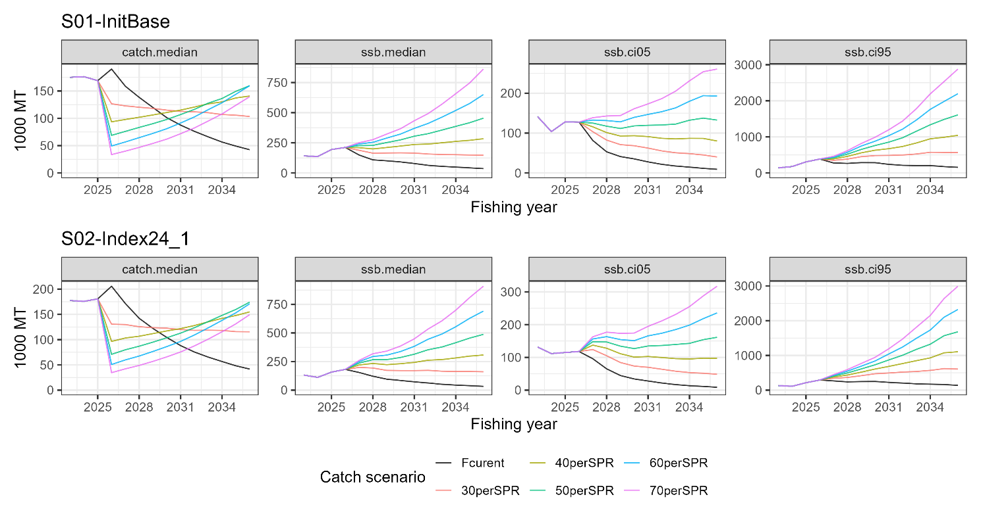
Fig. 11. Comparison of future trajectories in different levels of constant F (30-70%SPR) for median catch (first column, catch.median), median SSB (second column, ssb.median), the 5th percentile of SSB (third column, ssb.ci05), and the 95th percentile of SSB (fourth column, ssb.ci95) under Scenarios S01-InitBase (top) and S02-Index24_1 (bottom).

Appendix: Results of future projections with biological parameters of all-year averages

Table A1. Medians of catch and SSB under different constant-catch levels in S01-InitBase.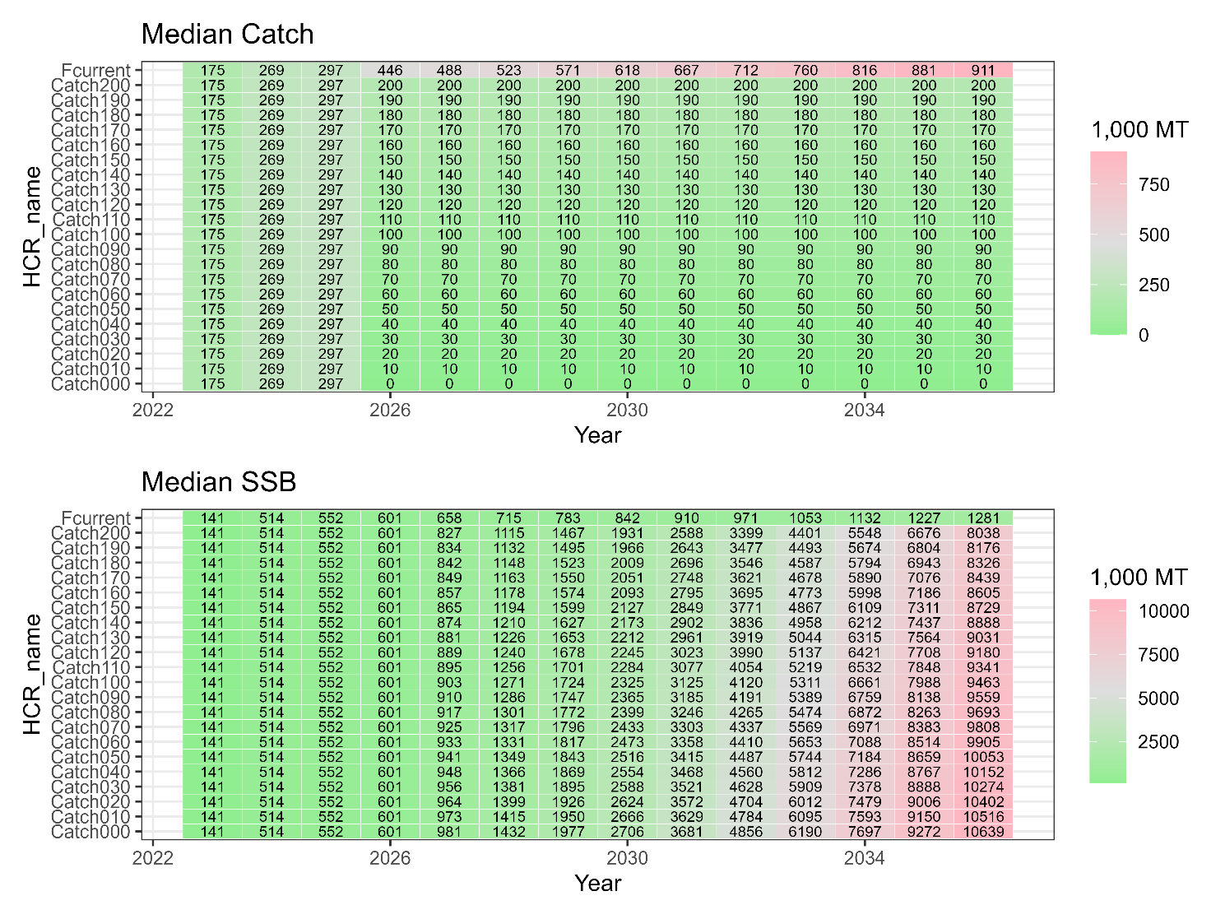

Table A2. Same as Table A1 except that the scenario is S02-Index24_1.
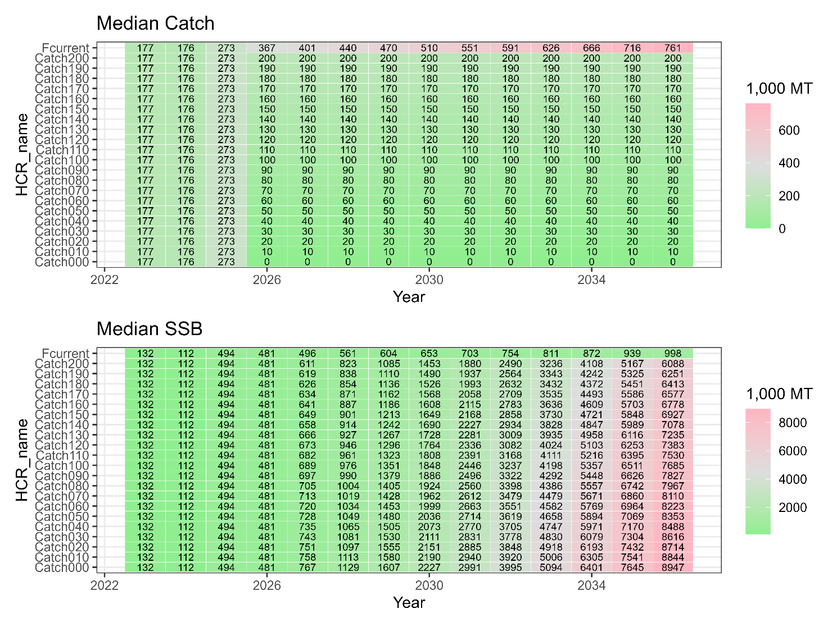

Table A3. Probabilities (%) that SSB is over SSB_{MSY}, the third quartile (Q3), the median, and the first quartile (Q1) under different levels of constant catch in S01-InitBase.
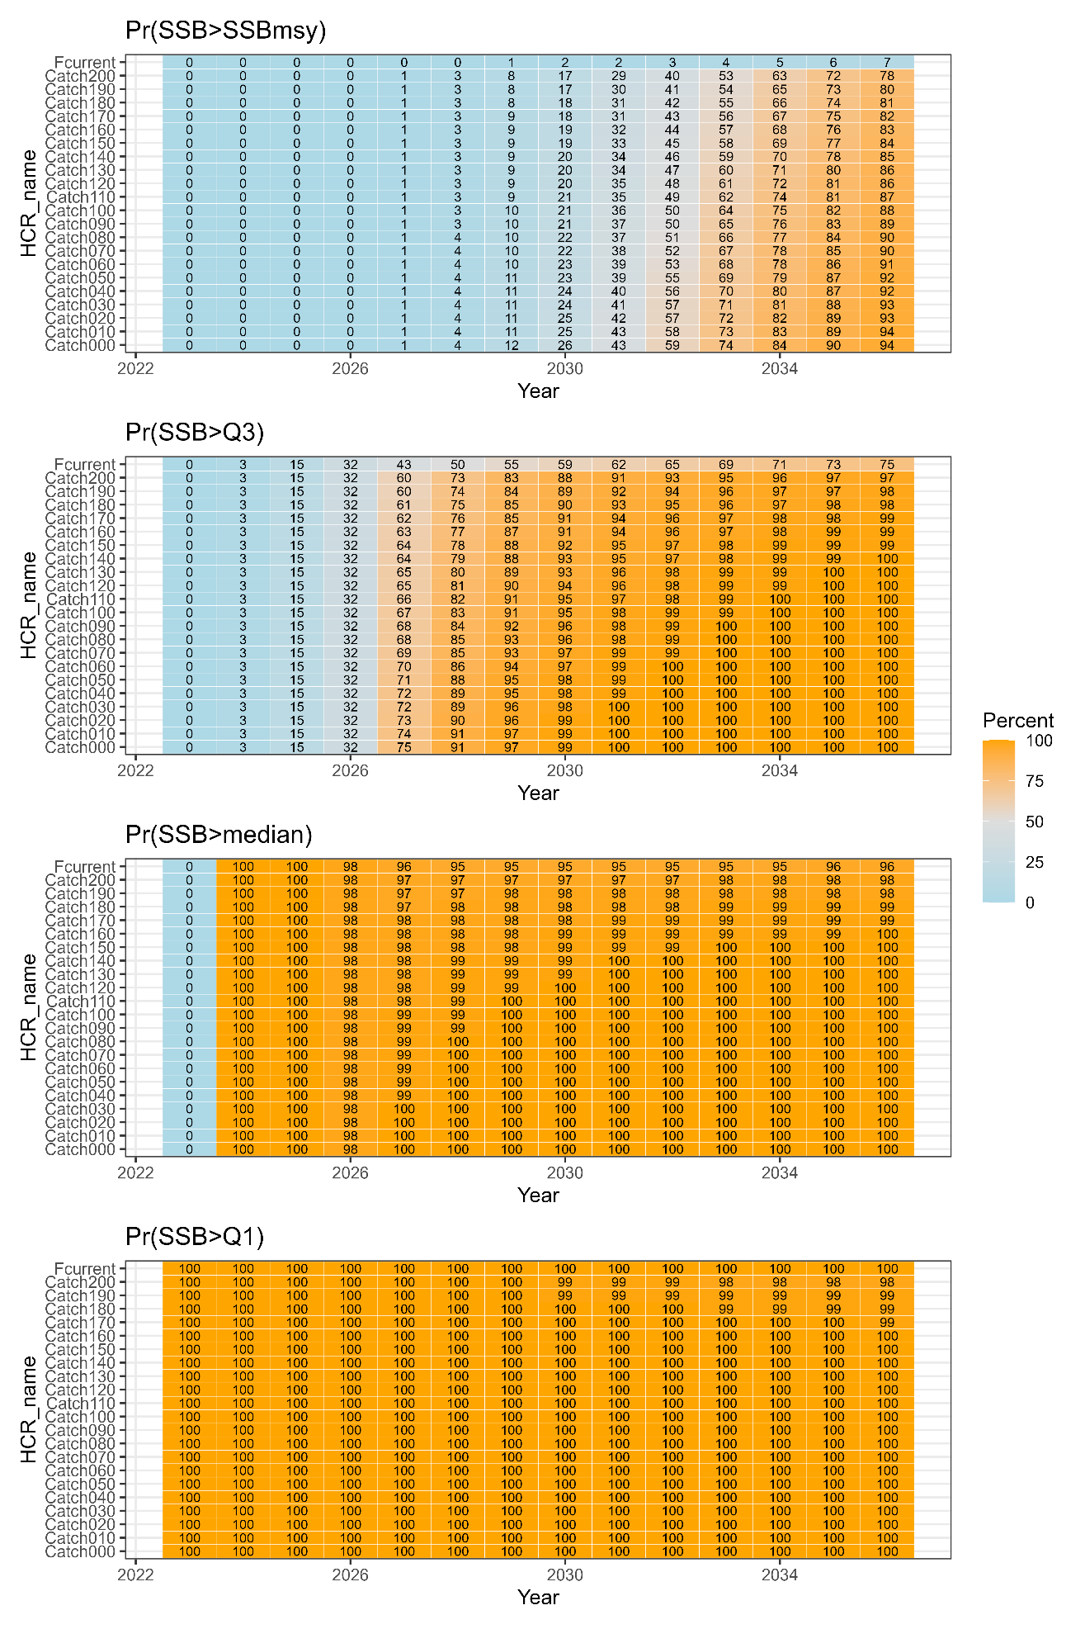

Table A4. Same as Table A3 except that the scenario is S02-Index24_1.
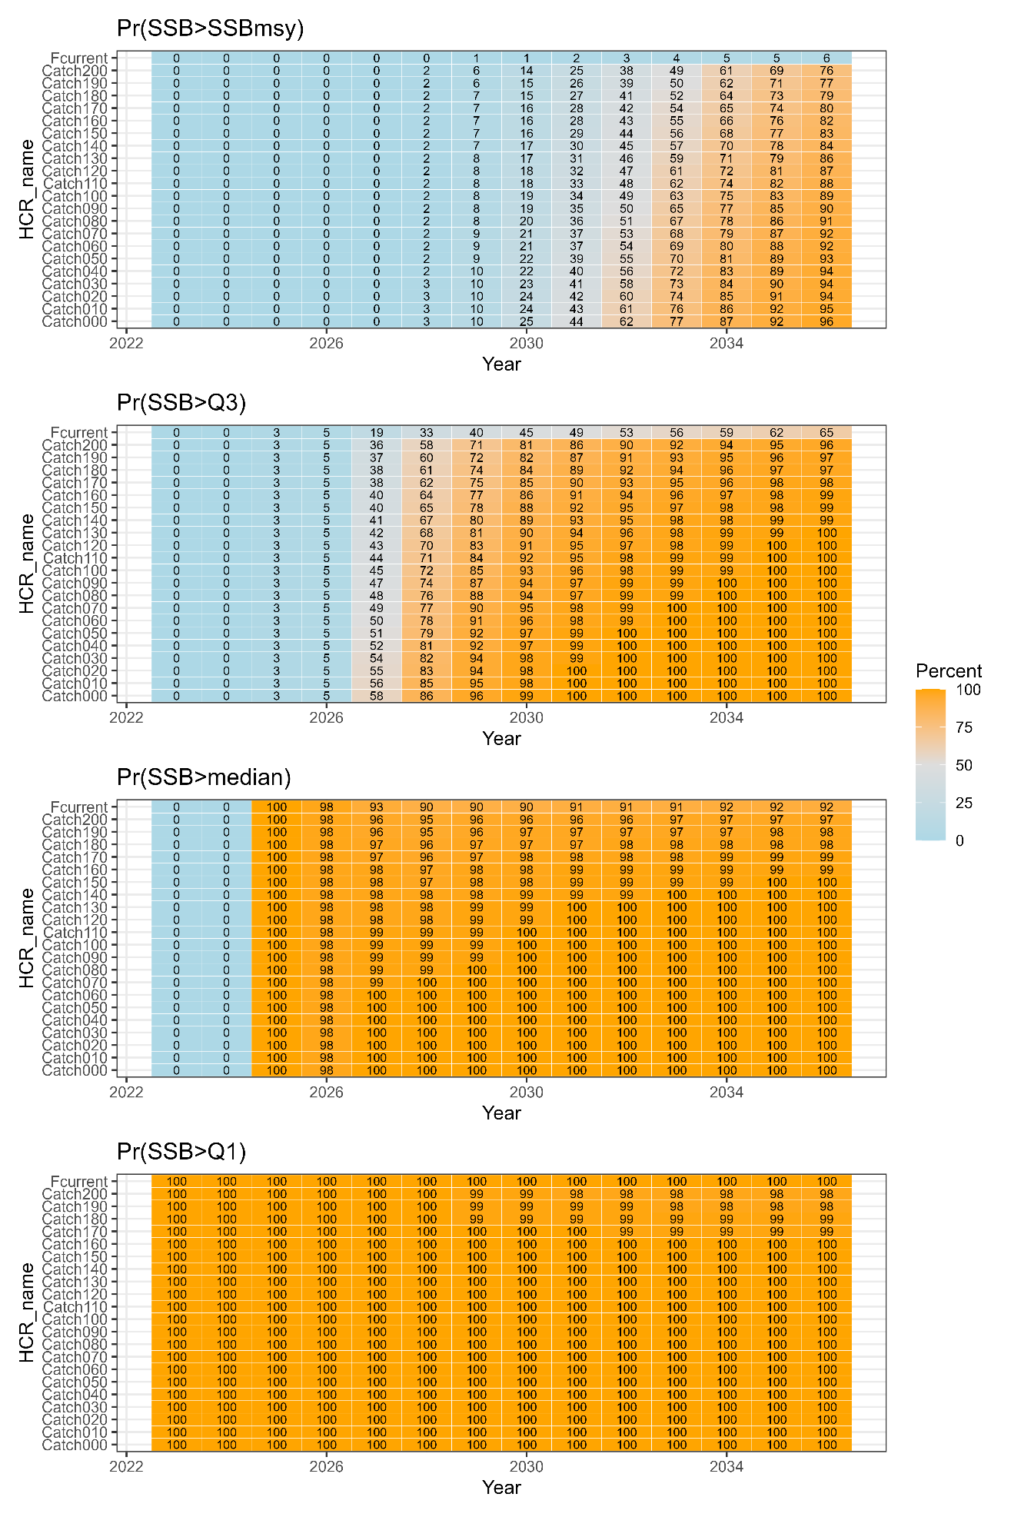

Table A5. Medians of catch and SSB under different constant-F levels in S01-InitBase.
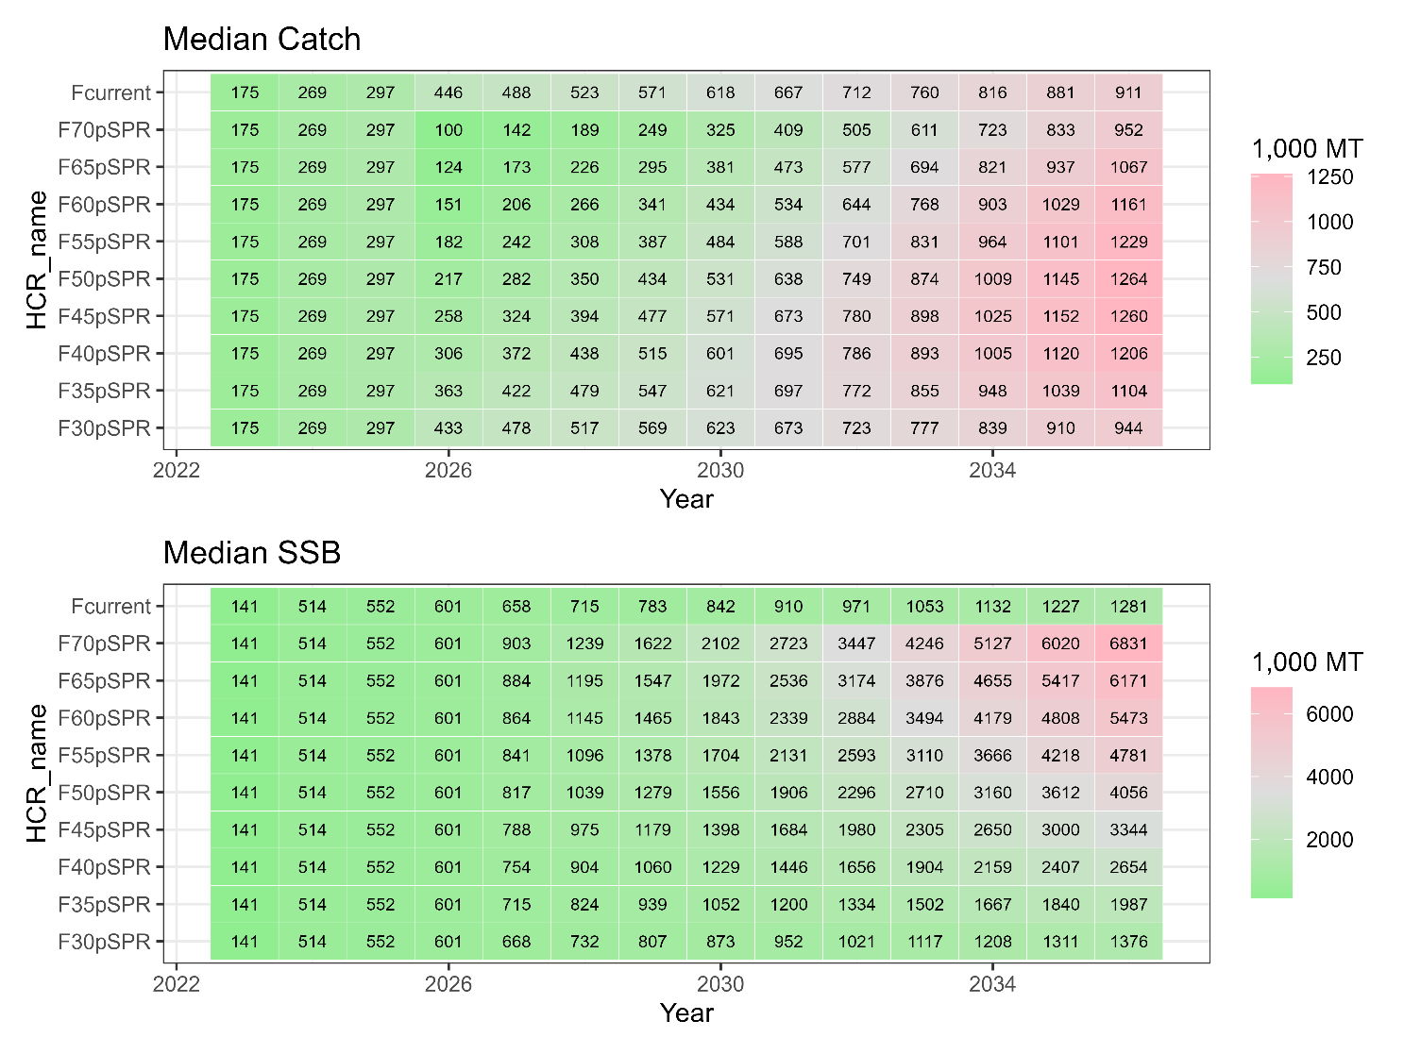

Table A6. Same as Table 7A5 except that the scenario is S02-Index24_1.
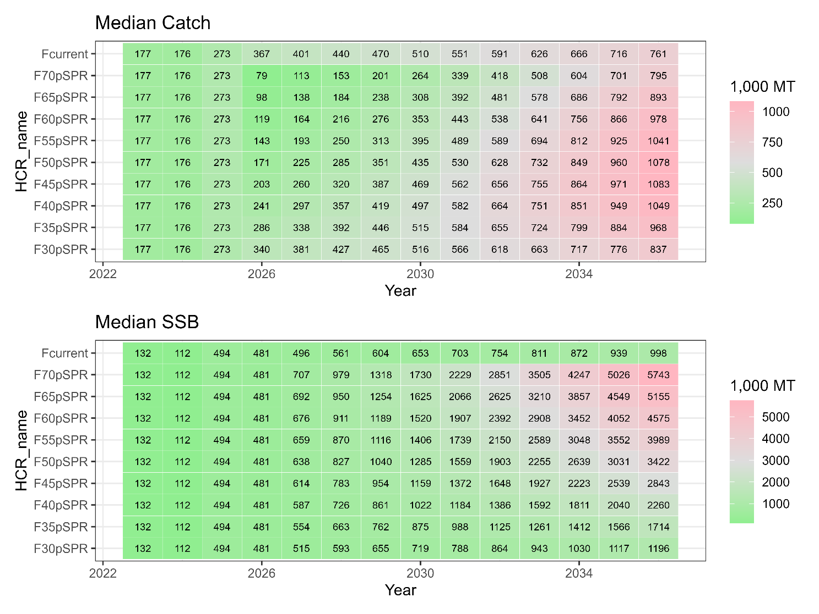

Table A7. Probabilities (%) that SSB is over SSB_{MSY}, the third quartile (Q3), the median, and the first quartile (Q1) under different levels of constant F in S01-InitBase.
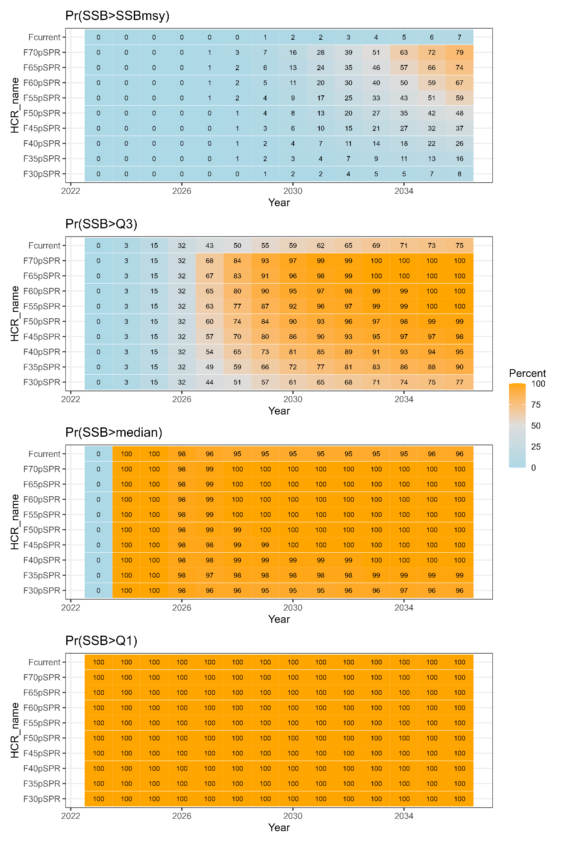
Table A8. Same as Table A7 except that the scenario is S02-Index24_1.
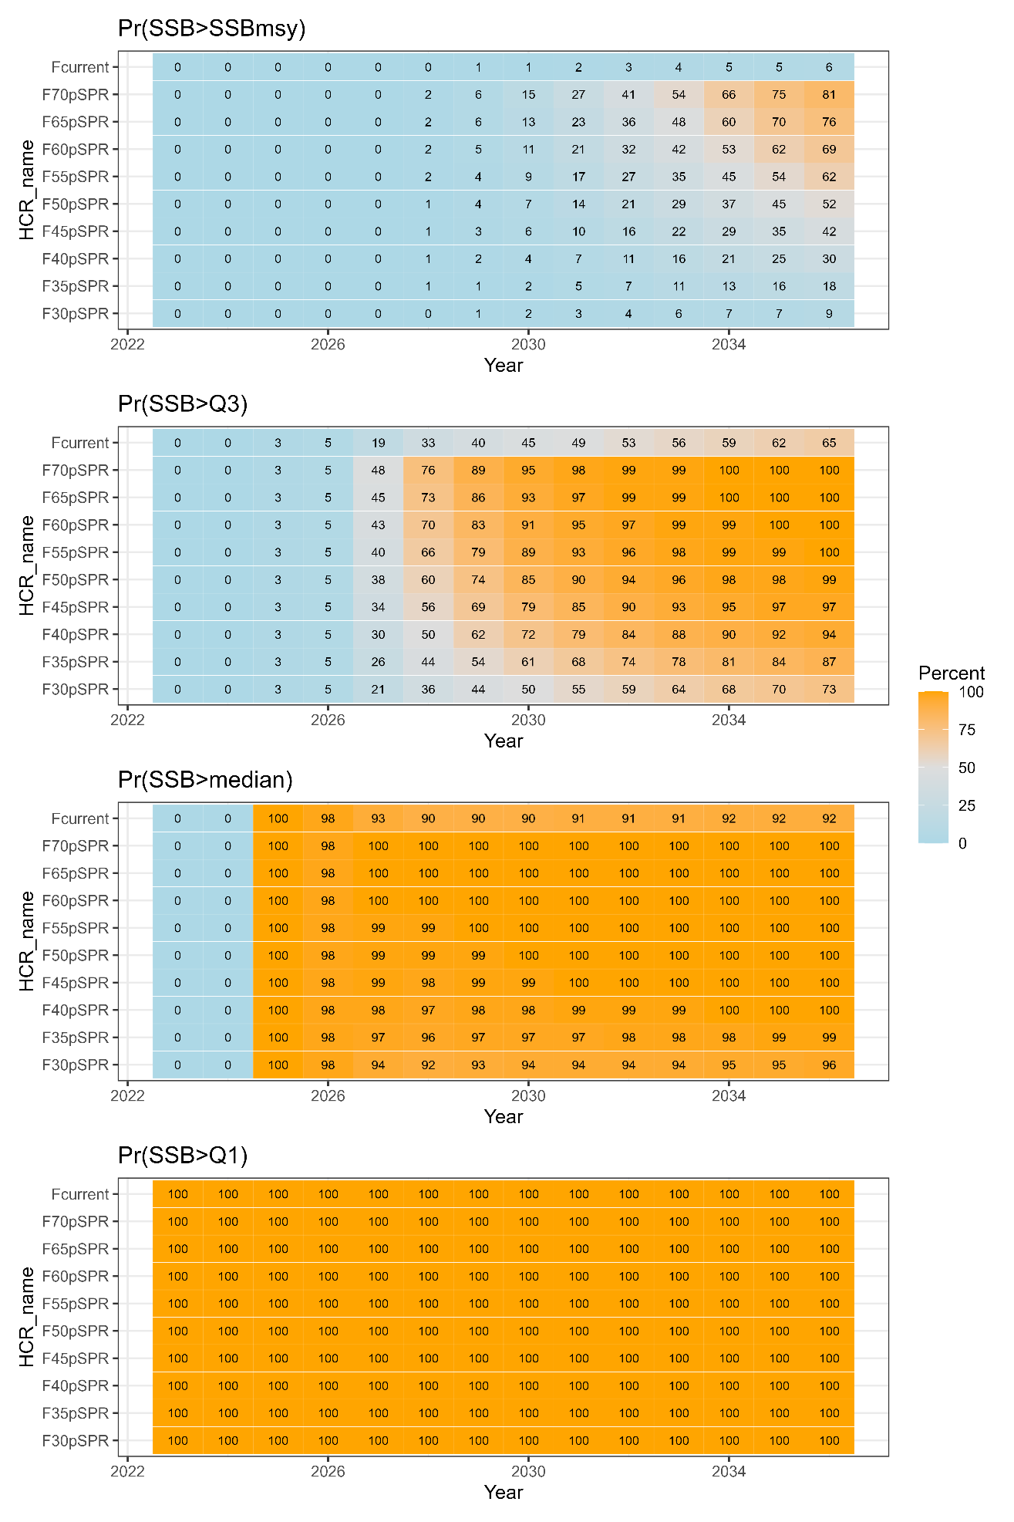
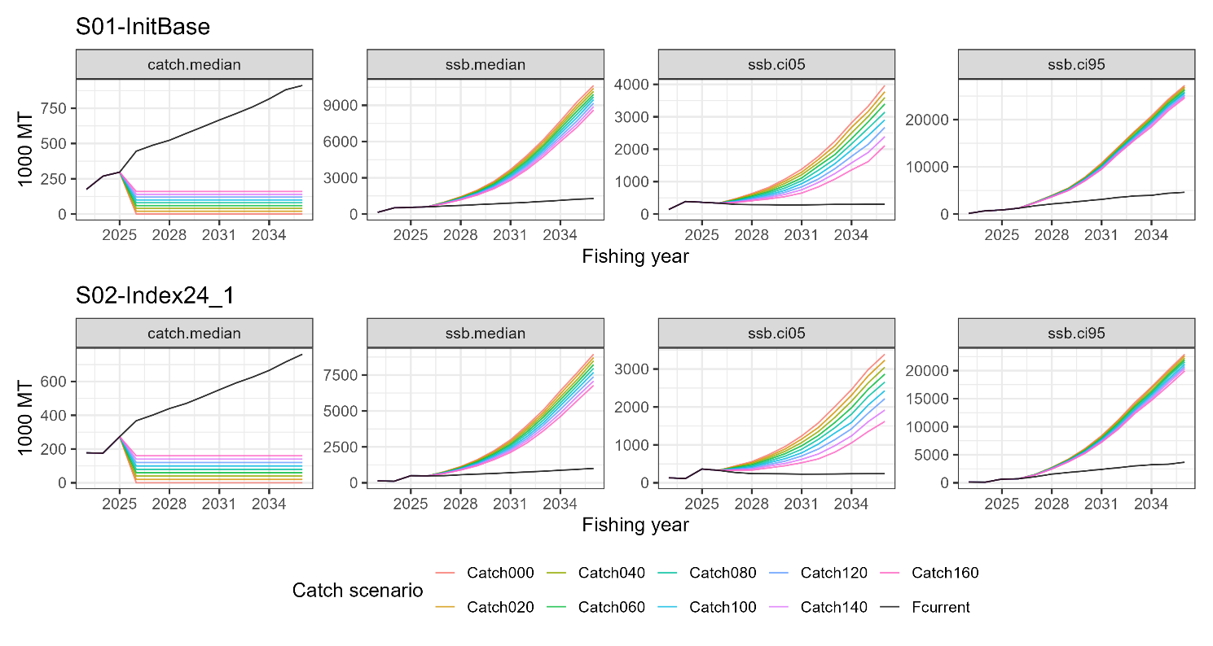
Fig. A1. Comparison of future trajectories in different levels of constant catch (“Catch100” means 100,000 tons of constant catch) for median catch (first column, catch.median), median SSB (second column, ssb.median), the 5th percentile of SSB (third column, ssb.ci05), and the 95th percentile of SSB (fourth column, ssb.ci95) under Scenarios S01-InitBase (top) and S02-Index24_1 (bottom).

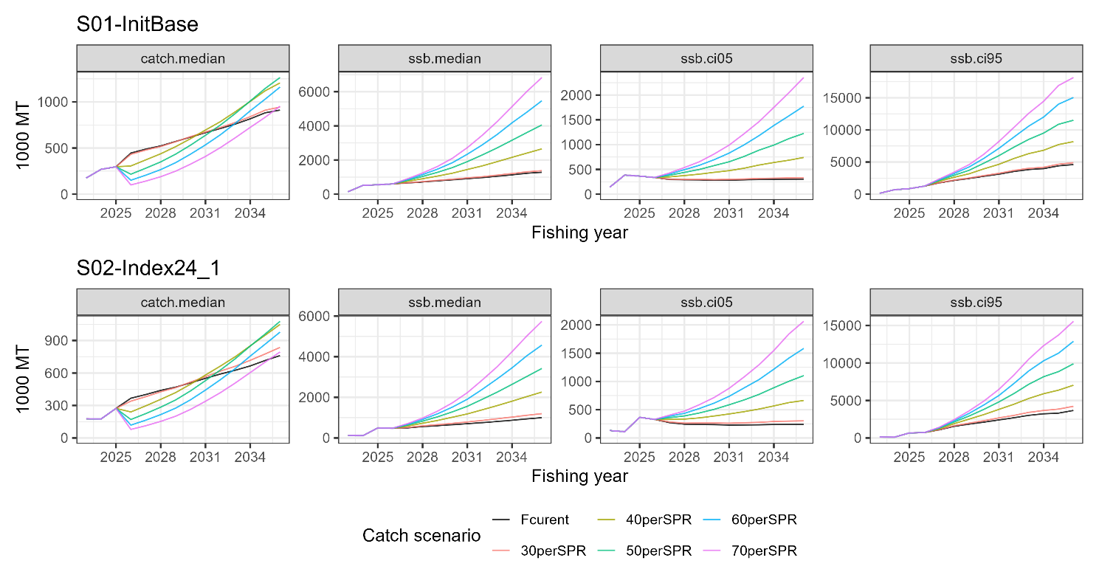
Fig. A2. Comparison of future trajectories in different levels of constant F (30-70%SPR) for median catch (first column, catch.median), median SSB (second column, ssb.median), the 5th percentile of SSB (third column, ssb.ci05), and the 95th percentile of SSB (fourth column, ssb.ci95) under Scenarios S01-InitBase (top) and S02-Index24_1 (bottom).

