NPFC-2025-SSC PS15-WP08

# Standardized CPUE of Pacific saury (*Cololabis saira*) caught by Russian vessels up to 2024

Vladimir KULIK1, Aleksei BAITALIUK1,2 and Oleg KATUGIN1

1 *Pacific branch of the Russian Federal Research Institute of Fisheries and Oceanography «VNIRO» («TINRO»)*

2 *Russian Federal Research Institute of Fisheries and Oceanography «VNIRO»*

Russian Vessel Monitoring System (VMS) records changes in position of all vessels, that officially enter the Russian EEZ, but the catch and place of each operation were not provided in daily electronic reports (DER) before 2022. TINRO has got information about daily catches of Russian vessels in the period of 1994 — 2002 and foreign vessels in the Russian EEZ after 2002. We deleted foreign catches from 2003 to avoid duplication of the other Member’s catches in CPUE estimation.

## Literature review

Geographic range of the Pacific saury (*Cololabis saira*) in the Pacific Ocean extends from Japan eastward to the Gulf of Alaska and further southward down to Mexico, and the species distribution patterns depend on environmental conditions (Parin 1960). The timing, abundance, and geographic distribution of fish aggregations are associated with sea surface temperature (SST) (Huang et al. 2007). In open waters of the Pacific Ocean, saury forms aggregations in the early summer, and these aggregations experience intra-seasonal changes (Baitaliuk et al. 2013). Unfortunately, we could not find data from *in situ* measurements of SST and other potentially useful hydrographic measurements in Russian VMS records as well as exact place and volume of each operation before 2022.

## Temporal and spatial scales for data grouping for CPUE standardization

The data is marked by such factors as Year and Month with observations on a daily scale from 1994 to 2024. The oldest data is stored in TINRO from the period 1994 to 1999. The data from the period of 2000-2015 was provided to the NPFC as an Attachment to Annex 1 of NPFC-2017-AR (Annual report by Russia). It includes daily catch records for each vessel. We added all saury DER catches reported in 2016–2024 years to and provided by of Federal government-financed institution "Centre of Fishery Monitoring and Communications". Then we applied a filter on August-November and Russian flag on vessels. Many of the 207 vessels did not report saury catches for several years and their catches were not targeted. In our previous document (NPFC-2022-SSC PS09-WP03) we selected the most active 52 vessels, which in fact reported at least 227 days of saury catches. The selection included 24303 reports made by those 52 vessels before 2022. They took part in saury fishery for at least 5 years. This filter could not pass vessels in 2023 and 2024. So, we added new predictors such as “built” — the country or member of the NPFC, where a vessel was built, and “tves” — type of vessels instead of unique identifiers of vessels. Even though we had to drop several vessels of very rear type which included less than 6 DER per vessel type. Finally, we got 201 vessels in 36069 DER. We did not use preselected regions for spatial grouping, because we believe that an interaction term between Year and Month factors captures spatial differences due to temporal migration patterns. We also did not continue to use GLORYS12V1 data for SDM as we did in our previous document (NPFC-2023-SSC PS11-WP03) because it became unavailable to Russia after 2022. Another reason to refuse spatial and environmental information is that we could restore probable positions only for 1/3 of DER before 2022. So, we preferred to keep as much DER as possible. Nevertheless, some vessels started to report operations separately in a new form in 2020, but not all of them, because electronic fishing log became obligatory in Russia only in 2023.

## Spatio-temporal distributions of fishing efforts and catch

Spatio-temporal distributions of fishing efforts and catch are provided annually to the NPFC at monthly level of grouping (*see* Appendix II and III), but not daily as the catches which were used here. The main problem is that we did not know exact amount of catch for each operation before 2022, because catch reports were submitted in sum for each day by each vessel though they did 4-8 and sometimes even more sets per night which could be far away from each other. Positions aggregated for the Appendices were selected on time of report submission around 11 pm local time and per operation from 2021. There was less than 1 kg catch of saury in 2022 by research vessel “TINRO”, so during standardization it was omitted.

## Correlations between each pair of predictors and response

We do not have continuous variables as predictors, because all of them – Year, Month, and their interaction term as well as vessel types and places where they were built are presented as factors. Nevertheless, we transformed back to numeric values such factors as years and months just for demonstration purposes.

There were no strong correlations, but all of them were highly significant due to huge number of selected observations – 36069 DER (Fig. 1).

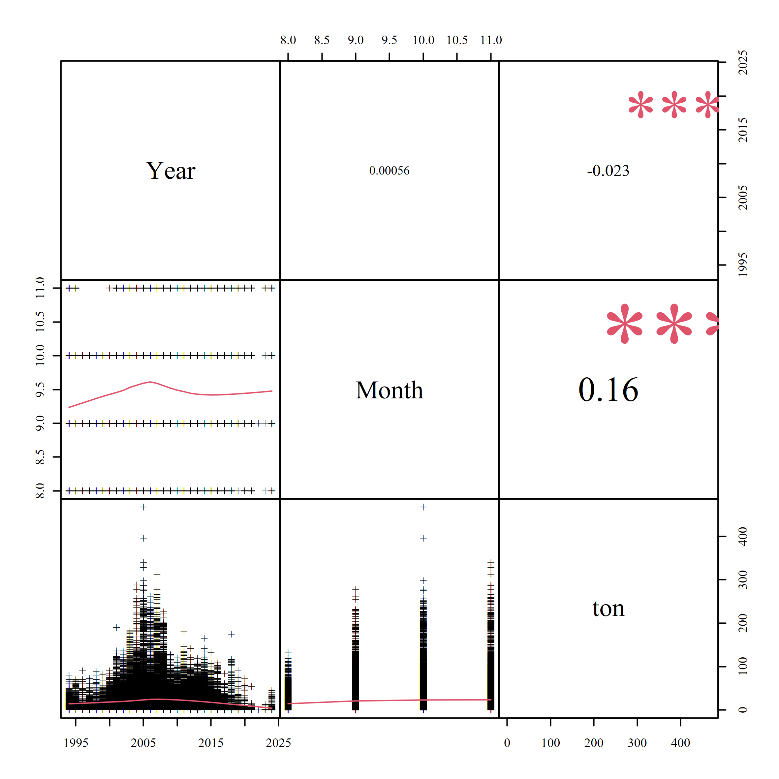

Figure 1 – Pearson’s correlations, where “***” indicates *p* < 0.001, “**” – *p* < 0.01,   
“*” – *p* < 0.05 and “∙” – *p* < 0.1

## Potential explanatory variables based on (1) – (4) to develop full model for the CPUE standardization

According to published information (see Literature review), months could be good predictors. Therefore, the full model may include them. We do not have officially reported values for SST as well as other possible predictors, so we will use only those additional factors, that we can find in our dataset – Month, “built”, “tves”, and vessel unique identifiers (Idves), which were left in the data for stratification during cross-validation. So, the full model will include Year, Month, and their interaction (Month:Year), “built”, and “tves” as additional factors. Year to year difference in the pattern of spatial distribution by Month could be captured by interaction term of Month given Year, therefore it will be also included in the full model.

## Fit candidate statistical models to the data

We did not include 0 catches, because such “catches” are just DER about positions of vessels during non-fishing operations. So, catches can be positive only and we will need a logarithmic link. We checked overdispersion using optimization of power parameter (*p*) in Tweedie family in mgcv package (Wood 2011) for the full model and found out that it is very close to the possible boundary of 2 (*p* = 1.99). It means that Gamma distribution may be the best candidate (Wood 2011), because Compound Poisson-Gamma model, which is a member of the Tweedie family, is approximately equal to Gamma model when *p =* 2*.* Thus, we fit Gamma instead of Tweedie and finally compared it to Gaussian distribution with the same link function (logarithmic). Full model with Gamma distribution was the best.

## Select and evaluate the models

We used BIC — Schwarz's Bayesian criterion, AIC — An Information Criterion AIC (Akaike 1974) and 100 runs of cross-validation for 20% out-of-bag (OOB) data excluded from model tuning each run stratified by Idves to keep the balance of proportions in sample for predictors.

At first, all models were tuned in mgcv package using maximum likelihood for step forward selection based on BIC and AIC. We used Generalized linear models, or GLMs. Common part of GLMs, which were used, can be expressed as follows:

$$g_{μ}(μ_{i})=η(t_{i}),μ_{i}=E(Y_{i}),Var(Y_{i})=φv\left(μ\right),Y_{i}|t_{i}\sim Gamma (y_{i}),i=1,...,n,$$

where $g_{μ}$— is the link function (natural logarithm here), which establishes the connection between the linear predictor, *η*, and the mean of the distribution, *µ*, in such way, that the inverse of link function equals to the expectation *E* of catches *Y* given the group of observations (*t*) from catches (*y*) in tons per day of each vessel distributed according to the variance function $v\left(μ\right)=μ^{2}$ with scale parameter $φ$. The variance function was from Gamma exponential family. Therefore, GLMs distinguished only by linear predictor and scale (Table 1). The best GLM contains linear predictor No 6, because it has the lowest AIC and BIC, highest explained deviance, and best performance in 100 cross-validation runs (see Tables 1 and 2).

Table 1 – Statistical properties of converged GLMs by linear predictors

|  |  |  |  |  |  |  |  |
| --- | --- | --- | --- | --- | --- | --- | --- |
| No |  |  | Adj. R2 | Deviance expl. % | AIC | BIC | *df* |
| 1 | $$β_{0}+β_{year_{i}}^{Y}$$ | 0.89 | 0.118 | 13.3 | 307434.7 | 307698.0 | 31 |
| 2 | $$β_{0}+β_{year_{i}}^{Y}\text{ + }β_{month_{i}}^{M}$$ | 0.87 | 0.130 | 15.2 | 306562.0 | 306850.8 | 34 |
| 3 |  | 0.83 | 0.155 | 19.1 | 304840.4 | 305834.1 | 117 |
| 4 |  | 0.83 | 0.158 | 19.6 | 304554.3 | 305590.5 | 122 |
| 5 |  | 0.82 | 0.163 | 20.3 | 304238.1 | 305367.7 | 133 |
| 6 |  | 0.82 | 0.165 | **20.6** | **304097.5** | **305252.6** | 136 |

*β*0 – intercept, $β_{year_{i}}^{Y}$– coefficient of *i*-th year (*yeari*), – coefficient of *i*-th month (*monthi*), – coefficient of *i*-th vessel place of birth (*builti*), and $β_{{type}_{i}}^{T}$– coefficient of *i*-th type of a vessel (*typei*).

Table 2 – statistical properties of 100 cross-validation runs on 20% of out of bag test sets

|  |  |  |  |  |  |
| --- | --- | --- | --- | --- | --- |
| GLM No | Average | SD | Median | MAD | IQR |
| Error measure: RMSE | | | | |
| 1 | 29.031 | 0.550 | 29.051 | 0.507 | 0.718 |
| 2 | 28.830 | 0.532 | 28.885 | 0.522 | 0.660 |
| 3 | 28.422 | 0.531 | 28.430 | 0.582 | 0.776 |
| 4 | 28.379 | 0.535 | 28.393 | 0.584 | 0.785 |
| 5 | 28.296 | 0.530 | 28.305 | 0.587 | 0.759 |
| 6 | **28.248** | 0.531 | **28.255** | 0.581 | 0.752 |
|  | Error measure: R2 | | | | |
| 1 | 0.117 | 0.005 | 0.117 | 0.005 | 0.006 |
| 2 | 0.129 | 0.006 | 0.129 | 0.005 | 0.007 |
| 3 | 0.154 | 0.008 | 0.153 | 0.009 | 0.012 |
| 4 | 0.156 | 0.008 | 0.156 | 0.008 | 0.011 |
| 5 | 0.161 | 0.007 | 0.161 | 0.008 | 0.011 |
| 6 | **0.164** | 0.007 | **0.164** | 0.008 | 0.011 |
|  | Error measure: MAE | | | | |
| 1 | 19.524 | 0.181 | 19.540 | 0.194 | 0.260 |
| 2 | 19.364 | 0.174 | 19.360 | 0.198 | 0.268 |
| 3 | 18.922 | 0.176 | 18.923 | 0.191 | 0.252 |
| 4 | 18.846 | 0.176 | 18.846 | 0.182 | 0.246 |
| 5 | 18.741 | 0.174 | 18.748 | 0.171 | 0.230 |
| 6 | **18.692** | 0.173 | **18.705** | 0.168 | 0.215 |

## Evaluate if distributional assumptions are satisfied and if there is a significant spatial/temporal pattern of residuals in CPUE standardization modeling

Gamma distribution suited very well to capture overdispersion and we do not see patterns in the residuals (Fig. 2). The rank of the final model is less than 1 (135/141) therefore huge number of parameters do not make our model a saturated one. The same model with Gaussian distribution (and log link) explained less deviance (17.0%) than with Gamma (20.6%). Therefore, we will continue to use Gamma distribution in the selected GLM as we did all the previous years.

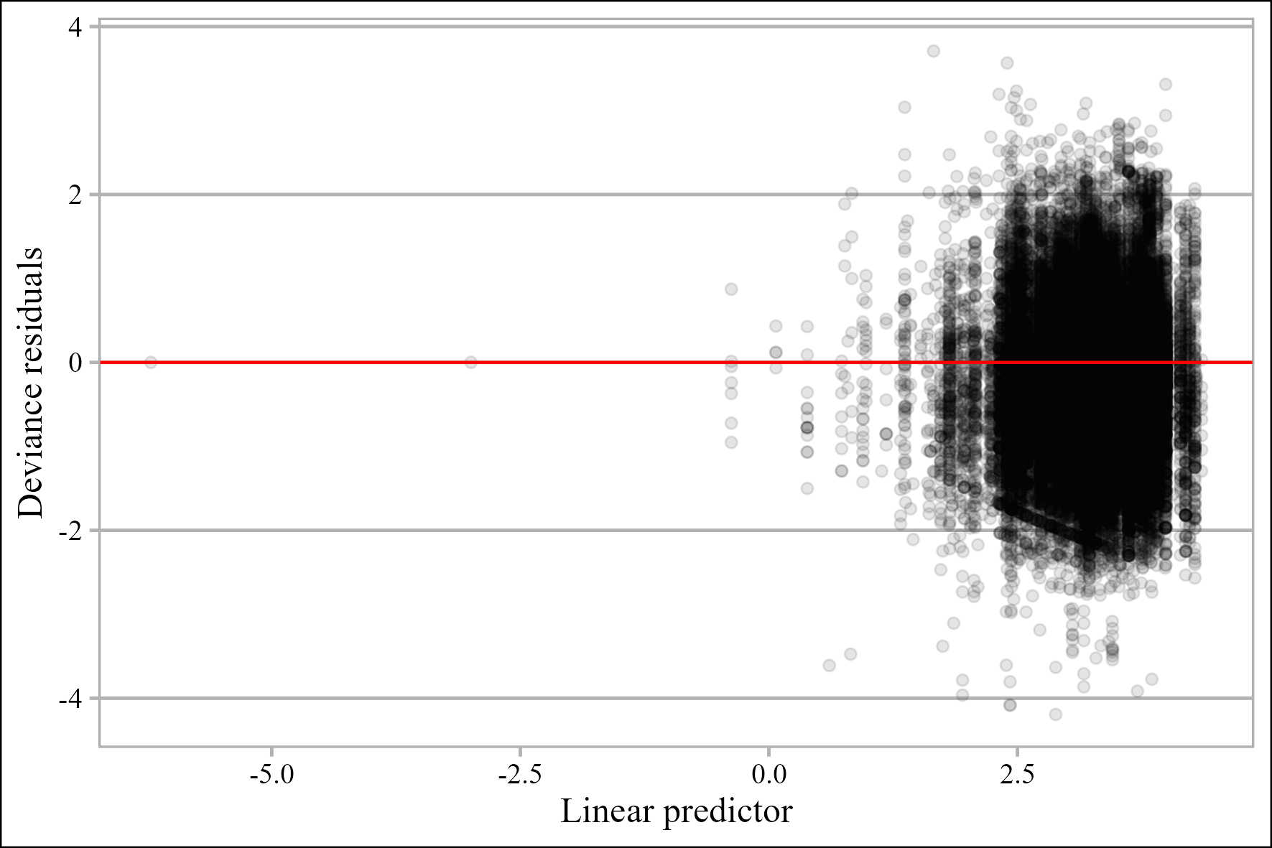

Figure 2 – Residuals of GLM No 6 versus linear predictor

Median annual residual autocorrelation was checked by generalized Durbin-Watson (D-W) statistic, which bootstrapped p-values are significant (*p* = 0.026) at lag of 2 years (Table 3).

Table 3 – Autocorrelation, D-W statistic, and its significance by different lags in time

|  |  |  |  |
| --- | --- | --- | --- |
| lag | Autocorrelation | D-W Statistic | bootstrapped p-value |
| 1 | -0.032 | 1.850 | 0.640 |
| 2 | 0.211 | 1.130 | 0.026 |
| 3 | 0.054 | 1.420 | 0.180 |
| 4 | -0.320 | 2.160 | 0.328 |
| 5 | -0.033 | 1.530 | 0.600 |

Histogram and quantile-quantile Plot show that normality assumption about residuals is not violated (Fig. 3). Deviance residuals overlapped by inter-quartile ranges (IQR) by years (Fig. 4).

Изображение выглядит как линия, График, диаграмма

Содержимое, созданное искусственным интеллектом, может быть неверным.Изображение выглядит как текст, диаграмма, линия, График

Содержимое, созданное искусственным интеллектом, может быть неверным.

Figure 3 – Quantile-quantile plot (left) conditional on the fitted model coefficients and scale parameter with 1000 simulated quantiles of the residual distribution and histogram (right) of residuals from GLM No 6 on a link scale

Изображение выглядит как текст, линия, черно-белый, типография

Содержимое, созданное искусственным интеллектом, может быть неверным.

Figure 4 – Distribution of deviance residuals by years, where notched boxes show IQR and dots inside them show the average and outside show the values higher than 1.5*IQR

Deviance residuals overlapped by inter-quartile ranges (IQR) by years given month also (Fig. 5).

Изображение выглядит как текст, Шрифт, черно-белый, снимок экрана

Содержимое, созданное искусственным интеллектом, может быть неверным.

Figure 5 – Distribution of deviance residuals by years given month (numbers in the box to the right of each plot), where boxes show IQRs and dots inside them show the average and outside show the values higher than 1.5*IQR

The highest influence (Bentley et al., 2012) was found for the interaction term after 2020 (>8). The most part of the vessels did not take part in saury fishing in 2019 and there was only 1 vessel in 2020-2021 most of the time, while the second vessel in 2020-2021 fished occasionally. Looking at the influence we can notice that there was a serious shift in types of vessels and their place of birth in 2017 (Fig. 6-7).

## Extract yearly standardized CPUE and standard error

We could continue to increase the number of predictors, e.g. to include power of vessels. But many parameters, describing vessels are causally linked with each vessel (or its Idves). So, we decided to stop including other covariates to avoid overfitting. Therefore, our optimal model is GLM No 6.



Figure 6 – Influence and share of the total number of records of $β_{{built}_{i}}^{B}$ by Year (circles), 2022 year is skipped



Figure 7 – Influence and share of the total number of records for each “tves” $β_{{type}_{i}}^{T}$ by Year

## A time series of yearly standardized CPUE and associated uncertainty

Interaction term of factor Month given factor Year complicates the use of Year’s coefficients as indices of abundance in GLM No 6. To overcome this difficulty, we expanded a grid which included all used levels of months (from August to November), years (1994-2024, except 2022), and the most frequent type of a vessel built in Russia (Refrigerated seiner-trawler type “Alpinist” project #503). Then we predicted catches using GLM No 6 and summarized them. Summary statistics of predicted values are given below by years (table 4). We show all the uncertainty in the predictions with boxplots in Fig. 8 as we did in our previous working papers.

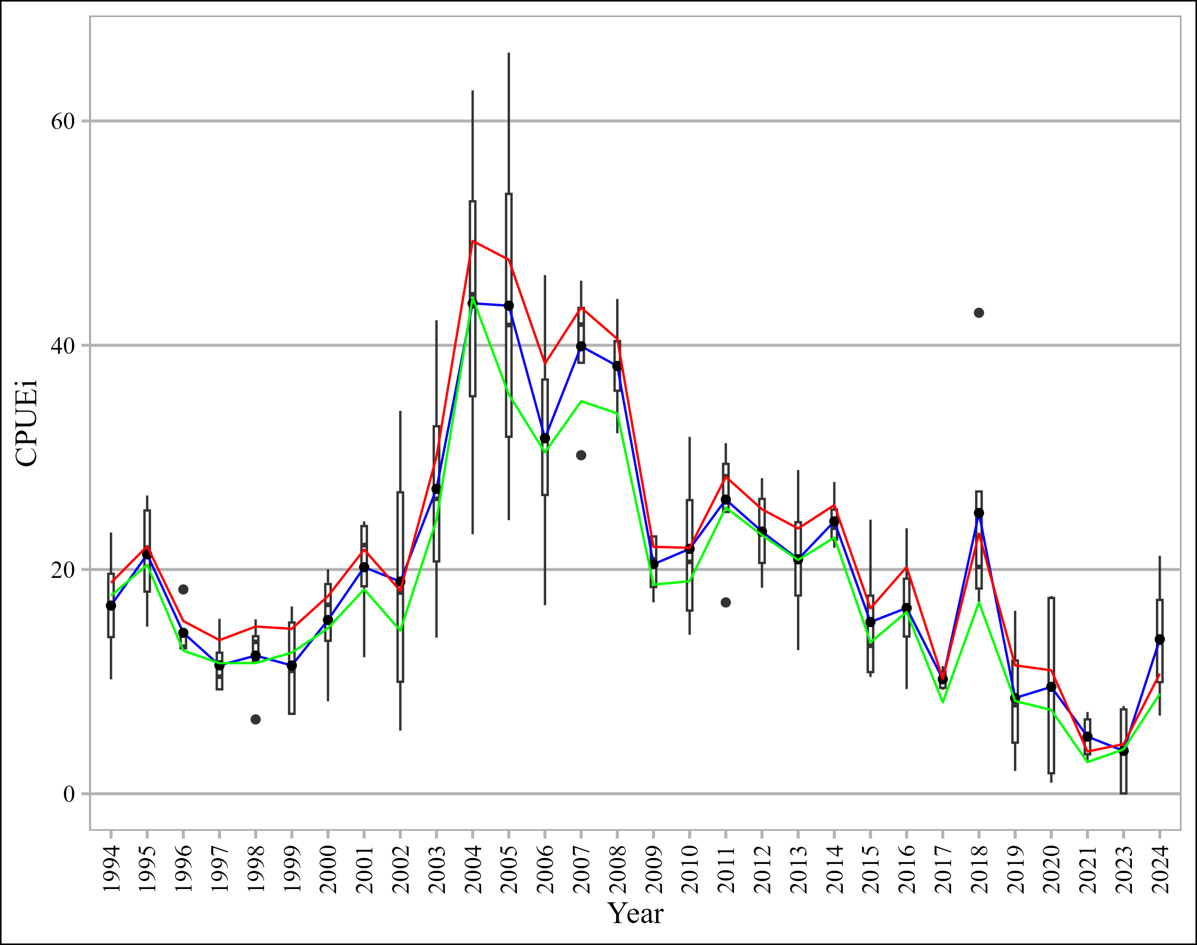

Figure 8 – Box plots for catches per day per vessel (CPUEi) predicted from GLM No 6, where blue line connects means of predictions, red line connects means of raw CPUE – catch values (tons per day per vessel) used for standardization, while green line connects trimmed means of original CPUE

Figure 9 shows all 100 runs by different GLMS during cross-validation. Figure 10 shows 100 runs by GLM6 during cross-validation.

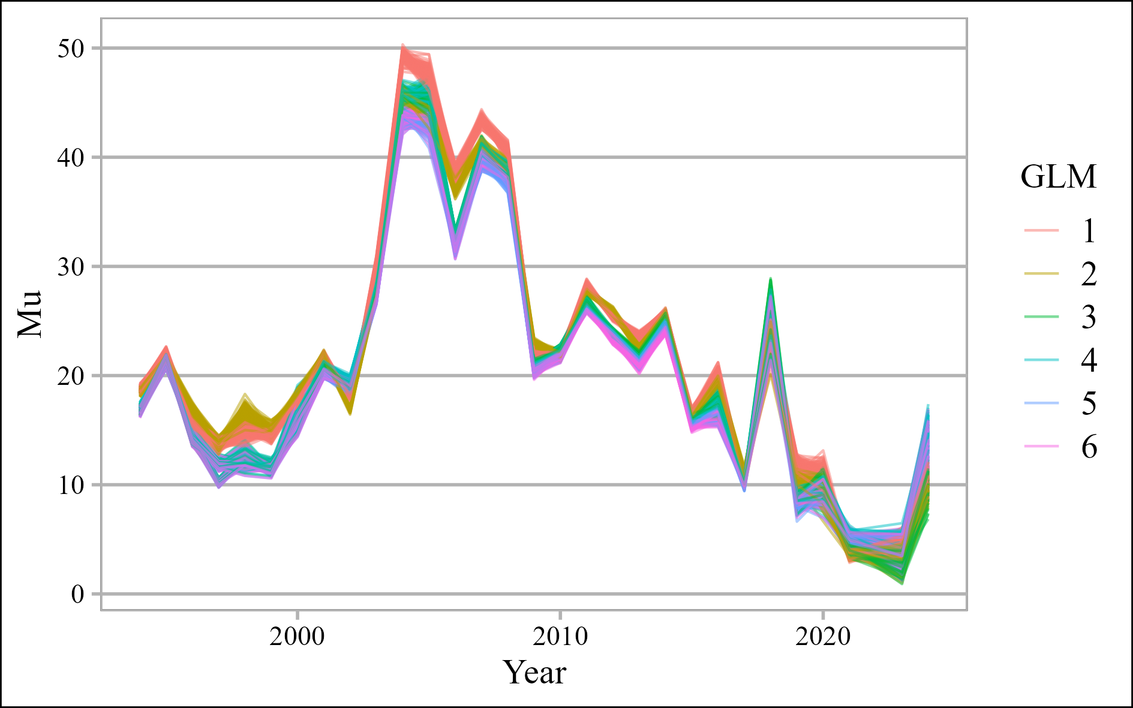

Figure 9 – Estimates from expanded grids which were used for predictions by different GLMs

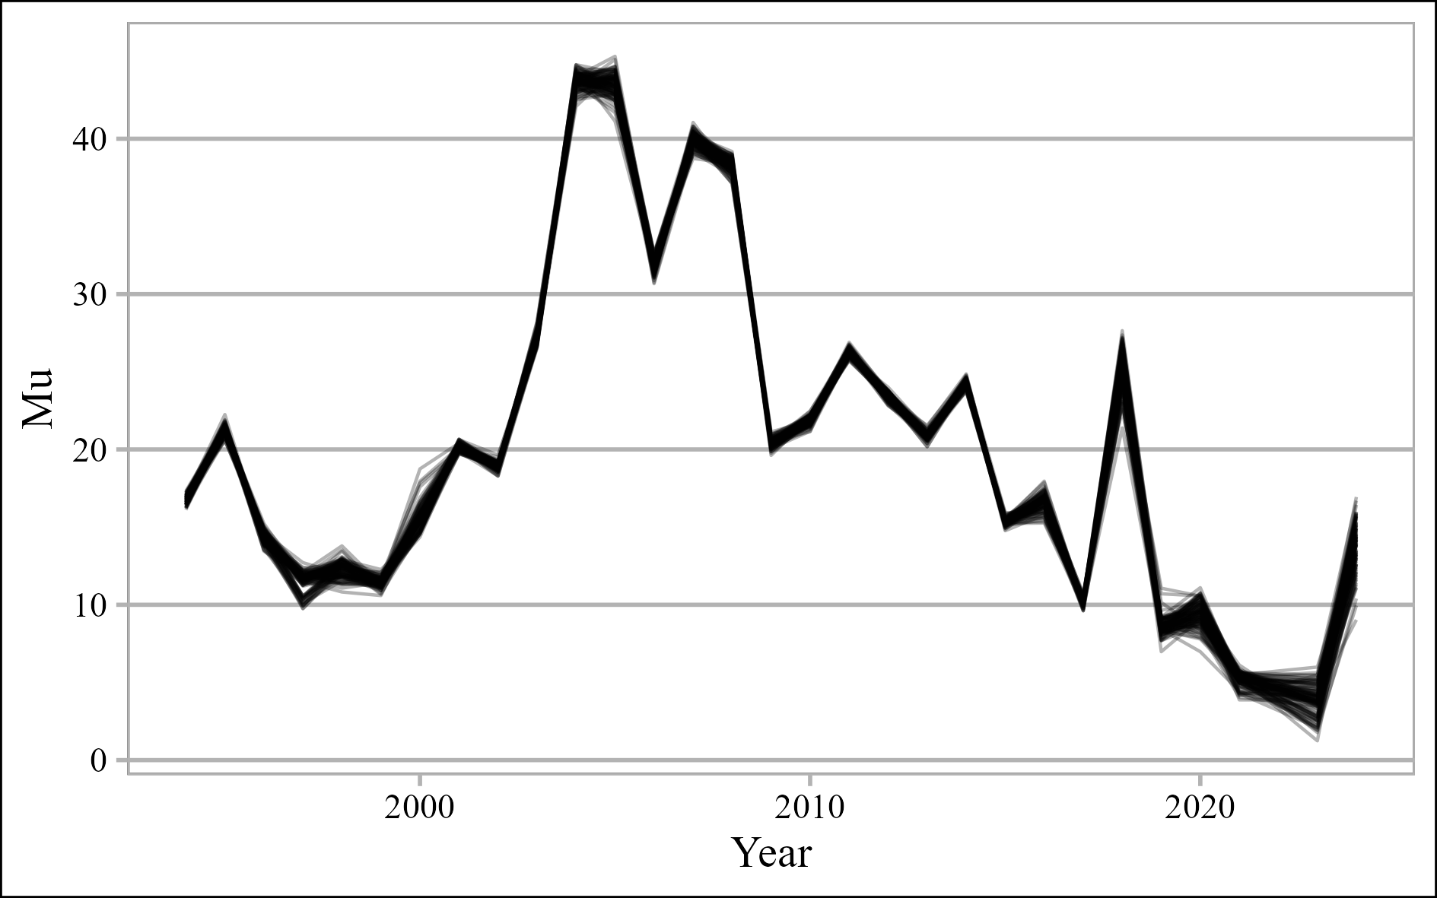

Figure 10 – Mean timeseries from expanded grid which was used for predictions by GLM6

Descriptive statistics for all 100 runs of GLM6 are given in table 4. We recommend using the mean estimates from table 4.

Table 4 – Statistics of 100 mean predictions on expanded grids from GLM6 of catches of saury per day per vessel in metric tons, which were trained using 80% resamples each time

|  |  |  |  |  |  |  |
| --- | --- | --- | --- | --- | --- | --- |
| Year | Nominal | Mean | SD | CV | Quantile 0.025 | Quantile 0.975 |
| 1994 | 18.82 | 16.73 | 0.274 | 1.6% | 16.216 | 17.224 |
| 1995 | 22.07 | 21.33 | 0.305 | 1.4% | 20.696 | 21.846 |
| 1996 | 15.40 | 14.37 | 0.372 | 2.6% | 13.553 | 15.029 |
| 1997 | 13.70 | 11.46 | 0.695 | 6.1% | 9.907 | 12.293 |
| 1998 | 14.91 | 12.29 | 0.548 | 4.5% | 11.307 | 13.282 |
| 1999 | 14.71 | 11.43 | 0.308 | 2.7% | 10.819 | 12.056 |
| 2000 | 17.62 | 15.60 | 0.739 | 4.7% | 14.560 | 17.720 |
| 2001 | 21.78 | 20.19 | 0.233 | 1.2% | 19.741 | 20.644 |
| 2002 | 18.10 | 18.90 | 0.246 | 1.3% | 18.345 | 19.289 |
| 2003 | 30.07 | 27.25 | 0.372 | 1.4% | 26.606 | 28.035 |
| 2004 | 49.30 | 43.73 | 0.541 | 1.2% | 42.562 | 44.703 |
| 2005 | 47.63 | 43.50 | 0.721 | 1.7% | 42.023 | 44.662 |
| 2006 | 38.36 | 31.79 | 0.425 | 1.3% | 30.940 | 32.577 |
| 2007 | 43.36 | 39.97 | 0.463 | 1.2% | 39.007 | 40.795 |
| 2008 | 40.56 | 38.26 | 0.453 | 1.2% | 37.264 | 38.990 |
| 2009 | 22.02 | 20.43 | 0.281 | 1.4% | 19.854 | 20.959 |
| 2010 | 21.93 | 21.85 | 0.277 | 1.3% | 21.297 | 22.310 |
| 2011 | 28.27 | 26.24 | 0.248 | 0.9% | 25.798 | 26.753 |
| 2012 | 25.37 | 23.42 | 0.253 | 1.1% | 22.896 | 23.812 |
| 2013 | 23.66 | 20.86 | 0.247 | 1.2% | 20.376 | 21.325 |
| 2014 | 25.75 | 24.26 | 0.247 | 1.0% | 23.774 | 24.724 |
| 2015 | 16.54 | 15.31 | 0.220 | 1.4% | 14.932 | 15.771 |
| 2016 | 20.23 | 16.64 | 0.532 | 3.2% | 15.517 | 17.591 |
| 2017 | 10.24 | 10.18 | 0.238 | 2.3% | 9.659 | 10.585 |
| 2018 | 23.20 | 25.15 | 1.158 | 4.6% | 22.956 | 27.207 |
| 2019 | 11.45 | 8.60 | 0.572 | 6.7% | 7.694 | 9.912 |
| 2020 | 11.01 | 9.45 | 0.790 | 8.4% | 7.878 | 10.721 |
| 2021 | 3.76 | 5.18 | 0.440 | 8.5% | 4.179 | 5.812 |
| 2023 | 4.43 | 3.81 | 0.977 | 25.7% | 1.921 | 5.473 |
| 2024 | 10.71 | 13.88 | 1.513 | 10.9% | 10.721 | 16.225 |

## Plot nominal and standardized CPUEs over time

Nominal CPUE statistics are shown in Appendix IV. Standardized CPUE from Table 4 is compared to Standardized CPUE from NPFC-2023-SSC PS11-WP03 and NPFC-2022-SSC PS09-WP03 in Fig. 11 after mean centering on a logarithmic scale and exponentiating back.

Figure 11 – Mean centered on a log scale and exponentiated back CPUEs up to 2021-2024, while dashed green line shows nominal CPUE in 2024

**Table 5** Analysis of deviance table for GLM6

|  |  |  |  |  |  |
| --- | --- | --- | --- | --- | --- |
|  | SS | Df | F | Pr(>F) | Signif. codes |
| Year | 4088861 | 29 | 37.32 | < 2.2e-16 | *** |
| Built | 129837 | 5 | 32.30 | < 2.2e-16 | *** |
| Type | 241264 | 14 | 38.61 | < 2.2e-16 | *** |
| Year:Month.int | 1335147 | 86 | 33.83 | < 2.2e-16 | *** |
| Residuals | 28766295 | 35934 |  |  |  |
| Residual standard error: 28.29366 | | | | | |
| Signif. codes: 0 ‘***’ 0.001 ‘**’ 0.01 ‘*’ 0.05 ‘.’ 0.1 ‘ ’ 1 | | | | | |

**REFERENCES**

Akaike, H. (1974). A new look at the statistical model identification. *IEEE Transactions on Automatic Control*, *19*(6), 716–723. https://doi.org/10.1109/TAC.1974.1100705

Baitaliuk, A. A., Orlov, A. M., & Ermakov, Y. K. (2013). Characteristic features of ecology of the Pacific saury Cololabis saira (Scomberesocidae, Beloniformes) in open waters and in the northeast Pacific ocean. *Journal of Ichthyology*, *53*(11), 899–913. https://doi.org/10.1134/S0032945213110027

Bentley, N., Kendrick, T. H., Starr, P. J., & Breen, P. A. (2012). Influence plots and metrics: tools for better understanding fisheries catch-per-unit-effort standardizations. *ICES Journal of Marine Science*, *69*(1), 84–88. https://doi.org/10.1093/icesjms/fsr174

Huang, W.-B., Lo, N. C. H., Chiu, T.-S., & Chen, C.-S. (2007). Geographical Distribution and Abundance of Pacific Saury, Cololabis saira (Brevoort) (Scomberesocidae), Fishing Stocks in the Northwestern Pacific in Relation to Sea Temperatures. *Zoological Studies*, *46*(6), 705–716. Retrieved from http://zoolstud.sinica.edu.tw/Journals/46.6/705.pdf

Parin, N. V. 1960. The range of the saury (Cololabis saira Brev.-Scombresocidae, Pices) and effects of oceanographic features on its distribution. *Proc. Acad. Sci. USSR*, *130*(3), 649–652.

Wood, S. N. (2011). Fast stable restricted maximum likelihood and marginal likelihood estimation of semiparametric generalized linear models. *Journal of the Royal Statistical Society: Series B (Statistical Methodology)*, *73*(1), 3–36. https://doi.org/10.1111/j.1467-9868.2010.00749.x

# Appendix I: Checklist for the CPUE standardization protocol

|  |  |  |
| --- | --- | --- |
| (1) | Conduct a thorough literature review to identify key factors (i.e., spatial, temporal, environmental, and fisheries variables) that may influence CPUE values; | Yes |
| (2) | Determine temporal and spatial scales for data grouping for CPUE standardization; | Yes and No  (exact spatial information is not available at the same level of details as the catches are) |
| (3) | Plot spatio-temporal distributions of fishing efforts and catch to evaluate spatio-temporal patterns of fishing effort and catch; | Yes (*see* Appendix II and III) |
| (4) | Calculate correlation matrix to evaluate correlations between each pair of those variables; | Yes (*see* Fig. 1) |
| (5) | Identify potential explanatory variables based on (1)-(4) as well as interaction terms to develop full model for the CPUE standardization; | Yes |
| (6) | Fit candidate statistical models to the data (e.g., GLM, GAM, Delta-lognormal GLM, Neural Networks, Regression Trees, Habitat based models, and Statistical habitat-based models); | Yes (GLM) |
| (7) | Evaluate the models using information criteria like AIC or BIC. If the candidate models employ distinct parameter estimation methods (e.g. GLM with maximum likelihood vs. GAM with penalized likelihood), evaluate the models through cross-validation; | Yes (AIC and BIC, *see* Table 1, and cross-validation, *see* Table 2) |
| (8) | Evaluate if distributional assumptions are satisfied and if there is a significant spatial/temporal pattern of residuals in CPUE standardization modeling; | Yes, for distribution assumption and temporal term (*see* Fig. 2 – 5 and Table 3), and No, for spatial, because there is no exact spatial information. |
| (9) | Extract yearly standardized CPUE and standard error by a method that is able to account for spatial heterogeneity of effort, such as least squares mean or expanded grid. If the model includes area and the size of spatial strata differs or the model includes interactions between time and area, then standardized CPUE should be calculated with area weighting for each time step. Model with interactions between area and season or month requires careful consideration on a case by case basis; | Yes, the expanded grid was used (*see* Table 4). Spatial grouping is not available. |
| (10) | Recommend a time series of yearly standardized CPUE and associated uncertainty. | Yes, recommended mean estimates (*see* Table 4) |
| (11) | Plot nominal and standardized CPUEs over time; | Yes, see Fig. 8, 10 and 11 |

**Appendix II:** Monthly catches of Russian vessels for Pacific saury from 1994 to 2024

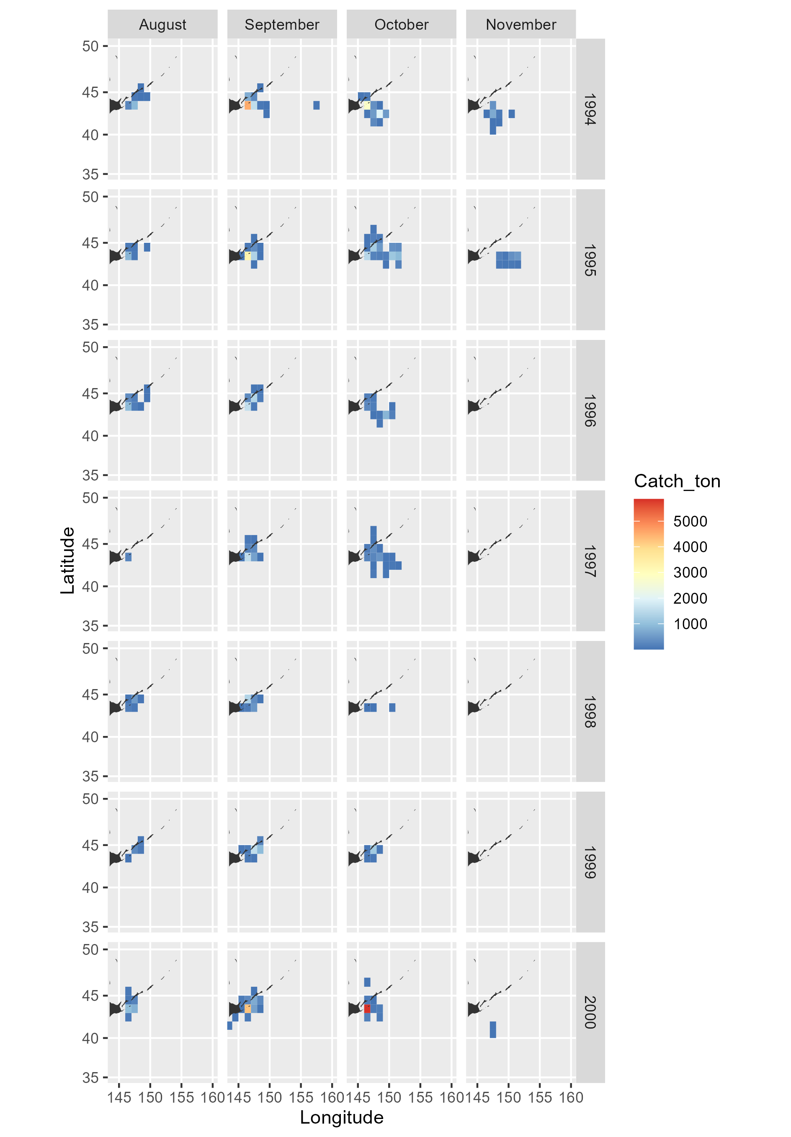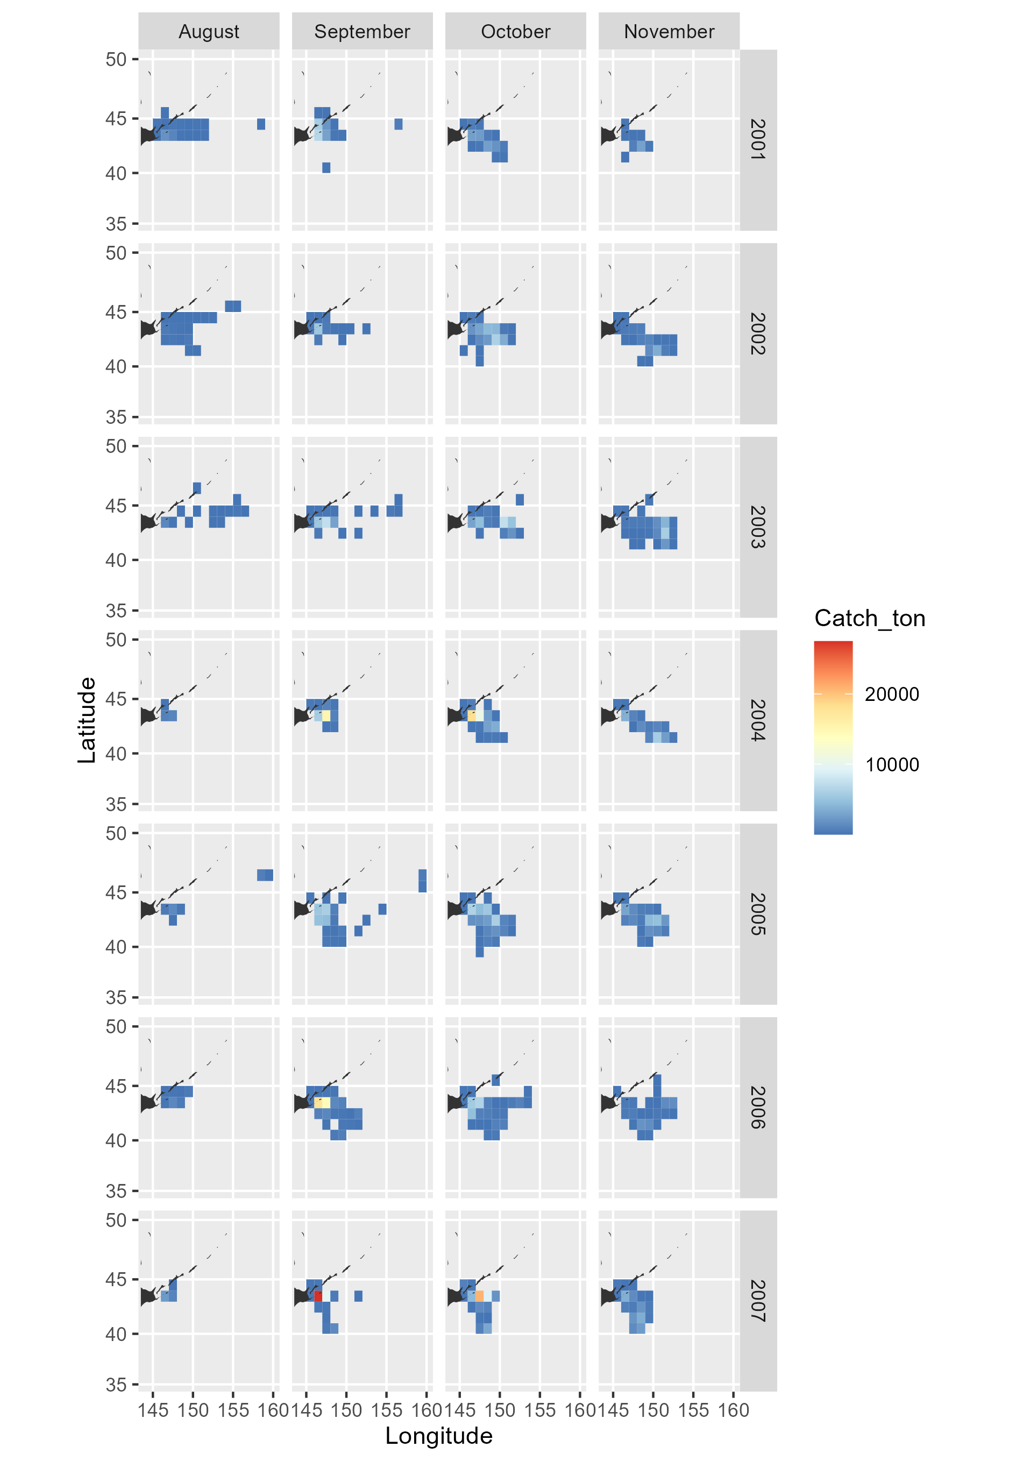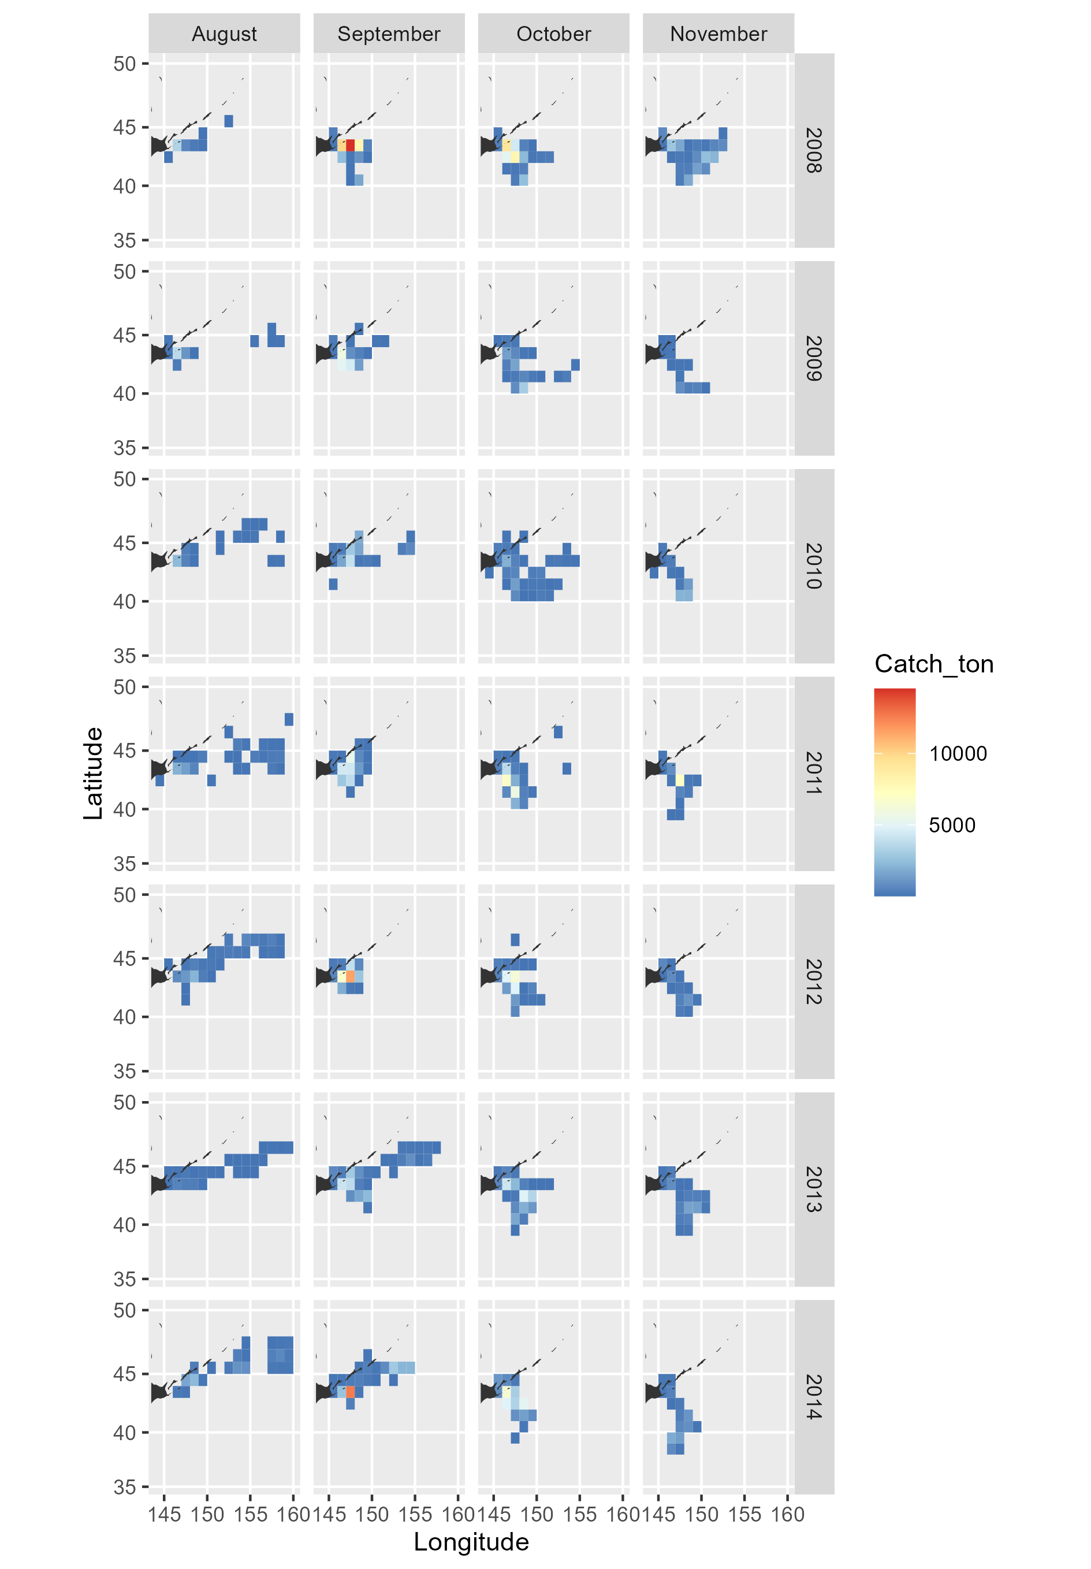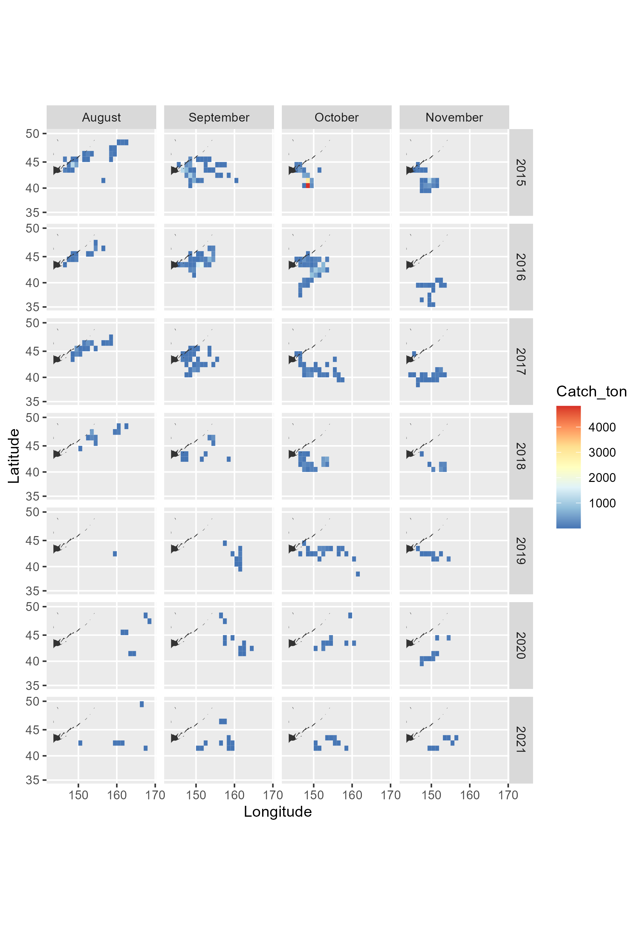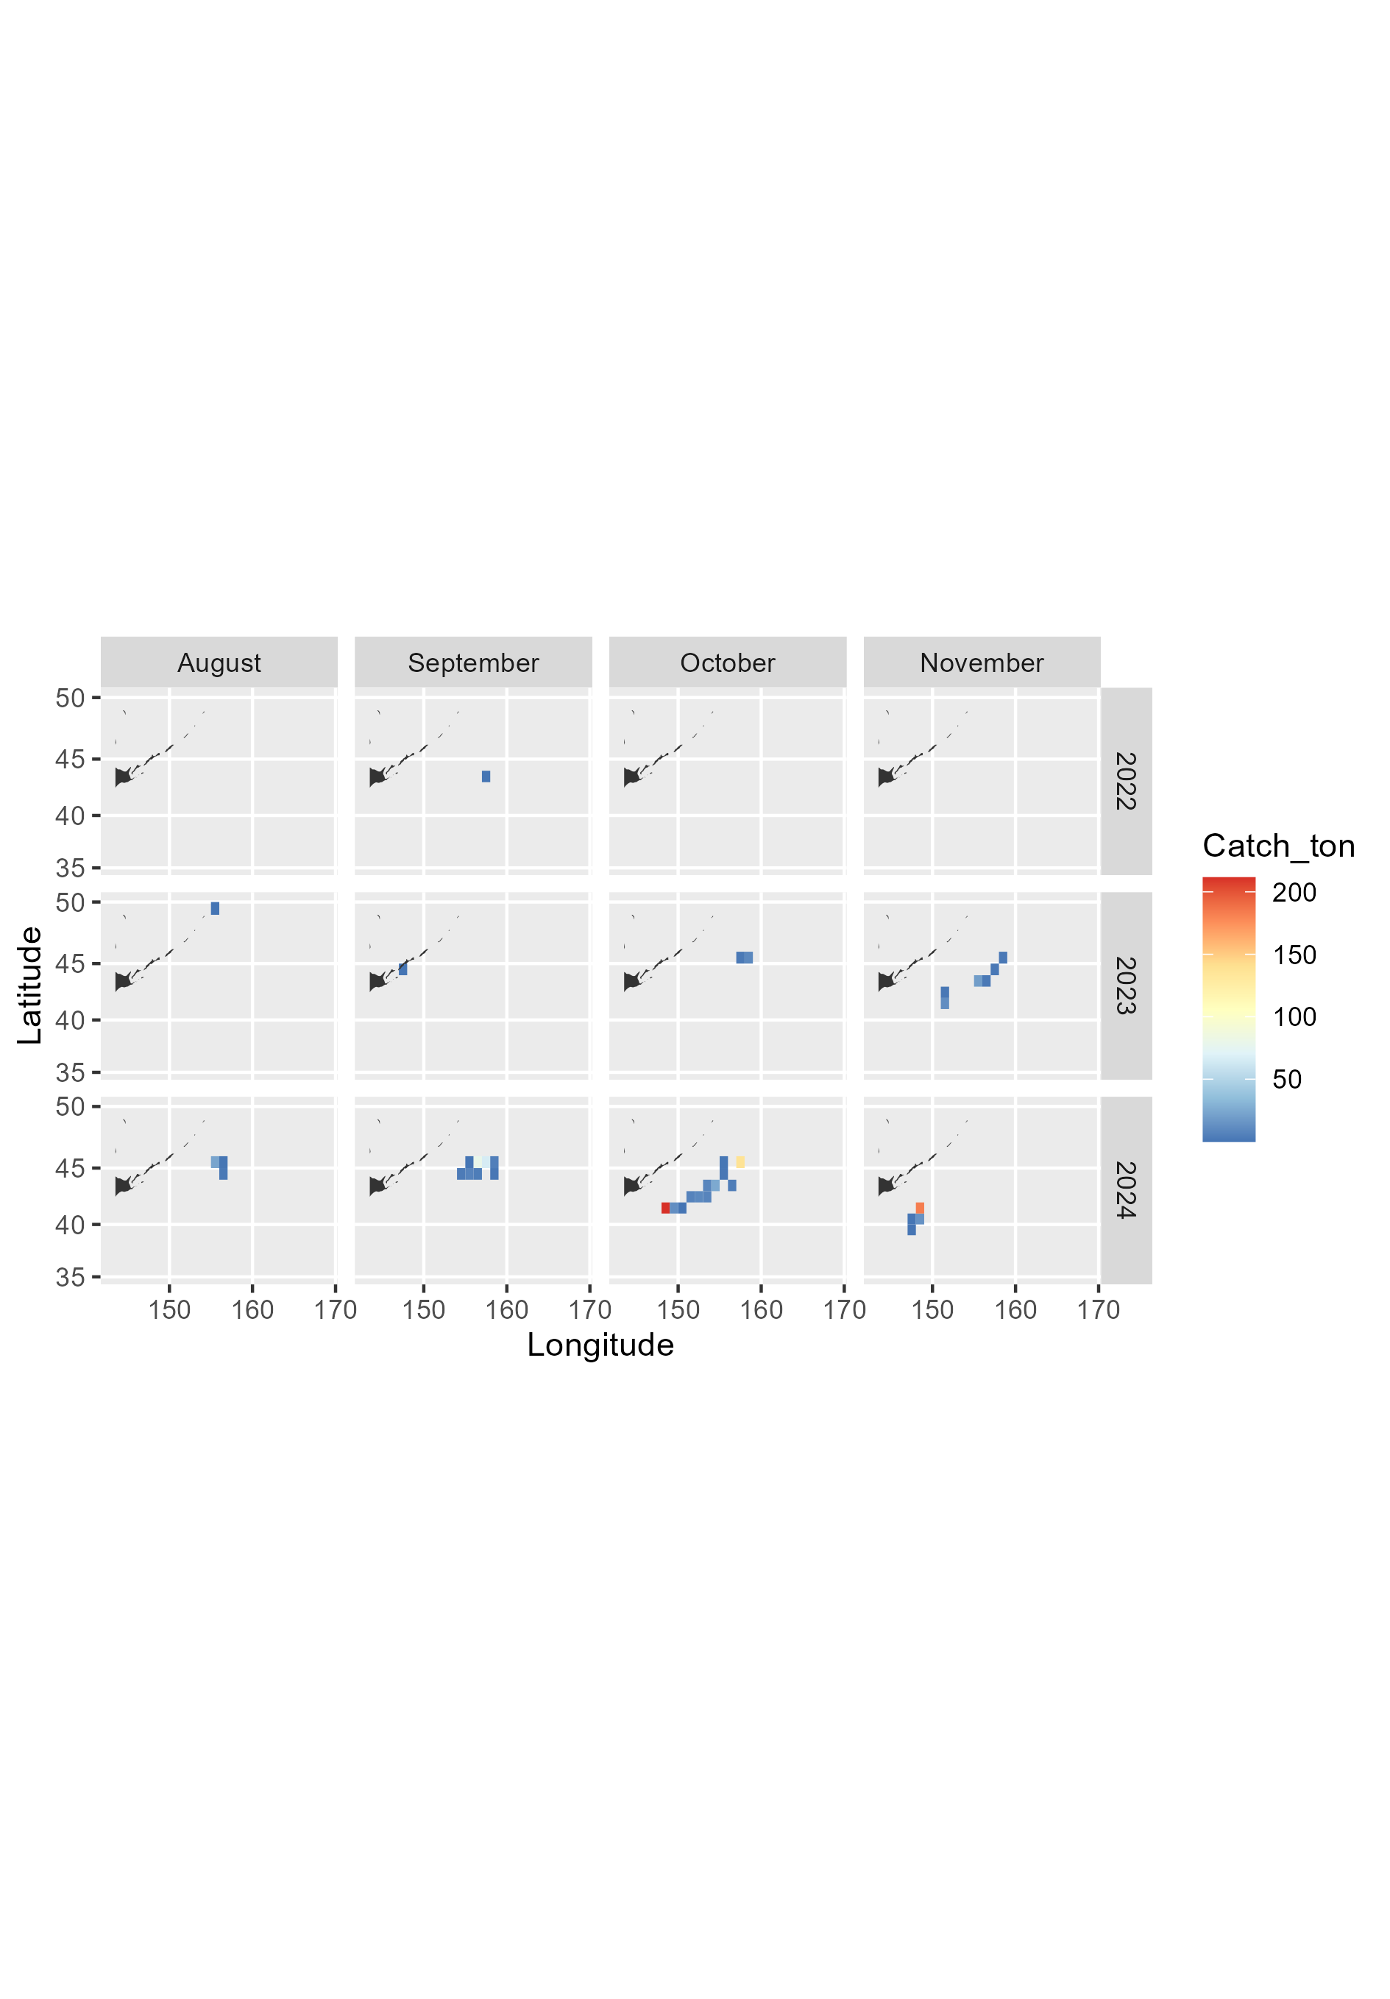

**Appendix III:** Monthly sum of fishing days of Russian vessels that caught saury from 1994 to 2024

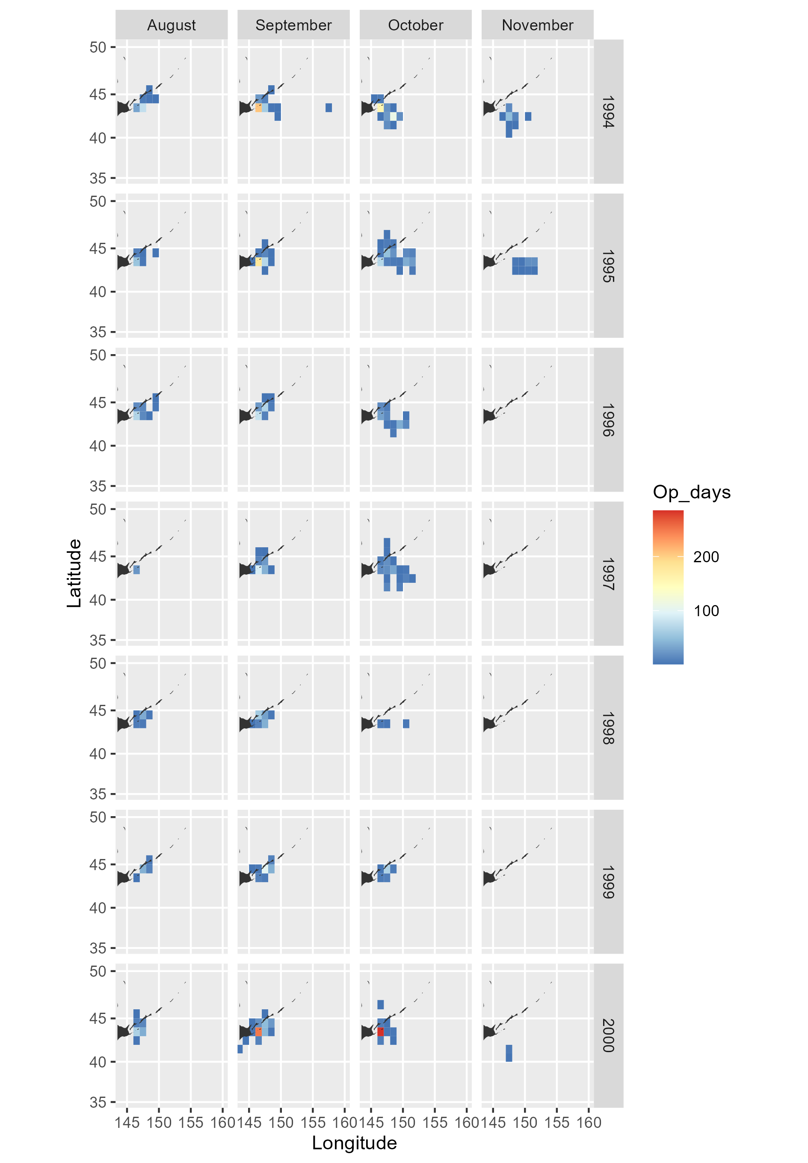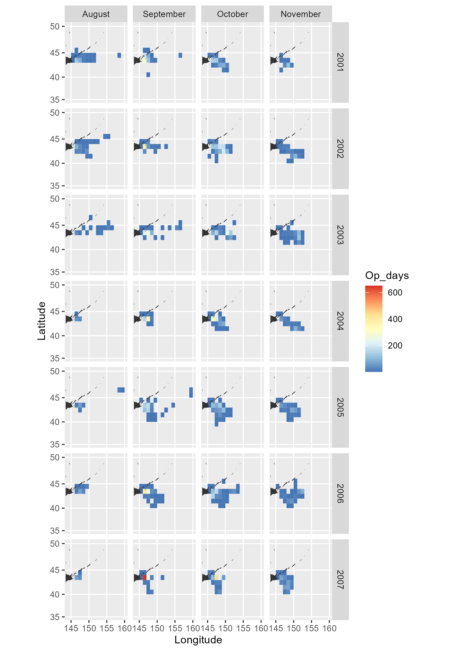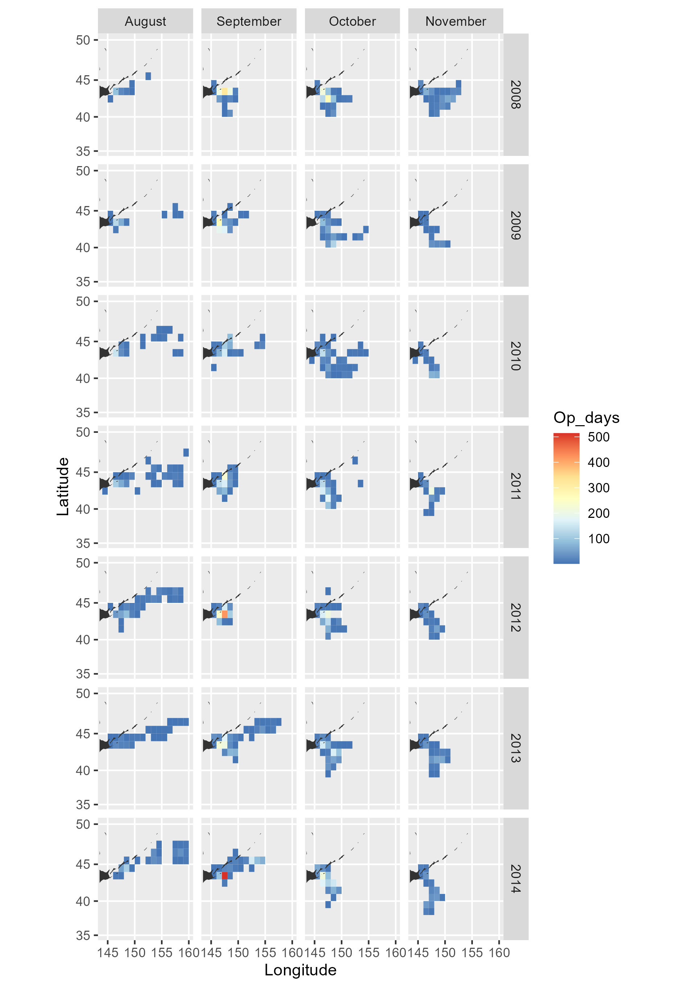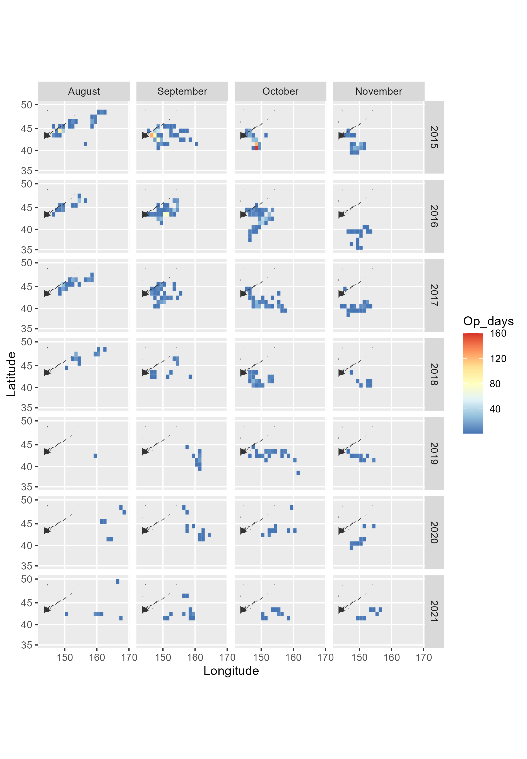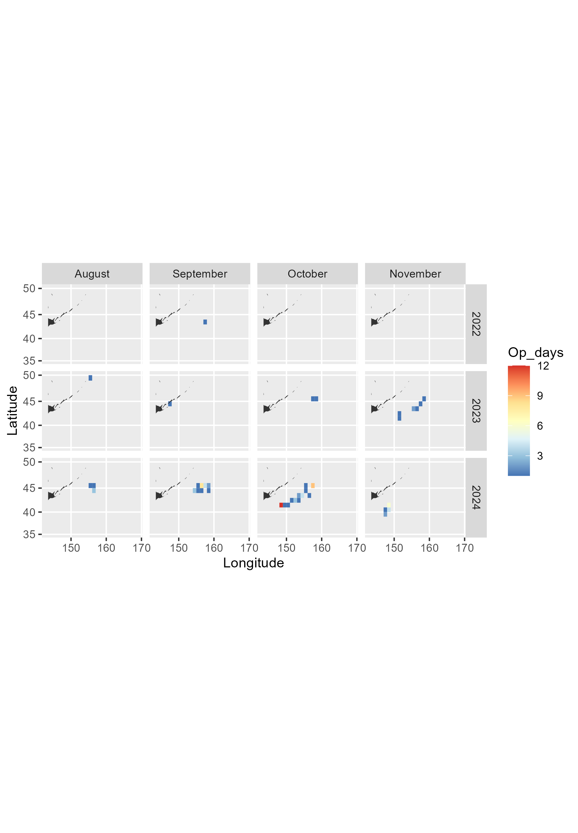

**Appendix IV:** Summary statistics of raw catch (metric tons per day per vessel) values used for CPUE standardization

|  |  |  |  |  |  |  |  |  |  |  |  |
| --- | --- | --- | --- | --- | --- | --- | --- | --- | --- | --- | --- |
| Year | n | Mean | SD | SE | Median | Trimmed mean by  10% | MAD | Min | Max | Skew | Kur-tosis |
| 1994 | 859 | 18.820 | 12.610 | 0.430 | 15.000 | 17.665 | 13.343 | 0.500 | 80.000 | 0.926 | 0.933 |
| 1995 | 644 | 22.073 | 15.471 | 0.610 | 20.000 | 20.413 | 14.826 | 1.000 | 70.000 | 0.836 | -0.010 |
| 1996 | 434 | 15.401 | 14.965 | 0.718 | 10.000 | 12.757 | 8.896 | 0.500 | 90.000 | 1.603 | 2.336 |
| 1997 | 328 | 13.699 | 12.092 | 0.668 | 10.000 | 11.646 | 8.154 | 1.000 | 72.000 | 1.830 | 4.012 |
| 1998 | 205 | 14.912 | 16.354 | 1.142 | 10.000 | 11.656 | 9.192 | 0.500 | 88.000 | 1.996 | 4.061 |
| 1999 | 311 | 14.713 | 13.783 | 0.782 | 10.000 | 12.584 | 10.378 | 0.500 | 82.700 | 1.670 | 3.675 |
| 2000 | 825 | 17.624 | 16.732 | 0.583 | 12.000 | 14.756 | 11.564 | 0.500 | 90.000 | 1.638 | 2.731 |
| 2001 | 1714 | 21.776 | 20.957 | 0.506 | 15.000 | 18.236 | 14.826 | 0.059 | 190.000 | 2.050 | 6.326 |
| 2002 | 2850 | 18.103 | 19.291 | 0.361 | 11.200 | 14.550 | 11.861 | 0.020 | 136.100 | 2.129 | 5.851 |
| 2003 | 1911 | 30.065 | 30.755 | 0.704 | 19.332 | 24.406 | 19.321 | 0.222 | 182.500 | 1.928 | 4.261 |
| 2004 | 1694 | 49.302 | 38.693 | 0.940 | 42.000 | 44.242 | 32.321 | 0.045 | 288.000 | 1.896 | 6.132 |
| 2005 | 1852 | 47.629 | 56.315 | 1.309 | 27.700 | 35.609 | 29.148 | 0.007 | 467.500 | 2.281 | 6.187 |
| 2006 | 1938 | 38.364 | 40.825 | 0.927 | 25.000 | 30.440 | 22.239 | 0.354 | 262.000 | 2.452 | 7.238 |
| 2007 | 2490 | 43.361 | 43.489 | 0.872 | 30.000 | 35.010 | 28.292 | 0.500 | 312.500 | 2.117 | 5.209 |
| 2008 | 2368 | 40.557 | 38.621 | 0.794 | 28.112 | 33.921 | 26.705 | 0.333 | 226.000 | 1.886 | 4.128 |
| 2009 | 1633 | 22.021 | 20.304 | 0.502 | 16.200 | 18.652 | 15.102 | 0.229 | 127.435 | 1.726 | 3.522 |
| 2010 | 1434 | 21.932 | 19.127 | 0.505 | 16.471 | 18.958 | 14.700 | 0.110 | 120.000 | 1.543 | 2.720 |
| 2011 | 2179 | 28.266 | 22.141 | 0.474 | 23.591 | 25.521 | 20.177 | 0.100 | 181.400 | 1.381 | 2.953 |
| 2012 | 2403 | 25.372 | 18.644 | 0.380 | 21.402 | 23.064 | 16.015 | 0.001 | 141.500 | 1.363 | 2.623 |
| 2013 | 2206 | 23.658 | 19.929 | 0.424 | 18.500 | 20.853 | 17.305 | 0.020 | 118.100 | 1.259 | 1.427 |
| 2014 | 2740 | 25.746 | 21.246 | 0.406 | 20.000 | 22.849 | 18.418 | 0.404 | 165.000 | 1.370 | 2.425 |
| 2015 | 1303 | 16.537 | 16.775 | 0.465 | 11.000 | 13.511 | 11.038 | 0.019 | 131.700 | 2.130 | 6.106 |
| 2016 | 704 | 20.226 | 20.950 | 0.790 | 12.671 | 16.213 | 13.114 | 0.006 | 108.309 | 1.847 | 3.477 |
| 2017 | 460 | 10.239 | 11.025 | 0.514 | 6.452 | 8.150 | 6.509 | 0.001 | 83.013 | 2.319 | 7.371 |
| 2018 | 228 | 23.202 | 29.752 | 1.970 | 10.950 | 17.075 | 12.733 | 0.005 | 174.267 | 1.951 | 3.884 |
| 2019 | 116 | 11.451 | 15.653 | 1.453 | 5.025 | 8.268 | 5.744 | 0.001 | 91.455 | 2.532 | 7.637 |
| 2020 | 67 | 11.009 | 16.129 | 1.970 | 3.216 | 7.472 | 3.874 | 0.201 | 71.757 | 1.912 | 3.097 |
| 2021 | 86 | 3.764 | 6.072 | 0.655 | 2.412 | 2.821 | 2.086 | 0.001 | 53.466 | 6.477 | 49.432 |
| 2023 | 11 | 4.427 | 4.841 | 1.460 | 2.010 | 3.959 | 2.906 | 0.002 | 13.065 | 0.713 | -1.303 |
| 2024 | 76 | 10.710 | 12.099 | 1.388 | 6.171 | 8.911 | 8.255 | 0.035 | 44.552 | 1.134 | 0.086 |