NPFC-2025-SSC PS15-WP10 (Rev. 1)

Joint CPUE standardization of the Pacific saury in the Northwest Pacific Ocean by using the spatio-temporal modelling approach

Jhen Hsu and Yi-Jay Chang
Institute of Oceanography, National Taiwan University

Abstract

Reliable indices of population abundance are essential for stock assessment. This study had two main objectives: (1) to evaluate the feasibility of using the R package sdmTMB as an alternative to the VAST model for CPUE standardization of Pacific saury, and (2) to update the joint CPUE index through 2024 using sdmTMB. The comparison using data through 2023 showed that sdmTMB produced results consistent with previous VAST assessments, while offering greater transparency and reproducibility. The updated standardized CPUE index indicated pronounced fluctuations over time, lower levels in recent years compared to the mid-1990s, and a slight increase in 2023 - 2024. Overall, sdmTMB provides a reliable framework for CPUE standardization and contributes to the stock assessment of Pacific saury.

1. Introduction

Pacific saury (Cololabis saira) is a migratory small pelagic fish broadly distributed across the Northwestern Pacific Ocean (Fukushima, 1979). It supports important commercial fisheries in this region, primarily targeted by stick-held dip net fleets. Offshore fleets from Japan and Russia mainly operate within their exclusive economic zones, whereas the distant-water fleets of China, Korea, and Chinese Taipei fish predominantly east of Hokkaido and the Kuril Islands. Given that standardized CPUE indices produced independently by members often show discrepancies, the 3rd Technical Working Group on the Pacific Saury Stock Assessment (TWG PSSA) recommended developing a joint CPUE index using catch and effort data from all members (NPFC-2018-TWG PSSA03-Final Report). A joint CPUE index is valuable because it integrates information across fleets, reduces the influence of fleet-specific biases, and provides a more representative measure of stock abundance. This unified approach improves comparability and enhances consistency in stock assessments.

To date, the Vector-Autoregressive Spatio-Temporal (VAST) model (Thorson, 2019) has been employed to standardize the joint CPUE data, and this standardized index has been adopted as the base case abundance index in the Pacific saury stock assessment (cited Report). Recently, the R package sdmTMB (Anderson et al., 2022) has been developed as a flexible and efficient framework for spatio-temporal modelling. It incorporates temporal and spatial autocorrelation similar to VAST, has demonstrated comparable performance to other software, and has been applied in CPUE standardization for other highly migratory species in different RFMO contexts (e.g., Makoto et al., 2025 for skipjack; Teears et al., 2024 for albacore).

In this study, we first assess the feasibility of applying sdmTMB as an alternative to VAST by re-analyzing joint CPUE data for Pacific saury through 2023 using identical model and spatial configurations. This comparison highlights the consistency of results between the two software packages. We then extend the application of sdmTMB to Pacific saury by standardizing the joint CPUE dataset covering 1994 – 2024, performing diagnostic evaluations, and updating the abundance index for future stock assessments.

2. Methods

2.1 Data preparation

The joint CPUE dataset for stick-held dip net fisheries was compiled by the NPFC from its members: Japan (JP), Chinese Taipei (CT), China (CHN), Korea (KOR), Russia (RUS), and Vanuatu (VAN), covering 1994 – 2024. It also serves as the basis for fisheries summary plots of catch, operating days, and nominal CPUE for each fleet (Appendix Figures 1 - 6). Data were aggregated by year and month at a spatial resolution of 1° × 1°, spanning the Northwestern Pacific Ocean from 32.5° - 51.5°N and 139.5° - 176.5°E. Seven fleets were included: JP1, JP2, CT, CHN, KOR, RUS, and VAN. The Japanese fleets were divided by vessel size (gross registered tonnage, GRT): JP1 (≥100 GRT) and JP2 (<100 GRT). CPUE was defined as Pacific saury catch (metric tons) per operating day.

To reduce the influence of extreme values, CPUE outliers were removed using the conventional boxplot rule, excluding observations below Q1 − 1.5×IQR or above Q3 + 1.5×IQR. This process eliminated 870 records (approximately 6% of the dataset) and ensured that standardized CPUE analyses were not distorted by anomalous values. After filtering, the dataset contained 13,896 records across all members. Figure 1 shows the temporal distribution of operating records by member, with no records from Russia in 2022 – 2023. Figure 2 shows the monthly distribution of records by fleets, highlighting that in 2023 – 2024 both CHN and CT reached their quotas in certain months and ceased operations. In general, records were distributed across all months, although the number of observations varied by month.

The spatial and temporal patterns of nominal joint catch, operating days, and CPUE over successive 5-year periods from 1994 to 2024 are shown in Figures 2 – 4. A notable decline in high-CPUE areas is evident in the most recent period (2019 – 2023), with lower values and reduced spatial concentration compared with earlier periods. In addition, the spatial and temporal patterns of nominal joint catch, operating days, and CPUE over successive 5-year periods for each fleet were shown in Figure Ax – Ax.

2.2 Modelling approach

(1) VAST to sdmTMB

The spatio-temporal modelling framework used in this study builds on the approaches implemented in the R packages VAST (VAST_v14_0_1; https://github.com/James-Thorson-NOAA/VAST; Thorson et al., 2015) and sdmTMB (sdmTMB 0.7.4; https://pbs-assess.github.io/sdmTMB/index.html; Anderson et al., 2022). We modelled the Pacific saury joint CPUE data through 2023 using sdmTMB with the same model structure as in the previous VAST analysis (Hsu et al., 2024), including Year-Month effects, spatial and spatio-temporal random effects, fleet effects, and a spline effect of SST, to enable direct comparison of results. The mesh configurations from the two approaches are shown in Figure 6, indicating broadly similar knot distribution (knot number for VAST = 216, for sdmTMB = 222). This comparison provides an evaluation of whether sdmTMB can provide as a replacement for VAST in further joint CPUE standardization analyses.

This comparison provided a demonstration of how similar the two software packages were at modeling the same joint CPUE dataset (Figure 7). After demonstrating that these two software packages produced similar results, we selected sdmTMB to evaluate and select potential density covariates and to model the updated data through 2024.

(2) CPUE standardization model

Spatiotemporal models have been shown to be more accurate and less biased than
equivalently structured delta-GLMs when fit to fisheries dependent data (Grüss et al., 2019; Zhou et al., 2019; Hsu et al., 2022). These models accounted for an interactive relationship between space and time and were specified using Gaussian random fields to define the spatial and spatiotemporal components of the model (Thorson et al., 2015, Anderson et al., 2022). The model structure implemented in R using the sdmTMB package (Anderson et al., 2022) to update the CPUE analysis.

The logarithm prediction of Pacific saury density, p(s,t), in knot s and year-month t is described below:

(1)
(2)

where i is the record number, β(t_{i}) is the intercept for each year-month t (220 timesteps; 1994 – 2024; May to December) as a fixed effect, ω(s_{i}) is a time-invariant spatial autocorrelated variation for knot s (222 knots, Figure 8), and ε(s_{i}, t_{i}) is a spatio-temporal autocorrelated variation for knot s and in each year-month t (i.e., the interaction of spatial variation and time). γ(p_{i}) represents the impact of SST with SST value X(s_{i}, t_{i,} p_{i}) on density for knot s and year-month t. SST were also evaluated and assumed to impact abundance in model runs and were included as a cubic regression polynomial spline (with 3 knots). η(v_{i}) are the fixed effects for 7 fleets (i.e., JP1, JP2, CT, CHN, KOR, RUS and VAN). The detail information of explanatory variables used in sdmTMB was shown in Table 1. The correlation matrix for these explanatory variables of sdmTMB is shown in Figure 9.

(3) Standardized CPUE trend

Predictions of standardized Pacific saury density then excludes the value for the covariates linked to catchability, here are the fleet but otherwise retains the other predictors of density in space and time. Estimated values of fixed and random effects are used to predict the relative density p(s, t) except for the catchability variables (Thorson, 2019). The year-month density, d(t), for sdmTMB is described below (Thorson, 2019; Grüss et al., 2019):

(3)

where d(t) is the area re-weighted biomass density in year-month t throughout the population domain, λ(SST) is the SST effect; n is the number of knot s, and SA(s) is the area of knot s. Standard errors of the annual standardized CPUEs estimated by the spatio-temporal model were computed using a generalization of the delta method (Thorson et al., 2015; Thorson and Barnett, 2017). Annual standardized CPUE is calculated as the
averaged density across the month.

(4) Model diagnostics
Residual analysis was performed using probability-integrated-transform (PIT) residuals (Warton et al., 2017), evaluated using the DHARMa R package (Hartig and Lohse, 2017). The diagnostic plots of the PIT residuals, aggregated across the time series at the level of the 1° × 1°grid cell.

3. Results and discussion

(1) Model selection and diagnostic

The convergence of the optimization was confirmed for each model when the Hessian matrix was positive and the maximum absolute gradient component was smaller than 0.0001. Based on AIC values (Table 2), results suggested that using a spline function for SST effects (V-9) improved model fit compared with linear and quadratic functions. We also tested an interaction between month and SST (V-10), but those models failed to converge. Therefore, we selected V-9 (R² = 0.59; AIC = 88860) as the best model for calculating the abundance index of Pacific saury.

Spatial distribution of PIT residuals from the best-fitting CPUE standardization model (V-9) is shown in Figure 10. Residuals are aggregated at the 1° × 1° grid-cell level. The central fishing grounds generally exhibited residuals close to 0.5, indicating a good model fit, whereas peripheral areas, particularly in the south and east, showed more extreme values, suggesting greater uncertainty in relative density estimates in those regions. In addition, Figure 11 shows the histogram of aggregated PIT residuals at the 1° × 1° grid-cell level. The distribution is centered around 0.5, consistent with expectations under a well-fitting model. This pattern indicates that the standardized CPUE model provided an overall reasonable description of the data, with some variability remaining in peripheral grid cells.

(2) Standardized CPUE index

The effects of catchability covariates (fleet) indicated variability among fleets (Figure 12). The figure shows that predicted CPUE levels differed across fleets, with some fleets (e.g., Fleet 1 = JP1 and Fleet 6 = RUS) tending to have higher catch rates, while others (e.g., Fleet 5 = KOR) were relatively lower. In addition, Figure 13 shows that the relationship between Pacific saury predicted log-CPUE and SST is relatively weak, exhibiting a slight nonlinear pattern, specifically CPUE relatively slightly increased around 15°C.

The relative density of Pacific saury exhibited pronounced monthly fluctuations over time (Figure 14). The relative standardized CPUE has remained at lower levels in recent years compared to earlier periods, although a slight increase was observed in 2023 and 2024. A summary of the annual standardized CPUEs, accounting for spline-based SST effects during 1994–2024, is presented in Figure 15 and Table 3.

We applied a CPUE standardization approach using sdmTMB for Pacific saury stock assessment. The model converged successfully and reproduced the general trends from previous assessments, demonstrating its reliability. Spatio-temporal models such as VAST and sdmTMB, which explicitly account for temporal and spatial autocorrelation, provide valuable tools for generating robust CPUE indices. While both VAST and sdmTMB have distinct advantages and limitations, we selected sdmTMB due to concerns over reproducibility and its increasing adoption in CPUE standardization analyses for tunas across other RFMOs (e.g., WCPFC). VAST offers convenient automation for mesh construction and parameter-space configuration, but this can complicate troubleshooting. In contrast, sdmTMB requires manual configuration of the mesh and parameter space, yet provides greater transparency and traceability.
Overall, this analysis not only contributes directly to the NPFC stock assessment of Pacific saury, but also provides a framework for applying spatio-temporal modeling approaches to CPUE standardization.

References

Anderson, S. C., Ward, E. J., English, P. A., and Barnett, L. A. K. (2022). sdmTMB: an R package for fast, flexible, and user-friendly generalized linear mixed effects models with spatial and spatiotemporal random fields. preprint, Ecology.

Grüss, A., Walter III, J. F., Babcock, E. A., Forrestal, F. C., Thorson, J. T., Lauretta, M. V., and Schirripa, M. J. (2019). Evaluation of the impacts of different treatments of spatio-temporal variation in catch-per-unit-effort standardization models. Fish. Res., 213: 75–93.

Hartig, F., and Lohse, L. (2017). Residual diagnostics for hierarchical (multi-level/mixed) regression models. R package version, 0.1: 5–21.

Makoto, N., Aoki, Y., Matsubara, N., Tsuda, Y., Kiyofuji, H., Teears, T., Yao, N., and Hamer, P. (2025). CPUE standardization using sdmTMB for skipjack tuna stock assessment (WCPFC-SC21-2025/SA-IP-05). 21st Regular Session of the Scientific Committee of the Western and Central Pacific Fisheries Commission (WCPFC-SC21), Tonga, 13–21 August 2025.

Shelton, A. O., Thorson, J. T., Ward, E. J., and Feist, B. E. (2014). Spatial semiparametric models improve estimates of species abundance and distribution. Can. J. Fish. Aquat. Sci., 71(11): 1655–1666.

Teears, T., Day, J., Hampton, J., Magnusson, A., McKechnie, S., Peatman, T., Scutt-Phillips, J., Williams, P., and Hamer, P. (2023). CPUE analysis and data inputs for the 2023 bigeye and yellowfin tuna assessments in the WCPO (WCPFC-SC19-2023/SA-WP-03 Rev.1). 19th Regular Session of the Scientific Committee of the Western and Central Pacific Fisheries Commission (WCPFC-SC19), Koror, Palau, 16–24 August 2023.

Thorson, J. T., Shelton, A. O., Ward, E. J., and Skaug, H. J. (2015). Geostatistical delta-generalized linear mixed models improve precision for estimated abundance indices for West Coast groundfishes. ICES J. Mar. Sci., 72(5): 1297–1310.

Thorson, J. T. (2019). Guidance for decisions using the Vector Autoregressive Spatio-Temporal (VAST) package in stock, ecosystem, habitat and climate assessments. Fish. Res., 210: 143–161.

Warton, D. I., Thibaut, L., and Wang, Y. A. (2017). The pit-trap – a “model-free” bootstrap procedure for inference about regression models with discrete, multivariate responses. PLoS One, 12(7): e0181790.

Zhou, S., Campbell, R. A., and Hoyle, S. D. (2019). Catch per unit effort standardization using spatio-temporal models for Australia’s Eastern Tuna and Billfish Fishery. ICES J. Mar. Sci.
Table 1. Summary of explanatory variables used in sdmTMB.
Variables |  | Number of categories | Detail | Note
Year-month | Yr-mo | 220 | 1994 – 2024; May – December  (199405 = 1; 199406 = 2…; 202412 = 220)
Spatial knot | s | 222 | 32 – 54°N and 140 – 180°E | See Figure 8
Sea surface temperature | SST | 1 | Continues variable (5 – 22°C) | See Figure 13
 | SST+SST² | 1
Fleet | Fleet | 7 | JP1: Japanese vessel less than 100 GRT (Fleet 1);  JP2: Japanese vessel larger than 100 GRT (Fleet 2);  CT: Chinese Taipei (Fleet 3);  CHN: China (Fleet 4);  KOR: Korea (Fleet 5);  RUS: Russia (Fleet 6);  VAN: Vanuatu (Fleet 7)

Table 2. Summary of the model selection information from sdmTMB. “*” represented that the model did not have coverage.
No. | Model structure | Number of parameters (fixed effect) | AIC | R² | Maximum  gradient
V-1 | Year-month | 220 | 90340 | 0.12 | <0.0001
V-2* | Year-month + Spatial | 221 | 90099 | 0.39 | <0.0001
V-3 | Year-month + Spatial + Spatio-temporal | 222 | 89514 | 0.54 | <0.0001
V-4 | Year-month + Spatial + Spatio-temporal + Fleet | 229 | 88990 | 0.56 | <0.0001
V-5 | Year-month + Spatial + Spatio-temporal + Fleet + SST | 230 | 88976 | 0.58 | <0.0001
V-6 | Year-month + Spatial + Spatio-temporal + Fleet + SST + SST² | 231 | 88974 | 0.58 | <0.0001
V-7 | Year-month + Spatial + Spatio-temporal + Fleet + log(SST) | 230 | 88972 | 0.58 | <0.0001
V-8 | Year-month + Spatial + Spatio-temporal + Fleet + log(SST) + log(SST²) | 231 | 88971 | 0.58 | <0.0001
V-9 | Year-month + Spatial + Spatio-temporal + Fleet +  s(SST, degree = 3) | 230 | 88860 | 0.59 | <0.0001
V-10* | Year-month + Spatial + Spatio-temporal + Fleet + Month * SST | 237 | - | - | -

Table 3. Annual relative (relative to mean) nominal and standardized indices from sdmTMB for Pacific saury during 1994 and 2024 in the Northwestern Pacific Ocean. Lower and upper = lower and upper limits of the 95% confidence intervals. CV = coefficient of variation.
Year | Standardized CPUE | Lower | Upper | CV
1994 | 1.50 | 0.84 | 2.74 | 0.315
1995 | 1.79 | 0.99 | 3.33 | 0.314
1996 | 0.90 | 0.53 | 1.56 | 0.306
1997 | 2.01 | 1.02 | 4.07 | 0.337
1998 | 0.73 | 0.41 | 1.31 | 0.361
1999 | 0.77 | 0.42 | 1.39 | 0.312
2000 | 0.92 | 0.54 | 1.61 | 0.295
2001 | 0.81 | 0.52 | 1.28 | 0.269
2002 | 0.76 | 0.49 | 1.20 | 0.259
2003 | 1.24 | 0.80 | 1.96 | 0.258
2004 | 1.03 | 0.65 | 1.65 | 0.251
2005 | 1.47 | 0.94 | 2.37 | 0.246
2006 | 0.83 | 0.54 | 1.28 | 0.236
2007 | 1.12 | 0.74 | 1.72 | 0.238
2008 | 1.65 | 1.08 | 2.52 | 0.224
2009 | 1.07 | 0.70 | 1.67 | 0.237
2010 | 0.99 | 0.64 | 1.53 | 0.230
2011 | 1.24 | 0.78 | 2.01 | 0.248
2012 | 1.17 | 0.73 | 1.94 | 0.256
2013 | 0.94 | 0.62 | 1.44 | 0.233
2014 | 1.36 | 0.92 | 2.02 | 0.210
2015 | 0.94 | 0.59 | 1.52 | 0.247
2016 | 0.89 | 0.59 | 1.37 | 0.224
2017 | 0.91 | 0.59 | 1.43 | 0.22
2018 | 1.36 | 0.86 | 2.23 | 0.238
2019 | 0.56 | 0.41 | 0.78 | 0.176
2020 | 0.39 | 0.26 | 0.59 | 0.228
2021 | 0.40 | 0.25 | 0.68 | 0.262
2022 | 0.23 | 0.15 | 0.36 | 0.250
2023 | 0.42 | 0.28 | 0.66 | 0.308
2024 | 0.61 | 0.39 | 0.96 | 0.262

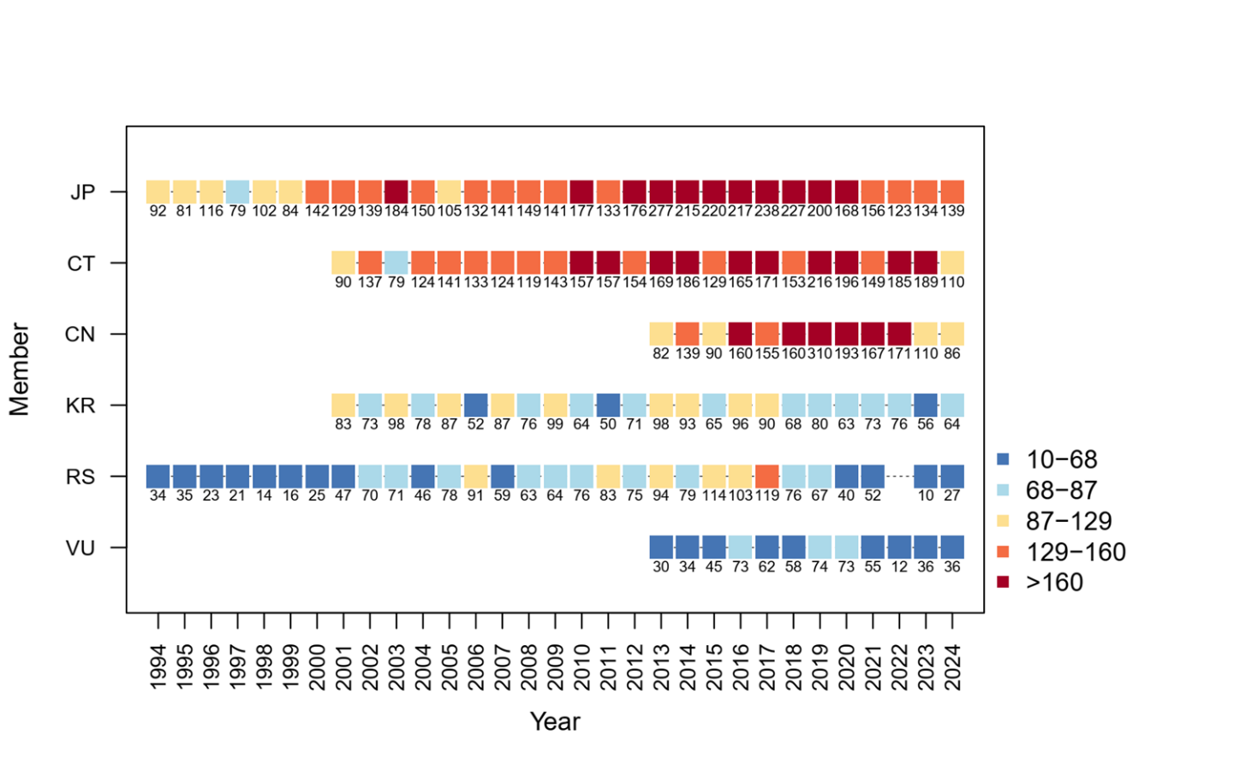
Figure 1. Distribution of Pacific saury data records by NPFC members in the joint CPUE dataset during 1994 – 2023 (JP = Japan; CT = Chinese Taipei; CN = China; KR = Korea; RS = Russia; VU = Vanuatu).
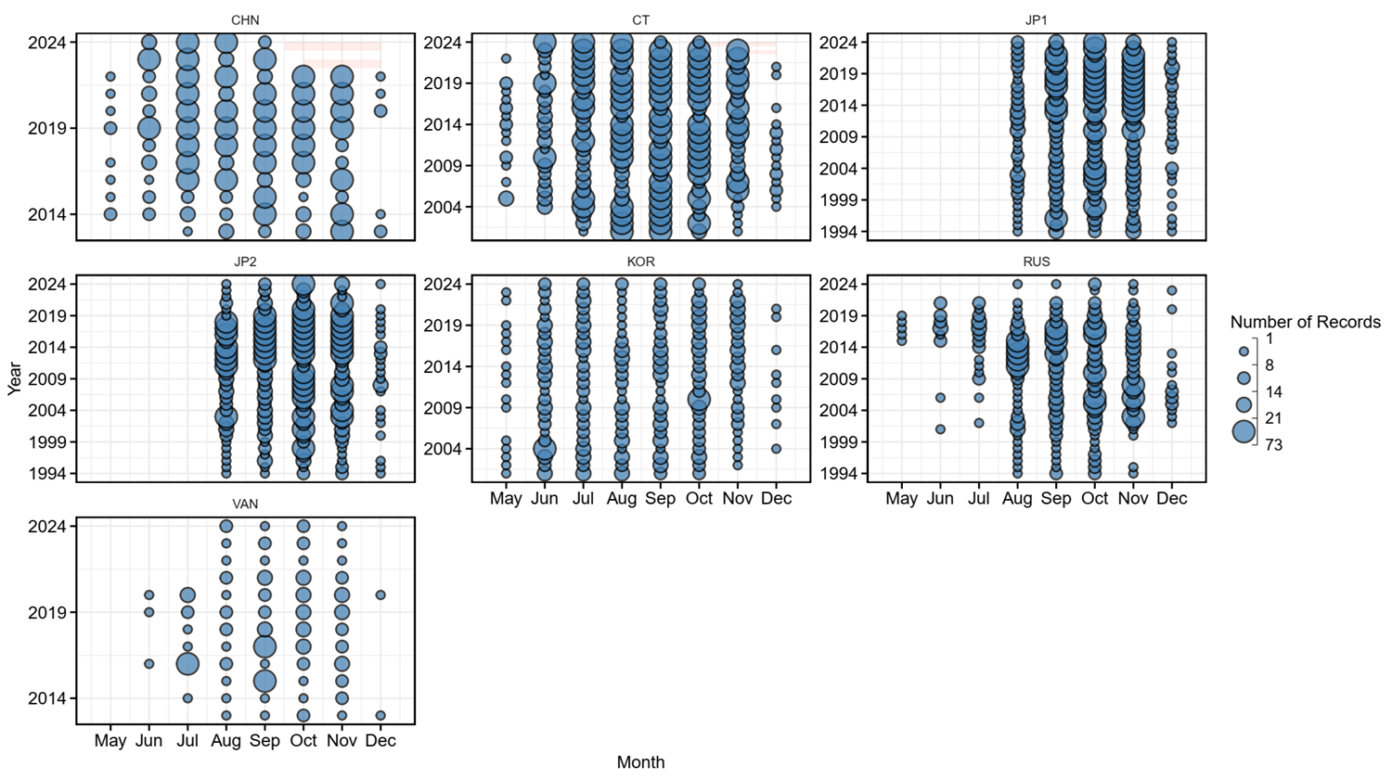
Figure 2. Monthly distribution of Pacific saury data records by fleet in the joint CPUE dataset from May to December, 1994–2024. The red polygon areas indicate months when fleets ceased fishing after reaching their quota. Fleet codes: JP = Japan, CT = Chinese Taipei, CN = China, KR = Korea, RS = Russia, VU = Vanuatu. The Japanese fleet is further divided by vessel size (gross registered tonnage, GRT): JP1 (≥100 GRT) and JP2 (<100 GRT).
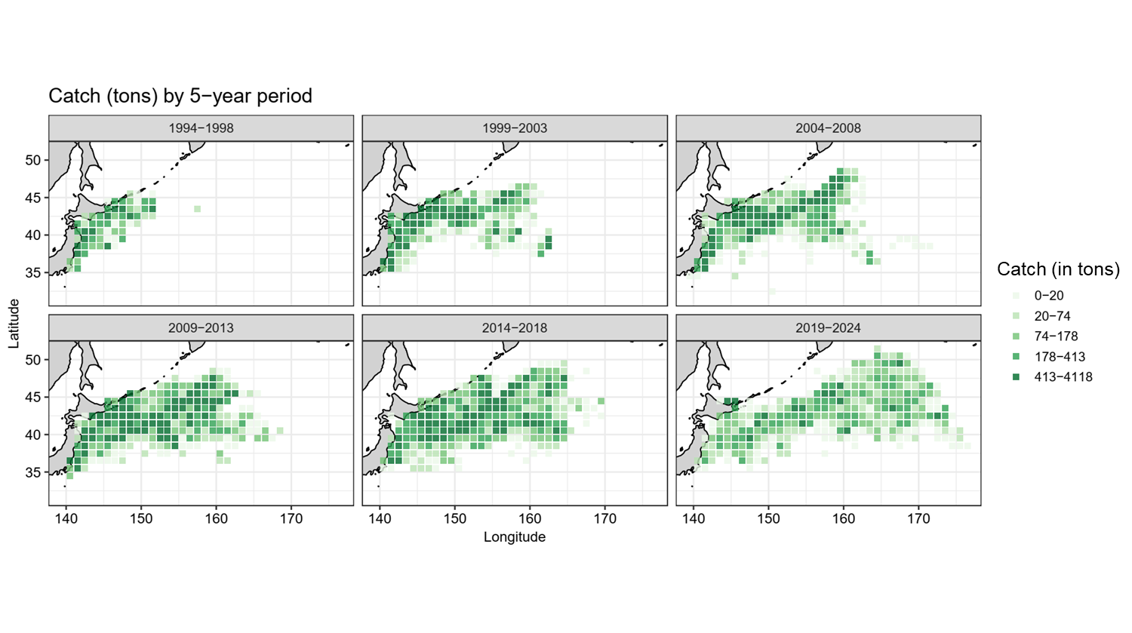
Figure 4. Spatial and temporal distribution of Pacific saury catches (metric tons) averaged over 5-year periods in the Northwestern Pacific Ocean during 1994 – 2024.
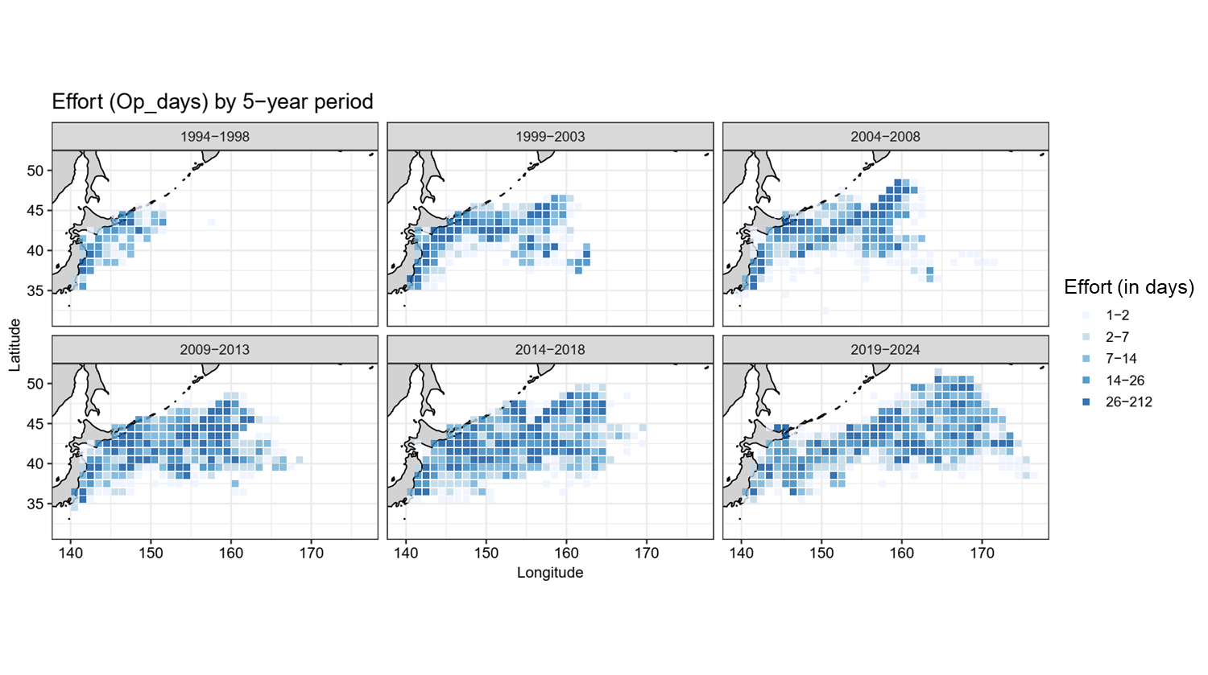
Figure 5. Spatial and temporal distribution of Pacific saury effort (operating days) averaged over 5-year periods in the Northwestern Pacific Ocean during 1994 – 2024.
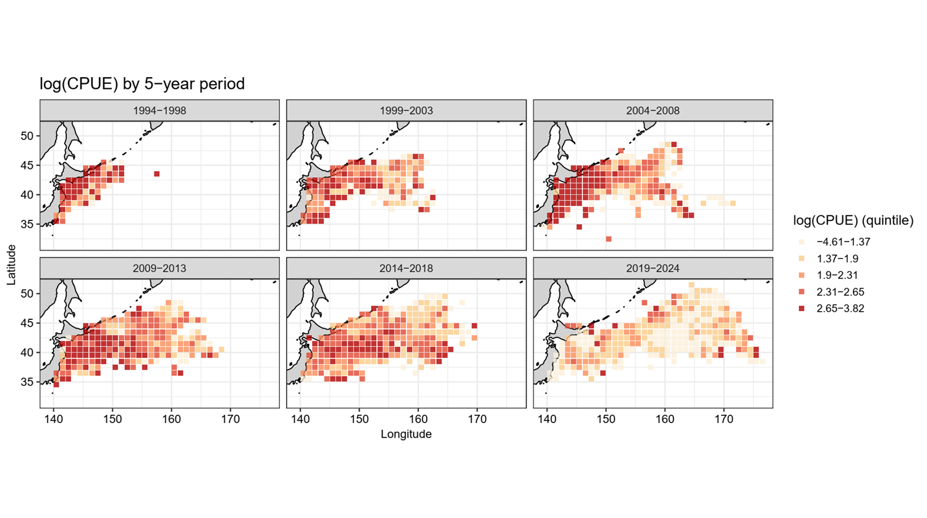
Figure 4. Spatial and temporal distribution of Pacific saury log-transformed nominal CPUE (tons/day) averaged over 5-year periods in the Northwestern Pacific Ocean during 1994 – 2024.
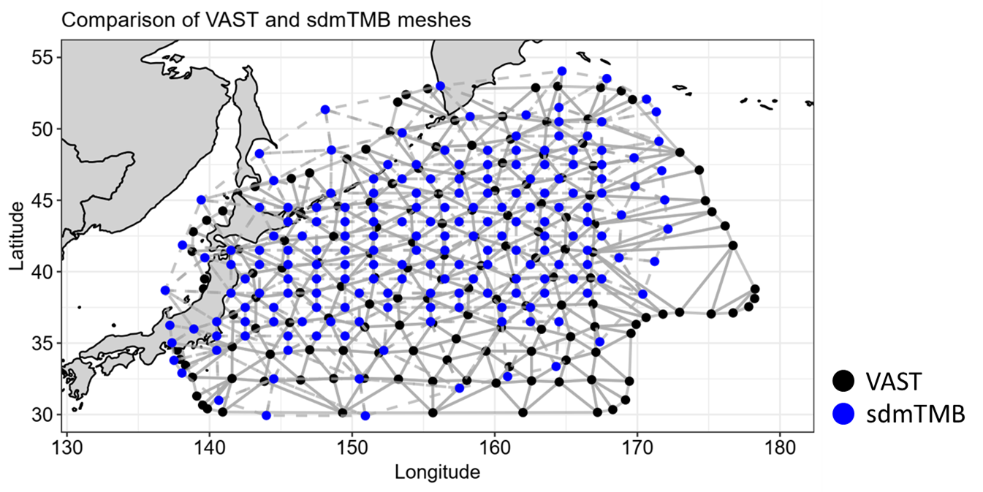
Figure 5. Comparison of the spatial meshes used in VAST (black points) and sdmTMB (blue points) for Pacific saury CPUE standardization by using data during 1994 – 2023. Points indicate the locations of spatial knots, and gray lines illustrate the mesh connections among knots.

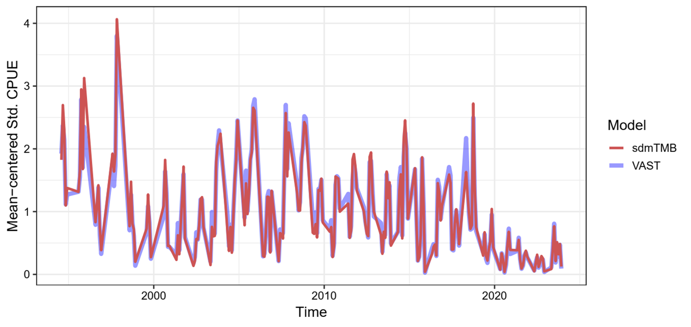

Figure 7. Comparison of mean-centered standardized CPUE indices for Pacific saury estimated using sdmTMB (red line) and VAST (blue line) by using data from 1994 – 2023. The same model structure was applied in both sdmTMB and VAST.

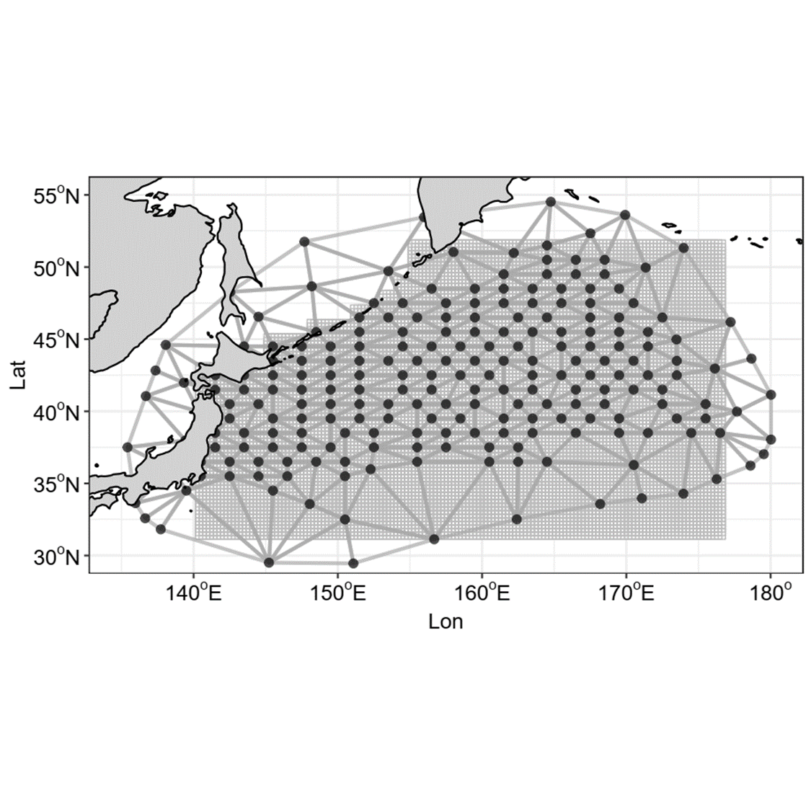
Figure 8. Spatial distribution of mesh used in sdmTMB for Pacific saury CPUE standardization by using data during 1994 – 2024. Points indicate the locations of spatial knots, and gray lines illustrate the mesh connections among knots. Gray squares represent the full spatial domain over which predictions were made.
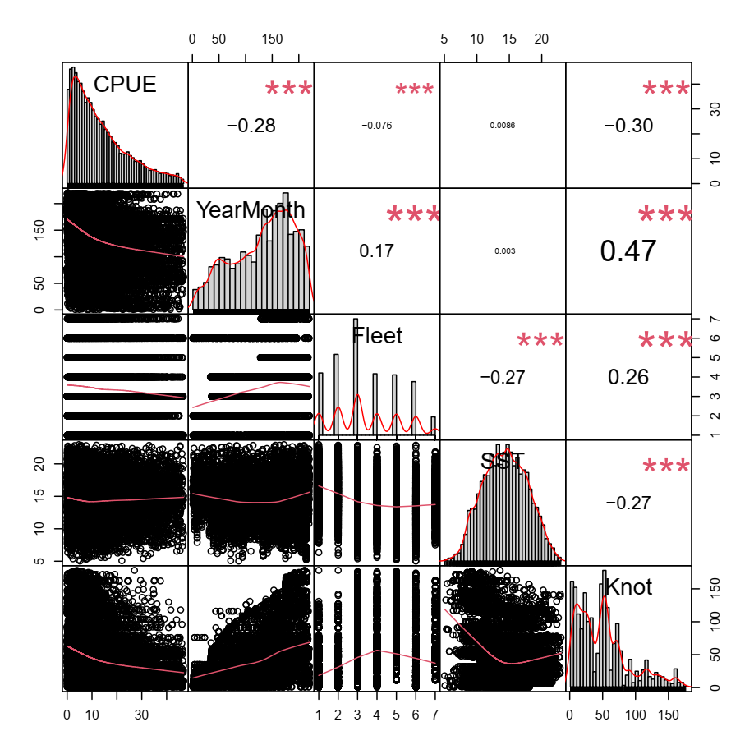
Figure 9. Correlation matrix of explanatory variables used in sdmTMB analysis. The distribution of each variable is shown on the diagonal. On the bottom of the diagonal is the bivariate scatter plots with a fitted red line and on the top of the diagonal is the value of the correlation plus the significance level as stars. Each significance level is associated to a symbol: p-values (0***, 0.001**, 0.01*, 0.05., 0.1).
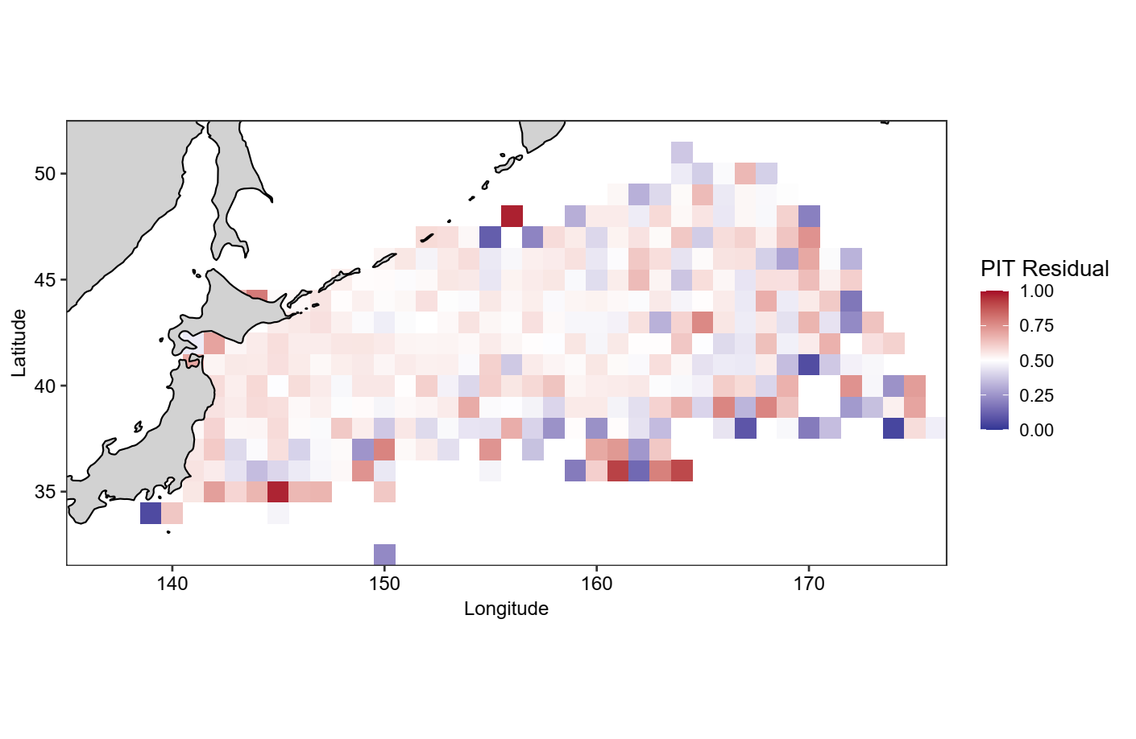
Figure 10. Spatial distribution of probability integral transform (PIT) residuals from the best-fitting CPUE standardization model (V-9), aggregated at the 1° × 1° grid-cell level.

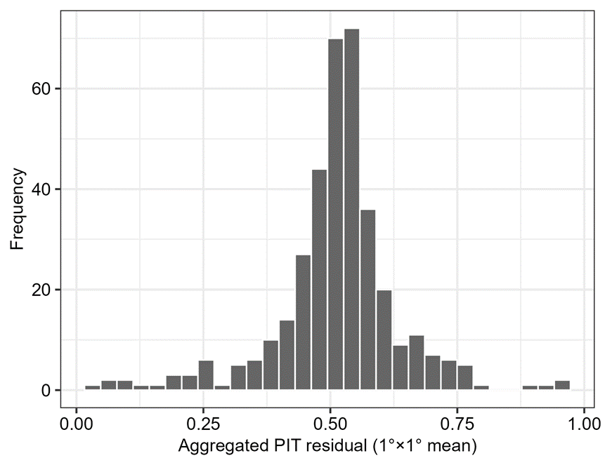
Figure 11. Histogram of aggregated probability integral transform (PIT) residuals at the 1° × 1° grid-cell level.
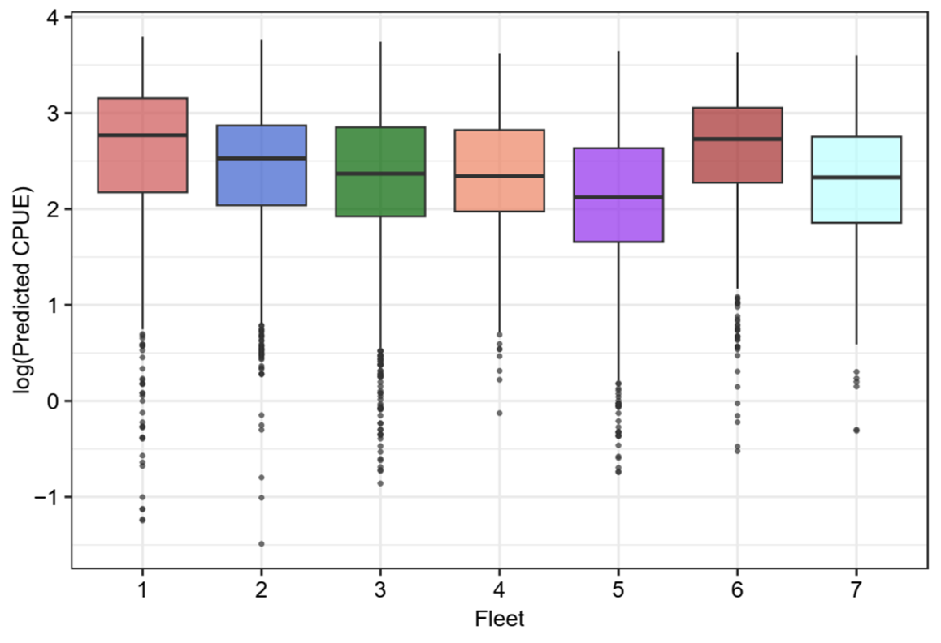
Figure 12. Boxplots of predicted log-transformed CPUE by fleet from the best-fitting standardization model (V-9) by using sdmTMB. Fleet code please refer to Table 1.

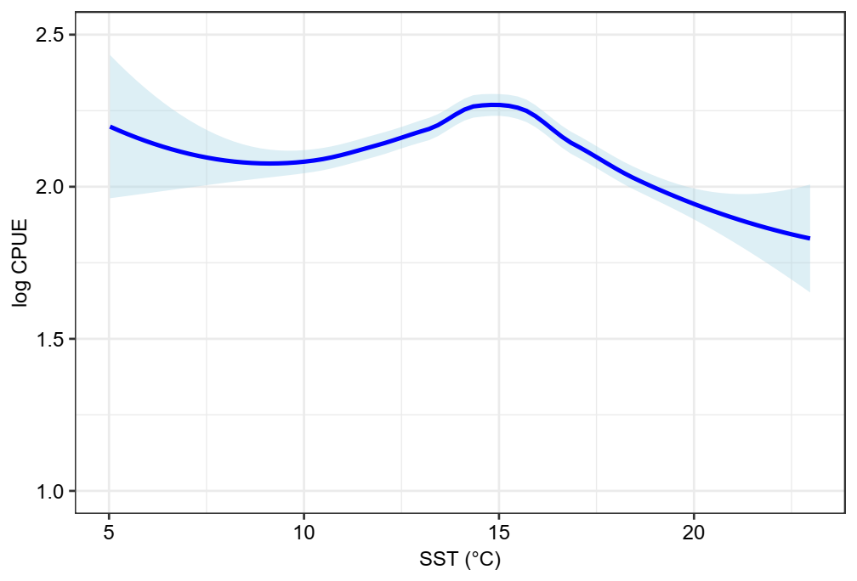
Figure 13. Relationship between predicted log-transformed CPUE and sea surface temperature (SST) from the best-fitting standardization model (V-9) by using sdmTMB. Points are colored by fleets, and the solid line represents the fitted smooth effect of SST.

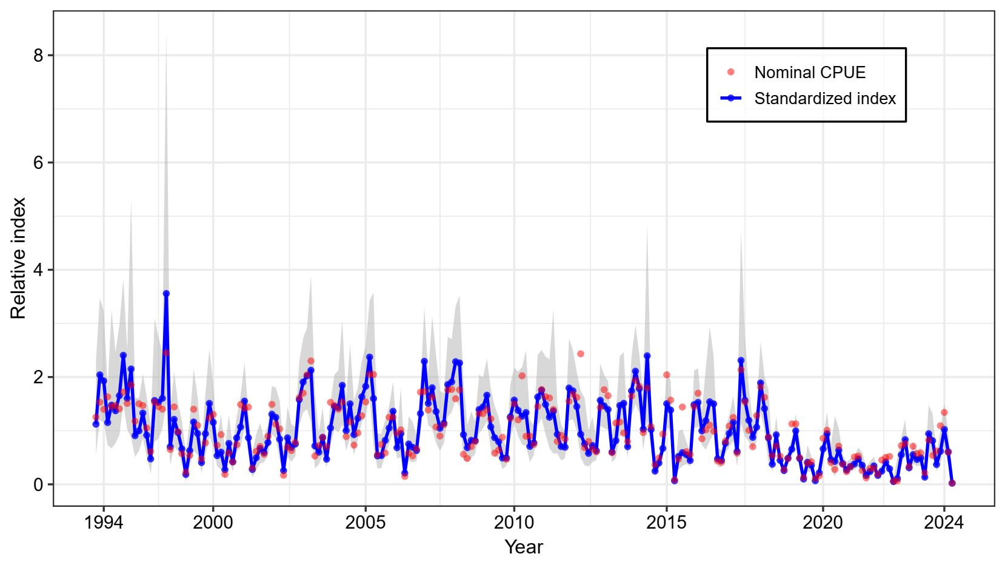
Figure 14. Time series of year-month relative standardized indices (relative to mean) the Pacific saury in the Northwest Pacific Ocean during 1994 - 2024. The shaded areas denote the 95% confidence intervals. Red points indicate nominal CPUEs.
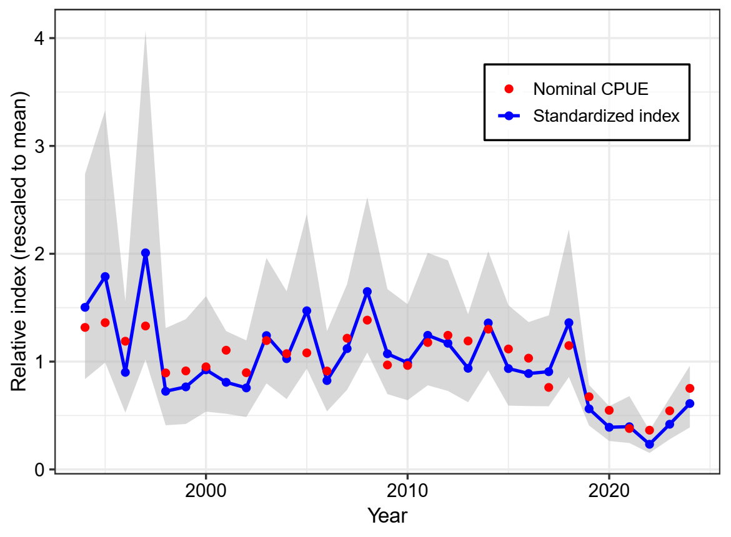
Figure 15. Annual relative standardized indices (relative to mean) the Pacific saury in the Northwest Pacific Ocean during 1994 - 2024. The shaded areas denote the 95% confidence intervals. Red points indicate nominal CPUEs.
Appendix figures

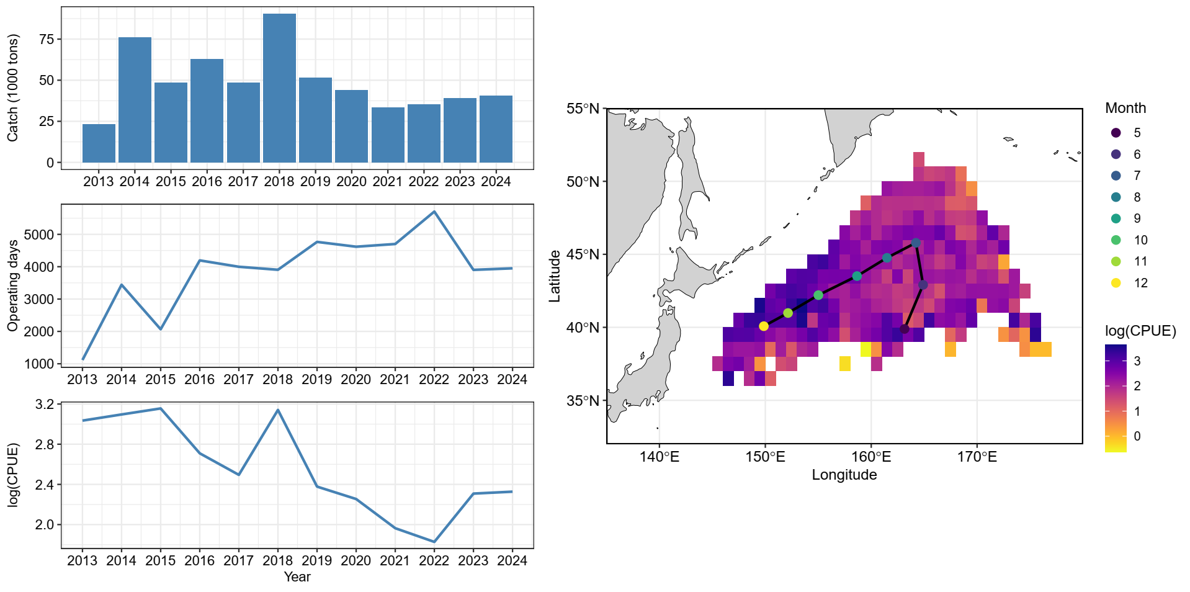

Figure A1. The summary plot of catch (in 1,000 tons), effort (in operating days), nominal CPUE (in tons/day), and the spatial distribution of CPUE from 2013 - 2024 for Pacific saury collected from China. The circle of the map represents the monthly centroid of gravity of nominal CPUE over years.

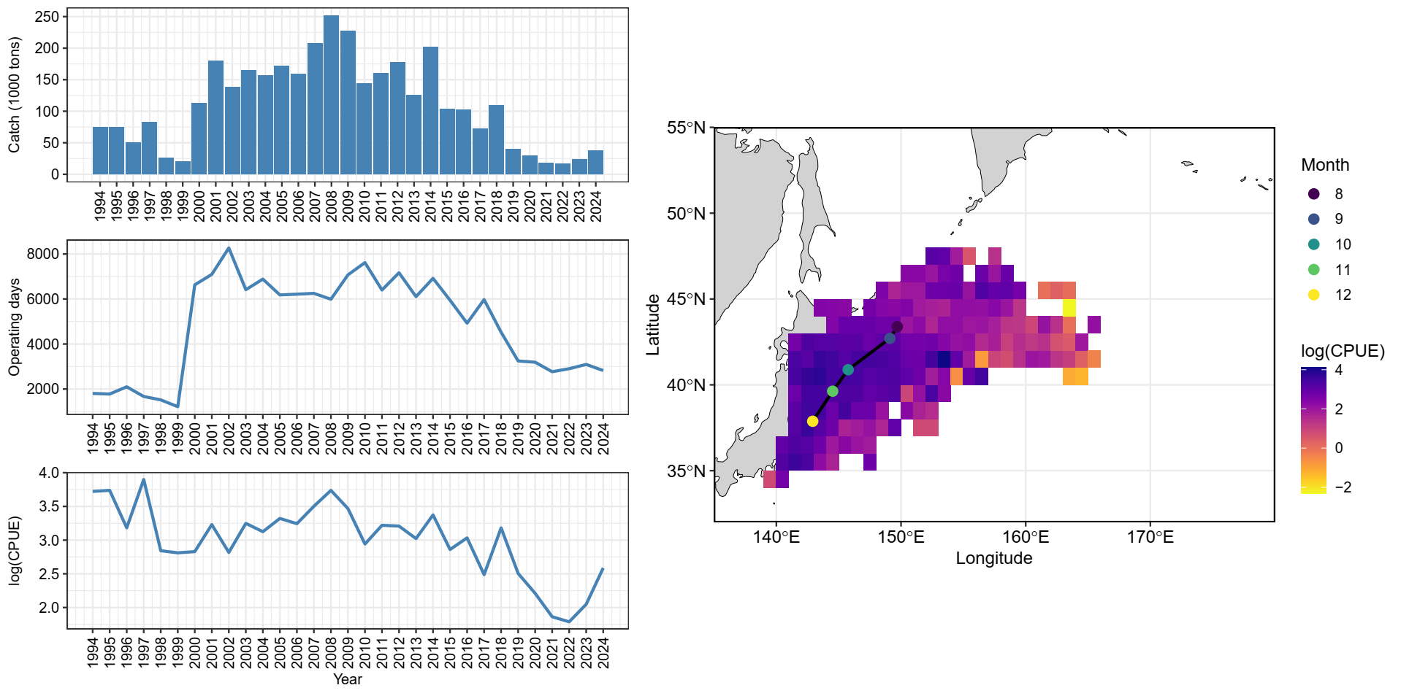
Figure A2. The summary plot of catch (in 1,000 tons), effort (in operating days), nominal CPUE (in tons/day), and the spatial distribution of CPUE from 1994 - 2024 for Pacific saury collected from Japan. The circle of the map represents the monthly centroid of gravity of nominal CPUE over years.

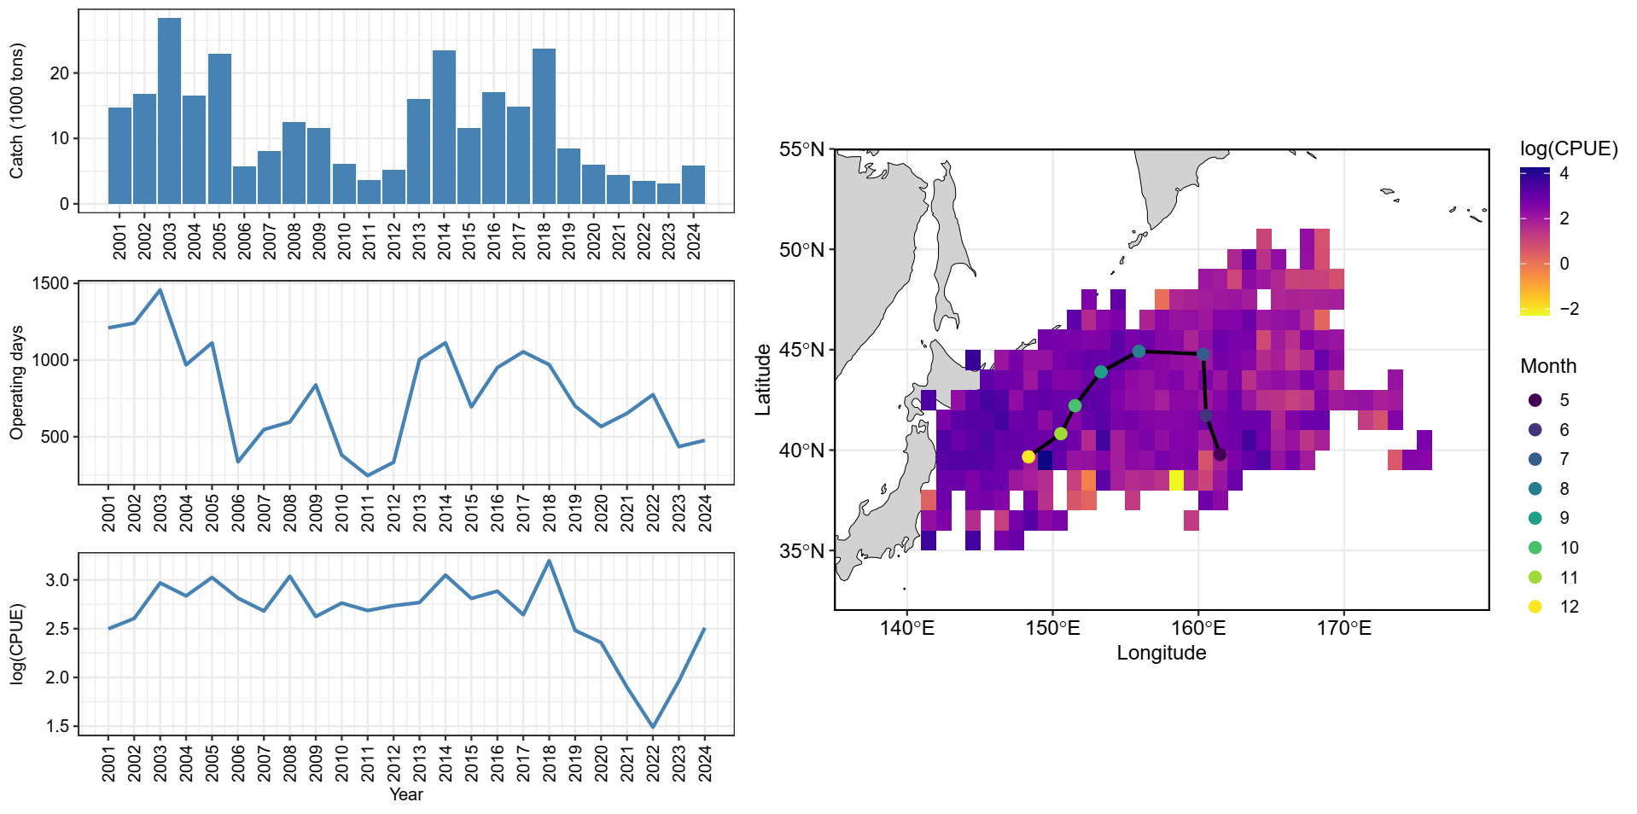
Figure A3. The summary plot of catch (in 1,000 tons), effort (in operating days), nominal CPUE (in tons/day), and the spatial distribution of CPUE from 2001 – 2024 for Pacific saury collected from Korea. The circle of the map represents the monthly centroid of gravity of nominal CPUE over years.

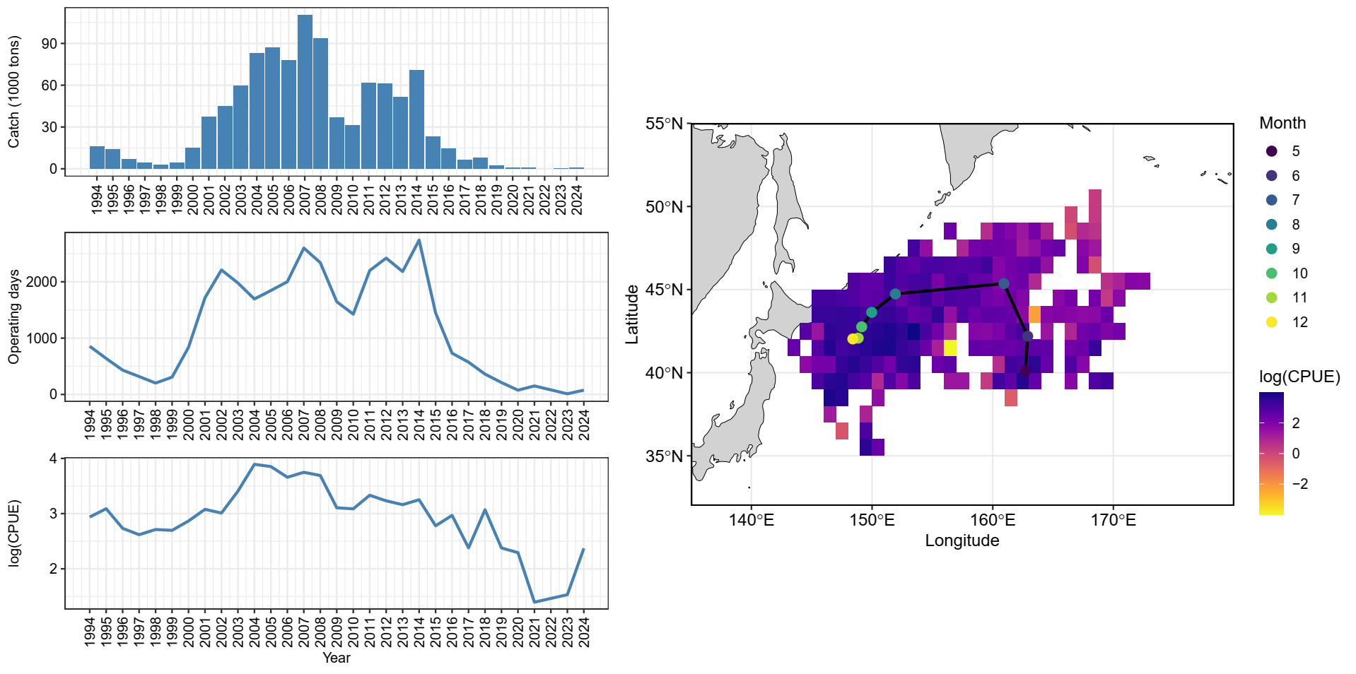
Figure A4. The summary plot of catch (in 1,000 tons), effort (in operating days), nominal CPUE (in tons/day), and the spatial distribution of CPUE from 1994 – 2024 for Pacific saury collected from Russia. The circle of the map represents the monthly centroid of gravity of nominal CPUE over years.

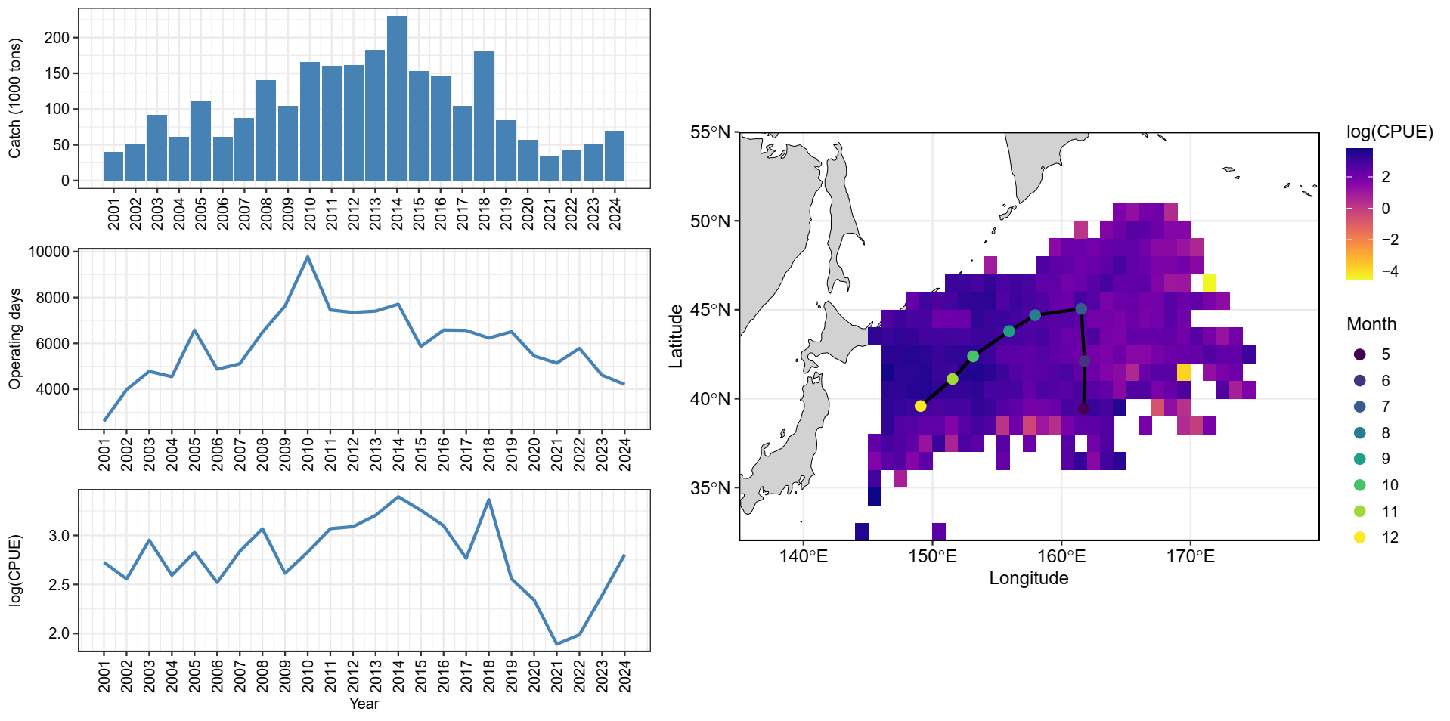
Figure A5. The summary plot of catch (in 1,000 tons), effort (in operating days), nominal CPUE (in tons/day), and the spatial distribution of CPUE from 2001 – 2024 for Pacific saury collected from Chinese Taipei. The circle of the map represents the monthly centroid of gravity of nominal CPUE over years.

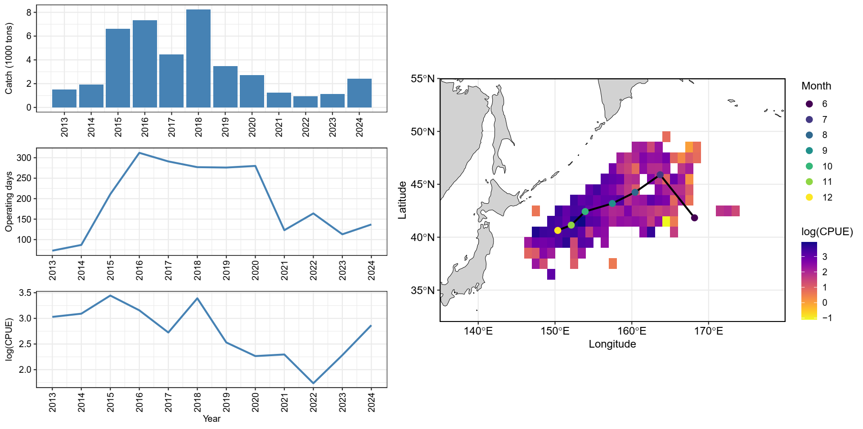

Figure A6. The summary plot of catch (in 1,000 tons), effort (in operating days), nominal CPUE (in tons/day), and the spatial distribution of CPUE from 2013 – 2024 for Pacific saury collected from Vanuatu. The circle of the map represents the monthly centroid of gravity of nominal CPUE over years.

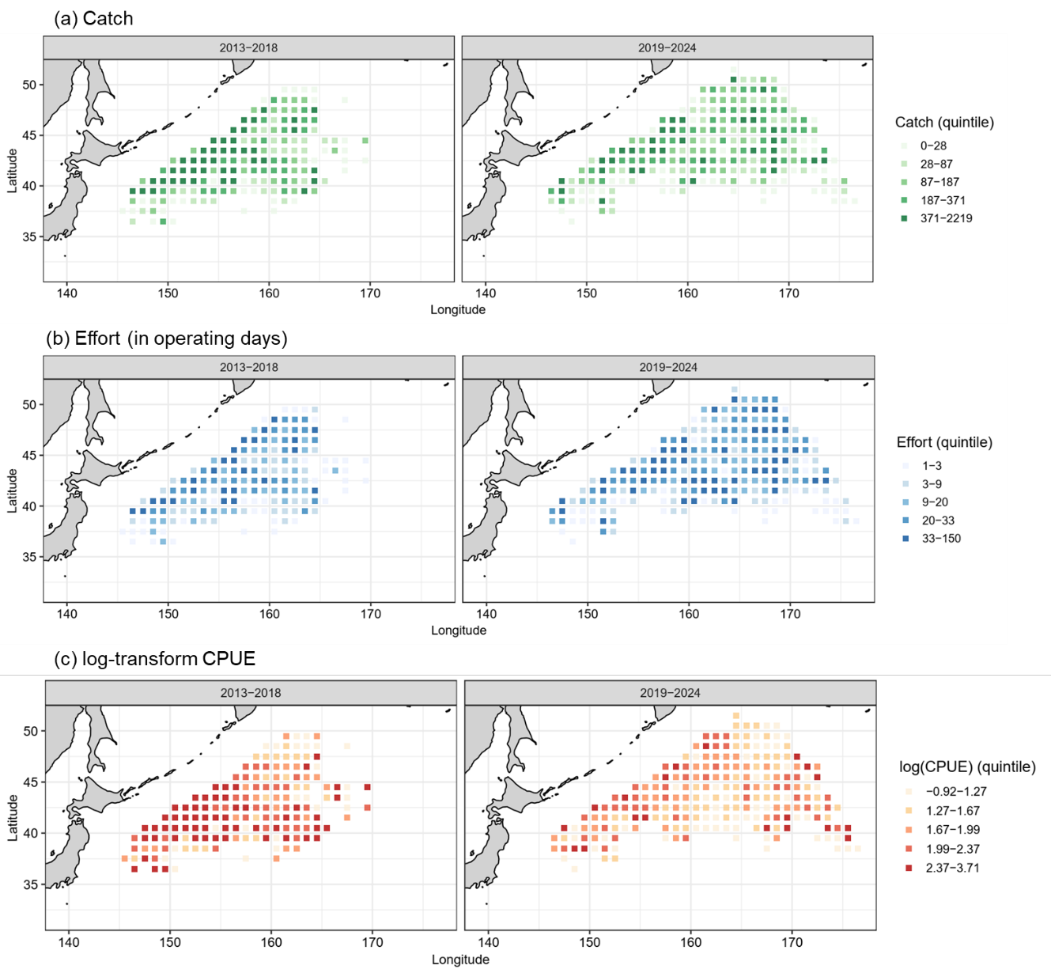

Figure A7. The spatial and temporal patterns of nominal (a) catch (in tons), (b) operating days, and (c) log-transform CPUE (tons/day) over successive 5-year periods for China during 2013 – 2024.
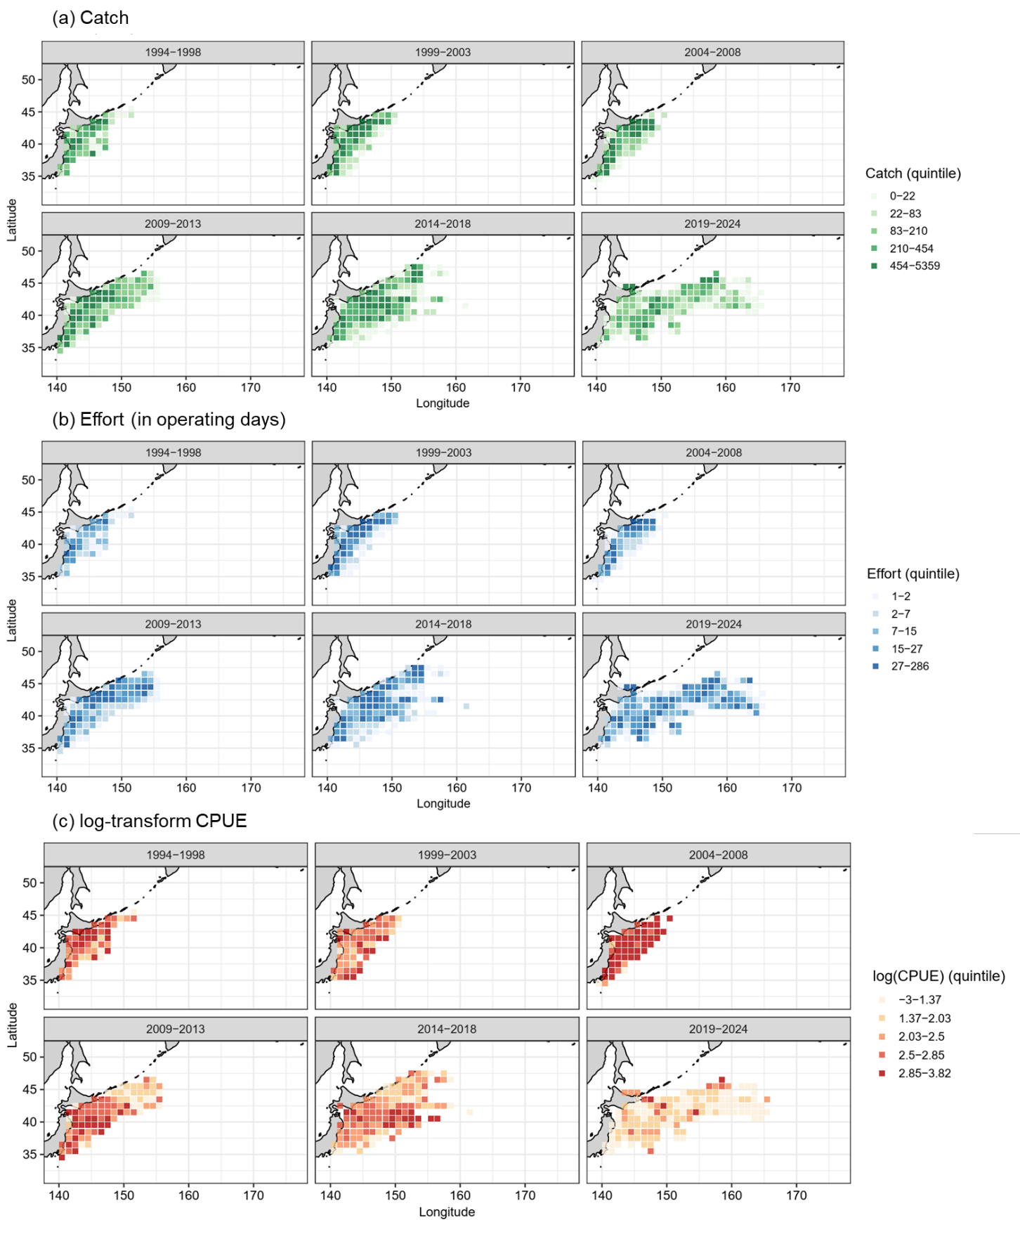
Figure A8. The spatial and temporal patterns of nominal (a) catch (in tons), (b) operating days, and (c) log-transform CPUE (tons/day) over successive 5-year periods for Japan during 1994 – 2024.
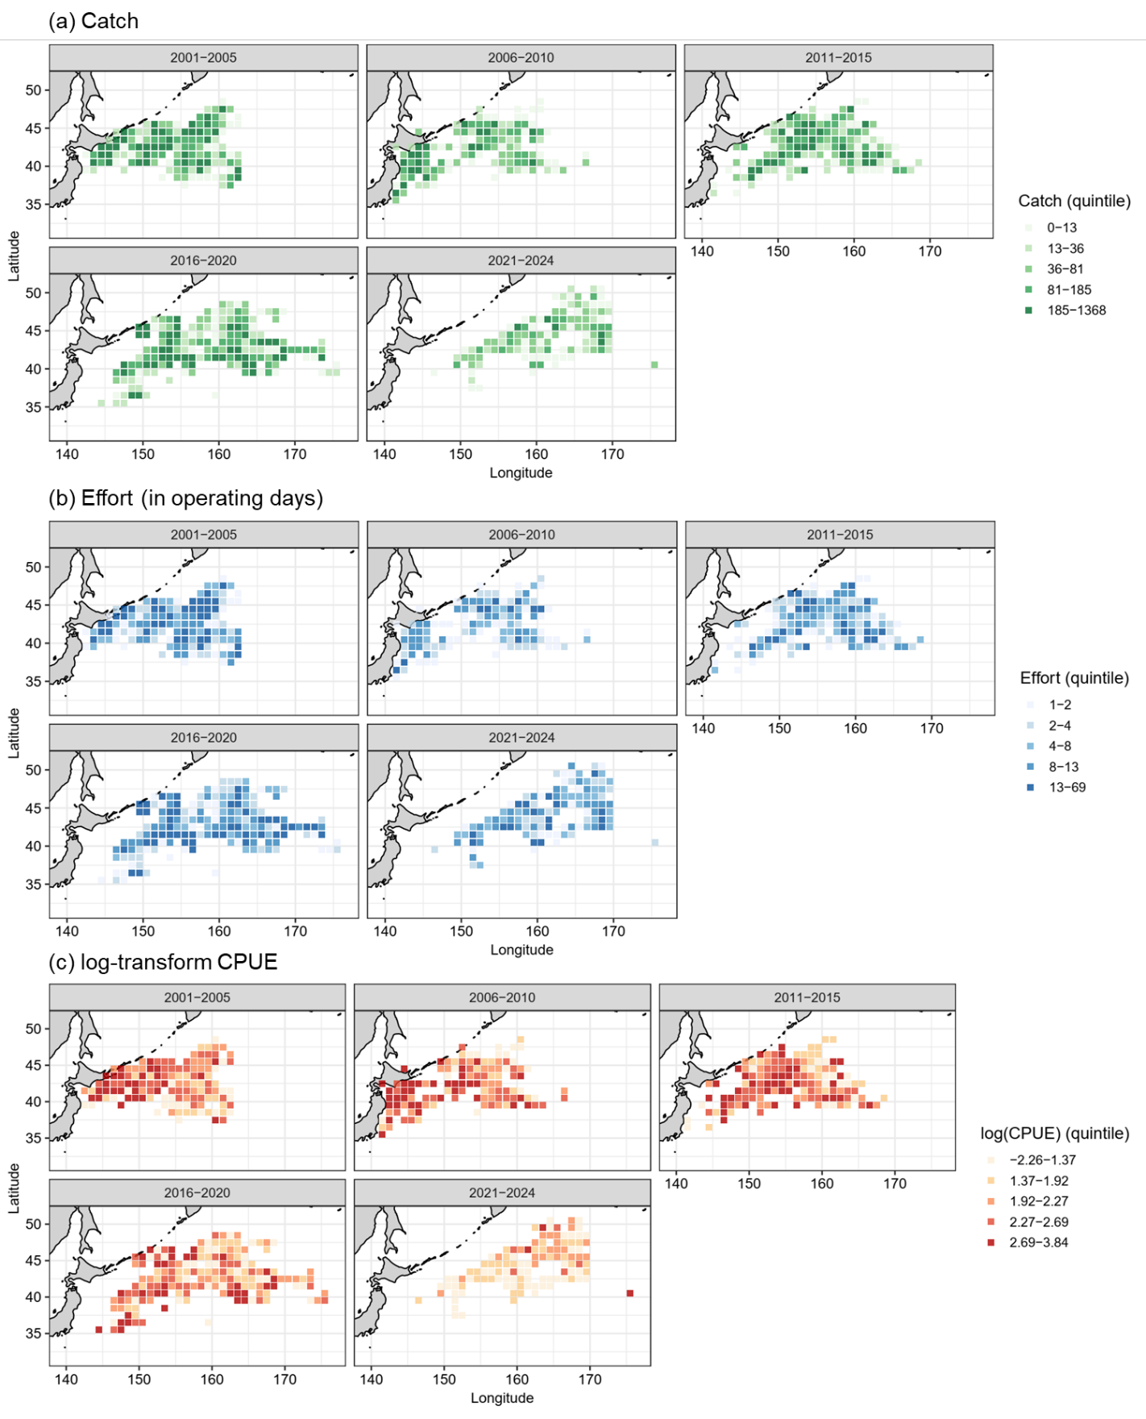
Figure A9. The spatial and temporal patterns of nominal (a) catch (in tons), (b) operating days, and (c) log-transform CPUE (tons/day) over successive 5-year periods for Korea during 2001 – 2024.
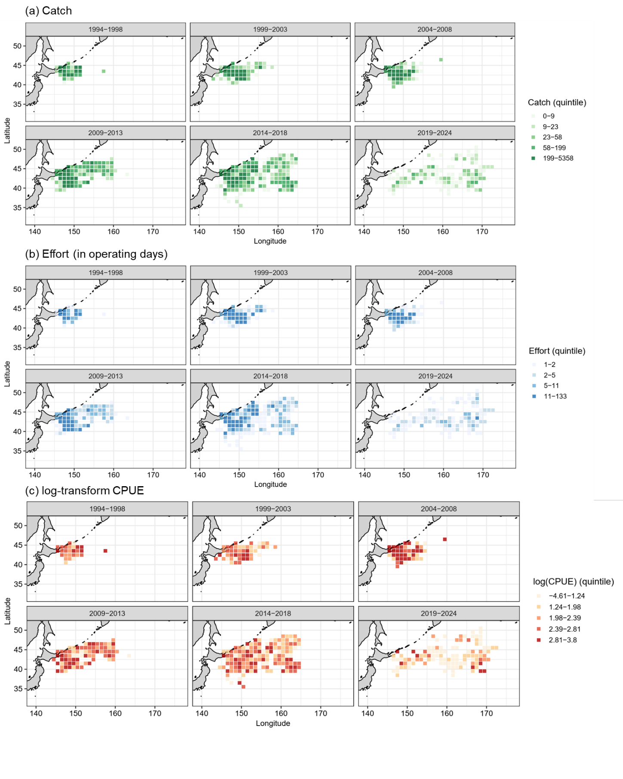
Figure A10. The spatial and temporal patterns of nominal (a) catch (in tons), (b) operating days, and (c) log-transform CPUE (tons/day) over successive 5-year periods for Russia during 1994 – 2024.
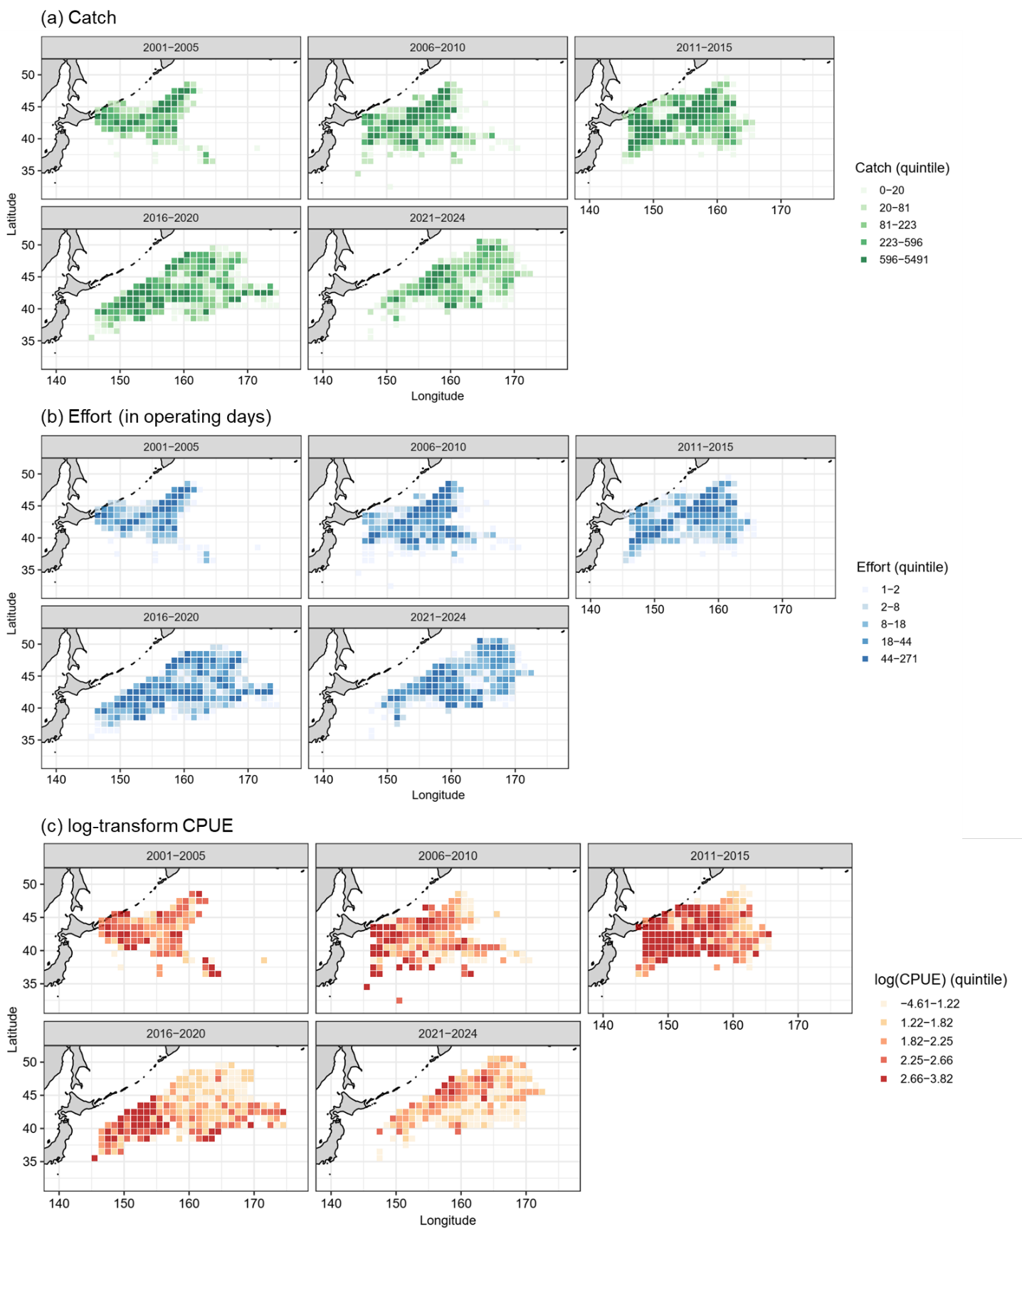
Figure A11. The spatial and temporal patterns of nominal (a) catch (in tons), (b) operating days, and (c) log-transform CPUE (tons/day) over successive 5-year periods for Taiwan during 2001 – 2024.
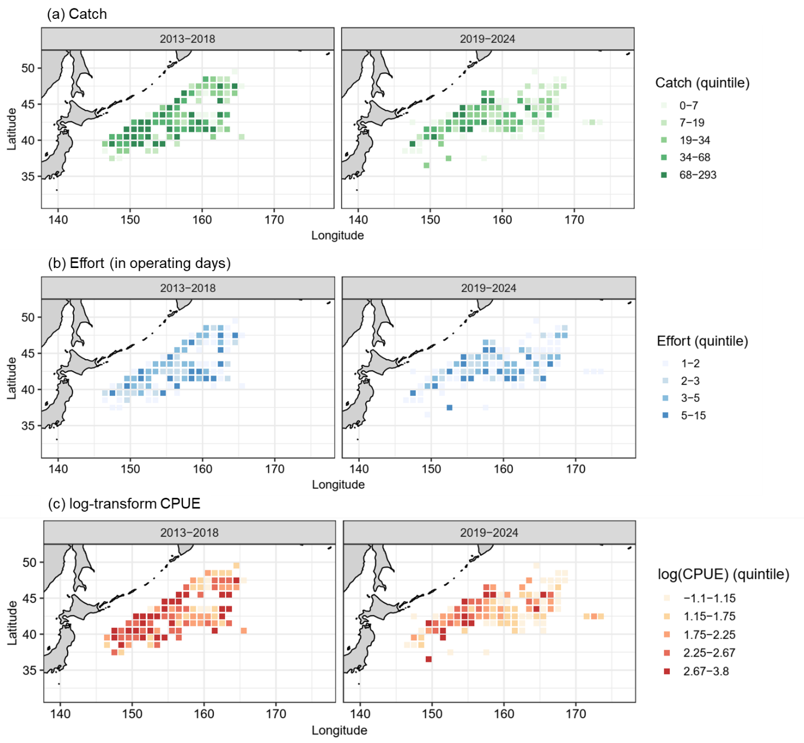
Figure A11. The spatial and temporal patterns of nominal (a) catch (in tons), (b) operating days, and (c) log-transform CPUE (tons/day) over successive 5-year periods for Vanuatu during 2013 – 2024.

