NPFC-2025-SSC BFME06-IP02

Korea’s Research Expedition to the Emperor Seamount Chain and Northwestern Hawaiian Ridge

Se-Jong Ju

¹ Korea Institute of Ocean Science and Technology 385 Haeyang-ro, Yeongdo-gu, Busan, South Korea. Email: sjju@kiost.ac.kr

Korea’s Ministry of Oceans and Fisheries (MOF) and Institute of Ocean Science and Technology (KIOST) are planning a research expedition to the Emperor Seamount Chain and Northwestern Hawaiian Ridge, which will take place in 2027. This expedition is part of the project ‘Development of a Scientific Framework for Regional Management of the Emperor Seamounts to Conserve Biodiversity and Promote Sustainable Use’ to enhance contributions to the international community, including regional fishery management organizations (RFMOs), by leveraging advanced scientific technologies to secure and provide scientific data and information, as well as fostering capacity-building activities.

This survey will be designed to study marine biodiversity (e.g., pelagic and benthic organisms) and help identify potential vulnerable marine ecosystems, as well as climate change impacts. This survey also aims to collect oceanographic data, observations of marine litter (including abandoned, lost, or otherwise discarded fishing gear), eDNA samples, and observations of encounters with vulnerable species (e.g., marine mammals, marine reptiles, sea birds). The data collected will support RFMOs in assessing the risks and sustainability of current and future fisheries in the Emperor Seamount region.

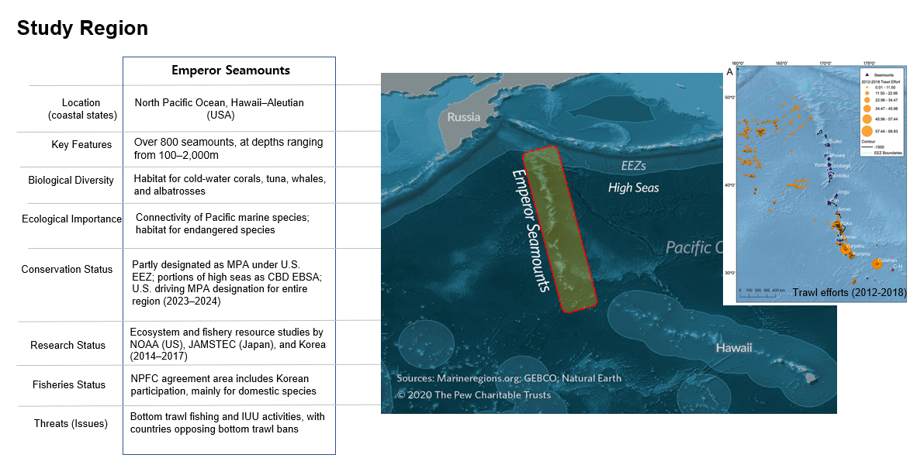

Korea is committed to working collaboratively with the North Pacific Fisheries Commission (NPFC) and welcomes feedback as the planning phase progresses. Korea will make efforts to continuously share the trends related to this study with the NPFC Scientific Committee and the SSC on Bottom Fisheries and Marine Ecosystems from 2026 onward, continuing through the duration of the project.

