NPFC-2025-BFME06-WP13

Catch per unit effort standardization of splendid alfonsino Beryx splendens in the Emperor Seamounts

Christopher G. Ayer and Kota Sawada

Oceanic Resources Group, Fisheries Resources Institute,
Japan Fisheries Research and Education Agency

December 2025

This paper may be cited in the following manner:
Ayer, C.G. and Sawada, K. 2025. Catch per unit effort of splendid alfonsino Beryx splendens in the Emperor Seamounts. NPFC-2025-SSC BFME04-WP13. 9 pp. Available at https://www.npfc.int/

Catch per unit effort standardization of splendid alfonsino Beryx splendens in the Emperor Seamounts

Christopher G. Ayer and Kota Sawada

Oceanic Resources Group, Fisheries Resources Institute,
Japan Fisheries Research and Education Agency

Abstract
Initial estimates of standardized CPUE for splendid alfonsino in the Emperor Seamounts, with records from 2010 to 2024 by the bottom trawl and bottom gillnet fisheries. Trawl and gillnet data was analyzed separately, due to differences in record methodology and fishing history. For statistical analysis we employed a delta-gamma model utilizing the sdmTMB package to compare CPUE over time. While we found the sdmTMB delta-gamma model to fit our data well according to quantile-quantile plot, due to ongoing issues with coding, we have been unable to calculate the index values and associated uncertainty necessary for integrated modeling. Additionally, gillnet standard error for binomial component for several years were unusually large; this is likely the result of low sample size and few instances of zero-catch hauls in those years and will need to be addressed going forward. More work is necessary to further optimize the model and produce index values, so the current results are strictly preliminary.

Introduction

Splendid alfonsino Beryx splendens Lowe 1834 is one of the commercially important demersal fish stocks in the NPFC Convention Area, especially in the Emperor Seamounts area. As an approach to assess this stock, the SSC BF-ME and the SWG NPA-SA recommended the use of integrated modeling (Sawada 2024; Small Scientific Committee on Bottom Fish and Marine Ecosystems 2024).
Index of stock abundance is an important metric in integrated modeling. For stocks with limited surveys, catch-per-unit-effort (CPUE) by commercial vessels is commonly used as such an index. Because the catchability by fishing vessels often depends on a variety of factors, standardization of CPUE using statistical modeling is desirable (Hoyle et al. 2024).
Here we present our initial results and methodology for calculating the standardized CPUE of splendid alfonsino caught in the Emperor Seamounts between 2010 and 2024. Due to ongoing analysis to improve our models, the following methodology and results must be viewed as preliminary and will undoubtedly be subject to further changes in the future.

Materials and Methods
Scientific observer data from Japanese fishing vessels was used in this analysis. Data was separated by gear type (bottom trawl and bottom gillnet) because of different units of effort metrics (towing time or number of panels retrieved) and different selectivity (Pons et al. 2024).Additionally, we only used fishery data where splendid alfonsino was the target species of the haul (based on the intended target species recorded by observers), this is because including hauls where splendid alfonsino was caught in low numbers as bycatch would bias CPUE calculations. For the trawl fishery, we used 8143 recorded hauls taken between 2009 and 2024 from 7 different vessels fishing at the seamounts Colahan, Kammu, Kinmei, Koko, North Koko, and Yuryaku. Trawl CPUE was calculated based on catch weight (kg) per haul time (hours), mean annual CPUE was used to compare vessels over time (fig. 1). While we have data available for 2009, for our analysis 2009 was omitted due to lack of observer data in the first half of 2009, which could bias the results of our models. For gillnet, amounts of catch were recorded daily or on set-by-set basis in 2009-2017 and in 2018-present, respectively. We converted set-by-set data into daily data by summing up catch and effort per day and used daily data throughout the period, to obtain a longer time series, after confirming that this aggregation did not significantly affect CPUE trend since 2018. As a result of this aggregation, targeting information cannot be used for gillnet analysis. With this method, we can use data from 1452 recorded fishing days between 2010 and 2024 in the analysis (fig. 2). Fishing was conducted at the seamounts Colahan, Jingu, Kammu, Kinmei, Koko, North Koko, Nintoku, Suiko and Yuryaku. While 2 gillnet fishing vessels were active during this period, one is the replacement of the other and both are operated by mostly the same crew. As a result, these vessels never operated in the same year. Therefore, we did not include vessels as a factor in the gillnet analysis.
At the recommendation of other members of the working group, we decided to use a delta-gamma model utilizing the sdmTMB package (Anderson et al 2024), with a logit link and a log link. For the model, we set the response variable as CPUE, the explanatory variable as year, and seamount and vessel (trawl only) as random effects to account for differences in fishing conditions or practices. These parameters produced the best model fit as indicated by quantile-quantile (QQ) plot.

Results and Discussion
We found our delta-gamma models fit the data well for both trawl and gillnet, with QQ plots indicating that there was little deviation in model residuals (fig. 3 and 4). While no particularly unusual values were observed from the trawl sdmTMB, the gillnet results found unusually large standard error values for the years 2012, 2013, 2015, 2016, and 2017 in the binomial logit link portion of the delta-gamma model (Table 1). This is related to low sample sizes and few instances of zero-catch hauls during those years and may be remedied by modifying the model to including hauls targeting other species. Currently, due to issues with coding, we have yet to obtain index values from two components of the delta model combined, and so the coefficients of variation (CV) are not yet available.
Though seemingly straight forward, our attempts at standardizing CPUE have met with various setbacks to date, generally related to coding. In particular, we were not successful in obtaining a single time series of standardized CPUE by combining two components of the delta model, from the output object of sdmTMB. Going forward, our first priority is to resolve this coding issue and calculate index values such as CV, while also looking to better optimize the existing model to account for the unusually large gillnet standard errors in the gillnet model.

Acknowledgements
This work is conducted as part of the research and assessment program for fisheries resources, the Fisheries Agency of Japan, and submitted under the approval of the Agency. We thank the participants of the SWG NPA-SA for their helpful comments and constructive discussions. We would also like to thank the fisheries personnel and observers through whose effort fish data could be collected.

References

Anderson S.C., Ward E.J., English P.A., Barnett L.A.K., Thorson J.T. (2024). sdmTMB: an R package for fast, flexible, and user-friendly generalized linear mixed effects models with spatial and spatiotemporal random fields. bioRxiv preprint, https://doi.org/10.1101/2022.03.24.485545.
R Core Team (2023). R: A language and environment for statistical computing. R Foundation for Statistical Computing, Vienna, Austria. URL https://www.R-project.org/.
Hoyle, S.D., Campbell, R.A., Ducharme-Barth, N.D., Grüss, A., Moore, B.R., Thorson, J.T., Tremblay-Boyer, L., Winker, H., Zhou, S., Maunder, M.N. (2024). Catch per unit effort modelling for stock assessment: A summary of good practices. Fish Res 269:106860. https://doi.org/10.1016/j.fishres.2023.106860
Pons, M., Amoroso, R., Sawada, K. (2024). Yield per recruit and spawning biomass per recruit analyses for Splendid Alfonsino (Beryx splendens) in the North Pacific. NPFC-2024-SSC BFME05-WP09 (Rev. 1), 22 pp.
Sawada, K. (2024). Small Working Group on NPA and SA - Summary for 2024. NPFC-2024-SSC BFME05-WP17, 4 pp.
Small Scientific Committee on Bottom Fish and Marine Ecosystems (2024) 5th Meeting Report. NPFC-2024-SSC BF-ME05-Final Rep, 149 pp.
Table 1 – Delta-gamma model coefficients and standard error for splendid alfonsino data between 2010 and 2024
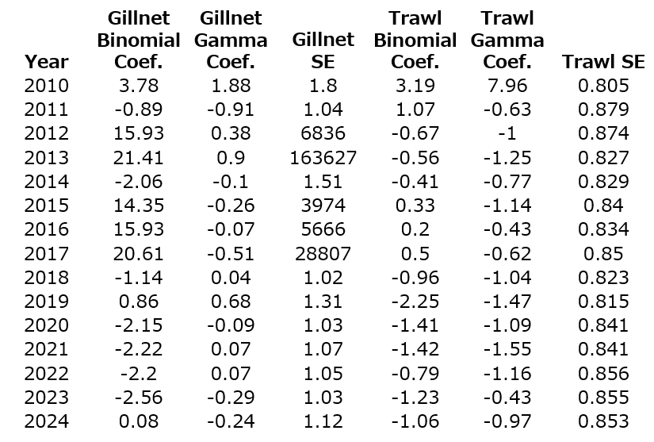

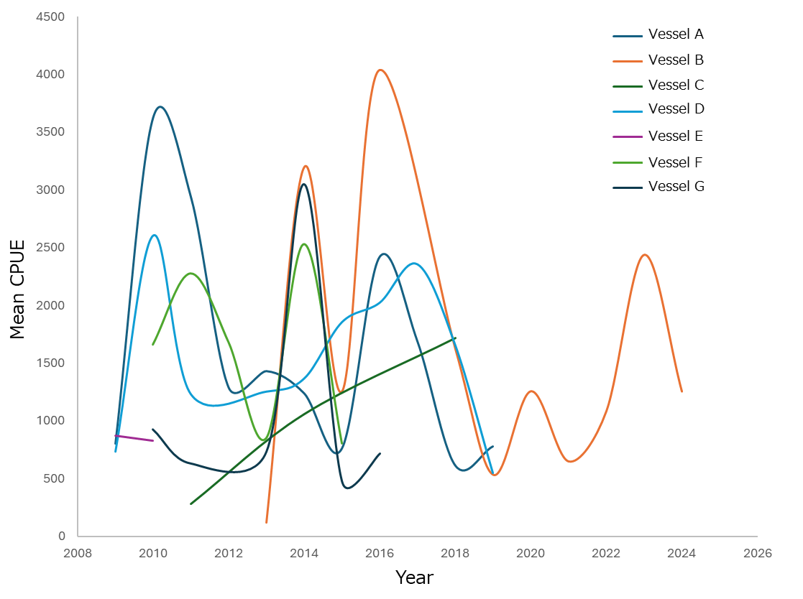
Fig. 1 – Bottom trawl fishery mean annual splendid alfonsino CPUE by vessel from 2009 to 2024

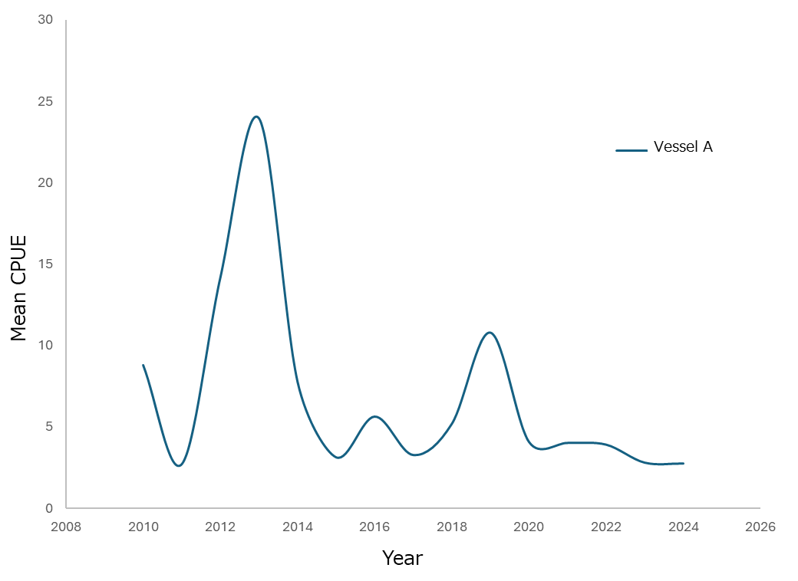
Fig. 2 - Bottom gillnet fishery mean annual splendid alfonsino CPUE from 2009 to 2024

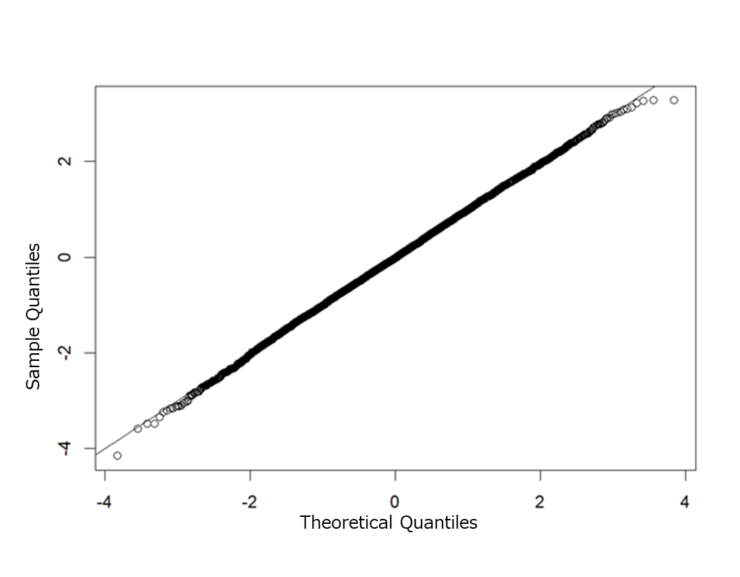
Fig. 3 - QQ Plot for splendid alfonsino trawl CPUE delta-gamma model

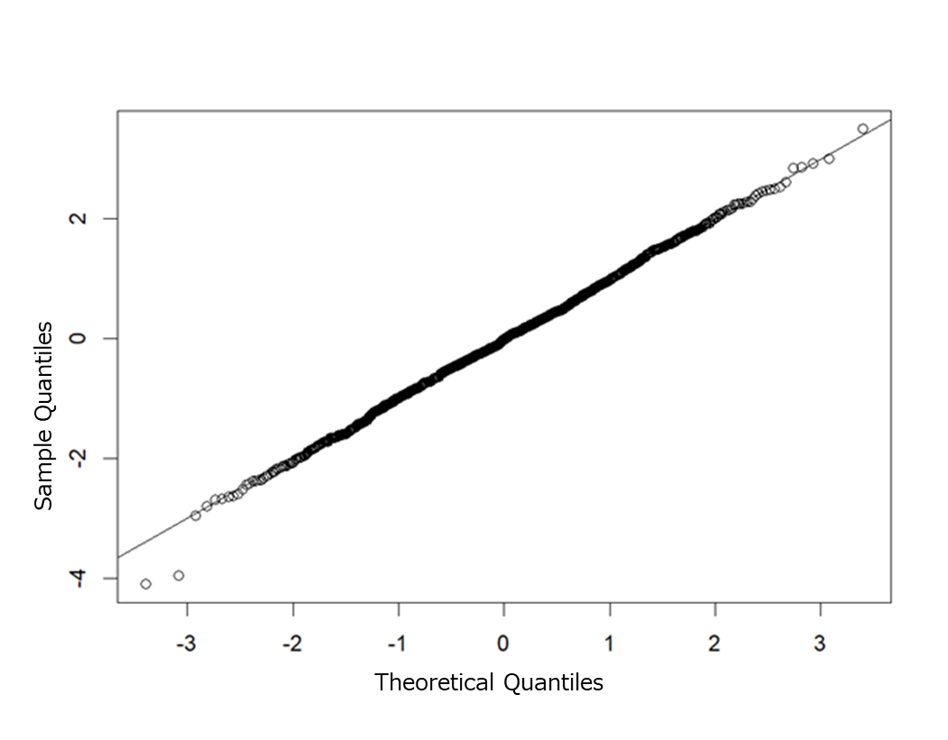
Fig. 4 - QQ Plot for splendid alfonsino gillnet CPUE delta-gamma model

