NPFC-2025-SC10-WP07 (Rev. 1)

Review of the Scientific Committee structure and workflow

SC Chair, SC Vice-Chair and Secretariat

Abstract:
The Scientific Committee (SC) will hold its anniversary 10th meeting in December 2025. This paper reviews the SC structure and workflow that have been developed over the past ten years. It identifies potential issues and proposes improvements for consideration by SC Members.

Background
This year, the NPFC celebrated its first 10 years of operation, and the SC will hold its 10th meeting in December. In celebrating 10th anniversary, Members highlighted remarkable progress made by the Commission since its establishment in 2015 while noting challenges it faces. Over the past 10 years, the NPFC has grown significantly in terms of the number of Members, subsidiary bodies and meetings that enhance its capacity to deliver on the objective of the NPFC Convention. However, the growing amount of work and, as a result, number of expert groups and their meetings lead to increasing pressure on Members and the Secretariat, including human and financial resources. This may require streamlining historical practices to enable achieving the goals with available resources.

The purpose of this paper is to review the structure and workflow of the SC, identify potential issues and propose improvements for consideration by SC Members.

1. SC structure and procedures
1.1 Historical and current practices
The SC currently consists of four formal subsidiary expert groups (TWG CMSA and SSCs BF-ME, PS and NFS) and eight informal small working groups (SWGs VME, NPA-SA, JS, JFS, BM, NSAM, Data and Observer Program) (Figure 1). The SWG JS will be considered for upgrading to an SSC at SC10. Formal expert groups provide advice and recommendations to the SC on stock status of the NPFC priority species and assessment of marine ecosystems. Informal SWGs are formed to facilitate intersessional work of SC and its SSCs.

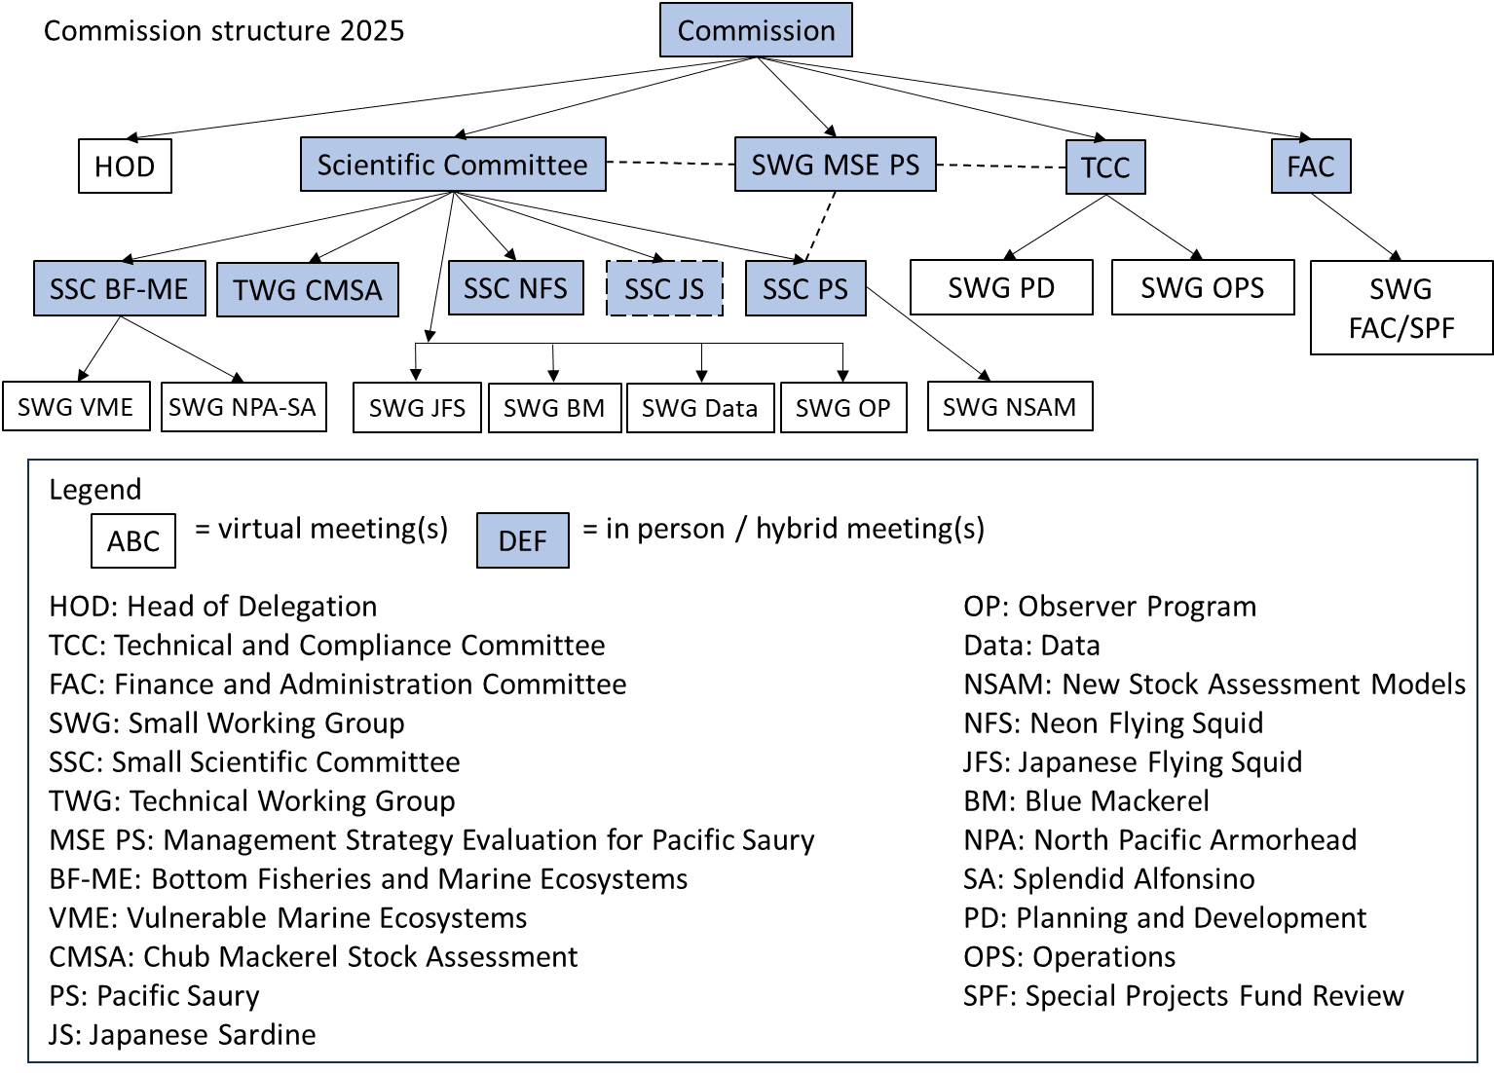
Figure 1: The structure of the NPFC in 2025

In early years, the work of SC’s expert groups (SSC and TWG) was organized around agreements on and formalization of the main elements of the stock assessment process including model selection, data preparation, model development, review of results and scientific advice (Figure 2). These agreements were made through formal meetings and recorded in a meeting report adopted by consensus. Such approach provides well-documented inputs to the stock assessment process but does not allow any flexibility in making corrections or improvements intersessionally.

In those years, SC’s expert groups followed the meeting procedure for the Commission in the absence of their own regulations. A provisional meeting agenda should be circulated to Commission Members 90 days prior to a meeting of SSC/TWG and its final version is to be re-circulated 60 days before the meeting. Meeting documents should be submitted by Members one month before a meeting. A meeting report should be adopted by consensus. A draft meeting report should be distributed to Commission members 15 days after a meeting and a final report is to be distributed 45 days after a meeting. A Chair and a Vice-Chair should be formally selected by an expert group and serve in accordance with the rules for the Commission.

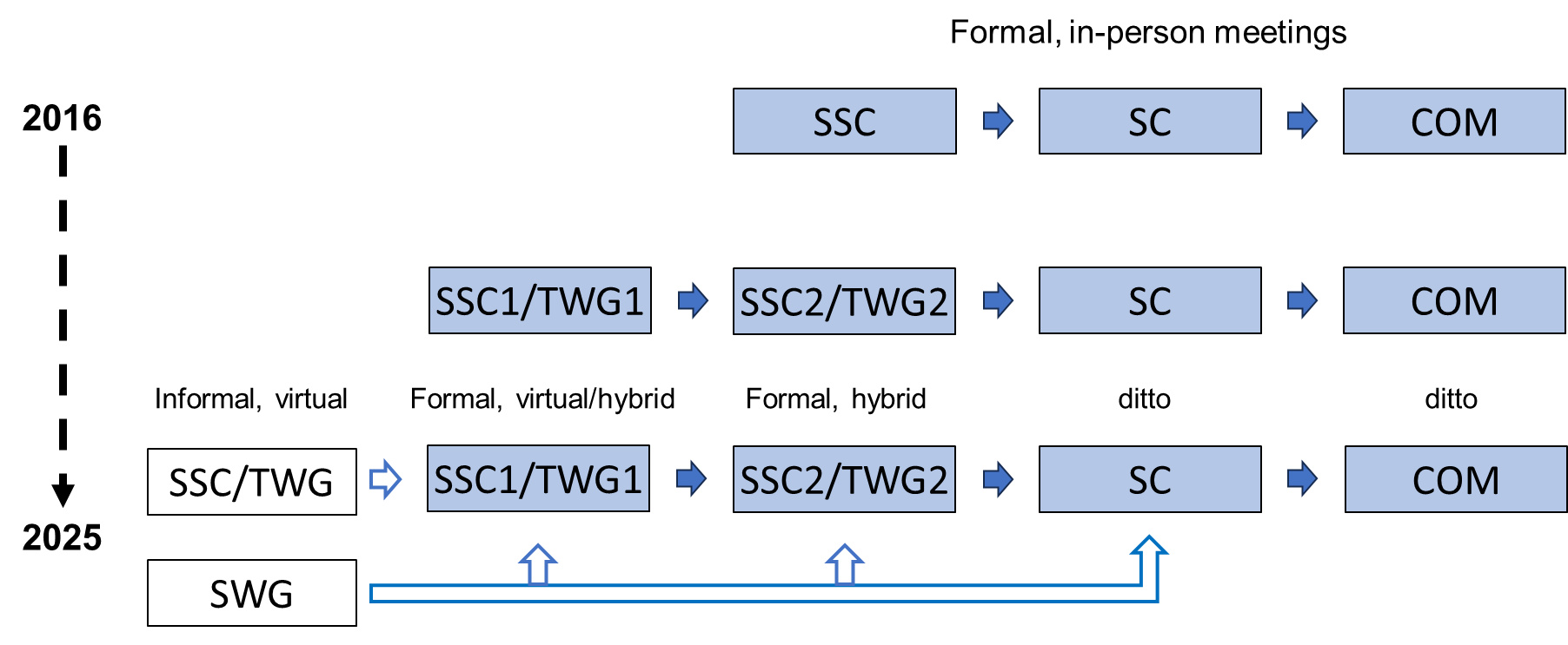
Figure 2: History of SC workflow from 2016 to 2025

The SC has recently eased some rules inherited from the Commission. In particular, the one-month deadline for document submission may be shortened, if needed. Chairs may serve more than two terms. SC, SSC and TWG may have informal virtual meetings which do not require approval by the Commission.

1.2 Potential issues
From 2016 to 2024, the number of SC expert groups and meetings per year increased from 4 to 14 (+250%) and from 7 to 23 (+229%), respectively. In 2025, this trend continued with six additional meetings (SWG Data, SWG Observer Program, PA workshop), a new project for SC database, and a new policy for reviewing invited experts’ performance and intersessional requests from Members (Annex). These increases were primarily in response to increased tasks and delivery of science advice to the Commission.

The budget for science support allocated by the Commission was 12-13 mil JPY on average in 2016-2025 (less in 2019-2020 and more in 2024-2025) which is close to the level identified by COM01 (100,000USD) in 2015.

The increasing amount of work, including the number of meetings, projects and additional tasks/requests from the Commission, may require further revision of the SC procedures and workflow. This involves the following issues:
- Meeting status: informal versus formal (managed by SC internally versus requiring approval by COM)
- Meeting format: in-person/hybrid versus virtual
- Funding: data preparatory meetings (SSC/TWG; funding required) versus stock assessment meetings (SSC/TWG; funding required) versus informal meetings (SSC/TWG and SWG; funding not required)
- Meeting documents and reports: Website versus Collaboration site
- Rapporteur: Contractor versus Secretariat
- Coordination and logistics: Secretariat versus Members

2. SC workflow
2.1 Historical and current practices
Table 1 outlines the SC workflow in early years (2016~). At that time, all areas of work, including data preparation, required formalization through a formal meeting. SSC/TWG held data preparatory meetings to make agreements on data, indices and models, then worked intersessionally in accordance with those agreements and finally held another meeting to review results and make recommendations to the SC. Recently, some SSCs and TWG have started to convene informal online meetings, in addition to their data preparatory meetings (e.g. SWG NSAM, TWG CMSAint), to track progress and facilitate intersessional work.

Table 1: The SC workflow in early years
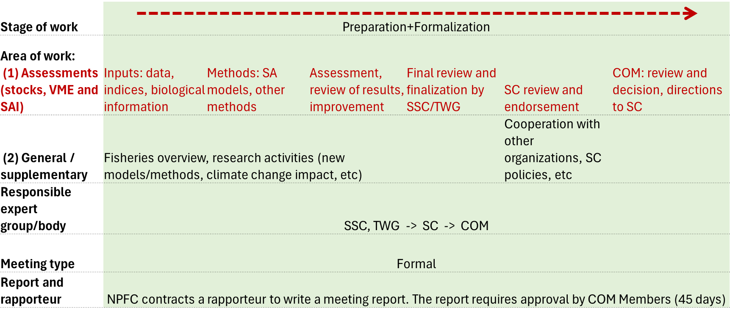

2.2 Proposed improvements
To respond to the substantial increase of the SC workload and growing budgetary pressure, the following suggestions have been made for consideration by Members (Table 2):
- Separate preparatory work from the formalization of recommendations and scientific advice by turning the status of data preparatory meetings from formal to informal.
- Hold one formal meeting of each SSC and TWG per year for formalizing scientific advice.
- Fund formal meetings including SC’s annual session by the NPFC, unless Members volunteer to host and sponsor them. Informal meetings should be virtual by default but may be organized in a hybrid format if funded by Members (e.g. through their voluntary contributions (e.g. SWG NSAM 2025-02)).
- Task the Science Manager to draft meeting summaries for data preparatory meetings, subject to nonmonetary compensation∗.
- Task the Science Manager to post agendas and summaries of informal meetings on the website (available to Members, CNCP, invited experts and authorized observers only).
- Use the new SC database for the submission and dissemination of data shared for routine/recurring assessments.
- Continue to use the Collaboration site for uploading ppt slides and informal meeting papers and, in addition, for sharing data for exploratory analyses.
- Shorten the deadline for document submission to formal meetings of SSCs and TWG from one month to two weeks.
- For SWGs, turn “Leads” into “Chairs” for consistency of names and roles.

Table 2: Proposed SC workflow. Red text shows suggested changes.
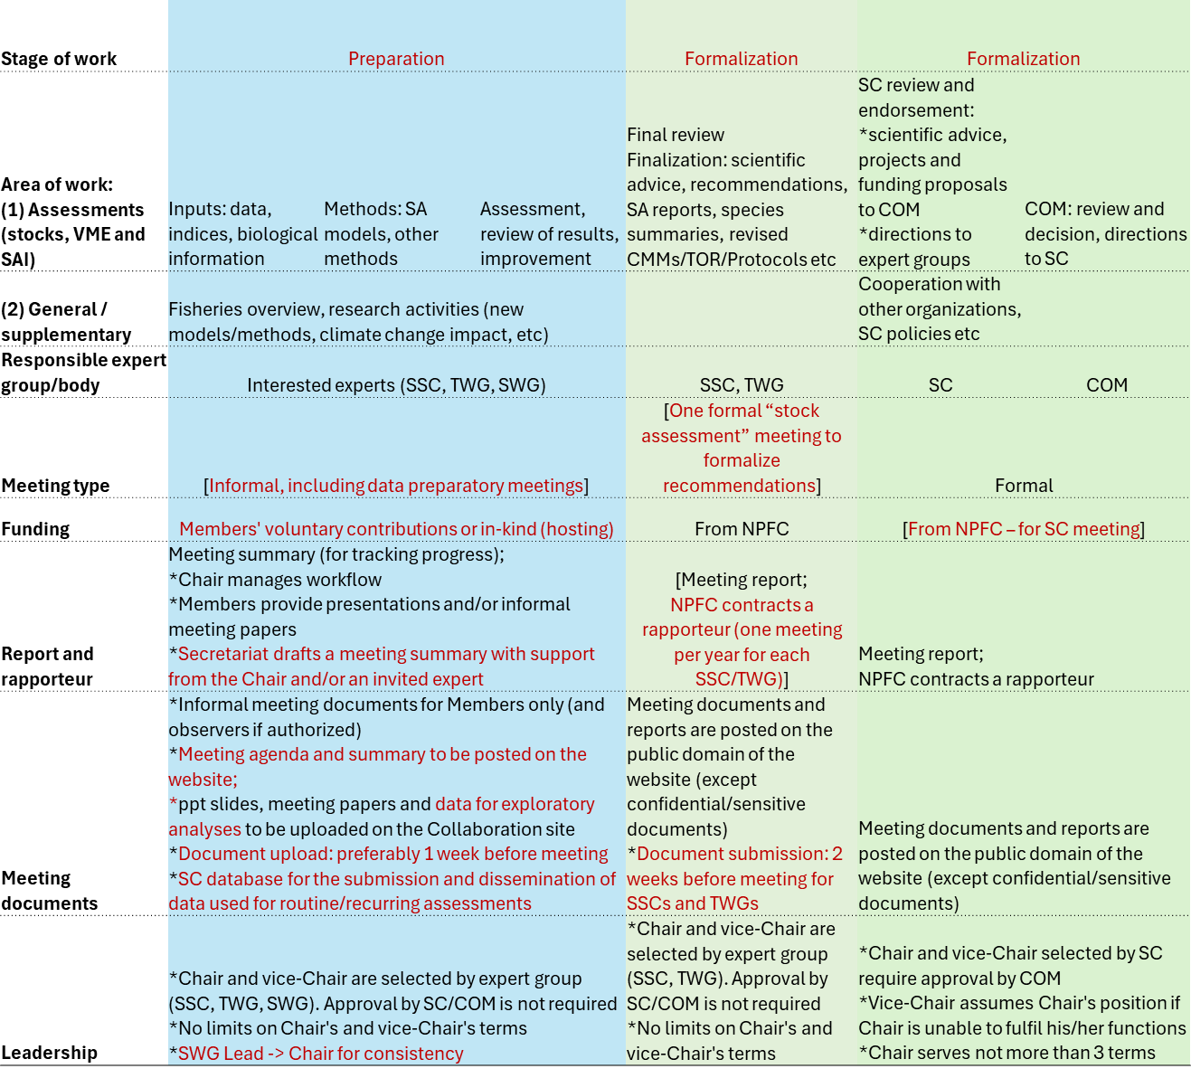
Table 3 differentiates two types of SC meetings, formal and informal. This table may be amended based on discussions of the proposed SC workflow. Also, relevant amendments shall be made to the Guidelines for Scientific Committee’s Small Working Groups (NPFC-2025-SC10-WP08).

Table 3: Two types of NPFC meetings
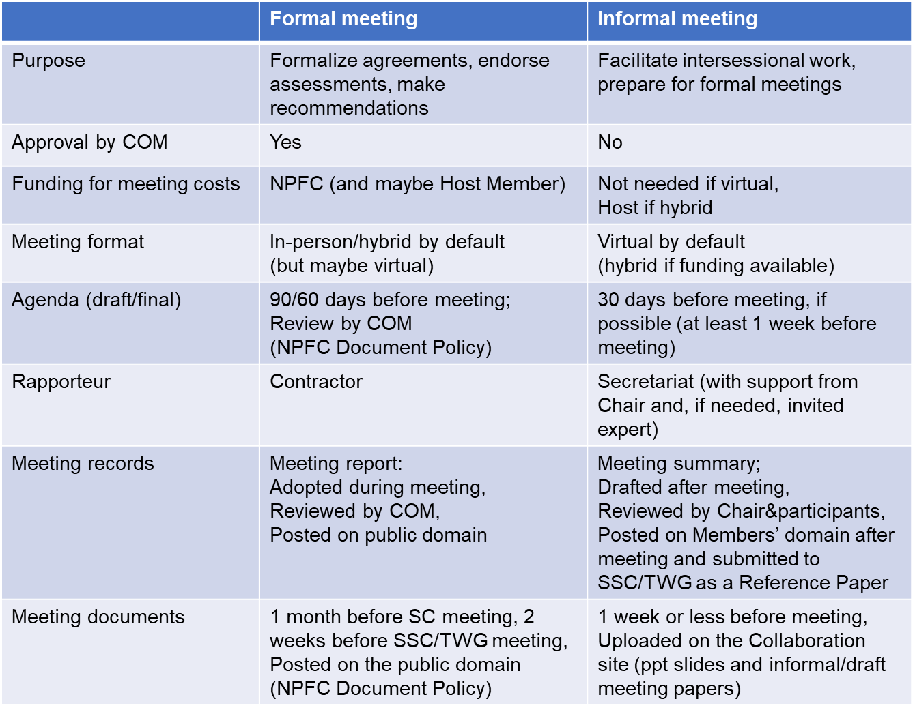

Annex
The number of SC-related activities in 2016 and 2024

Meetings | 2016 | 2024 | % increase
# meetings | 7 | 23 | +229%
# groups | 4 | 14 | +250%
# invited experts | 1 | 6 | +500%
# mtng papers by Sec | 30 | 77 | +157%
# projects | 0 | 5 | extra work
# intersessional reports | 1 | 6 | +500%

∗ i.e. remote work 50% of working days per month in line with the principle outlined in Staff Regulation 3.2.

