NPFC-2025-SC10-WP22 (Rev. 2)
Response to Tasks from COM9 to TWG CMSA
Technical Working Group on Chub Mackerel Stock Assessment (TWG CMSA)

- Background
At COM09, the Commission tasked the TWG CMSA with the following (NPFC-2025-COM09-WP17):
- Provision and analysis of gear specific data to explore whether there is a need to protect the immature portion of the stock and advice on options for achieving that, as appropriate. This includes also accessory devices used for fishing purposes, such as FADs, light devices, etc.
- Clarification of the correspondence of fishing days and the level of catch in relevant fleets, such as the purse seine fleet.
- Based on the next stock assessment, provide projections and associated probabilities, based on constant catch scenarios (e.g. increments of 5.000 mt) or constant F scenarios, aiming at reaching an appropriate MSY proxy (SSB and F) within 5 to 10 years [with a probability higher than 50%.]
The third task has been addressed through the future projections as part of the 2025 chub mackerel stock assessment. This paper therefore provides the TWG CMSA’s responses to Tasks 1 and 2.

- Response to Task 1
The TWG CMSA examined various model outputs available from the SAM assessment model in an attempt to address the issue of whether more protections were needed for the immature portions of the stock. However, after extensive discussion and preliminary analyses, it was determined that none of the model outputs were alone sufficient to address this issue. In order to respond to this Task thoroughly, the TWG CMSA needs gear specific catch-at-age / catch-at-length data by all Members, which is currently not submitted through data submission requirement. Should Commission wish this Task to be completed, Commission should require the Members to submit such data including accessory devices used for fishing purposes for both the Convention area and EEZs.

- Response to Task 2
As a first step for responding to task #2 from the Commission, the TWG CMSA agreed to prepare a description of how each Member defines and calculates “fishing day” and to present this information to SC10, and, in the longer-term, to work towards a common methodology for defining and calculating “fishing day” (NPFC-2025-TWG CMSA11-Final Report).
Descriptions provided by Members are compiled below.

China
In the NPFC footprint data table, due to the lack of a clear definition and calculation standard for fishing days in the early stages, our understanding of fishing days may differ slightly from that of other Members. We primarily count the days starting from the day the fishing vessel arrives at the fishing ground and continuing until the vessel ceases fishing, including days spent sheltering or other days not involving netting or trawling.
For a small number of vessels, it is inevitable that the statistics represent the cumulative days from departure to return to port, which adds complexity. Therefore, if NPFC has a standardized definition for fishing days, particularly for the footprint data of various fisheries, it would be beneficial for us to better collect fishing-days data.
In the vessel-days column of the standardized CPUE table for chub mackerel submitted by the Chinese delegation at the TWG CMSA11 meeting (NPFC-2025-TWG CMSA11-WP12), “vessel days” refers to the number of days when fishing vessels engaged in fishing activities at sea.
[Definition]
Fishing days refer to the cumulative number of days on which fishing vessels conducted actual fishing operations. A “fishing day” is counted when a vessel engages in fishing activities such as setting, towing, or hauling gear, regardless of how many operations were performed that day. The unit of fishing days is expressed as “vessel-days” or “boat-days.” This measure represents vessel-based fishing effort, where one boat operating for one day equals one boat-day. If more than one vessel operates on the same day, fishing days are summed by vessel, with each vessel counted as one boat-day.
[How to calculate fishing days]
The Chinese statistics for fishing days are based on the daily catch logs of purse seine or trawling vessels. When a purse seine vessel engages in fishing activities on a given day, it is counted as one fishing day. The cumulative fishing days for all purse seine or trawling vessels are calculated separately for the fleet. Purse seine vessels exclusively use purse seine methods, while trawling vessels exclusively employ trawling methods. The target fish species for Chinese purse seine fisheries are mackerels and sardines, and in theory, the annual fishing days for mackerels and sardines are the same.

Japan
[Definition]
Fishing days refer to the cumulative number of days on which fishing vessels conducted actual fishing operations. A “fishing day” is counted when a vessel performs activities such as setting, towing, or hauling. The unit is “boat-days,” where one vessel fishing for one day equals one boat-day.
[How to calculate fishing days]
Japan uses logbook data submitted by each vessel. One logbook record corresponds to one day in which actual fishing operations were conducted. For purse seine and bottom trawl vessels, the number of sets or tows performed in that day is recorded within a single logbook entry. Therefore, the count of logbook records equals the number of fishing days.

Russia
[Definition]
The Russian definition of “fishing days” is the same as the Japanese one.
[How to calculate fishing days]
Russia does not use logbook data submitted by each fishing vessel to calculate fishing days, because:
- In the Russian case, each record of the electronic logbook corresponds to each operation (setting, towing, hauling gear, etc.), which we do not fully trust (we suppose that in many cases these “operations” are actually the result of aggregating multiple operations).
- We received an official announcement from the Russian Federal Agency for Fishery on 19 October 2020 regarding the extension of our access to electronic logbook data. However, the new format became obligatory for all Russian vessels with engine power > 55 kW or gross tonnage > 80 MT only from 1 December 2023 (though many vessels started reporting e-logbook data much earlier).
Therefore, instead of using electronic logbook data, we use electronic daily reports (EDR) of each vessel (stored in the table “catch”), which we trust more than e-logbooks. However, some records of EDR may not be unique per vessel per day, because they may be split by regions and permission numbers.
Thus, we count distinct results of concatenation between vessel identifiers (id_ves) and dates using the SQL function “my_cast2vchar”:
select cast(cast($1 as varchar) || '_' || cast($2 as varchar) as varchar);
Therefore, the final SQL in TINRO’s PostgreSQL copy of VMS and EDR, for example for the 2024 national report, looks like this:
select extract(year from c.date)::smallint as "Year",
(case when o.id_oper = 14 then 'Purse seine'
when o.id_oper = 24 then 'Stick-held dip net'
when left(o.oper,6) = 'трал р' then 'Mid-water trawl'
when left(o.oper,6) = 'трал п' then 'Mid-water trawl'
when left(o.oper,6) = 'трал д' then 'Bottom trawl'
when left(o.oper,9) = 'снюрревод' then 'Danish seine'
when left(o.oper,6) = 'ярус в' then 'Squid jigging'
else 'Others' end) as "Fishing_Gear",
(case when id_region IN(57,299,300,9006) then 'CA' else 'NW' end) as "Statistical_Area",
COUNT(DISTINCT c.id_ves) as nves,
COUNT(DISTINCT my_cast2vchar(c.id_ves, c.date)) as ndays,
round(sum(c.catch_volume::numeric),3) as "Tons"
from ocm.catch c
join ltrees.own_russian using (id_own)
left join ocm.operation using(id_ves, date)
left join ocm.oper o using(id_oper)
where
c.id_fish = 645 -- Chub&Blue Mackerels
and c.date between '2024-01-01' and '2024-12-31'
and c.id_region IN (266,267,269,270,271,285,57,299,300,9006)
and c.catch_volume > 0
group by "Year", "Fishing_Gear", "Statistical_Area"
order by "Year" DESC, "Fishing_Gear" DESC, "Statistical_Area" DESC;
and the answer in psql is:
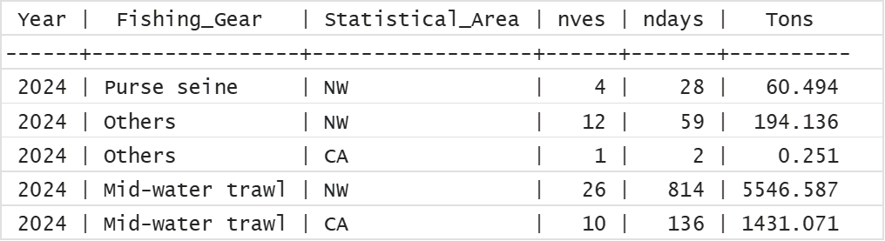
Exactly this output was used for the preparation of the Russian national report.

References cited
European Union. (2025) Chub mackerel CMM: proposed tasking for TWGCMSA and SC. NPFC-2025-COM09-WP17.
Technical Woking Group on Chub Mackerel Stock Assessment (2025) Stock assessment report for chub mackerel. NPFC-2025-SC10-WP10.
Yongchuang Shi, Heng Zhang, Haibin Han. Standardized CPUE of Chub mackerel (Scomber japonicas) caught by the China’s lighting purse seine fishery up to 2024. NPFC-2025-TWG CMSA11-WP12

