NPFC-2025-SC10-WP23
Species Summary
NPFC Japanese Sardine Small Working Group
2025

Japanese sardine (Sardinops melanostictus)
Common names:
拟沙丁鱼, Ni Sha Ding Yu (China)
マイワシ, Maiwashi (Japan)
정어리, Jeong-eoli (Korea)
Дальневосточная сардина (Russia)
遠東擬沙丁魚, Yuan-Dong-Ni-Sha-Ding-Yu (Chinese Taipei)
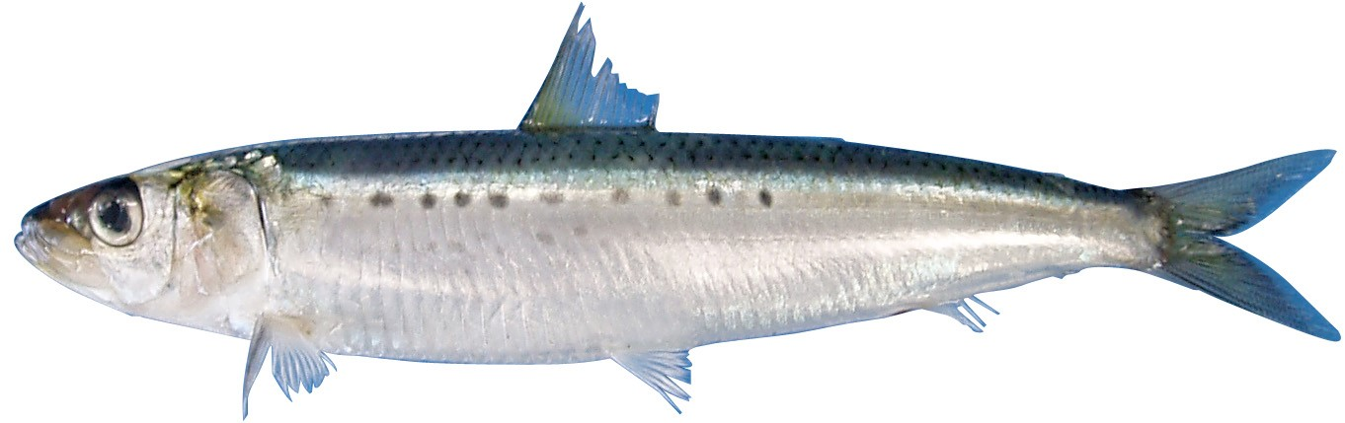
Figure 1. Japanese Sardine (Sardinops melanostictus).

Management

Active NPFC Management Measures
The following NPFC conservation and management measure (CMM) pertains to this species:
- CMM 2025-11 For Japanese Sardine, Neon Flying Squid and Japanese Flying Squid
Available from https://www.npfc.int/active-conservation-and-management-measures

Management Summary
The current management measure for Japanese Sardine does not specify catch or effort limits. The CMM states that Members and Cooperating non-Contracting Parties currently harvesting Japanese Sardine should refrain from expansion of the number of fishing vessels authorized to fish Japanese Sardine in the Convention Area. New harvest capacity should also be avoided until as stock assessment has been completed.
A stock assessment for Japanese Sardine is conducted by Japan within their EEZ and used for management of the domestic fishery.
Table 1. Current status of NPFC management measures
Convention or Management Principle | Status | Comment or Consideration
Biological reference point(s) | Not accomplished | Not established for NPFC CA (Established in Japan EEZ)
Stock status | Unknown | Status determination criteria not established for NPFC CA (Established in Japan EEZ)
Catch limit | Intermediate | Not established for NPFC CA (Recommended catch, effort limits in Japan EEZ)
Harvest control rule | Not accomplished | Not established for NPFC CA (Established in Japan EEZ)
Other | Intermediate | No expansion of fishing beyond currently fished areas

Assessment
There is currently no stock assessment for Japanese Sardine conducted by NPFC for the Convention Area.
Japan conducts an assessment of the Japanese Sardine stock using ridge VPA and a number of data sources described below (Hiroshi and Nishida 2005). The catch and biomass estimated by Japan’s stock assessment have both been increasing since 2010 (Figure 2). The spawning stock biomass is currently estimated to be higher than $SSB_{msy}$, but fishing mortality is higher than $F_{msy}$ indicating overfishing in the most recent 3 years (Figure 2). Japan’s domestic stock assessment includes catch data from the NPFC CA by China and Russia. Japanese Sardine has been identified as priority species for NPFC and Members started discussion for the development of NPFC stock assessment.

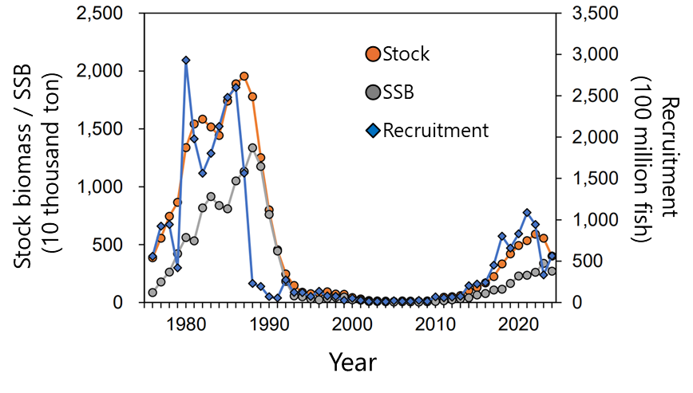

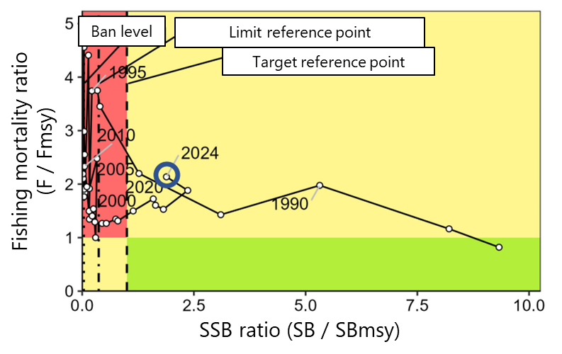
Figure 2. Time series of spawning stock biomass, total biomass and recruitment from the Japan’s domestic Japanese Sardine stock assessment (top panel). Kobe plot indicating historical and current status of Japanese sardine in relation to MSY-based reference points (reprinted from Japan’s domestic stock assessment of Japanese Sardine (bottom panel).

Data

Surveys
Japan conducts three surveys that estimate recruitment for a number of pelagic species, including Japanese Sardine (Table 2). The surveys target pre-recruits and juveniles to determine an index of recruitment. Japan also conducts a monthly egg and larval survey that is used to estimate spawning stock biomass. Surveys are conducted in spring (1995-2024), summer (2001-2024) and fall (2005-2024) at 30-130 stations per year. The survey protocol can be found at (Oozeki et al. 2007). Russia has conducted a summertime acoustic-trawl survey since 2010 that examines mid-water and upper epipelagic species including Japanese Sardine. China has been conducting a scientific survey using its fishery research vessel Song Hang in the convention area of NPFC since 2021. The survey is conducted during June-August, with methods of mid-trawling, acoustic and squid jigging, covering about 70 stations per year.

Fishery
China, Japan and Russia catch Japanese sardine (Figures 3 and 4). Catches are primarily by purse seine, with a smaller component of the catch taken by pelagic trawl. China’s catch of Japanese Sardine is taken exclusively from the Convention Area from April to December. China’s existing catch records are from 2016 to 2024 and show increasing catches during that time period as the stock may have been increasing. The historical catches (prior to 2016) are unknown, thought to be low and likely need to be confirmed.
Japan’s fishery for Japanese Sardine occurs inside their EEZ and is mostly conducted by large purse seine vessels (>90% of the catch). Additional components of the fishery include set nets, dip nets and other gears. The fishery experienced very high catches in the 1980’s and early 1990’s, a decline to very low catches from 1995 to ~2010 and has been recovering since then. The fishery is conducted year round, but mainly during the summer season.
The Russian fishery occurs inside their EEZ and is prosecuted primarily by pelagic trawling (>90% of the catch), with a smaller component of the catch coming from purse seines. The success of Russian fishery depends on the migration patterns and overall abundance of Japanese Sardine, as the sardine move into Russian waters when their abundance is high. For this reason, there was no catch from 1994-2011 when the stock abundance was low, but in recent years (since 2016) as the stock has recovered and water temperatures have been warm there have been increasing catches in Russia. The Russian fishery occurs primarily from June to November.

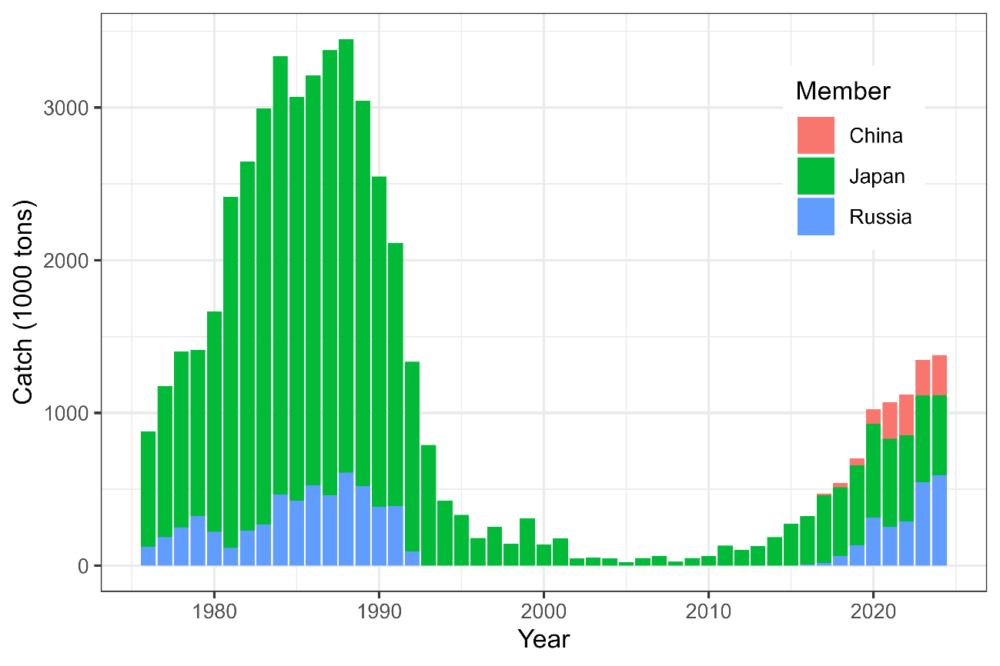
Figure 3. Historical catch of Japanese Sardine by Members in both the CA and inside Members EEZs.
Other NPFC Members (Canada, EU, Korea, Chinese Taipei, USA and Vanuatu) do not target Japanese Sardine. Chinese Taipei has some historical records of Japanese Sardine bycatch in the Pacific Saury fishery (~100 mt) and Korea has a small amount of historical bycatch data from the bottom trawl fishery. Vanuatu, USA, EU and Canada have no record of Japanese Sardine catches. However, there have been recent (since 2022) occurrences of Japanese Sardine along the USA west coast.
Fishery catch data is available for Members from the NPFC website (https://www.npfc.int/system/files/2024-04/NPFC-2024-AR-Annual%20Summary%20Footprint%20-%20Japanese%20Sardine.xlsx) since 2001.

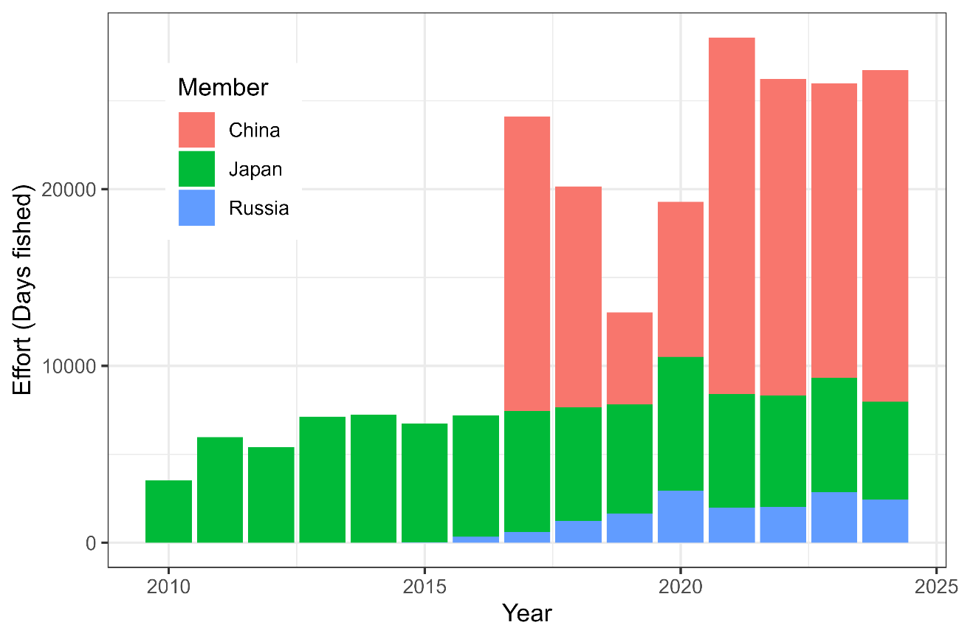
Figure 4. Historical fishing effort for Japanese Sardine.

Biological collections
China has collected biological data from fishery catches of Japanese Sardine since 2020. These collections included length data as well as maturity and age structures.
Russia collects length and weight data, age structures (scales) and maturity data from both commercial catches and surveys.
Japan also collects length, weight, maturity and age data from the survey and fishery to support their stock assessment.
Table 2. Data availability from Members regarding Japanese sardine
Data | Source | Years | Comment
Catch | China | 2015-present | Catches from convention area
 | Japan | 1995-present | Historical catch data from 1968 available, catches in national waters
 | Korea |  | Minor bycatch in bottom trawl fishery
 | Russia | 2016-present | Catches primarily in national waters, not convention area
 | Chinese Taipei |  | Minor bycatch in Pacific saury fishery
CPUE |  |  | not developed
Survey | Japan |  | Pre-recruit survey
 | Japan |  | Juvenile survey
 | Japan |  | Monthly egg and larval survey
 | Russia | 2010-present | Acoustic-trawl survey
 | China | 2021-present | Midwater trawling and acoustics
Age data | China | 2020-present | Commercial catch
 | Japan |  | Commercial and survey catches
 | Russia |  | Commercial and survey catches
Length data | China | 2020-present | Commercial catch
 | Japan |  | Commercial and survey catches
 | Russia |  | Commercial and survey catches
Maturity/fecundity | China | 2020-present | Commercial catch
 | Japan |  | Commercial and survey catches
 | Russia |  | Commercial and survey catches

Special Comments
None

Biological Information

Distribution
Japanese Sardine (Sardinops melanostichtus; Figure 1) are a pelagic species that occurs in large migratory schools in the coastal waters of China, Chinese Taipei, Japan, Korea and Russia (Figure 5, (Kaschner et al. 2019)). They generally migrate from the south to the north during summer, returning to inshore areas in the south to spawn in the winter. Japanese sardine feed mainly on zooplankton and phytoplankton.

Life history
Japanese Sardine are short-lived and fast growing, maturing early at 2-years old. Their maximum length is ~24 cm and their longevity is 7 years. Their growth rates and spawning patterns are highly influenced by the environment (Niino et al. 2021)
Taxonomically, the Japanese sardine are closely related to other species around the globe including Sardinops from southern Africa, Australia, South America and California.
A review of the impacts of the environment and climate change on Japanese Sardine was completed by the Small Working Group on Japanese Sardine in 2025 and can be found at https://www.npfc.int/literature-review-studies-relating-environmental-conditions-japanese-sardine-sardinops-melanosticta.
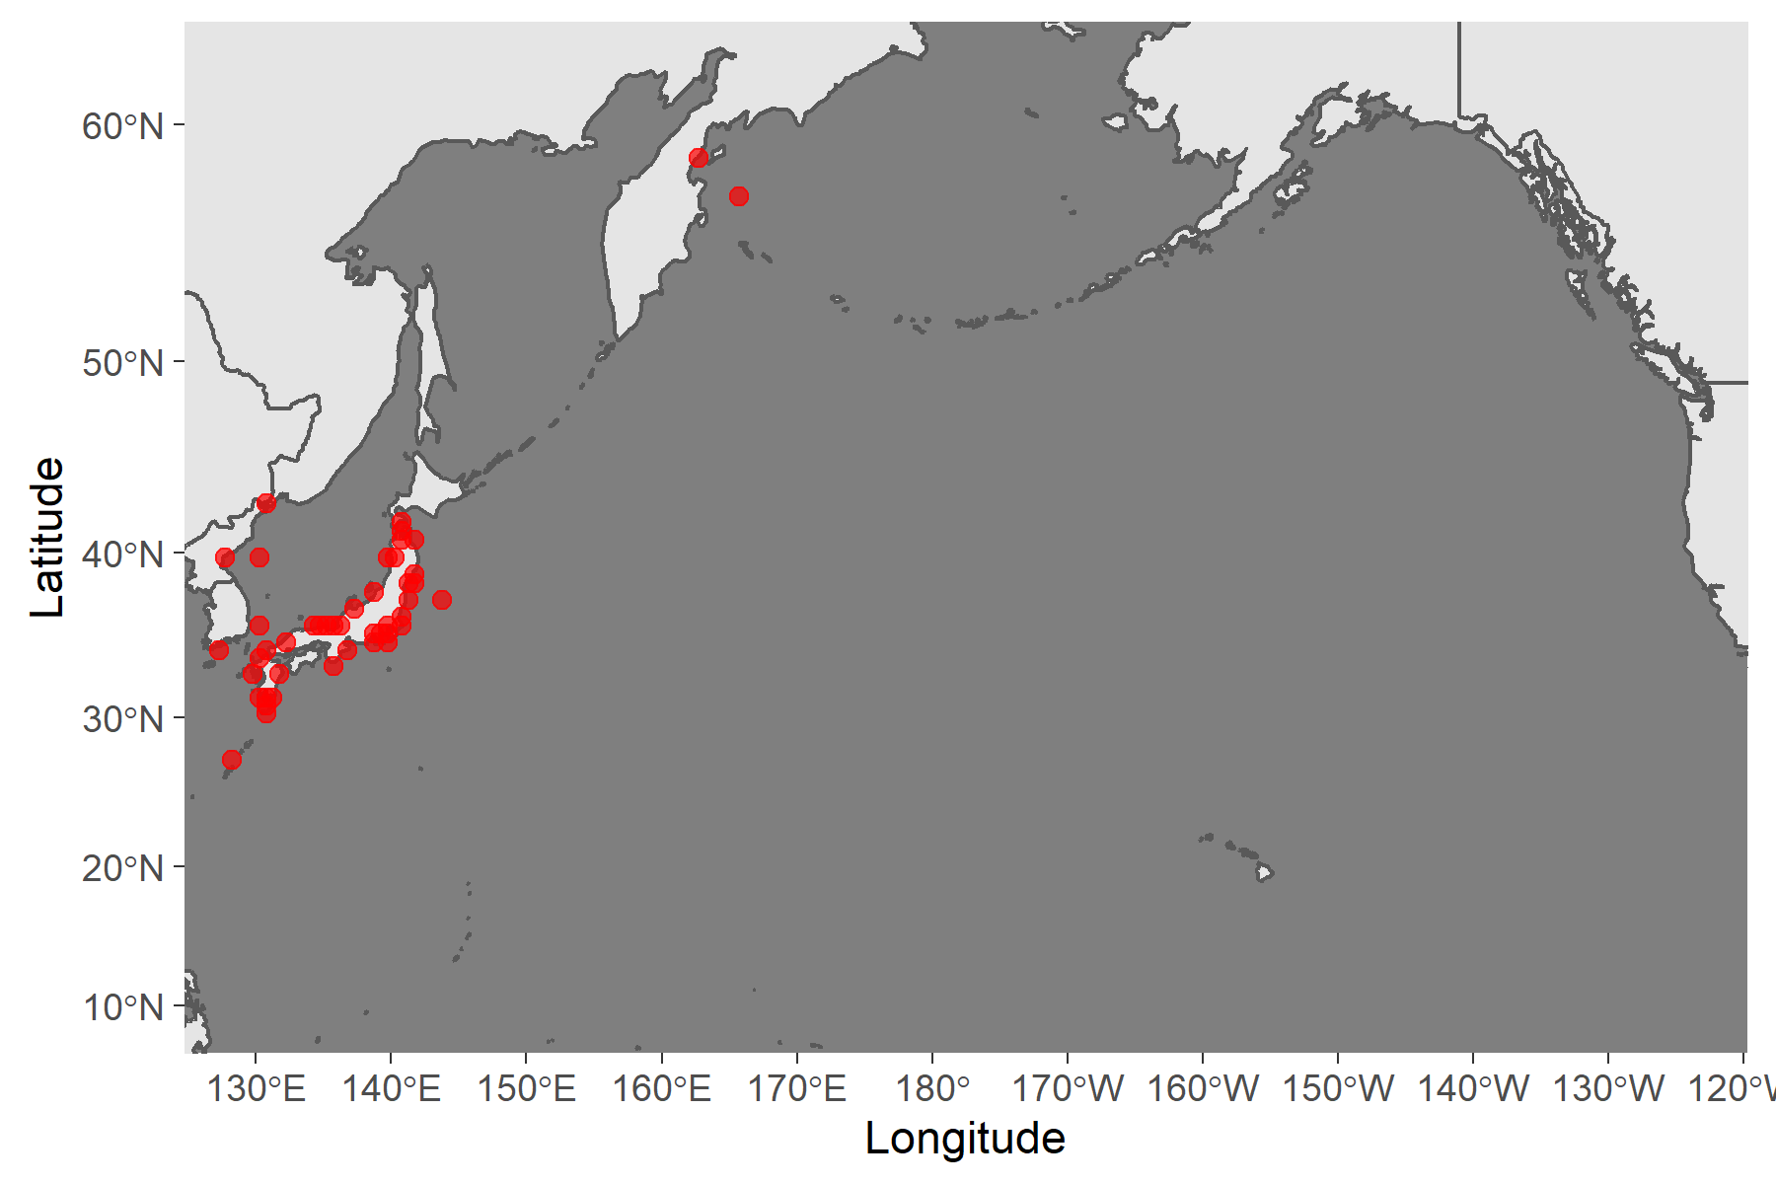
Figure 5. Map of distribution of Sardine species in the North Pacific.

Literature cited
Hiroshi, and Nishida. 2005. “Stock Assessment and ABC Calculation for Japanese Sardine (Sardinops Melanostictus) in the Northwestern Pacific Under Japanese TAC System.” In.
Karthik Ram, Carl Boettiger, and Andrew Dyck. 2013. “Rfisheries: R Interface for Fisheries Data. R Package Version 0.1.” 2013. http://CRAN.R-project.org/package=rfisheries.
Kaschner, K., Kesner-Reyes K., Garilao C., Segschneider J., J. Rius-Barile, Rees T., and R. Froese. 2019. “AquaMaps: Predicted Range Maps for Aquatic Species. Data Retrieved from Https://Www.aquamaps.org.”
Niino, Yohei, Sho Furuichi, Yasuhiro Kamimura, and Ryuji Yukami. 2021. “Spatiotemporal spawning patterns and early growth of Japanese sardine in the western North Pacific during the recent stock increase.” Fisheries Oceanography, no. April: 1–10. https://doi.org/10.1111/fog.12542.
Oozeki, Yoshioki, Akinori Takasuka, Hiroshi Kubota, and Manuel Barange. 2007. “Characterizing Spawning Habitats of Japanese Sardine (Sardinops Melanostictus), Japanese Anchovy (Engraulis Japonicus), and Pacific Round Herring (Etrumeus Teres) in the Northwestern Pacific.” CalCOFI Rep. 48 (December).
Whitehead, Peter J. P. 1985. “FAO Species Catalogue. Vol. 7. Clupeoid Fishes of the World (Suborder Clupeoidei). An Annotated and Illustrated Catalogue of the Herrings, Sardines, Pilchards, Sprats, Shads, Anchovies and Wolf-Herrings.” FAO Fish. Synop. 125(7/1): 1–303.

