NPFC-2025-SSC BFME06-IP05

Joint Canada-USA International Seamount Survey – 2022 & 2024 Update for BFME06

Chris Rooper¹, Christina Conrath², Pam Goddard³, Lauri Sadorus³ (¹ Pacific Biological Station, Fisheries and Oceans Canada and ² AFSC-RACE, ³Thalassa LLC)

Background and Objectives:
The Joint Canada-USA International Seamount Surveys (JCUISS) were designed to study deep-sea coral and sponge communities on seamounts in international waters. Deep sea coral and sponge distributions outside of US and Canada EEZ’s are relatively under explored, with the exception of a handful of studies conducted at the Cobb Seamount complex off of southern British Columbia. Historically (1970’s – 1990’s) many of these offshore seamounts were fished by both domestic (Canadian and USA) and foreign (Russia, Korea and Japan) fishing fleets. Currently, there is limited fishing by the Canadian Sablefish longline trap fleet at seamounts in international waters. The intersection between deep-sea coral and sponge distribution and fisheries is an ongoing concern of the North Pacific Fisheries Commission, the Regional Fisheries Management Organization for international waters of the North Pacific Ocean (www.npfc.int). The NPFC manages fisheries and vulnerable marine ecosystems (VME’s) to monitor potential significant and adverse impacts on deep sea corals and sponges.

In 2022 and 2024 ~two-week surveys using an underwater stereo camera were undertaken at 5 seamounts in the Cobb Seamount Chain. Data were collected at 77 transects in 2022 and 58 transects in 2024 (Figure 1). Analyses of these data have shown that deep-sea corals are widespread at relatively low densities across all the seamounts examined and especially at depths below 400 m where the majority of the sampling occurred. Preliminary species distribution models have been developed for coral and sponge taxonomic groups based on these data, but data from these international seamounts are limited.

Approach:

The main tool used in this work was the underwater stereo camera system developed during the Alaska Coral and Sponge Initiative in 2012-2015. The stereo-camera survey followed a standard protocol outlined in Rooper et al. (2016), with a target of 15 minutes of on-bottom time for each transect. Images will be processed to determine substrate type, density and size of structure forming invertebrates and density and size of fish species using Sebastes software (Williams et al. 2015). The visual survey was designed in a robust statistically sound method so that inferences about the deep-sea coral and sponge communities on seamounts can be made. In addition distribution models for deep-sea coral and sponge taxa were developed to aid in the selection of depth strata. An estimate of the total abundance of deep-sea coral and sponge (and associated fishes) will be generated using the sampling for each of the seamounts and the seamount chain. Further species distribution modeling will also be conducted to predict hotspots of abundance and diversity in the seamounts that may warrant protection as vulnerable marine ecosystems (FAO 2009).

In addition to the visual survey, we also collected temperature data. We also collected water samples with adjoining images that can contribute to ongoing eDNA studies and taxonomic studies. Acoustic data from scientific echosounders was also collected during nighttime benthic mapping. A series of benthic grabs were collected to document the sediment at selected locations on Cobb seamount.

Significant Results to Date:.

Image analysis is complete for the 2022 transects and partially complete for the 2024 transects (anticipated completion by March 2026). The preliminary results showed that gorgonian corals were present at 56% of the transects occupied. Most of the corals occurred at depths below 400 m and corals were present at most transects on all seamounts below this depth (Figure 2). Coral taxa appeared to consist of Primnoidae, Isididae and other Octocorallians and Antipatharians at deeper depths. Hexactinellid sponges had a similar distribution to the corals, although they occurred in only 50% of the transects. Hydrocorals were common at shallow depths on Cobb and Corn seamount, while sea whips and sea pens were not common, but found at most depths. Reef building scleractinians were observed at 8 transects across both years. Figure 3 shows the density for VME indicator taxa and Figure 4 shows the height of VME indicator taxa measured with the stereo camera system.

During the 2022 camera survey longline gear (mostly groundline) was observed at ~55% of transects between 200 and 800 m on Cobb Seamount and at ~10% of transects at these depths on Warwick and Corn Seamounts. No discarded gear was observed at Brown Bear or Eickelberg
Seamounts

It should be noted that these data are the result of a cursory look at the transect data and will change when detailed image analysis is completed.

Figures:

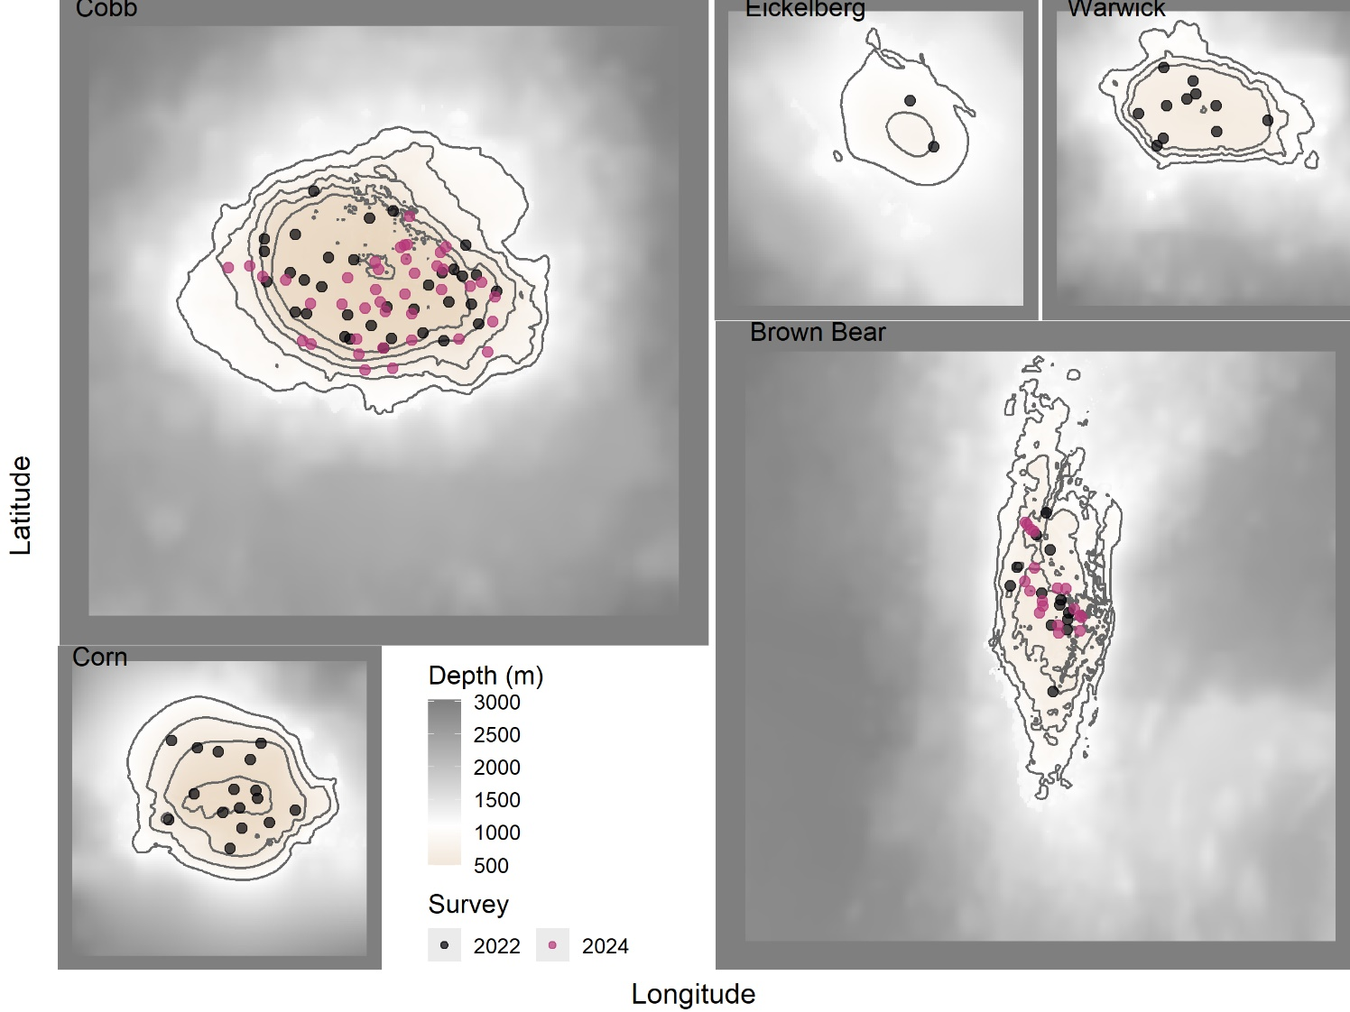
Figure 1. Map showing distribution of randomly sampled transects in 2022 and 2024 at the five seamounts surveyed on the cruise in bold text (Cobb, Corn, Warwick, Eickelberg and Brown Bear).

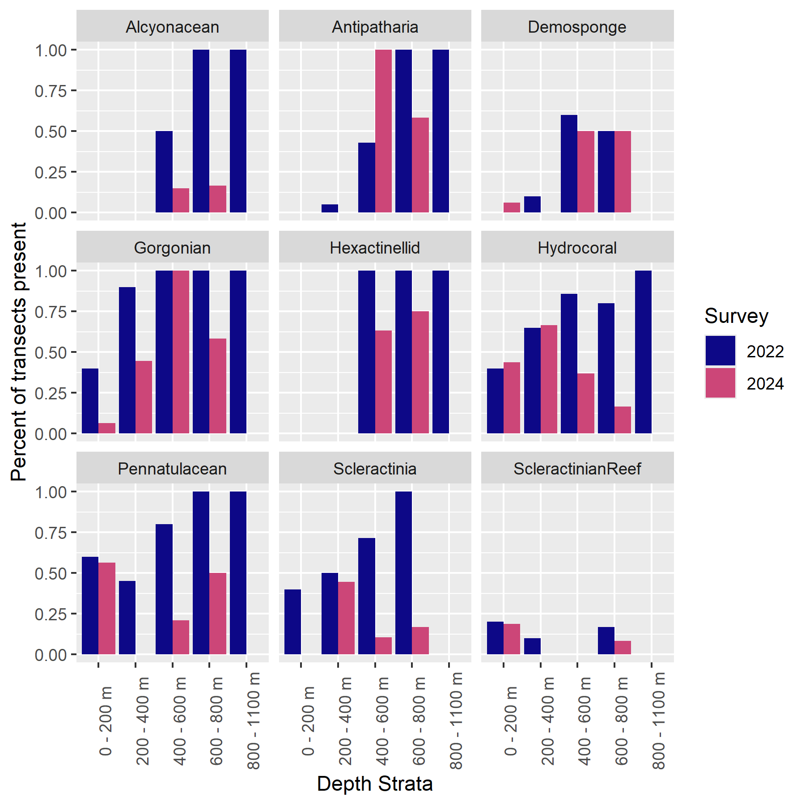
Figure 2. Percentages present for the most common structure forming invertebrates at the five seamounts surveyed during the Joint Canada USA International Seamounts cruise.

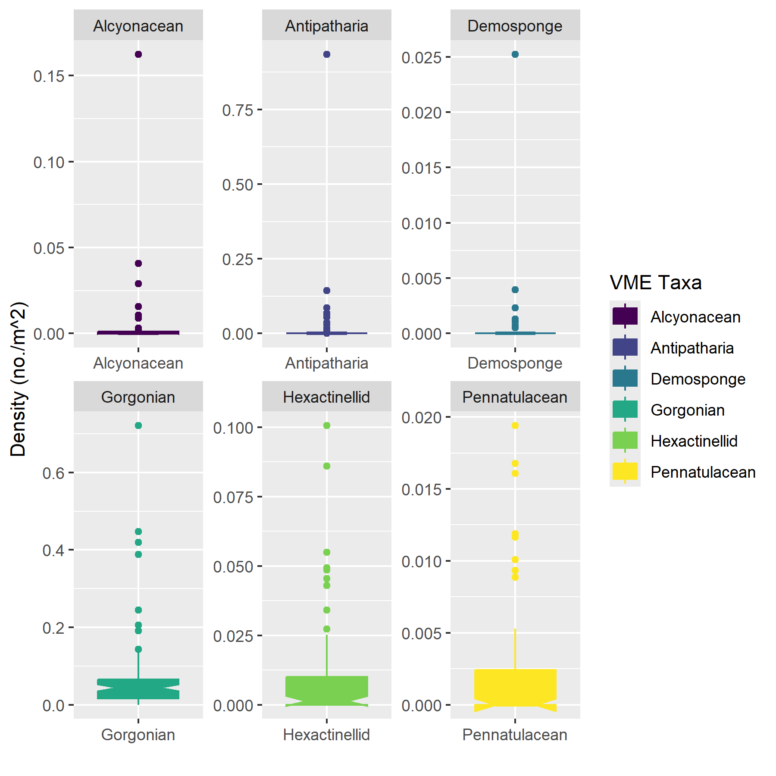

Figure 3. Densities of the most common structure forming invertebrates occurring at the five seamounts surveyed during the Joint Canada USA International Seamounts cruise.
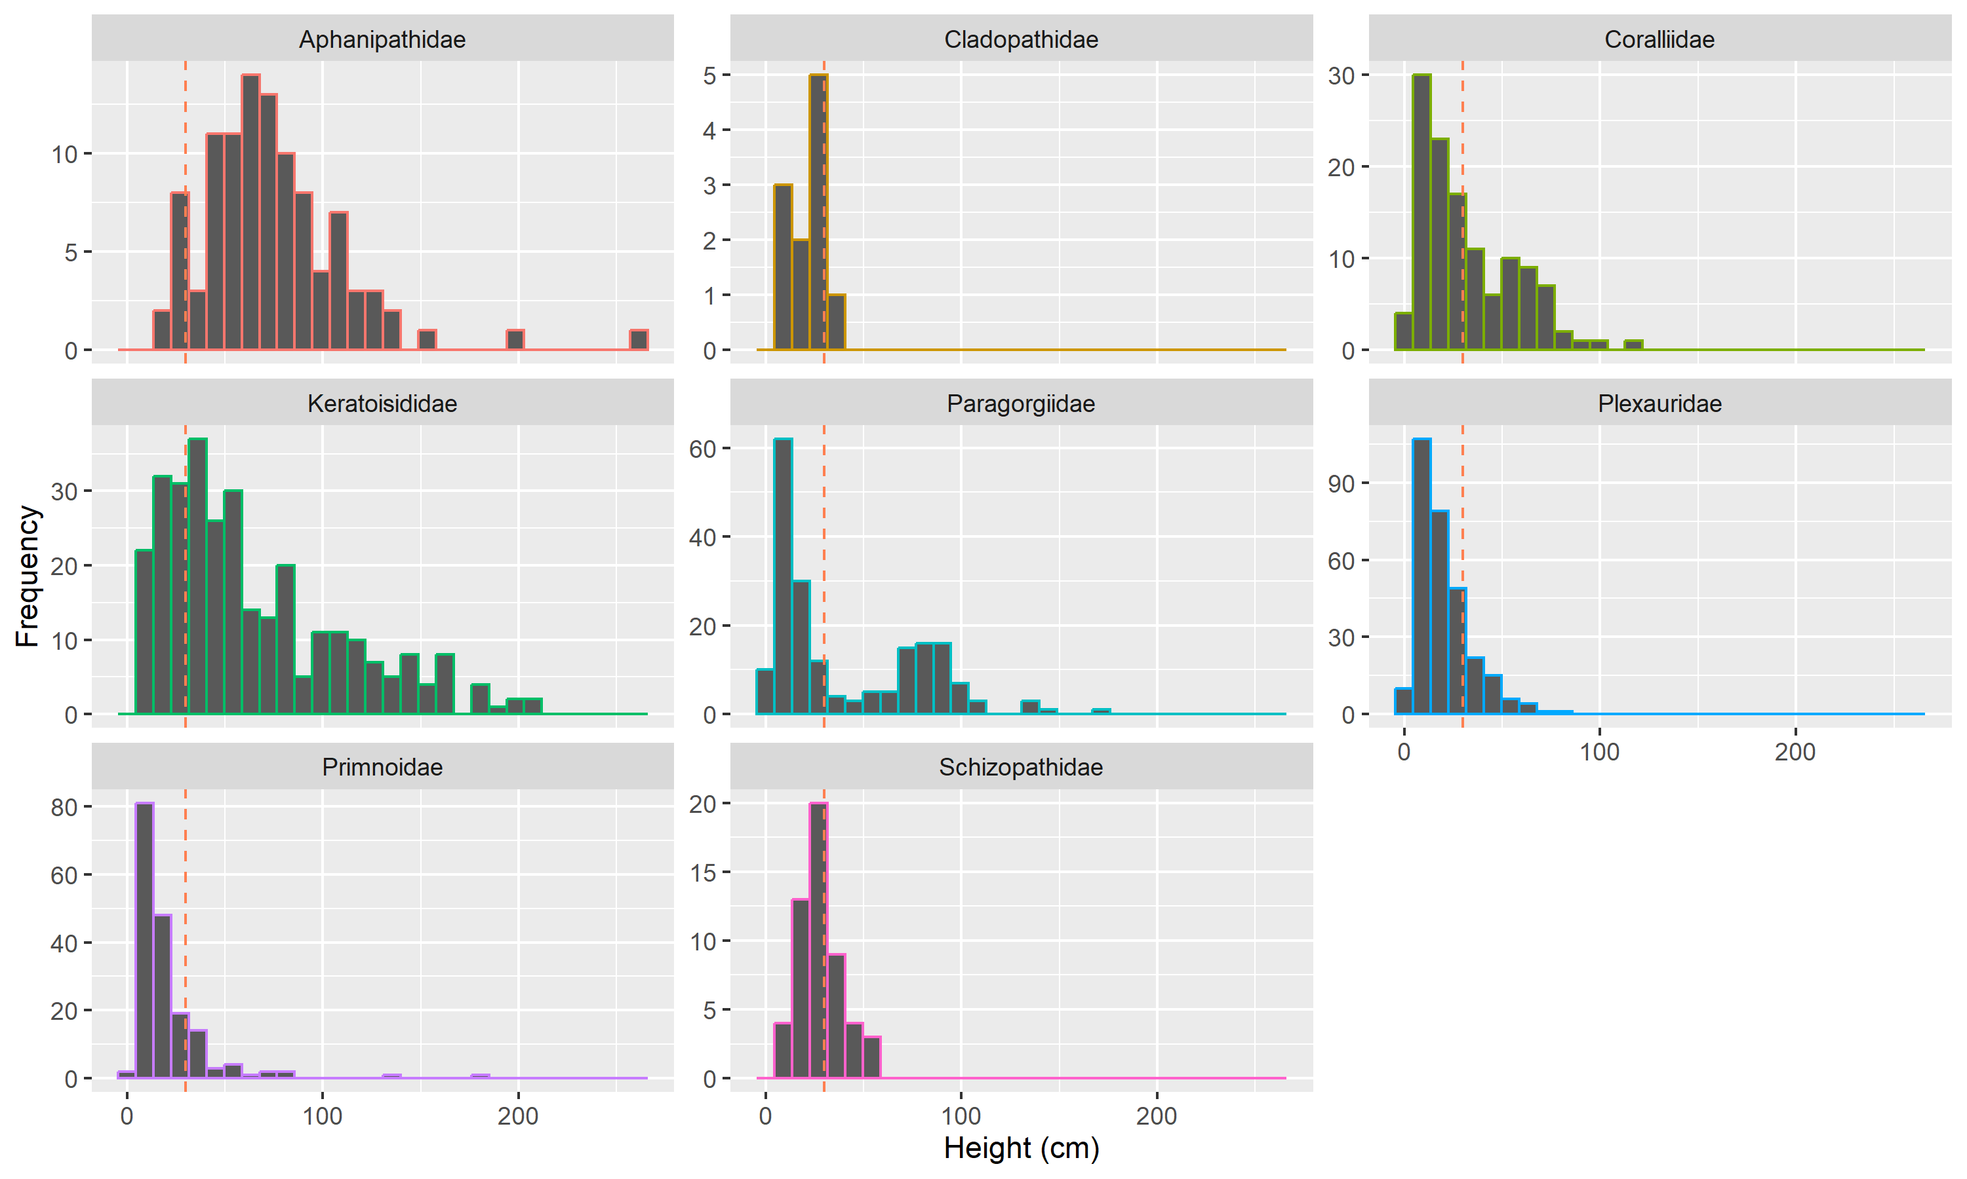
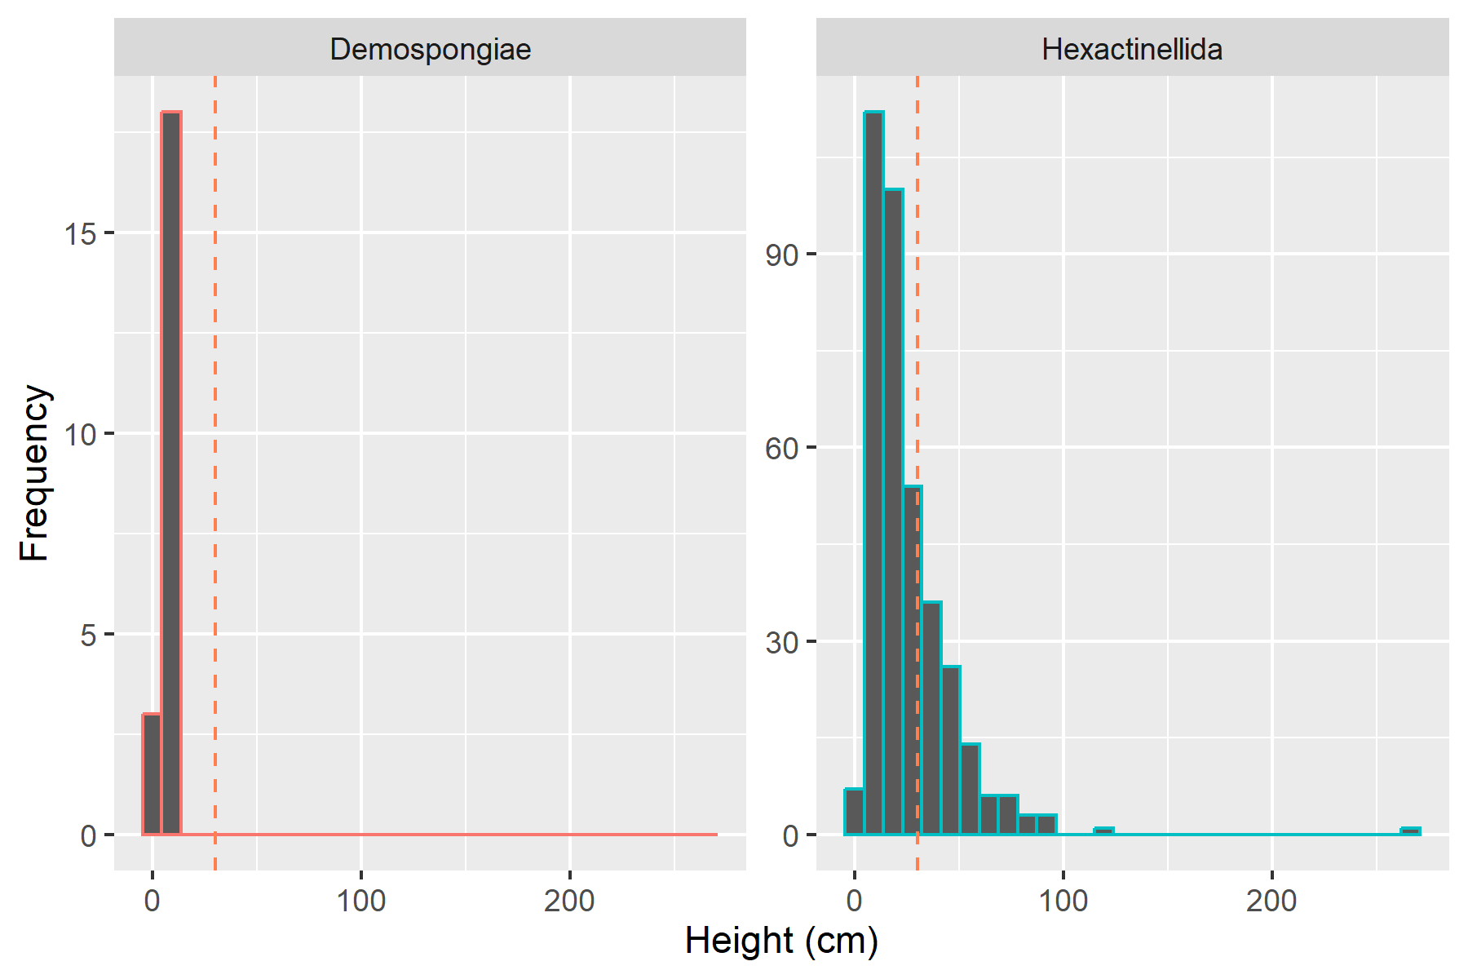

Figure 4. Height distributions of common families of corals and classes of sponges observed at seamounts in international waters.

