NPFC-2025-SSC BFME06-WP15
Report of the Small Working Group on VME
2025 Activities

Background

The Small Working Group on VME was assigned seven tasks by the SSC BF-ME05 for the intersessional period of 2025. The tasks were:
    - Continue working on visual data objectives (Objective 2b and Objective 3)
      - Identify high density VME areas on each fished seamount
      - Develop new species distribution (presence/absence and abundance) models for VME taxa on all seamounts
    - Prepare to update fishing impacts assessment
    - Continue to work to develop a synchronized approach for assessing and managing the risk of SAI and determine data requirements and spatial/temporal resolution for SAI assessment
    - Develop or research alternative methods to apply to Japan and Korea’s indicator taxa bycatch to further refine encounter thresholds that are taxon and gear specific
    - Consider and explore other methods for identifying VME
    - Discuss value of using fisheries VME indicator taxa bycatch data for managing VME and develop TOR if sharing is necessary
    - Literature review of connectivity, recruitment and recovery of VME indicator taxa among seamounts

To complete these tasks, the SWG VME met twice intersessionally on 12 June 2025 and 2 October 2025 in the format of video conferencing via WebEx. In addition to the meetings, the group also corresponded via email throughout the intersessional period to maintain progress on the assigned work. The following report identifies the progress made in 2025, with some recommendations for the Scientific Committee. We also recommend some future and ongoing work that may be beneficial to complete during the next year.

Item 1. Continue working on visual data objectives (Objective 2b and Objective 3)

A couple of outstanding issues were completed on the visual data objectives during the past year. Three documents are submitted as appendices to this report that show the final result from the analysis of the observation data. All the observation data from Members was compiled for mapping in 2024. The presence and absence mapping of VME indicator taxa (Objective 1) was updated to include new data from a 2024 research survey in the Cobb Seamount Chain and can be found in the attached document “Mapping_the_VME_Presence”. Densities of VME indicator taxa were also mapped throughout the Emperor and Cobb Seamount chains (Objective 2a). New data from a 2022 research survey was added to this document and a new analysis shows the kernel density maps for each VME indicator taxa and seamount where sufficient data was available to make the estimate (Objective 2c). These results can be found in the attached document “Mapping_the_VME_Density”. Finally, the VME model validation exercise (Objective 2b) was updated with new data from 2022 and 2024 and a new model for gorgonians in the Emperor Seamount Chain (Miyamoto et al. 2018). The model comparison results can be found in the attached document “VME_Model_Testing”.

The final objective of the visual survey data sharing was to develop new species distribution models for VME indicator taxa using the data and also highlight areas where surveys should be conducted (Objective 3). Although the SWG VME did not undertake this work in 2025 as a group exercise, there will be new models presented at the SSC BF-ME06 by Canada that utilize the shared data from the Cobb Seamount Chain and for the past few years Japan has been using the shared data (particularly the data shared by the USA) to help prioritize areas for underwater camera surveys.

Future work on this item could focus on model development or annual updates of the documents with new data as it becomes available.

Item 2. Prepare to update fishing impacts assessment

During the 1st meeting of the SWG VME in June, Members discussed the template for fishing impacts assessment reports and identified the information needed for each component. During the second meeting Japan presented the preliminary draft and methodology for their impacts assessment report. Japan’s approach involves four steps: (1) Characterization of the benthic communities, (2) Fine-scale overlap with fishing efforts, (3) Risk scoring of the underwater survey locations, and (4) Identification of VME sites. It will be based on seafloor images taken at 407 locations by drop camera surveys of R/V Kaiyo-maru from 2009-2024 and fishing operation data collected by Japanese scientific observers from June 2009 through October 2024. For analyzing fine-scale overlap with fishing efforts, likelihood cross validation will be applied to select a smoothing bandwidth for kernel estimation of point process intensity. Risk assessment in survey limited areas/seamounts will be conducted using sparr package for R that provides functions to estimate fixed and adaptive kernel-smoothed spatial relative risk surfaces.

During this meeting a few issues were brought up regarding the template and its completeness. Although this impact assessment update will be based on relatively recent data which are available for analyses (e.g. since 2009 for Japan), literature about historical impacts will be also considered. The template for reports on identification of VMEs and assessment of impacts caused by individual fishing activities on VMEs or marine species lacks a section on cumulative impacts, historical SAI and potential areas for VME recovery, but this information can be added in the future. Habitat suitability modelling is a possible way to fill this gap, although there are uncertainties that should be addressed when translating results of such analyses into management advice.

It was suggested that Members may consider convening a second VME workshop to address the above issues. This idea will be discussed by SSC BF-ME in December.

It was agreed that Japan and Canada would present their draft updates to fishing impacts assessments at SSC BF-ME06. Other Members (Korea, Russia) will provide updated assessments in 2026.

Item 3. Continue to work to develop a synchronized approach for assessing and managing the risk of SAI and determine data requirements and spatial/temporal resolution for SAI assessment

Japan and Canada completed their work on a synchronized approach for assessing and managing risk of SAI and will present the results at BF-ME06.

Item 4. Develop or research alternative methods to apply to Japan and Korea’s indicator taxa bycatch to further refine encounter thresholds that are taxon and gear specific

Japan and Korea continued to work on alternative methods to define an encounter threshold that is taxon and gear specific using their catch data. Japan updated participants on the progress in the task from SSC BF-ME05 during the second meeting of SWG VME. Following up with its previous research (NPFC-2024-SSC BFME05-WP13) in 2024 based on the method proposed by Canada (NPFC-2023-SSC BFME04-WP04), Japan revised estimated VME encounter thresholds using corrected code and conducted initial data preparatory analysis to explore the possibility of using combined Japanese and Korean data. Two issues with combining data were identified: (1) Data limitation: dissimilarity/discrepancy in Japanese and Korean data that raises a question if they can be treated equally, and (2) Spatial mismatch between survey and fishing data. The first issue may be caused by either different taxonomic background/viability determination process (dead versus alive samples) between the two Members or by differences in the catchability (different mesh size, operation depth, etc.). Japan concluded that data refinement/clarification of the cause of data discrepancy might be required before putting data together.

Japan plans to use fishing data that overlap spatially and by quantile-level with survey data and present results of this analysis to SSC BF-ME06.

Item 5. Consider and explore other methods for identifying VME

No new methods for identifying VME were proposed by Members for discussion during the two meetings of the SWG VME. However, the observers suggested that Members try the method for identifying VME from imagery presented by Amy Baco-Taylor last year (Baco et al., 2023).

They presented a flowchart for determining whether the faunal community from a single frame or image represents a VME.
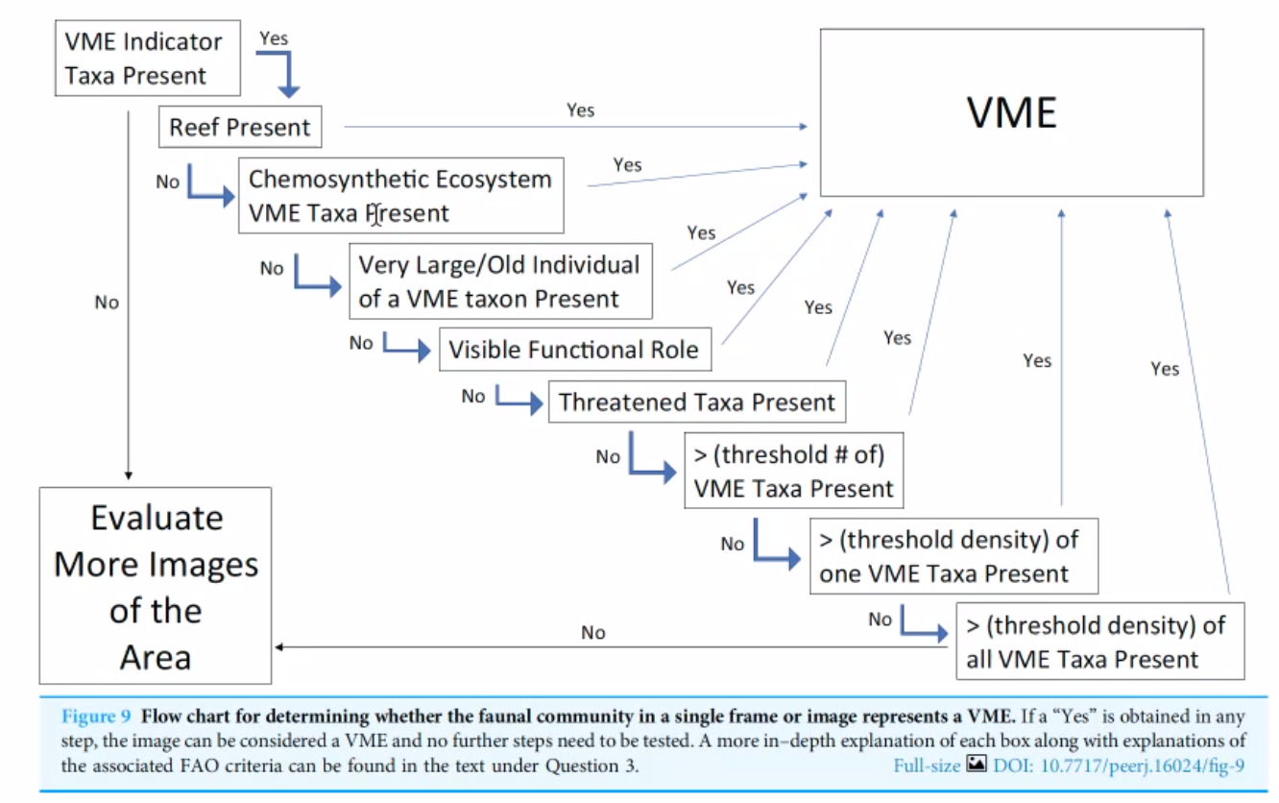

Amy Baco-Taylor will present this method for identifying VME at SSC BF-ME06 in December for consideration by Members.

Item 6. Discuss value of using fisheries VME indicator taxa bycatch data for managing VME and develop TOR if sharing is necessary

This topic was discussed at the first meeting of the SWG VME. Participants noted that SAI assessment will mostly rely on visual survey data. Therefore, sharing data on VME indicator taxa bycatch may not be needed. The participants view was generally there was not a need to share this data at the moment, but this decision could be revisited in the future.

Item 7. Literature review of connectivity, recruitment and recovery of VME indicator taxa among seamounts

As no progress was made on this task, the Lead suggested carrying it over to the next year. However, participants were informed that a proposal to form a new Working Group on Seamount Connectivity will be submitted at PICES’ BIO committee virtual meeting in September and then at the PICES annual meeting in November. The literature review on connectivity will be one of the components of this WG’s workplan. Several PICES countries, including Canada, Korea, and Russia, expressed interest in participation in the new WG. It was noted that all SWG VME participants were invited to join this initiative. The SWG VME supported these efforts and is looking forward to any updates from Members at SSC BF-ME06 in December.

It was suggested that the draft literature review on connectivity might be best completed in 2026. Potentially this activity could be in cooperation with a new PICES expert group.

Conclusions and recommendations for future work

There were two outstanding items from 2025 that need more work
- Using visual observation data to build new species distribution models for VME indicator taxa
- The literature review on seamount connectivity

There were two ongoing activities which may need consideration in 2026
- The completion of the updated risk assessments
- The generic call for new methods to identify VME

One item was brought up for consideration by the SSC BF-ME06 for discussion
- A workshop on VME and SAI that would follow-up on the 2018 workshop

