NPFC-2026-SSC NFS03-WP03

CPUE standardization of neon flying squid caught by Chinese Taipei’s squid jigging fishery up to 2024

Chih-Shin Chen¹, Don-Hsieh Chiang², Ren-Fen Wu², Han-Ching Chuang³

¹Institute of Marine Affairs and Resource Management, National Taiwan Ocean University, Keelung 202301.
²Overseas Fisheries Development Council of the Republic of China, Taipei 106018
³Fisheries Agency, Ministry of Agriculture, Taipei 100060

Summary
Catch and effort data for the Chinese Taipei neon flying squid fishery in the Northwest Pacific were collected from 2001 to 2024. However, the fishery was temporarily halted in 2010 and during 2012-2015. Catch per unit effort (CPUE) of neon flying squid was standardized using a generalized linear model (GLM) incorporating temporal, spatial, environmental, and vessel-related factors during 2016–2024. Most main explanatory variables and interaction terms included in the models were statistically significant. The standardized CPUE decreased from 2016 to 2018 and exhibited relatively limited interannual variation during 2019–2024.

1. Introduction
The neon flying squid (NFS), Ommastrephes bartramii, is a large oceanic squid widely distributed in the subtropical and temperate waters of the world’s oceans (Jereb and Roper, 2010). In the North Pacific, the NFS population comprises two seasonal cohorts, an autumn cohort hatching from September to February, and a winter-spring cohort hatching from January to August (Yatsu et al., 1997). The feeding grounds of the autumn cohort are located just east of 170°E, whereas those of the winter–spring cohort are distributed across the North Pacific. Thus, NFS caught west of 170°E are primarily considered part of the winter–spring cohort (the NW stock of Chen and Chiu, 2003).
In the North Pacific, NFS has been commercially exploited by international fishing fleets since the 1980s. The neon flying squid fishery of Chinese Taipei commenced in 1977, utilizing jigging gear for harvesting. During the 1980s, some fishing vessels deployed driftnets to harvest NFS. After the moratorium on high seas driftnet fishing took effect in late 1992, NFS has been harvested by jigging (hand and machine) after 1993.
Since 2000, the number of vessels and catches in the neon flying squid fishery have gradually declined, as most vessels were equipped with torch-light nets and shifted their target to Pacific saury in the Northwest Pacific. There were no vessels harvesting NFS during 2012–2015. Nevertheless, the neon flying squid fishery of Chinese Taipei resumed in 2016, operating as a part-time fishery in conjunction with the Pacific saury fishery. During 2016–2024, the number of active vessels ranged from 2 to 91, and the annual catches ranged from 2 to 3,589 tons.

2. Materials and methods
2.1. Fisheries data and water temperature
The catch data series of neon flying squid catch of Chinese Taipei’s squid-jigging fishery during 2016–2024 was used in this study. The fishery data for Chinese Taipei’s squid-jigging fishery have been collected by the Fisheries Agency and are maintained by the Overseas Fisheries Development Council (OFDC). The records include operation dates and locations, total squid catch (by weight category), and sea surface temperature (SST).
The catch data were compiled in a geographic reference format with a unit statistical grid of 0.5° (0.5° longitude by 0.5° latitude). Catch per unit effort (CPUE) was calculated as the weight of squid caught per vessel per day (i.e. t/vessel-day).
The Chinese Taipei squid fleet consists of vessels ranging from 700 to 1,200 GT, each vessel is typically manned by 30–40 fishers and equipped with 40–60 jigging machines. Fishing operations are conducted at night from about 18:00 h to 06:00 h. There is no bycatch in the fishery due to the high selectivity of the jig as a fishing gear.
The fishery data for neon flying squid used in this study consisted of 4,515 valid daily catch records collected between July and November during 2016–2024. The dataset comprised exclusively positive catch records. However, the annual distribution of records was uneven, with particularly limited fishing operations in 2018 (n = 2) and 2024 (n = 7).

2.2. Full model description and model selection
The generalized linear model (GLM) was applied to standardize the CPUE of NFS during 2016–2024. The explanatory variables included temporal factors (year and month), spatial factors (longitude and latitude), vessel characteristics (gross tonnage, GT), and environmental conditions (sea surface temperature, SST). Prior to fitting the GLM, Spearman correlation coefficients among explanatory variables were calculated. In addition, variance inflation factor (VIF) was used to measure the degree of multi-collinearity among the independent variables in models.
Given that fisheries CPUE data are typically right-skewed, the model error structure was assumed to follow a lognormal distribution. Accordingly, the natural logarithm of CPUE was used as the response variable in the GLM. The model formulation is expressed as follows:

ln(CPUE) = β₀ +Year + Month + Lat + Lon + GT + SST + two-way IAs + ε

where Year is a categorical variable from 2016 to 2024 (9 years), and Month is a categorical variable with 6 calendar months (July–November). Due to relatively limited data available in June, the June data was incorporated into the July data. Latitude (Lat) and longitude (Lon) were included as categorical variables to account for spatial variability. Vessel gross tonnage (GT) and sea surface temperature (SST) were each divided into four intervals and treated as categorical predictors. The model structure comprised an intercept (β₀), significant two-way interaction terms (two-way IAs), and an error term (ε), with ε assumed to follow a normal distribution, ε ~ N(0, σ²). A summary of the explanatory variables used in the GLM analyses is shown in Table 1.
Model assumptions followed the assumptions for GLM. Lognormal error distribution was assumed in the CPUE standardization. Model selection was conducted using a stepwise regression approach, in which the contribution of each additional predictor was evaluated based on changes in deviance explained and the proportion of deviance explained relative to the total explained deviance. In addition, the Akaike Information Criterion (AIC) was employed as an objective criterion for model comparison and selection. A suite of diagnostic tools, including residual distribution analyses and quantile–quantile (Q–Q) plots, was performed to evaluate model adequacy, goodness-of-fit, and the validity of the assumed error structure. Finally, the standardized CPUE index was derived from the optimal generalized linear model (GLM) and compared with the nominal CPUE to characterize long-term trends in the abundance of neon flying squid in the Northwest Pacific.

2.3. Year trend extraction
The standardized CPUE and its standard deviation (SD) represent the estimates of the mean and SD of predictions from the suggested model, respectively.

3. Results and discussion
During 2016–2024, the Chinese Taipei squid jigging fleet targeting NFS operated primarily in the NPFC Convention Area, mainly aggregating between 41–43°N and 161–163°E (Fig. 1).
Potential redundancy among explanatory variables was systematically evaluated using Spearman’s rank correlation coefficients and variance inflation factors (VIF). Most pairs of covariates exhibited significant monotonic correlations (p <0.001), with the exception of the relationships between SST and month, as well as between vessel tonnage and geographic coordinates (Table 2; Fig. 3). All VIF values were below the commonly accepted diagnostic threshold of 10 (Kleinbaum et al., 1988), indicating the absence of severe multi-collinearity among the predictors. These diagnostic results support the relative orthogonality of the selected explanatory variables and ensure the numerical stability and interpretability of the estimated GLM coefficients used for CPUE standardization.
The optimal model achieved an Akaike Information Criterion (AIC) value of 3,084 and explained 67.7% of the total deviance (Table 3), with the corresponding analysis of deviance presented in Table 4. Model diagnostics, including quantile–quantile (Q–Q) plots, residual histograms, and annual residual plots, indicated that the residuals were approximately normally distributed. These diagnostic results support the adequacy of the model fit and validate the assumption of a lognormal error structure adopted for CPUE standardization (Fig. 3).
The annual standardized CPUE values for NFS, derived from the optimal GLM, exhibited interannual variability over the study period (Fig. 4). The CPUE values decreased from 2016 to 2018 and exhibited relatively limited interannual variation during 2019–2024.
A comparison of the standardized CPUE sequence with the nominal CPUE sequence reveals that while the interannual variation patterns of the two indicators are broadly similar, the standardized CPUE exhibits less variability and a smoother temporal dynamic. This suggests that the significant fluctuations in nominal CPUE are largely attributable to changes in fishing effort distribution, fishing vessel characteristics, and environmental conditions, rather than solely to variations in population abundance itself. These results underscore the practicality of the standardization framework based on the generalized linear model (GLM) in providing more reliable indicators for assessing long-term trends in the abundance of NFS in the Northwest Pacific.

4. References

Chen, C-S., Chiu, T-S., 2003. Variations of life history parameters in two geographical groups of the neon flying squid, Ommastrephes bartramii, from the North Pacific. Fish. Res. 63, 349–366.
Jereb, P., Roper, C.F.E., (Eds.), 2010. Cephalopods of the world. An annotated and illustrated catalogue of cephalopod species known to date. Volume 2. Myopsid and Oegopsid Squids. FAO Species Catalogue for Fishery Purposes. No. 4, Vol. 2. FAO, Rome.
Kleinbaum, D.G., Kupper, L.L., Muller, K.E., 1988. Applied Regression Analysis and Other Multivariable Methods. 2nd Ed. Boston: PWS-Kent. 718 pp.
Matsui, H., Nishizawa, B., Okamoto, S., Oshima, K., 2024, Differences in the distribution of the neon flying squid by spawning cohort in the North Pacific Ocean based on the results of age determination using statoliths. NPFC-2024-SSC NFS01-WP10.
Nishizawa, B., Matsui, H., Okamoto, S., Oshima, K., 2025. Standardized CPUE for the autumn and winter-spring cohorts of neon flying squid based on Japanese driftnet surveys from 2001 to 2024. NPFC-2025-SSC NFS02-WP03.
Yatsu, A., Tanaka, H., Mori, J., 1998. Population structure of the neon flying squid, Ommastrephes bartramii, in the North Pacific Ocean. In: Okutani, T. (Ed.) International symposium on large pelagic squids. Japan Marine Fishery Resources Research Center, Tokyo, pp 31–48.

Table 1. Explanatory variables used in the GLM analyses for CPUE standardization of neon flying squid caught by Chinese Taipei’s squid jigging fishery.

Variables | Codes | No. of Categoroes | Description
Year | Year | 9 | 2016–2024
Month | Month | 5 | July–November
Latitude | Lat | 25 | 0.5° × 0.5° grids  (33.75°N – 48.25°N)
Longitude | Lon | 48 | 0.5° × 0.5° grids  (146.25°E – 169.75°E)
Vessel size (Gross Tonnage) | GT | 4 | (1) <950; (2) 950-1050;  (3) 1050-1200; (4) ≥1200 (tons)
Sea Surface Temperature | SST | 4 | (1) <16; (2) 16-17;  (3) 17-18; (4) ≥18 (°C)

Table 2. Spearman correlation coefficient and variance inflation factor among the explanatory variables.

 | Coefficient / p value |  |  |  |  |  | VIF
 | Year | Month | Lat. | Lon. | SST | GT | VIF
Year |  | <0.001 | <0.001 | <0.001 | <0.001 | <0.001 | 1.43
Month | 0.120 |  | <0.001 | <0.001 | 0.104 | <0.001 | 2.63
Lat. | 0.257 | 0.113 |  | <0.001 | <0.001 | 0.009 | 1.17
Lon. | 0.192 | -0.621 | -0.122 |  | <0.001 | 0.645 | 2.85
SST | -0.168 | -0.045 | -0.278 | -0.228 |  | 0.105 | 1.29
GT | 0.262 | 0.116 | 0.072 | -0.013 | -0.045 |  | 1.08
Spearman correlation coefficients are shown under the table, and p-values are shown above the table.

Table 3. Results of model selection using a GLM approach for CPUE standardization of neon flying squid caught by Chinese Taipei’s squid jigging fishery.

No. | Model | AIC | Exp. Dev. (%)
1 | ln(CPUE) ~ β + Year | 3595 | 28.4
2 | ln(CPUE) ~ β + Year + Month | 3549 | 33.5
3 | ln(CPUE) ~ β + Year + Month + Lat | 3518 | 35.5
4 | ln(CPUE) ~ β + Year + Month + Lat + GT | 3504 | 36.5
5 | ln(CPUE) ~ β + Year + Month + Lat + GT + SST | 3497 | 37.1
6 | ln(CPUE) ~ β + Year + Month + Lat + GT + SST + Year:Month | 3300 | 51.4
7 | ln(CPUE) ~ β + Year + Month + Lat + GT + SST + Year:Month + Year:Lat | 3211 | 55.9
8 | ln(CPUE) ~ β + Year + Month + Lat + GT + SST + Year:Month + Year:Lat + Lat:Month | 3173 | 59.8
9 | ln(CPUE) ~ β + Year + Month + Lat + GT + SST + Year:Month + Year:Lat + Lat:Month + Year:GT | 3130 | 62.3
10 | ln(CPUE) ~ β + Year + Month + Lat + GT + SST + Year:Month + Year:Lat + Lat:Month + Year:GT + Lat:SST | 3105 | 65.1
11 | ln(CPUE) ~β + Year + Month + Lat + GT + SST + Year:Month + Year:Lat + Lat:Month + Year:GT + Lat:SST + Month:GT | 3095 | 66.0
12 | ln(CPUE) ~β + Year + Month + Lat + GT + SST + Year:Month + Year:Lat + Lat:Month + Year:GT + Lat:SST + Month:GT + Year:SST | 3091 | 67.1
13 | ln(CPUE) ~ β + Year + Month + Lat + GT + SST + Year:Month + Year:Lat + Lat:Month + Year:GT + Lat:SST + Month:GT + Year:SST+ Month:SST | 3084 | 67.7

Table 4. Analysis of deviance table of the GLM approach for CPUE standardization of neon flying squid caught by Chinese Taipei’s squid jigging fishery.

Variables | df | F | p-value | Signif. codes
Year | 8 | 113.24 | < 0.001 | ***
Lat | 24 | 6.68 | < 0.001 | ***
Month | 4 | 15.69 | 0.020 | ***
GT | 3 | 10.35 | < 0.001 | ***
SST | 3 | 6.51 | < 0.001 | ***
Year:Lat | 69 | 6.61 | < 0.001 | ***
Year:Month | 19 | 7.61 | < 0.001 | ***
Lat:Month | 41 | 3.03 | < 0.001 | ***
Year:GT | 19 | 4.08 | < 0.001 | ***
Lat:SST | 38 | 2.37 | < 0.001 | ***
Month:GT | 12 | 2.36 | 0.005 | **
Year:SST | 19 | 1.83 | 0.016 | *
Month:SST | 10 | 2.13 | 0.020 | *
***, < 0.001; **, < 0.01; *, < 0.05

Final model
ln(CPUE) ~ β + Year + Lat + Month + GT + SST + Year:Lat + Year:Month + Lat:Month + Year:GT+ Lat:SST + Month:GT+ Year:SST + Month:SST + ε

Table 5. Nominal CPUEs, standardized CPUEs, and summary statistics by the GLM approach for the Chinese Taipei squid-jigging fishery in the Northwestern Pacific from 2016 to 2024.

Year | Nominal CPUE (mt/vessel/day) | Standardized CPUE  (GLM) | SD  (GLM) | 95% CI (GLM)
 |  |  |  | Lower | Upper
2016 | 4.77 | 4.53 | 4.00 | 3.22 | 5.83
2017 | 2.00 | 1.71 | 0.62 | 1.45 | 1.96
2018 | 0.89 | 0.88 | 0.55 | -0.61 | 2.38
2019 | 0.97 | 0.84 | 0.33 | 0.79 | 0.90
2020 | 0.99 | 0.81 | 0.89 | 0.54 | 1.08
2021 | 0.60 | 0.54 | 0.30 | 0.40 | 0.67
2022 | 0.75 | 0.64 | 0.75 | 0.41 | 0.87
2023 | 1.04 | 0.83 | 0.80 | 0.58 | 1.08
2024 | 0.60 | 0.60 | 0.54 | -0.18 | 1.80

Figure. 1. Distributions of fishing effort (day/vessel) for Chinese Taipei squid jigging fishery in the NPFC Convention Area between 2016 and 2024.

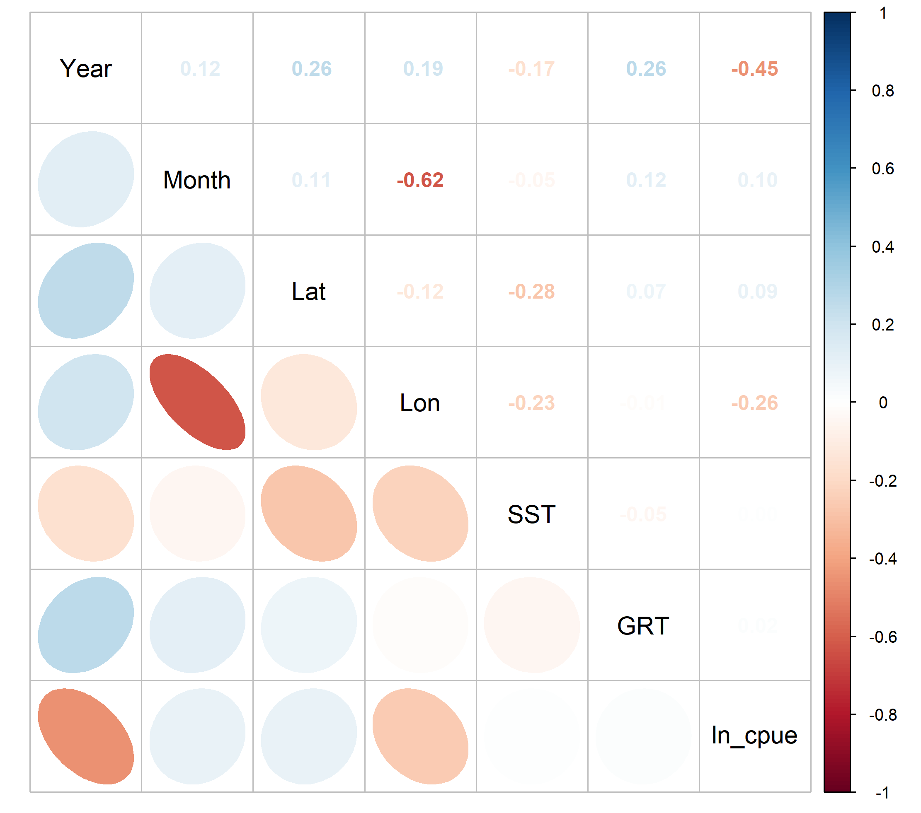

Figure 2. Correlation matrix of explanatory variables used in the GLM analyses for neon flying squid CPUE standardization.

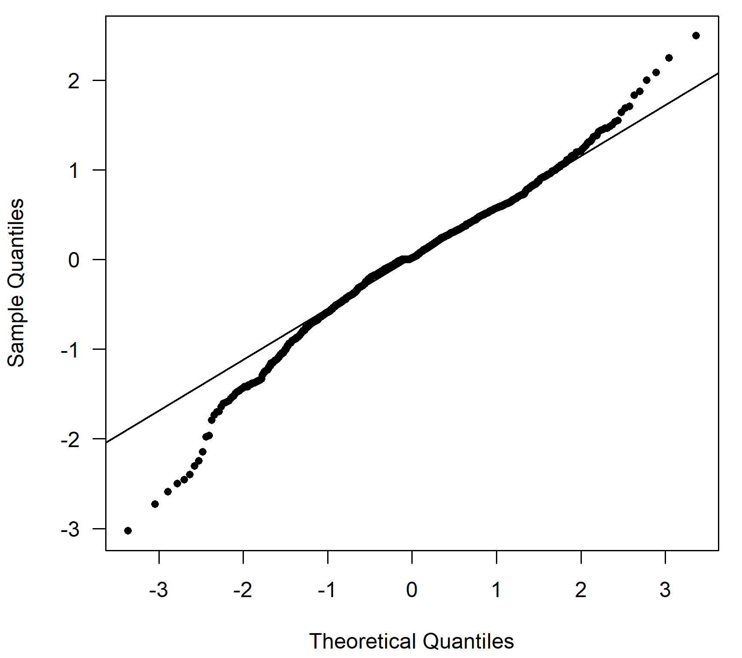 | 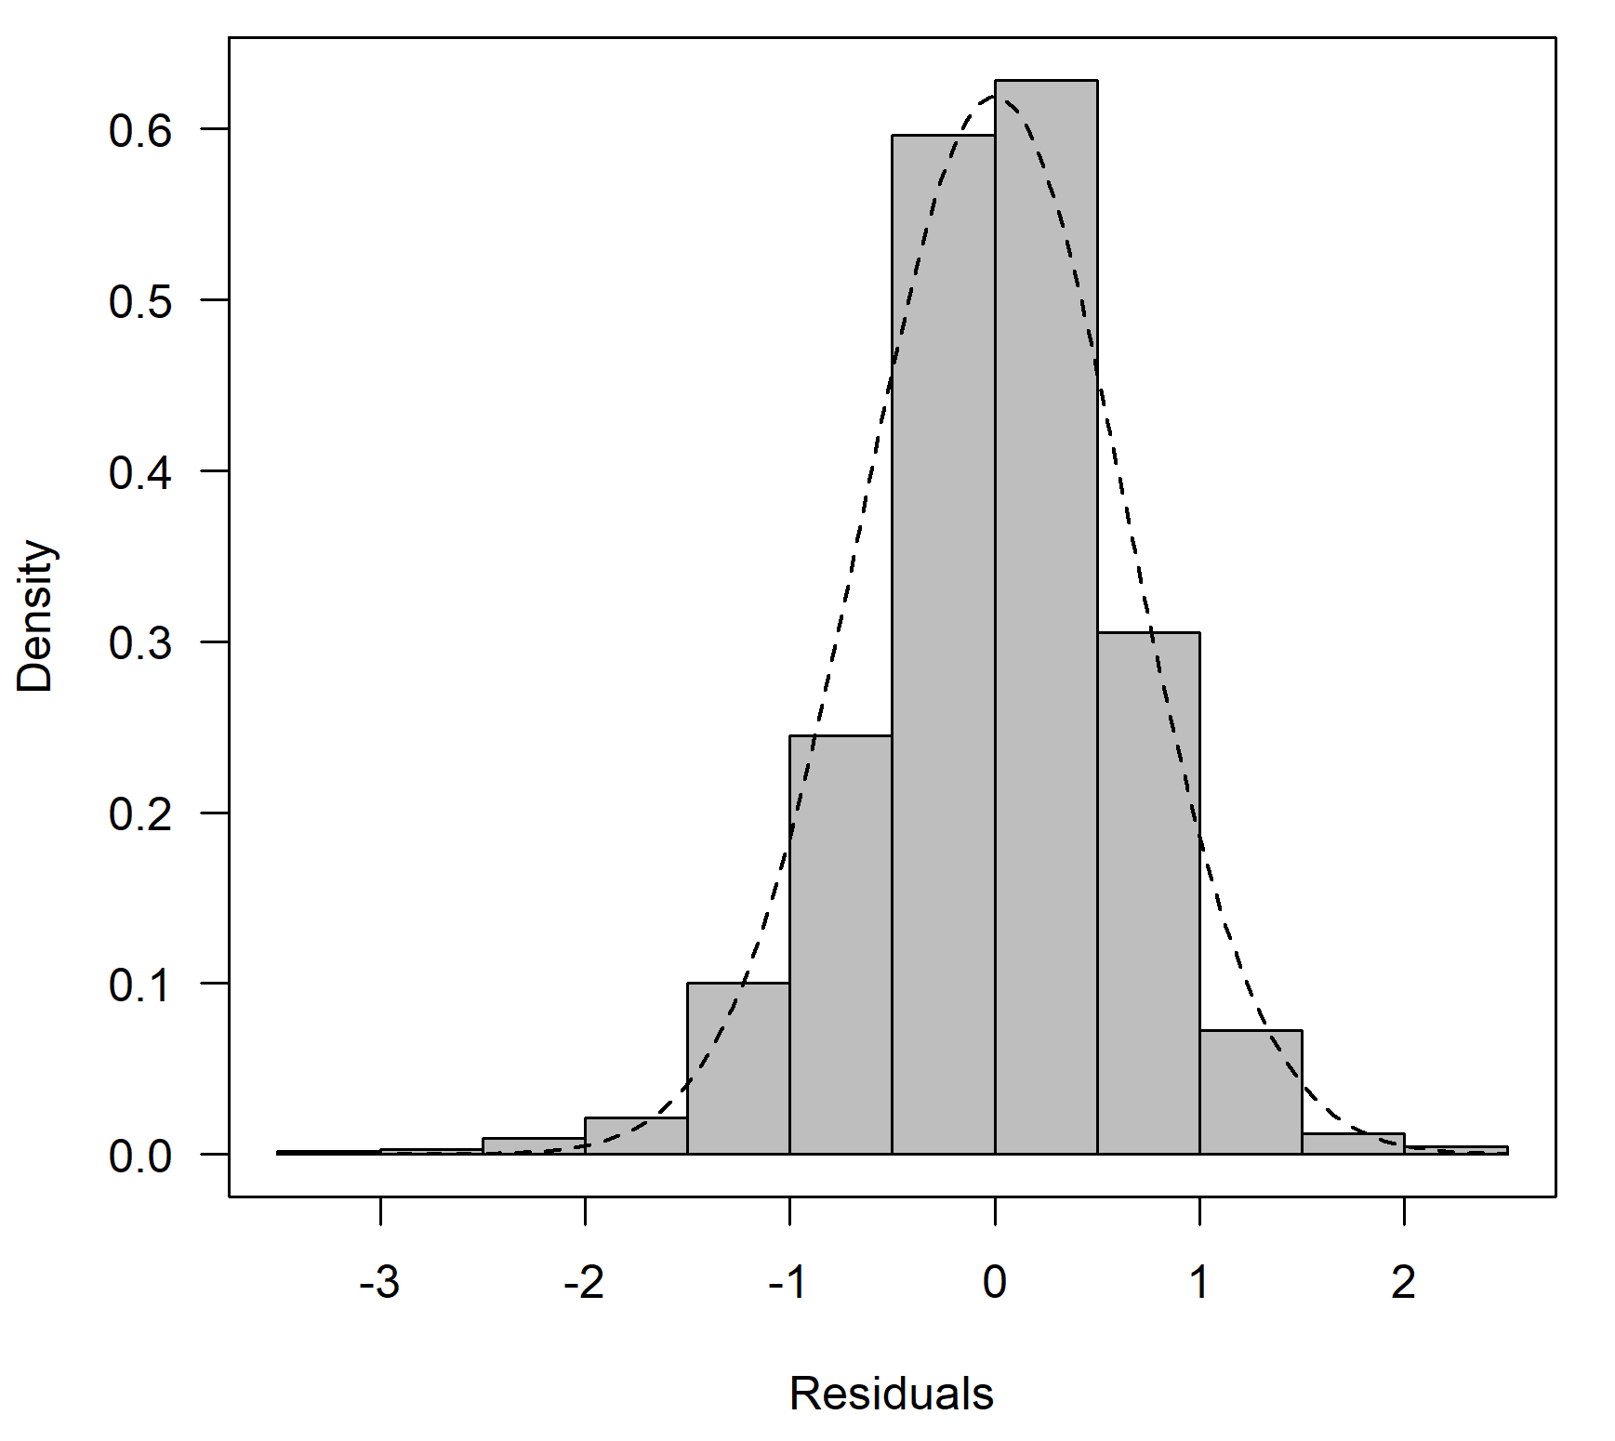
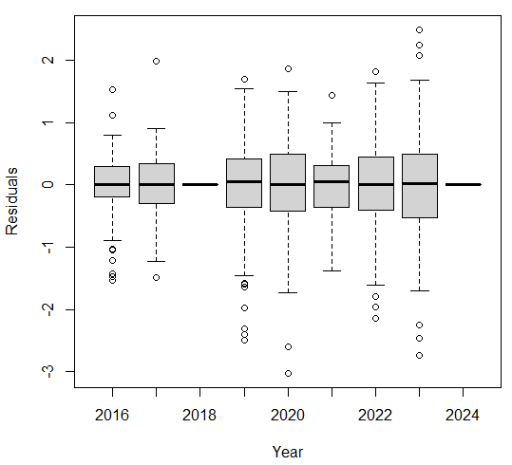

Figure 3. Q-Q plots, histograms of residuals, and residual plots across years for the best model from the GLM approach.

Figure 4. The nominal CPUE (gray) and standardized CPUE (GLM, blue) of neon flying squid for Chinese Taipei squid jigging fishery in the Northwest Pacific from 2016 to 2024. (shaded, 95% confidence interval)

