NPFC-2026-SSC NFS03-WP06

Interannual trends in the abundance and biomass of the autumn and winter-spring cohorts defined by two cohort separating methods
using Japanese driftnet survey data

Bungo Nishizawa*, Hajime Matsui, Suguru Okamoto, and Kazuhiro Oshima

Fisheries Resources Institute, Japan Fisheries Research and Education Agency
*Corresponding Author
E-mail: nishizawa_bungo05@fra.go.jp

1. Summary
In this study, using driftnet survey data, we investigate the interannual trends in the abundance, biomass, and abundance-based CPUE of the two cohorts separating using two methods: separating them by the 170˚E line and by size. Similar trends in abundance, biomass, and abundance-based CPUE were observed for the winter-spring cohort using the two cohort-separating methods. However, for the autumn cohort, there were large differences in abundance and abundance-based CPUE between the two cohort-separating methods in some years due mainly to the high abundance of smaller squid (<30 cm) sampled in the area east of the 170°E line. While the overall interannual trends in the biomass were similar for both cohorts between the two cohort-separating methods, information on the size of squid caught by the commercial jigging fishery should be confirmed for cohort-specific stock assessments.

2. Introduction
The neon flying squid is an oceanic squid that occurs worldwide in subtropical and temperate waters (Roper et al. 1984). The North Pacific population comprises an autumn cohort and a winter-spring cohort (Yatsu et al. 1997, 1998). Since the spatial distribution ranges of each cohort overlap especially in the area east of 170˚E (Matsui et al. 2024a, b), the catch possibly contains both cohorts. This suggests that the 170°E boundary line alone may be insufficient for appropriately separating the cohorts (Matsui et al. 2024a). For more accurate separation of the cohorts, it is important to consider the size composition of the catch (Small Scientific Committee on Neon Flying Squid 2024, 2025). In this study, using driftnet survey data, we compared the interannual trends in the abundance, biomass, and abundance-based CPUE of the two cohorts separating using two methods: separating them by the 170˚E line and by size. This study may provide insight into discussions about separating the two cohorts of neon flying squid for conducting cohort-specific stock assessments.

3. Methods
We conducted driftnet surveys onboard the R/V Kaiun-maru (Aomori Prefecture, Japan) annually from June to August (mostly in July) in the western North Pacific. Driftnet surveys were made at 14–26 sites each year from 2001 to 2025. Each driftnet site was generally located on three longitudinal lines at 175.5ºE, 155ºE, and 144ºE between 30ºN and 50ºN. At each driftnet station, 50 panels of net were deployed in the evening and retrieved the following morning at sunrise. The time duration from the net deployment to retrieval was 10-13 h. Each panel was 50 m long and 7 m deep. The survey driftnets comprised non-size-selective nets (14 mesh sizes ranging from 22 to 157 mm) to catch different sizes of squid. The dorsal mantle length (ML) of all squid caught was measured onboard to the nearest 1 cm.

From 2001 to 2025, a total of 30,154 neon flying squid were collected with driftnet surveys. These squids were separated into two cohorts (autumn and winter-spring cohorts) using two different methods: sampled location and size of squid. Using the sampled location, we defined the individuals captured in the area east and west of 170°E as the “autumn cohort” and “winter-spring cohort”, respectively. On the other hands, using the size of the squid, individuals with a ML of 30 cm or smaller and lager than 31 cm were regarded as the “winter-spring cohort” and the “autumn cohort”, respectively (Ichii et al. 2004, Nishizawa et al. 2024, 2025). Then, we compared the abundance (the number of squids captured), biomass (the weight of squids captured), and abundance-based CPUE of NFS (number of individuals per driftnet panel) between the two separation methods.

4. Results and Discussion
From 2006 to 2024, the years during which the survey areas included locations east and west of 170°E, neon flying squid were captured across a broad range of our study area (Fig. 1). According to their size distribution, larger squids (> 31 cm) were mainly captured from the area east of 170°E (Fig. 2), while smaller squid (< 30 cm) were captured from both sides of 170°E.

Figure 3 shows the interannual trends in abundance, biomass, and abundance-based CPUE for two cohorts, which are separated using two different methods (170°E and size). Similar trends in abundance, biomass, and CPUE were observed for the winter-spring cohort using the two cohort-separating methods. However, for the autumn cohort, there were large differences in abundance and abundance-based CPUE between the two methods. For instance, in 2008 and 2023, the abundance and abundance-based CPUE of the autumn cohort defined by the 170°E line was much higher than the abundance defined by size. This difference was due to the high abundance of smaller squid (<30 cm) being collected in the area east of the 170°E line. However, the differences were less obvious in the biomass because the smaller squid did not largely contribute to the total weight.

Using driftnet survey data, this study reported interannual trends in the abundance and biomass of the autumn and winter-spring cohorts defined by two cohort separating methods. While the overall interannual trends in the biomass were similar for both cohorts between the two cohort-separating methods, information on the size of squid caught by the commercial jigging fishery should be confirmed for cohort-specific stock assessments.

References
Ichii T, Mahapatra K, Sakai M, Inagake D, Okada Y (2004) Differing body size between the autumn and the winter−spring cohorts of neon flying squid (Ommastrephes bartramii) related to the oceanographic regime in the North Pacific: a hypothesis. Fisheries Oceanography 13: 295−309
Matsui H, Nishizawa B, Okamoto S, Oshima K (2024a) Differences in the distribution of the neon flying squid by spawning cohort in the North Pacific Ocean based on the results of age determination using statoliths. NPFC-2024-SSC NFS01-WP10
Matsui H, Nishizawa B, Okamoto S, Oshima K (2024b) Brief summary of the Japanese surveys for spawning grounds of the neon flying squid in the North Pacific Ocean. NPFC-2024-SSC NFS01-WP11
Nishizawa B, Matsui H, Okamoto S, Oshima K (2024) Standardizing catch per unit effort for the autumn and winter-spring cohorts of neon flying squid based on Japanese driftnet surveys. NPFC-2024-SSC NFS01-WP09
Nishizawa B, Matsui H, Okamoto S, Oshima K (2025) Standardized CPUE for the autumn and winter-spring cohorts of neon flying squid based on Japanese driftnet surveys from 2001 to 2024. NPFC-2025-SSC NFS02-WP03
Roper CFE, Sweeney MJ, Nauen CE (1984) FAO species catalogue. Vol 3: cephalopods of the world. An annotated and illustrated catalogue of species of interest to fisheries. FAO Fish Synop 125, Rome
Small Scientific Committee on Neon Flying Squid (2024) 1st meeting report. NPFC-2024-SSC NFS01-Final Report. 30 pp.
Small Scientific Committee on Neon Flying Squid (2025) 2nd meeting report. NPFC-2025-SSC NFS02-Final Report. 31 pp.
Yatsu A, Midorikawa S, Shimada T, Uozumi Y (1997) Age and growth of the neon flying squid, Ommastrephes bartramii, in the North Pacific Ocean. Fish Res 29:257–270
Yatsu A, Tanaka H, Mori J (1998) Population structure of the neon flying squid, Ommastrephes bartramii, in the North Pacific Ocean. In: Okutani T (ed) International symposium on large pelagic squids. Japan Marine Fishery Resources Research Center, Tokyo, p 31–48

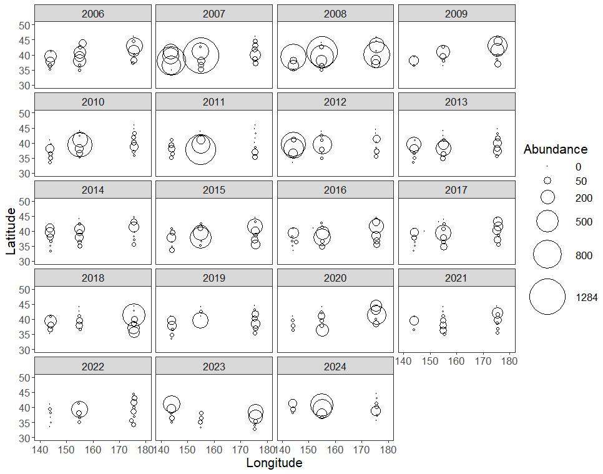
Fig. 1. The number of Ommastrephes bartramii (all individuals) caught at each driftnet survey station between 2006 and 2024. These years included survey areas both east and west of the 170°E.

Fig. 2. Histogram for mantle length of Ommastrephes bartramii (n = 30,154 individuals) caught by driftnet surveys. The black arrow indicates the 31 cm boundary, separating the two cohorts (autumn and winter-spring cohorts). The red bars show individuals caught west of 170E, while the blue bars are individuals caught east of 170E.

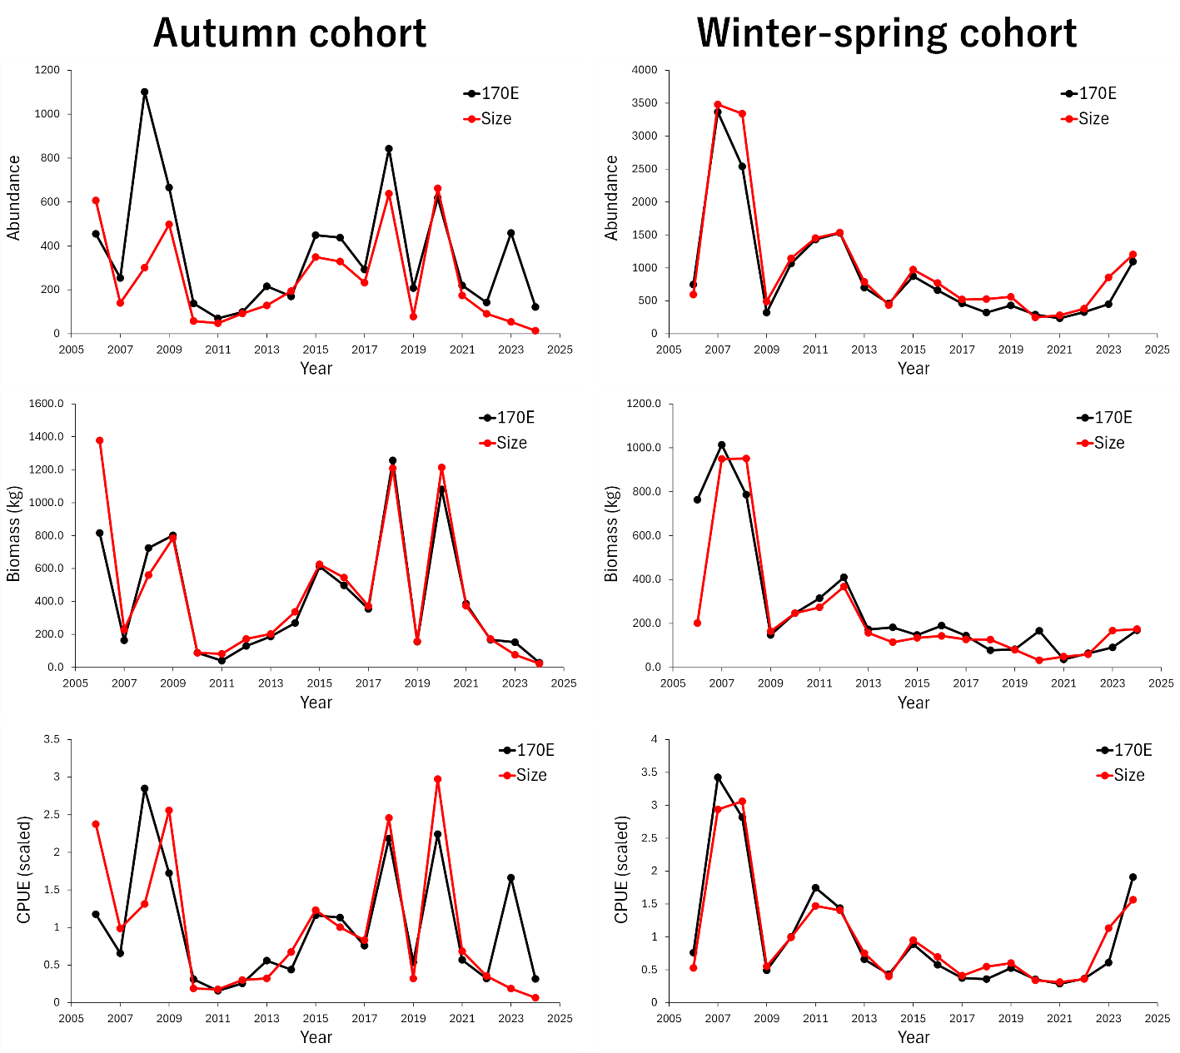

Fig. 3. Interannual trends in abundance, biomass, and abundance-based CPUE for two cohorts, which are separated using two different methods (170°E and size).

