NPFC-2026-SSC NFS03-WP07

Preliminary standardized CPUE for the autumn cohort of neon flying squid caught by Japanese squid jigging fishery from 2007 to 2025
in the North Pacific

Bungo Nishizawa*, Hajime Matsui, Suguru Okamoto, and Kazuhiro Oshima

Fisheries Resources Institute, Japan Fisheries Research and Education Agency

*Corresponding Author
Email: nishizawa_bungo05@fra.go.jp

- Summary
We standardized the catch per unit effort (CPUE) of the autumn cohort of neon flying squid (Ommastrephes bartramii), based on Japanese squid jigging fisheries in the North Pacific during the summer between 2007 and 2025. The cohort was defined as individuals caught in areas east of the 170°E longitude line. We used generalized additive models to standardize the nominal CPUE, incorporating temporal (year and month) and spatial (longitude and latitude) variables. The model with the lowest AIC value was selected as the best performing model. We found that the annual standardized CPUE derived from the best GAM showed a similar trend to the nominal CPUE. Although there is still room for improvement in cohort separation methods, this standardized CPUE can serve as a fishery-dependent abundance index in future stock assessments of this species.

Introduction
The neon flying squid (NFS) is an oceanic squid occurring in subtropical and temperate waters around the world (Roper et al. 1984), and the North Pacific population comprises an autumn cohort and a winter-spring cohort (Yatsu et al. 1997, 1998). For the cohort-specific stock assessments of this species, indices of abundance based on fishery CPUE are essential (Maunder and Punt 2004). Here, we present Japanese fishery-dependent CPUE for autumn cohort of neon flying squid and CPUE standardized by a generalized additive model (GAM) that incorporates temporal and spatial variables.

Methods
Data on Japanese squid jigging fisheries was obtained from fishing logbooks during summer (May to September) from 2007 to 2025. The data includes the date of catch, the daily fishing location (longitude and latitude), and the daily catch in weight for each fishing vessel. While fishing locations were available for all vessels targeting neon flying squid from 2017 onward, location data was unavailable for some vessels prior to 2016. Therefore, data from all vessels was used for CPUE standardization starting in 2017, while data from only some vessels (those providing complete information, hereafter called “sampling vessels”) was used before 2016 (see Table 1). Prior to standardization, we examined whether the spatial distribution of fishing locations and the annual trends in nominal CPUE differed between the sample vessels and other vessels. We confirmed that there was no discrepancy in the spatial distribution of fishing locations or the annual trends in nominal CPUE between the sample vessels and other vessels (Figs. 1 and 2). In this study, we defined the NFS catches in the waters east of 170°E longitude as the “autumn cohort” for calculation purposes.

Standardization of CPUE for NFS was conducted following the standardization protocol for NFS (NPFC-2024-SSC NFS01-WP02). The nominal CPUE was calculated by dividing the total catch by the total number of operating days. We used a generalized additive model (GAM) to standardize nominal CPUE, with CPUE (catch/day/vessel, n = 20,696) as the response variable, assuming a log-normal error. Year, Month, and operational location (interaction between longitude and latitude) were included as explanatory variables (equation 1). Year and month were categorical variables, and the functions such as s(Lon, Lat) were spline functions.

$$\ln\left(CPUE\right)= Intercept+Year+Month+s(Lon, Lat)+ε, ε \sim N(0, σ2) (1)$$

We considered four models, always including at least Year (Table 2) and assumed that the model with lowest Akaike Information Criterion (AIC) value is the best model (Burnham and Anderson 2010).

Time series of standardized CPUE were estimated using the best GAM. We used the expanded grid function in R software to generate a series of explanatory variables and then calculated predicted values of CPUE. Then, the annual standardized CPUE was calculated as the mean of the CPUE. The 95% confidence intervals for the standardized CPUE were calculated by bootstrap resampled residuals with 1000 replications.

Results and discussion
During the summer months, Japanese squid jigging fisheries are typically found in the region spanning 175°E to 195°E and 40°N to 45°N (Fig. 3). CPUE was slightly higher between June and August than in May and September (Fig. 1). There was variation in CPUE between years, with low values observed in 2010–2011 and 2013 (Fig. 3).

Based on AIC, the full model was selected as the best GAM (Table 2). The diagnostics of the best model are shown in Figure 4. The Q-Q plot and the distribution of residuals indicated that the residuals were normally distributed around 0, although long tails were observed at both ends. Additionally, there were no trends in the residuals across the years. Furthermore, the GAM-derived effects of the variables on CPUE well reflected their original relationships, as shown in Figure 5. These results suggest that the best GAM appropriately modeled CPUE.

The annual standardized CPUE derived from the best GAM for the autumn cohort exhibited a similar trend to the nominal CPUE (Fig. 6). Since 2007, the lowest values of CPUE were recorded in 2010 and 2011 (Fig. 6 and Table 1). The logbook data from the squid jigging fishery provides vessel-specific daily catch and effort information, but does not include any size-category data. Therefore, CPUE during the summer fishing season cannot be separated into two cohorts based on size information. In this document, the autumn cohort was defined as NFS caught in waters east of 170°E, without considering size composition. The proportion of the winter-spring cohort catch in the annual total catch during the summer fishing season ranged 0.5% to 10.0%, with an average of 4.1% from 2010 to 2025 (Matsui et al., 2026). Although some catch from the winter-spring cohort is included in the total catch in waters east of 170°E, the 170°E boundary can be regarded as conventional and practical criterion for the cohort separation in CPUE analysis.

References
Burnham KP, Anderson DR (2010) Model selection and multi-model inference: a practical information-theoretic approach, 2nd edn. Springer, New York
Matsui H, Nishizawa B, Okamoto S, Oshima K (2026) Size composition of neon flying squid caught by Japanese squid jigging vessels in waters east of 170°E in 2025 and a preliminary estimation of catch by cohort. NPFC-2026-SSC NFS03-WPXX.
Maunder, M.N., Punt, A.E., 2004. Standardizing catch and effort data: a review of recent approaches. Fish. Res. 70: 141–159.
Nishizawa B, Matsui H, Okamoto S, Oshima K (2024) Standardizing catch per unit effort for the autumn and winter-spring cohorts of neon flying squid based on Japanese driftnet surveys. NPFC-2024-SSC NFS01-WP09
Roper CFE, Sweeney MJ, Nauen CE (1984) FAO species catalogue. Vol 3: cephalopods of the world. An annotated and illustrated catalogue of species of interest to fisheries. FAO Fish Synop 125, Rome
Yatsu A, Midorikawa S, Shimada T, Uozumi Y (1997) Age and growth of the neon flying squid, Ommastrephes bartramii, in the North Pacific Ocean. Fisheries Research 29:257–270
Yatsu A, Tanaka H, Mori J (1998) Population structure of the neon flying squid, Ommastrephes bartramii, in the North Pacific Ocean. In: Okutani T (ed) International symposium on large pelagic squids. Japan Marine Fishery Resources Research Center, Tokyo, p 31–48
Table 1. Summary of the Japanese squid jigging fisheries, as well as the nominal CPUE (total catch per total days operated) and standardized CPUE for the autumn cohort of Ommastrephes bartramii between 2007 and 2025.

Table 2. Results of model selection based on AIC for the autumn cohort of Ommastrephes bartramii. The best model with lowest AIC for each cohort is shown in bold.

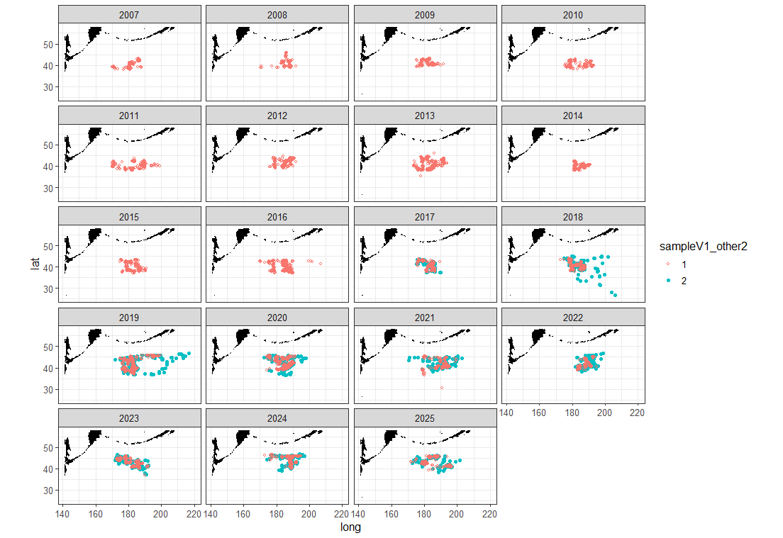
Fig. 1. Spatial distributions of fishing locations between 2007 and 2025. Red circles represent sampling vessels and blue circles show other vessels.

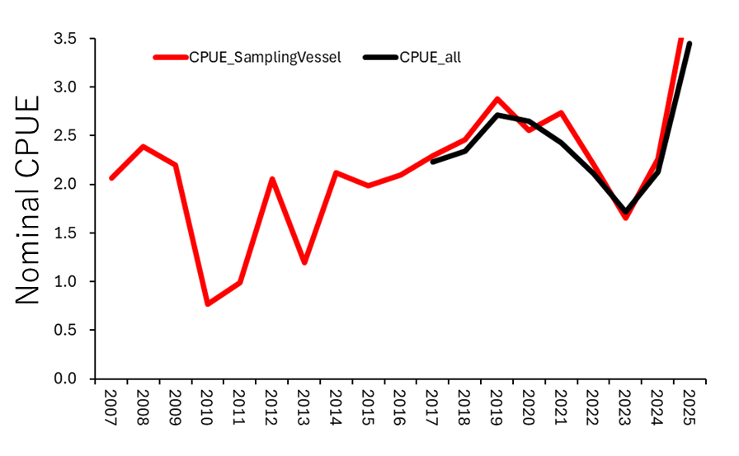
Fig. 2. Interannual trend in nominal CPUEs for sampling vessels (red line) and all vessels including sampling vessels (black line).

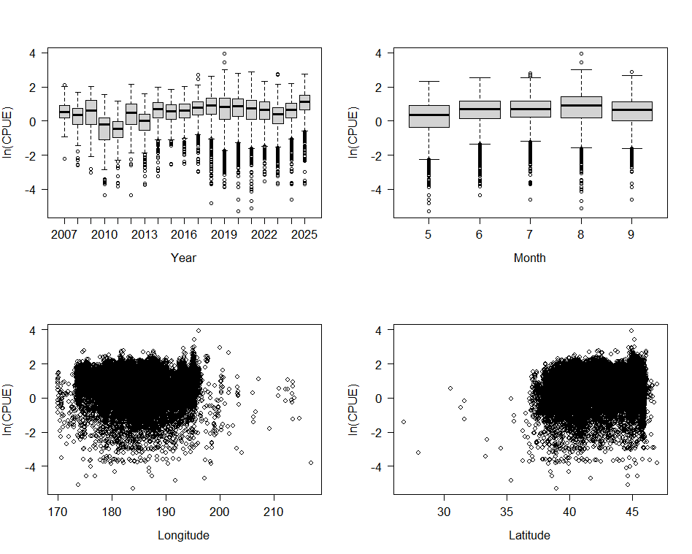
Fig. 3. Relationship between CPUE and each explanatory variable (Year, Month, Longitude, and Latitude).

Fig. 4. Diagnostics of the best model for the autumn cohort of Ommastrephes bartramii, including Q-Q plot, histogram of residuals, the relationship between observed and fitted values, and the residual plots across years and months.

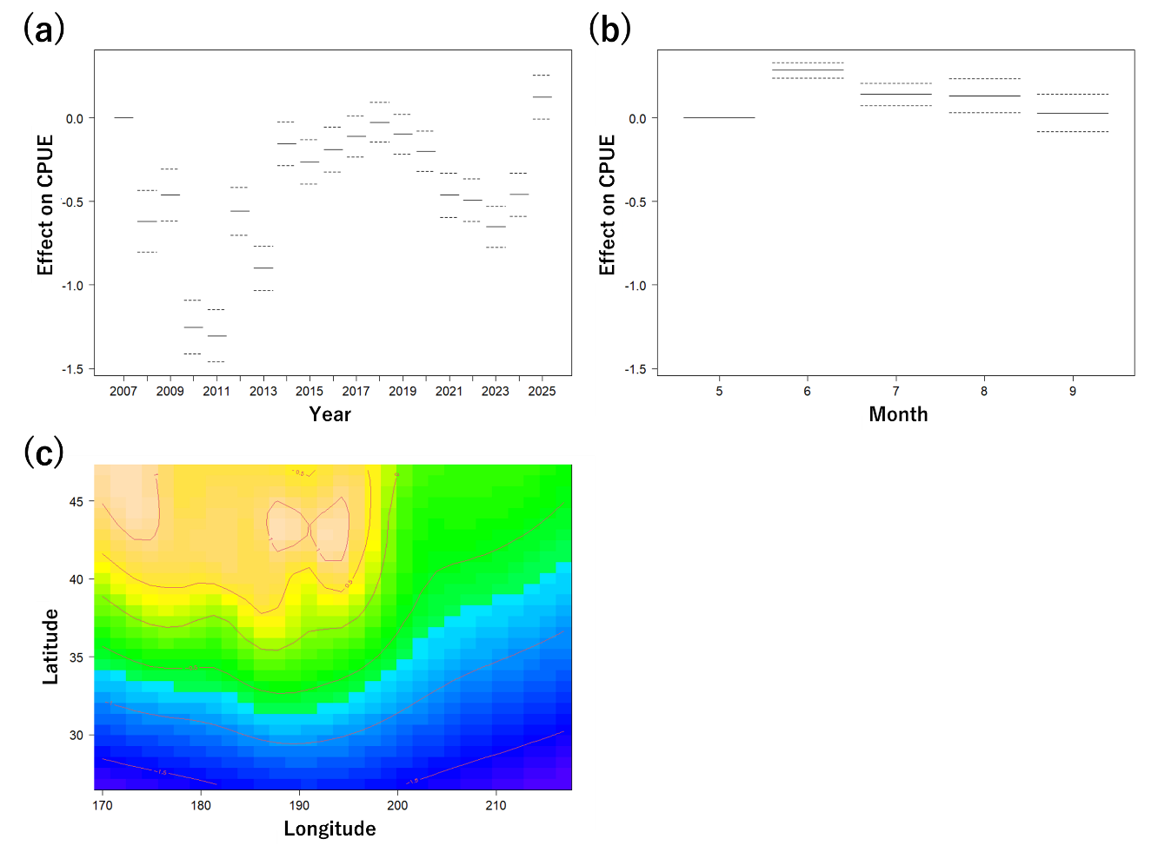
Fig. 5. GAM-derived effect of explanatory variables (a: Year, b: Month, c: Latitude and Longitude) on CPUE for the autumn cohort in the best model. The dotted lines indicate the 95% conﬁdence intervals, and the solid line shows the ﬁtted GAM function that describes the effect of a predictor variable on CPUE. The warmer color in (c) represents a higher CPUE estimated by the best GAM.

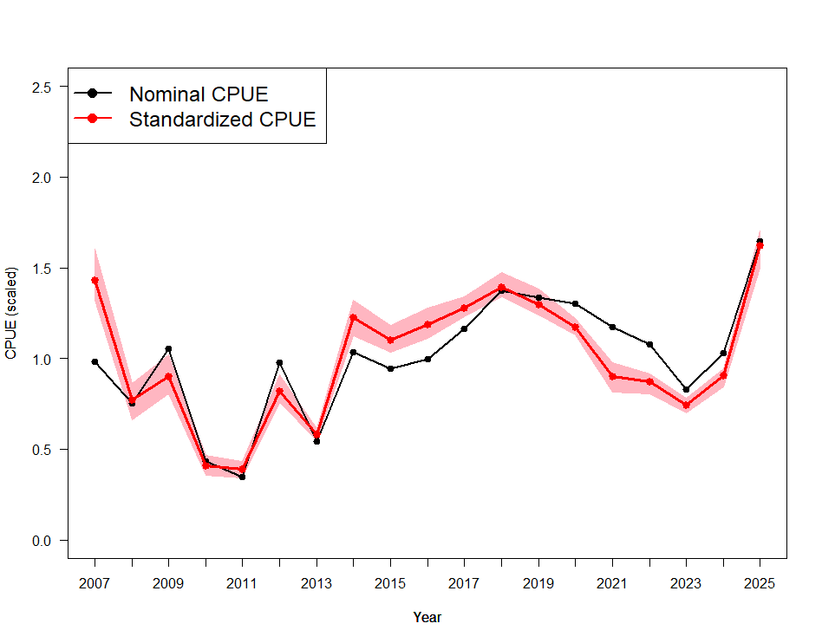
Fig. 6. Interannual changes in CPUE for the autumn cohort of Ommastrephes bartramii between 2007 and 2025. The black and red lines indicate nominal and standardized CPUE, respectively. The shaded red areas indicate the 95% bootstrap confidence intervals, obtained by resampling the data 1,000 times.

