NPFC-2026-COM10-WP02 Rev.1

Submitted by Japan and Korea

Proposed revisions to CMM 2025-07 for Chub Mackerel

Abstract

Rev.1: Korea is added as a co-sponsor (25 March 2026)

Japan proposes amendments to CMM 2025-07 to update catch limits for 2026.

Explanatory Note

The NPFC Technical Working Group on Chub Mackerel Stock Assessment (TWG-CM) conducted stock assessment for Chub mackerel, and the stock assessment report was endorsed by the 10th meeting of the Scientific Committee. The assessment report indicates that SSB has been on the sharp decline since 2018, along with a drastic decrease in maturity at age and in the weight at age, which resulted in an unprecedented drop in spawners per recruit without fishing (SPR0) since 2016.

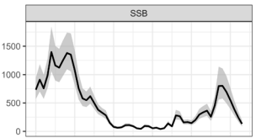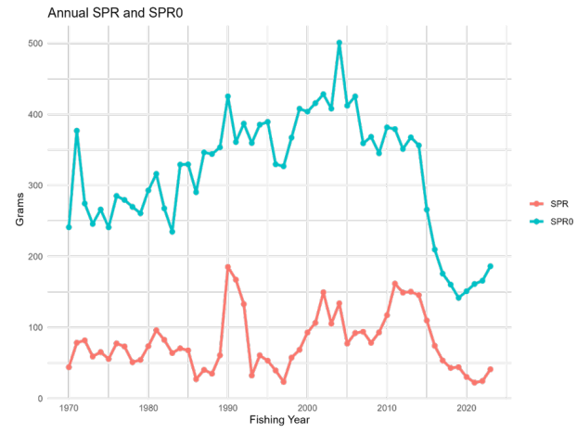

The NPFC stock assessment report advised that the current (2021-2023) fishing mortality is unsustainable and showed probabilities of achieving reference levels under F-constant scenarios, 50 percentile, and 70 percentiles of the estimated historical SSB. The 10th meeting of the Scientific Committee in December 2025 (SC10) recommended the reduction of fishing mortality to recover SSB, taking into account the future projections. According to the future projections provided in the Table below, in order to achieve 70 percentile SSB or 50 percentile SSB by 2036 with a probability of at least 50%, it is necessary to reduce fishing mortality to the following level, respectively:
70 percentile of the historical SSB: F55%SPR (50% probability in 2036),
50 percentile of the historical SSB: F40%SPR (53% probability in 2036).

Table 1 of the stock assessment report provides the ratios of F60%SPR, F50%SPR and F40%SPR relative to the current fishing mortality (Fcur) as follows:
F60%SPR/Fcur=0.207
F50%SPR/Fcur=0.295
F40%SPR/Fcur=0.412.

The proxies of the catch levels equivalent to F60%SPR, F50%SPR and F60%SPR can be calculated in the following manner:
F60%SPR: 89,724mt (*) × 0.207 = 18,573mt
F50%SPR: 89,724 mt (*) × 0.295 = 26,469mt
F40%SPR: 89,724 mt (*) × 0.412 = 36,966mt
*89,274mt is the average catch in the Convention Area in 2021-2023

Further, from the above, the proxy of the catch level equivalent to F55% is estimated at 22,521mt (the mean value of 18,573mt and 26,469mt).

Japan is of the view that the chub mackerel stock should be managed to achieve at least 70 percentile SSB (585 thousand mt) since this SSB level is the level achieved in the late 2010s after years of Japan’s stock recovery efforts since the 1990s and we observed viable fishing operations. Accordingly, Japan proposes to set a TAC in the Convention Area at 22,521mt with the aim of achieving 70 percentile SSB in 2036.

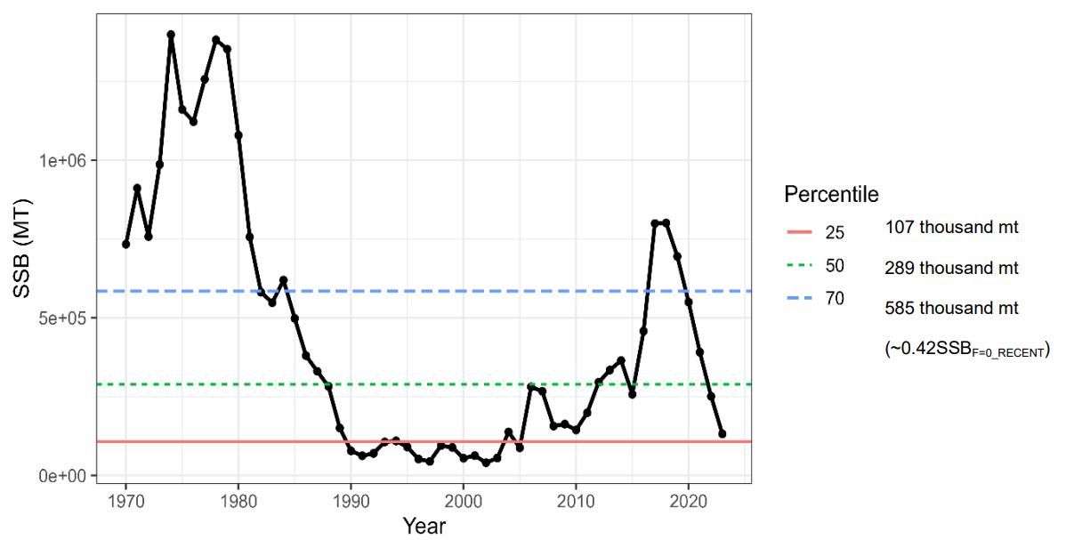
Figure. Estimated spawning stock biomass and its 25, 50 and 70 percentiles.

Chub mackerel is a straddling stock of which spawning grounds are formed in the Japanese coastal waters, and the main distribution area lies within the EEZs of Coastal Members. It has been one of the most important fishery resources for Japanese coastal and offshore fisheries as well as local communities. The chub mackerel stock had experienced historical low levels for years since the 1990s, and Japanese fishers and administrators made great efforts to restore the stock since then. Such efforts include (1) catch management through a TAC system, (2) limiting fishing efforts by setting no-fishing days, and (3) banning the use of fish aggregating lights. As a result of such conservation efforts, the stock showed a tangible recovery in the 2010s. However, since 2016 when the fishing for chub mackerel in the high seas started, the stock again has been drastically dwindling.

For information, Japan, as a coastal State, has reduced its domestic TAC in 2026 for chub mackerel by over 70% from 2024, taking seriously into account the pessimistic chub mackerel stock status. Under UNFSA, in managing a straddling stock on the high-seas, it is required to take into account the measures that coastal States implement in their EEZs, and to ensure that measures on the high-seas do not undermine the effectiveness of measures of coastal states. NPFC is required to take appropriate actions accordingly.

With these backgrounds, Japan proposes the revisions to Conservation and Management Measure of Chub Mackerel to set a revised catch limit in the Convention Area as attached, with a view to preventing fishing operations in the Convention Area from undermining the conservation efforts by coastal Members.

CMM 2026-07
(Entered into forced 1 June 2026)

CONSERVATION AND MANAGEMENT MEASURE FOR CHUB MACKEREL

The North Pacific Fisheries Commission (NPFC),

Recognizing that outcomes of the small ad hoc workshop for the scientific analysis of chub mackerel stock were presented to the Scientific Committee (SC) in April 2017 and the SC recommended to establish the Technical Working Group on Chub Mackerel Stock Assessment (TWG CMSA);

Noting that CMM 2016-07 states the SC will complete the stock assessment of chub mackerel as soon as practicable, even if such assessment is provisional, and provide advice and recommendations to the Commission in accordance with Article 10, paragraph 4(b) of the Convention;

Reaffirming the General Principles provided in Article 3 of the Convention, in particular, paragraph (h) stipulating that any expansion of fishing effort does not proceed without prior assessment of the impacts of those fishing activities on the long-term sustainability of fisheries resources;

Noting paragraph 1(a) of Article 7 of the Agreement for the Implementation of the Provisions of the United Nations Convention on the Law of the Sea of 10 December 1982 relating to the Conservation and Management of Straddling Fish Stocks and Highly Migratory Fish Stocks of 4 December 1995 (hereinafter, “1995 Agreement”), stipulating that the relevant coastal States and the States whose nationals fish for straddling fish stocks in the adjacent high seas area shall seek to agree upon the measures necessary for the conservation of these stocks in the adjacent high seas area;

Recognizing paragraph 2(a) of Article 7 of the 1995 Agreement stipulating that the conservation and management measures adopted and applied in accordance with article 61 of the United Nations Convention on the Law of the Sea in respect of the same stocks by coastal States within areas under national jurisdiction and ensure that measures established in respect of such stocks for the high seas do not undermine the effectiveness of such measures;

Reaffirming paragraph (i) of Article 3 of the Convention, stipulating in accordance with Article 7 of the 1995 Agreement, that conservation and management measures established for straddling fish stocks on the high seas and those adopted for areas under national jurisdiction are compatible in order to ensure conservation and management of these fisheries resources in their entirety;

Recalling that concern was expressed on an adverse impact on the stock of chub mackerel given the rapid increase in vessels that appear to be fishing for chub mackerel in the Convention Area, as articulated in paragraphs 9 and 10 of Report of the 1st Meeting of the Technical and Compliance Committee;

Noting that the NPFC Catch/Effort statistics shows a significant fall in chub mackerel catch in 2022, 2023, 2024 and 2025 from those in previous years;

Recognizing that the 10th meeting of the Scientific Committee in December 2025 recommended the reduction of fishing mortality to recover SSB to the interim reference levels, 25th percentile, 50th percentile, and 70th percentile of estimated historical SSB, based on the stock assessment of Chub mackerel conducted by the Technical Working Group on Chub Mackerel Stock Assessment and the advice of the Scientific Committee of NPFC;

Further recognizing that urgent needs to take responsible actions to prevent further degradation and to ensure recovery of the Chub Mackerel stock:

Adopts the following conservation and management measure in accordance with Article 7 of the Convention:

- Members of the Commission and Cooperating non-Contracting Parties (CNCPs) with substantial harvest of chub mackerel in the Convention Area shall refrain from expansion, in the Convention Area, of the number of fishing vessels entitled to fly their flags and authorized to fish for chub mackerel from the historical existing level.

- Members of the Commission and CNCPs without substantial harvest of chub mackerel in the Convention Area are encouraged to refrain from expansion, in the Convention Area, of the number of fishing vessels entitled to fly their flags and authorized to fish for chub mackerel from the historical existing level.

- As a provisional measure, Members shall take necessary measures to ensure that the fishing activities for chub mackerel in the Convention Area shall be undertaken in accordance with the fishing season defined in paragraph 17 and the following provisions:

- The annual total allowable catch of chub mackerel in the Convention Area, excluding the amount in paragraph 11, shall be set at 22,521 tonnes for the 2026 fishing season.

- Of this annual total allowable catch, the catch for trawlers shall not exceed XXX tonnes for the 2026 fishing season.

- Of this annual total allowable catch, the catch for purse seiners shall not exceed XXX tonnes for the 2026 fishing season.

- China shall not authorize more than 3 trawlers to conduct fishing operations at the same time.

- The EU shall not authorize more than 1 trawler to conduct fishing operations at the same time.

- Members of the Commission participating in chub mackerel fisheries in areas under national jurisdiction adjacent to the Convention Area are requested to take compatible measures in paragraph 1 and 3. Such Members may divert part of their catch limit for areas under their jurisdiction to their own catch of chub mackerel in the Convention Area by vessels entitled to fly their flags and authorized to fish for chub mackerel, provided that: (i) the Member has established a catch limit for chub mackerel in its jurisdiction; (ii) the Member has notified the Commission of the catch limit; and (iii) the total catch of the Member in the Convention Area and the areas under their jurisdiction adjacent to the Convention Area will not exceed the Member’s total catch limit for its jurisdiction.

- Members of the Commission and CNCPs shall prohibit fishing vessels over 10,000 Gross Tonnage that are flying their flag and authorized to fish for chub mackerel, from fishing in the Convention Area.

- Members of the Commission and CNCPs shall ensure that fishing vessels flying their flag that fish for chub mackerel in the Convention Area record their catches, including incidental catches of other NPFC species, and any discards and report them to the relevant flag state authorities in accordance with their national data recording and reporting requirements.

- To comply with the provisional measure stipulated in paragraph 3, Members of the Commission shall report to the Executive Secretary, in electronic format, monthly catches of chub mackerel in the Convention Area by fishing vessels flying their flags, as follows:
- For trawlers: By the 10th of the next month, until the total accumulated catch by Members in a fishing season reaches 60% of the catch limit set out in paragraph 3 (b). After the total accumulated catch by Members in a fishing season reaches 60% of the annual catch limit set out in paragraph 3 (b), Members of the Commission shall report to the Executive Secretary, in electronic format, weekly catches of chub mackerel in the Convention Area by trawlers flying their flags, by Wednesday of the next week.
- For purse seiners: By the 10th of the next month, until the total accumulated catch by Members in a fishing season reaches 60% of the catch limit set out in paragraph 3 (c). After the total accumulated catch by Members in a fishing season reaches 60% of the annual catch limit set out in paragraph 3 (c), Members of the Commission shall report to the Executive Secretary, in electronic format, weekly catches of chub mackerel in the Convention Area by purse seiners flying their flags, by Wednesday of the next week.

- The Executive Secretary shall make publicly available the compiled catch of chub mackerel in the Convention Area on the Commission’s website, as well as each Member’s catch of chub mackerel in the Convention Area, on the Member’s page of Commission website without delay.

- In the event that the total accumulated catch by Members in a fishing season reaches 95% of the annual catch limit set out in paragraph 3 (b) or (c), the Executive Secretary shall notify Members of that fact without delay, and each Member participating in the chub mackerel fishery shall close the fishery for its flagged vessels within 2 days from the above notification by the Secretariat until the end of the fishing season.

- Development of new fishing activity for the chub mackerel fishery in the Convention Area by Members of the Commission without documented historical catch for chub mackerel in the Convention Area shall be determined in accordance with relevant provisions, including but not limited to, as appropriate, Article 3, paragraph (h) and Article 7, subparagraphs 1(g) and (h) of the Convention.

- In accordance with paragraph 10, and in addition to the fishing opportunities under paragraph 3 (b), once the annual total allowable catch under 3 (b) has been exhausted the EU shall be entitled to fish an additional XXX tonnes of chub mackerel for 2026 fishing season, without prejudice to future discussions on chub mackerel allocation in the Convention Area. In case the EU does not harvest any chub mackerel in the Convention Area in the 2025 fishing season, XXX tons shall be carried over to the catch limit in this paragraph.

- Members of the Commission and CNCPs shall ensure that fishing vessels flying their flag operating in the Convention Area to fish chub mackerel are to be equipped with an operational vessel monitoring system that is activated at all times.

- Members of the Commission and CNCPs shall provide their data on chub mackerel separated by the Convention Area and the areas under national jurisdiction adjacent to the Convention Area in accordance with the data requirements adopted by the Commission in the Annual Report every year. The Commission shall review such information at the annual meeting every year.

- Members of the Commission and CNCPs shall cooperate to take necessary measures including sharing information, in order to accurately understand the situation and eliminate IUU fishing for chub mackerel.

- After the chub mackerel stock assessment has been completed, the provisions in Paragraph 1, 3 and 11 shall be reviewed by the Commission and those provisions shall not be a precedent to hinder those Members who are not harvesting substantial amounts of chub mackerel in the Convention Area to develop their own chub mackerel fisheries in the Convention Area, noting the Commission shall regularly review chub mackerel harvests in the Convention Area by all Members.

- This management measure enters into force on 1 June 2026 (aligned with the start of the fishing season for chub mackerel). The Commission shall review and revise, as appropriate, this CMM based on the advice and recommendations from the SC, but no later than at the 12th Commission meeting.

- For the purpose of this measure the ‘fishing season’ starts on 1 June and ends on 31 May.

- This CMM is an amendment of the NPFC CMM 2025-07.

Paragraph 4 applies to Russia and Japan.

