NPFC-2026-FAC08-WP01 Rev.1

DRAFT COMMISSION BUDGETS 2026/2027 to 2029/2030

ABSTRACT

Rev.1 contains editorial updates:
- Budget total on page 1 was updated due to a typo in the original total. This does not affect the % increase.
- Footnotes for the assessed contributions (Annexes B and C) were updated to reflect the updated data used in the calculations reflected in the Tables but the dates were not updated in the footnotes.

The NPFC Secretariat submits this paper to the Commission on:

- Update on income and expenditures for 2025/2026 fiscal year,
- Proposed 2026/2027 and 2027/2028 budgets and indicative budgets for 2028/2029 and 2029/2030 in accordance with the NPFC Convention and Financial Regulations, and
- Members’ contributions for 2026/2027 and 2027/2028.

The annual budget amount proposed for 2026/2027 is ¥171,098,326, an increase of 3.1%, when expressed in JPY, from the 2025/2026 budget. Several transfers from reserve funds are also proposed to allow for this small increase. The increases are based on a further weakening of the yen (in the current context estimates make use of 155 JPY to the USD rather than the estimates used in 2025 of 150. This 5-point difference equates to a 3% cost increase for USD denominated contracts (VMS, database, science experts) without accounting for inflation. New budget costs are also proposed to support the increased pace of stocks assessments and the work of the Small Working Group on Management Strategy Evaluation for Pacific Saury (SWG MSE). Offsets are proposed from the Working Capital Fund, Special Projects Fund and Panama (held in reserve) that reduce the impact on the assessed contributions. The proposed budget for 2027/2028 is ¥177,545,728. This is presented in Annex B and represents an increase of 3.6% over 2026/2027.

DETAILS

Objective of this paper:

Submit to the Commission:

- proposed budgets for 2026/2027 and 2027/2028,
- indicative budgets 2028/2029 and 2029/2030, and
- calculation of contributions for 2026/2027 and 2027/2028

Note: The Budget is in Japanese Yen (¥, JPY) as per the Financial Regulations Paragraph 4 and Convention Article 12. The financial year is from 1 April to 31 March of the following year.

Introduction:

- Statement of Income and Expenditures:

Income
Member contributions are the primary source of income of the Commission and shall be paid by 31 March of the fiscal year. For 2025/2026, payments of ¥165,881,708 have been received as of 31 December 2025 with ¥22,000,000 outstanding as accounts receivable (Japan) and Russia with a surplus (held in trust) of ¥317,346.

Status of Members’ Contributions for the 2025/2026 (in ¥)

Member | Adopted | Received | Date of Receipt | Outstanding
Canada | 7,702,949 | 7,702,949 | 16/04/2025 | 0
China | 65,396,238 | 65,396,238 | 30/09/2025 | 0
European Union | 7,172,967 | 7,172,967 | 21/05/2025 | 0
Japan | 44,000,000 | 22,000,000 | 23/07/2025 | 22,000,000
Korea | 7,483,443 | 7,483,443 | 25/06/2025 | 0
Russia | 6,093,579 | 6,093,579 | 23/12/2025 | Advance payment of ¥317,346
Chinese Taipei | 13,388,308 | 13,388,308 | 10/04/2025 | 0
United States | 8,990,148 | 8,990,148 | 13/06/2025 | 0
Vanuatu | 5,654,076 | 5,654,076 | 22/07/2025 | 0
Total | 165,881,708 | 143,881,708
Members’ contributions for the 2025/2026 fiscal year were notified to Members after the 9th Commission meeting held in March 2025. Panama (as CNCP) was also invited to make a payment pursuant to the Commission decision granting them CNCP status. As noted in Circular 007-2026, they have indicated they will make a payment when their vessels are able to operate starting in FY2026/2027 and thus did not make a payment in FY 2025/2026 .

Expenses

For the 2025/2026 fiscal year, there were no COM and related meetings held as COM09 was held in March of the previous fiscal year and COM10 in the next fiscal year. Thus, the Working Capital Fund increased in 2025/2026 by ¥11,535,476 (on expenditures of ¥181,216,746 (or about 6% of the overall budget including the transfer from the Working Capital Fund of ¥20,000,000). For the current FY, the expenditures continue to be affected by the low value of the Japanese yen (with numerous contracts in US dollars).

- Personnel Costs
This budget category includes salaries, benefits, and allowances of all staff members. Note that no increase was provided for any staff in fiscal year 2023/2024 while increments were included for all staff in 2024/2025 and 2025/2026.

- Other Service Costs
This budget category includes general operational costs, of which Data Management, MCS Costs, Science Support, Meeting Costs, Contractual Services, and staff duty travel are the main components. These costs are increasing with an increasing number of meetings, inflation and the persistent low value of the Japanese yen. Note as well the agreement to have the Secretariat organize and use NPFC funds for COM related meetings hosted in Japan. These costs have been covered using transfers from the Working Capital Fund to date but a longer term approach to incorporate these costs into the budget is provided for. There will be a separate discussion on the size of the Working Capital Fund at FAC08. Funding for many SC related meetings in 2025/2026 has been paid from the SC support component (2.12) as well as duty travel (2.6) and contractual services (2.8).

Commission Surplus
For 2024/2025, the overall Commission surplus was ¥11,535,476 which was transferred to the Working Capital Fund.

Voluntary Contributions
Following the NPFC Financial Regulations 26, the NPFC can accept voluntary contributions from Members and non-Members if it is consistent with the policies, aims, and activities of the Commission. In the current fiscal year, as of 31 December 2025, voluntary contributions have been made from European Union and China.

Status of Voluntary Contributions for 2025/2026 (as of 31 December 2025)

Member | Amount | Date of Receipt
European Union | 5.859,250 | 01/06/2025
European Union | 2,616,750 | Account receivable
China | ¥4,500,000  (deposited as USD 30,000) | 24/09/2025
Total | 12,406,280

Proposed Budgets for 2026/2027 and 2027/2028, and indicative budgets for 2028/2029 and 2029/2030

Overall notes for reviewing the budget proposal (referenced in draft budgets):

- A major change to the budget is related to the support for the science program.
  - All significant costs are now reported under 2.12 and draw upon the recommendations produced by SC10 related to the science program (SC10 report, Annex M).
  - Budgeted funds related to Duty Travel (2.6) and Contractual Services (2.8) have each been reduced by ¥3 million (combined total of ¥6 million) and these funds now appear in the Science Support line item (2.12) where they are expended (budget estimates for travel by Secretariat staff to SC related meetings and rapporteur costs).
- Since COM08, the cost of the Commission related meetings (COM/TCC and FAC) have been included in the budget. Based on discussions at SC10, and with no Member offering to host and subsidize the SC related meetings, this cost is included in the budget for a combined 15 day in-person/hybrid set of meetings in January 2027 (4 back-to-back meetings).
  - Additional funds are still required as the science program has expanded with an increased number of stock assessments. The SC plans to meet in person (hybrid format) for a total of 21 days in FY 2026. Increased costs are also associated with invited experts.
  - To help reduce the proposed budget increase, a transfer is proposed from the Special Projects Fund (project proposal will be provided to FAC08) to fund an invited expert and also a ¥2 million transfer from the Working Capital Fund is proposed. These two transfers help offset some of the incremental costs. A separate discussion on the size of Working Capital Fund will occur at FAC08.
- Another significant change to the budget is funding to support the proposal to advance the work of the Small Working Group on Management Strategy Evaluation for Pacific Saury (SWG MSE).
  - The SWG MSE is proposing an increased workload including the potential for 7 days of in-person/hybrid meetings and increased use of an invited expert. These costs have been added to the budget.
  - To manage the cost, transfers from the funds received in past years from Panama (Panama voluntary contribution and held in reserve) are proposed. In the past these funds have been used to support the NPAFC International Year of the Salmon in FY2021 (¥3.55 million Circular 049/2021).
- Relocation costs to repatriate the existing Compliance Manager and move the incoming replacement to Tokyo are captured. These costs can be covered through expensing them using funds from the repatriation fund that has been put in place to address these known liabilities. These estimates are reflected in the budget but are fully offset by a transfer from the Repatriation Fund.
- Ongoing low value of the JPY. The current exchange rate is averaging around ¥155 to the USD. This is reflected in the chart below. The red line is the fixed exchange rate used for salary calculation for Managers and Executive Secretary in converting USD denominated salaries into JPY (124.36 – based on the rate in 2015).

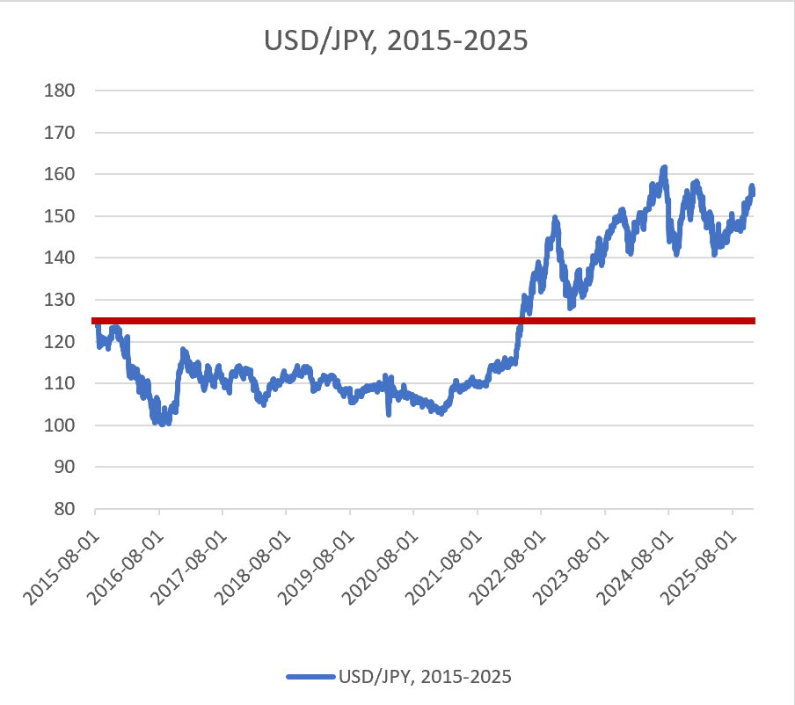

- Based on the adopted changes to the Staff Regulations, health insurance for internationally recruited staff costs are reduced going forward. Working with a labor attorney, we have confirmed that staff with the status of an Official are able to join the Japanese national health insurance at an advantageous rate and with this transition we are able to reduce the costs associated with individual private insurance. Some staff will maintain their current approach, but this will apply to new staff and to those who wish to make the transition.

- Accident / disability insurance (work and commuting related) is now included, starting in 2025/2026 for all staff (worker’s accident insurance, rodo saigai hoken). Previously, it was only provided for Japanese staff.

- The overall amount of budget proposed for 2026/2027 is just under ¥172 million, an increase of 3.1%, when expressed in JPY, from the 2025/2026 budget adopted by COM09. The proposed budget for 2026/2027 is under ¥178 million. This is in part done by using reserve funds to offset some increased costs.

The budget is addressed in two parts: Personnel and Other Service Costs (Annex A).

Detailed notes:

Part 1 – Personnel Costs
The main components of the Part 1 budget are to support the Secretariat staff being hired in two classes – three professional staff (P and D) and two general service (GS) staff - and includes expenses for staff salary, social security and insurance, staff allowances, training and education allowance.
- The salary levels presented for 2026/2027 reflect
  - the ongoing use of the UN salaries (salary scale for P and D published January 2026) and converting using the fixed exchange rate of 124.36 JPY to the USD.
  - The increment for GS is drawn from the 2025 amended UN GS pay scale (amended in 2025 but with salary levels unaffected). This scale is expressed in JPY. It is understood that GS pay scale is being discussed in the FAC email contact group discussion.
- Social Security & Insurance and Pension Costs include medical insurance, pension, group long term disability, employment insurance (local staff only), etc. As noted above, it is now possible to provide broader insurance coverage in some instances (workers accident) and this is reflected in the budget. Other costs can now be reduced (e.g. health insurance).
- Home Leave covers travel expenses (economy class airfare only) to the internationally recruited staff member's home country (staff member and their dependents - SR 7.12). This amount varies somewhat depending on the date of hiring and size of families.
- Expenses for the items Staff Allowances –
  - Repatriation: this amount is paid into the repatriation account to provide a reserve for the relocation of the internationally recruited staff. This is now budgeted separately for both the return and also recruitment of new staff (i.e., Compliance Manager in 2026). On separation from service, an internationally recruited staff member shall be entitled to a repatriation allowance consistent with United Nations’ practice, including economy class airfares and payment of removal costs. The proposed budget continues the practice of allocating funds for the expected future separation of staff.
  - Relocation: costs for repatriation of existing staff and the settling of new Secretariat staff, including airfare, moving expense and allowances. In 2026/2027, a replacement for the Compliance Manager will be in place. Funds have been allocated in the Repatriation Fund account for this purpose.
  - Education fees support the education of dependents of Professional staff (SR 5.10).

Part 2 – Other Service Costs
This is the operational component of the Commission, namely office administrative costs, contractual services, and key activities, including: data management, MCS/compliance costs; support for scientific projects, data collection and analyses; costs of meetings and workshops in support of science and compliance activities; and duty travel.

- Office administration costs include equipment, supplies, printing, and communication, and have been reduced from previous years. Aged equipment purchased in 2015 and 2016 (notably printers and photocopier) will be replaced.
- Contractual services in the past covered the cost for hiring a professional rapporteur for Commission meetings (SC/SSC, TCC, FAC and COM meetings cost). These costs are now reflected in the meeting costs and thus costs for contractual services have been reduced. It now includes contracts for QuickBooks expert, payments for interns, legal analysis (domestic, labor and international) on an as-needed basis. ¥3,000,000 has been reallocated to Science Support (2.12)
- Audit costs have increased due to the increased complexity of the funds managed for the Commission as well as the overall magnitude of funds (i.e., addition of the Transshipment Observer Program).
- Database Management mainly covers management and upgrade of the website and human resources and administration system. It also includes tasks related to VMS, transshipment, e-reporting system, Vessel Registry, and IUU fishing vessels. A significant investment is envisioned for upgrades to our database as well as analytical support. Use will likely continue to be made of voluntary contributions in this area (e.g., science-data database development).
- MCS costs include a three-year contract estimated at around ¥42,500,000 from FY 2026/2027 to August 2029 to support the NPFC VMS system. This increase from the initial contract is part inflation (5%) and the contract being in USD.
- Meeting costs are a significant element for NPFC. Cost effective locations are being sought but some public facilities are not able to commit to meeting space in a realistic timeframe and thus commercial facilities are used. Locations away from the Secretariat office will necessitate Secretariat travel costs. Expenses for Science Support reflects a 5-year work plan and projects adopted by the Scientific Committee, including intersessional meeting costs, data management, stock assessments of priority species, etc.

Items that may affect the planned budget

- Exchange rates are having an effect on the budget.
- The costs for recruitment including the “set-up” costs and eventual repatriation are being set aside in the Repatriation fund for known liabilities.
- Establishment of a transshipment observer scheme ideally has limited impact on the operational budget, with some set-up costs for observer report ingestion into the database possibly being borne using funds already available (e.g., Special Project Fund or Panama Voluntary Contribution Fund). Otherwise, the costs will be borne by the participants in the scheme.
- Development of an NPFC Port State measure (if directed by the Commission) may require investment in on-line reporting.

C. Members’ Contributions for 2026/2027 and 2027/2028

In accordance with Paragraph 12 of the NPFC Financial Regulations, Members’ contributions are calculated by the following formula:
  - 35 percent of the budget shall be divided equally among members of the Commission.
  - 55 percent of the budget shall be divided proportionally among members of the Commission based on the three-year average, ending one year before the year of the annual dues, of the total catches by weight in the Convention Area of the species covered by the Convention; and
  - 10 percent of the budget shall be divided proportionally among members of the Commission based on each member’s Gross Domestic Product (GDP) per capita.

Members’ Contributions for Part (b) of the formula in 2026/2027 were based on average catches for years 2022, 2023, and 2024 inclusive. Members’ Contributions for 2027/2028 shall be adjusted in early 2027 according to 2025 catch reports and any GDP update. The assessed contributions of Members for the years 2026/2027 and 2027/2028 (planned) are attached as Annexes B and C.

Attached for consideration are the following:

Annex A Proposed budgets for 2026/2027 and 2027/2028 and indicative budgets for 2028/2029 and 2029/2030

Annex B Table of contributions for Members (and Panama as CNCP) for 2026/2027 noting that Japan’s contribution remains fixed at ¥44,000,000/year

Annex C Table of contributions for Members (and Panama as CNCP) for 2027/2028 noting that Japan’s contribution remains fixed at ¥44,000,000/year and using the 2-year average for catch

Annex D Update on Voluntary Contribution Fund, Repatriation Fund, Special Project Fund, Working Capital Fund and Transshipment Observer Program Fund

Annex A
Proposed budgets for 2026/2027 and 2027/2028 and indicative budgets for 2028/2029 and 2029/2030

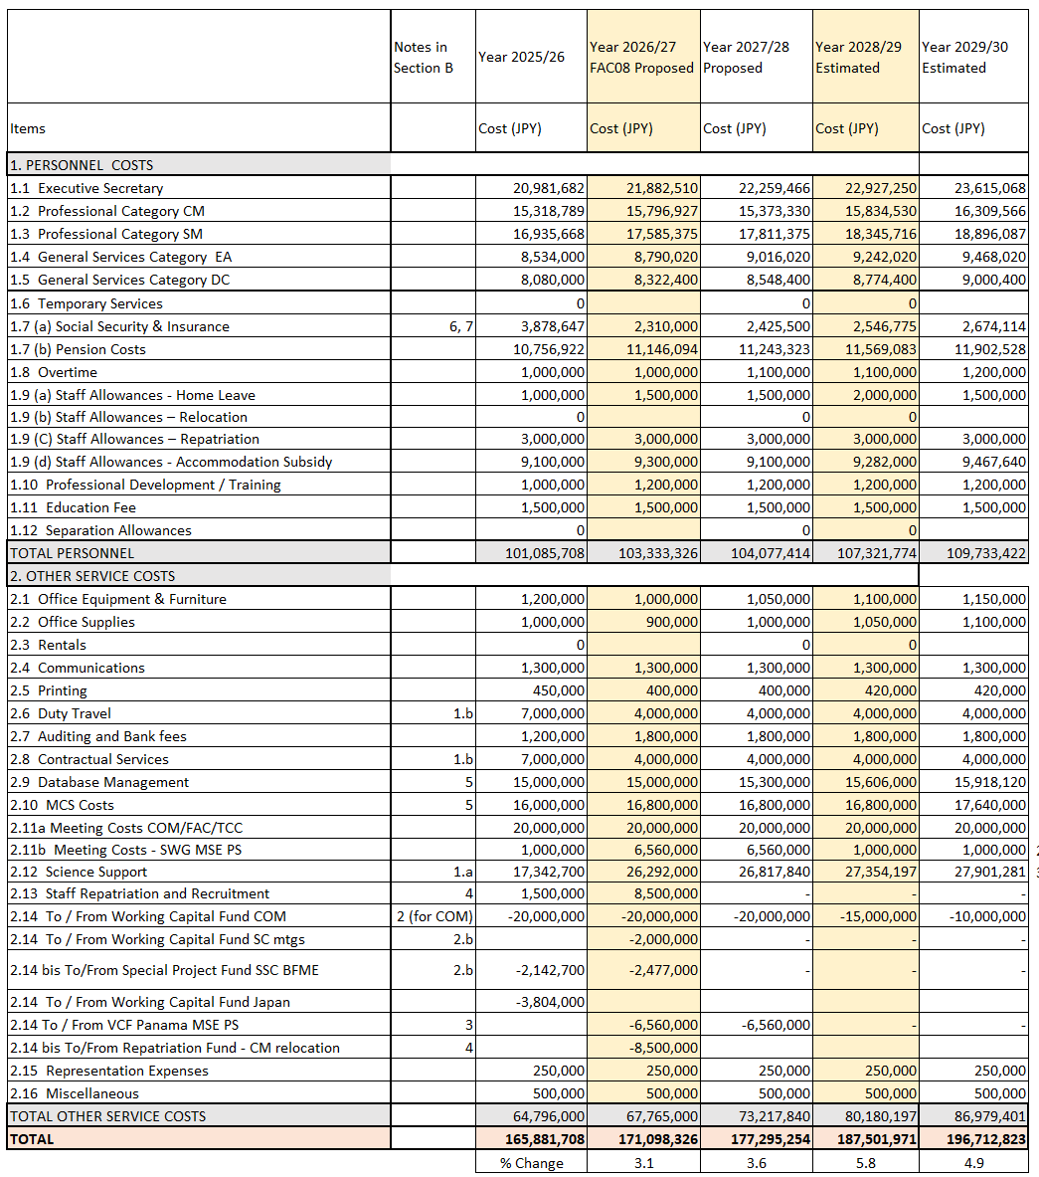
Explanations for budget items:

      - Staff Salary for five Secretariat Staff (ES, CM, SM, EA, DC)

1.6 Temporary Services Part-time clerical assistance for meeting preparation and other special events
  - (a) Social Security + Insurance, and 1.7 (b) Pension Costs
Pension, medical insurance, employment insurance (local staff only), etc.
  - Overtime
Overtime work for General Service and Temporary Service categories. Professional Staff are not eligible to receive overtime pay.
  - (a) Staff Allowances - Home leave
Travel expenses (economy airfare only) to staff member’s home country for internationally recruited staff members and their dependents.
1.9 (b) Staff Allowance – Relocation and
1.9 (c) Staff Allowances – Repatriation
The Commission pays for the relocation to Tokyo and the subsequent removal of internationally recruited staff along with associated allowances consistent with United Nations’ practice, including economy class airfares, payment of removal costs and allowance. As well, related costs of pension payment and payment of unused vacation leave are addressed. The budget in the next few years proposes replenishment of the account as it is a known liability.
  - (d) Accommodation subsidy
The allowance is based on the actual contracts and set at a maximum of JPY 240,000 per month. The Commission shall reimburse 75% of actual expenses within the cap set above. Based on COM03 decision this was to be reviewed on a 3 year basis.
  - Professional Development / Training
Includes language learning and other training for Secretariat staff to pursue capacity building.
  - Education fee
The education allowance entitlement for Professional staff members is a maximum of JPY 2,000,000 per annum per dependent child. The Commission shall reimburse 75% of actual expenses within the cap set above.
  - Office equipment + Furniture
Equipment and furniture costs for staff members and in case of its breakage.
  - Office supplies
Includes general expenditures for the normal functioning of the Secretariat.
  - Communications
Includes estimated costs of telephone, fax, internet, postage and courier services.
  - Printing
Includes brochures, annual Compendium of Conservation and Management Measures, yearbook and other publications for meetings and public awareness.
  - Duty travel
Based on anticipated costs. Includes travel expenses to attend workshops, FAO COFI Regional Secretary Network (RSN) and related RFMO meetings with the approval of the Commission.
  - Auditing Costs and Bank Fees
Cost of hiring an external auditor and bank fees.
  - Contractual services
Hiring part-time specialists and consultants to assist in the Secretariat works for finance and administration as well as any interns.
  - Database management
Establishing the Commission’s database management system. Database Management mainly covers management and upgrade of the website and human resources and administration system, and tasks related to managing and security of all data received from Members for Science and Compliance purposes.
  - MCS costs
MCS costs for the NPFC VMS development through a three-year consultancy and other MCS tools for implementing CMMs for compliance.
2.11 Meeting costs & Workshops Based on current meeting costs for hosting NPFC meetings. Includes additional costs of JPY20,000,000 for holding Commission meetings if no host is identified, associated subsidiary body meetings, and workshops. SWG MSE costs are included here along with associated costs for invited expert and rapporteur.
  - Science Support
Support the overall science program including meeting costs, data management system, stock assessments, workshops, observer program, external expert support, travel costs for NPFC Member representatives to other organizations’ meetings and other scientific activities in accordance with the scientific program developed by SC and adopted by the Commission.
  - Staff recruitment + hiring
Based on estimated costs associated with travel expenses of candidates for possible recruitment of Secretariat staff.
  - Working Capital Fund
Transfer of JPY20,000,000 from the Working Capital Fund will be used to cover meeting costs of the Commission (COM, TCC and FAC) if no Member hosts them. JPY2,000,000 will be used to support SC11 meeting costs.
  - bis Special Project Fund
Established to support special projects both in science and compliance not covered by the general fund.
  - Representation expenses
Expenses for the hospitality of the Commission and Secretariat.
  - Miscellaneous
Expenses not covered elsewhere

Annex B

Members’ Annual contributions for 2026/2027

Member\Rule | a) | b) | c) | Fixed Contribution | Total | %
Canada | 5,560,552 | 0 | 2,426,932 |  | 7,987,483 | 4.7
China | 5,560,552 | 59,116,040 | 592,543 |  | 65,269,134 | 38.1
EU | 5,560,552 | 0 | 1,925,451 |  | 7,486,003 | 4.4
Korea | 5,560,552 | 648,619 | 1,612,817 |  | 7,821,988 | 4.6
Russia | 5,560,552 | 1,620,955 | 661,854 |  | 7,843,361 | 4.6
Chinese Taipei | 5,560,552 | 8,288,124 | 1,515,841 |  | 15,364,516 | 9.0
USA | 5,560,552 | 0 | 3,833,913 |  | 9,394,464 | 5.5
Vanuatu | 5,560,552 | 230,342 | 140,482 |  | 5,931,376 | 3.5
Japan |  |  |  | 44,000,000 | 44,000,000 | 25.7
Total | 44,484,414 | 69,904,079 | 12,709,833 | 44,000,000 | 171,098,326 | 100.0

- 35 % of the budget shall be divided equally among members of the Commission except Japan.
- 55 % of the budget shall be divided proportionally among members of the Commission based on the three-year average, 2022-2024, of the total catches by weight in the Convention Area of the species covered by the Convention; and
- 10 % of the budget shall be divided proportionally among members of the Commission based on each member’s Gross Domestic Product (GDP) per capita in 2024.

Note per Rules of Procedure 10.5: Panama as CNCP: 5,742,875

Annex C

Members’ Annual contributions for 2027/2028 using the 2-year average

Member\Rule | a) | b) | c) | Fixed Contribution | Total | %
Canada | 5,831,667 | 0 | 2,545,262 |  | 8,376,929 | 4.7
China | 5,831,667 | 59,905,235 | 621,434 |  | 66,358,336 | 37.4
EU | 5,831,667 | 0 | 2,019,330 |  | 7,850,998 | 4.4
Korea | 5,831,667 | 751,298 | 1,691,453 |  | 8,274,418 | 4.7
Russia | 5,831,667 | 2,592,824 | 694,124 |  | 9,118,616 | 5.1
Chinese Taipei | 5,831,667 | 9,771,515 | 1,589,749 |  | 17,192,931 | 9.7
USA | 5,831,667 | 0 | 4,020,843 |  | 9,852,510 | 5.6
Vanuatu | 5,831,667 | 291,518 | 147,332 |  | 6,270,516 | 3.5
Japan |  |  |  | 44,000,000 | 44,000,000 | 24.8
Total | 46,653,339 | 73,312,389 | 13,329,525 | 44,000,000 | 177,295,254 | 100.0

- 35 % of the budget shall be divided equally among members of the Commission except Japan.
- 55 % of the budget shall be divided proportionally among members of the Commission based on the two-year average, 2023-2024, of the total catches by weight in the Convention Area of the species covered by the Convention; and
- 10 % of the budget shall be divided proportionally among members of the Commission based on each member’s Gross Domestic Product (GDP) per capita in 2024. Members’ Contributions for 2027/2028 shall be adjusted in early 2027 according to 2025 catch reports and GDP.

Note per Rules of Procedure 10.5: Panama as CNCP: 6,022,881

Annex D Status of Other Funds

Status of Voluntary
Contribution Funds
Status of Special Projects Funds

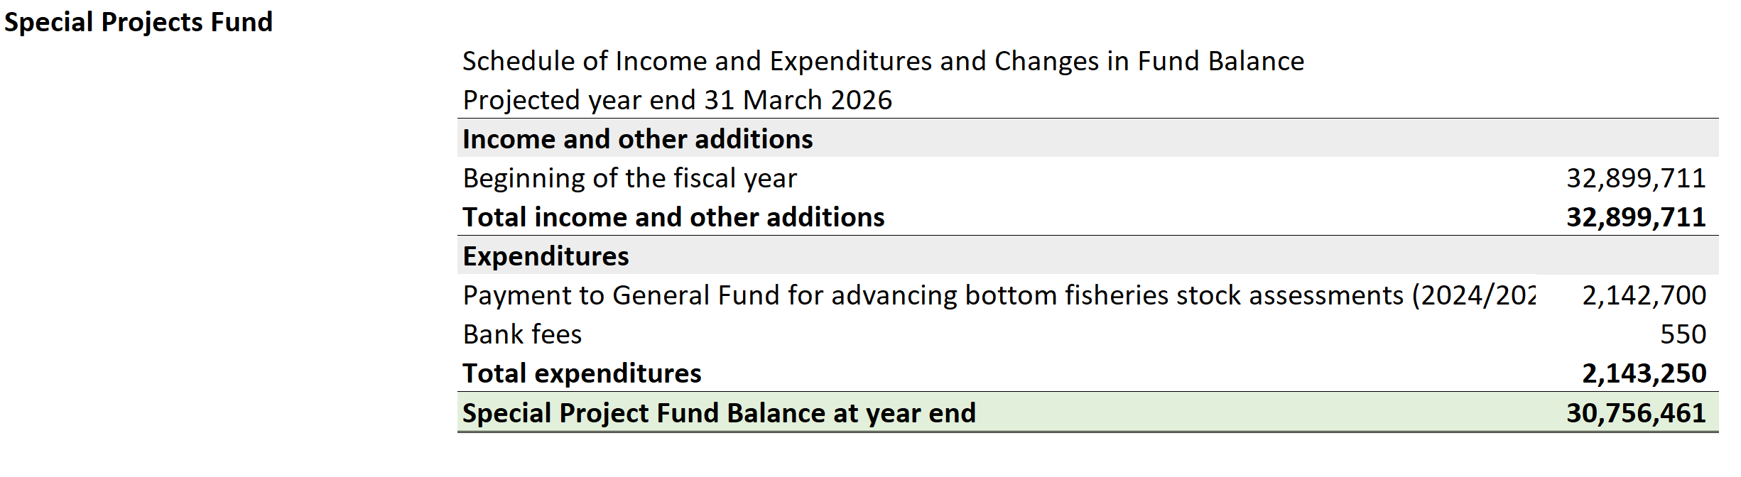

Status of Repatriation Fund

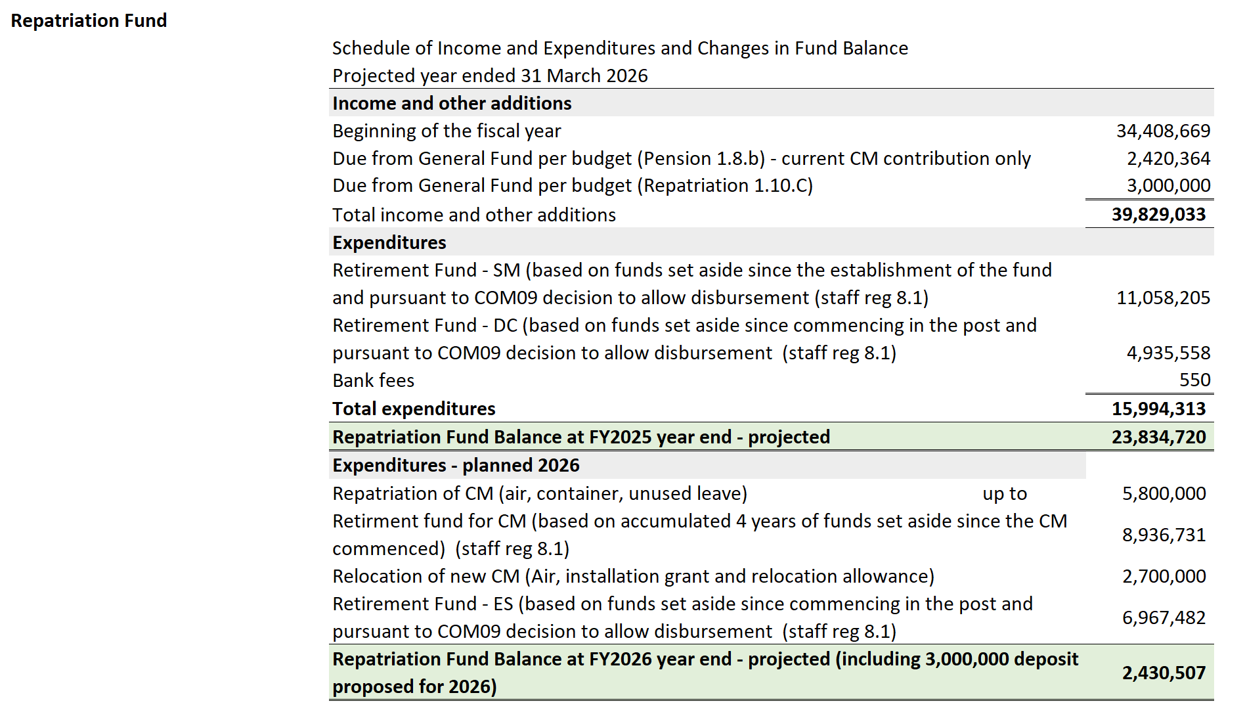

Status of Working capital Fund

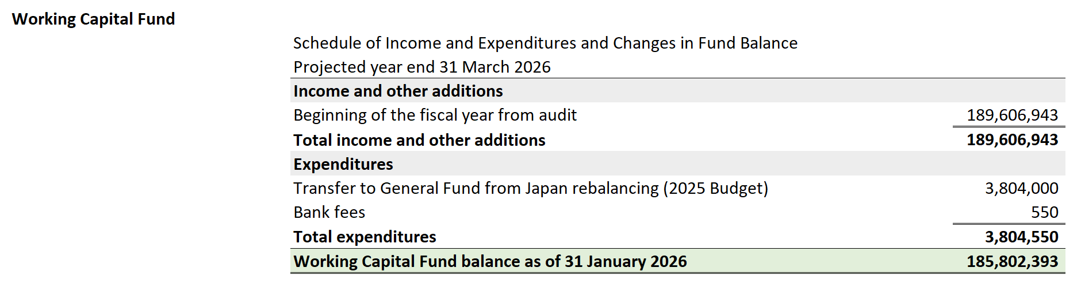

Status of Transshipment Observer Program Fund (in USD)

