NPFC-2026-COM10-WP08 Rev.3

Submitted by Canada

Introduction of Bycatch Exclusion Strategies in NPFC Pelagic Trawl Fisheries
(CMM 2025-07 for Chub Mackerel, 2025-08 for Pacific Saury and 2025-11 for Japanese Sardine, Neon Flying Squid and Japanese Squid)

Abstract: Canada is proposing a similar measure in each of the three pelagic CMMs to manage interactions with megafauna by introducing two paragraphs into each of the measures.

Rev.1 updates the paragraph numbering in the three referenced CMM using bis/ter.

Rev.2 incorporates feedback from the EU to propose a second type of excluder device that reflects their industry practices

Rev. 3 provides feedback to include the option of using a flexible (non-rigid) bycatch excluder device, similar to what is used in some member’s domestic fisheries. This option now has a diagram to help members visualize how this device would be affixed and operate

NPFC-2026-COM10-WP08 Rev.3

CMM 2025-11
(Entered into force 10 July 2025)

CONSERVATION AND MANAGEMENT MEASURE FOR JAPANESE SARDINE, NEON FLYING SQUID AND JAPANESE FLYING SQUID

The North Pacific Fisheries Commission (NPFC),

Recalling that six pelagic species – Pacific saury, chub mackerel, blue mackerel, Japanese sardine, neon flying squid, and Japanese flying squid – are identified as priority species;

Also recalling that the NPFC has adopted the CMMs on two species – Pacific saury and chub mackerel;

Noting that specific measures for the remaining four species have yet to be introduced while those species have been subject to extensive fishing practices, whether they are target or bycatch species;

Reaffirming the General Principles provided in Article 3 of the Convention, in particular, Paragraph (h) stipulating that any expansion of fishing effort does not proceed without prior assessment of the impacts of those fishing activities on the long-term sustainability of fisheries resources;

Adopts the following conservation and management measure in accordance with Article 7 of the Convention:

- Members of the Commission and Cooperating non-Contracting Parties (CNCPs) with substantial harvest of any of Japanese sardine, neon flying squid and Japanese flying squid (hereinafter referred to as “the three Pelagic Species”) in the Convention Area shall refrain from expansion, in the Convention Area, of the number of fishing vessels entitled to fly their flags and authorized to fish for such species from the historical existing level until the stock assessment for such species by the SC has been completed.

- Members of the Commission and CNCPs without substantial harvest of the three Pelagic Species in the Convention Area are encouraged to refrain from expansion, in the Convention Area, of the number of fishing vessels entitled to fly their flags and authorized to fish for such species from the historical existing level until the stock assessment for such species by the SC has been completed.

- Members of the Commission participating in fishing for the three Pelagic Species in areas under their jurisdiction adjacent to the Convention Area are requested to take compatible measures in paragraph 1. Such Members may divert part of their catch limit for areas under their jurisdiction to their own catch of the species in the Convention Area by vessels entitled to fly their flags and authorized to fish for the species, provided that: (i) the Member has established a catch limit for the species in its jurisdiction; (ii) the Member has notified the Commission of the catch limit; and (iii) the total catch of the species in the Convention Area and the areas under their jurisdiction adjacent to the Convention Area will not exceed the Member’s total catch limit for its jurisdiction respectively.

- Development of new fishing activity for the three Pelagic Species in the Convention Area by Members of the Commission without documented historical catch for such species in the Convention Area shall be determined in accordance with relevant provisions, as appropriate, including but not limited to Article 3, paragraph (h) and Article 7, subparagraphs 1(g) and (h) of the Convention.

- Members of the Commission and CNCPs shall ensure that fishing vessels flying their flag operating in the Convention Area authorized to fish the three Pelagic Species are to be equipped with an operational vessel monitoring system that is activated at all times.

- Members of the Commission and CNCPs shall ensure that fishing vessels flying their flag that fish for the three Pelagic Species in the Convention Area record their catches, including incidental catches of other NPFC species, and any discards and report them to the relevant flag state authorities in accordance with their national data recording and reporting requirements.

6 bis. To minimize the impact of fishing activities on non-target species, Members shall ensure that all trawl-geared fishing vessels flying their flag use a bycatch excluder device as prescribed in Annex I, while conducting fishing operations in the Convention Area. In addition, Members may use other bycatch exclusion strategies that have been proven to reduce incidental bycatch of non-target species, also described in Annex I. Bycatch excluder devices shall be made available for inspection in a timely manner, upon the request of an inspector during high seas boarding and inspections activities.

6 ter. Members shall ensure that all fishing vessels flying their flag maintain a record of incidentally caught sharks, rays, marine mammals, turtles, and other mega-fauna (defined as large marine organisms that typically occupy high trophic levels in oceans ecosystems) by genus and species where known, quantity per set or tow, and if released, whether the specimen was released live.

- Members of the Commission and CNCPs shall provide their data on the three Pelagic Species in accordance with the data requirements adopted by the Commission in the Annual Report by the end of February, every year. The Commission shall review such information at the annual meeting of every year.

- Members of the Commission and CNCPs shall cooperate to take necessary measures including sharing information, in order to accurately understand the situation and eliminate IUU fishing for the three Pelagic Species.

- After a stock assessment for any of the three Pelagic Species has been completed, the provisions in Paragraph 1 shall be reviewed by the Commission and those provisions shall not be a precedent to hinder those Members who are not harvesting substantial amounts of the three Pelagic Species assessed in the Convention Area to develop their own fisheries in the Convention Area noting the Commission shall regularly review the harvests of such species in the Convention Area by all Members.

- This management measure shall expire and be replaced by the measure to be adopted by the Commission based on the advice and recommendations from the Scientific Committee.

Annex I

Bycatch Exclusion Strategies, Devices, and Methods

- Bycatch Excluder Device Specifications: the use of a bycatch excluder device is mandatory for all trawl-geared fishing vessels. The excluder device shall be constructed of durable materials and shall meet the specifications of the option selected :

  - Rigid device: The frame and bars (grid) shall be rigid and smooth, composed of steel or aluminum with the grid oriented at a 30-45° angle relative to the net’s horizontal plane.

  - Flexible or semi-rigid device: The excluder device may alternatively consist of smooth, durable, rigid plastic bars or tubes strung over a high-strength netting substrate arranged in a grid pattern so that the device remains flexible. The grid may consist of multiple sections (e.g., soft, semi-hard, and hard sections) The device may incorporate a non-return section to guide the target species towards the codend.

- The grid or excluder panel, regardless of which type is selected, shall be large enough to cover the entire inner cross-section of the net and secured to the inner surface of the net. It shall be placed within the neck of the trawl and forward of the codend portion of the net. The device may be affixed with floatation and/or weighting to support regular, unimpeded vessel operations.

- The grid bars or tubes shall be spaced with a maximum of 20cm between each bar or tube, measured in either the longitudinal, or in the transverse direction, between adjacent bars or tubes. Individual grid sections may use tighter spacing where appropriate.

- For rigid devices, the escape opening shall be positioned on the top of the net, above the grid. For flexible or semi-rigid devices, the escape opening may be positioned in the lower panel of the net, below or adjacent to the grid sections.

- The escape opening shall allow unimpeded passage of non-target species out of the trawl and shall be a uniformly shaped opening positioned just in front of the aft connection of the grid to the net. The dimensions of the escape opening shall be a minimum of 70 cm wide and 1.0 m long.

- The escape opening may be covered by an exit hole hood or single mesh panel that can move freely to allow non-target species to escape.

Figure 1. Rigid Bycatch Excluder Device for reference only (source: Hamilton and Baker, 2019). Members will be responsible for implementing their own excluder devices to meet the objective of reducing incidental bycatch of mega-fauna and non-target species, in line with the specifications noted in a through f.

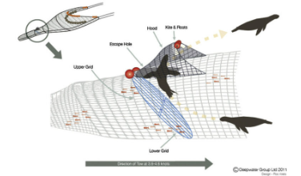

Figure 2. Flexible Bycatch Excluder Device showing the grid positioned to facilitate bottom escape:

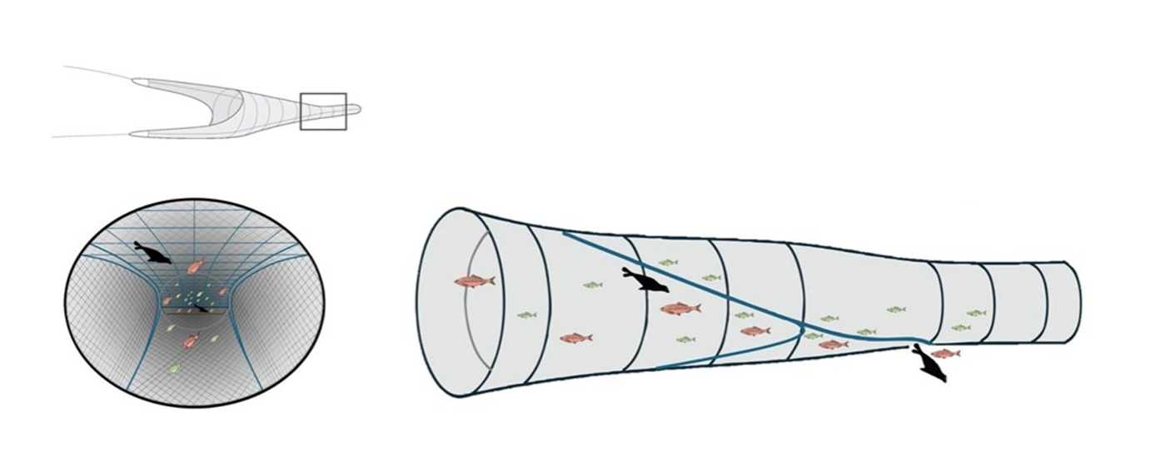

- Other Bycatch Exclusion Strategies to Reduce Incidental Bycatch:

- Acoustic Deterrent Devices: These sound emitting electronic devices create an aversive response to discourage sharks from entering specific areas. When deployed with trawl gear, these devices have been found to reduce the capture of sharks and marine mammals.
- Olfactory Deterrents: Semio-chemical shark deterrents using ammonia-based compounds that illicit aversive or repellant response.
- Offal discard management: Avoid the release of offal while actively fishing or towing trawl gear.
- Light Deterrents: Light emitting devices in various wavelengths including ultra-violet light have been used as an effective method to reduce shark, marine mammal, turtle, and other incidental bycatch in trawl fisheries.

Paragraph 3 applies to Russia and Japan

