NPFC-2026-TWG CMSA12-WP03

The estimation method and data on catch, weight, and maturity at age of the chub mackerel caught by Japan up to CY2026/Q2

Akihiro MANABE, and Ryuji YUKAMI

Fisheries Resources Institute
Japan Fisheries Research and Education Agency (FRA)
(corresponding author: Akihiro MANABE, manabe_akihiro97@fra.go.jp)

Summary
Stock assessment of chub mackerel (CM) in the Northwest Pacific has long been conducted in Japan. For nearly half a century, the length and age data of chub mackerel are collected based on the catch from the Pacific coast of Japan. Catch data are collected by month, prefecture, and gear type. Measurement of length data is obtained from the major landing port to develop catch at length from each prefectures on quarterly basis. Age data are obtained from the subsample of mackerels which fork length are measured and annulus of scale or annual increments of otolith are counted. The age data are subdivided into the Eastern and Western part of Pacific coastal prefectures of Japan to construct age-length key and catch at age is calculated for each quarter. In the present paper, updated data used to construct catch at age through CY2026/Q2 are presented. Catch numbers remained low in recent fishing years, while CY2025 showed a slight increase in total catch number and a relatively large contribution of age-0 fish. These updated data are proposed for use in the forthcoming stock assessment of CMs in NPFC.

Introduction
In 2025, the Technical Working Group on Chub Mackerel Stock Assessment (TWG CMSA) had published its second stock assessment in the northwest Pacific incorporating the data from China, Japan, and Russia in both the EEZ and the conventional area (NPFC 2025a). The stock assessment, however, is based on the data up to 2023 in fishing year (FY2023) (i.e., June 2024, where fishing year is from July to the following June) owing to the timing of stock assessment and data availability. Toward the next stock assessment, it is important to update the catch at age, weight at age, and maturity at age data to sufficiently capture the most recent population dynamics.
In this document we summarized the methodology for estimating catch at size, catch at age, and weight at age of chub mackerel in the Northwest Pacific Ocean estimated in Japan. This document also describes the methodology to derive maturity at age data used for the stock assessment. Furthermore, this document presents updated data on catch at age, weight at age, and maturity at age up to CY2026/Q2, which is up to the end of FY2025, to be used for the forthcoming stock assessment.

Method
Catch data
Catch data of chub mackerel are collected from 18 prefectures along the Pacific coast of Japan (Hokkaido to Miyazaki prefecture). The data are collected at the major landing ports by the local prefectural fisheries research institutions. The catch data are categorized by prefecture, month, and gear type. In some prefectures, the catch data of chub mackerel and blue mackerel (S. australasicus) are combined and reported as the “mackerels”. In such cases, the proportion of chub mackerels and blue mackerels are estimated by sorting the subsample of the catch every month. Then the monthly catch of chub mackerel is estimated by applying the monthly chub-blue ratio to the catch of mackerels of the same month.

Length, weight, and age data
Length frequency data are collected from each prefecture by month. Since the selectivity of gear type is not the same throughout different gear types, the length frequency data are treated differently for each gear type. The sample for length frequency measurement is obtained by spill sampling from the catch at the major landing port and fork length (FL) is measured up to 1 millimeter. Likewise, weight data are measured from the same sample up to 0.1 gram. The measured length and weight data are combined by each prefecture level every year and length-weight relationship is estimated every year for each prefecture as $w=aL^{b}$, where $w$ is body weight, $L$ is FL, and $a$ and $b$ are coefficients.
Each set of length frequency data is gathered by prefecture, month and gear. Using the length-weight relationship, the mean length and the mean weight of the sample are calculated as follows:
$\overline{L}=\sum_{j=5}^{50}{\left(\left(\frac{s_{j}}{\sum_{j=5}^{j}{s_{j}}}\right)j\right)}$ (1)
$\overline{w}=\sum_{j=5}^{50}{\left(\left({aj}^{b}\right)\left(\frac{s_{j}}{\sum_{j=5}^{j}{s_{j}}}\right)\right)}$ (2)
where $j$ is the length bin of the length frequency of sample, $s_{j}$ is number of fish in the length bin $j$.
Next, number of fish caught in a single prefecture, month, and gear $N_{c}$ are calculated as:
$N_{c}=\frac{C}{\overline{w}}$ (3)
where $c$ is the catch in weight of the same prefecture, month, and gear of the equivalent length frequency data. The number of fish is multiplied by the length composition ratio to calculate catch at size as:
$c_{j}=N_{C}\frac{s_{j}}{\sum_{j=5}^{50}{s_{j}}}$ (4)

where $c_{j}$ is catch number at length $j$.
Age data are collected from each prefecture. Sample for age estimation are subsampled at random from the length sample and increments of otolith or annulus of scale are counted to estimate the age. For fish with age of 7 or older, age is categorized as 7+ owing to the difficulty of age estimation and small proportion within the samples.

Age-length keys
To construct age-length key for chub mackerel, length and age data from each prefecture are combined and subdivided by quarter-year: January to March (Q1), April to June (Q2), July to September (Q3), and October to December (Q4). Since the stock of chub mackerel migrates seasonally, the age-length data are subdivided into two geographical groups: Eastern and Western part of Pacific coast of Japan (Figure 1). Eastern and Western groups consist of catches from East of Shizuoka Prefecture and West of Mie Prefecture, respectively.
Age-length key is developed for each group and each quarter-year using the method of forward-age-length key, which describes the probability of age at given size (Fridriksson 1934, Ailloud and Hoenig 2019).
Age and length data are sorted in 1 year old and 1 cm bins, respectively. Any CMs with FL below 15 cm and 45 cm are treated as age 0 and 7+, respectively. The proportion of age t at length bin j is described as $r_{t, j}$ is calculated as,
$r_{t,j}=\frac{m_{t,j}}{\sum_{t=0}^{7}{m_{t,j}}}$ (5)
where $m_{t,j}$ is the number of measured samples at age t and length bin j.
When there is no age composition information available at a certain length bin in which the catch is observed, a mean ALK of CY2002-CY2014 is used for substitution to that bin as the “default ALK” for each quarter and region.

Catch at age
Age length key is applied to catch at length data for each quarter/year. The proportion of age t at length j is described as $r_{t, j}$ and catch at length is converted into age basis as follows,
$c_{t,j}= c_{j}* r_{j}$ (6)
where $c_{t,j}$ is catch in number with age t at length j. Catch at age for each quarter and region is calculated as
$c_{t}=\sum_{j=5}^{50}{c_{t,j}}$ (7)
Catch at age for each quarter and region is calculated by aggregating the catch at each length bin for each age group. Catch at age in number from Japan is calculated by adding the quarterly catch at age from Eastern and Western Japan.

Weight at age
Catch number at length is converted into weight basis by applying L-W relationship to the equivalent quarter and region, catch number at age. Using equation (7) and L-W relationship, catch in weight at age $w_{t}$ is calculated as
$w_{t}=\sum_{j=5}^{50}{c_{t,j}*a*j^{b}}$ (8)
and weight at age $W_{t}$ is calculated as
$W_{t}=\frac{w_{t}}{c_{t}}$ (9)
Maturity at age
For the stock assessment, maturity at age is derived based on Watanabe and Yatsu (2006) that studied the maturation of spawning chub mackerel in waters around Izu Islands and Joban area. Since the maturity at age is known to differ by the stock status as presented in Watanabe (2010), the observed maturity rate at age is averaged during the periods with similar stock levels (very high, high, medium, low, and extremely low) estimated from in the domestic stock assessment (Yukami et al. 2025). The maturity at age is estimated using combined method of KG observation and age composition of aggregating spawning fish in the main spawning ground, i.e., Izu Islands waters.

Results and Discussion
Length frequency from major landing ports
Catch at length from CY2014-CY2026/Q2 was updated for Eastern and Western Japan (Figure 2-4). The CY2025 length composition was characterized by a relatively high proportion of small fish (Figure 4). The catch at length pattern of Eastern and Western Japan are different throughout the quarters and years which justifies the separation of data into two geographical regions.

Age determination and Age-length key
Table 1 presents the number of age determination conducted from the Eastern and Western Japan between CY2014Q1-CY2026/Q2. Age determination is consistently conducted throughout the region with a greater number of age measurements being conducted in the Eastern region from 1025 to 3320 measurements annually, meanwhile the age measurement in the Western region is less from 113 to 1867 measurements annually. In CY2014/Q3, CY2015/Q3, and CY2020/Q3, Western region has no aged data.
Figures 5-7 show the ALK for CY2014-CY2026/Q2 for the Eastern and Western Japan with ages 0 to 7+. The age is adjusted to be incremented on January 1st, which requires additional procedure to convert into the fishing year basis.

Catch-at-age
Catch-at-age is calculated from catch-at-length data and ALK from the Eastern and Western Japan (Figure 8-10). The catch-at-age series was updated through CY2025/Q2 for Eastern and Western Japan yet further age treatment is necessary to convert the FY-based catch-at-age due to above-mentioned reason. Catch numbers remained at a low level in recent years, particularly in Western Japan. Figure 11 shows the CY-based annual catch-at-age. The total catch number increased slightly in CY2025, with a relatively large contribution of age-0 fish.

Weight at age
Quarterly and annual weight-at-age data for Eastern and Western Japan were updated through CY2026/Q2 (Figure 12). As described in Kamimura et al. (2021), which presented the recent decline in growth rate due to density dependence after CY2014, the overall weight at age remains lower in the recent years (i.e., CY2020-CY2026/Q2) than CY2014 although gradually increasing in the recent few years. The weight at age is greater in Western Japan than Eastern Japan, that may be due to difference in migration pattern, which CMs in Western Japan tend to be more coastally associated while CMs in Eastern Japan migrate further in offshore for feeding.

Maturity at age
Figure 13 shows the proportion of matured females at age used for the stock assessment in Japan since FY1970. Maturity at age 0 is considered as 0 (immature) throughout the years and maturity at age 1 is consistently immature except for FY2000-FY2005, where stock level was considered as low. Age 2 fish exhibit dynamic variations in maturity throughout the years with increased maturity to FY2000-FY2005, with declining trend to 0 in FY2015 and thereafter. Age 3 fish are considered fully matured in FY1987-FY2015 but declined to 0.3 since FY2016 and thereafter. Age 4 and above were historically considered fully mature; the recent maturity-at-age values used in the assessment were retained through FY2025.

Catch discrepancies from the Annual Footprint
Annual catch weight is calculated from quarterly catch-at-age and weight-at-age. Figure 14 and Table 2 show the total catch of CM from Japan in calendar year basis. The total catch remained declining trend since CY2021 with 43,318 tons in CY2025. Figure 15 shows the comparison between Annual Footprint. The difference (Calculated catch – Annual footprint) shows negative and positive values between CY2014-CY2024 with maximum difference of 717 tons in CY2014 while the percentage of difference being greatest in CY2024 as -0.7% of CY2014-2024. The maximum difference of -0.7% between calculated catch and the Annual Footprint is considered acceptable, taking into account that NPFC TWG CMSA previously accepted this level of discrepancy as acceptable (Manabe et al. 2025; NPFC-2025-TWG CMSA11 WP04). In CY2025, the difference was 6,660 tons (15.4% of the calculated catch); however, the Annual Footprint for CY2025 is based on preliminary data, including some estimated values.

Conclusions
This document summarized and overviewed the methodology to estimate the catch at age of chub mackerel caught in the northwestern Pacific Ocean by Japanese fleets. The measurement of length, weight, and age of chub mackerel on the annual basis allows development of age-length key and estimation of catch at age with up-to-date demographics. The updated CAL, CAA, and WAA data through CY2026/Q2 were consistent with the previously submitted historical series. Catch calculated from CAA and WAA was also consistent with the Annual Footprint, with differences below 1% for the comparable historical years. CY2025 showed a slight increase in catch number and a relatively high contribution of age-0 fish, while catch in Western Japan remained low. These updates provide the most recent demographic information for the forthcoming stock assessment.

Reference
Ailloud, L. E., and Hoenig J. M. (2019). A general theory of age-length keys: combining the forward and inverse keys to estimate age composition from incomplete data. ICES J. Mar. Sci. 76(6). 1515-1523.
Fridriksson, A. (1934). On the calculation of age distribution within a stock of cod by means of relatively few age-determinations as a key to measurement on a large scale. Rapports et Process-verbaux des Reunions du Conseil International pour l’Exploration de la Mer. 86. 1-14.
Jennings, S., Reynolds, J. D., and Mills, S. C. (1998). Life history correlates of responses to fisheries exploitation. Proc. Roy. Soc B. 265. 333-339.
Kamimura, Y., Taga, M., Yukami, R., Watanabe, C., and Furuichi, S. (2021). Intra- and inter-specific density dependence of body condition, growth, and habitat temperature in chub mackerel (Scomber japonicus). ICES J. Mar. Sci. 78(9). 3254-3264.
https://doi.org/10.1093/icesjms/fsab191
Manabe A., Yukami, R., Zhang, H., Shi, Y., Chernienko, I., Chernienko, E, and Oshima, K. (2025). Details and resolution on the discrepancy of annual footprint and sum of product of catch at age and weight at age from China, Japan, and Russia. NPFC-2025-TWG CMSA11-WP04, pp.1-19.
NPFC (2025) Stock assessment of chub mackerel in the Northwest Pacific Ocean. NPFC-2025-SC10-WP10. pp1-90.
Watanabe, C. and Yatsu, A. (2006). Long-term changes in maturity at age of chub mackerel (Scomber japonicus) in relation to population declines in the waters off northeastern Japan. Fish. Res., 78. 323-332.
Watanabe, C. (2010). Changes in the reproductive traits of the Pacific stock of chub mackerel Scomber japonicus and their effects on the population dynamics. Bull. Jpn. Soc. Fish. Oceanogr. 74. 46-50. (in Japanese with English abstract).
Yukami, R., Nishijima, S., Kamimura, Y., Isu, S., Furuichi, S., Watanabe, R., Higashiguchi, K., Izawa, Y., Saito, R., and Ishikawa, K. (2025). Stock assessment of Pacific stock of chub mackerel in FY2024. FRA-SA205-SC17-01. Fisheries Research and Education Agency. pp1-80. (in Japanese).

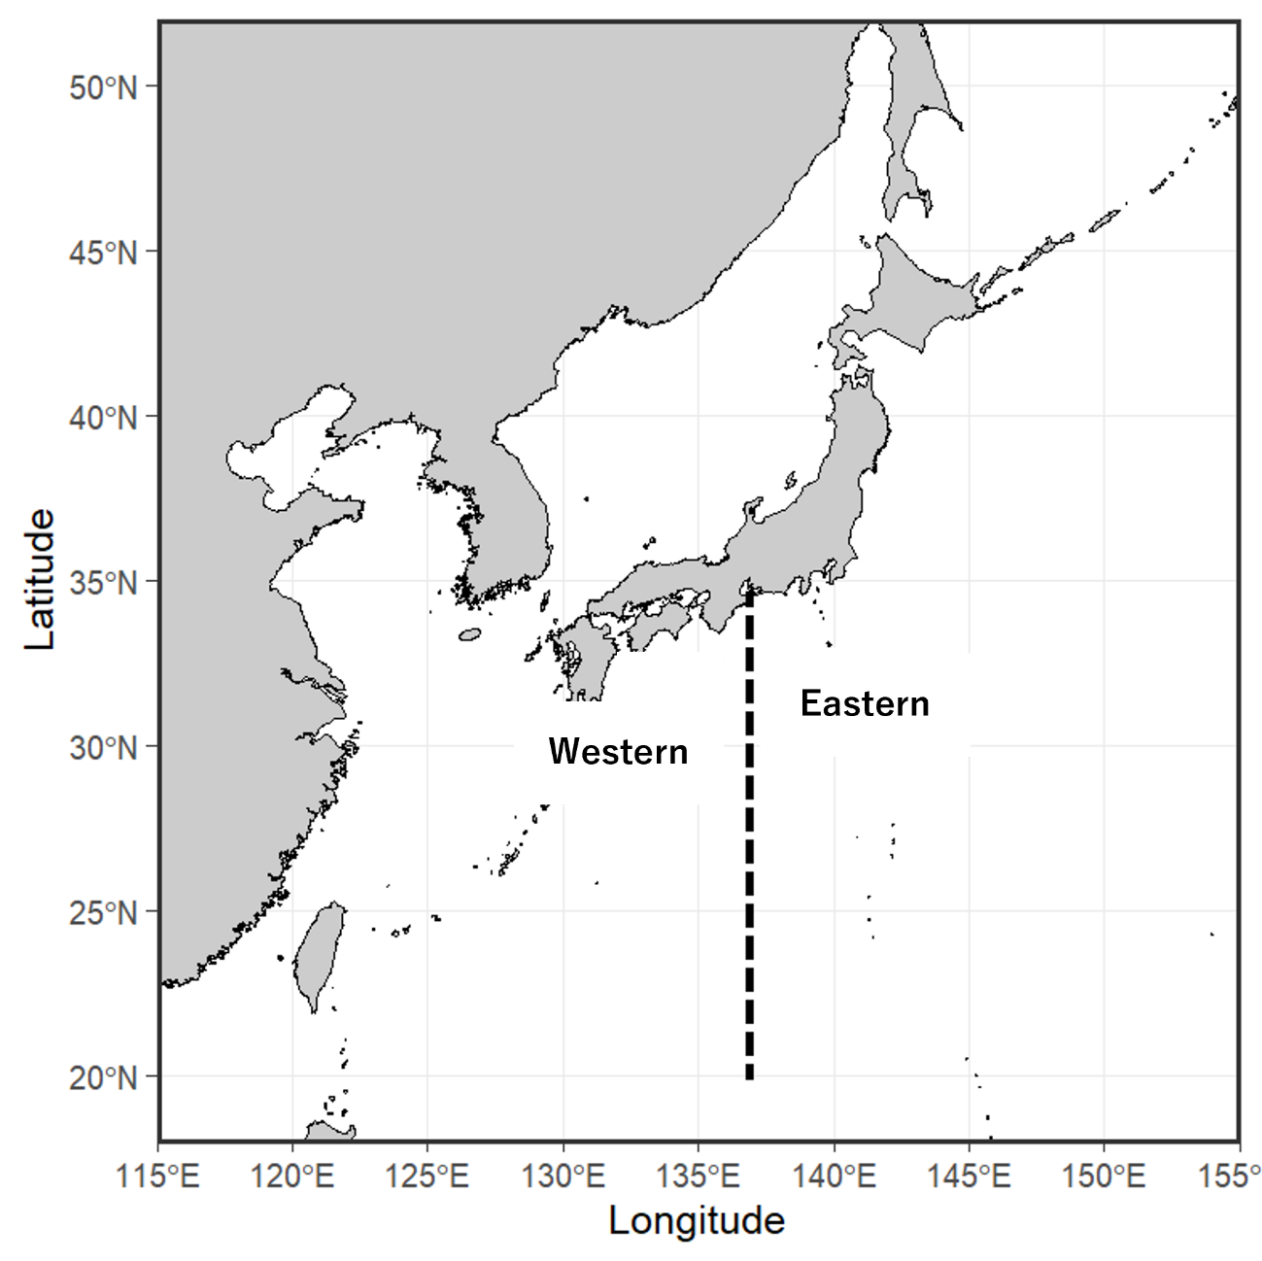
Figure 1. Area definition of Eastern and Western Pacific coast of Japan.

- CY2014-CY2017; East
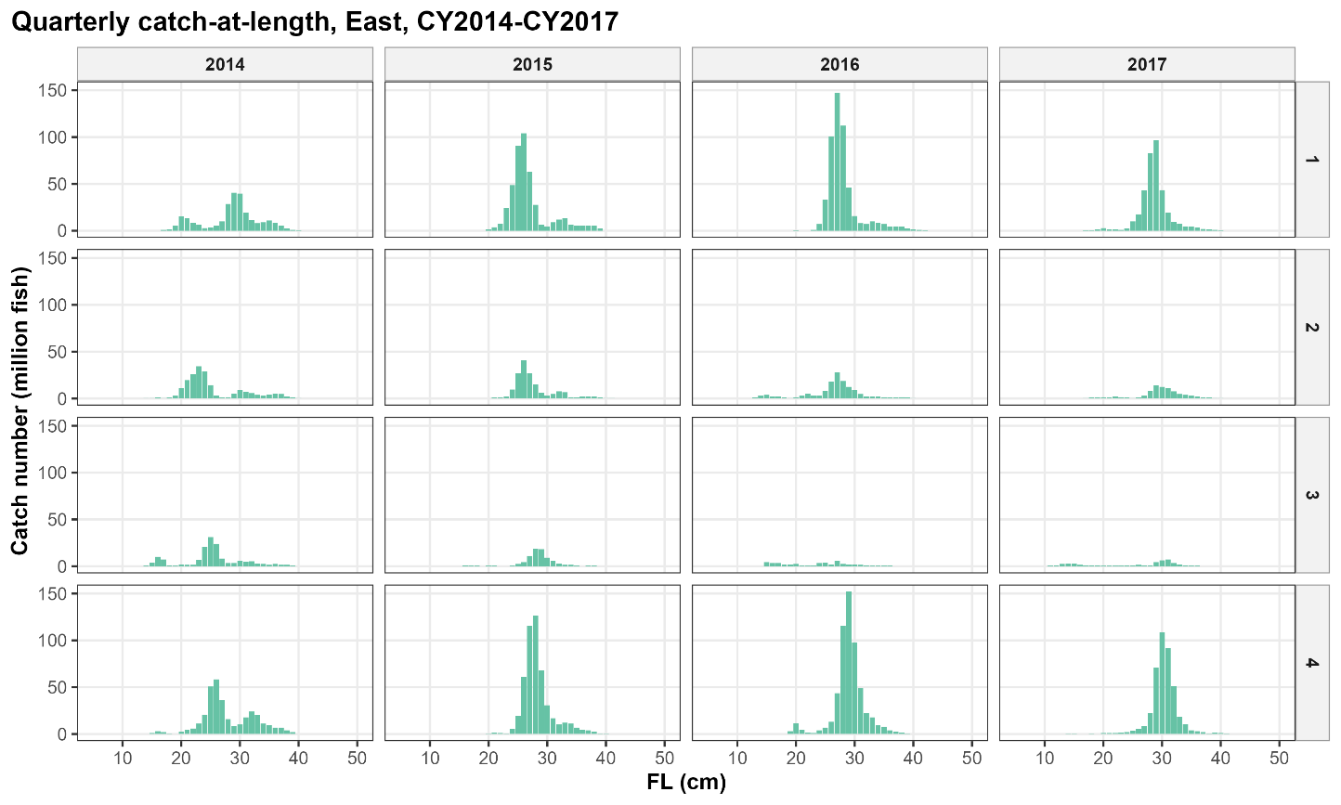

(b) CY2014-CY2017; West
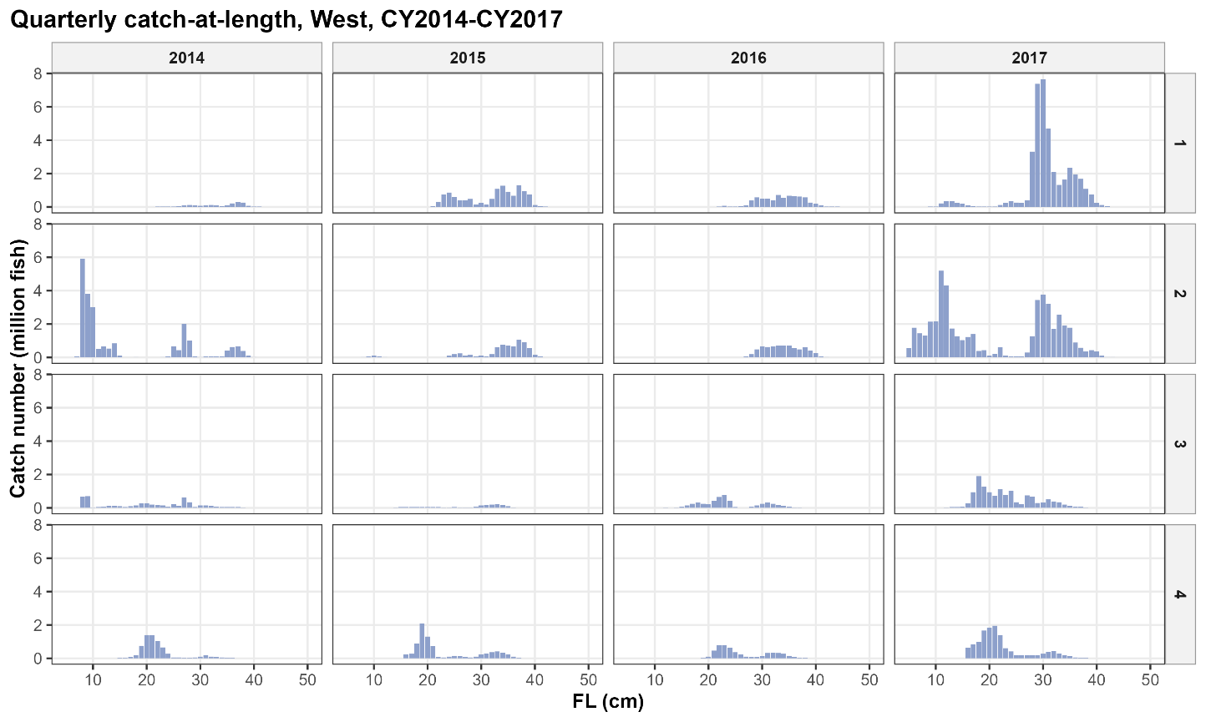
Figure 2. Quarterly catch-at-length of chub mackerel of CY2014-CY2017 from (a) Eastern Japan and (b) Western Japan.
(a) CY2018-CY2021; East
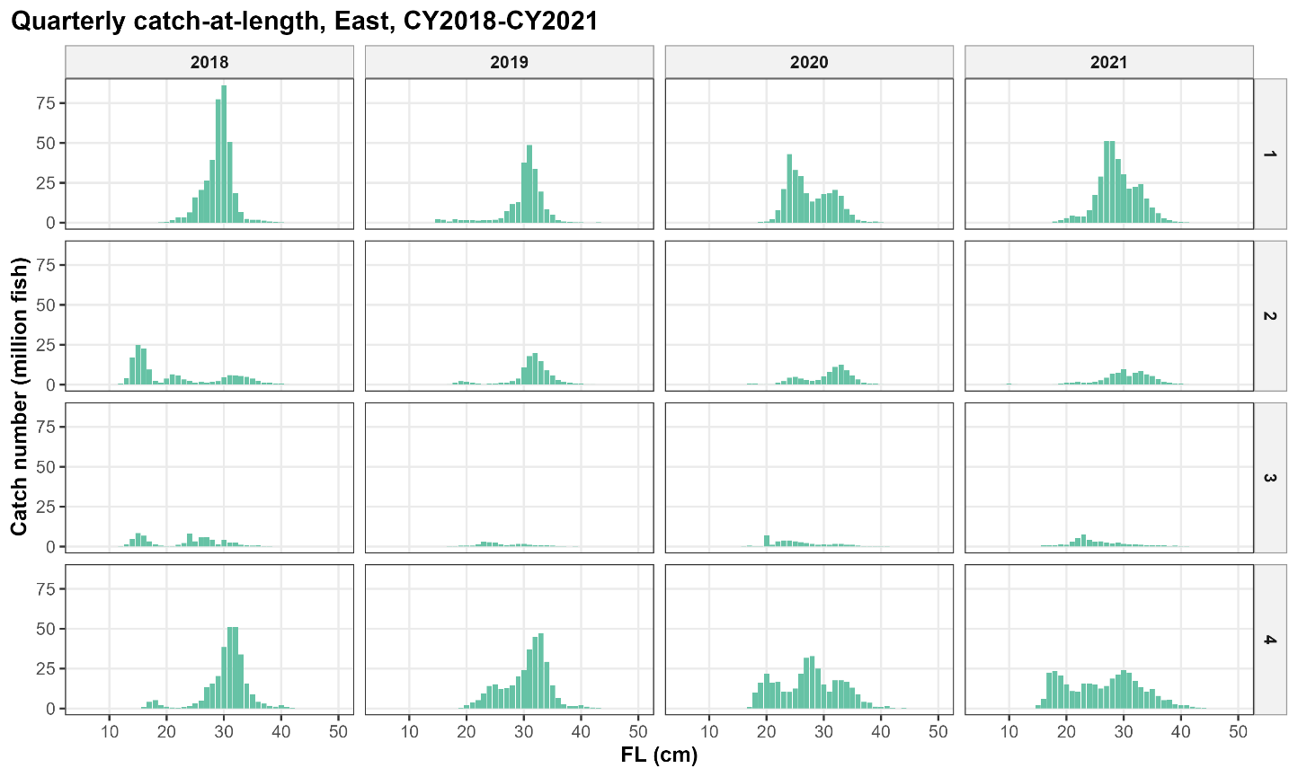

(b) CY2018-CY2021; West
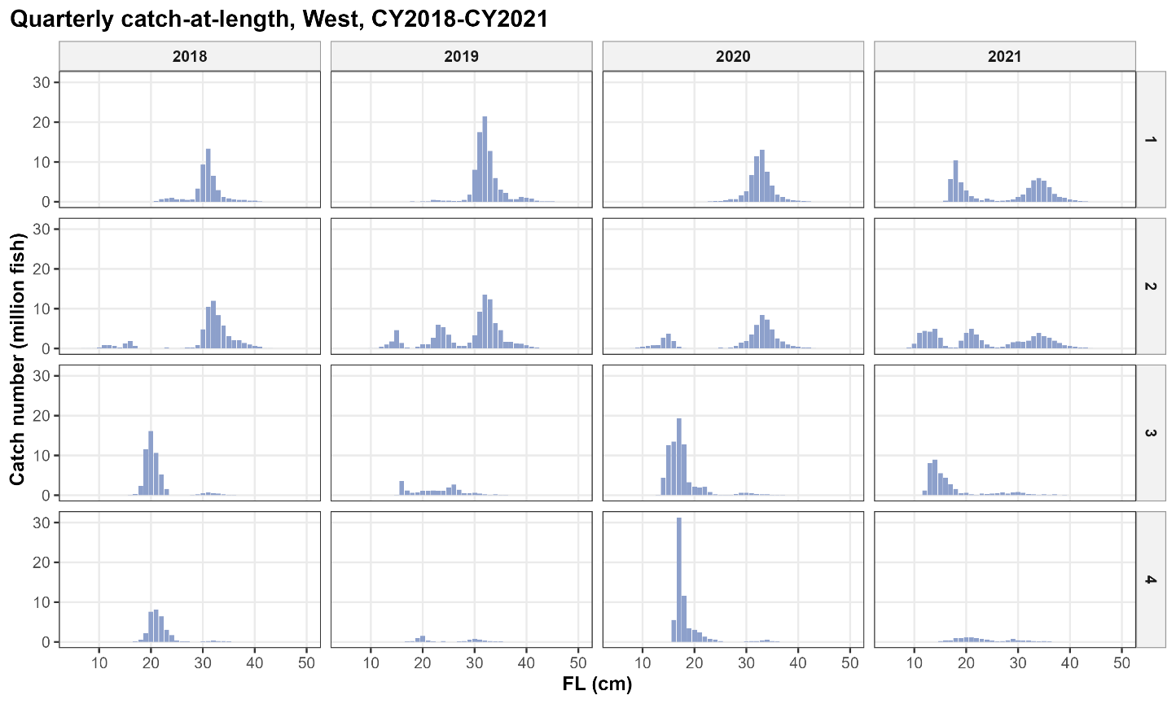
Figure 3. Quarterly catch-at-length of chub mackerel of CY2018-CY2021 from (a) Eastern Japan and (b) Western Japan.
(a) CY2022-CY2026/Q2; East
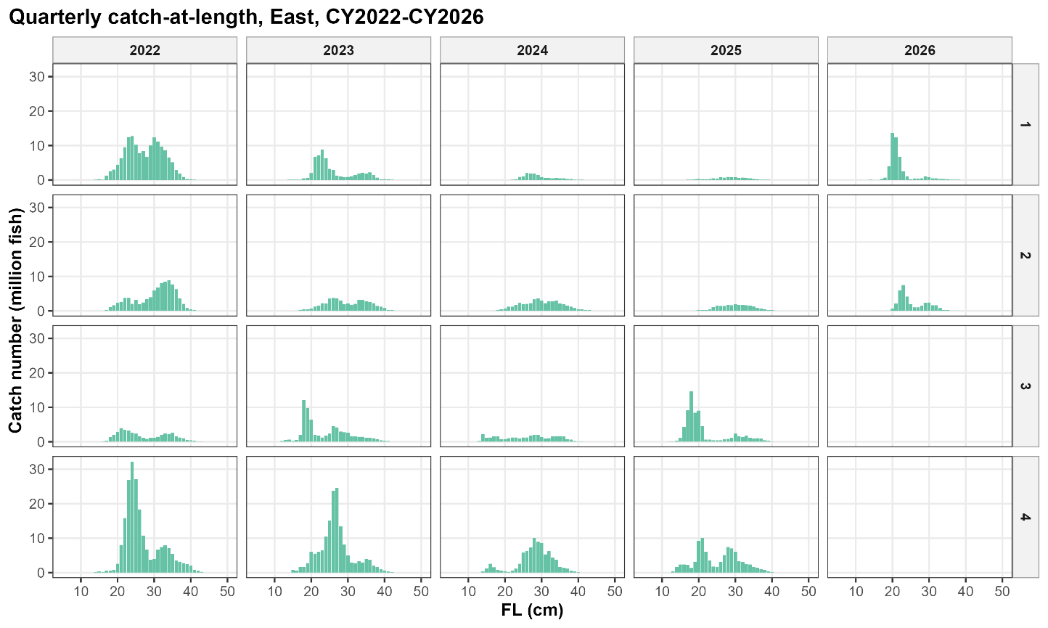

(b) CY2022-CY2026/Q2; West
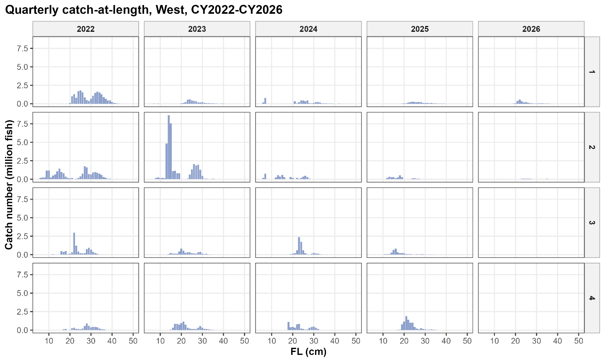
Figure 4. Quarterly catch-at-length of chub mackerel of CY2012-CY2026/Q2 from (a) Eastern Japan and (b) Western Japan.
(a) CY2014-CY2017; East
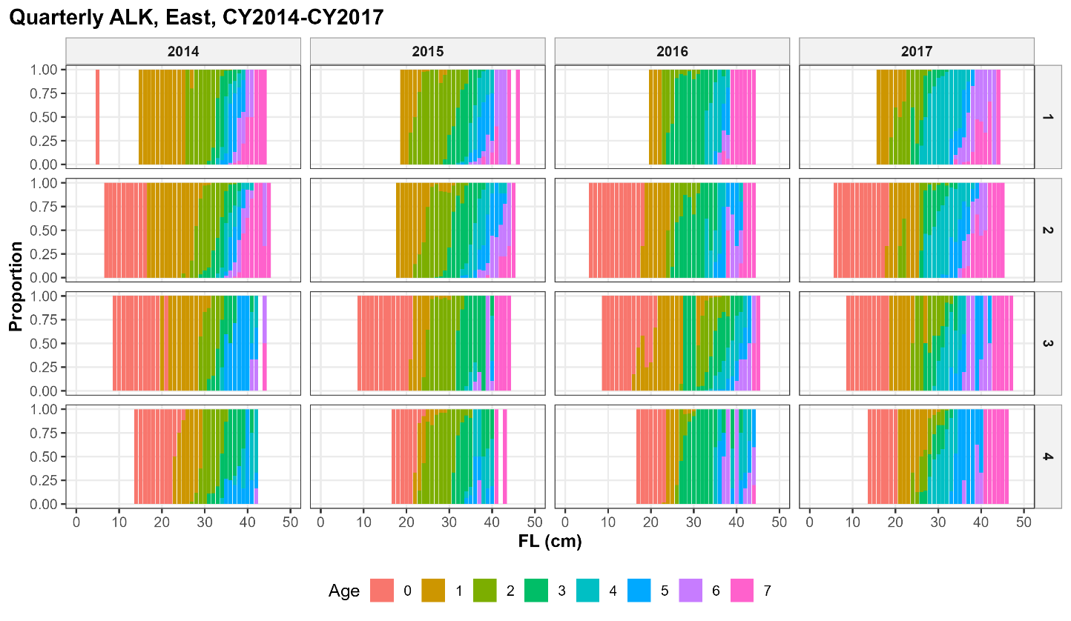

(b) CY2014-CY2017; West
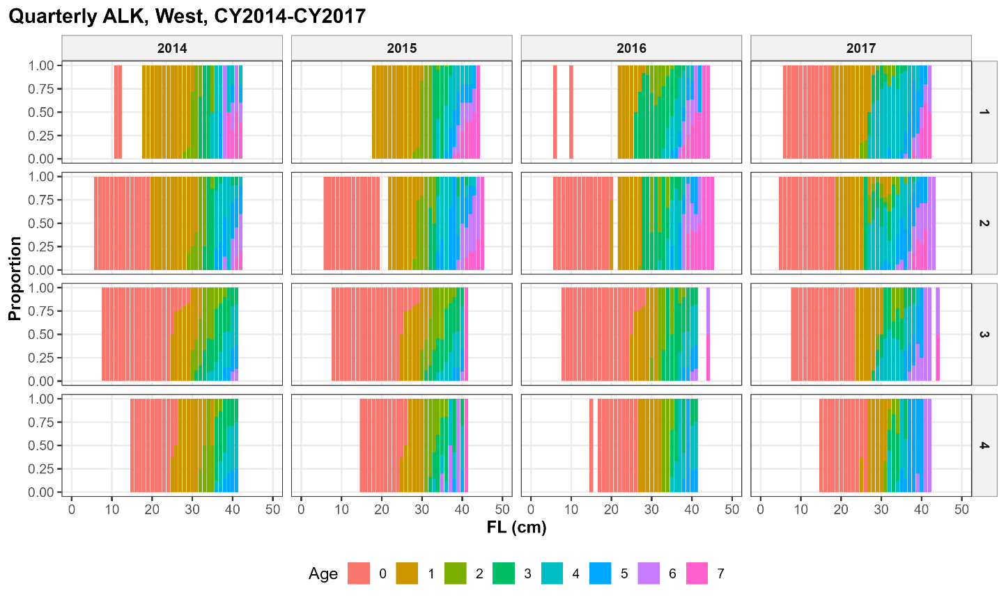
Figure 5. Quarterly age-length keys in CY2014-CY2017 for (a) Eastern Japan and (b) Western Japan.
(a) CY2018-CY2021; East
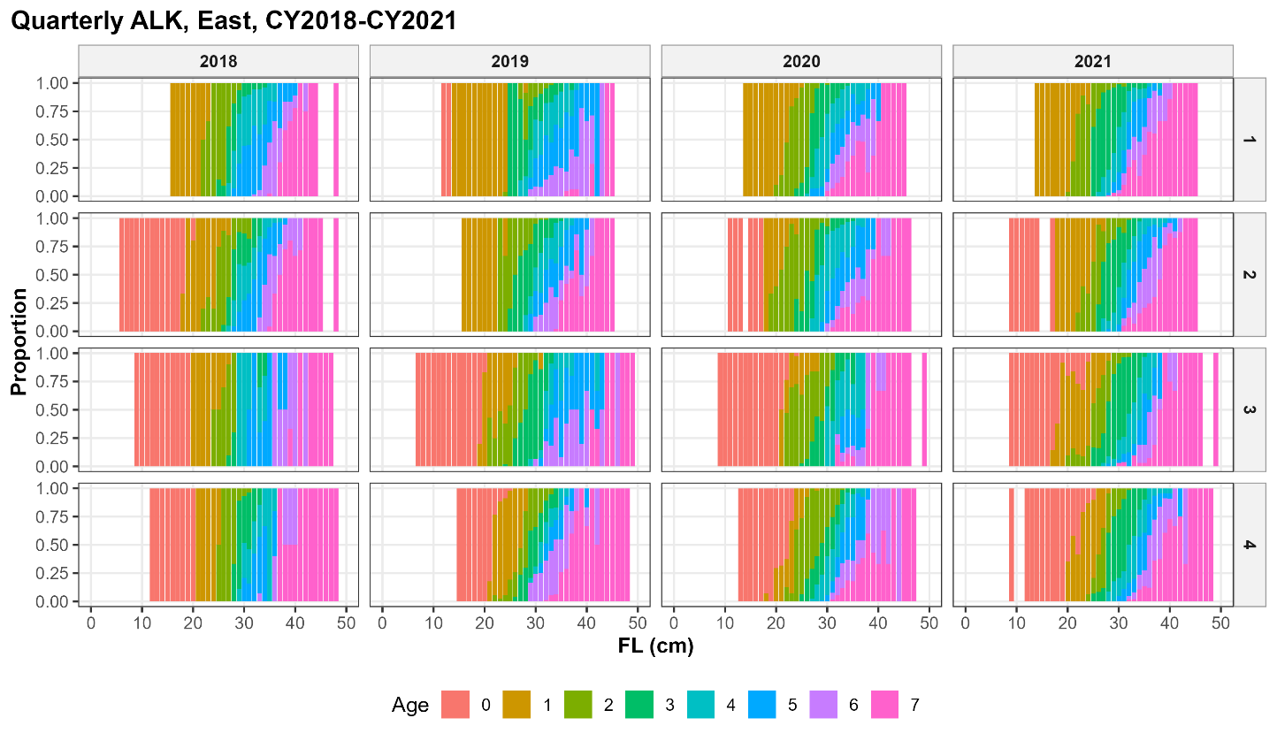

(b) CY2018-CY2021; West
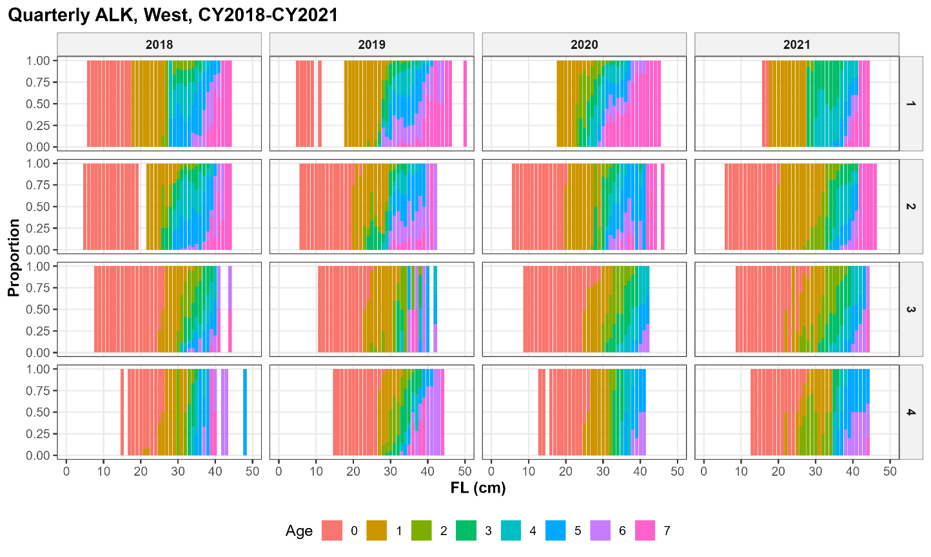
Figure 6. Quarterly age-length keys in CY2018-CY2021 for (a) Eastern Japan and (b) Western Japan.
(a) CY2022-CY2026/Q2; East
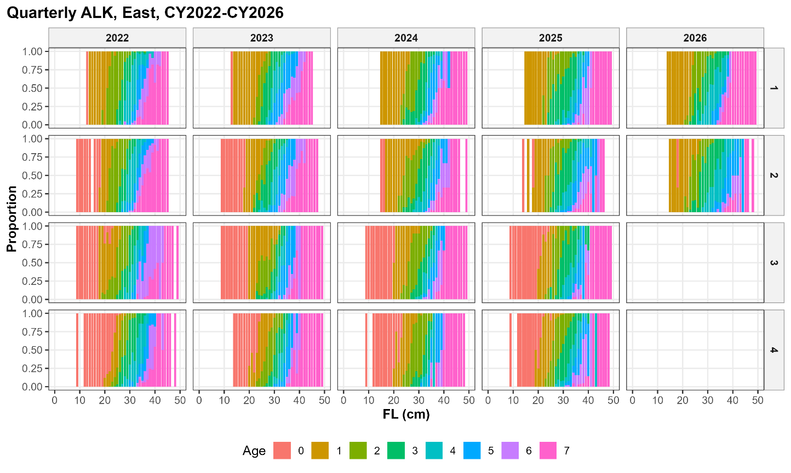

(b) CY2022-CY2026/Q2; West
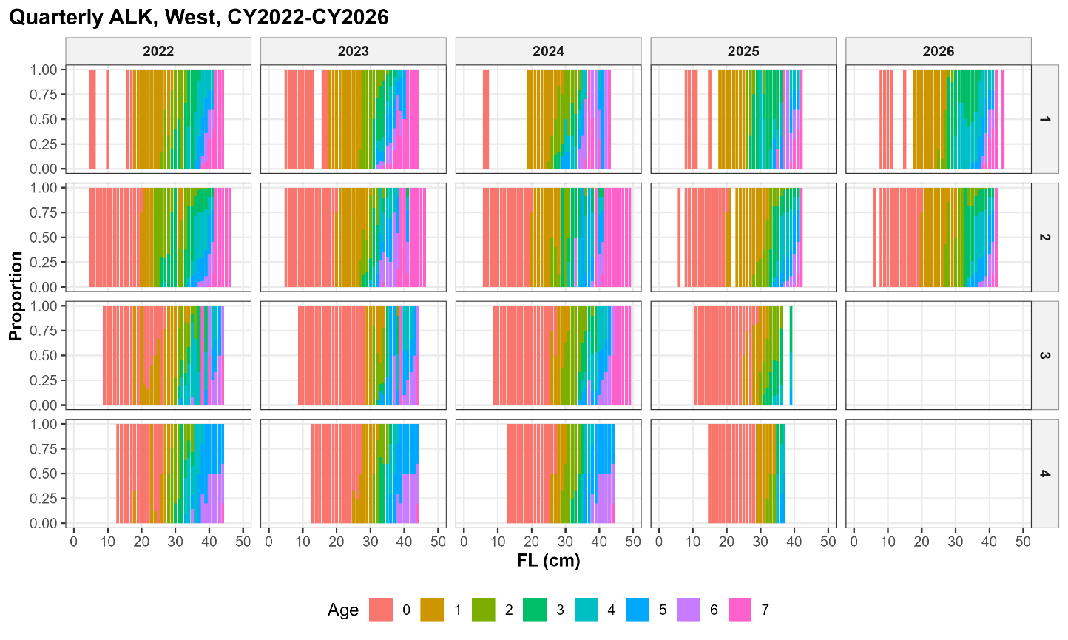
Figure 7. Quarterly age-length keys in CY2022-CY2026/Q2 for (a) Eastern Japan and (b) Western Japan.
(a) CY2014-CY2017; East
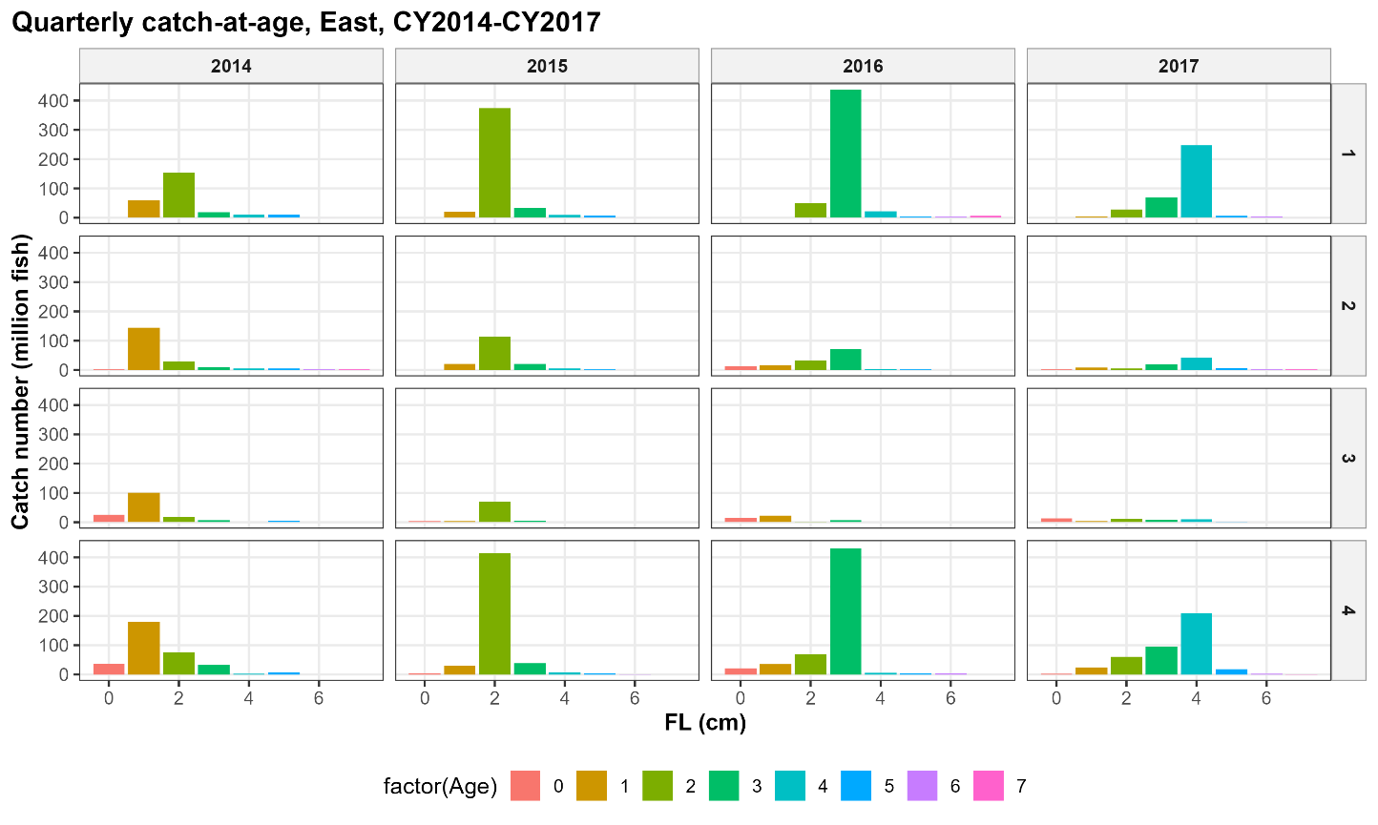

(b) CY2014-CY2017; West
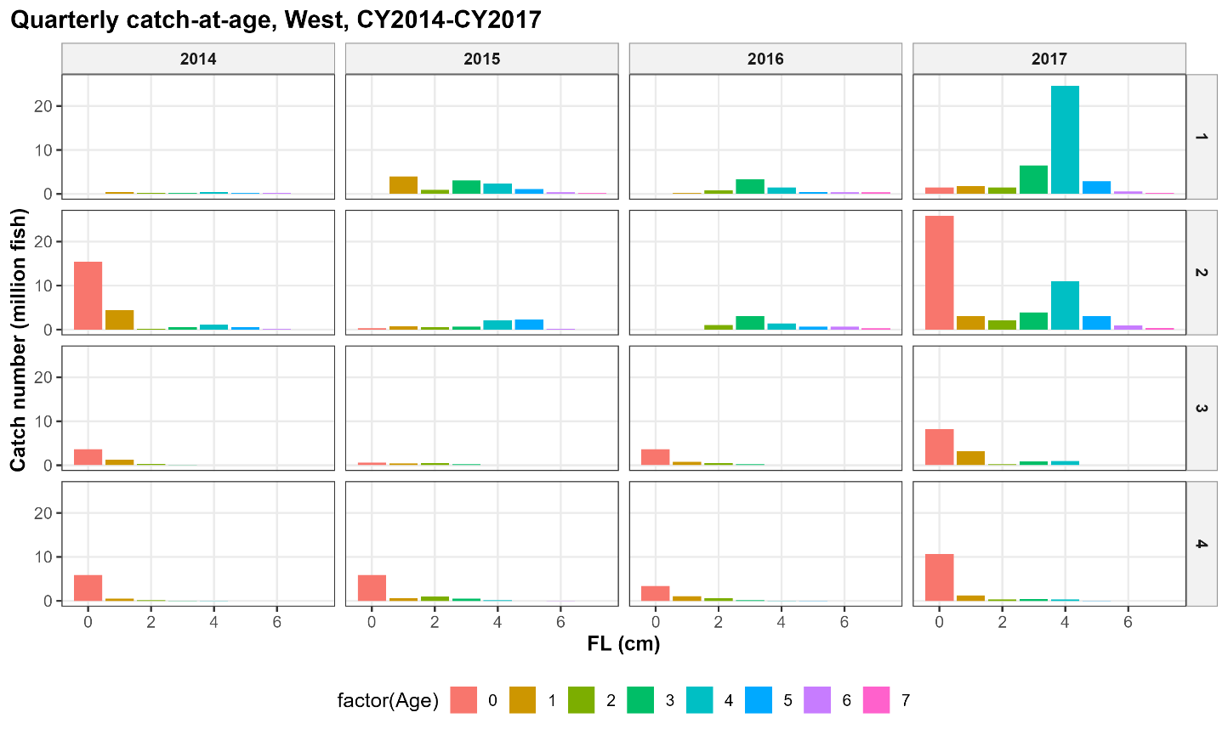
Figure 8. Quarterly catch-at-age of CY2014-FY2019 for (a) Eastern Japan and (b) Western Japan.
(a) CY2018-CY2021; East
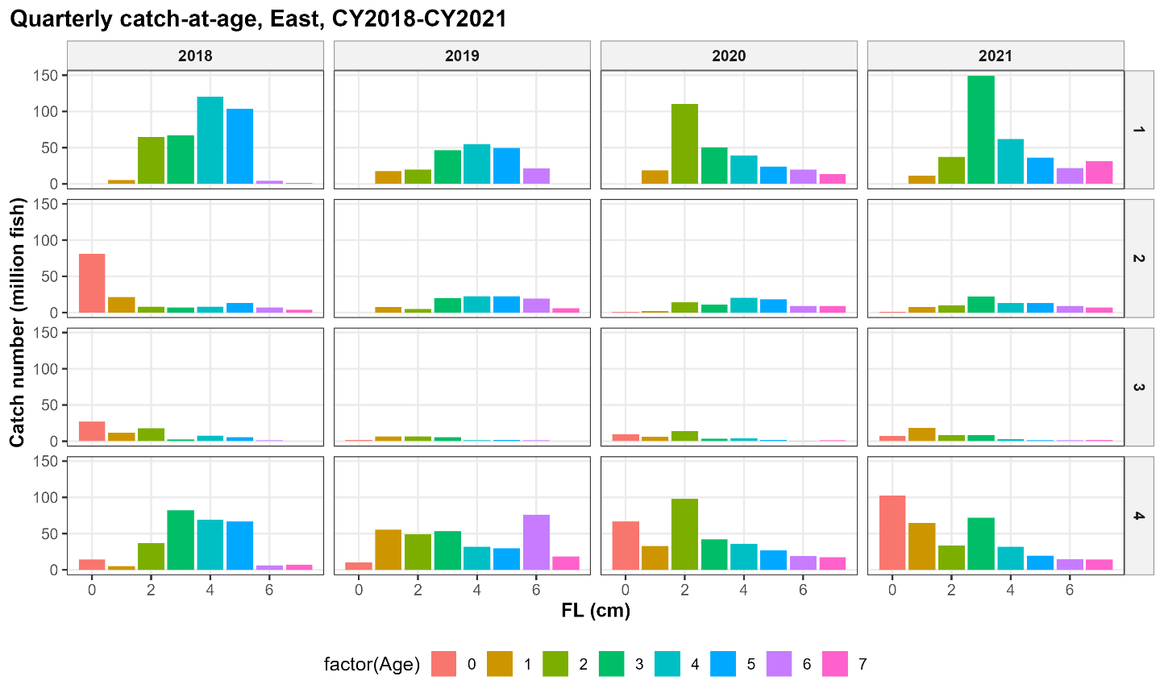

(b) CY2018-CY2021; West
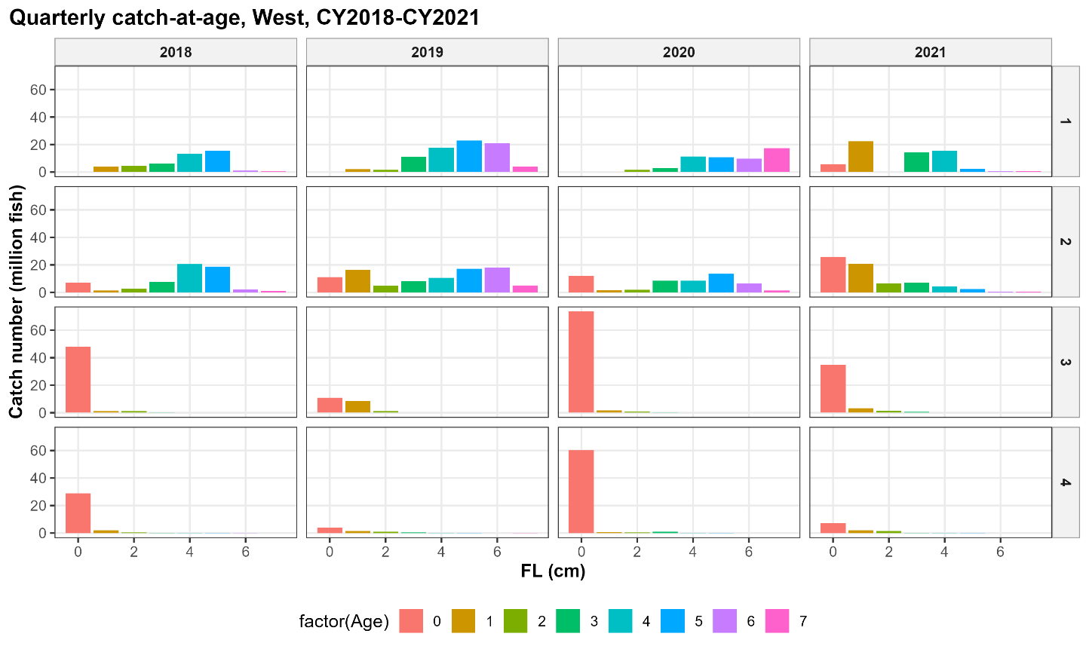
Figure 9. Quarterly catch-at-age of CY2018-FY2021 for (a) Eastern Japan and (b) Western Japan.
(a) CY2022-CY2026/Q2; East
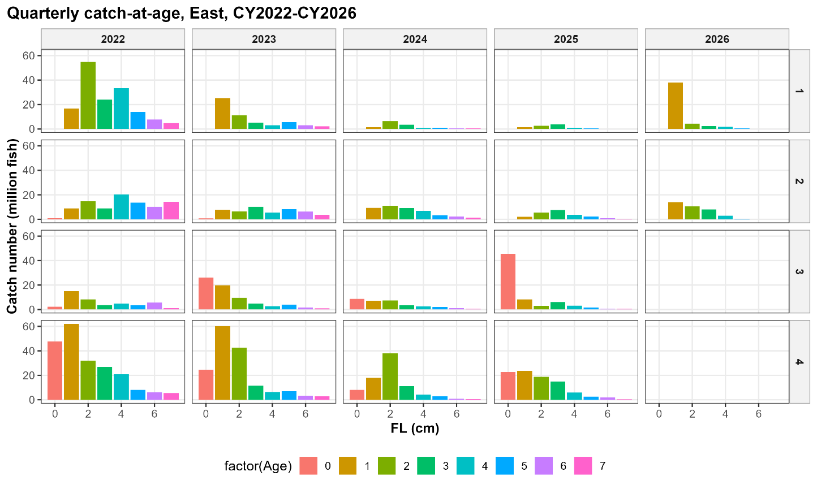

(b) CY2022-CY2026/Q2; West
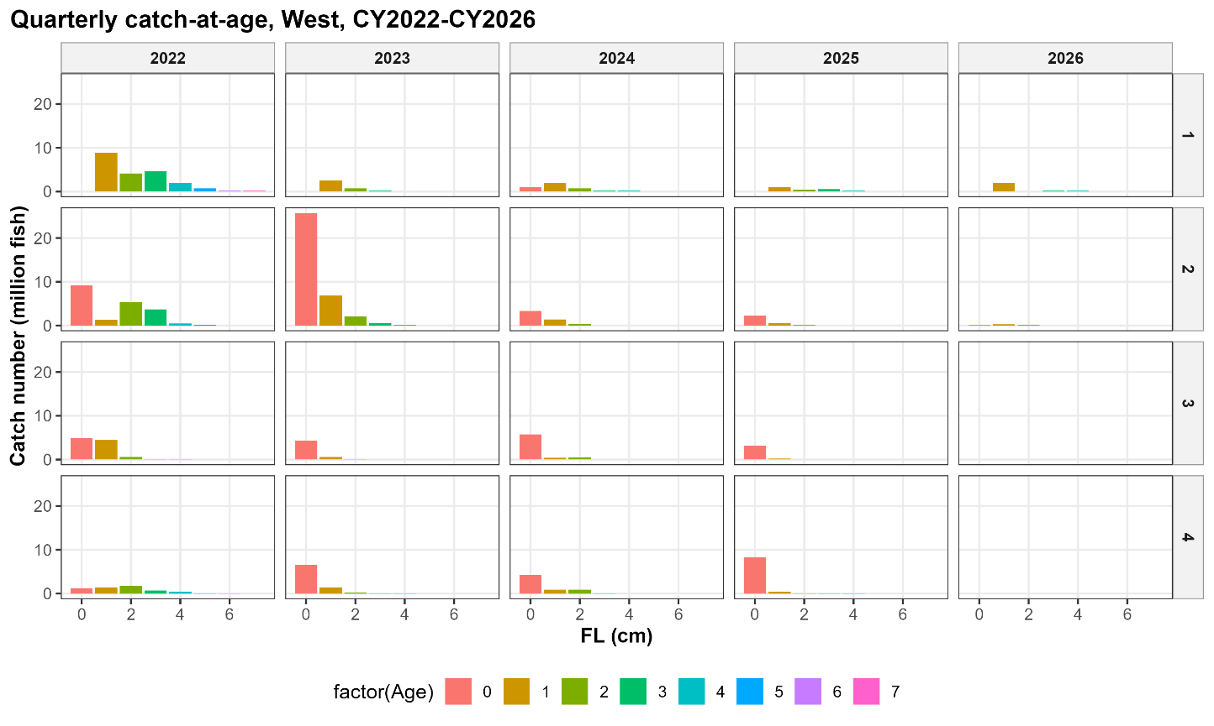
Figure 10. Quarterly catch-at-age of CY2022-FY2026/Q2 for (a) Eastern Japan and (b) Western Japan.
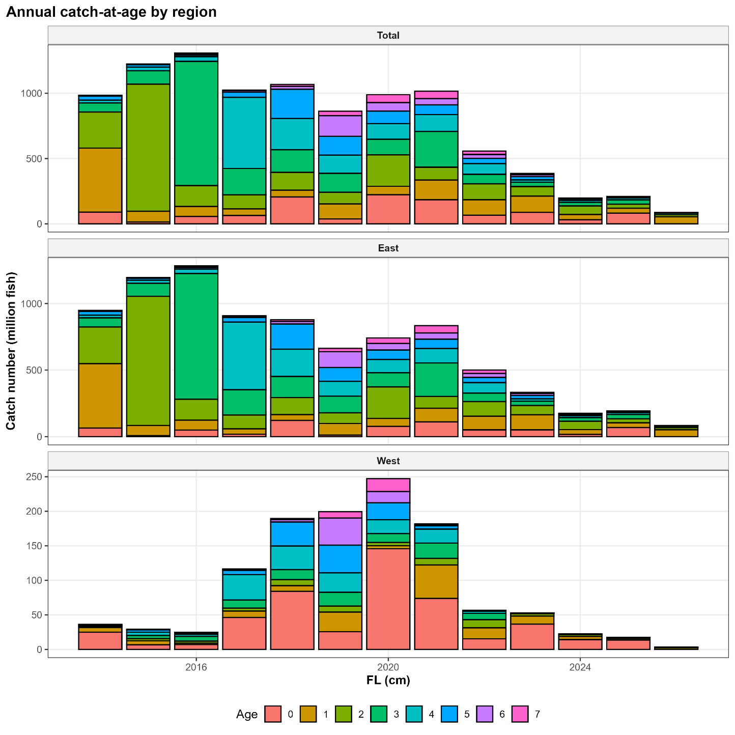
Figure 11. Calendar-year-based annual catch-at-age for Eastern and Western Japan with Total value, CY2014-CY2026/Q2.

(a) CY2014-CY2019
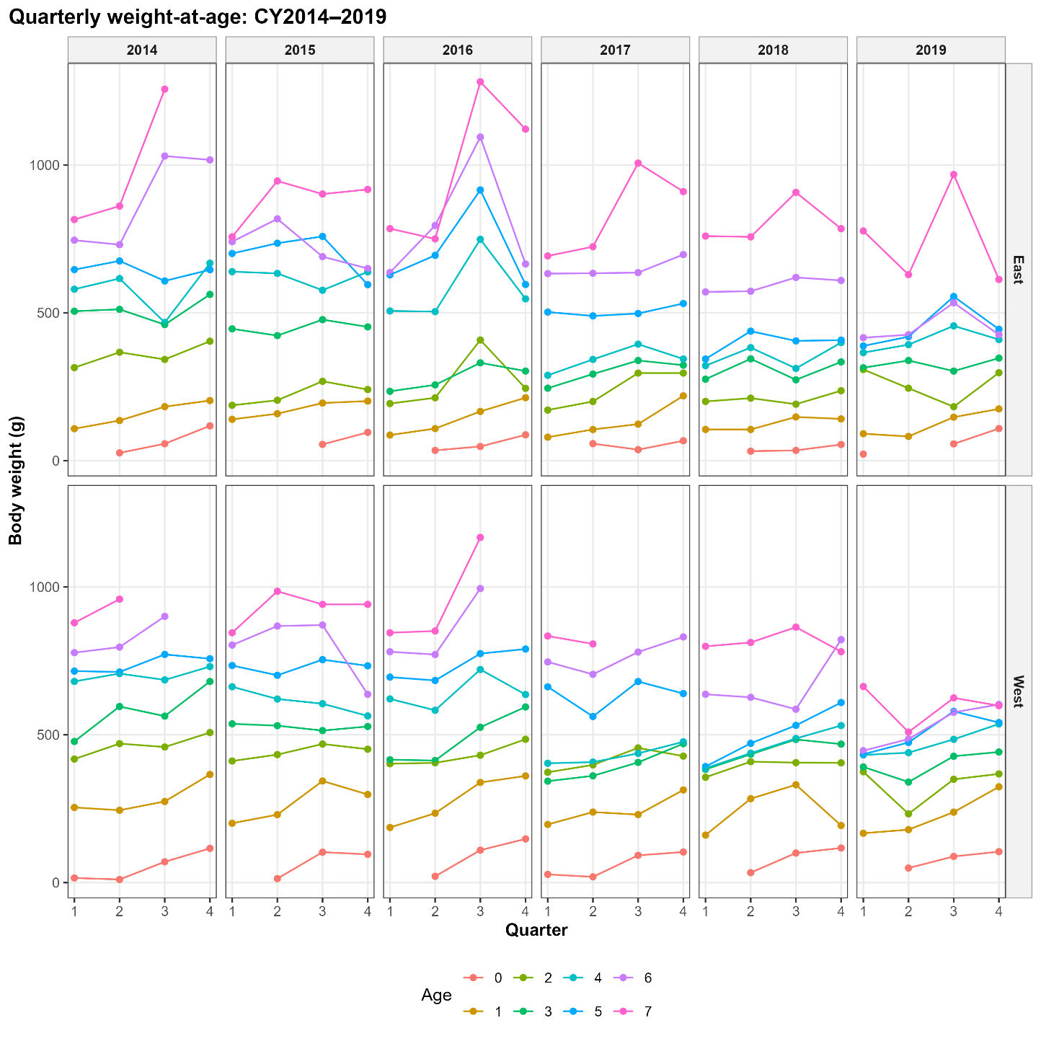
Figure 12. Quarterly weight-at-age for Eastern and Western Japan in (a) CY2014-CY2019 and (b) CY2020-CY2026/Q2.

(b) CY2020-CY2026/Q2
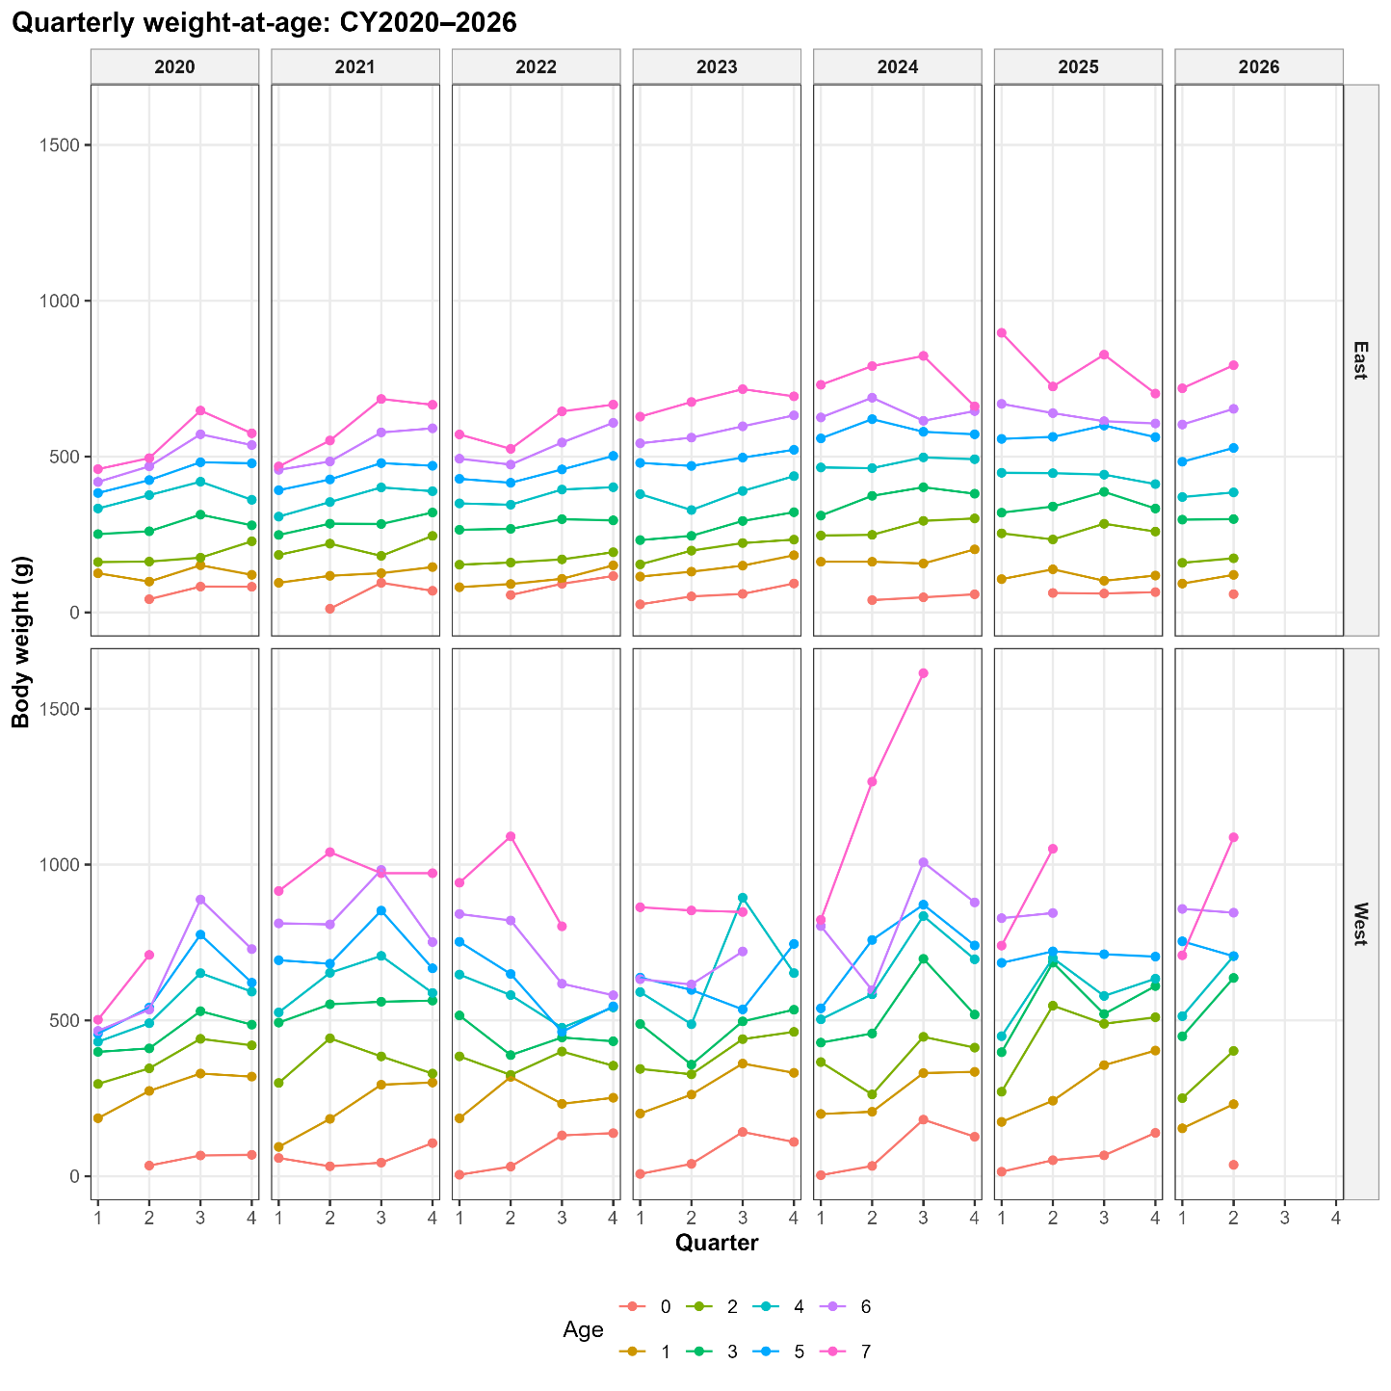
Figure 12. Continued.
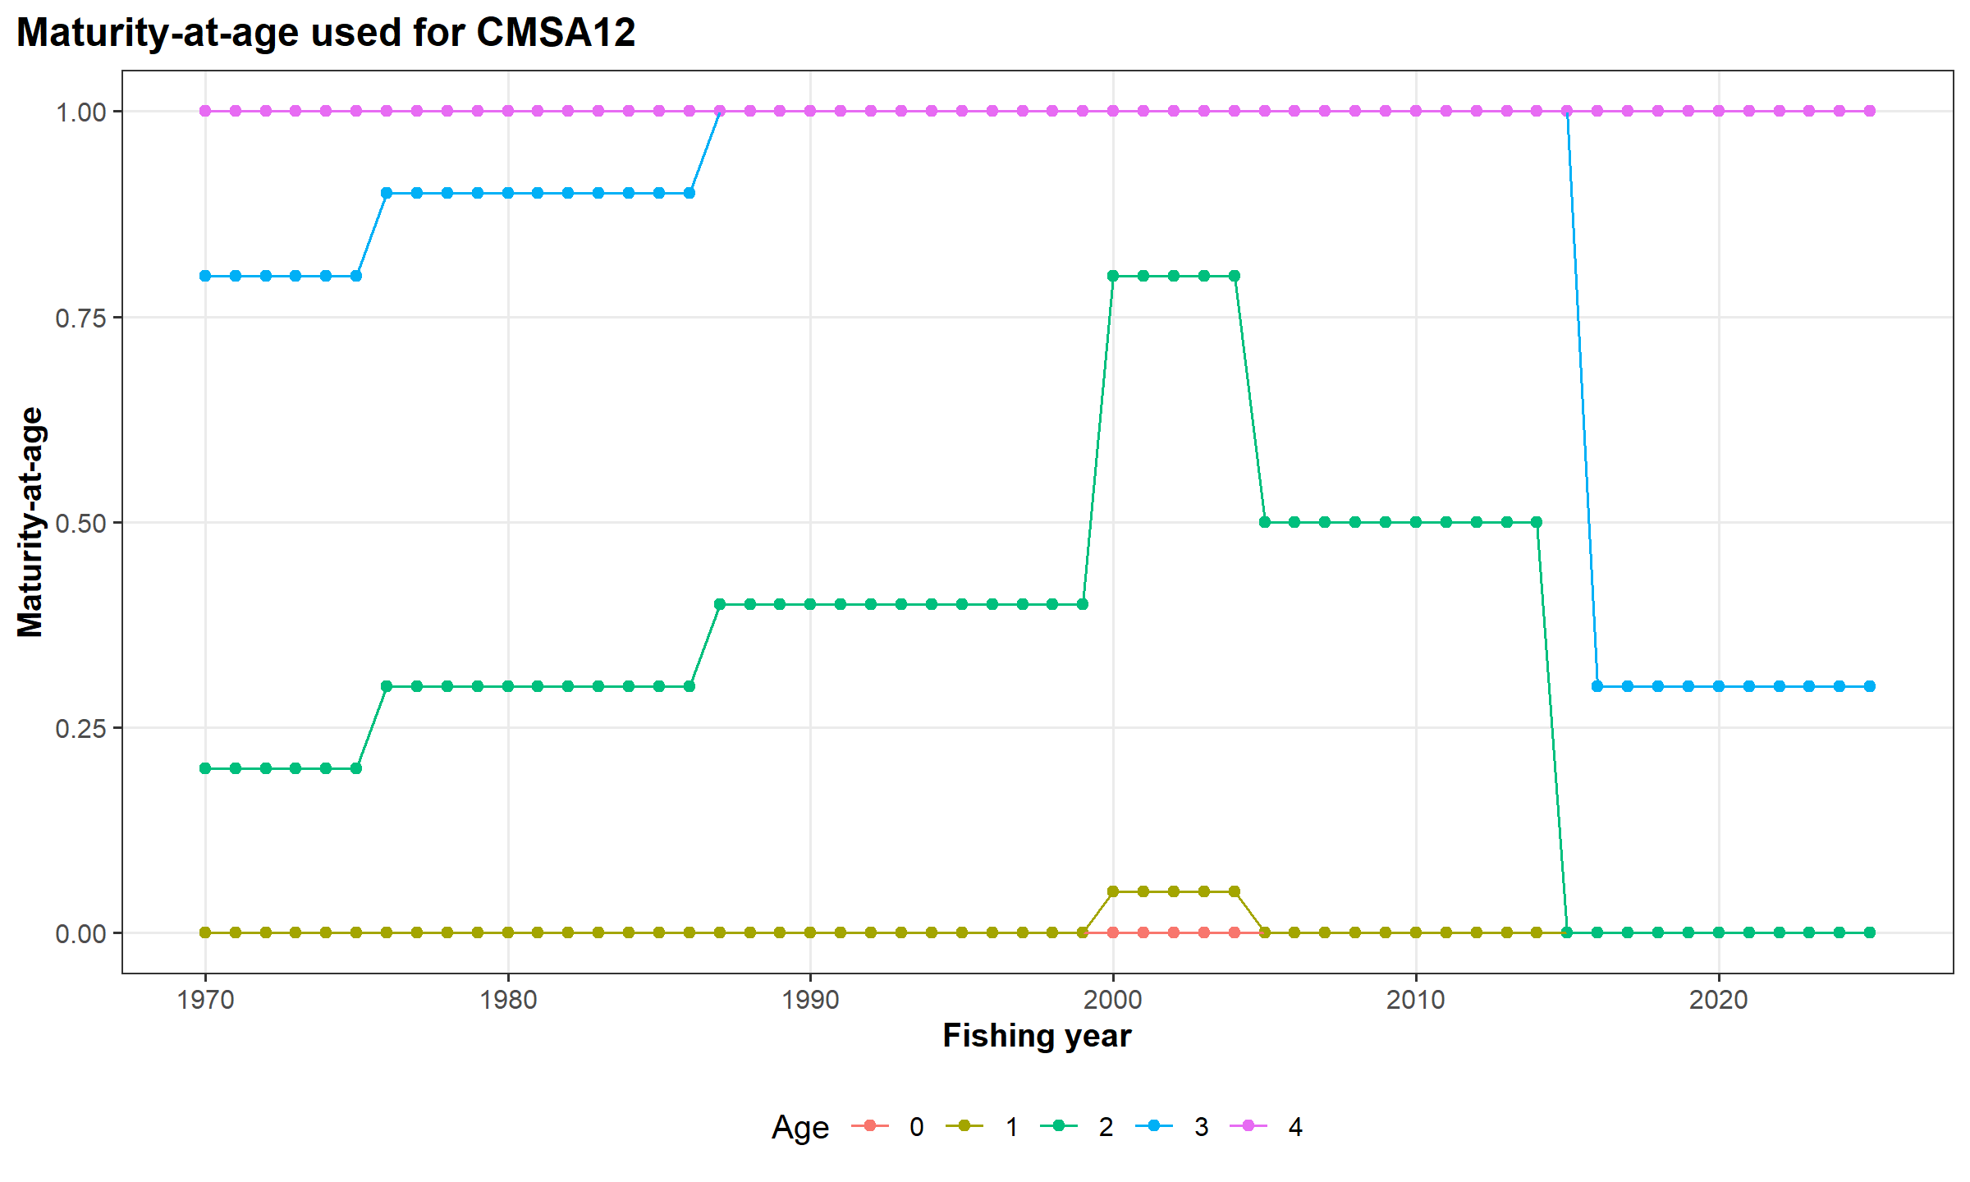
Figure 13. Maturity-at-age from FY1970 to FY2025. Age-4 and above are considered as equal.

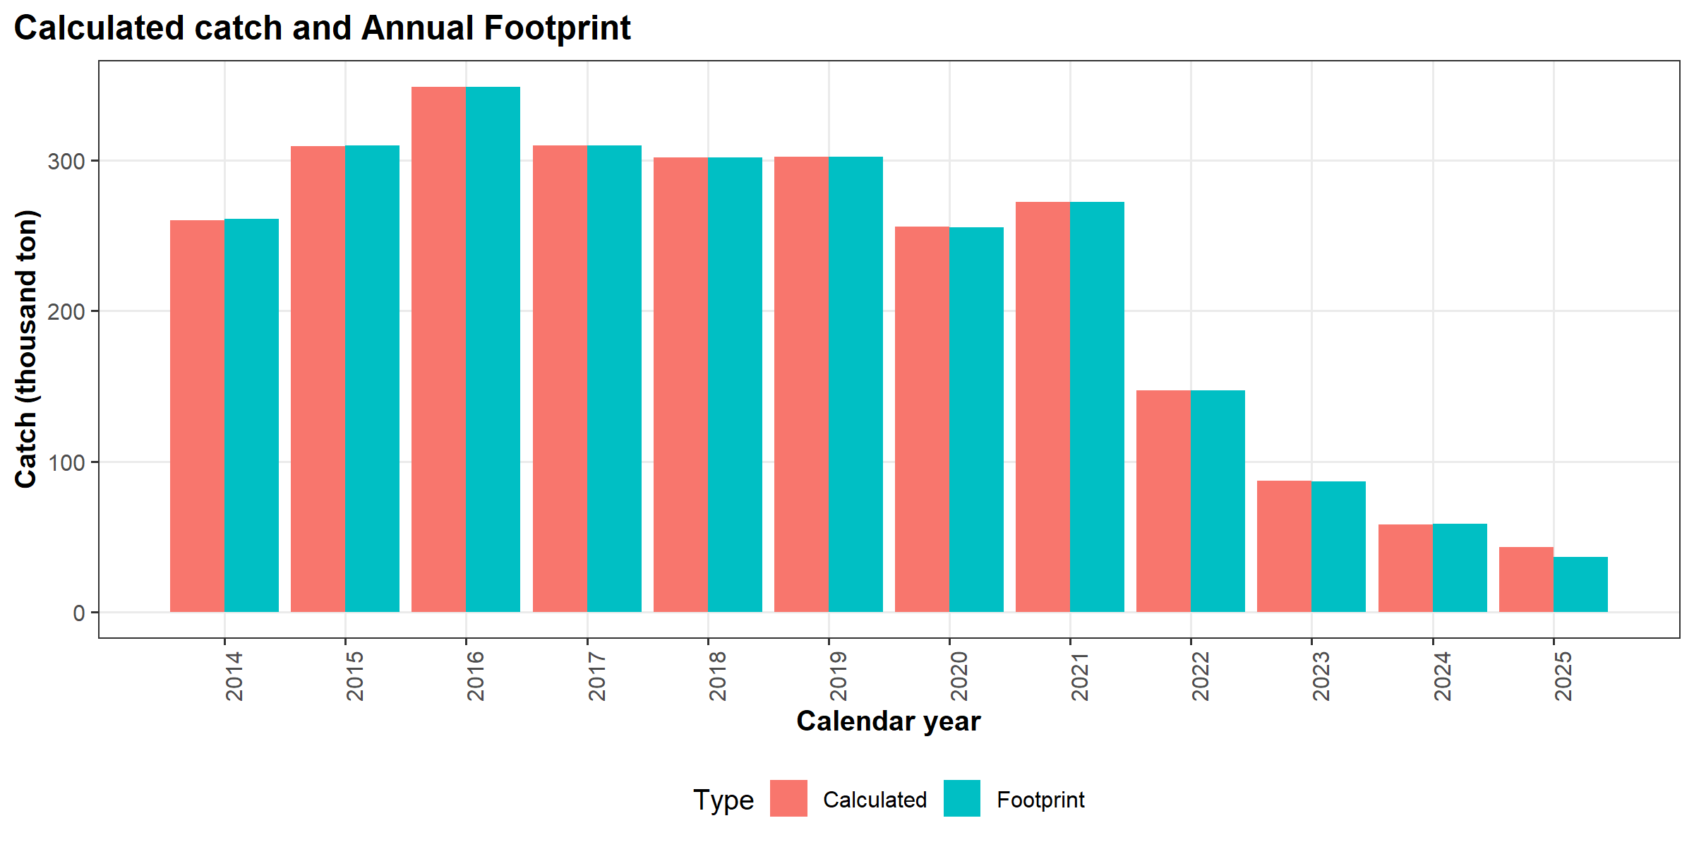
Figure 14. Calculated catch and the Annual Footprint.
Table 1. Number of age determination by year, quarter, and region from CY2014 Q1 to CY2025 Q2.
Year | Region | Q1 | Q2 | Q3 | Q4 | Total
2014 | East | 742 | 839 | 225 | 514 | 2320
2015 | East | 739 | 1029 | 494 | 505 | 2767
2016 | East | 453 | 239 | 111 | 222 | 1025
2017 | East | 752 | 592 | 194 | 491 | 2029
2018 | East | 836 | 661 | 44 | 162 | 1703
2019 | East | 808 | 485 | 340 | 641 | 2274
2020 | East | 1204 | 597 | 404 | 858 | 3063
2021 | East | 1012 | 818 | 645 | 845 | 3320
2022 | East | 837 | 663 | 511 | 912 | 2923
2023 | East | 734 | 622 | 373 | 797 | 2526
2024 | East | 559 | 708 | 478 | 450 | 2195
2025 | East | 567 | 708 | 436 | 685 | 2396
2026 | East | 706 | 583 | - | - | 1289
2014 | West | 96 | 131 | 0 | 2 | 229
2015 | West | 30 | 54 | 0 | 35 | 119
2016 | West | 240 | 88 | 22 | 33 | 383
2017 | West | 193 | 241 | 144 | 58 | 636
2018 | West | 311 | 388 | 296 | 124 | 1119
2019 | West | 779 | 667 | 122 | 299 | 1867
2020 | West | 659 | 126 | 0 | 17 | 802
2021 | West | 22 | 23 | 67 | 72 | 184
2022 | West | 68 | 64 | 201 | 82 | 415
2023 | West | 273 | 156 | 103 | 78 | 610
2024 | West | 121 | 27 | 95 | 51 | 294
2025 | West | 69 | 7 | 13 | 24 | 113
2026 | West | 67 | 60 | - | - | 127

Table 2. Catch discrepancies between calculated catch and the Annual Footprint. Difference represents calculated catch – footprint, difference (%) represents difference over calculated catch.
Calendar  Year | Calculated catch  (ton) | Footprint  (ton) | Difference  (ton) | Difference  (%)
2025 | 43,318 | 36,658 * | 6,660 | 15.4%
2024 | 58,104 | 58,491 | -387 | -0.7%
2023 | 86,943 | 86,932 | 11 | 0.0%
2022 | 147,237 | 147,180 | 57 | 0.0%
2021 | 272,254 | 272,191 | 64 | 0.0%
2020 | 255,530 | 255,467 | 63 | 0.0%
2019 | 301,981 | 302,322 | -342 | -0.1%
2018 | 301,630 | 301,824 | -193 | -0.1%
2017 | 309,607 | 309,375 | 232 | 0.1%
2016 | 348,531 | 348,674 | -144 | 0.0%
2015 | 308,996 | 309,458 | -462 | -0.1%
2014 | 260,067 | 260,784 | -717 | -0.3%
* Preliminary value.

