NPFC-2026-TWG CMSA12-WP04
Standardized abundance index for recruitment of chub mackerel from Northwest Pacific summer surveys up to 2026

Shota Nishijima, Yasuhiro Kamimura, Yuto Izawa, Kaho Adachi, Ryosuke Watanabe, Sho Furuichi and Ryuji Yukami
Fisheries Resources Institute, Japan Fisheries Research and Education Agency

Summary
We conducted CPUE standardization for summer surface-trawl surveys for Pacific chub mackerel using the Vector Autoregressive Spatio-Temporal (VAST) model. We estimated local densities of young-of-the-year fish in the Northwest Pacific from 2002 to 2026 while accounting for sea surface temperature (SST) and temperature at 50 m depth, and spatial autocorrelation. The analysis showed high recruitment index values have occurred frequently since 2013, although the recruitment has declined since 2021. In 2026, the nominal and standardized indices decreased to 1% and 4% of their respective 2025 values, representing the lowest levels since 2012. Model diagnostics found no serious problems in residual patterns. We propose using this standardized recruitment index as an abundance index for age 0 fish in the Technical Working Group on the Chub Mackerel Stock Assessment (TWG CMSA).

1. BACKGROUND
Chub mackerel (Scomber japonicus) is a small pelagic species with highly variable recruitment. Understanding the strength of recruitment is important for estimating the current and near-future stock abundance of chub mackerel. Japan Fisheries Research and Education Agency (FRA) has conducted a sea surface trawl net survey in a broad area of northwestern Pacific Ocean (Fig. 1) from June to July annually to collect biological and abundance information on small pelagic fish including chub mackerel (here called summer survey). The survey area largely covers the spatial distribution of young-of-the-year (YOY) fish of chub mackerel and, therefore, the catch rate or catch-per-unit effort (CPUE) can be used as a recruitment (i.e., age 0) index for CMSA.
Here, we updated the standardized CPUE values of the summer survey up to 2026. As in the previous working paper (Nishijima et al. 2025), we used the Vector Autoregressive Spatio-Temporal (VAST) model (Thorson 2019) in this paper. In this analysis, we used principal components (PCs) calculated from principal component analysis (PCA) for in situ sea surface temperature (SST) and 50m-depth temperature (T50) as orthogonal covariates.

2. METHOD

2.1 The data
The sea surface trawl net surveys have been conducted by FRA in a broad range of the Northwestern Pacific in summer (June and July) annually (Fig. 1). These summer surveys have been conducted annually in the area approximately from 141.5º E to 170.0ºW and from 32.0ºN to 45.0ºN. We conducted CPUE standardization from 2002 to 2026. This survey began in 2001, but we removed the 2001 samples from analyzed data because the number of stations and geographic coverage in the first year were small (Tables 1 and 2, Fig. 1). Except in 2011, when survey operations were affected by the Great East Japan Earthquake, and in 2020, when they were affected by the COVID-19 pandemic, more than 100 stations were sampled annually from 2003 onward (Table 1). Although fewer stations were sampled in 2026 than in typical years because an operational issue with the survey equipment prevented sampling in the easternmost part of the survey area, west of the International Date Line, this is unlikely to have materially affected the standardized index because chub mackerel are rarely caught in this area (Fig. 1).
The towing duration, which was used as effort, was generally one hour (Table 1, Fig. 1A). The CPUEs (Fig. 1B, C) were calculated as the number of fish per hour of towing. The proportions of positive catches were generally low despite substantial interannual variation (2−42%). We removed samples with no information on SST or T50 from the analyzed data (Table 2). The final sample size was 3,295.

2.2 Associations between independent variables and between dependent and independent variables
SST and T50 were highly correlated, with a Pearson’s correlation coefficient of r = 0.70 (Fig. 2, left). Such collinearity in multiple regression models could destabilize parameter estimates and predictions for new data, potentially complicating the interpretation of results and model predictions in CPUE standardization. Therefore, we conducted PCA and used PC1 and PC2 as orthogonal covariates (Fig. 2, right). PC1 was negatively correlated with SST and T50, indicating a common component of SST and T50. By contrast, PC2 was positively correlated with SST but negatively correlated with T50, reflecting the difference between SST and T50. The proportions of variance explained by PC1 and PC2 were 84.8% and 15.2%, respectively (Fig. 2).
We found no systematic interannual patterns in SST, T50, PC1, or PC2 (Fig. 3). SST and T50 tended to be higher in the south than in the north (Fig. 4A, B). PC1, which was negatively correlated with SST and T50, was thus higher in the north (Fig. 4C). PC2 tended to be higher off the Pacific coast of Japan (Fig. 4D). Accordingly, PC1 and PC2 represented north–south and east–west gradients, respectively.

2.3 Full model description and model selection
We used the VAST model to standardize CPUE for age-0 fish in the summer survey. In simulations, VAST demonstrated better overall performance in CPUE standardization than generalized linear models or generalized additive models (Grüss et al. 2019). In VAST, survey CPUE is represented using two linear predictors for each sample i: encounter probability (p₁(i)) and density (or CPUE) conditional on encounter (p₂(i)).
$$p_{1}\left(i\right)=β_{1}\left(t_{i}\right)+ω_{1}\left(s_{i}\right)+ε_{1}\left(s_{i},t_{i}\right)+\sum_{k_{1}}^{n_{k1}}{λ_{1}\left(k_{1}\right)Q_{i}\left(i,k_{1}\right) }$$ | (1)
$$p_{2}\left(i\right)=β_{2}\left(t_{i}\right)+ω_{2}\left(s_{i}\right)+ε_{2}\left(s_{i},t_{i}\right)+\sum_{k_{2}}^{n_{k2}}{λ_{2}(k_{2})Q_{i}(i,k_{2})}$$ | (2)
The first term on the right-hand side, $β\left(t_{i}\right)$, represents the coefficient indicating the effect of survey year t. The second term, $ω\left(s_{i}\right)$, signifies the spatial random effect for survey year t, while the third term, $ε\left(s_{i},t_{i}\right)$, denotes the spatiotemporal random effect for survey year t and location s. The fourth term represents the covariate Q influencing catchability, with its corresponding coefficient λ. In the VAST model, initially, spatial distribution is approximated by determining knots through a form of clustering called k-means from spatial information. The spatiotemporal variation in relative density at these knots is then modeled. Previous studies recommend using 100 or more knots (Thorson 2019), and following this guidance, we selected 100 knots for this study. The probability density function for spatial effects is modeled using a multivariate normal distribution (MVN):
$$ω_{1}\left(∙,f\right)\sim MVN\left(0,R_{1}\right), ω_{2}\left(∙,f\right)\sim MVN\left(0,R_{2}\right) ,$$ | (3)
where R₁ and R₂ are Matérn correlation functions:
$$R_{1}\left(s_{n},s_{m}\right)=\frac{1}{2^{φ-1}Γ(φ)}×{\left(κ_{1}\left|d\left(s_{n},s_{m}\right)H\right|\right)}^{φ}×K_{υ}\left(κ_{1}\left|d\left(s_{n},s_{m}\right)H\right|\right) ,$$ | (4)
$$R_{2}\left(s_{n},s_{m}\right)=\frac{1}{2^{φ-1}Γ(φ)}×{\left(κ_{2}\left|d\left(s_{n},s_{m}\right)H\right|\right)}^{φ}×K_{υ}\left(κ_{2}\left|d\left(s_{n},s_{m}\right)H\right|\right) .$$ | (5)
In VAST, the parameter $φ$ is not estimated, but rather fixed at $φ=1$. Here, $Γ$ represents the gamma function, K_{ν} is the modified Bessel function of the second kind, $κ_{1}$ and $κ_{2}$ are decorrelation rates to be estimated, $d\left(s_{n},s_{m}\right)$ is the distance between knots, and H is the matrix representing geographical anisotropy (variation in correlation depending on the direction). However, geographical anisotropy was not assumed ($H=I$) due to challenges in estimation. Similarly, the probability density function for spatiotemporal effects is given as follows:
$$ε_{1}\left(∙,f,t\right)\sim \left\{\begin{matrix}MVN(0,R_{1}) & if t=1 \\ MVN(ρ_{ε1}ε_{1}\left(∙,f,t-1\right),R_{1}) & if t>1\end{matrix}\right. ,$$ | (6)
$$ε_{2}\left(∙,f,t\right)\sim \left\{\begin{matrix}MVN(0,R_{2}) & if t=1 \\ MVN(ρ_{ε2}ε_{2}\left(∙,f,t-1\right),R_{2}) & if t>1\end{matrix}\right. .$$ | (7)
As part of the default settings in VAST, the effects for each year (β) were estimated as fixed effects, and the spatiotemporal effects were assumed to be independent ($ρ_{ε1}=ρ_{ε2}=0$).
In the analysis, a delta model using binomial and gamma distributions was fitted. The predicted encounter rate (r₁(i)) and predicted CPUE conditional on encounter (r₂(i)) were expressed using the following equations (Thorson 2017):
$$r_{1}\left(i\right)={logit}^{-1}p_{1}\left(i\right) ,$$ | (8)
$$r_{2}\left(i\right)=a_{i}×\log^{-1}p_{2}\left(i\right) .$$ | (9)
The term a_{i} represents the offset and was set to 1 because CPUE was the response variable. The probability distribution of the observed CPUE is expressed as follows, and the parameters were estimated by maximizing the marginal likelihood.
$$\operatorname{Pr}\left(b_{i}=B\right)=\left\{\begin{matrix}1-r_{1}\left(i\right) & if B=0 \\ r_{1}\left(i\right)×g\{\left.B|r_{2}\left(i\right),σ_{m}^{2}\}\right. & if B>0\end{matrix}\right.$$ |  | (10)
The parameters of the model described above were estimated by maximum likelihood. We used the VAST package available on GitHub (https://github.com/James-Thorson-NOAA/VAST; Thorson 2019). Template Model Builder was used to efficiently perform the complex integrations required for models with numerous random effects (Kristensen et al. 2016).
The candidate catchability covariates included PC1, PC2, their squared terms, and the interaction between PC1 and PC2 (Table 3). Model selection was conducted by exhaustive search based on the corrected Akaike information criterion (AICc).

2.4 Yearly trend extraction
The abundance index was calculated by employing the model with the lowest AICc. In VAST, the density for each year (t) and each knot (s) is computed as $d\left(s,t\right)=r_{1}^{*}(s,t)×r_{2}^{*}(s,t)$, where r* is obtained using equations 8 and 9 from equations 1 and 2, excluding the fourth term reresenting catchability. The abundance was then determined by summing the product of the area ($a\left(s\right)$) and the density for each knot. Since the density is represented by CPUE (individuals/hour) in this analysis, the standardized CPUE (individuals/hour) was calculated by dividing the sum by the total area.
$$I\left(t\right)=\frac{\sum_{s=1}^{n_{s}}{\left(a(s)×d\left(s,t\right)\right)}}{\sum_{s=1}^{n_{S}}{a(s)}}$$ | (11)
The total sum of the areas for each knot remains constant across years; therefore, this procedure does not alter the relative trends of the standardized index values.

3. RESULTS AND DISCUSSION
In the best model, all candidate variables were selected in the binomial component, whereas only the linear effect of PC1 was selected in the gamma component (Table 4). The maximum likelihood estimates and standard errors of the fixed-effect parameters were not extreme, and all gradients were close to zero (Table 5). The best model explained 56.0% of the deviance.
We generated scaled residuals using the R package DHARMa (Hartig 2022) for model diagnostics. This package simulates scaled residuals that should theoretically follow a uniform distribution between zero and one. The QQ plot and Kolmogorov–Smirnov test showed that the scaled residuals did not deviate significantly from the expected uniform distribution (Fig. 6). Moreover, the scaled residuals remained nearly constant across predicted CPUE values and explanatory variables (PC1, PC2, and year) (Fig. 6). There were no apparent systematic spatial patterns in the scaled residuals (Fig. 7).
Estimated densities of YOY fish were low until 2012, increased to high levels from 2013 onward, but declined substantially in 2026 (Fig. 8). The centroid of the fish distribution was relatively constant among years. The partial dependence plots showed concave-down relationships between the probability of positive catch and both PC1 and PC2 (Fig. 9). CPUE conditional on encounter showed a negative relationship with PC1 and a concave-up relationship with PC2. To examine the effects of independent changes in SST and T50, we generated partial dependence plots for the original variables. The results indicated that SST had a greater influence than T50 (Fig. 9). The probability of positive catch peaked at an SST of approximately 17.5°C, whereas CPUE conditional on encounter increased at SST values above 8.4°C. Consequently, the combined prediction indicated that expected CPUE was highest at temperatures above 20°C.
Standardized CPUE remained low until 2012, but high values were frequently observed from 2013 onward (Fig. 10). The highest values occurred in 2013, 2018, and 2021, whereas values during the most recent five years (2022–2026) were lower. In particular, the standardized index in 2026 decreased to 3.8% of its 2025 value, reaching its lowest level since 2012. The annual trend in standardized CPUE was broadly similar to that in nominal CPUE. The coefficient of variation (CV) of standardized CPUE ranged from 0.25 to 0.65 among years (Table 6). The CV in 2026 was relatively high at 0.52, probably because of the low proportion of positive catches and the small sample size.
The standardized index obtained from this analysis covers a long time series encompassing both poor and strong recruitment of Pacific chub mackerel. The broad survey coverage, use of the VAST model, and favorable model diagnostics support its utility for stock assessment. Although survey coverage was reduced and the CV was relatively high in 2026, the results suggest that the 2026 year class was the smallest in the past 15 years. The index is therefore expected to contribute to estimating recent recruitment and projecting near-future stock abundance. Accordingly, we propose using the standardized index from the summer survey as a recruitment index for the chub mackerel stock assessment in TWG CMSA.

4. REFERENCES
Grüss, A., J. F. Walter III, E. A. Babcock, F. C. Forrestal, J. T. Thorson, M. V. Lauretta and M. J. Schirripa (2019) Evaluation of the impacts of different treatments of spatio-temporal variation in catch-per-unit-effort standardization models. Fish. Res., 213, 75–93.
Hartig, F. (2022) DHARMa: Residual Diagnostics for Hierarchical (Multi-Level/Mixed) Regression Models. R package version 0.4.5. https://CRAN.R-project.org/package=DHARMa.
Kristensen, K., A. Nielsen, C. E. Berg, H. Skaug and B. M. Bell (2016) TMB: automatic differentiation and Laplace approximation. J. Stat. Softw., 70, 1–21.
Nishijima, S., K. Higashiguchi, Y. Kamimura, M. Ichinokawa and R. Yukami (2025) Standardized abundance index for recruitment of chub mackerel from Northwest Pacific summer surveys up to 2024. NPFC-2025-TWG CMSA10-WP08.
Thorson, J. T. (2017) Three problems with the conventional delta-model for biomass sampling data, and a computationally efficient alternative. Can. J. Fish. Aquat. Sci., 75, 1369–1382.
Thorson, J. T. (2019) Guidance for decisions using the Vector Autoregressive Spatio-Temporal (VAST) package in stock, ecosystem, habitat and climate assessments. Fish. Res., 210, 143–161.

Table 1
Annual catch and effort information from the summer survey.
Year | Number of observations (stations) | Total sweeping time (h) | Total swept area (km²) | Total catch (ind) | Number of observations with positive catch | Percentage of positive catch (%)
2001 | 58 | 59.00 | 12.02 | 113.5 | 9 | 15.52
2002 | 93 | 93.00 | 18.26 | 259.0 | 17 | 18.28
2003 | 157 | 155.37 | 30.55 | 4063.8 | 15 | 9.55
2004 | 179 | 178.50 | 36.35 | 21262.5 | 24 | 13.41
2005 | 164 | 162.95 | 31.12 | 2389.0 | 16 | 9.76
2006 | 163 | 162.63 | 30.19 | 39.0 | 3 | 1.84
2007 | 155 | 154.50 | 29.58 | 36441.0 | 24 | 15.48
2008 | 169 | 169.00 | 33.08 | 6024.0 | 16 | 9.47
2009 | 168 | 168.02 | 39.43 | 5568.0 | 25 | 14.88
2010 | 126 | 126.18 | 24.88 | 2504.0 | 18 | 14.29
2011 | 97 | 97.00 | 17.48 | 363.5 | 12 | 12.37
2012 | 135 | 134.85 | 25.12 | 4745.5 | 20 | 14.81
2013 | 125 | 122.48 | 26.27 | 183151.5 | 17 | 13.60
2014 | 122 | 108.95 | 20.29 | 884.8 | 5 | 4.10
2015 | 121 | 121.00 | 22.99 | 4358.6 | 19 | 15.70
2016 | 122 | 121.47 | 22.73 | 81005.6 | 32 | 26.23
2017 | 129 | 128.65 | 24.18 | 68441.9 | 18 | 13.95
2018 | 104 | 97.93 | 18.74 | 192845.9 | 23 | 22.12
2019 | 134 | 134.00 | 28.27 | 9998.5 | 26 | 19.40
2020 | 67 | 66.20 | 11.53 | 29231.4 | 28 | 41.79
2021 | 143 | 136.45 | 32.21 | 250694.6 | 60 | 41.96
2022 | 156 | 154.61 | 30.76 | 100144.9 | 55 | 35.26
2023 | 143 | 142.77 | 28.44 | 41228.2 | 53 | 37.06
2024 | 139 | 136.97 | 23.88 | 35726.4 | 20 | 14.39
2025 | 136 | 135.97 | 24.50 | 65021.1 | 23 | 16.91
2026 | 104 | 103.67 | 18.63 | 510.4 | 11 | 10.58

Table 2
Filtering rules applied to the data for CPUE standardization and their effects on the overall sample size.
Filter Applied | Number of Records Remaining | Number Removed | Number of Records with Chub Mackerel Catch >0
Initial dataset | 3409 | - | 589
Remove 2001 data | 3351 | 58 | 580
Remove data with no SST | 3349 | 2 | 580
Remove data without temperature measurements at 50 m depth | 3295 | 54 | 578

Table 3
Summary of explanatory variables used in VAST.
Variable | Symbol¹ | Number of categories | Detail | Note
Year |  | 25 | 2002-2026 | Categorical variable with fixed effect
Spatial |  | - | Average over years | Estimated as random effects by SPDE approximation
Spatio-temporal |  | - | Independent among years | Estimated as random effects by SPDE approximation
PC1 |  | - | Negatively correlated with SST and T50 | Continuous variable used as a catchability covariate
PC1 squared |  | - | Squared PC1 | Continuous variable used as a catchability covariate
PC2 |  | - | Positively correlated with SST and negatively correlated with T50 | Continuous variable used as a catchability covariate
PC2 squared |  | - | Squared PC2 | Continuous variable used as a catchability covariate
PC1 × PC2 |  | - | Interaction between the two PC axes | Continuous variable used as a catchability covariate
1: See Equations (1) and (2).

Table 4
The 20 models with the lowest AICc values. B: selected in the binomial component. G: selected in the gamma component.
Rank | PC1 | PC1 squared | PC2 | PC2 squared | PC1xPC2 | Df | logLik | AICc | ΔAICc
1 | B,G | B | B,G | B,G | B | 65 | -4688.84 | 9510.339 | 0
2 | B,G | B | B,G | B | B | 64 | -4689.95 | 9510.484 | 0.145053
3 | B,G | B,G | B,G | B,G | B | 66 | -4688.21 | 9511.166 | 0.827337
4 | B,G | B,G | B,G | B | B | 65 | -4689.29 | 9511.237 | 0.897998
5 | B,G | B,G | B,G | B | B,G | 66 | -4688.77 | 9512.273 | 1.933833
6 | B,G | B | B,G | B,G | B,G | 66 | -4688.79 | 9512.317 | 1.978149
7 | B,G | B | B,G | B | B,G | 65 | -4689.86 | 9512.372 | 2.033429
8 | B,G | B,G | B,G | B,G | B,G | 67 | -4688.18 | 9513.177 | 2.838057
9 | B,G | B | B,G | G | B | 64 | -4691.8 | 9514.183 | 3.844623
10 | B,G | B | B,G |  | B | 63 | -4692.92 | 9514.33 | 3.990965
11 | B,G | B,G | B,G |  | B | 64 | -4692.25 | 9515.081 | 4.742621
12 | B,G | B,G | B,G |  | B,G | 65 | -4691.73 | 9516.116 | 5.777166
13 | B,G | B | B,G | G | B,G | 65 | -4691.75 | 9516.16 | 5.821482
14 | B,G | B,G | B,G | G | B,G | 66 | -4691.14 | 9517.019 | 6.680099
15 | B,G | B | B | B | B | 63 | -4696.73 | 9521.963 | 11.62427
16 | B | B | B,G | B | B | 63 | -4696.98 | 9522.459 | 12.12062
17 | B,G | B,G | B | B | B | 64 | -4696.13 | 9522.841 | 12.50255
18 | B | B | B,G | B,G | B | 64 | -4696.3 | 9523.169 | 12.8304
19 | B | B | B | B | B | 62 | -4699.49 | 9525.391 | 15.05209
20 | B,G | B | B |  | B | 62 | -4699.7 | 9525.81 | 15.47147

Table 5
Maximum likelihood estimates (MLE), standard errors (SE), and final gradients of parameters.
Parameter | MLE | SE | final gradient
beta1_ft | -3.08714 | 0.99248 | -1.49E-11
beta1_ft | -4.42083 | 1.01376 | 3.53E-13
beta1_ft | -3.30058 | 0.963645 | -4.07E-11
beta1_ft | -3.94823 | 0.988367 | -3.18E-11
beta1_ft | -6.45436 | 1.175597 | 3.11E-11
beta1_ft | -3.88556 | 0.98247 | 1.06E-11
beta1_ft | -4.84472 | 1.071588 | 1.31E-10
beta1_ft | -4.06349 | 0.997125 | -1.67E-11
beta1_ft | -3.38188 | 0.988689 | -4.16E-12
beta1_ft | -4.29074 | 1.034764 | -2.88E-11
beta1_ft | -3.2777 | 0.990972 | -1.79E-11
beta1_ft | -3.64093 | 0.998715 | -4.23E-12
beta1_ft | -5.23561 | 1.103935 | -5.26E-12
beta1_ft | -2.45818 | 0.947536 | 3.29E-12
beta1_ft | -2.29509 | 0.966342 | -1.48E-11
beta1_ft | -3.20883 | 1.009114 | -1.41E-12
beta1_ft | -2.14055 | 0.998548 | 1.05E-11
beta1_ft | -2.63239 | 0.960678 | 2.95E-12
beta1_ft | -1.37762 | 1.038454 | -3.41E-11
beta1_ft | -0.74663 | 0.932906 | -3.31E-11
beta1_ft | -1.37362 | 0.927655 | -9.45E-13
beta1_ft | -1.78601 | 0.955388 | -1.99E-11
beta1_ft | -3.04568 | 0.984533 | 4.57E-12
beta1_ft | -2.8678 | 0.980796 | 2.72E-11
beta1_ft | -4.02844 | 1.055552 | 1.14E-10
lambda1_k | -1.53475 | 0.146593 | 4.51E-10
lambda1_k | -0.54777 | 0.05672 | -2.26E-10
lambda1_k | 1.325571 | 0.273277 | 1.12E-10
lambda1_k | -0.37982 | 0.156107 | 3.38E-10
lambda1_k | 0.730716 | 0.141524 | 2.72E-10
L_omega1_z | 1.349132 | 0.223059 | -5.85E-10
L_epsilon1_z | 0.883447 | 0.20338 | -2.78E-09
logkappa1 | -6.02782 | 0.227603 | 1.28E-09
beta2_ft | 2.426073 | 0.778027 | 2.17E-10
beta2_ft | 2.507269 | 0.867224 | 8.70E-12
beta2_ft | 3.705429 | 0.744917 | 3.00E-10
beta2_ft | 3.004493 | 0.829804 | -2.34E-10
beta2_ft | 1.417099 | 1.356778 | -2.70E-11
beta2_ft | 4.335136 | 0.790322 | 1.21E-11
beta2_ft | 3.029284 | 0.949561 | 5.64E-11
beta2_ft | 2.538515 | 0.750249 | 3.86E-11
beta2_ft | 2.749415 | 0.789566 | -8.52E-11
beta2_ft | 1.385758 | 0.880589 | 5.08E-12
beta2_ft | 2.891134 | 0.787093 | 1.12E-10
beta2_ft | 7.195043 | 0.896432 | -1.44E-10
beta2_ft | 2.81977 | 1.154654 | 8.87E-11
beta2_ft | 4.555839 | 0.753423 | -4.07E-11
beta2_ft | 5.746607 | 0.736845 | 3.52E-11
beta2_ft | 5.783955 | 0.852413 | -1.88E-10
beta2_ft | 7.180131 | 0.742812 | 2.35E-10
beta2_ft | 4.246749 | 0.685954 | 2.06E-10
beta2_ft | 5.708147 | 0.77707 | 3.50E-11
beta2_ft | 6.384352 | 0.646543 | -6.03E-10
beta2_ft | 5.182691 | 0.619799 | 2.06E-10
beta2_ft | 4.301625 | 0.681159 | 1.75E-10
beta2_ft | 4.368397 | 0.792331 | 2.32E-10
beta2_ft | 5.282127 | 0.785856 | -2.86E-11
beta2_ft | 2.950593 | 1.003737 | -8.69E-11
lambda2_k | -0.57227 | 0.146178 | -2.75E-09
lambda2_k | 0.407436 | 0.346278 | 9.48E-10
lambda2_k | 0.290449 | 0.195988 | 2.05E-09
L_omega2_z | 1.667283 | 0.473519 | -3.76E-08
L_epsilon2_z | 1.380249 | 0.483987 | 1.22E-08
logkappa2 | -4.81862 | 0.52563 | -6.80E-08
logSigmaM | 0.47007 | 0.034479 | 2.54E-08

Table 6
Nominal and standardized CPUE with CV and 95% CI from 2002 to 2026.
Year | Nominal (ind/h) | Standardized (ind/h) | CV | Lower 95%CI | Upper 95%CI
2002 | 2.94 | 7.95 | 0.39 | 1.65 | 38.17
2003 | 26.22 | 5.55 | 0.36 | 1.50 | 20.52
2004 | 132.07 | 55.67 | 0.33 | 17.07 | 181.52
2005 | 15.31 | 8.96 | 0.37 | 2.16 | 37.07
2006 | 0.24 | 0.24 | 0.65 | 0.01 | 4.10
2007 | 236.63 | 40.38 | 0.36 | 10.43 | 156.31
2008 | 37.65 | 5.11 | 0.40 | 1.09 | 23.94
2009 | 33.33 | 9.94 | 0.29 | 3.78 | 26.14
2010 | 19.97 | 14.87 | 0.38 | 3.58 | 61.79
2011 | 3.75 | 1.83 | 0.38 | 0.42 | 8.04
2012 | 35.95 | 16.27 | 0.32 | 5.11 | 51.79
2013 | 1443.45 | 983.06 | 0.44 | 182.97 | 5281.92
2014 | 14.03 | 4.38 | 0.52 | 0.50 | 38.30
2015 | 36.02 | 83.74 | 0.37 | 19.24 | 364.43
2016 | 663.42 | 454.53 | 0.33 | 138.78 | 1488.68
2017 | 543.68 | 517.46 | 0.30 | 181.11 | 1478.48
2018 | 2382.26 | 2372.78 | 0.31 | 784.19 | 7179.51
2019 | 74.62 | 85.34 | 0.31 | 27.28 | 267.02
2020 | 443.27 | 491.64 | 0.38 | 115.52 | 2092.38
2021 | 2077.32 | 1430.71 | 0.25 | 598.60 | 3419.56
2022 | 477.73 | 219.22 | 0.25 | 90.16 | 533.00
2023 | 288.17 | 127.81 | 0.35 | 37.40 | 436.83
2024 | 257.07 | 99.84 | 0.33 | 30.28 | 329.21
2025 | 478.22 | 217.63 | 0.32 | 71.08 | 666.35
2026 | 4.92 | 8.22 | 0.52 | 1.03 | 65.32

Figure 1A
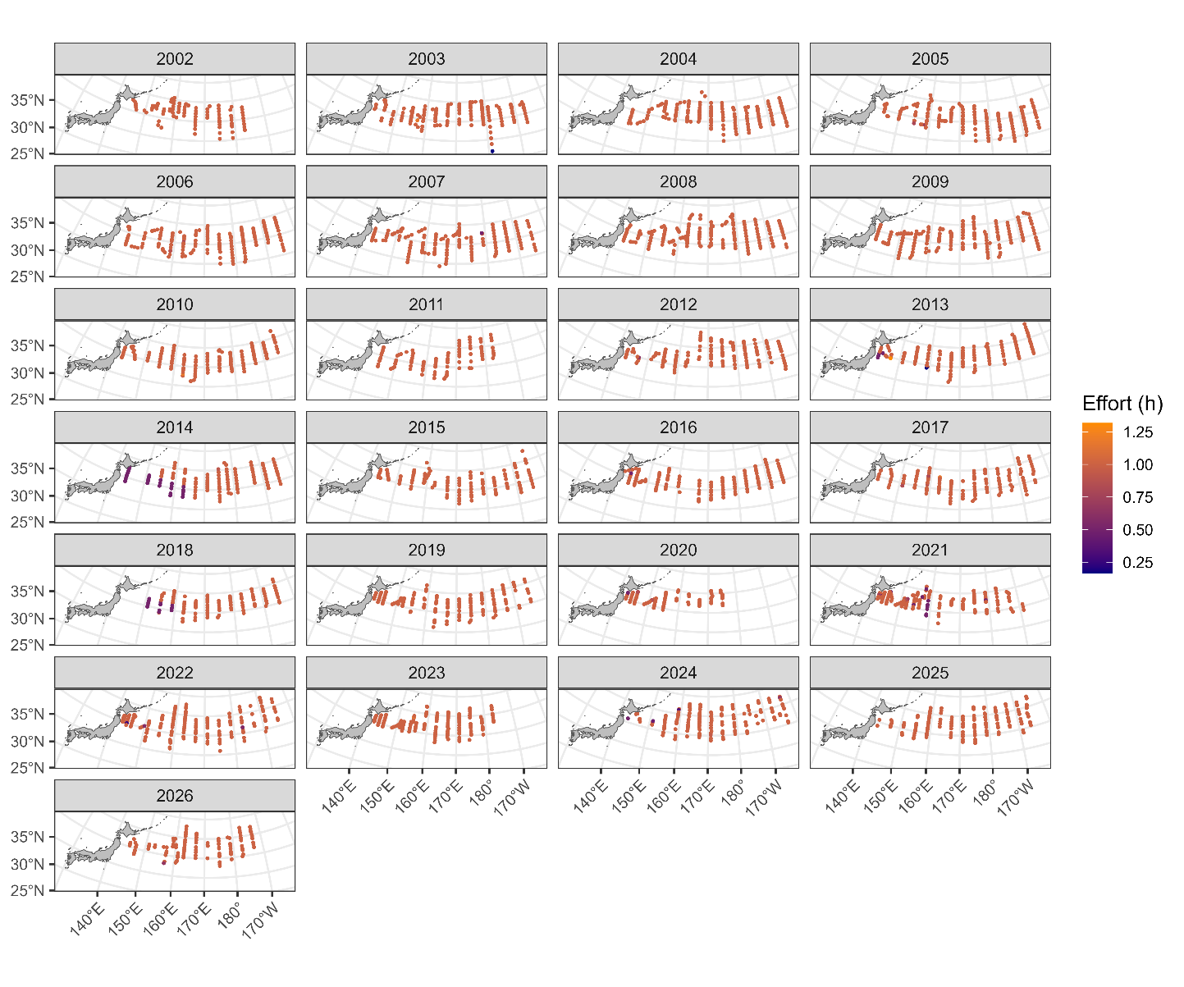
Map of summer survey stations from 2002 to 2026. Colors indicate sweeping time.

Figure 1B
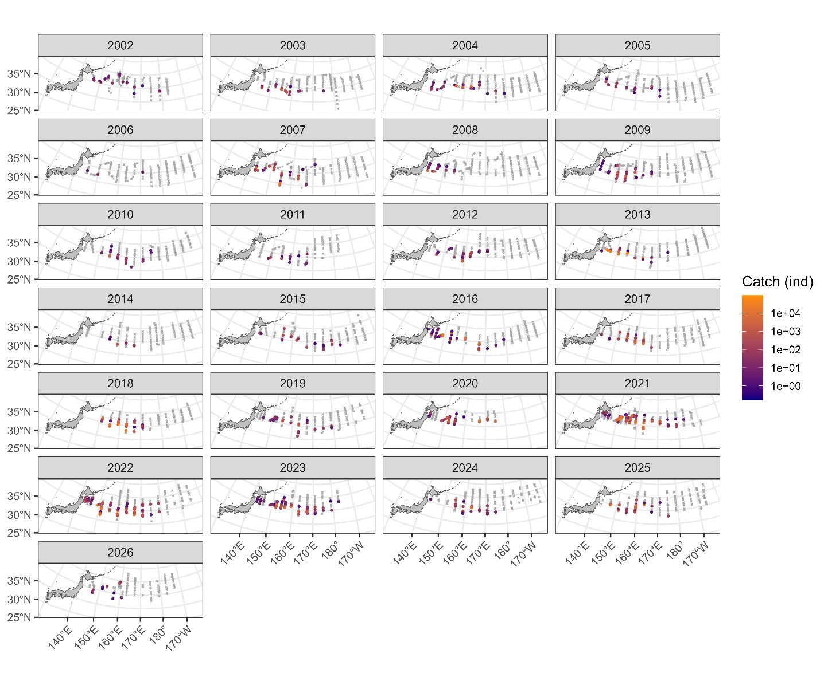
Map of catch amounts from 2002 to 2026 in the summer survey. The gray X indicates zero catch while the colors of circles indicate the amount of positive catch.

Figure 1C
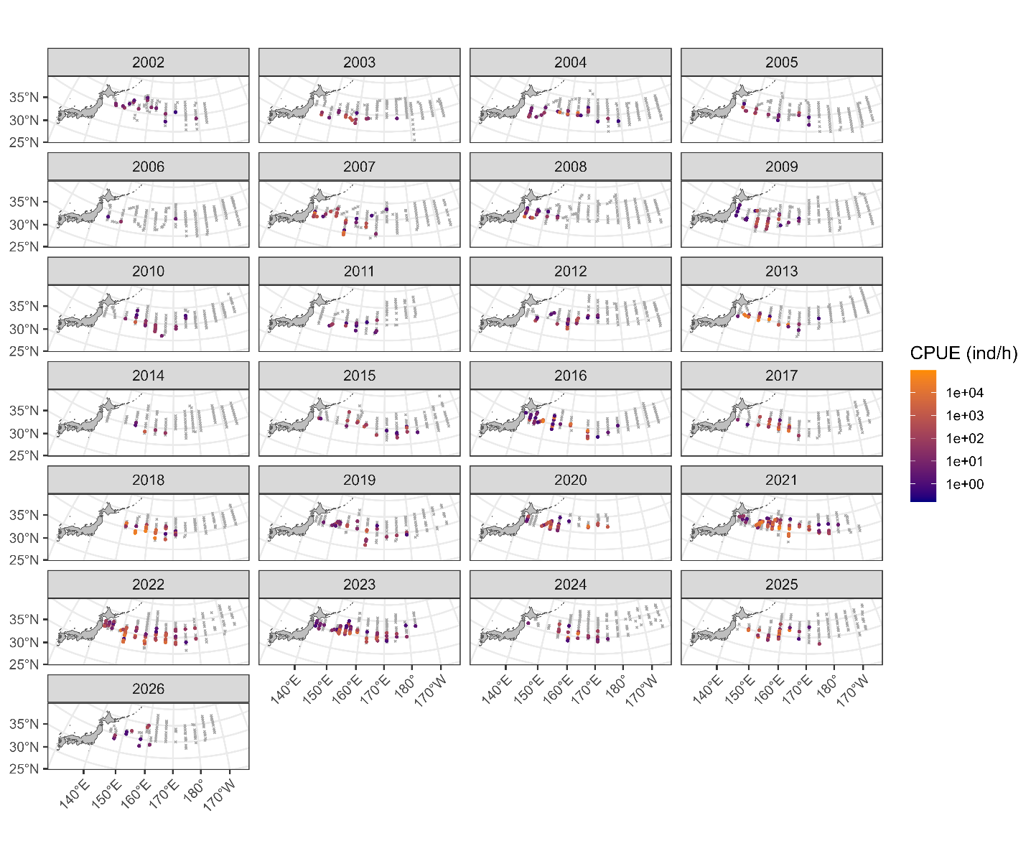
Map of CPUE from 2002 to 2026 in the summer survey. The gray X indicates zero catch while the colors of circles indicate the amount of positive catch. Because most tows lasted approximately one hour (panel A), the spatial pattern of CPUE in panel C is similar to that of catch in panel B.

Figure 2

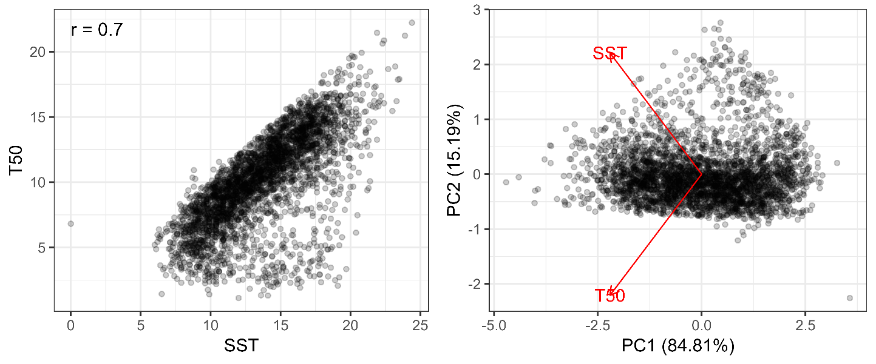
(left) Relationship between SST and T50. The Pearson’s correlation coefficient is shown at the upper-left corner. (right) Relationship between PC1 and PC2 along with the directions of SST and T50. The proportions of variance in each component are shown in the axis labels.

Figure 3

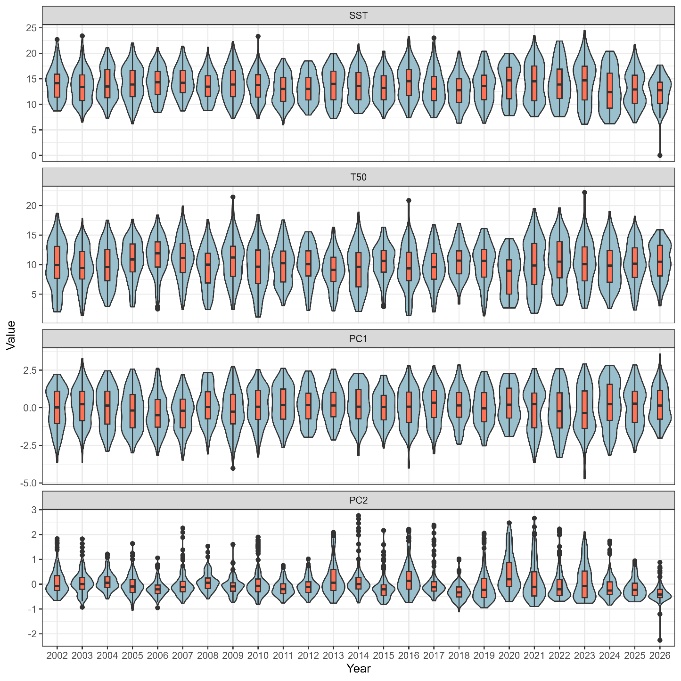
Relationships between year and each of SST, T50, PC1, and PC2 (see Fig. 2).

Figure 4A
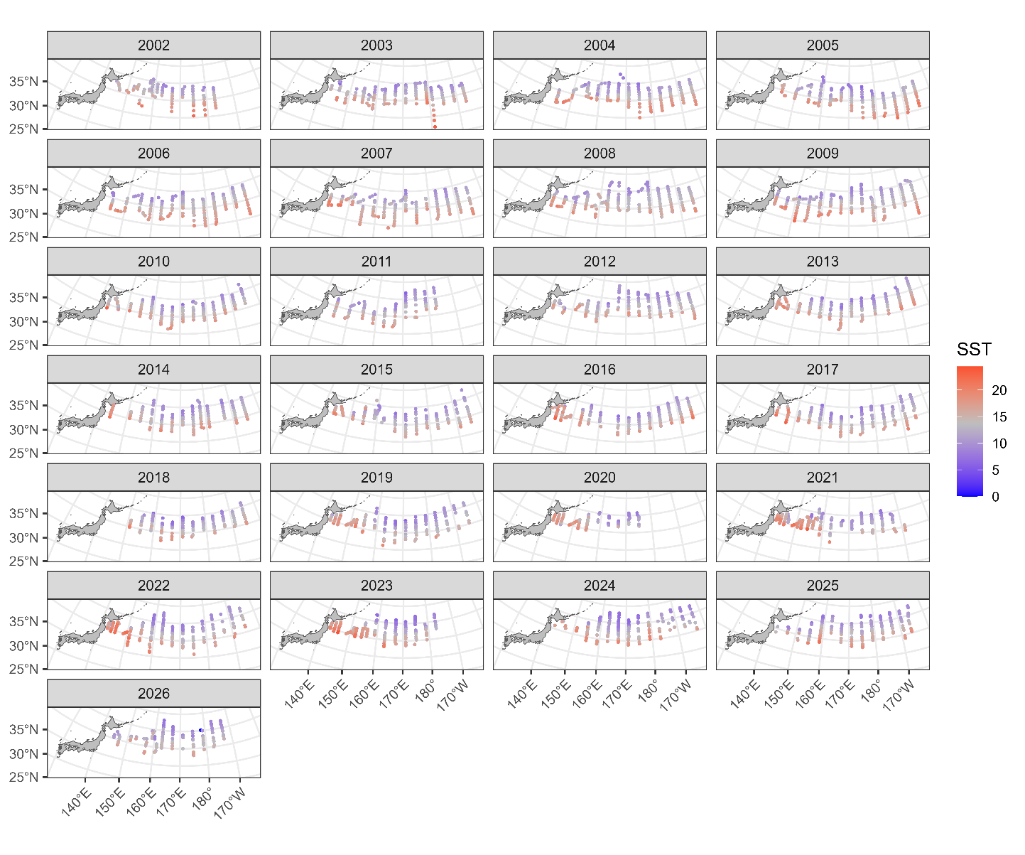
Map of SST at sampling stations from 2002 to 2026.

Figure 4B
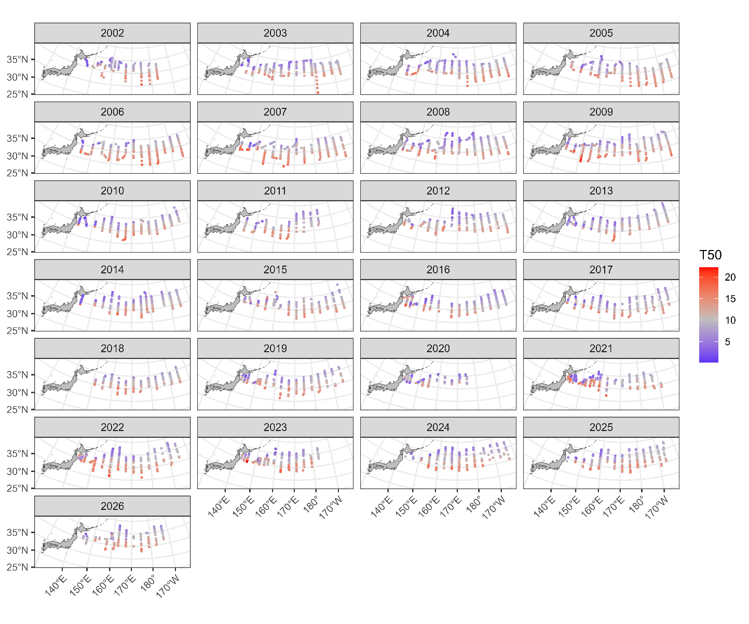
Map of T50 (50m depth temperature) at sampling stations from 2002 to 2026.

Figure 4C
Map of PC1 (see Fig. 2) at sampling stations from 2002 to 2026.

Figure 4D

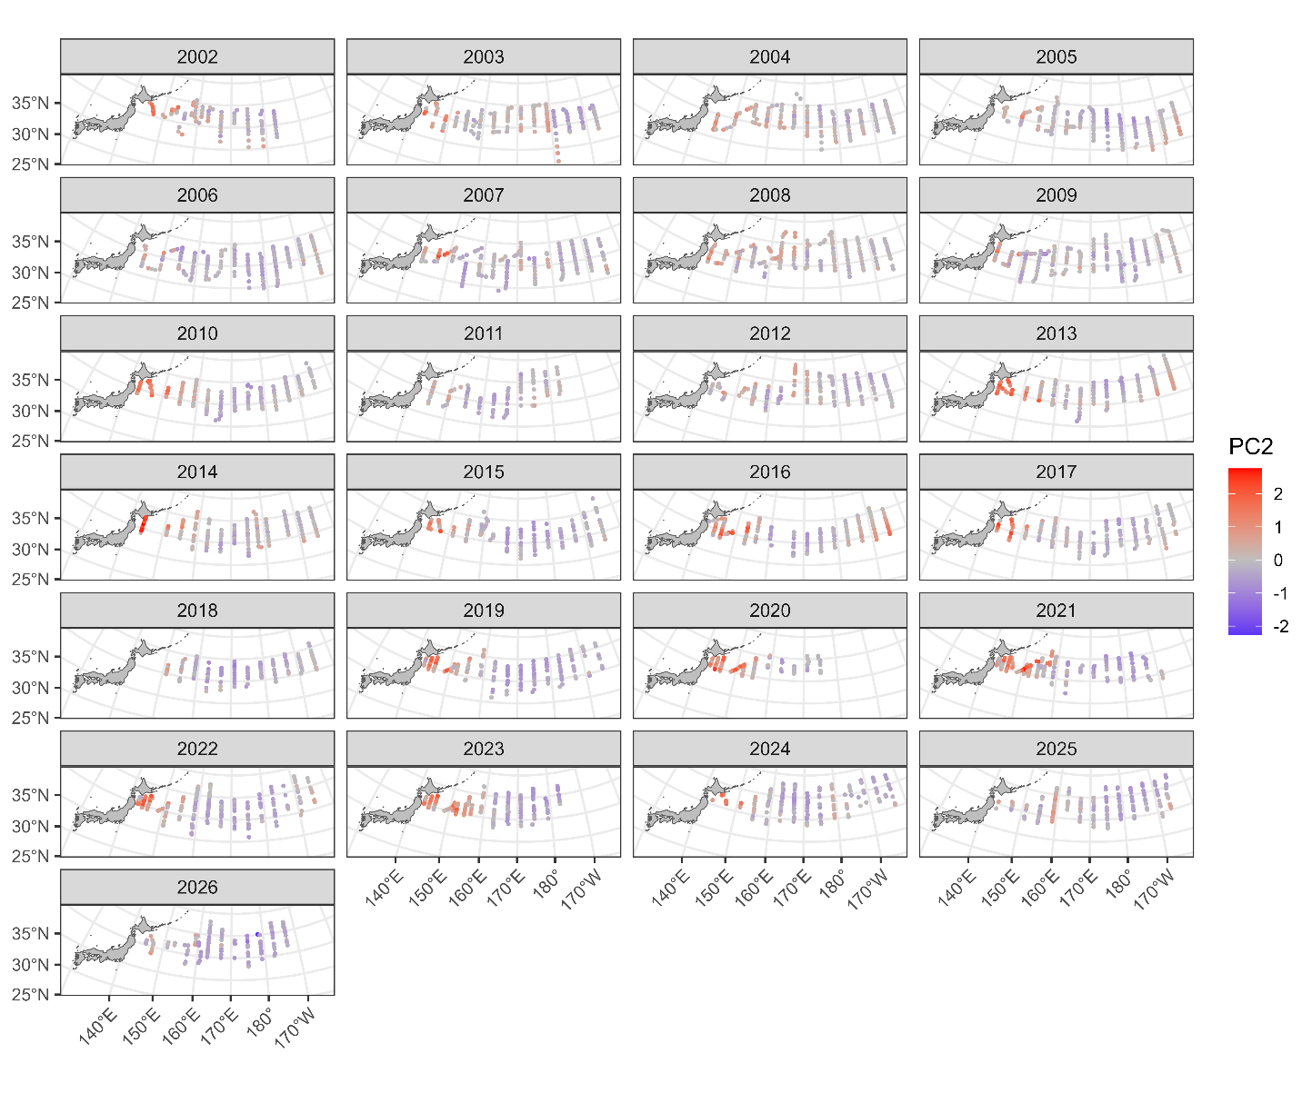
Map of PC2 (see Fig. 2) at sampling stations from 2002 to 2026.

Figure 5
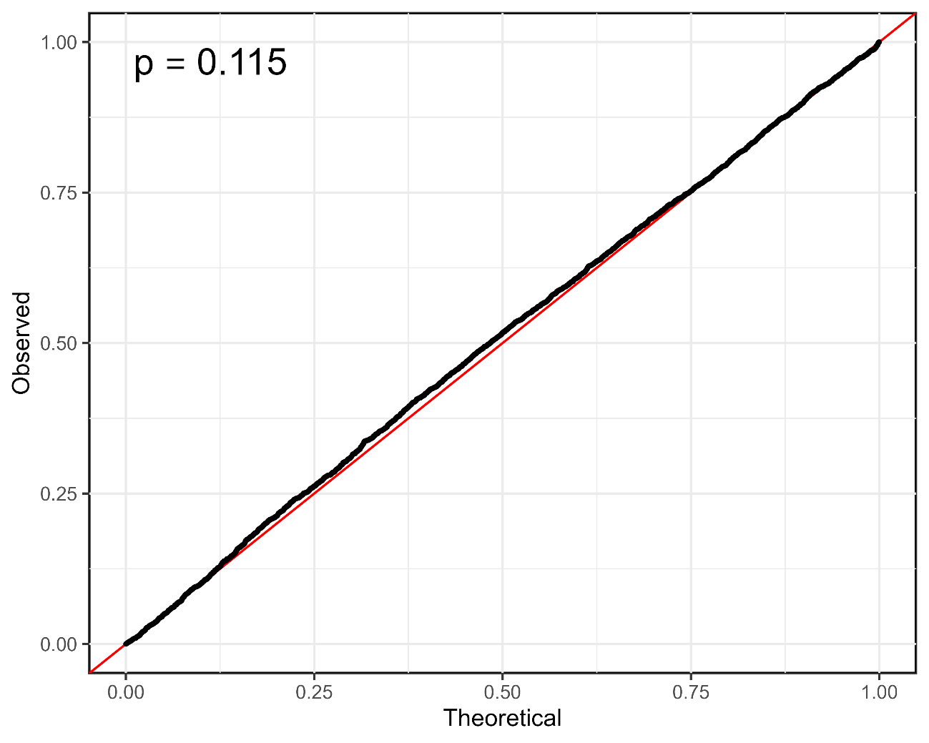
QQ plot along with p value in the Kolmogorov-Smirnov test at the upper-left corner.

Figure 6
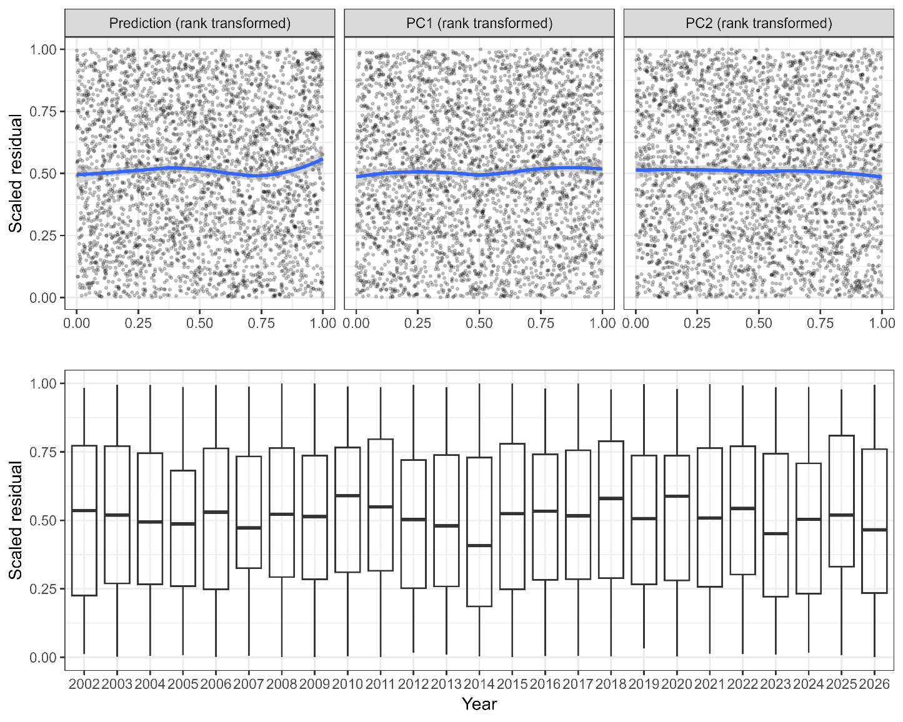
Relationships between scaled residuals and the selected variables or predicted CPUE. Continuous variables are all rank transformed. Smooth curves in blue for the upper panels are described by LOESS.

Figure 7
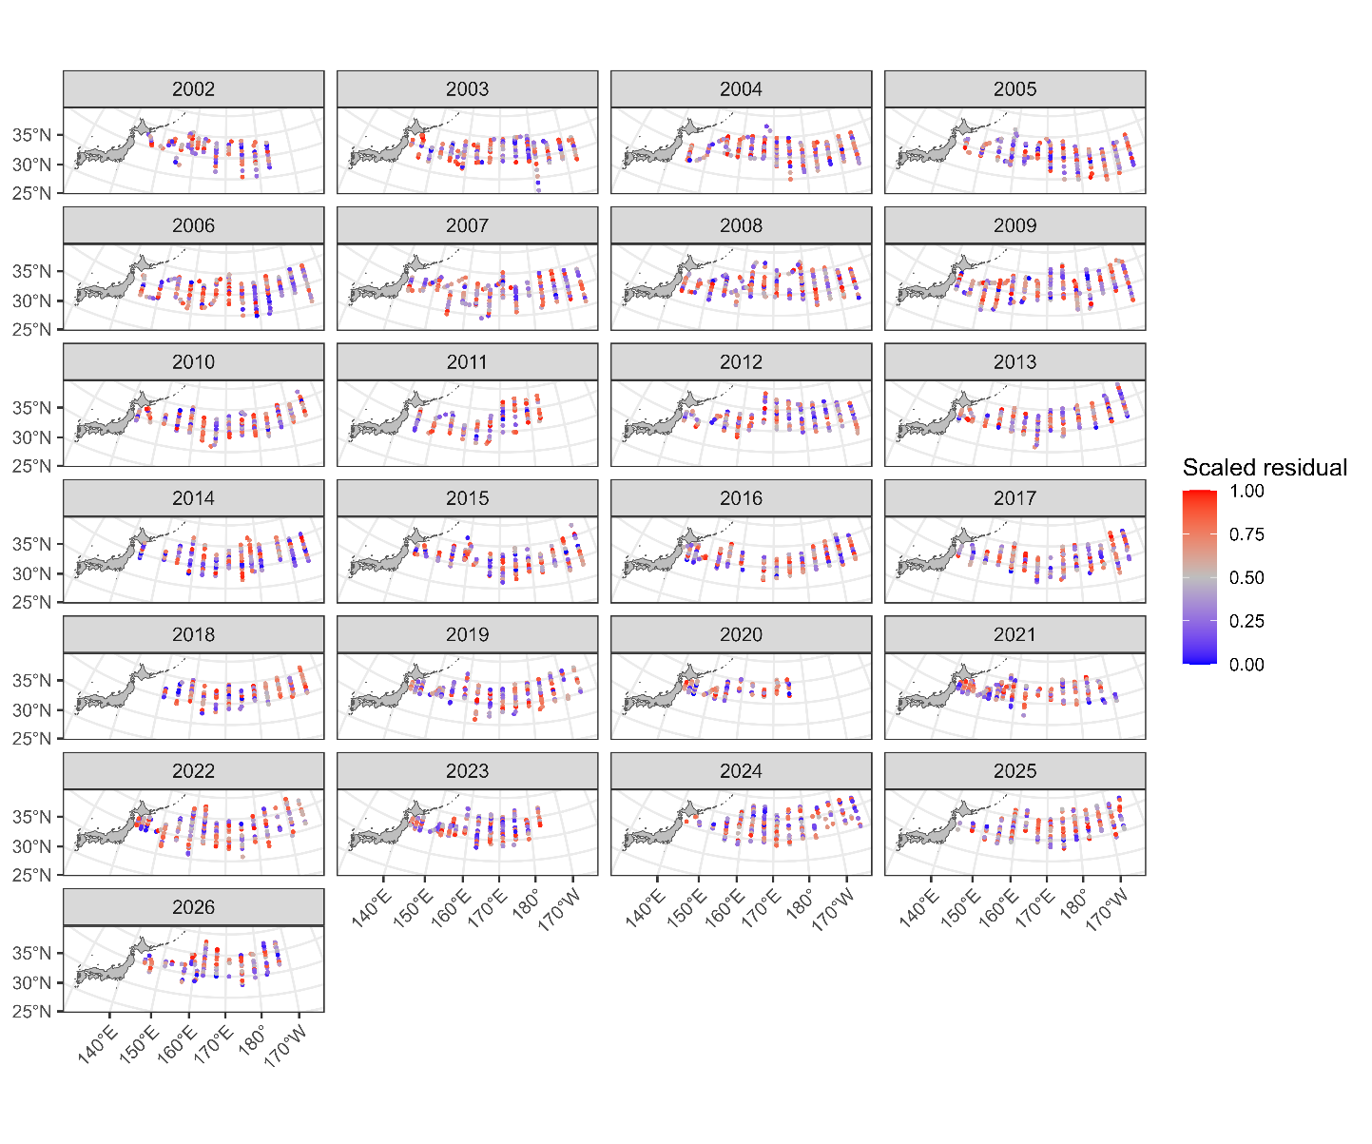
Maps of the scaled residuals from 2002 to 2026.

Figure 8

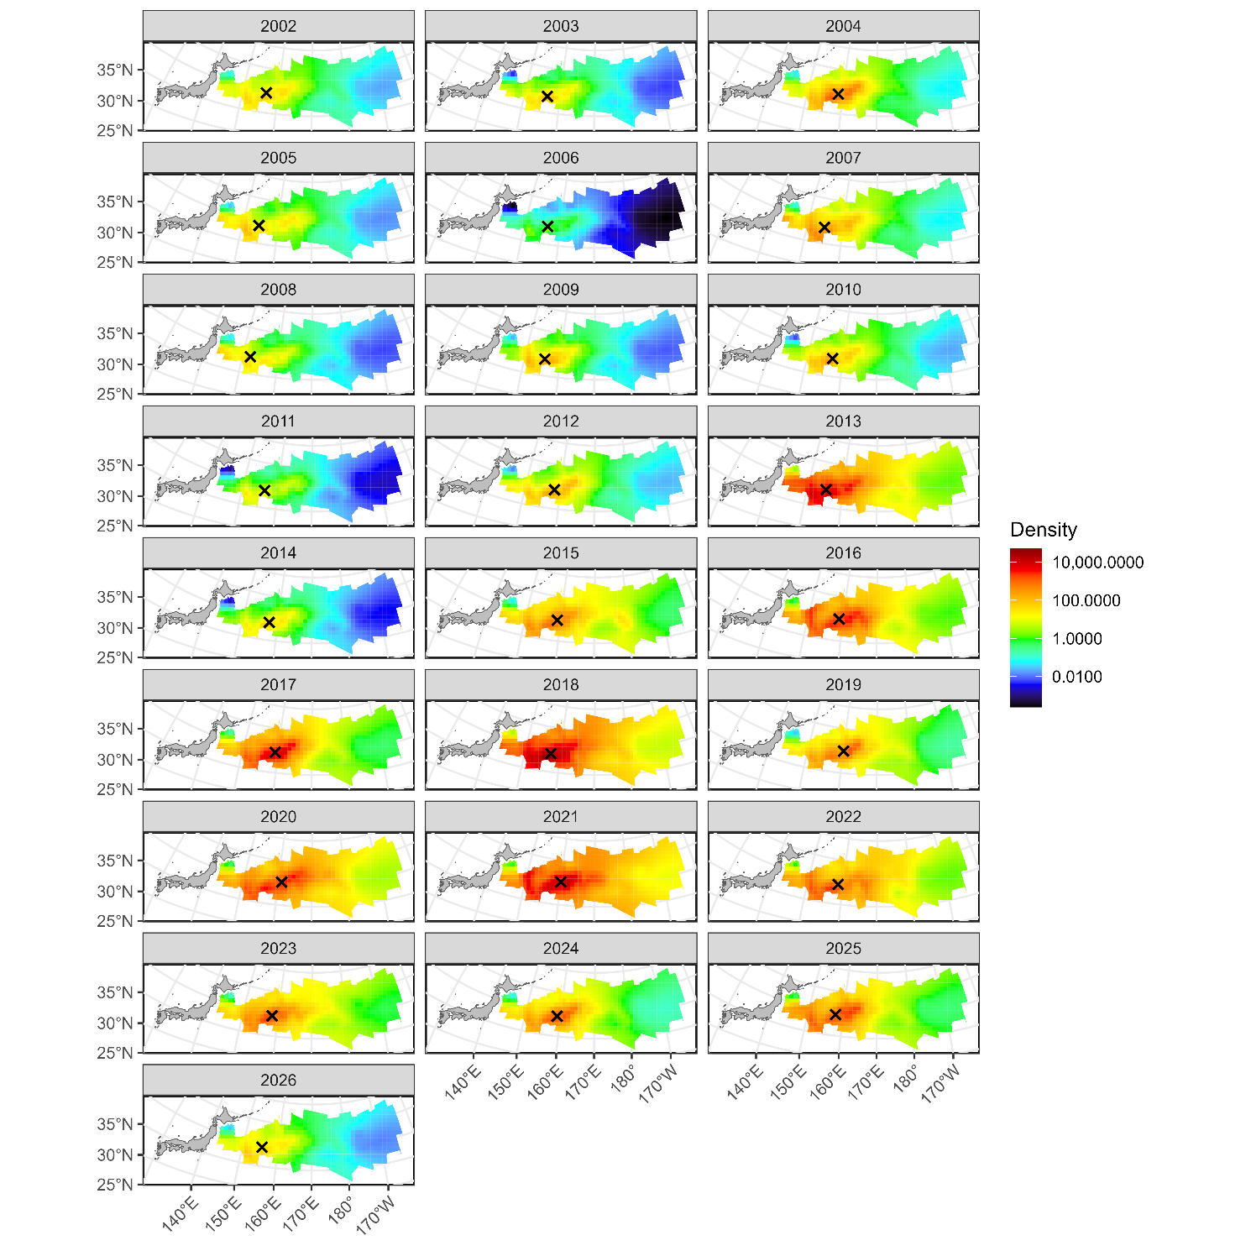
Estimated densities from 2002 to 2026. The signs of X indicate the centroid of spatial distributions.

Figure 9
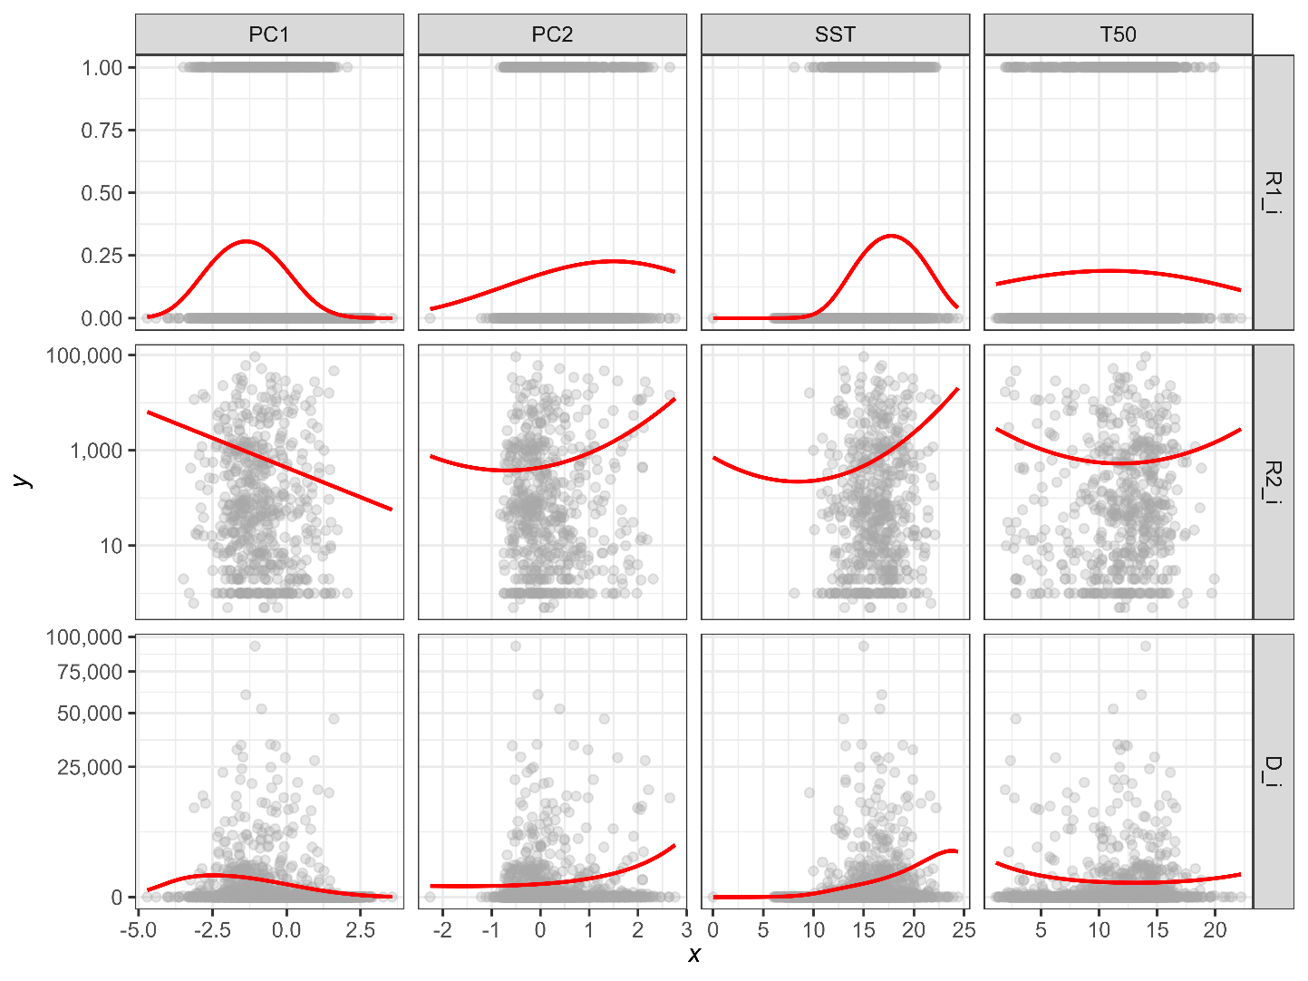
Estimated relationships between environmental variables (PC1, PC2, SST, and T50) and expected CPUE (upper: probability of positive catch, middle: positive catch rate, lower: catch rate). The expected CPUE versus SST and T50 was calculated with the assumption that the original variables SST and T50 change independently.

Figure 10
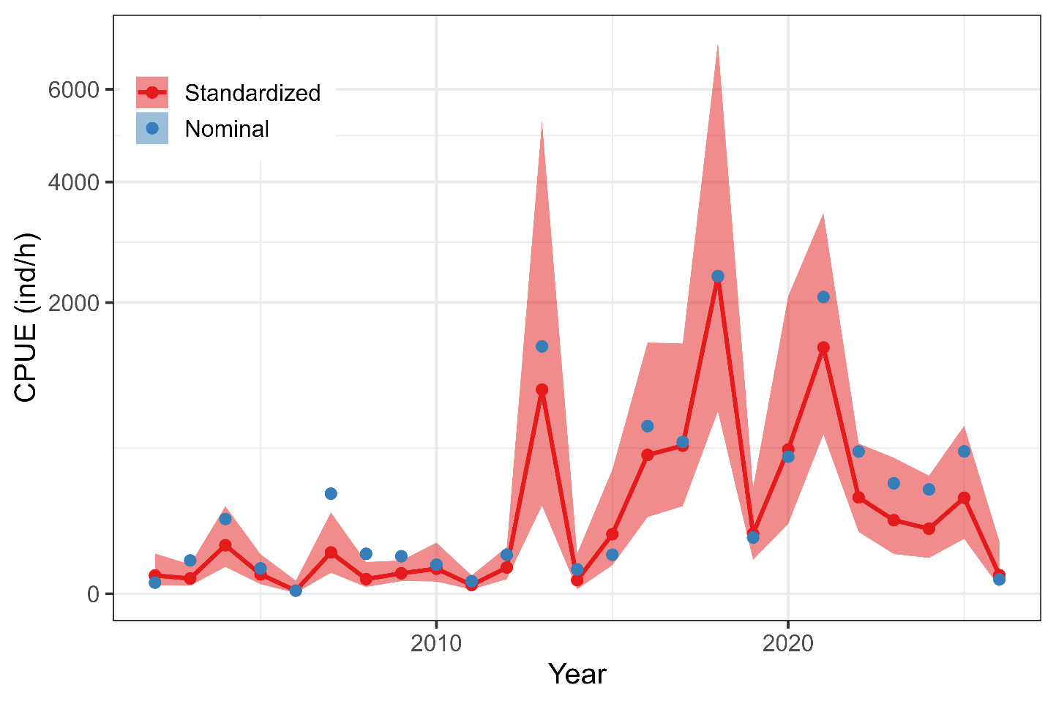
Time series of nominal and standardized CPUE from 2002 to 2026. The shadow area represents 95% confidence intervals of standardized CPUE.

AppendIX
Checklist for the CPUE standardization protocol
No. | Step-by-step protocols | yes/no | Note
1 | Provide a description of the type of data (logbook, observer, survey, etc. ), and the "resolution" of the data (aggregated, set-by-set etc..). This description should also include the representativeness of the data in two tables: (1st table) Number of observations, % Coverage of CPUE fleet (catch), % Coverage of CPUE fleet (effort), Total Catch CPUE fleet (mt), Total Effort CPUE fleet, Percentage of overall catch by member (across all fleets/gears); and (2nd table) Number of records remaining, Number removed, Number of records with chub mackerel catch >0; | Yes | Section 2.1 (pages 1-2) and Tables 1 (page 7) and 2 (page 8)
2 | Conduct a thorough literature review to identify key factors (i.e., spatial, temporal, environmental, and fisheries variables) that may influence CPUE values; | Yes | Section 1. Background (page 1)
3 | Plot annual/monthly spatial distributions of fishing efforts, catch and nominal CPUE to determine temporal and spatial resolution for CPUE standardization | Yes | Fig. 1, (pages 13-15)
4 | Make scatter plots (for continuous variables) and/or box plots (for categorical variables) and present correlation matrix if possible to evaluate correlations between each pair of those variables; | Yes | Figs. 2-4 (pages 14-21]
5 | Describe selected explanatory variables based on (2)-(4) to develop full model for the CPUE standardization; | Yes | Section 2.3. (pages 2-4) and Table 3 (page 9)
6 | Specify model type and software (packages) and fit the data to the assumed statistical models (i.e., GLM, GAM, Delta-lognormal GLM, Neural Networks, Regression Trees, Habitat based models, and Statistical habitat based models); | Yes | Section 2.3. (pages 2-4)
7 | Evaluate and select the best model(s) using methods such as likelihood ratio test, information criterions, cross validation etc.; | Yes | Table 4 (page 9)
8 | Provide diagnostic plots to support the chosen model is appropriate and assumption are met (QQ plot and residual plots along with predicted values and important explanatory variables, etc.); | Yes | Figs. 5-6 (page 22-24)
9 | Present estimated values of parameters and uncertainty in the parameters in table; | Yes | Table 5 (pages 10-11)
10 | Present the relationship between the response variable and the explanatory variables. Check if it is interpretable. | Yes | Figs. 8-9 (pages 25-26)
11 | Extract yearly standardized CPUE and standard error by a method that is able to account for spatial heterogeneity of effort, such as least squares mean or expanded grid. If the model includes area and the size of spatial strata differs or the model includes interactions between time and area, then standardized CPUE should be calculated with area weighting for each time step. Model with interactions between area and season or month requires careful consideration on a case by case basis. Provide details on how the CPUE index was extracted. | Yes | Section 2.4. (page 4)
12 | Calculate uncertainty (SD, CV, CI) for standardized CPUE for each year. Provide detailed explanation on how the uncertainty was calculated; | Yes | Table 6 (page 12) and Fig. 10 (page 27)
13 | Provide a table and a plot of nominal and standardized CPUEs over time. When the trends between nominal and standardized CPUE are largely different, explain the reasons (e.g. spatial shift of fishing efforts), whenever possible. | Yes | Table 6 (page 12) and Fig. 10 (page 27)

