NPFC-2026-TWG CMSA12-WP05
Standardized CPUE of Japanese commercial dip-net fishery targeting spawners of chub mackerel in the Northwest Pacific up to 2026

Shota Nishijima, Kaho Adachi, and Ryuji Yukami
Fisheries Resources Institute, Japan Fisheries Research and Education Agency

Summary
We updated CPUE standardization of the Japanese commercial dip-net fishery for Pacific chub mackerel using a generalized linear mixed-effects model. Dip-net fishery CPUE was affected by month, area, sea surface temperature, fishing vessel, and year. The abundance index standardized for variables other than year declined markedly after remaining high from 2011 to 2021. In 2026, the standardized index fell substantially below both the previous year’s value and the previous minimum observed in 2005. However, the 2026 estimate had substantially greater uncertainty because of its much more limited temporal and spatial coverage than in previous years. Considering these limitations, we propose using the standardized index through 2025 as the base-case input for SAM and the index including 2026 in a sensitivity analysis.

1. BACKGROUND
The dip-net fishery operating around Izu islands is a small-scale artisanal fishery targeting spawning chub mackerel during the spawning season. While the total catch amount of chub mackerel in this fishery contributes less than 1% of the overall catch by Japan (Table 1), it is the only fishery that targets spawning chub mackerel and operates in the main spawning ground around the Izu Islands during the spawning season (Matsuda et al. 1994; Kanamori et al. 2019; Yamada et al. 1998). While chub mackerel are widely distributed along the Pacific coast of Japan and northwestern Pacific for foraging, most mature fish are known to migrate to this area for spawning (Watanabe and Yatsu 2006). Therefore, the catch per unit effort (CPUE) of the dip-net fishery is considered to represent the relative abundance of spawning stock biomass (SSB) for the Pacific chub mackerel. The CPUE has long been used as a reliable abundance index of SSB in the Japanese domestic stock assessment.
Following the previous document that reported the standardized CPUE values from 2003 to 2024 in the dip-net fishery (Nishijima et al. 2025), this document updated the results of CPUE standardization until 2026 by considering the effects of environmental and spatial variables. Since the dip-net CPUE of chub mackerel is known to be affected by water temperature (Nishijima et al. 2022), we used the sea surface temperature (SST) as an explanatory variable. The in-situ SST was recorded in each set. Furthermore, to account for the possible spatial and seasonal effects on the CPUE, we added explanatory variables of area and month.

2. METHOD

2.1 The data
The data of dip-net fishery from 2003 to 2026 was obtained from the logbooks from eight sampling vessels in Kanagawa and Shizuoka Prefectures. The coverage of catch from the sampling vessels against the total catch of the dip-net fishery is 10 to 56% and recorded 100% in 2026 (Table 1). The data was recorded by operation by vessel, along with the information on locations (longitude/latitude or area name), sea surface temperatures (SST), the number of fishermen, and fishing time.
The number of samples in the original data was 2,719. We removed data with no spatial information, data with no effort information (fishing time and the number of fishermen), and no SST information from the analysis (Table 2). We exclusively focused on the data from January to June, the main spawning season of chub mackerel, and removed the data obtained during the other months. The sample size of the final dataset was 2,412 and that having positive catch was 1,921 (79.6%).
The dip-net fishery operates approximately between 138° and 140.5° E and between 32.5° and 35° N (Fig. 1). Many records contained either geographic coordinates or an area name, but not both. For each record containing only longitude and latitude, we assigned the area whose center was closest to the recorded coordinates and then used area as a categorical variable in the CPUE-standardization model. Catch, effort, and CPUE by area and month from 2003 to 2026 are shown in Fig. 2. We also mapped catch, effort, and CPUE for records containing longitude and latitude (Fig. 3).
Since 2022, data have been available from only one sampling vessel (Fig. 4A), and fishing effort has remained low (Fig. 2B). This vessel ceased operations at the end of March 2026. Consequently, the 2026 data cover only January through March and are based on limited total effort and spatial coverage (Table 1; Figs. 2B and 3). Both the catch and nominal CPUE were extremely low in 2026 (Figs. 2A and 2C). The proportion of positive catches in 2026 was substantially lower than in previous years, with only three positive-catch records (Table 1). Given the limited temporal and spatial coverage and the small number of positive-catch records, we considered excluding 2026 from the analysis. However, exceptionally low catch rates observed in 2026 may contain important information on stock abundance that would otherwise be lost. We therefore decided to include the 2026 data in the CPUE standardization, while recognizing the uncertainty associated with the limited spatial and temporal coverage. As a sensitivity analysis, we repeated the model-selection and standardization procedures after excluding the 2026 data. At present, there is no prospect of obtaining data from another sampling vessel in subsequent years; therefore, this abundance-index time series is likely to end in 2026.

2.2 Associations between independent variables and between dependent and independent variables
Independent variables available were year (categorical), month (categorical), area (categorical), SST (continuous), prefecture (categorical), and vessel (categorical; represented as “ship” in the model and figures) (Table 3). Associations among the categorical variables are shown in Figs. 4A and 4B. The ship variable represents vessel-specific effects. Ship and prefecture had a nested structure, and the years in which vessels operated depended strongly on prefecture (Fig. 4A). Thus, Cramer’s V was high between prefecture and ship and between year and prefecture (Fig. 4C). Moderate associations were observed between area and prefecture, year and area, and year and ship.
SST was strongly correlated with month, but there was no apparent correlation of SST to the other categorical variable (Fig. 4D). The plots for the relationship between CPUE and each categorical variable showed that CPUE was seemingly correlated by all of these variables (Fig. 4E). The correlation between SST and CPUE was weak (Fig. 4F).

2.3 Full model description and model selection
The dependent variable CPUE (kg/net-hour) was a continuous value more than or equal to zero. We fitted a generalized linear mixed-effects model (GLMM) with a zero-inflated Tweedie distribution via the R package ‘glmmTMB’ (Brooks et al. 2017). The model comprised a structural-zero component with a logit link and a Tweedie mean component with a log link.
The full model involved all the five categorical variables (year, month, area, prefecture, and ship) (Table 3). We considered the squared term of SST in the full model because CPUE seemed to be the highest at an intermediate level of SST (Fig. 4F). We did not consider interactions between any combination of the independent variables because including interactions would cause many missing categories (Fig. 4A, B). We estimated all parameters as fixed effect except for the year effect in the binomial model. We used random effects for the year effect in the binomial model, because all samples in several years were positive catch and using fixed effect for the year variable greatly increased estimation uncertainty (i.e., huge standard error and wide confidence interval).
We conducted the brute-force model selection approach except that the year effect was always selected and models with both prefecture and ship were not considered because of their nested structure and the strongest correlation (Fig. 4A, C), using the R package ‘MuMIn’ (Bartoń 2022). We determined the best model based on AICc.

2.4 Yearly trend extraction
To derive standardized CPUE values, we calculated predicted CPUE for each combination of categories of the selected variables; continuous variables were evaluated at small, regularly spaced intervals over their ranges. For example, the prediction grid included Area = A, B, C, …; Year = 2003, 2004, 2005, …; and SST = 10.0, 11.0, 12.0, …. We then calculated the arithmetic mean of the predicted values for each year. This averaging was necessary to extract the annual trend because of the nonlinearity of the logit link in the zero-inflated Tweedie model. We did not apply area weighting because the size of each area was unknown. Confidence intervals for standardized CPUE were calculated by simulating parameter vectors from the multivariate normal distribution defined by the estimated parameters and their covariance matrix.

3. RESULT
The model selection showed that the effects of area, month, and SST had significant influences on CPUE and were always selected in both Tweedie and binomial components in the top 10 models (Table 4). The highest-ranked model included area, month, SST, and squared SST in both the Tweedie and binomial components. Ship was included in the Tweedie component but not in the binomial component of the highest-ranked model. The selected model was identical to that reported in the previous study (Nishijima et al. 2025). According to the model-selection results, we selected the model with the minimum AICc in the Table 4 as the base model.
The percent deviance explained of the base model was 9.46% (Table 5). The coefficients and standard errors of estimated parameters in the base model were not extremely large (Table 6), indicating the successful convergence of parameter estimation.
We generated scaled residuals using the R package DHARMa (Hartig 2022). Under an adequately fitted model, these simulated residuals should follow a uniform distribution between zero and one. The QQ plot and Kolmogorov–Smirnov test indicated a significant departure from uniformity (Fig. 5A), and the residuals showed systematic patterns with predicted CPUE and year (Fig. 5B).
Partial dependence plots for estimated relationships between the selected explanatory variables and predicted CPUE are shown in Fig. 6. CPUE was expected be the highest at 19.4℃ and higher in February to April than in the other months.
Standardized CPUE was relatively low until 2005, increased thereafter, and remained relatively stable at a high level from 2011 to 2021 (Fig. 7). It declined markedly after 2021 and reached extremely low levels in 2025 and 2026. The standardized CPUE in 2026 was substantially lower than the previous minimum observed in 2005 over the 2003–2025 period. In 2026, the standardized and nominal CPUE values decreased to 0.3% and 0.1% of their respective 2025 values, respectively (Table 7). The annual trends in standardized and nominal CPUE were generally similar, except that the scaled standardized CPUE was much lower than the scaled nominal CPUE in 2020. The coefficients of variation (CVs) of the standardized estimates ranged from 0.13 to 0.28 through 2025 but increased sharply to 1.34 in 2026 (Table 7), indicating substantial uncertainty in the 2026 estimate. This high uncertainty was probably attributable to the small sample size, limited monthly and spatial coverage, low fishing effort, and small number of positive-catch observations in 2026.
Excluding the 2026 data resulted in the same selected model, and the standardized CPUE estimates through 2025 were nearly identical to those obtained from the analysis including 2026 (Table 7). The maximum relative difference in standardized CPUE estimates through 2025 between the two analyses was less than 0.3%.

4. DISCUSSION
This analysis showed that dip-net fishery CPUE was influenced by month, area, in-situ SST, and ship. Because these factors can affect CPUE independently of annual stock abundance, we standardized their effects to reduce sampling bias. The standardized and nominal indices showed generally similar annual patterns, although the standardized value was lower than the nominal value in 2020. In 2020, observations were concentrated from February through April and on ship IDs 3 and 4, conditions associated with higher CPUE, whereas no operations occurred in areas B and D, where CPUE tended to be lower. This sampling pattern likely elevated nominal CPUE relative to the standardized value. The standardized index remained relatively stable at high levels from 2011 to 2021 and then declined sharply from 2022 through 2025, with a further marked decrease in 2026.
Model diagnostics indicated departures of the scaled residuals from their theoretical distribution, and the percentage of deviance explained was low. These results may reflect the considerable variability in the original data and the omission of other influential variables. We did not include interactions as fixed effects because many combinations of explanatory-variable categories were unobserved. Future analyses could evaluate model improvements by incorporating additional explanatory variables, modifying the current covariate structure, or using mixed-effects models in which appropriate interaction terms are represented by random effects.
Most mature chub mackerel are considered to migrate to the waters around the Izu Islands for spawning; therefore, the standardized CPUE from the dip-net fishery provides an important index of SSB. However, the reliability of the 2026 estimate as an indicator of SSB is uncertain. The only remaining sampling vessel ceased operations at the end of March 2026, and no data were available from April onward (Fig. 2). Spatial coverage was also narrower than in previous years (Fig. 3), and only three positive-catch records were available (Table 1). The standardized CPUE estimate for 2026 also had a high coefficient of variation (CV; Table 7). In addition, the extremely low catches of chub mackerel may have prompted the vessel to shift its fishing target from chub mackerel to blue mackerel, although the available data do not allow us to determine whether such a shift occurred.
The 2026 data were included in the CPUE standardization. However, given these limitations, we propose excluding the 2026 estimate from the base-case input to SAM while using the full index series through 2026 in a sensitivity analysis. As all sampling vessels have ceased operations, this index is unlikely to be updated in future years. Therefore, alternative indices that provide information on spawning stock biomass and the abundance of older fish need to be developed.

5. REFERENCES
Bartoń K (2022). MuMIn: Multi-Model Inference. R package version 1.47.1.
Brooks M., E., Kristensen K., van Benthem K. J., Magnusson A., Berg C. W., Nielsen A., Skaug H. J., Maechler, M., Bolker B. M. (2017). glmmTMB Balances Speed and Flexibility Among Packages for Zero-inflated Generalized Linear Mixed Modeling. The R Journal, 9(2), 378-400. doi: 10.32614/RJ-2017-066.
Hartig F (2022). DHARMa: Residual Diagnostics for Hierarchical (Multi-Level / Mixed) Regression Models. R package version 0.4.5.
Kanamori Y, Takasuka A, Nishijima S, Okamura H. (2019) Climate change shifts the spawning ground northward and extends the spawning period of chub mackerel in the western North Pacific. Marine Ecology Progress Series 624:155–166.
Matsuda, H., Mitani, I., Asano K. (1994) Impact factors of purse seine net and dip net fisheries on a chub mackerel population. Researches on Population Ecology. 36, 201–207.
Nishijima, S., Kisara Y., Ichinokawa M., Manabe A., and Yukami R. (2022) Standardizing CPUE of Japanese commercial dip-net fishery targeting spawners of chub mackerel in the Northwest Pacific. NPFC-2022-TWG CMSA06-WP09.
Nishijima, S., Yukami R., and Ichinokawa M. (2025) Standardized CPUE of Japanese commercial dip-net fishery targeting spawners of chub mackerel in the Northwest Pacific up to 2024. NPFC-2025-TWG CMSA10-WP06.
Yamada T, Aoki I, Mitani I (1998) Spawning time, spawning frequency and fecundity of Japanese chub mackerel, Scomber japonicus in the waters around the Izu Islands, Japan. Fisheries Research 38:83–89.
Watanabe C, Yatsu A (2006) Long-term changes in maturity at age of chub mackerel (Scomber japonicus) in relation to population declines in the waters off northeastern Japan. Fisheries Research 78:323–332

Table 1
Catch and effort information by CPUE FLEET.
Year | Number of observations¹ | % Coverage of CPUE FLEET (catch)² | % Coverage of CPUE FLEET (effort)² | Total Catch CPUE FLEET (mt) | Total Effort for CPUE FLEET (fishing days)³ | Percentage of overall catch by member (%)⁴ | Number of positive catch | Proportion of positive catch
2003 | 132 | 21.56 | 20.99 | 60.81 | 132 | 0.13 | 47 | 0.35
2004 | 168 | 25.96 | 27.57 | 41.68 | 166 | 0.06 | 76 | 0.45
2005 | 117 | 26.64 | 25.16 | 34.97 | 117 | 0.02 | 49 | 0.42
2006 | 117 | 46.38 | 49.16 | 143.86 | 117 | 0.06 | 36 | 0.31
2007 | 198 | 14.91 | 43.14 | 350.95 | 198 | 0.14 | 198 | 1.00
2008 | 104 | 28.46 | 13.22 | 124.77 | 103 | 0.07 | 104 | 1.00
2009 | 112 | 31.22 | 31.73 | 137.79 | 112 | 0.08 | 112 | 1.00
2010 | 118 | 36.34 | 39.33 | 124.15 | 118 | 0.10 | 96 | 0.81
2011 | 105 | 22.57 | 43.15 | 177.01 | 104 | 0.14 | 61 | 0.58
2012 | 76 | 10.05 | 44.44 | 49.99 | 76 | 0.05 | 61 | 0.80
2013 | 98 | 21.01 | 26.98 | 495.18 | 58 | 0.39 | 83 | 0.85
2014 | 117 | 25.06 | 30.93 | 723.53 | 73 | 0.33 | 115 | 0.98
2015 | 84 | 36.59 | 32.70 | 851.09 | 52 | 0.30 | 78 | 0.93
2016 | 129 | 31.37 | 26.81 | 1492.43 | 85 | 0.45 | 120 | 0.93
2017 | 124 | 55.52 | 38.30 | 537.62 | 72 | 0.16 | 108 | 0.87
2018 | 113 | 33.38 | 26.84 | 1194.23 | 73 | 0.36 | 106 | 0.94
2019 | 120 | 45.37 | 32.43 | 1436.21 | 84 | 0.48 | 110 | 0.92
2020 | 178 | 47.64 | 37.06 | 1980.79 | 106 | 0.74 | 166 | 0.93
2021 | 179 | 44.69 | 33.44 | 1467.18 | 104 | 0.53 | 146 | 0.82
2022 | 72 | 36.31 | 22.61 | 549.65 | 52 | 0.29 | 52 | 0.72
2023 | 88 | 41.25 | 24.66 | 253.88 | 73 | 0.27 | 67 | 0.76
2024 | 81 | 49.04 | 26.86 | 145.66 | 65 | 0.20 | 51 | 0.63
2025 | 68 | 50.68 | 24.43 | 90.21 | 54 | 0.19 | 38 | 0.56
2026 | 21 | 100 | 22.58 | 0.017 | 14 | 0.000036 | 3 | 0.14
1: The data was recorded by operation from each sampling vessel in logbooks.
2: ‘% Coverage of CPUE FLEET’ indicates the proportion of catch or effort of sampling vessels to overall catch or effort of the dip-net fishery.
3: The unit of effort in this table (fishing days) is different from the unit used for the analysis of CPUE standardization (net-hour).
4: This column indicates the proportion of overall dip-net fishery catch to the total catch by Japan in each fishing year.

Table 2
Filtering “rules” used on data for CPUE standardization and the effect on the overall sample size.
Filter Applied | Number of Records Remaining | Number Removed | Number of Records with Chub Mackerel Catch >0
Initial Data set | 2,719 | - | 2,083
Remove data with no spatial information (area or long/lat) | 2,709 | 10 | 2,079
Remove data with no effort (time and person) | 2,604 | 105 | 2,001
Remove data with SST = NA or 0 (not recorded) | 2,586 | 18 | 1,991
Select data between January and June | 2,412 | 174 | 1,921

Table 3
Summary of explanatory variables used in GLMM.
Variable | Abbreviation | Number of categories | Detail | Note
Year | year | 24 | 2003-2026 | Treated as fixed effect for Tweedie and as random effect for the binomial distribution
Month | month | 6 | January-June | Categorical variable with fixed effect
Area | area | 7 | A-G | Categorical variable with fixed effect
Sea surface temperature | SST | - | 13.2-28.2 | Continuous variable scaled by mean and SD
SST squared | I(SST^2) | - | Squared SST | Squared values of the scaled SST
Prefecture | pref | 2 | Belonging of vessel (Kanagawa or Shizuoka) | Categorical variable with fixed effect
Ship | ship | 8 | Sampling vessel | Categorical variable with fixed effect

Table 4
Selected variables in the top 20 models from the lowest AICc. (T) Tweedie distribution. (B) Binomial distribution.
Rank | (T)area | (T)month | (T)pref | (T)ship | (T)SST | (T)I(SST^2) | (T)year | (B)area | (B)month | (B)pref | (B)ship | (B)SST | (B)I(SST^2) | df | logLik | AICc | ΔAICc
1 | + | + |  | + | 0.108627 | -0.11996 | + | + | + |  |  | 0.789645 | 0.208876 | 61 | -10521.5 | 21168.28 | 0
2 | + | + |  | + | 0.108082 | -0.11967 | + | + | + | + |  | 0.77848 | 0.20706 | 62 | -10520.5 | 21168.33 | 0.05
3 | + | + |  | + | 0.108904 | -0.12484 | + | + | + |  |  | 0.838173 |  | 60 | -10525 | 21173.07 | 4.79
4 | + | + |  | + | 0.107968 | -0.12416 | + | + | + | + |  | 0.815869 |  | 61 | -10524 | 21173.17 | 4.89
5 | + | + |  | + | 0.107833 | -0.11969 | + | + | + |  | + | 0.75414 | 0.207986 | 68 | -10518.9 | 21177.75 | 9.47
6 | + | + |  | + | 0.107818 | -0.12417 | + | + | + |  | + | 0.796854 |  | 67 | -10522.4 | 21182.68 | 14.4
7 | + | + | + |  | 0.1316 | -0.11615 | + | + | + |  |  | 0.795342 | 0.213607 | 55 | -10536.1 | 21184.82 | 16.54
8 | + | + | + |  | 0.13102 | -0.11581 | + | + | + | + |  | 0.782259 | 0.212002 | 56 | -10535.1 | 21184.93 | 16.65
9 | + | + |  | + | 0.153323 |  | + | + | + | + |  | 0.779874 | 0.223533 | 61 | -10531 | 21187.2 | 18.92
10 | + | + |  | + | 0.153907 |  | + | + | + |  |  | 0.789398 | 0.226125 | 60 | -10532.1 | 21187.21 | 18.93
11 | + | + | + |  | 0.131992 | -0.12127 | + | + | + |  |  | 0.844738 |  | 54 | -10539.7 | 21189.85 | 21.57
12 | + | + | + |  | 0.13092 | -0.12045 | + | + | + | + |  | 0.817434 |  | 55 | -10538.7 | 21190.05 | 21.77
13 | + | + |  | + | 0.155332 |  | + | + | + | + |  | 0.81869 |  | 60 | -10535.2 | 21193.51 | 25.23
14 | + | + |  | + | 0.156317 |  | + | + | + |  |  | 0.836667 |  | 59 | -10536.3 | 21193.56 | 25.28
15 | + | + | + |  | 0.131163 | -0.11576 | + | + | + |  | + | 0.762898 | 0.21378 | 62 | -10533.5 | 21194.23 | 25.95
16 | + | + |  | + | 0.153049 |  | + | + | + |  | + | 0.755295 | 0.224283 | 67 | -10529.4 | 21196.62 | 28.34
17 | + | + |  |  | 0.121299 | -0.1149 | + | + | + |  |  | 0.806892 | 0.213095 | 54 | -10543.4 | 21197.22 | 28.94
18 | + | + |  |  | 0.12047 | -0.11446 | + | + | + | + |  | 0.790134 | 0.211789 | 55 | -10542.5 | 21197.66 | 29.38
19 | + | + | + |  | 0.131232 | -0.12045 | + | + | + |  | + | 0.804605 |  | 61 | -10537.2 | 21199.51 | 31.23
20 | + | + |  | + |  |  | + | + | + | + |  | 0.751294 | 0.226228 | 60 | -10538.3 | 21199.61 | 31.33

Table 5
Analysis of deviance table for the best model.
Variable | Chisq | Df | Pr(>Chisq) | signif.code | %deviance explained
Tweedie
area | 351.37 | 7 | 6.27E-72 | *** | 9.46%
month | 174.26 | 5 | 9.01E-36 | ***
ship | 45.08 | 7 | 1.32E-07 | ***
SST | 7.14 | 1 | 7.56E-03 | **
I(SST^2) | 21.47 | 1 | 3.60E-06 | ***
year | 466.61 | 23 | 3.05E-84 | ***
Binomial
area | 93.82 | 6 | 4.88E-18 | ***
month | 53.02 | 5 | 3.33E-10 | ***
SST | 26.38 | 1 | 2.80E-07 | ***
I(SST^2) | 7.01 | 1 | 8.10E-03 | **
Significance codes: 0 ‘***’ 0.001 ‘**’ 0.01 ‘*’ 0.05 ‘.’ 0.1 ‘ ’ 1

Table 6
Estimated coefficients and their standard errors in the best model. (T) Tweedie distribution. (B) Binomial distribution.
Variable | (T) Estimate | (T) Std. Error | (B) Estimate | (B) Std. Error
(Intercept) | 2.931 | 0.275802 | -0.26422 | 0.71607
I(SST^2) | -0.1199 | 0.025893 | 0.208869 | 0.078884
SST | 0.108636 | 0.040664 | 0.789633 | 0.153736
areaB | -3.71343 | 0.402391 | -2.59571 | 2.230624
areaC | -0.12014 | 0.111708 | 0.565235 | 0.390919
areaD | 0.199364 | 0.118279 | -3.12289 | 0.812766
areaE | -1.04053 | 0.161328 | -2.7799 | 0.548626
areaF | 0.085966 | 0.108522 | -4.42411 | 0.586707
areaG | -0.77726 | 0.130442 | -0.00914 | 0.454714
month2 | 0.793232 | 0.093323 | -1.88897 | 0.382461
month3 | 0.789688 | 0.108153 | -2.81789 | 0.459223
month4 | 0.772416 | 0.106837 | -2.4971 | 0.450308
month5 | 0.330367 | 0.120345 | -0.94117 | 0.437411
month6 | -0.78991 | 0.167056 | 0.539497 | 0.566162
ship4 | 0.061786 | 0.064617
shipIK | -0.38232 | 0.160025
shipIW | -1.62604 | 0.279204
shipKG | -0.3996 | 0.119782
shipKM | -0.27134 | 0.177585
shipKW | -0.31753 | 0.244728
shipSE | -1.13131 | 0.317487
year2003 |  |  | 4.185361 | 0.710328
year2004 | 0.068036 | 0.264117 | 2.194767 | 0.647829
year2005 | -0.44943 | 0.288819 | 4.513664 | 0.800319
year2006 | 0.96518 | 0.281908 | 2.766536 | 0.703228
year2007 | 1.445321 | 0.223506 | -3.63017 | 1.478345
year2008 | 0.565694 | 0.241959 | -2.44271 | 1.529302
year2009 | 0.987648 | 0.239458 | -3.39048 | 1.464226
year2010 | 0.970098 | 0.236645 | -2.04817 | 1.028571
year2011 | 1.726122 | 0.242484 | -0.06155 | 0.781064
year2012 | 1.716296 | 0.24253 | -1.19391 | 0.87171
year2013 | 1.836485 | 0.339959 | -1.84771 | 1.673176
year2014 | 1.558028 | 0.271921 | -2.37808 | 0.997927
year2015 | 1.547698 | 0.274619 | -0.77747 | 0.950716
year2016 | 2.043773 | 0.260507 | -1.51585 | 0.748112
year2017 | 1.396102 | 0.275133 | -0.81402 | 0.704371
year2018 | 1.875971 | 0.262638 | -1.93447 | 0.876376
year2019 | 1.769064 | 0.255826 | -0.41384 | 0.797081
year2020 | 1.759453 | 0.25568 | -0.47744 | 0.70558
year2021 | 1.940653 | 0.266124 | 1.502677 | 0.670894
year2022 | 1.142485 | 0.28739 | 1.47606 | 0.705521
year2023 | 0.207579 | 0.301389 | 1.413301 | 0.708058
year2024 | 0.111068 | 0.315989 | 2.388972 | 0.770227
year2025 | -0.60903 | 0.326004 | 3.689148 | 0.810541
year2026 | -6.50287 | 1.139868 | 3.461637 | 1.216841
* ‘year2003’ was set as the reference category in the Tweedie model, while in the binomial model, the effect of all years was estimated as random effects.

Table 7
Annual nominal and standardized CPUE estimates and their uncertainties. “Standardized CPUE (data through 2025)” was obtained by repeating model selection and CPUE standardization after excluding the 2026 data.
Year | Nominal CPUE (kg/man-hour) | Standardized CPUE (data through 2026) (kg/man-hour) | Standardized CPUE (data through 2025) (kg/man-hour) | CV  (data through 2026) | Lower 95% CI (data through 2026) | Upper 95% CI (data through 2026)
2003 | 5.49 | 3.27 | 3.27 | 0.22 | 2.18 | 5.06
2004 | 4.46 | 5.69 | 5.68 | 0.21 | 3.91 | 8.56
2005 | 3.29 | 1.89 | 1.89 | 0.27 | 1.15 | 3.25
2006 | 25.46 | 12.39 | 12.36 | 0.22 | 8.41 | 19.22
2007 | 86.56 | 37.66 | 37.65 | 0.13 | 30.45 | 50.2
2008 | 45.53 | 15.08 | 15.08 | 0.16 | 11.37 | 20.91
2009 | 56.51 | 23.69 | 23.67 | 0.15 | 18.38 | 32.63
2010 | 54.51 | 22.23 | 22.21 | 0.15 | 17.11 | 30.32
2011 | 116.21 | 41.26 | 41.18 | 0.16 | 31.22 | 58.04
2012 | 120.54 | 44.75 | 44.69 | 0.16 | 33.87 | 62.51
2013 | 131.91 | 52.37 | 52.39 | 0.28 | 30.91 | 90.03
2014 | 110.94 | 40.58 | 40.53 | 0.15 | 31.26 | 55.82
2015 | 120.32 | 36.72 | 36.65 | 0.17 | 28.01 | 52.83
2016 | 172.48 | 63.3 | 63.21 | 0.15 | 49.52 | 86.92
2017 | 81.48 | 31.64 | 31.58 | 0.17 | 24.23 | 45.16
2018 | 142.86 | 54.70 | 54.63 | 0.15 | 42.41 | 75.76
2019 | 142.44 | 44.49 | 44.45 | 0.13 | 35.34 | 59.79
2020 | 167.34 | 44.31 | 44.29 | 0.13 | 35.03 | 58.28
2021 | 115.21 | 41.85 | 41.88 | 0.15 | 33.08 | 56.68
2022 | 63.17 | 18.92 | 18.92 | 0.18 | 13.89 | 27.61
2023 | 23.91 | 7.5 | 7.5 | 0.2 | 5.41 | 11.17
2024 | 16.15 | 5.71 | 5.72 | 0.22 | 3.98 | 9.05
2025 | 11.75 | 2.05 | 2.05 | 0.24 | 1.36 | 3.39
2026 | 0.0092 | 0.006 | - | 1.34 | 0.0008 | 0.046

Figure 1
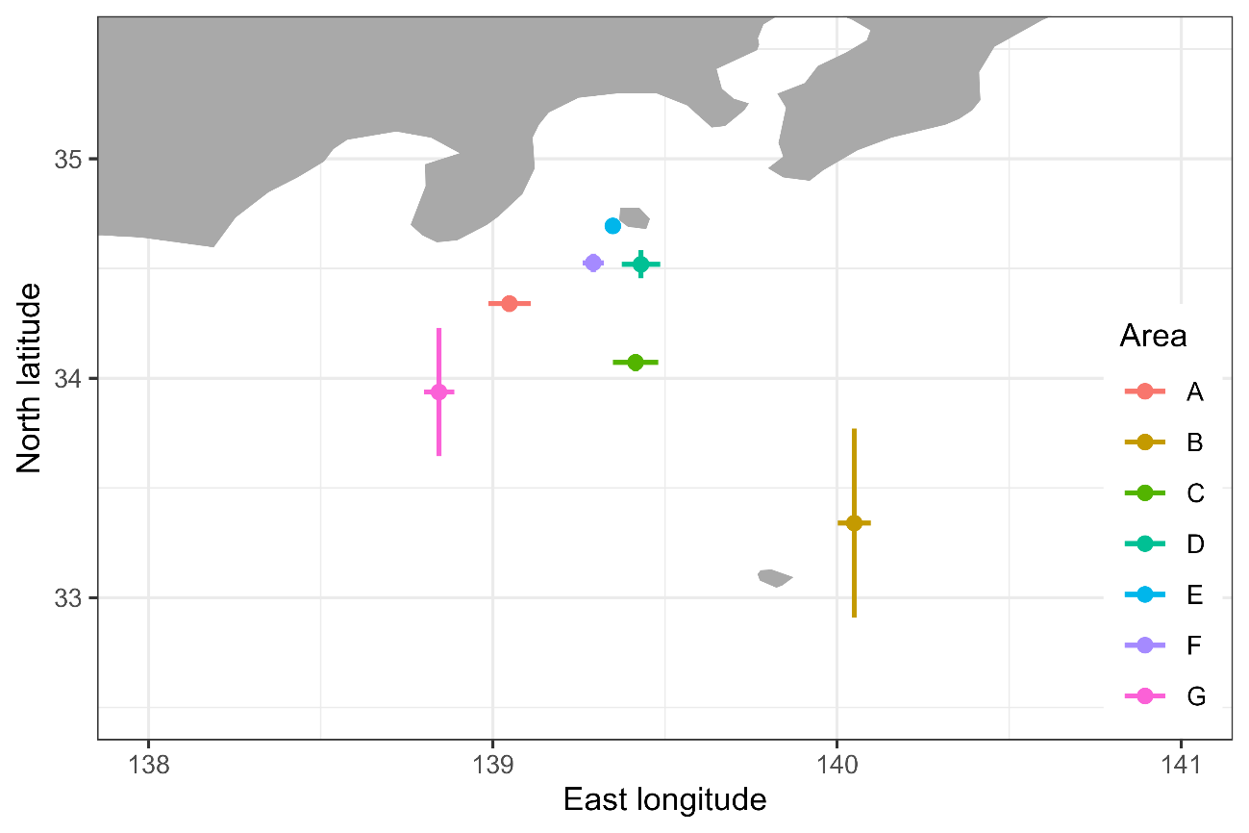
Map of the area category (A to G). Each point represents the center of the fishing location of each category of the area, and error bars represent the dispersion (1 SD) of the fishing locations within the same category.

Figure 2A
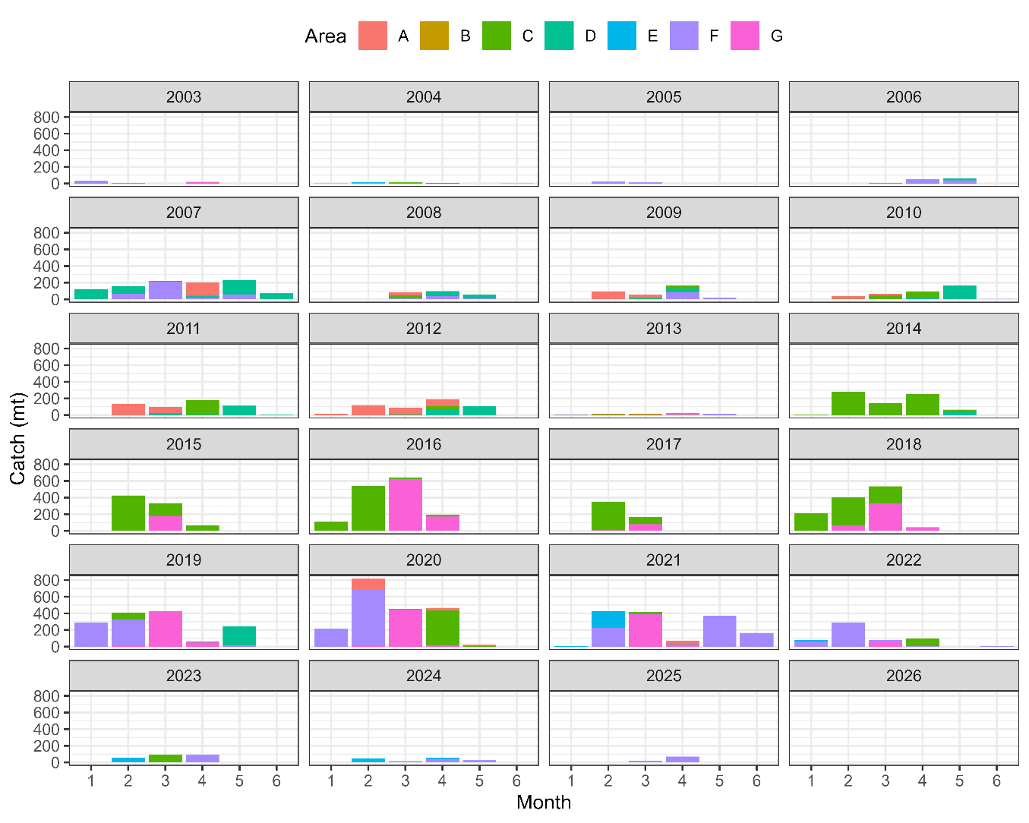
Catch amounts (mt) by area (color, see Fig. 1) by month (x-axis) from 2003 to 2026.

Figure 2B
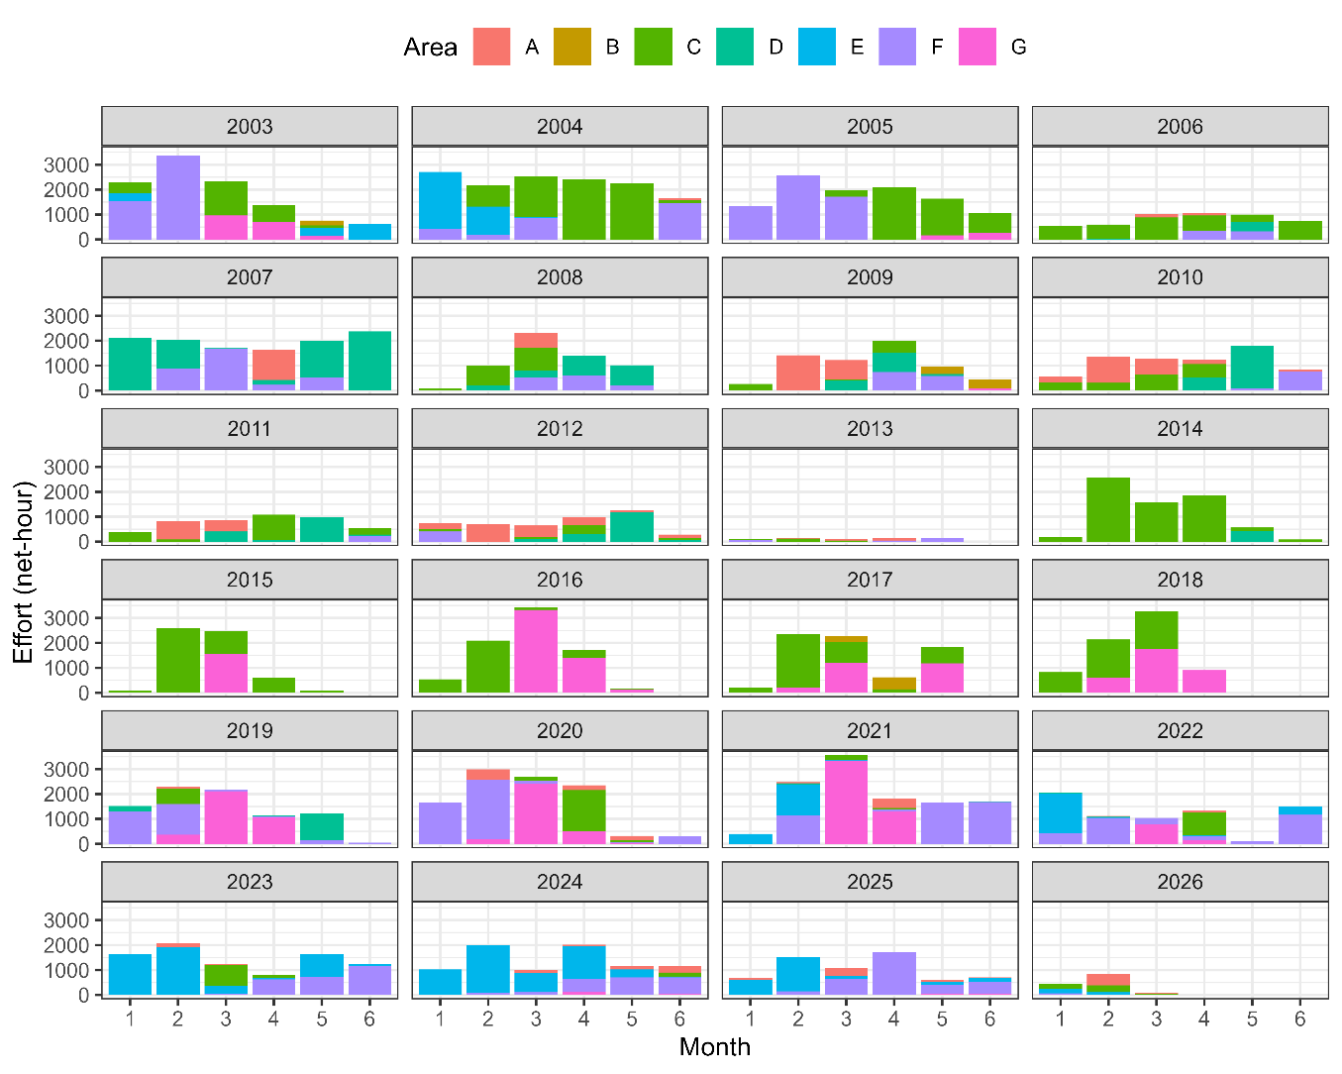
Effort amounts (net-hour) by area (color, see Fig. 1) by month (x-axis) from 2003 to 2026.

Figure 2C
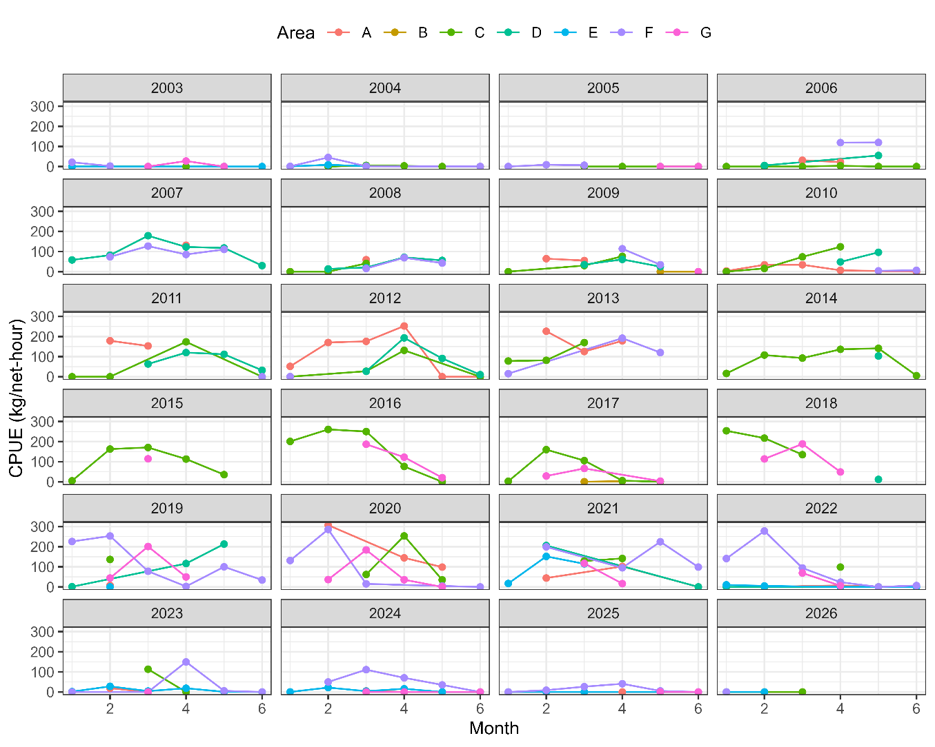
CPUE (kg/net-hour) by area (color, see Fig. 1) by month (x-axis) from 2003 to 2026.

Figure 3A
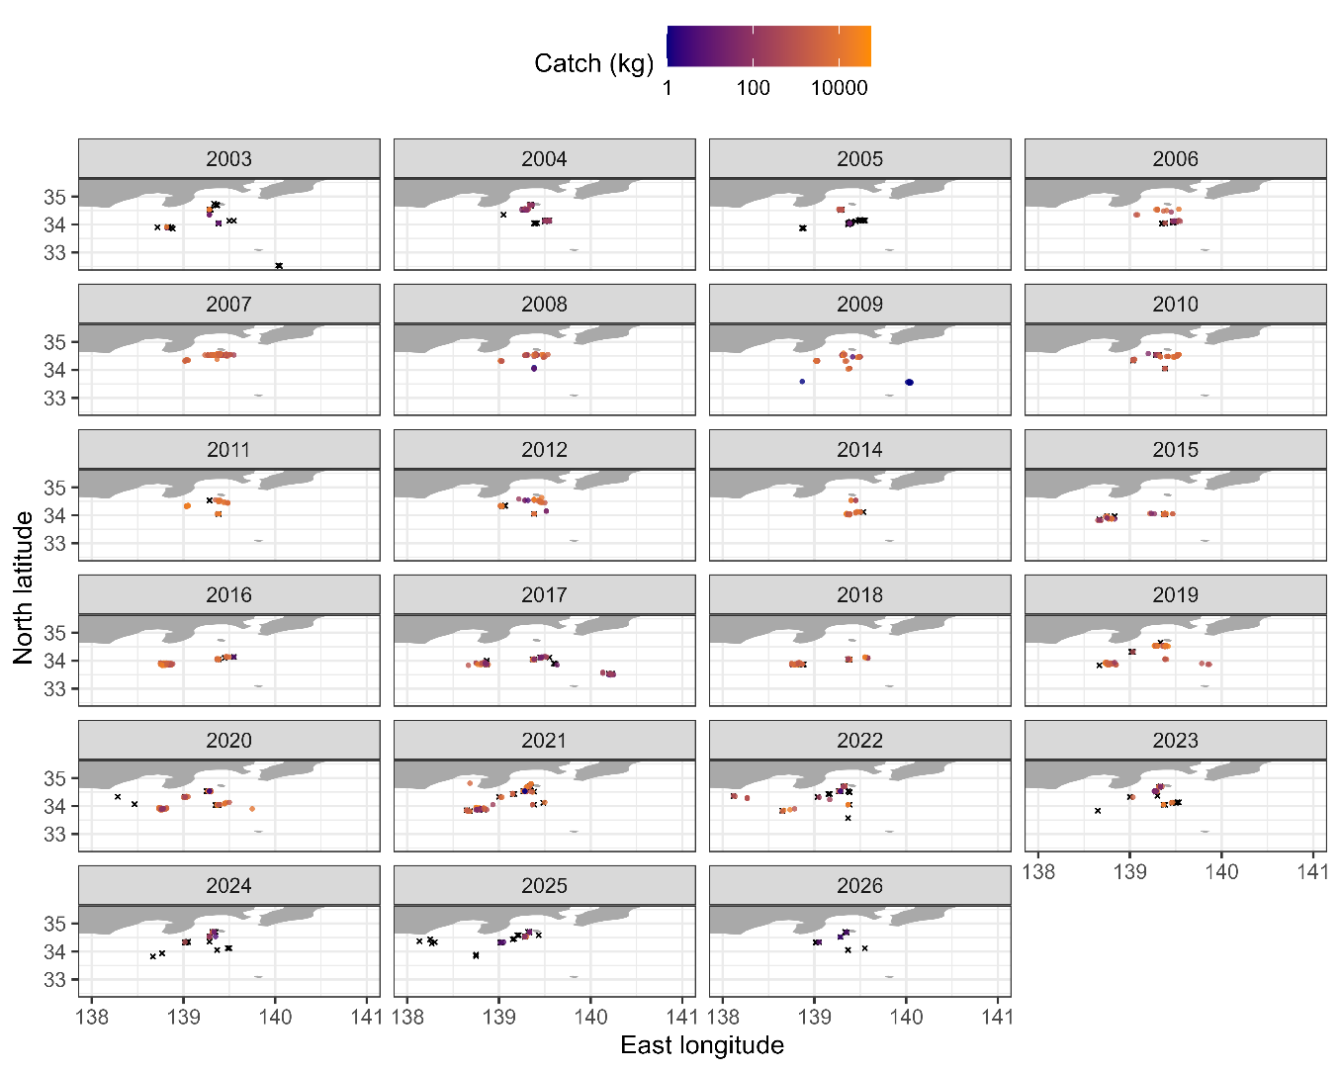
Map of catch from 2003 to 2026 for samples having the information on longitude and latitude. Zero catch is shown as X in black and positive catch is shown as O with color scaling in log space. Note that the lack of 2013 is because no sample has the information on longitude and latitude in 2013.

Figure 3B
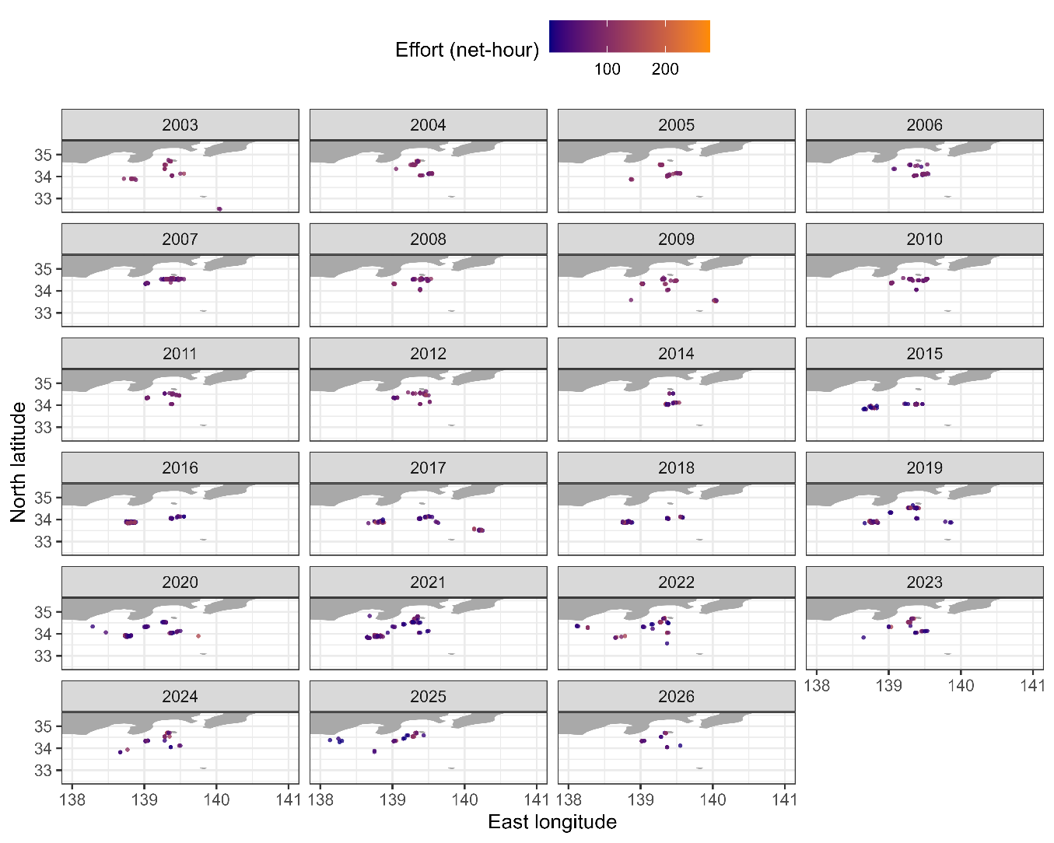
Map of effort from 2003 to 2026 for samples having the information on longitude and latitude. The amount of effort is expressed by color scaling. Note that the lack of 2013 is because no sample has the information on longitude and latitude in 2013.

Figure 3C
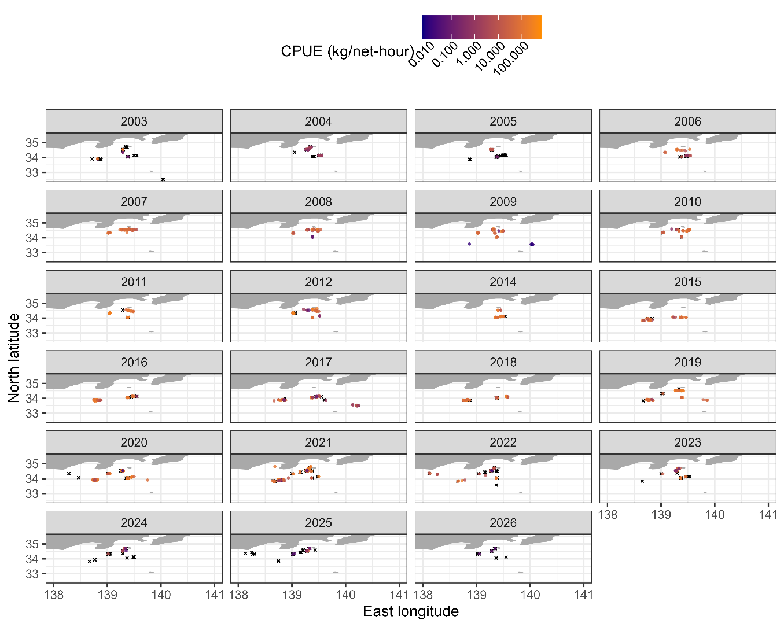
Map of CPUE from 2003 to 2026 for samples having the information on longitude and latitude. Zero catch is shown as X in black and positive catch is shown as O with color scaling in log space. Note that the lack of 2013 is because no sample has the information on longitude and latitude in 2013.

Figure 4A
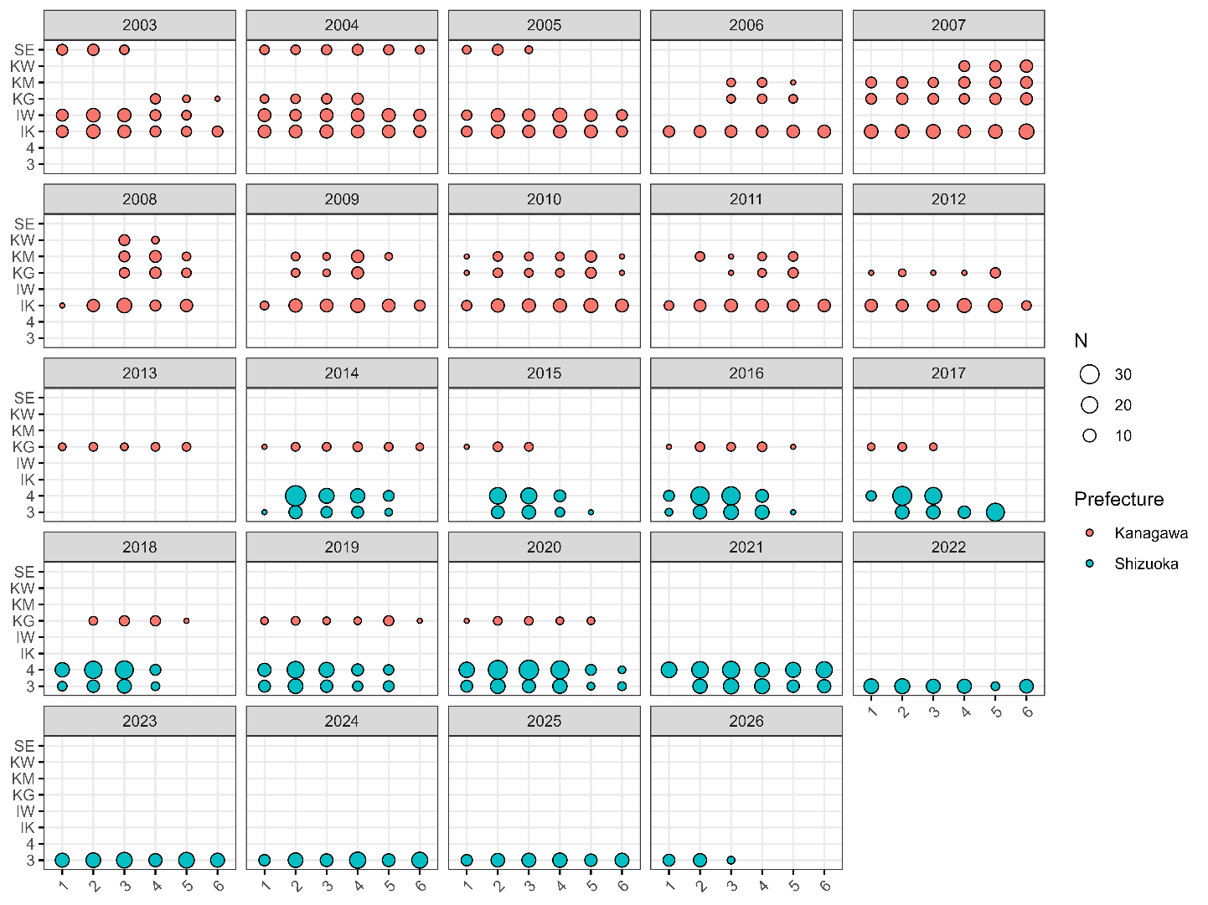
Balloon plots showing sample sizes (represented by the magnitude of circles) in each category by month (x-axis) by ship (y-axis) from 2003 to 2026. The color represents the prefectures that ships belonged to.

Figure 4B
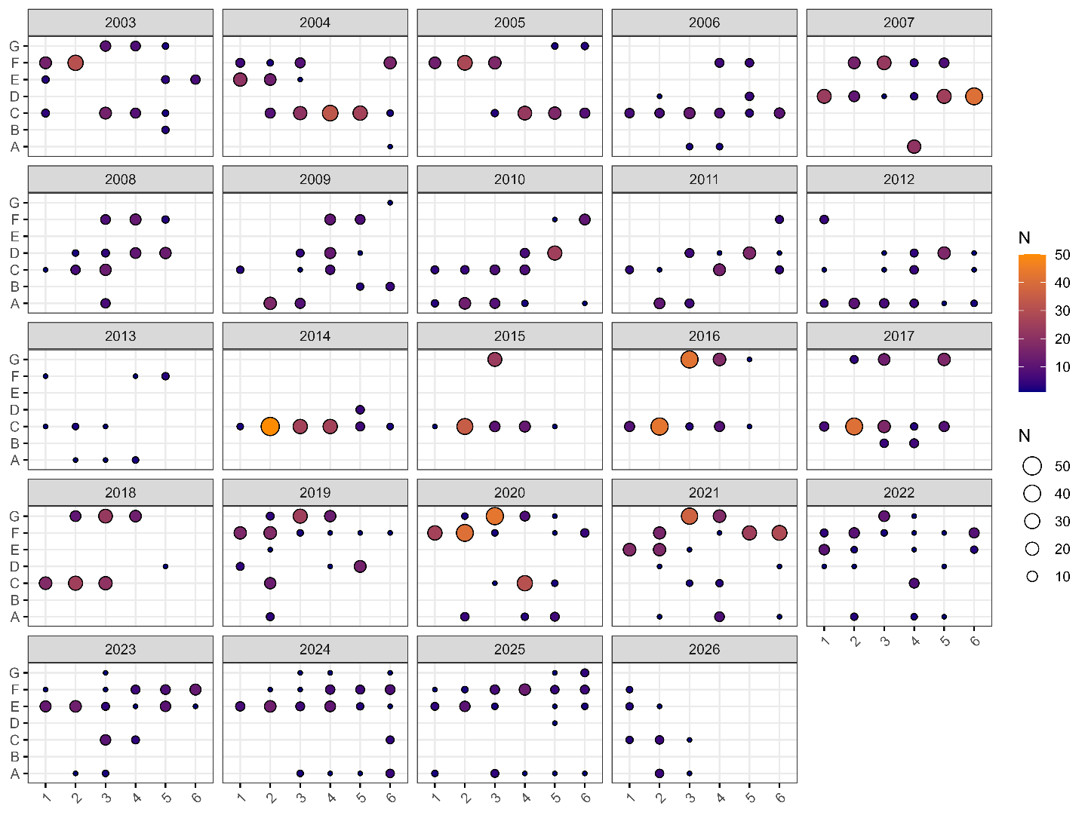
Balloon plots showing sample sizes (represented by the magnitude of circles and color) in each category by month (x-axis) by area (y-axis) from 2003 to 2026.

Figure 4C
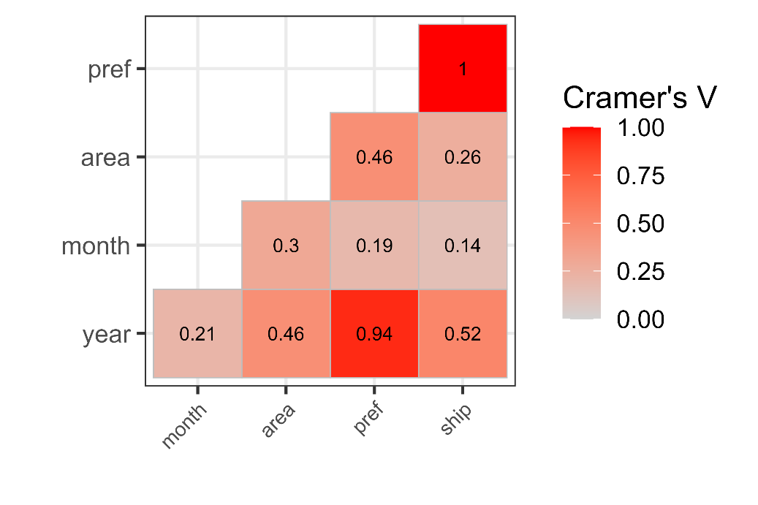
Cramer’s V between two categorical variables.

Figure 4D
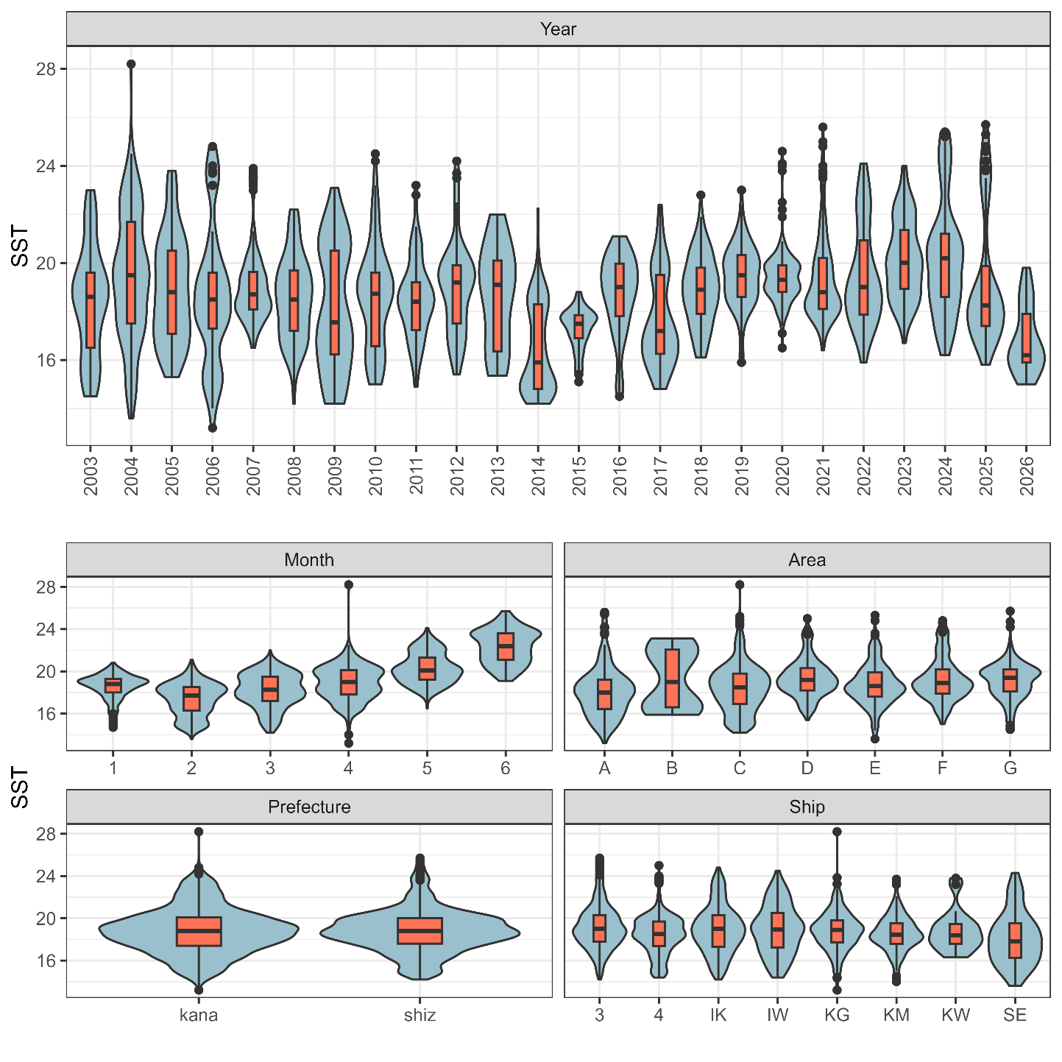
Violin plots showing the relationship between SST and categorical variables (year, month, area prefecture, ship). Box plots are shown to indicate medians, quantiles, and outliers.

Figure 4E
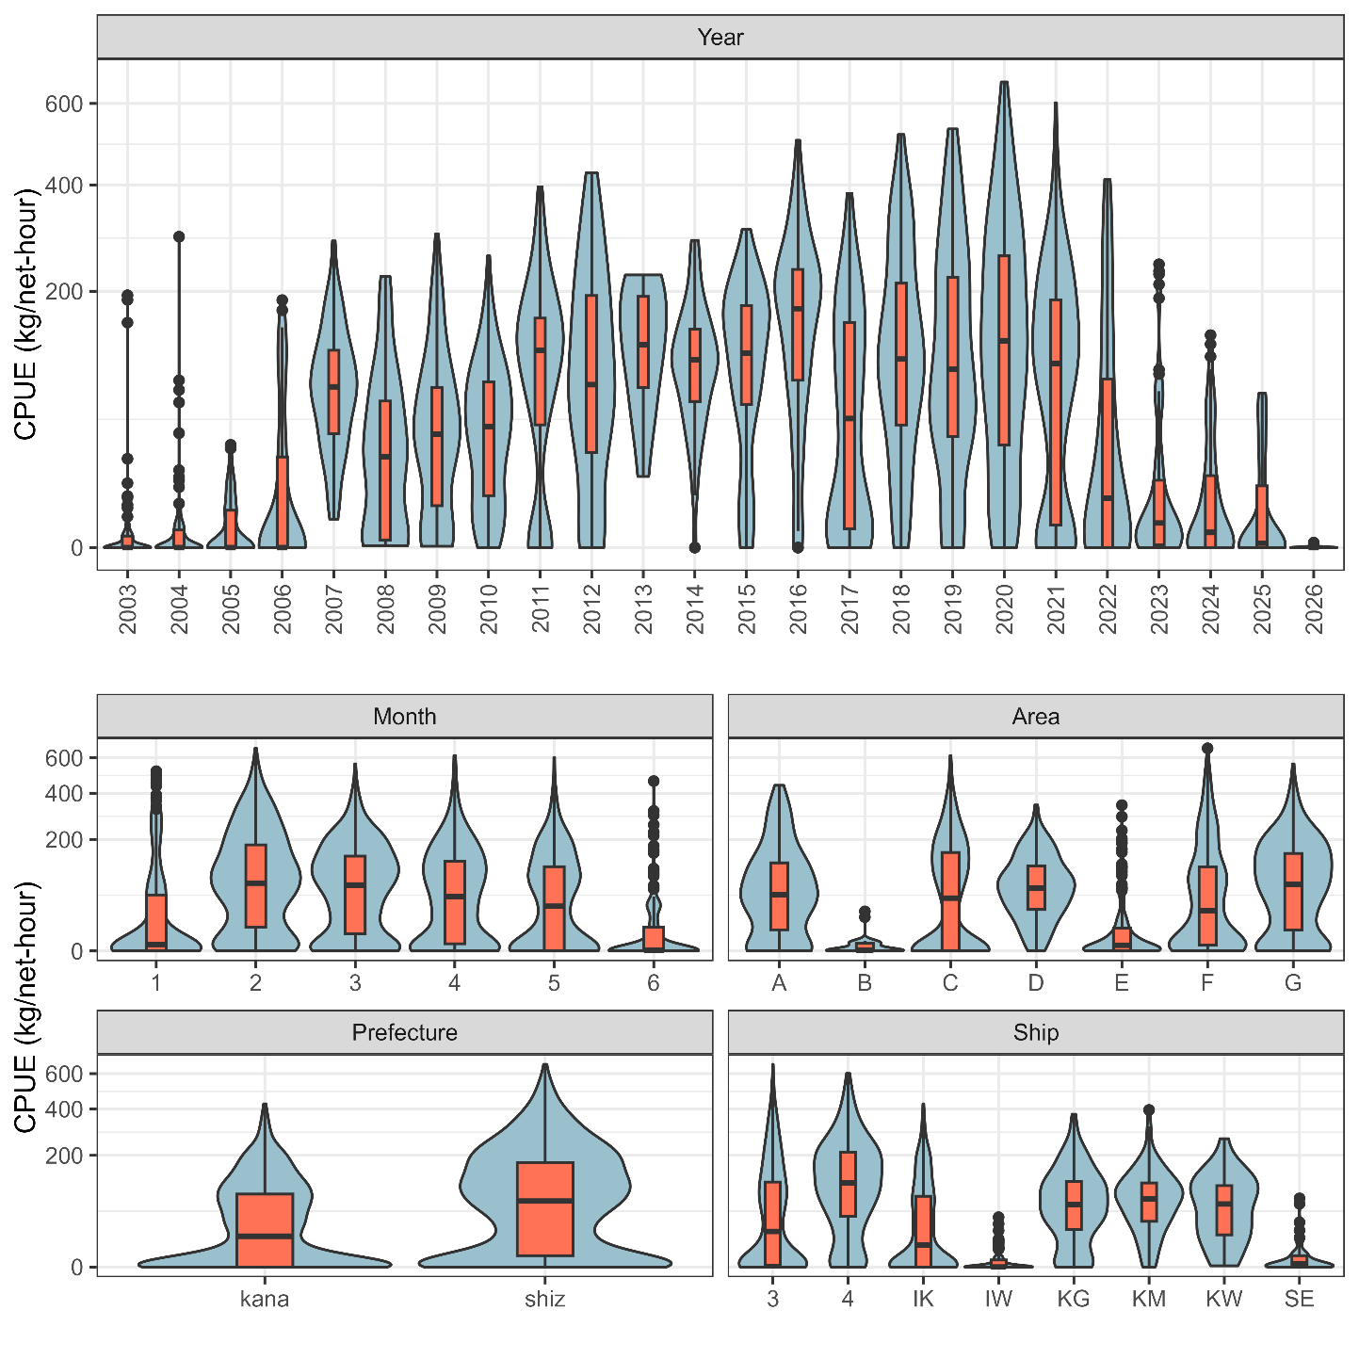
Violin plots showing the relationship between CPUE (including zero-catches) and categorical variables (year, month, area prefecture, ship). Box plots are shown to indicate medians, quantiles, and outliers. Note that the y-axis is scaled by the square root for visualization.

Figure 4F
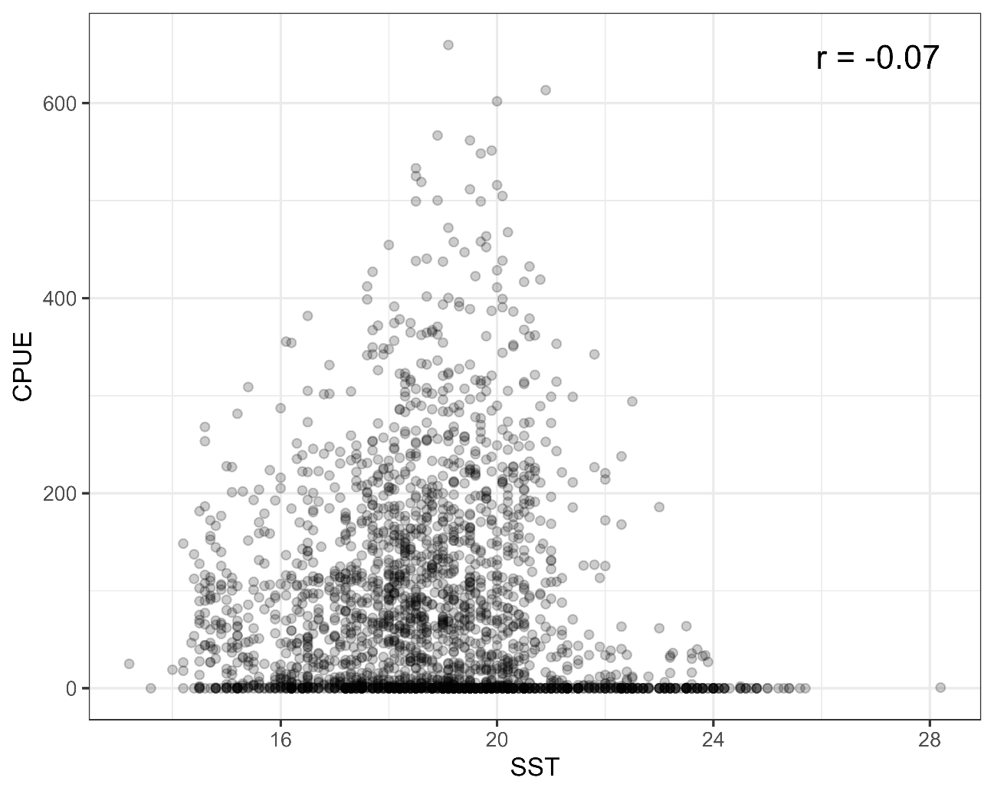
Relationship between SST and CPUE. The Pearson’s correlation coefficient is shown at the upper right corner.

Figure 5A
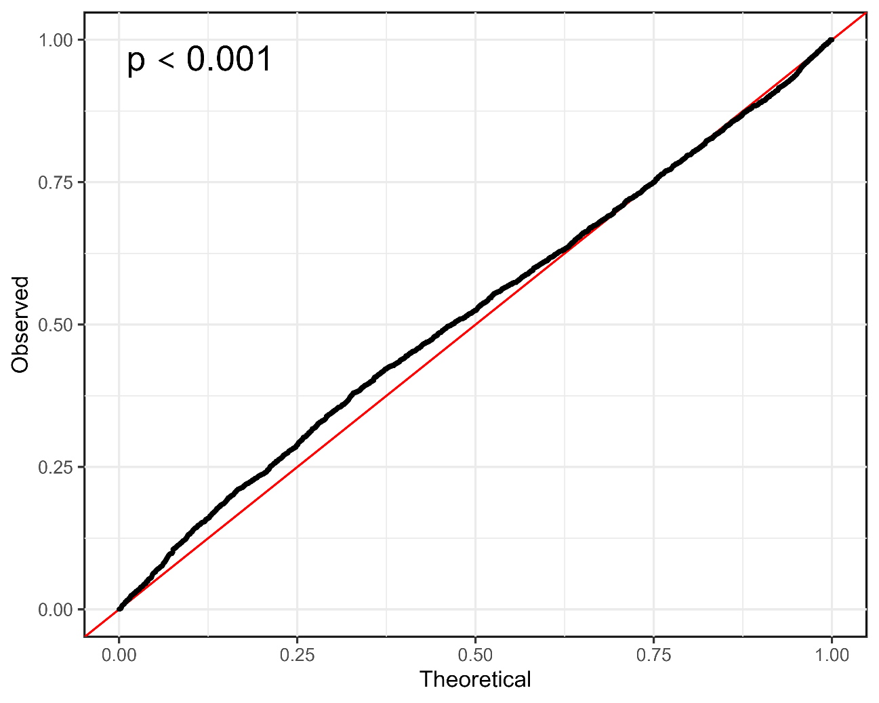
QQ plot along with p value in the Kolmogorov-Smirnov test at the upper-left corner.

Figure 5B
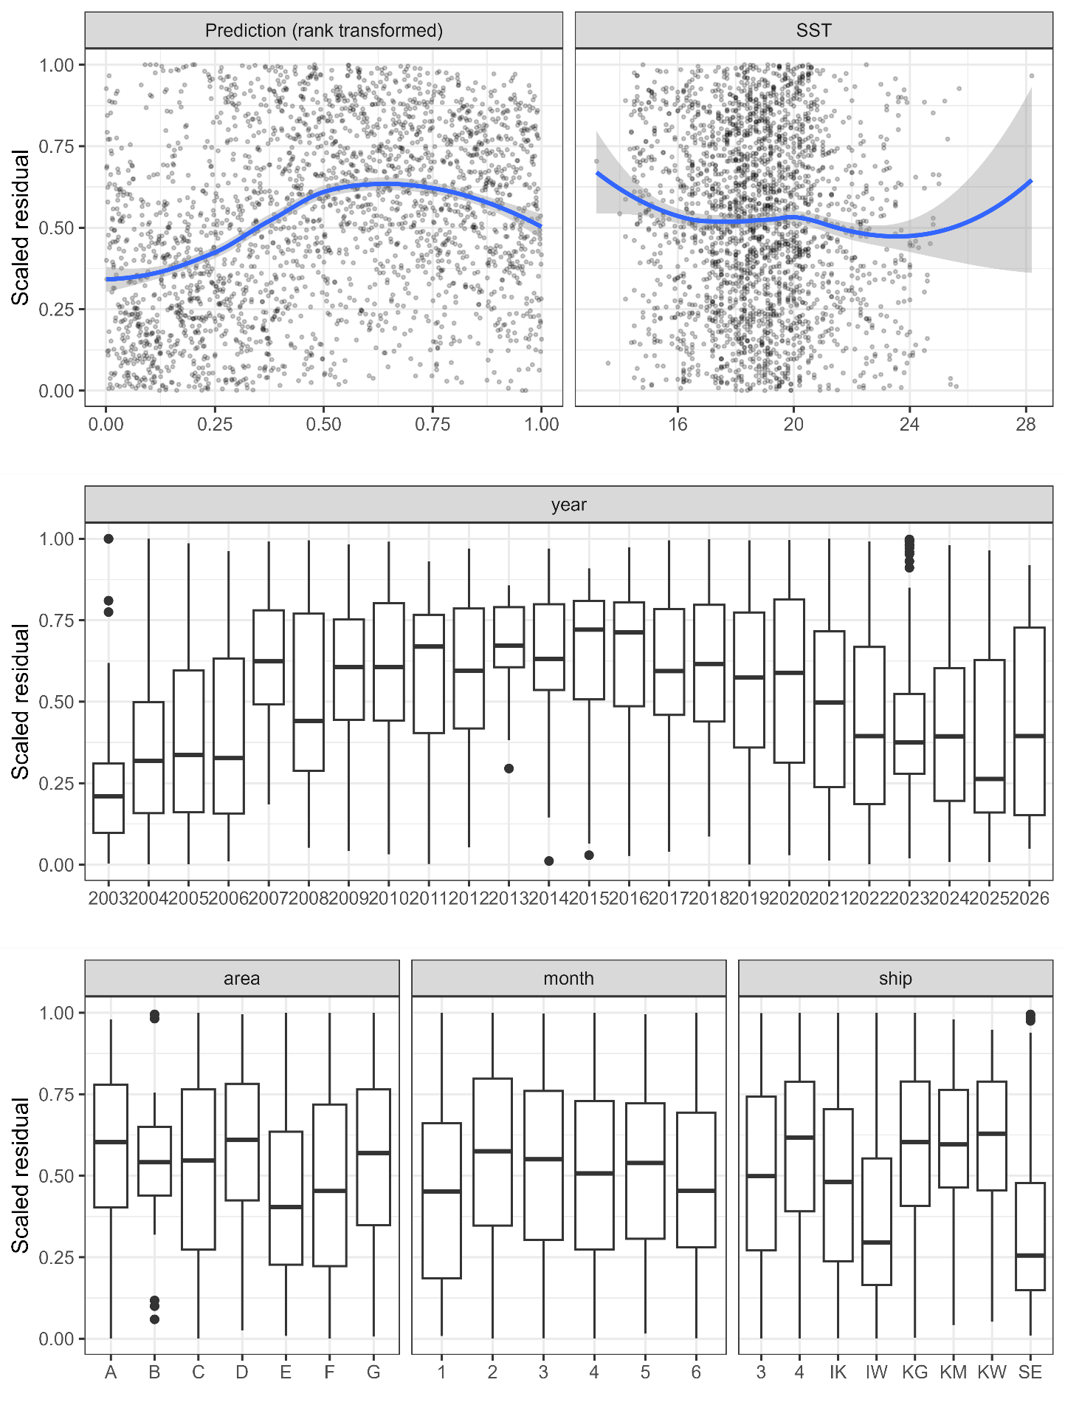
Relationships between scaled residuals and the selected variables or predicted CPUE (rank-transformed, upper-left). Smooth curves in blue for the upper panels are described by LOESS.

Figure 6
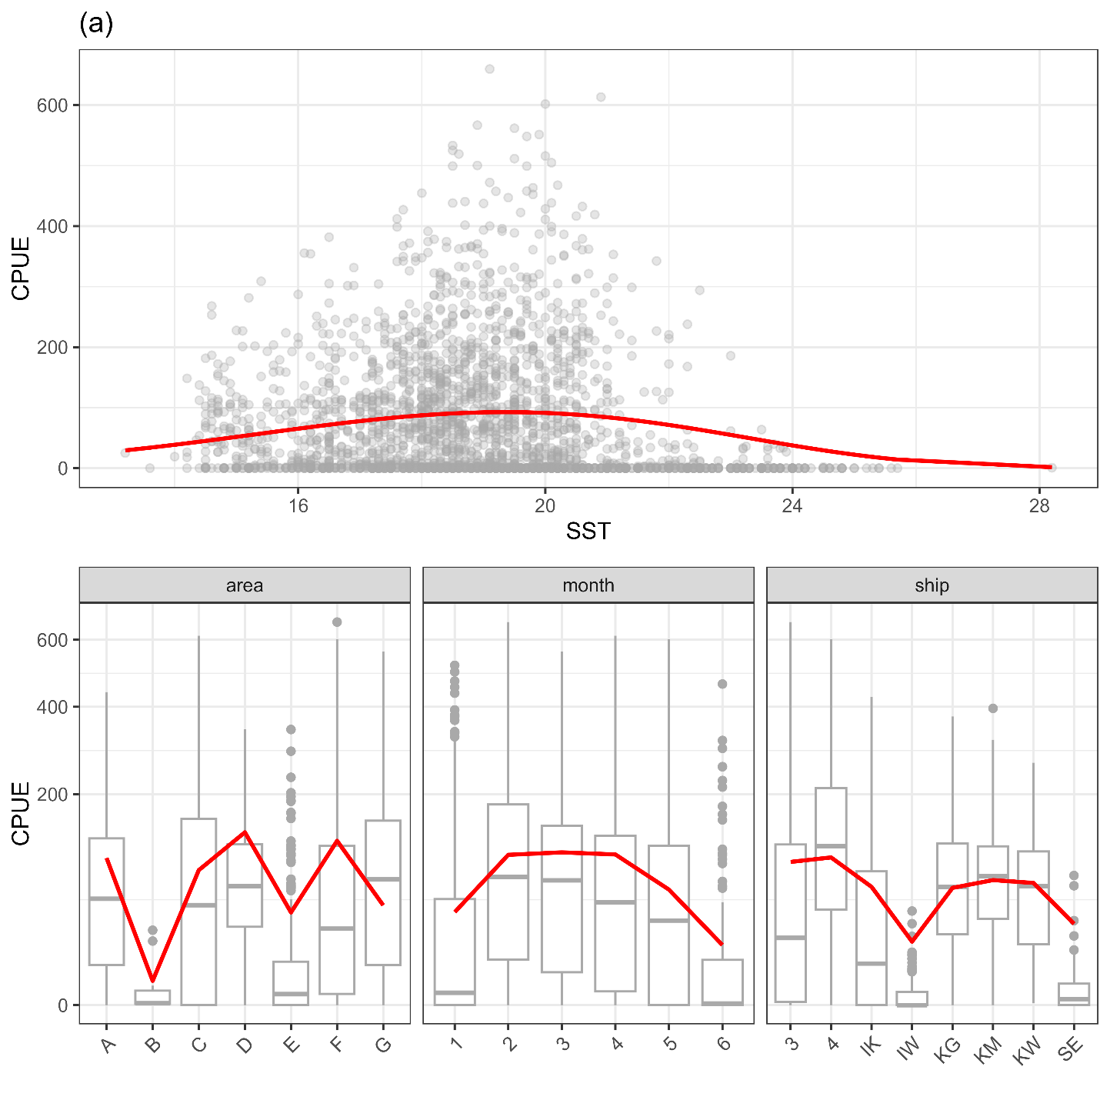
Estimated relationships between independent variables and expected CPUE predicted by the best model. Note that the y-axis is scaled by the square root for visualization.

Figure 7
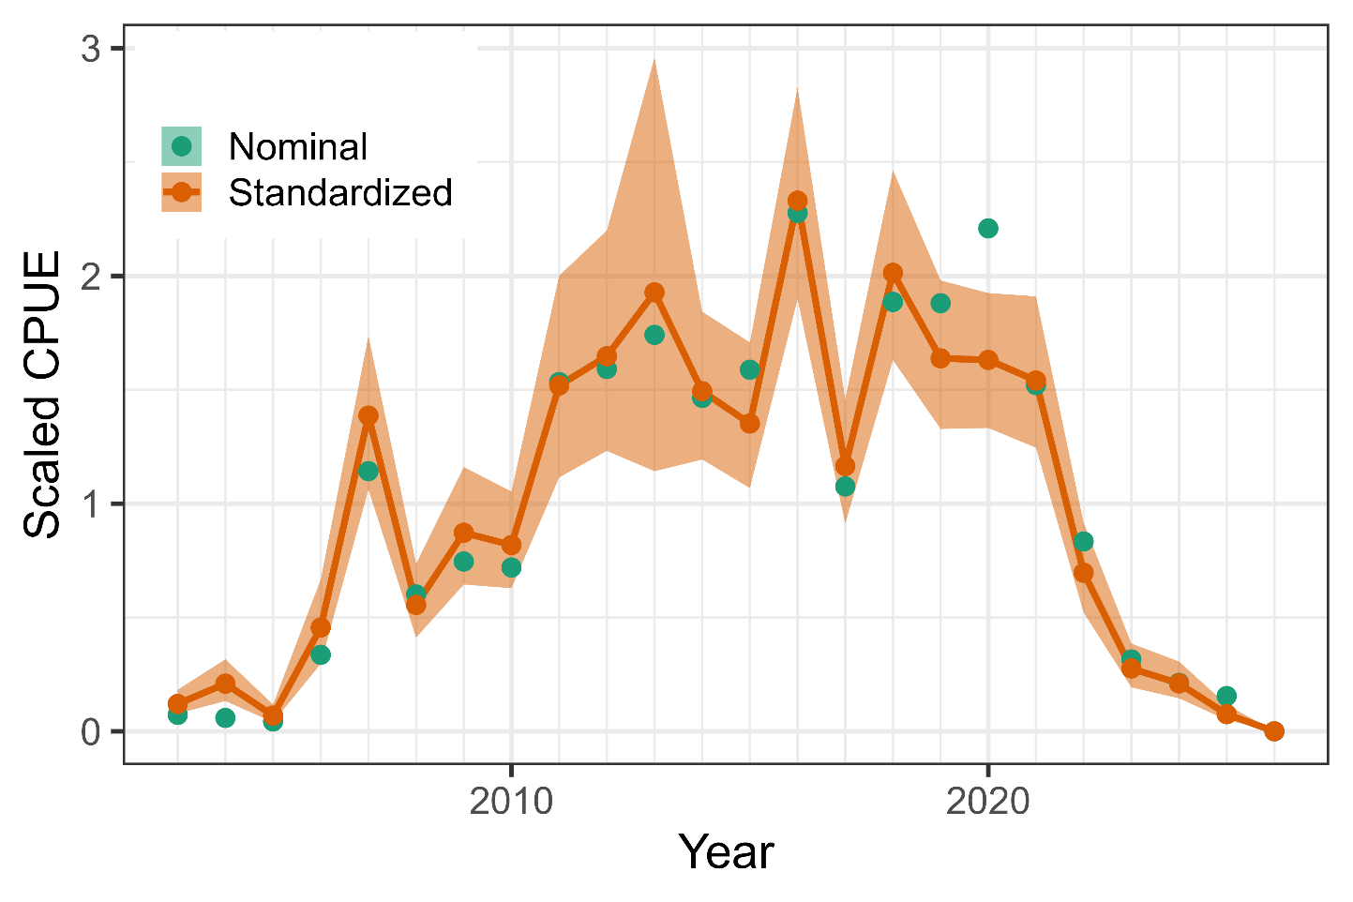
Time series of scaled nominal and standardized CPUE from 2003 to 2026. The index values were scaled by mean and SD. The shadow area represents 95% confidence intervals of standardized CPUE.

AppendIX
Checklist for the CPUE standardization protocol
No. | Step-by-step protocols | yes/no | Note
1 | Provide a description of the type of data (logbook, observer, survey, etc. ), and the “resolution” of the data (aggregated, set-by-set etc..). This description should also include the representativeness of the data in two tables: (1st table) Number of observations, % Coverage of CPUE fleet (catch), % Coverage of CPUE fleet (effort), Total Catch CPUE fleet (mt), Total Effort CPUE fleet, Percentage of overall catch by member (across all fleets/gears); and (2nd table) Number of records remaining, Number removed, Number of records with chub mackerel catch >0; | Yes | Section 2.1 (pages 1-2) and Tables 1 (page 6) and 2 (page 7)
2 | Conduct a thorough literature review to identify key factors (i.e., spatial, temporal, environmental, and fisheries variables) that may influence CPUE values; | Yes | Section 1. Background (page 1)
3 | Plot annual/monthly spatial distributions of fishing efforts, catch and nominal CPUE to determine temporal and spatial resolution for CPUE standardization | Yes | Figs. 2-3 (pages 13-18)
4 | Make scatter plots (for continuous variables) and/or box plots (for categorical variables) and present correlation matrix if possible to evaluate correlations between each pair of those variables; | Yes | Fig 4. (pages 19-21]
5 | Describe selected explanatory variables based on (2)-(4) to develop full model for the CPUE standardization; | Yes | Section 2.3. (pages 2-3) and Table 3 (page 7)
6 | Specify model type and software (packages) and fit the data to the assumed statistical models (i.e., GLM, GAM, Delta-lognormal GLM, Neural Networks, Regression Trees, Habitat based models, and Statistical habitat based models); | Yes | Section 2.3. (pages 2-3)
7 | Evaluate and select the best model(s) using methods such as likelihood ratio test, information criterions, cross validation etc.; | Yes | Tables 4 and 5 (pages 8-9)
8 | Provide diagnostic plots to support the chosen model is appropriate and assumption are met (QQ plot and residual plots along with predicted values and important explanatory variables, etc.); | Yes | Fig. 5 (pages 25-26)
9 | Present estimated values of parameters and uncertainty in the parameters in table; | Yes | Table 6 (pages 9-10)
10 | Present the relationship between the response variable and the explanatory variables. Check if it is interpretable. | Yes | Fig. 6 (page 27)
11 | Extract yearly standardized CPUE and standard error by a method that is able to account for spatial heterogeneity of effort, such as least squares mean or expanded grid. If the model includes area and the size of spatial strata differs or the model includes interactions between time and area, then standardized CPUE should be calculated with area weighting for each time step. Model with interactions between area and season or month requires careful consideration on a case by case basis. Provide details on how the CPUE index was extracted. | Yes | Section 2.4. (page 3)
12 | Calculate uncertainty (SD, CV, CI) for standardized CPUE for each year. Provide detailed explanation on how the uncertainty was calculated; | Yes | Table 7 (page 11) and Fig. 7 (page 28)
13 | Provide a table and a plot of nominal and standardized CPUEs over time. When the trends between nominal and standardized CPUE are largely different, explain the reasons (e.g. spatial shift of fishing efforts), whenever possible. | Yes | Section 3 (page 4), Section 4 (page 4), Table 7 (page 11), and Fig. 7 (page 28)

